Lesson 19: Translating Functions

Student Outcomes
- Students recognize and use parent functions for linear, absolute value, quadratic, square root, and cube root functions to perform vertical and horizontal translations. They identify how the graph of $y=f(x)$ relates to the graphs of $y=f(x)+k$ and $y=f(x+k)$ for any specific values of $k$, positive or negative, and find the constant value, $k$, given the parent functions and the translated graphs. Students write the function representing the translated graphs.

Lesson Notes
In the Opening Exercise, students sketch the graphs of the equation $y=f\left(x\right)$ for a parent function, $f$, and graph the equations, $y=f(x)+k$ and$y=f\left(x+k\right),$representing transformations of $f$. The functions in this example are linear, absolute value, and quadratic. In Example 1, students identify the value of $k$ by looking at the graphs of the parent function and the translated functions. Students also write the function representing the translated graph. Concepts in this lesson relate directly to those in Module 3, Lessons 17 and 18. In this lesson, the functions will expand to include quadratic, square root, cube root, and absolute value.

Classwork
Scaffolding:
It may be helpful for struggling students to also create a table of values for each set of graphs. Ask them to compare the $y$-coordinates of the parent function and the translated functions. For example, in the linear functions for part (a), they should see that for the function $g(x)=x+5$, the $y$-coordinates are $5$ more than the $y$-coordinates of $f(x)$. In the same manner, the $y$-coordinates of $h\left(x\right)=x-6$ are $6$less than those of$f(x)$.
Opening Exercise (10 minutes)
After providing the students with graphing calculators, have them graph each set of three functions in the same window. If graphing calculators are not accessible, provide the graphs of the functions, or project the graphs on the board. Ask students to explain what similarities and differences they see among the graphs. Remind students that part (c) is the same type of problem they solved in Module 3.
Opening Exercise
Graph each set of three functions in the same coordinate plane (on your graphing calculator or a piece of graph paper). Then, explain what similarities and differences you see among the graphs.
- $f(x)=x$  $$g(x)=x+5$$  $$h\left(x\right)=x-6$$ | - $f(x)=x^{2}$  $$g(x)=x^{2}+ 3$$  $h\left(x\right)=x^{2}-7$ | - $f(x)=|x|$  $$g(x)=|x+3|$$  $$h(x)=|x-4|$$
Part (a)—The graphs are parallel lines, but they have different $x$- and $y$-intercepts.
Part (b)—The graphs look the same (because they are congruent), but they have different vertices, which in this case means different minimum values. They are related by vertical translations.
Part (c)—The overall shapes of the graphs look the same (because they are congruent), but they have different vertices. They are related by horizontal translations.

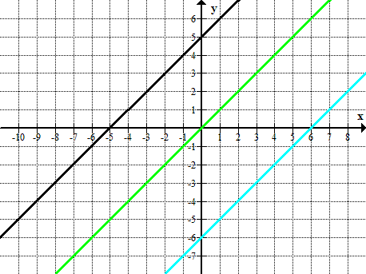
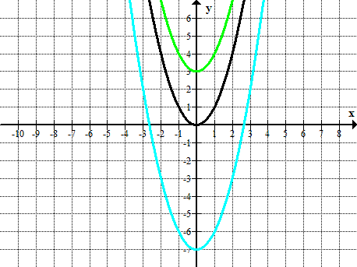
Part (b)
Part (a)
$$y=g(x)$$
$$y=f(x)$$
$$y=h(x)$$
$$y=f(x)$$
$$y=g(x)$$
$$y=h(x)$$

Part (c)
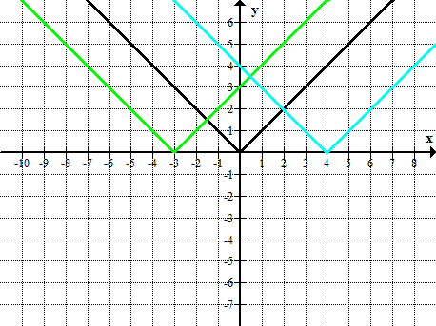
$$y=f(x)$$
$$y=g(x)$$
$$y=h(x)$$

- What do you notice about the coordinates of the points of the translated graphs in relation to the graph of their respective parent functions? How are the $y$-coordinates or $x$-coordinates of each of the three graphs related?
  - For part (a), at any given $x$, the $y$-coordinate of the graph of$g$is $5$ greater than the corresponding point on the graph of $f$, and the $y$-coordinate of the graph of $h$ is $6$ less than the corresponding point on the graph of $f$.
  - For part (b), at any given $x$, the $y$-coordinate of the graph of $g$ is $3$ greater than the corresponding point on the graph of $f$, and the$y$-coordinate of the graph of $h$ is $7$ less than the corresponding point on the graph of $f$. The constant values represent the different $y$-intercepts of different graphs.
  - For part (c), at a given value for $y$, the $x$-coordinates of the graph of$g$ are $3$ less than the corresponding point on the graph of $f$, and the $x$-coordinates of the graph of $h$ are $4$ greater than the corresponding points on the graph of $f$.
  - When comparing the corresponding points on the graphs of $g$ and $h$, we find that for part (a), the $y$-coordinate of the point on the graph of $g$ is $11$ more than that of the graph of $h$; for part (b), the$y$-coordinate of the point on the graph of $g$ is $10$ more than that of the graph of $h$; and for part (c), the $x$-coordinates of points on the graph of$g$ are $7$ less than the corresponding points on the graph of $h$.

- How are the graphs of $g$ and $h$ translated compared to that of$f$ and to each other?
  - For part (a), the graph of $g$ is $5$ units above the graph of $f$, while the graph of $h$ is $6$ units below the graph of$f$, and the graph of $g$ is $11$ units above the graph of$h$.
  - For part (b), the graph of $g$ is $3$ units above the graph of $f$, while the graph of $h$ is $7$ units below the graph of$f$, making the graph of$g$ $10$ units above the graph of $h$.
  - For part (c), the graph of $g$ is $3$ units left of the graph of$f$, the graph of $h$ is $4$ units right of the graph of$f$, and the graph of $g$ is $7$units to the left of the graph of $h$.
- Say you have a function defined by $f\left(x\right)=\sqrt{x}$, what can you conclude about the graph of $p\left(x\right)=\sqrt{x}+4$?
  - The graph of $p$is congruent to that of$f$, but it is translated $4$ units up.
- If you have the function, $f\left(x\right)=\sqrt[3]{x}$, what can you conclude about the graph of $q\left(x\right)=\sqrt[3]{x+5}$?
  - The general shape of the graph of $q$ is congruent to that of $f$ but is translated $5$ units left.
Students analyze the similarities and differences of the graphs to look for patterns. They then generalize the patterns to determine how vertical and horizontal shifts of the graphs are related to the structure of the equations. They also relate the structure of the equations for each function to that of the parent function and make the connection to the structure of the translated graphs of each.
MP.7
&
MP.8

Example (10 minutes)
On the board, post the following sets of graphs. For each set, ask the list of questions below.
Example
For each graph, answer the following:
- What is the parent function?
- How does the translated graph relate to the graph of the parent function?
- Write the formula for the function depicted by the translated graph.

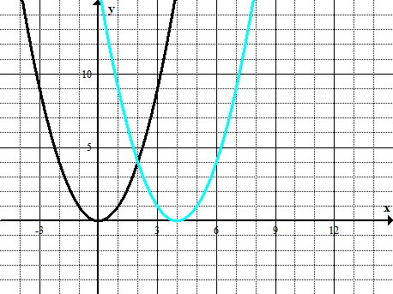
$$y=f(x)$$
$$y=g(x)$$

The parent function is $f(x)=x^{2}$. The graph is shifted $4$ units to the right. The function defined by the translated graph is $g(x)={(x-4)}^{2}$.

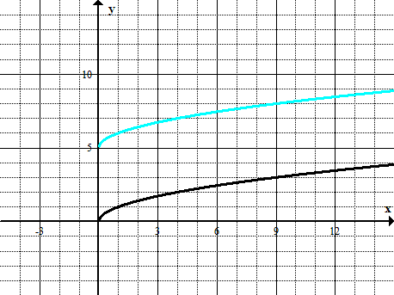
$$y=f(x)$$
$$y=g(x)$$

The parent function is $f\left(x\right)=\sqrt{x}.$ The constant value added to$f(x)$ is $5$because the graph is shifted $5$ steps up. The function defined by the translated graph is $g\left(x\right)=\sqrt{x}+5.$

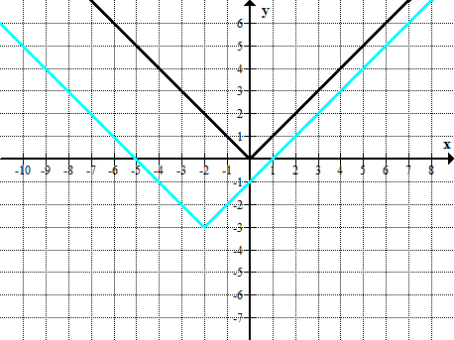
$$y=f(x)$$
$$y=g(x)$$

The parent function is$f(x)=|x|$. The constant values added to$f(x)$ are $-3$ and $+2$ because the graph is shifted $3$ steps down and $2$ steps to the left. The function defined by the translated graph is $g\left(x\right)=\left|x+2\right|-3$.

Exercises 1–3 (20 minutes)
Exercises 1–3
- For each of the following graphs, use the formula for the parent function $f$ to write the formula of the translated function.
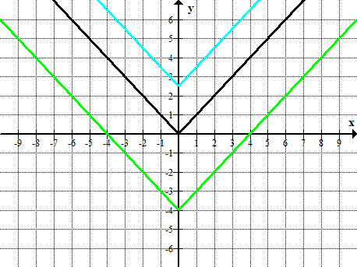
$$y=f(x)$$
$$y=g(x)$$
$$y=h(x)$$

Parent Function: $f(x)=|x|$
Translated Functions: $g(x)=|x|+2.5$,
$$h\left(x\right)=\left|x\right|-4$$

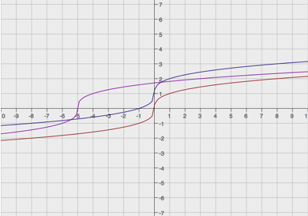
  - $0$
$$y=f(x)$$
$$y=g(x)$$
$$y=h(x)$$
Parent Function: $f\left(x\right)=\sqrt[3]{x}$
Translated Functions: $g\left(x\right)=\sqrt[3]{x}+1$,
$h\left(x\right)=\sqrt[3]{x+5}$

- Below is a graph of a piecewise function $f$ whose domain is $-5≤x≤3$. Sketch the graphs of the given functions on the same coordinate plane. Label your graphs correctly.
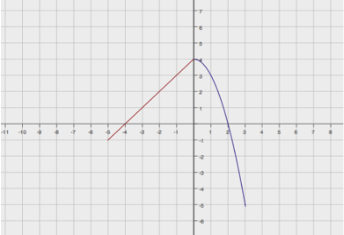
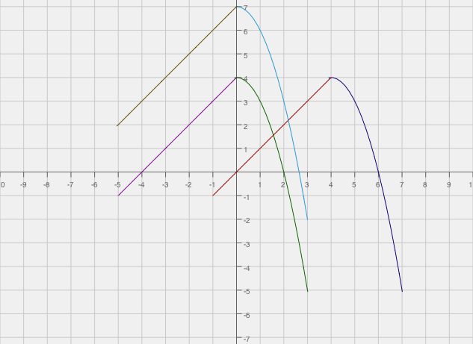
$g\left(x\right)=f(x)+3$ $h(x)=f(x-4)$
$$y=f(x)$$
$$y=f(x)$$
$$y=g(x)$$
$$y=h(x)$$

- Match the correct equation and description of the function with the given graphs.
Graphs | Equation | Description
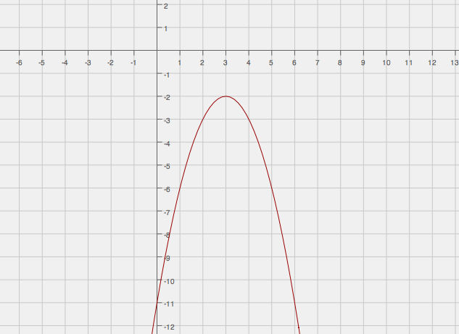  $y=f(x)$  Equation E3 Description D2 | E1. $y={(x-3)}^{2}$  E2. $y={(x+2)}^{2}-3$  E3. $y={-(x-3)}^{2}-2$  E4. $y={(x-2)}^{2}-3$ | D1. The graph of the parent function is translated down $3$ units and left $2$ units.  D2. The graph of the function does not have an $x$-intercept.  D3. The coordinate of the  $y$-intercept is $(0, 1)$, and both $x$-intercepts are positive.  D4. The graph of the function has only one $x$-intercept.
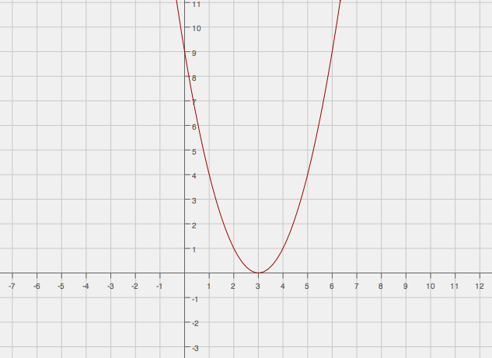
$y=g(x)$

Equation E1 Description D4

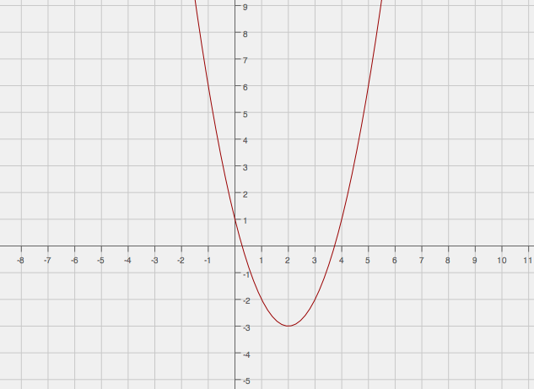
$y=h(x)$

Equation E4 Description D3
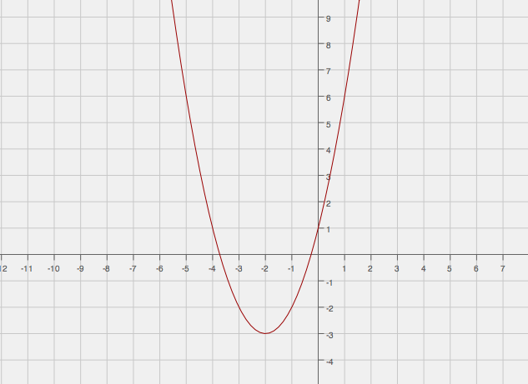
$y=p(x)$

Equation E2 Description D1

Closing (3 minutes)
- Given any function, how does adding a positive or negative value, $k$, to $f(x)$ or $x$ affect the graph of the parent function?
  - The value of the constant $k$shifts the graph of the original function $k$ units up (if $k>0$) and $k$ units down (if $k<0$) if$k$ is added to $f(x)$ such that the new function is $g(x)=f(x)+k$. The value of $k$shifts the graph of the original function $k$units to the left (if $k>0$) and$k$ units to the right (if $k<0$) if $k$ is added to$x$such that the new function is $g(x)=f(x+k)$.

Exit Ticket (5 minutes)
Students analyze the graph and critique the reasoning of others. Then, they provide a valid explanation about their argument.

Name ___________________________________________________ Date____________________
Lesson 19: Translating Functions

Exit Ticket

- Ana sketched the graphs of $f(x)=x^{2}$ and $g\left(x\right)=x^{2}-6$ as shown below. Did she graph both of the functions correctly? Explain how you know.
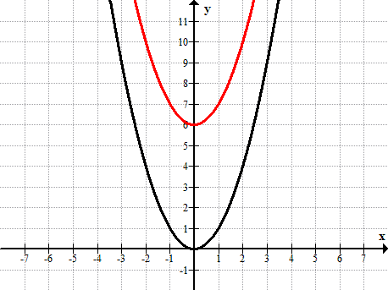
$$y=f(x)$$
$$y=g(x)$$

- Use transformations of the graph of $f\left(x\right)=\sqrt{x}$ to sketch the graph of $f\left(x\right)=\sqrt{x-1}+3$.
Exit Ticket Sample Solutions

- Ana sketched the graphs of $f(x)=x^{2}$ and $g\left(x\right)=x^{2}-6$ as shown below. Did she graph both of the functions correctly? Explain how you know.
$$y=f(x)$$
$$y=g(x)$$

The function $f$ was graphed correctly, but not $g$. The graph of $g$should have been translated $6$ units below the graph of $f$.
MP.3

- Use transformations of the graph of $f\left(x\right)=\sqrt{x}$ to sketch the graph of $f\left(x\right)=\sqrt{x-1}+3$.
The graph should depict the graph of the square root function translated $1$ unit right and $3$units up.

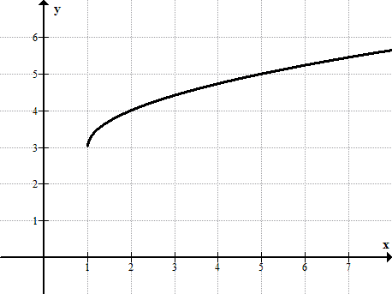

Problem Set Sample Solutions
Students should complete these problems without using a graphing calculator. The following solutions indicate an understanding of the lesson objectives.

- Graph the functions in the same coordinate plane. Do not use a graphing calculator.
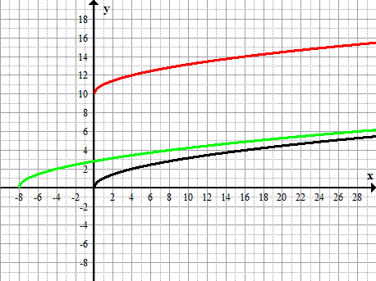
$f\left(x\right)=\sqrt{x}$
$$y=f(x)$$
$$y=p(x)$$
$$y=q(x)$$

$$p(x)=10+\sqrt{x}$$
$$q\left(x\right)=\sqrt{x+8}$$

- Write a function that translates the graph of the parent function $f\left(x\right)=x^{2}$ down $7.5$ units and right $2.5$units.
$f\left(x\right)={(x-2.5)}^{2}-7.5$

- How would the graph of $f(x)=|x|$ be affected if the function were transformed to $f(x)=|x+6|+10$?
The graph would be shifted $10$ units up and $6$ units to the left.

- Below is a graph of a piecewise function $f$ whose domain is the interval $-4≤x≤2$. Sketch the graph of the given functions below. Label your graphs correctly.
$g\left(x\right)=f\left(x\right)-1$ $h(x)=g(x-2)$ (Be careful, this one might be a challenge.)
Point out that the graph of $h$ is related to $g$ rather than $f$. Make sure students recognize that they must find the graph of $g$ first, and then translate it to find $h$.
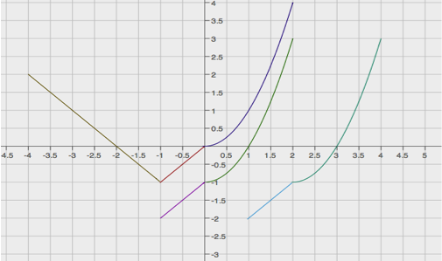
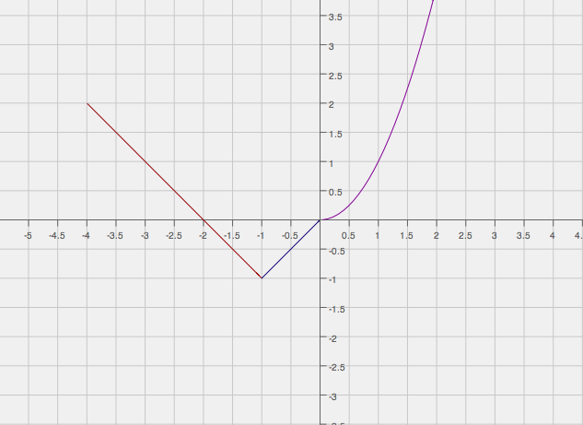
$$y=h(x)$$
$$y=g(x)$$
$$y=f(x)$$
$$y=f(x)$$

- Study the graphs below. Identify the parent function and the transformations of that function depicted by the second graph. Then, write the formula for the transformed function.
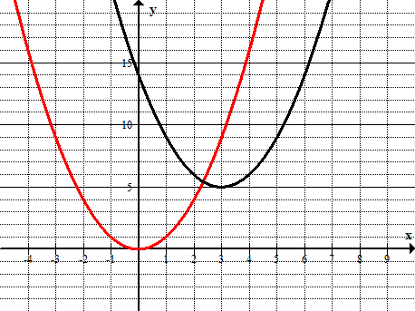
$$y=g(x)$$
$$y=f(x)$$

The parent function is $f\left(x\right)=x^{2}$, in red. The graph of the transformed function, in black, is the graph of $y=f(x)$ shifted $3$ units to the right and 5 units up. The function defined by the translated graph is $g\left(x\right)={(x-3)}^{2}+5$.

