Lesson 18: Graphing Cubic, Square Root, and Cube Root Functions

Student Outcomes
- Students compare the basic quadratic (parent) function, $y=x^{2}$, to the square root function and do the same with cubic and cube root functions. They then sketch graphs of square root and cube root functions, taking into consideration any constraints on the domain and range.

Lesson Notes
In these exercises, students explore the effects of squaring, taking the square root of, cubing, and taking the cube root of various values. They then use visible patterns to make generalizations about the graphs of square root and cube root functions, as well as cubic functions.

Classwork
Opening Exercises (5 minutes)
Scaffolding:
For students who are not as familiar working with radicals, it may be important to spend a few minutes discussing the difference between the solutions for the equations $x^{2}=25$ and $x=\sqrt{25}$. In the first case, there are two possible solutions: $5$ and $-5$. But in the second, there is only one: $5$. The square root symbol originates from the geometric application of finding the length of the hypotenuse. The use of that symbol is reserved to mean the positive value that when squared would yield the value inside. Hence, when we solve for $x$ in the equation $x^{2}=25,$ we state the solution as $x=±\sqrt{25}$.
Students review evaluating expressions that involve radicals and exponents so that they are prepared to work with quadratic, square root, cubic, and cube root functions.
Opening Exercises
- Evaluate $x^{2}$ when $x=7$.
$$49$$

- Evaluate $\sqrt{x}$ when $x=81$.
$$9$$

- Evaluate $x^{3}$ when $x=5$.
$$125$$

- Evaluate $\sqrt[3]{x}$ when $x=27$.
$$3$$

Exploratory Challenge 1 (5 minutes)
Exploratory Challenge 1
Use your graphing calculator to create a data table for the functions $y=x^{2}$ and $y=\sqrt{x}$ for a variety of $x$-values. Use both negative and positive numbers, and round decimal answers to the nearest hundredth.
Scaffolding:
- Provide struggling students with tables that include several $x$-values.
- Some students might need to try many more values before recognizing the patterns.
$$x$$ | $$y=x^{2}$$ | $$y=\sqrt{x}$$
$$4$$ | $$16$$ | $$2$$
$$2$$ | $$4$$ | $$1.41$$
$$0$$ | $$0$$ | $$0$$
$$-2$$ | $$4$$ | Error
$$-4$$ | $$16$$ | Error

Discussion (5 minutes)
Compare the two$y$-columns in the data table from Exercise 1. Students can use their calculators to explore additional values of these functions.
- Observe both $y$-columns from above. What do you notice about the values in the two $y$-columns?
  - In the column for $y=x^{2}$, all $y$-values are positive.
  - In the column for $y=\sqrt{x}$, all negative $x$-values produce an error.
- Why are all $y$-values for $y=x^{2}$positive?
  - All $y$-values are positive since they are obtained by squaring the $x$-value.
- Why do all negative $x$-values produce an error for $y=\sqrt{x}$?
  - No real number, when squared, produces a negative result. Therefore, the calculator produces an error.
- What is the domain of $y=x^{2}$ and $y=\sqrt{x}$?
  - The domain of $y=x^{2}$is all real numbers.
  - The domain of $y=\sqrt{x}$is $x≥0$.
- What is the range of $y=x^{2}$ and $y=\sqrt{x}$?
  - The range of $y=x^{2}$is $y≥0$.
  - The range of $y=\sqrt{x}$ is $y≥0$.
- Compare the domain and range of $y=x^{2}$and $y=\sqrt{x}$.
  - The domain of $y=\sqrt{x}$ is limited to non-negative values, while the domain of $y=x^{2}$includes all real numbers.
  - The range of both functions is the same set of all nonnegative real numbers.
- What is the result if we take the square root of $x^{2}$? Have students try making a third column in the chart to see if they can come up with a rule for $\sqrt{x^{2}}$. This should help them understand the need for the $±$ when taking the square root of a variable expression.
  - If $x$ is a negative number, the result is $\left(-x\right),$ and if $x$ is a positive number, the result is$x$. So, $\sqrt{x^{2}}=|x|$.
Exploratory Challenge 2 (10 minutes)
Exploratory Challenge 2
Scaffolding:
Provide students with the axes drawn and numbered.
Create the graphs of $y=x^{2}$ and $y=\sqrt{x}$ on the same set of axes.
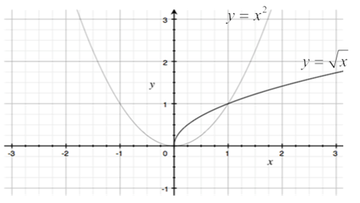

- What additional observations can we make when comparing the graphs of these functions?
  - They intersect at $(0,0)$ and $(1, 1)$. The square root function is a reflection of the part of the quadratic function in the first quadrant, about $y=x$ (when $x$ is non-negative).
- Why do they intersect at $(0,0)$ and $(1,1)$?
  - $0^{2}$ and $\sqrt{0}$ are both equal to $0$.
  - $1^{2}$ and $\sqrt{1}$ are both equal to $1$.

Exploratory Challenge 3 (15 minutes)
- Predict the relationship between $y=x^{3}$ and $y=\sqrt[3]{x}$.
  - Both functions will include all real numbers in their domain and range since a cubed number can be positive or negative, as well as the cube root of a number.
Exploratory Challenge 3
Create a data table for $y=x^{3}$ and $y=\sqrt[3]{x}$, and graph both functions on the same set of axes. Round decimal answers to the nearest hundredth.
$$x$$ | $$y=x^{3}$$ | $$y=\sqrt[3]{x}$$
$$-8$$ | $$-512$$ | $$-2$$
$$-2$$ | $$-8$$ | $$-1.26$$
$$-1$$ | $$-1$$ | $$-1$$
$$0$$ | $$0$$ | $$0$$
$$1$$ | $$1$$ | $$1$$
$$2$$ | $$8$$ | $$1.26$$
$$8$$ | $$512$$ | $$2$$
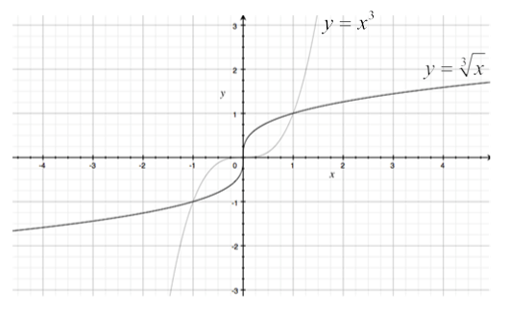

- Using the table and graphs, what observations can you make about the relationships between $y=x^{3}$ and
$y=\sqrt[3]{x}$?
  - They share the points $(0, 0)$, $(1, 1)$, and $(-1,-1)$. The domain and range of both functions are all real numbers. The functions are symmetrical about the origin. Each of these two functions is a reflection of the other across the line $y=x$.
If students do not arrive at the responses above, use the following prompts:
- What are the domain and range of each function?
- How are the graphs related to each other?
- Describe the symmetry that exists within the tables and graphs.

Closing (2 minutes)
- The square root function is a reflection of the quadratic function across the line $y=x$, when $x$ is non-negative.
- The domain of $y=x^{2}$, $y=x^{3}$, and $y=\sqrt[3]{x}$ is all real numbers. The domain of $y=\sqrt{x}$ is $x≥0$.
- The range of $y=x^{2}$ and $y=\sqrt{x}$ is $y≥0$. The range of $y=x^{3}$ and $y=\sqrt[3]{x}$ is all real numbers.
- $y=x^{3}$ and $y=\sqrt[3]{x}$ are each symmetrical about the origin, are reflections of each other across the line $y=x$, and the two operations reverse each other. Note that inverse functions have not yet been introduced, but this is an opportunity to offer a preview, depending on the ability and interest level of your students.
Lesson Summary
- The square root parent function is a reflection of the quadratic parent function across the line $y=x$, when $x$ is non-negative.
- The domain of quadratic, cubic, and cube root parent functions is all real numbers. The domain of square root functions is $x≥0$.
- The range of quadratic and square root parent functions is $[0, ∞)$. The range of the cubic and cube root parent functions is all real numbers.
- The cube root and cubic parent functions are symmetrical about the origin and are reflections of each other across the line $y=x$, and the two operations reverse each other.

Exit Ticket (3 minutes)

Name ___________________________________________________ Date____________________
Lesson 18: Graphing Cubic, Square Root, and Cube Root Functions

Exit Ticket

- Describe the relationship between the graphs of $y=x^{2}$ and $y=\sqrt{x}.$ How are they alike? How are they different?

- Describe the relationship between the graphs of $y=x^{3}$ and $y=\sqrt[3]{x}$. How are they alike? How are they different?

Exit Ticket Sample Solutions

- Describe the relationship between $y=x^{2}$ and $y=\sqrt{x}$. How are they alike? How are they different?
The square root function is a reflection of the quadratic function about $y=x,$ when $x$ is nonnegative. The domain of $y=x^{2}$ is all real numbers. The domain of $y=\sqrt{x}$ is $x≥0$. The range of $y=x^{2}$ and $y=\sqrt{x}$ is $y≥0$.

- Describe the relationship between the graphs of $y=x^{3}$ and $y=\sqrt[3]{x}$. How are they alike? How are they different?
The domain and range of $y=x^{3}$ and $y=\sqrt[3]{x}$ are all real numbers. The shape of the graphs of $y=x^{3}$ and $y=\sqrt[3]{x}$ are the same, but they are oriented differently. (Some students may be able to articulate that each graph appears to be a reflection of the other across a diagonal line going through the origin.)

Problem Set Sample Solutions

- Create the graphs of the functions $f(x)=x^{2}+2$ and $g(x)=\sqrt{x}+2$ using the given values. Use a calculator to help with decimal approximations.
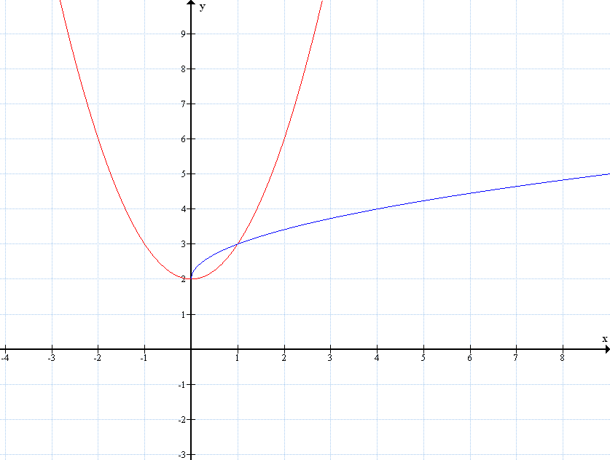
See values in table.
Graph of $y=x^{2}+2$
Graph of $y=\sqrt{x}+2$
$$x$$ | $$f(x)$$ | $$g(x)$$
$$-4$$ | $$18$$
$$-2$$ | $$6$$
$$-1$$ | $$3$$
$$0$$ | $$2$$ | $$2$$
$$1$$ | $$3$$ | $$3$$
$$2$$ | $$6$$ | $$3.4142…$$
$$4$$ | $$18$$ | $$4$$

- Why are the first three rows in the table under $g(x)$ crossed out?
The domain of $g(x)=\sqrt{x}+2$ is limited to nonnegative numbers since the square root of a negative number is not real.

- Describe the relationship between the graphs given by the equations $y=x^{2}+2$ and $y=\sqrt{x}+2$. How are they alike? How are they different?
The graph of the square root function is a reflection of the graph of the quadratic function when $x$ is nonnegative. The reflection is about the line given by the graph of the equation $y=x+2$. The domain of $y=x^{2}+2$ is all real numbers. The domain of $y=\sqrt{x}+2$ is $x≥0$. The range of $y=x^{2}+2$ and $y=\sqrt{x}+2$ is $y≥2$.

- Refer to your class notes for the graphs of $y=x^{2}$ and $y=\sqrt{x}$. How are the graphs of $y=x^{2}$ and $y=\sqrt{x}$ transformed to generate the graphs of $y=x^{2}+2$ and $y=\sqrt{x}+2$?
The graph of $y=x^{2}+2$ is the graph of $y=x^{2}$ translated vertically $2$units up. The graph of $y=\sqrt{x}+2$ is also the vertical translation of the graph of $y=\sqrt{x}$ translated $2$ units up.

- Create the graphs of $p\left(x\right)=x^{3}-2$ and $q(x)=\sqrt[3]{x}-2$ using the given values for $x$. Use a calculator to help with decimal approximations.
$$x$$ | $$p(x)$$ | $$q(x)$$
$$-8$$ | $$-514$$ | $$-4$$
$$-2$$ | $$-10$$ | $$-3.2599…$$
$$-1$$ | $$-3$$ | $$-3$$
$$0$$ | $$-2$$ | $$-2$$
$$1$$ | $$-1$$ | $$-1$$
$$2$$ | $$6$$ | $$-0.74007…$$
$$8$$ | $$510$$ | $$0$$
[Graph]
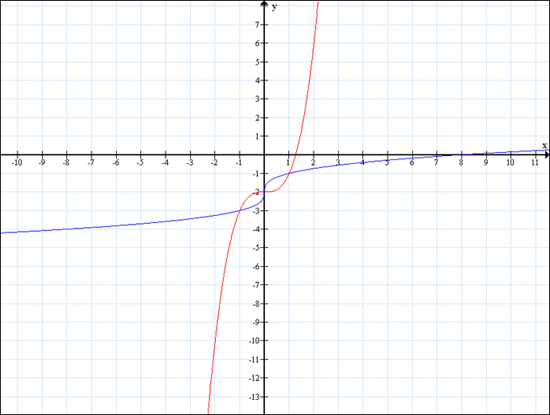
Graph of $y=x^{3}-2$
Graph of $y=\sqrt[3]{x}-2$

- Why aren’t there any rows crossed out in the table in Problem 5?
Unlike square roots, the domain of a cube root function includes all real numbers since the product of three (or any other odd number) factors of a negative number, yields a negative number. Since the domains for both functions include all real numbers, there are no excluded rows in the table.

- Describe the relationship between the domains and ranges of the functions $p(x)=x^{3}-2$ and $q\left(x\right)=\sqrt[3]{x}-2$. Describe the relationship between their graphs.
The domain and range of $p(x)=x^{3}-2$ and $q(x)=\sqrt[3]{x}-2$ are all real numbers. The graphs of $y=x^{3}-2$ and $y=\sqrt[3]{x}-2$ are each symmetrical about the line given by the equation $y=x-2$.
- Refer to your class notes for the graphs of $y=x^{3}$ and $y=\sqrt[3]{x}$. How are the graphs of $y=x^{3}$ and $y=\sqrt[3]{x}$ transformed to generate the graphs of $y=x^{3}-2$ and $y=\sqrt[3]{x}-2$?
The graph of $y=x^{3}-2$ is the graph of $y=x^{3}$ translated vertically $2$ units down. The graph of $y=\sqrt[3]{x}-2$ is also the vertical translation of the graph of $y=\sqrt[3]{x}$ translated $2$ units down.

- Using your responses to Problems 4 and 8, how do the functions given in Problems 1 and 5 differ from their parent functions? What effect does that difference seem to have on the graphs of those functions?
In Problem 1, $f$ is the squaring function $x^{2}$ plus $2$, and $g$ is the square root function $\sqrt{x}$ plus $2$. Adding $2$to a function translates the graph of the function $2$ units up vertically. In Problem 5, $p$ is the cubing function $x^{3}$ minus $2$, and $q$ is the cube root function $\sqrt[3]{x}$ minus $2$. Subtracting $2$ from a function translates the graph of the function $2$ units down vertically.

- Create your own functions using $r(x)=x^{2}-\boxed{}$ and $s(x)=\sqrt{x}-\boxed{}$ by filling in the box with a positive or negative number. Predict how the graphs of your functions will compare to the graphs of their parent functions based on the number that you put in the blank boxes. Generate a table of solutions for your functions, and graph the solutions.
Answers will vary. If $k$ is the number inserted into , then the graph of the function will be translated vertically $k$units down for positive $k$values and $-k$ units up for negative $k$ values.

