|  |
| --- |
|  |

Lesson 15: Using the Quadratic Formula

Student Outcomes

* Students use the quadratic formula to solve quadratic equations that cannot be easily factored.
* Students understand that the discriminant, , can be used to determine whether a quadratic equation has one, two, or no real solutions.

Lesson Notes

The focus of this lesson is two-fold. First, students use the quadratic formula appropriately (i.e., when other, simpler methods of solution are impossible or too difficult). Second, students identify the discriminant as and use it to determine the number and nature of the solutions. They understand that the sign of the discriminant can be used to determine the number of real solutions a quadratic equation has, which are defined as follows: a positive discriminant yields two real solutions, a negative discriminant yields no real solutions, and a discriminant equal to zero yields only one real solution. In addition, a discriminant that is a perfect square indicates the solutions are rational; therefore, the quadratic is factorable over the integers.

Classwork

Opening Exercises (5 minutes)

Students review how to solve quadratic equations using the quadratic formula from the previous lesson.

Opening Exercises

Solve the following:

Students should recognize that this is a difficult quadratic to solve. Accordingly, they should set it equal to zero and solve it using the quadratic formula:

*Scaffolding:*

* Discuss the definition of mathematical efficiency.
* Encourage all students to look for ways to make finding the solution for an equation more efficient (e.g., by factoring out the GCF or setting the equation equal to zero).

Check by substituting the approximated decimal value(s) into the original equation or by completing the square:



(Have students use their calculators to check that these are the same decimal values as the previous solutions.)

Initially, students may approach this problem by using the quadratic formula. While this approach works, encourage students to look for a more efficient pathway to the solution (in this case, to solve by factoring):

Checks:

**Discussion (3 minutes)**

Before moving on, review the Opening Exercises.

* What are the differences between these two quadratic equations? Is one easier to solve than the other?
  + *Some students will have used the quadratic formula for both; some may have observed the second exercise to be more efficiently solved by factoring. Both need to be manipulated before a decision can be made.*
* Is one pathway to solution “more correct” than another?
  + *Ultimately, students should be aware that while there are many ways to arrive at a correct solution, some methods are more efficient than others.*

**Exercises 1–5 (15 minutes)**

Have students solve the following three standard form quadratic equations independently using the quadratic formula. Ask them to watch for special circumstances in each.

Exercises

Solve Exercises 1–5 using the quadratic formula.



This quadratic factors easily as a perfect square, with a solution of . However, notice that when we use the quadratic formula, we can see that the number under the radical sign equals zero. This translates as one real solution and *one rational* solution in this case. We also sometimes call this a double solution (or a double root) since the factors of the perfect square give the equation , for which we find that there are two identical solutions, both of which are .

This quadratic may be confusing. Point out that substituting into the quadratic formula yields a negative square root, which is not a real number. Have students try finding on their calculators. They should get an error message or a message that says non-real answer. (Note that some calculators will produce an answer in terms of when in “complex mode.”) Explain that there is no *real* number whose square is a negative number. So, when we find that the number under the radical is negative, we say that the equation has *no real solutions*.

Point out that this time, the value under the radical, , is a perfect square. This translates into *two rational* solutions.

Point out that these last two times, the values under the radicals were not perfect squares but were greater than zero. This translated into *two irrational* solutions.

Discussion (5 minutes)

* Describe the solutions of these quadratic equations in your own words. This is where you can delve into what makes these equations different.
  + *We usually get two solutions, but the first equation has only one. We couldn’t solve the second problem because we get a negative under the radical sign. The third solution has a perfect square under the radical, so that the square root is eliminated from the answer. The last two were not perfect squares under the radical but did have a positive value; therefore, both answers were irrational.*

The expression under the radical is called the *discriminant*: . The value of the discriminant determines the number and nature of the solutions for a quadratic equation. As we saw in the Opening Exercises, when the discriminant is positive, then we have which will yield two real solutions (two rational solutions if the value is a perfect square). When the discriminant equals zero, as it did in Example 1, then we have which will yield only one solution, . When the discriminant is a negative number, then we have , which can never lead to a real solution.



Show students the following graphs of quadratic equations. Project or sketch them on the board or screen.

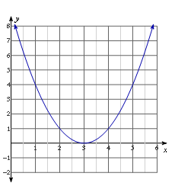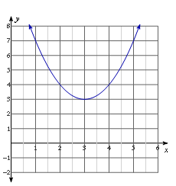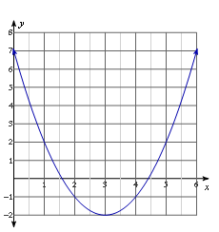

* What is the difference between these three graphs? Which of these graphs belongs to a quadratic equation with a positive discriminant? Which belongs to a quadratic with a negative discriminant? Which graph has a discriminant equal to zero?
  + *The first graph touches the -axis exactly once, corresponding to one real root and a discriminant equal to zero. The second graph lies entirely above the -axis, so it has no real roots; therefore, its discriminant must be negative. The third graph intersects the -axis in two points, so it has two real roots; therefore, its discriminant is positive.*

Note that the third graph *looks* like it may have rational solutions since it appears that the intercepts are and . Remind students that graphs are excellent for estimating, but algebra is used to find the exact solutions.

Exercises 6–10 (10 minutes)

For Exercises 6–9, determine the number of real solutions for each quadratic equation without solving.

one real solution



no real solutions

two real solutions

no real solutions

1. On the line below each graph, state whether the discriminant of each quadratic equation is positive, negative, or equal to zero. Then, identify which graph matches the discriminants below.

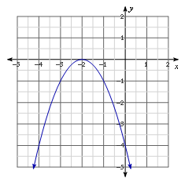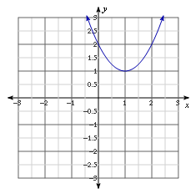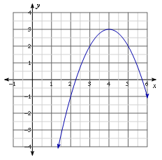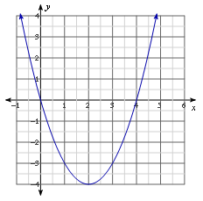

**Graph 1 Graph 2 Graph 3 Graph 4**

Equal to zero Negative Positive Positive (perfect square)

|  |  |  |  |
| --- | --- | --- | --- |
| Discriminant A:  Graph: | Discriminant B:  Graph: | Discriminant C:  Graph: | Discriminant D:  Graph: |

Closing (2 minutes)

* The quadratic formula can be used to solve any quadratic equation in standard form.
* The discriminant is the part of the quadratic formula that is under the radical. It can be used to determine the nature and number of solutions for a quadratic equation and whether the quadratic expression can be factored over the integers.

Lesson Summary

You can use the sign of the discriminant, , to determine the number of real solutions to a quadratic equation in the form , where . If the equation has a positive discriminant, there are two real solutions. A negative discriminant yields no real solutions, and a discriminant equal to zero yields only one real solution.

Exit Ticket (5 minutes)

Name ___________________________________________________ Date____________________

Lesson 15: Using the Quadratic Formula

Exit Ticket

1. Solve the following equation using the quadratic formula: .
2. Is the quadratic formula the most efficient way to solve this equation? Why or why not?
3. How many zeros does the function have? Explain how you know.

Exit Ticket Sample Solutions

1. Solve the following equation using the quadratic formula: .
2. Is the quadratic formula the most efficient way to solve this equation? Why or why not?

This is a personal preference. Some may consider the quadratic formula to be more efficient, while others may prefer completing the square. After the leading coefficient is factored out, the linear term coefficient is still even, making this a good candidate for completing the square.

1. How many zeros does the function have? Explain how you know.

Since the discriminant of the original equation is positive, , and yields two real solutions, the function must have two zeros. OR After solving the equation , I found that there were two irrational solutions. This means that the corresponding function will have two zeros.

Problem Set Sample Solutions

The Problem Set is identical in scope and style to the exercise set from class. Students are *not* being asked to solve the quadratic equations in each question, only to use the discriminant to find the number of roots or to use the number of roots to discuss the value of the discriminant.

Without solving, determine the number of real solutions for each quadratic equation.

two real solutions

one real solution

no real solutions

two real solutions

Based on the graph of each quadratic function, , determine the number of real solutions for each corresponding quadratic equation, .

1. 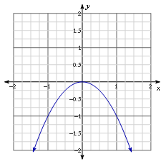

One real solution

1. 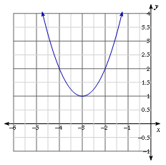

No real solutions

1. 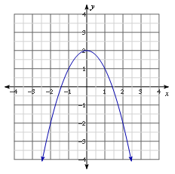

Two real solutions

1. 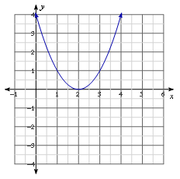

One real solution