Lesson 15: Using the Quadratic Formula

Classwork
Opening Exercises
Solve the following:
- $4x^{2}+5x+3=2x^{2}-3x$

- $c^{2}-14=5c$

Exercises
Solve Exercises 1–5 using the quadratic formula.
- $x^{2}-2x+1=0$

- ${3b}^{2}+4b+8=0$

- $2t^{2}+7t-4=0$

- $q^{2}-2q-1=0$

- $m^{2}-4=3$

For Exercises 6–9, determine the number of real solutions for each quadratic equation without solving.
- $p^{2}+7p+33=8-3p$

- $7x^{2}+2x+5=0$

- $2y^{2}+10y=y^{2}+4y-3$

- $4z^{2}+9=-4z$

- On the line below each graph, state whether the discriminant of each quadratic equation is positive, negative, or equal to zero. Then, identify which graph matches the discriminants below.
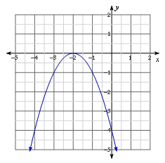
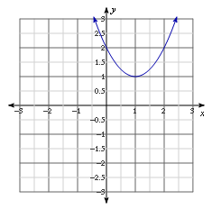
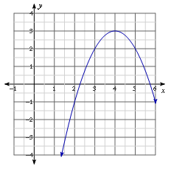
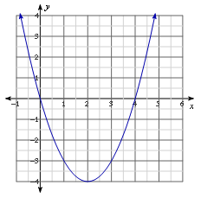
Graph 1 Graph 2 Graph 3 Graph 4
_____________________ ______________________ _______________________ ______________________

Discriminant A:  $${\left(-2\right)}^{2}-4\left(1\right)\left(2\right)$$  Graph: ______ | Discriminant B:  $${\left(-4\right)}^{2}-4\left(-1\right)\left(-4\right)$$  Graph: ______ | Discriminant C:  $${\left(-4\right)}^{2}-4\left(1\right)\left(0\right)$$  Graph: ______ | Discriminant D:  $${ \left(-8\right)}^{2}-4\left(-1\right)\left(-13\right)$$  Graph: ______

Problem Set
Lesson Summary
You can use the sign of the discriminant, $b^{2}-4ac$, to determine the number of real solutions to a quadratic equation in the form $ax^{2}+bx+c=0$, where $a≠0$. If the equation has a positive discriminant, there are two real solutions. A negative discriminant yields no real solutions, and a discriminant equal to zero yields only one real solution.

Without solving, determine the number of real solutions for each quadratic equation.
- $b^{2}-4b+3=0$

- $2n^{2}+7=-4n+5$

- $x-3x^{2}=5+2x-x^{2}$

- $4q+7=q^{2}-5q+1$

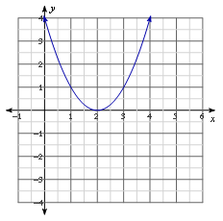
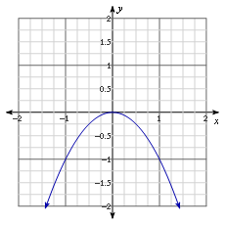
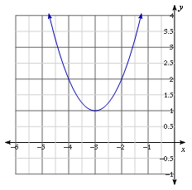
Based on the graph of each quadratic function,$y=f(x)$, determine the number of real solutions for each corresponding quadratic equation, $f(x)=0$.
- 6.

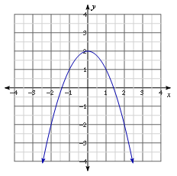
- 8.

