Lesson 10: Interpreting Quadratic Functions from Graphs and Tables

Student Outcomes
- Students interpret quadratic functions from graphs and tables: zeros ($x$-intercepts), $y$-intercept, the minimum or maximum value (vertex), the graph’s axis of symmetry, positive and negative values for the function, increasing and decreasing intervals, and the graph’s end behavior.
- Students determine an appropriate domain and range for a function’s graph and when given a quadratic function in a context, recognize restrictions on the domain.
MP.2
Throughout this lesson, students make sense of quantities, their units, and their relationships in problem situations.

Lesson Notes
This lesson focuses on F-IF.B.4 and F-IF.B.6 as students interpret the key features of graphs and estimate and interpret average rates of change from a graph. They continue to use graphs, tables, and equations to interpret and compare quadratic functions.

Classwork
Opening Exercise (5 minutes): Dolphins Jumping In and Out of the Water
Find a video of a dolphin jumping in and out of the water. (An example is provided below.) This clip is short enough that you may want to show it more than once or back up and repeat some segments. If you are able to slow or pause at several places in a jump, you can let students estimate the height of the dolphin at various times (in seconds). Some video players will show the time in seconds. (This example is a stock video on YouTube and is about $1.5$ minutes longer than the video described in the problem. The video is in slow motion and takes longer to run than the real time lapse.) http://www.youtube.com/watch?v=g8RoFdyYY3s
After watching the video clip of the dolphins jumping in and out of the ocean as an introduction, ask students what the graph of time vs. the height of the dolphin above and below sea level may look like. Then, project the graph for the problem onto the white board or screen. Note that this same graph and context is used in the End-Of-Module Assessment for Module 5.
It is important to discuss the fact that there is no measure of horizontal distance represented in the graph below (the graph does NOT trace the path of the dolphin’s motion). In fact, the dolphin might be jumping straight up and straight down, exiting and entering the water in exactly the same spot, and the graph would not look different than it does. This is because the height of the dolphin is related to the number of seconds that have passed, not the distance it moves forward or backward. So, the graph and function represent the TIME that is moving forward, not necessarily the dolphin.
Example 1 (10 minutes)
Show or project the graph on the board or screen. Read the prompt below aloud and have students take notes individually. Then, working in groups or with a partner, read the questions below aloud and give students time with their partner or group to work out the answers using their notes.
Example 1
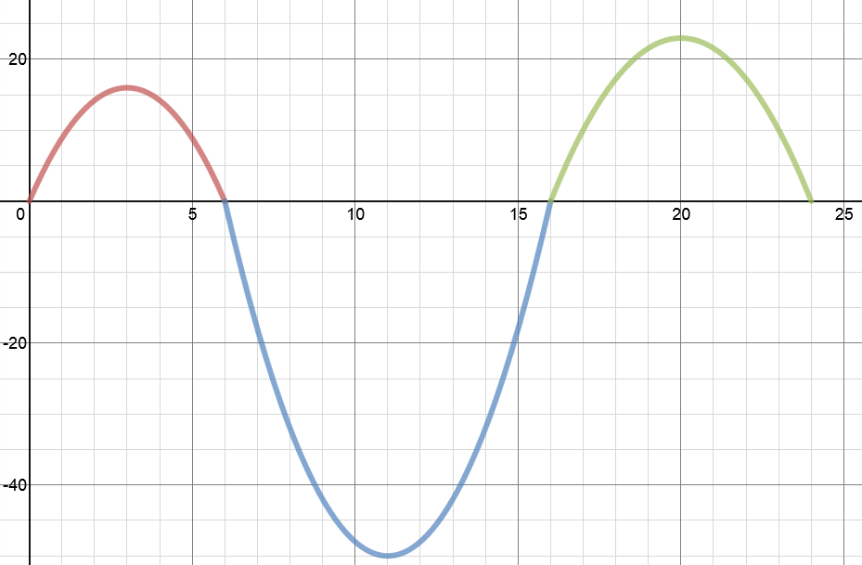
In a study of the activities of dolphins, a marine biologist made a $24$-second video of a dolphin swimming and jumping in the ocean with a specially equipped camera that recorded one dolphin’s position with respect to time. This graph represents a piecewise function, $f(t)$, that is defined by quadratic functions on each interval. It relates the dolphin’s vertical distance from the surface of the water, in feet, to the time from the start of the video, in seconds. Use the graph to answer the questions below.
$$t$$
$$y=f(t)$$
Height of the dolphin in feet (distance from water surface)
Time in seconds
$$y$$

  - Describe what you know for sure about the actions of the dolphin in the time interval from $0$–$6 sec$. Can you determine the horizontal distance the dolphin traveled in that time interval? Explain why or why not.
Scaffolding:
For students who are struggling with the concept of horizontal movement not being represented in the graph, remind them of the Module 1 video of the man who jumped straight up and down; the graph was still quadratic.
The dolphin jumped out of the water at$t=0 sec.$ and back into the water at$t=6 sec.$ We cannot determine the horizontal distance because the function models the vertical distance to time, not the horizontal distance to time.
Some students may interpret the graph as the path (or trajectory) of the dolphin jumping in and out of the water. It is important to point out that the graph does not indicate the forward motion of the dolphin. In fact, the dolphin can jump straight up and straight down, and the relationship of height to time will still have the same graph.

  - Where will you find the values for which $f(t)=0$? Explain what they mean in the context of this problem.
$f(0)=0$, $f(6)=0$, $f(16)=0$, $f(24)=0$
$f(t)=0$ represents the time when the dolphin enters the water or jumps out of the water. It is when the dolphin is at the water’s surface.

  - How long was the dolphin swimming under water in the recorded time period? Explain your answer or show your work.
$10 seconds$. Between $t=6 seconds$ and$t=16 seconds$, $f(t)<0$. This means that the dolphin is below the water level.
  - Estimate the maximum height, in feet, that the dolphin jumped in the recorded $24$-second time period? Explain how you determined your answer.
The vertex that is in the highest position is estimated to be $(20, 23)$. Students may indicate the vertex during the first jump. However, it is not the maximum of the entire function ($24$-second time period).

  - Locate the point on the graph where $f\left(t\right)=-50,$ and explain what information the coordinates of that point give you in the context of this problem.
$f\left(11\right)=-50$. This means after $11 seconds$ have passed, the dolphin is $50 feet$ below the water surface.

Example 2 (15 minutes)
For this example, we interpret a function from a table of values. Project the table below onto the board, and have students study the data and perhaps even make an informal plot. Read the prompt, and have students take notes. Then, have students work with partners or in small groups to answer the questions below as you read them aloud. Stop for discussion whenever it seems appropriate.
Example 2
The table below represents the value of Andrew’s stock portfolio, where $V$ represents the value of the portfolio in hundreds of dollars and $t$ is the time in months since he started investing. Answer the questions that follow based on the table of values.
$t$ (months) | $V(t)$ (hundreds of dollars)
$$2$$ | $$325$$
$$4$$ | $$385$$
$$6$$ | $$405$$
$$8$$ | $$385$$
$$10$$ | $$325$$
$$12$$ | $$225$$
$$14$$ | $$85$$
$$16$$ | $$-95$$
$$18$$ | $$-315$$
  - What kind of function could model the data in this table? How can you support your conclusion?
Students can make the conjecture that it might be quadratic based on the shape suggested by plotting the points or by noticing the suggested symmetry of the data. However, they should not make a claim that all U-shaped curves can be well modeled by a quadratic function. A more robust support would be to notice that the sequence of $V(t)$ values has constant second differences over equally spaced intervals of $t$, which is the characteristic of sequences defined by a quadratic expression.

  - Assuming this data is in fact quadratic, how much did Andrew invest in his stock initially? Explain how you arrived at this answer.
Andrew initially invested $\$225$. I used the symmetric value of the quadratic function to find that $V\left(0\right)=V\left(12\right)=225$.

  - What is the maximum value of his stock, and how long did it take to reach the maximum value?
$V(6)=405$. It took Andrew $6$ months to reach the maximum value of $\$405$.
  - If the pattern continues to follow the quadratic trend shown above, do you advise Andrew to sell or keep his stock portfolio? Explain why.
Andrew should sell. The stock initially increased, reaching a maximum value of $\$405$, then decreased. Since this is a quadratic function, it will not increase again. Rather, it continuously decreases after reaching the maximum.

  - How fast is Andrew’s stock value decreasing between $\left[10, 12\right]$? Find another two-month interval where the average rate of change is faster than $\left[10, 12\right]$ and explain why.
$$\frac{225-325}{12-10}=-\frac{100}{2}=-50$$
The average rate of change of Andrew's stock portfolio between $[10,12]$ is $-\$50$. The average rate of change is faster than $50$ for any two-month interval after $12$months. Students may calculate the actual rate of change to show that it decreases faster or explain that the quadratic model decreases at a faster rate.

  - Are there other two-month intervals where the rate of change is the same as $[10, 12]$? Explain your answer.
The rate of change for a quadratic function is not constant and changes from positive to zero to negative. It is not possible for another two-month interval to have the same rate of change as $[10, 12]$.

Closing (5 minutes)
- Give an example of what the rate of change for an interval of the graph of a quadratic function can tell you.
  - Answers will vary. For example, the rate of change over an interval can tell us the average rate of increase in profit or the average rate of speed of an object during a given time period.
Lesson Summary
When interpreting quadratic functions and their graphs, it is important to note that the graph does not necessarily depict the path of an object. In the case of free-falling objects, for example, it is height with respect to time.
The $y$-intercept can represent the initial value of the function given the context, and the vertex represents the highest (if a maximum) or the lowest (if a minimum) value.

Exit Ticket (10 minutes)

Name ___________________________________________________ Date____________________
Lesson 10: Interpreting Quadratic Functions from Graphs and Tables

Exit Ticket

A toy company is manufacturing a new toy and trying to decide on a price that will result in a maximum profit. The graph below represents profit ($P$) generated by each price of a toy ($x$). Answer the questions based on the graph of the quadratic function model.
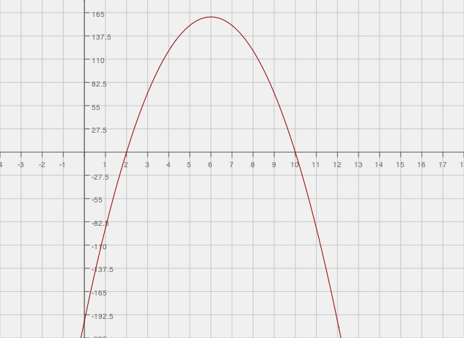
$$x$$
$$y=P(x)$$
$$y$$

  - If the company wants to make a maximum profit, what should the price of a new toy be?

  - What is the minimum price of a toy that will produce profit for the company? Explain your answer.

  - Estimate the value of $P\left(0\right),$ and explain what the value means in the problem and how this may be possible.

  - If the company wants to make a profit of $\$137$, for how much should the toy be sold?

  - Find the domain that will only result in a profit for the company, and find its corresponding range of profit.

  - Choose the interval where the profit is increasing the fastest:$[2, 3]$, $[4, 5]$, $[5.5, 6.5]$, $[6, 7]$. Explain your reasoning.

  - The company owner believes that selling the toy at a higher price will result in a greater profit. Explain to the owner how selling the toy at a higher price will affect the profit.

Exit Ticket Sample Solutions

A toy company is manufacturing a new toy and trying to decide the price that will result in a maximum profit. The graph below represents profit ($P$) generated by each price of a toy ($x$). Answer the questions based on the graph of the quadratic function model.
  - If the company wants to make a maximum profit, what should the price of a new toy be?
$$\$6$$
MP.2
&
MP.3
  - What is the minimum price of a toy that will produce profit for the company? Explain your answer.
The price of a toy must be more than $\$2$to generate a profit. $\$2$ will cause the company to break even and not make any profit.

  - Estimate the value of $P\left(0\right),$ and explain what the value means in the problem and how this may be possible.
$P(0)$ is approximately $-\$192.50$. Students should interpret an $x$-value of zero as the toy being given away for free. There is no way to say with certainty what the value $P\left(0\right)=-\$192.50$ represents in this context because we do not know what assumptions were made about how many of the toys would be produced at each price point. We only know what the company concluded about their profit at each price point. It is quite likely that the model is only useful for the domain $(2, 10)$ in this context.

  - If the company wants to make a profit of $\$137$, for how much should the toy be sold?
Approximately $\$4.50$ or $\$7.50$

  - Find the domain that will only result in a profit for the company, and find its corresponding range of profit.
Domain: $(2, 10)$
Range: $(0,160)$

  - Choose the interval where the profit is increasing the fastest:$[2, 3]$, $[4, 5]$, $[5.5, 6.5]$, $[6, 7]$. Explain your reasoning.
The profit is increasing the fastest on the interval $[2, 3]$. The function’s rate increases fastest during the interval $[2, 3]$. It should be noted that the function increases and then decreases. However, the rate of change decreases reaching the rate of change of $0$ at $x=6$ and then increases.

  - The company owner believes that selling the toy at a higher price will result in a greater profit. Explain to the owner how selling the toy at a higher price will affect the profit.
MP.2
&
MP.3
A higher priced toy does not necessarily make for a greater profit. The highest profit is produced when the toy is sold at $\$6$, and then decreases if it is sold at a higher price than $\$6$. Since this is a quadratic function, the profit will only decrease after it reaches its maximum.

Problem Set Sample Solutions

Pettitte and Ryu each threw a baseball into the air.
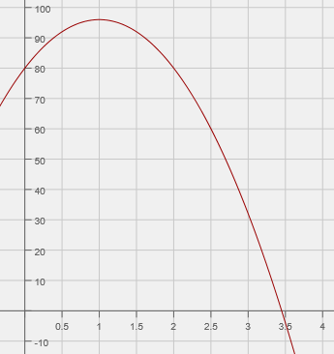
The vertical height of Pettitte’s baseball is represented by the graph $P(t)$ below. $P$ represents the vertical distance of the baseball from the ground in feet, and $t$represents time in seconds.
$$y=P(t)$$
$$t$$
$$y$$

The vertical height of Ryu’s baseball is represented by the table values $R(t)$ below.$R(t)$ represents the vertical distance of the baseball from the ground in feet, and $t$ represents time in seconds.
$$t$$ | $$R(t)$$
$$0$$ | $$86$$
$$0.5$$ | $$98$$
$$1$$ | $$102$$
$$1.5$$ | $$98$$
$$2$$ | $$86$$
$$2.5$$ | $$66$$
$$3$$ | $$38$$
$$3.52$$ | $$0$$

Use the above functions to answer the following questions.
  - Whose baseball reached the greatest height? Explain your answer.
Ryu’s baseball reached a maximum height of $102$, and Pettitte’s baseball reached a maximum height of $96$. Students compare the maximum heights represented in the graph and table and interpret the vertex values in context.

  - Whose ball reached the ground fastest? Explain your answer.
Pettitte’s ball took less than $3.5 seconds$, and Ryu’s ball took more than $3.5 seconds$. Students interpret
$x$-intercepts in context.

  - Pettitte claims that his ball reached its maximum faster than Ryu’s. Is his claim correct or incorrect? Explain your answer.
Pettitte’s claim is incorrect. It took both balls $1 second$ to reach their maximum heights. Students recognize that even though the vertex is different, both functions have the same axis of symmetry.

  - Find $P(0)$ and $R(0)$ values and explain what they mean in the problem. What conclusion can you make based on these values? Did Ryu and Pettitte throw their baseballs from the same height? Explain your answer.
$P\left(0\right)=80$ and $R(0)=86.$ Students interpret the $y$-intercept in context. Pettitte and Ryu threw their baseballs from $80 ft.$ and $86 ft.$ above the ground, respectively. They were throwing their baseballs from different initial heights.

  - Ryu claims that he can throw the ball higher than Pettitte. Is his claim correct or incorrect? Explain your answer.
Ryu’s claim is incorrect. Even though Ryu’s ball reached maximum height of$102 ft.$, he started from higher above the ground. He was initially at $86 ft.$ above the ground. Ryu and Pettitte both threw the ball $16 ft.$ vertically from their initial positions. Students need to interpret the vertex value in relation to the $y$-intercept.

