Lesson 9: Graphing Quadratic Functions from Factored Form, $f(x)=a(x-m)(x-n)$
Student Outcomes
- Students use the factored form of a quadratic equation to construct a rough graph, use the graph of a quadratic equation to construct a quadratic equation in factored form, and relate the solutions of a quadratic equation in one variable to the zeros of the function it defines.
- Students understand that the number of zeros in a polynomial function corresponds to the number of linear factors of the related expression and that different functions may have the same zeros but different maxima or minima.

Lesson Notes
Throughout this lesson, students apply mathematics to solve problems that arise in the physical world, specifically for objects in motion. They identify the important quantities of the situation and map the relationships between those quantities using graphs.
MP.4
In this lesson, students relate the solutions of a quadratic equation in one variable to the zeros of the function it defines. They sketch graphs of quadratic functions from tables, expressions, and verbal descriptions of relationships in real-world contexts, identifying key features of the quadratic functions from their graphs (A-APR.B.3). Also central to the lesson is
F-IF.C.7a, requiring students to graph and show the intercepts and minimum or maximum point.

Classwork
Opening Exercise (5 minutes)
Write the following quadratic equations on the board or screen and have students solve them. (These are a review of work done in previous lessons and should not take more than five minutes. If some students need more time, this is an indication that some review and intervention may be needed before continuing.)
Scaffolding:
Remind students of the product-sum rule for factoring quadratic expressions when the leading coefficient is 1: What two factors of the constant term can be added to give the coefficient of the linear term?
Or remind them that they can use the method of splitting the linear term.
Opening Exercise
Solve the following equations.
  - $x^{2}+6x-40=0$
The factored form is $(x+10)(x-4)=0$, so $x=-10 \text{or} 4$.

  - $2x^{2}+11x=x^{2}-x-32$
Gathering all terms onto the left side and setting equal to $0$:
$2x^{2}-x^{2}+11x+x+32=0$ $x^{2}+12x+32=0 \left(x+4\right)\left(x+8\right)=0$
So, $x=-4 \text{or}-8$.

Example 1 (13 minutes)
Display the equation $y=x^{2}+6x-4$ on the board or screen. Make sure students have graph paper before the lesson begins. Have students work with a partner or in small groups to answer the following questions based on the equation.
Example 1
Consider the equation $y=x^{2}+6x-40$.
  - Given this quadratic equation, can you find the point(s) where the graph crosses the $x$-axis?

(If students stall here, offer a hint. Ask: What is the $y$-value when the graph crosses the $x$-axis?)

The factors for $x^{2}+6x-40$ are $(x-4)(x+10)$, so the solutions for the equation with $y=0$ are
$x=4$and$x=-10$.

Give students about two minutes to work with a partner to find the solution. Students should have a head start in figuring out how to proceed based on their results from Example 1. Have students record and label the two $x$-intercepts. Point out that the ordered pairs are called the $x$-intercepts of the graph and that the $x$-values alone, when the equation is equal to zero, are called the zeros or roots of the equation. Students should be able to generalize that for any quadratic equation, the roots are the solution(s), where $y=0$, and these solutions correspond to the points where the graph of the equation crosses the $x$-axis.

  - How can we write a corresponding quadratic equation if we are given a pair of roots?
By reversing the zero product property, we can change the roots into the factors and can easily write a quadratic equation in factored form. Then, if we multiply the factors, we have the standard form for the same equation. However, we will not know if there is a leading coefficient other than $1$ without more information, so we cannot be sure if we have the unique equation for a specific function.

Allow students about two minutes to explore this idea. After taking suggestions, show students that a quadratic equation can be written in the form $y=a(x-m)(x-n)$, where $m$, $n$ are the roots of the quadratic. Point out to students that we always include leading coefficient $a$ in the general form, since leaving it out assumes it has a value of $1$, which is not always the case.

  - In the last lesson, we learned about the symmetrical nature of the graph of a quadratic function. How can we use that information to find the vertex for the graph?
Since the $x$-value of the vertex is halfway between the two roots, we just need to find the midpoint of the two roots’ $x$-values:$\frac{4+\left(-10\right)}{2}=-3$. Once students know the$x$-value of the vertex (which also tells us the equation for the axis of symmetry), they can substitute that value back into equation:$y=\left(x-4\right)\left(x+10\right)$. Thus, $y=\left(-3-4\right)\left(-3+10\right)=(-7)(7)=-49$, and the vertex is$(-3, -49)$.

  - How could we find the $y$-intercept (where the graph crosses the $y$-axis and where $x=0$)?
If we set $x$ equal to $0$, we can find where the graph crosses the $y$-axis.
$y=(x-4)(x+10)=(0-4)(0 +10)$ $=(-4)(10)=-40$
The $y$-intercept is $(0, -40)$.

  - What else can we say about the graph based on our knowledge of the symmetrical nature of the graph of a quadratic function? Can we determine the coordinates of any other points?
We know that the axis of symmetry is at $x=-3$ and that $0$ is $3$ units to the right of $-3$. Because the graph of a quadratic function is symmetrical, there exists another point with an $x$-coordinate $3$ units to the left of $-3$, which would be $x=-6$. The points with $x$-coordinates of $0$ and $-6$will have the same $y$-coordinate, which is $-40$. Therefore, another point on this graph would be $(-6,-40)$.

Have students plot the five points on graph paper and connect them, making the following graph of a quadratic function:

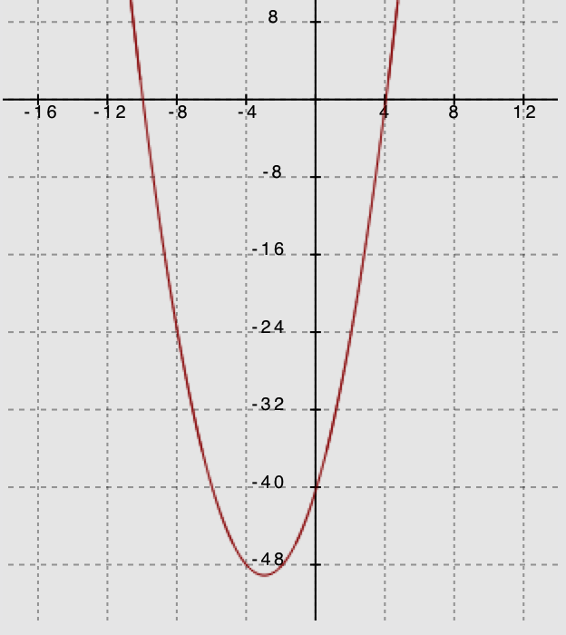
  - Plot the points you know for this equation on graph paper, and connect them to show the graph of the equation.
$$(4, 0)$$
$$(-10, 0)$$
$$(-3, -49)$$
$$(0, -40)$$
$$(-6, -40)$$

Exercise 1 (5 minutes)
Have students work with a partner or in small groups to graph the following.
Exercise 1
Graph the following functions, and identify key features of the graph.
- $f(x)=- (x+2)(x-5)$  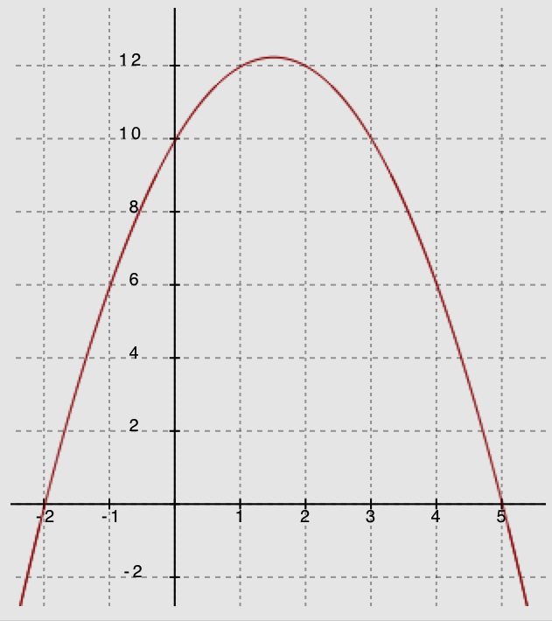  Key features: $x$-intercepts $(-2, 0) (5, 0)$; vertex at $x=1.5 (1.5, 12.25)$; $y$-intercept $(0, 10)$ | - $g\left(x\right)=x^{2}-5x-24$  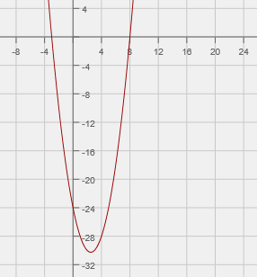  Key features: $x$-intercepts $(-3, 0) (8, 0)$; vertex at $x=2.5 (2.5, -30.25)$; $y$-intercept $(0, -24)$

In the example below, students must make sense of the quantities presented in the problem. They are given the problem in its context and must decontextualize to solve the problem and then recontextualize to interpret their solution.
MP.2

Example 2 (8 minutes)
Have students work with a partner or in small groups. Present the following problem and use the questions that follow to guide discussion to a path to the solutions. (Students may use their graphing calculators to see the graph. However, some class time may be needed to provide instruction in using the graphing calculator effectively.)
Example 2
A science class designed a ball launcher and tested it by shooting a tennis ball straight up from the top of a $15$-story building. They determined that the motion of the ball could be described by the function:
$h\left(t\right)=-16t^{2}+144t+160$,
where $t$represents the time the ball is in the air in seconds and $h(t)$ represents the height, in feet, of the ball above the ground at time $t$. What is the maximum height of the ball? At what time will the ball hit the ground?
  - With a graph, we can see the number of seconds it takes for the ball to reach its peak and how long it takes to hit the ground. How can factoring the expression help us graph this function?
Change the expression to factored form. First, factor out the $-16 (GCF)$: $-16(t^{2}-9t-10)$. Then, we can see that the quadratic expression remaining is factorable$: -16(t+1)(t-10)$.

  - Once we have the function in its factored form, what do we need to know in order to graph it? Now graph the function.
We can find the$t$-intercepts, $y$-intercept, axis of symmetry, and the vertex and then sketch the graph of the function. $t$-intercepts are$(10, 0)$ and $(-1, 0)$; $y$-intercept is$(0, 160)$; the axis of symmetry is $t=4.5$; and the vertex is$(4.5, 484)$. (We find the $y$-coordinate of the vertex by substituting$4.5$ into either form of the equation.)

Students determine the key features and graph the function, and the teacher puts the following graph on the board. Make a point that the domain is only $[0, 10]$ because the ball does not have height data before time zero, so there would be no negative time.
Closed interval notation is used here to describe the domain in the statement above. It is important to model accurate and precise notation for students.

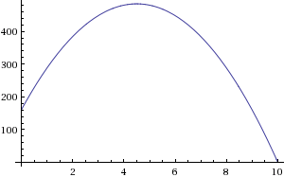
  - Using the graph, at what time does the ball hit the ground?
$$10 seconds$$

  - Over what domain is the ball rising? Over what domain is the ball falling?
The ball is rising from $0$ to $.5 seconds$ $(0, 4.5)$. It is falling from $4.5 seconds$ to $10 seconds$ $(4.5, 10).$ $4.5$ is the $t$-value of the vertex of the graph, and for this context it represents the time that the ball reaches its highest point, and then it begins to fall towards the ground. At $t=10$, the graph has an $h$-value of $0$, so in this context, it represents the time that the ball hits the ground and stops descending.

  - Using the graph, what is the maximum height the ball reaches?
$484 ft.$ (See work above.)

Exercises 2–3 (10 minutes)
Exercises 2–3
- Graph the following functions, and identify key features of the graph.
  - $f(x)=5(x-2)(x-3)$
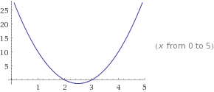
The $x$-intercepts are $(2, 0)$ and $(3, 0)$; vertex is where $x=2.5$:$(2.5, -1.25)$; and the $y$-intercept is $(0, 30)$; end behavior: this graph opens up (as $x$ approaches $±∞$, the$y$-value approaches $∞$).

  - $t\left(x\right)=x^{2}+ 8x-20$
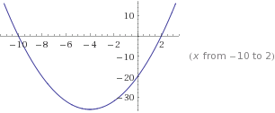
Factored form: $t(x)=(x+10)(x-2)$, so the $x$-intercepts are $(-10, 0)$ and $(2, 0)$; the $y$-intercept is $(0, -20)$; and the vertex is where $x=-4$:$(-4, -36)$; end behavior: this graph opens up (as $x$ approaches $±∞$, the$y$-value approaches $∞$).

  - $p\left(x\right)=-6x^{2}+ 42x-60$
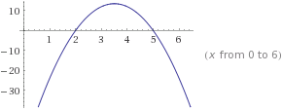
Factored form: $p\left(x\right)=-6\left(x^{2}-7x+10\right)=-6\left(x-5\right)\left(x-2\right),$ so the $x$-intercepts are $(5, 0)$ and $(2, 0)$; the $y$-intercept is $(0, -60)$; the axis of symmetry is at $x=3.5$; the vertex is$(3.5, 13.5)$; end behavior: this graph opens down (as $x$ approaches $±∞$, the$y$-value approaches $-∞$).

- The science class in Example 3 adjusted their ball launcher so that it could accommodate a heavier ball. They moved the launcher to the roof of a$23$-story building and launched an $8.8$-pound shot put straight up into the air. (Note: Olympic and high school women use the $8.8$-pound shot put in track and field competitions.) The motion is described by the function $h(t)=-16t^{2}+32t+240$, where $h(t)$ represents the height, in feet, of the shot put above the ground with respect to time $t$ in seconds. (Important: No one was harmed during this experiment!)
  - Graph the function, and identify the key features of the graph.
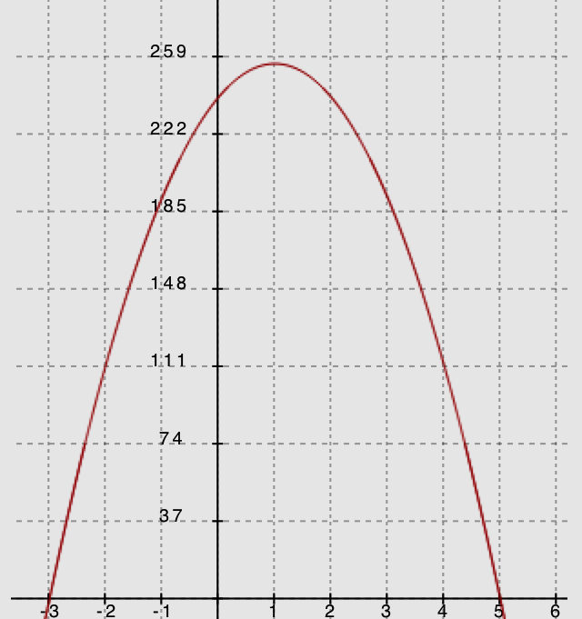

  - After how many seconds does the shot put hit the ground?
The factored form of the function: $h(t)=-16(t-5)(t+3)$, so the positive zero of the function is $\left(5, 0\right),$ and the shot put hits the ground at $5 seconds$.

  - What is the maximum height of the shot put?
The vertex is found where $x=1$, so the vertex is $\left(1, 256\right)$, and the shot put reaches a maximum height at $256 ft.$

  - What is the value of $h(0)$, and what does it mean for this problem?
$h\left(0\right)=240 ft.$, and it represents the shot put’s location at the beginning of the launch.

Closing (1 minute)
- Why is the leading coefficient always negative for functions representing falling objects?
  - Functions with negative leading coefficients have maximums, while functions with positive leading coefficients have minimums. A launched object rises and then falls and, therefore, has a maximum.

Lesson Summary
- When we have a quadratic function in factored form, we can find its $x$-intercepts, $y$-intercept, axis of symmetry, and vertex.
- For any quadratic equation, the roots are the solution(s) where $y=0$, and these solutions correspond to the points where the graph of the equation crosses the $x$-axis.
- A quadratic equation can be written in the form $y=a(x-m)(x-n)$, where $m$ and $n$ are the roots of the quadratic. Since the $x$-value of the vertex is the average of the $x$-values of the two roots, we can substitute that value back into equation to find the $y$-value of the vertex. If we set $x=0$, we can find the $y$-intercept.
- In order to construct the graph of a unique quadratic function, at least three distinct points of the function must be known.

Exit Ticket (3 minutes)

Name ___________________________________________________ Date____________________
Lesson 9: Graphing Quadratic Functions from Factored Form,
$$f(x)=a(x-m)(x-n)$$

Exit Ticket

Graph the following function, and identify the key features of the graph: $h(x)=-3(x-2)(x+2).$

Exit Ticket Sample Solutions

Graph the following function, and identify the key features of the graph: $h(x)=-3(x-2)(x+2)$.
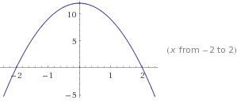
Key features: vertex $\left(0,12\right);$ axis of symmetry at$x=0;$ $y$-intercept$\left(0,12\right);$ $x$-intercepts $(-2,0)$ and $\left(2,0\right).$

Problem Set Sample Solutions
The first problem in this set offers a variety of quadratic functions to graph, including some in factored form, some in standard form, some that open up, some that open down, one that factors as the difference of squares, one that is a perfect square, and one that requires two steps to complete the factoring (GCF).

- Graph the following on your own graph paper, and identify the key features of the graph.
  - $f(x)=(x-2)(x + 7)$
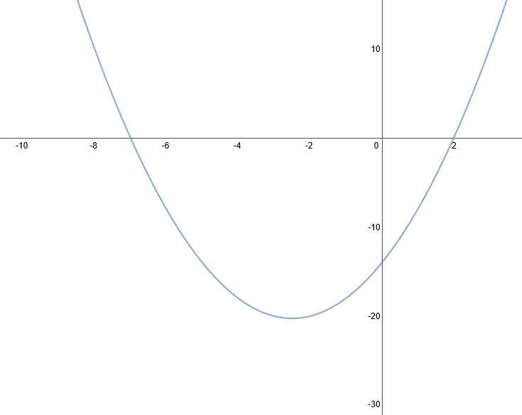
Key features: $x$-intercepts $(2, 0)$ and $(-7, 0)$; $y$-intercept $(0, -14)$; vertex at $x=-2.5 (-2.5, -20.25)$.

  - $g(x)=-2(x-2)(x+7)$
Key features: $x$-intercepts $(2, 0)$ and$(-7, 0)$; vertex is where $x=-2.5 (-2.5, 40.5)$; $y$-intercept is $(0, 28)$.
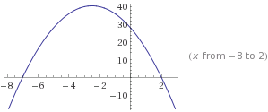

  - $h\left(x\right)=x^{2}-16$
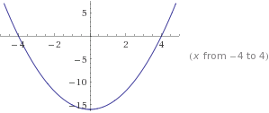
Key features: $x$-intercepts $\left(4, 0\right)$ and$(-4, 0)$; $y$-intercept and vertex are both $(0, -16)$.

  - $p\left(x\right)=x^{2}-2x+1$
Key features: $x$-intercept is a double root and is also the vertex $(1, 0)$; the $y$-intercept is $(0, 1)$.

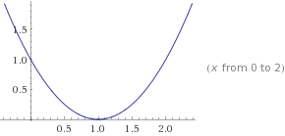

  - $q(x)=4x^{2}+20x+24$
Factored form: $q(x)=4(x^{2}+5x+6)=4(x+2)(x+3)$; $x$-intercepts $(-2, 0)$ and$(-3, 0)$; $y$-intercept $(0, 24)$; vertex is where $x= -2.5$ at the point $(-2.5, -1)$.
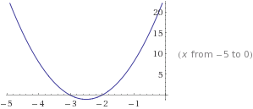

- A rocket is launched from a cliff. The relationship between the height of the rocket, $h$, in feet, and the time since its launch, $t$, in seconds, can be represented by the following function:
$$h\left(t\right)=-16t^{2}+80t+384.$$

  - Sketch the graph of the motion of the rocket.
Key features: factored form is $h(t)=-16(t^{2}-5t-24)=-16(t-8)(t+3)$; $t$-intercepts $(8, 0)$ and$(-3, 0)$; $y$-intercept $(0, 384)$; vertex at $t=2.5 (2.5, 484)$.
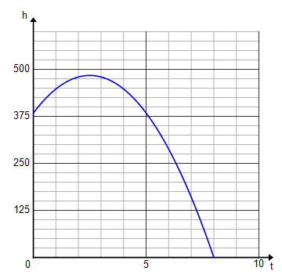

  - When will the rocket hit the ground?
The rocket will hit the ground after $8 seconds$. The zeros of the function are at$t=-3$ and $8$. Since the rocket was in the air from $t=0$, it would be airborne for $8 seconds$.

  - When will the rocket reach its maximum height?
The rocket will reach its maximum height after $2.5 seconds.$ The $t$-coordinate of the vertex, the highest point on the graph, is at $t=2.5$.

  - What is the maximum height the rocket reaches?
The maximum height is $484 ft.$ The vertex, which is the maximum point, is at $(2.5, 484)$.

  - At what height was the rocket launched?
The rocket was launched from a height of $384 ft.$ This is the height of the rocket at time $t=0$.

