Grade 3: Module 4: Unit 2: Lesson 8
Independent Research: The Challenges to Having Enough Clean Water for Everyone

Long-Term Targets Addressed (Based on NYSP12 ELA CCLS)
I can conduct a research project to become knowledgeable about a topic. (W.3.7)
I can determine the main idea of an informational text. (W.3.2)
I can retell key ideas from an informational text. (W.3.2)
Supporting Learning Targets | Ongoing Assessment
- I can ask and answer questions about the text I choose in order to build my knowledge about one specific challenge related to having enough clean water for everyone.  - I can identify key facts and details about my challenge topic. | - Asking and Answering Questions recording form, with text attached

Agenda | Teaching Notes
- Opening  - Engaging the Reader: Share Tracking My Progress (5 minutes)  - Unpacking Learning Targets (5 minutes)  - Work Time  - Launching Independent Research (10 minutes)  - Researching with Research Buddies (30 minutes)  - Closing and Assessment  - Sharing within Research Teams (5 minutes)  - Sharing across Research Teams (5 minutes)  - Homework | - This lesson formally launches students’ research. This research is designed for students to be fairly independent, in the sense that the teacher is not guiding every step of the research process. Students are driving their own inquiry process, asking their own questions, and choosing from a sampling of articles to read to build their knowledge. However, these research lessons include multiple structures to scaffold students’ work, and students are not doing the research by themselves.  - As detailed in the unit overview, some texts are provided to students in this series of lessons. However, there are two other critical factors. First, provide additional texts for students using the suggestions in the unit overview. Secondly, students should independently gather information that is connected to their research topic. Students can do this by reviewing the additional texts provided by you. They can search the Table of Contents to determine if that particular text would have information about their research topic. They can also scan the titles of the additional resources provided. The important aspect is that students are gathering resources and information with some independence—based on their questions.  - If there is ready access to technology or if the school’s media specialist is available, consider planning lessons to guide students in finding additional texts or web-based materials to support their research in Lessons 8–10.  - In this lesson, students begin working with a research buddy. The lesson asks students to recall their work in partnerships from Module 3A (when they read Peter Pan). If students did not experience that module, remind them about how partnerships work together: We sit next to each other and read on our own, but we have someone next to us to help us if we are stuck. We can talk to someone about what we have read.  - In advance: Review Launching Research Teams (for teacher reference in supporting materials). This is a more detailed note outlining the research process students will undertake in the next few lessons.  - As stated in the teaching note at the end of Lesson 7, assign students to one of the three research topics: demand for water, access, or pollution. Within each of these research teams, assign students to a research buddy. This buddy will be their main working partner. Students will use their research teams at the end of lessons to share what they have discovered (see Unit 2 Overview for details).  - Prepare research texts: eight copies of each text in each of the three categories. See Launching Research Teams for details.

Agenda | Teaching Notes (continued)
- Some students might finish reading their research article early. So be sure that there are texts available from the recommended text list. Consider placing a stack of the recommended texts in a basket or other container and place in the whole group area so students can easily access it.
- Identify one area of the classroom for each of the three research topics.
- Prepare a chart paper or paper for display on the document camera for the closing: What did you learn today about your topic?

Lesson Vocabulary | Materials
specific, identify | - Launching Research Teams (for teacher reference)  - Tracking My Progress, Mid-Unit 2 recording forms (one per student, from Lesson 7)  - Equity sticks  - Independent research directions (one per student)  - Research texts in folders: eight copies of each text (for Lessons 8, 9, and 10)  - Asking and Answering Questions recording form  - Water journal (one per student)  - Independent Reading recording form (one per student)

Opening | Meeting Students’ Needs
A. Engaging the Reader: Share Tracking Your Progress (5 minutes)
- Gather students in the whole group area. Distribute their Tracking Your Progress, Mid-Unit 2 recording forms from their mid-unit assessment. Tell students that before they get started today on their independent research, they will take a moment to reflect upon their progress with a partner.
- Using equity sticks, assign students to partnerships. Ask students to remain in the whole group area but to sit next to their new partner.
- Give students a few minutes to share their tracking progress forms. As students are sharing, circulate among the students and listen to their reflections.
- After students have had a few minutes to share, refocus students’ attention. Share a few specific things you heard from students as they were talking together. This could sound like: “I heard many of you talking, giving specific examples about how you met the target. Using specific details is important when you think about how you are meeting a target.”
- Emphasize to students why they use and reflect on learning targets in their work. This could sound like: “The reason we have learning targets is to help focus our learning together and give each of us specific things we can do to deepen our learning. Let’s now take a look at our targets for today.”
B. Unpacking Learning Targets (5 minutes)
- Invite one or two students to share the targets for today.
- Ask students to talk to a person next to them:
  - “Based on these targets, what will we be doing today?”
- Give students a moment to think and share together.
- Then, invite one or two partnerships to share their thinking. If students haven’t brought it up, remind them that the targets are things they have worked on in other lessons.
- Explain to students that the targets are new in the sense that today they will apply their work to their own independent research.

Work Time | Meeting Students’ Needs
A. Launching Independent Research (10 minutes)  - Remind students that they selected a particular challenge they wanted to know more about in the previous lesson. Tell students that for the next few lessons, they are going to get to find out more about one of these challenges on their own. They will have a research buddy to support their reading.  - Ask them:  - “How did you and your partner work together as you read ?”  - Give students time to think, then talk together, recalling their partnerships in Module 3A.  - Use equity sticks to call on a few students to share their thinking with the whole group. Listen for students to recall that they talked with their buddy about what they read, about hard words, and to find details about characters.  - Assign students their research challenge team and buddy. Ask students to move and sit facing their research buddy. Ask:  - “What kinds of questions do you have about your water challenge? What do you want to learn about this challenge?”  - Give buddies a minute to talk together.  - Then invite a few students to share:  - “What questions did your partner have?”  - “What did your partner say s/he wants to learn?”  - Then, display the independent research directions. Invite a few volunteers to read aloud the steps.  - Once the steps have been read aloud, ask students to consider:  - “How do these steps relate to the reading work we have been doing all year long?”  - Give them a moment to talk to their partner again.  - Using equity sticks, cold call a few students to share out. Guide students to notice that the pattern: “Read,” “Write,” “Think,” and “Talk” are the basic steps in this research process. Explain that this document will be with them while they are working to support their independent work.  - Explain that each research team will have a folder with a variety of informational research texts (eight copies of each text) about their water challenge and that their first task will be to think about which text they want to read. | - Strategic partnerships is the first support for struggling learners in this research process. As outlined in the module overview and the unit overview, students should be in supportive partnerships.  - Struggling learners also benefit from visual symbols on their Independent Research Directions. Students will use this document throughout the next three lessons. Placing symbolic representation on the directions will provide an easy reference. (For example, place a pair of glasses symbol next to the phrase “preview the text,” or a next to the Asking and Answering Questions recording form, or two faces talking to each other next to “talk to your buddy” etc.).

Work Time (continued) | Meeting Students’ Needs
B. Researching with Research Buddies (30 minutes)  - Assign an area in the classroom in which each of the research teams can work. Students will be only working with their research buddy once they select their text, but for ease in conferring, have the research teams gathered in the same general area. Be sure that there is a research folder for each team at one of the tables in their area. Spread the texts out so that students can preview them. Invite students to move with their research buddy to select a text.  - Give students a few minutes to preview their texts. Circulate around the tables. Guide partners with their text selection. When students are previewing the texts, guide them with the following types of prompts:  - “Check the title of the text. Does it sound like this might answer some of your questions?”  - “Scan the text. Are the graphics and photos interesting and do they provoke your curiosity?”  - “Talk to your partner about what the text might be about.”  - Once each pair of students has selected a text, ask them to review the Independent Research Directions and get their Asking and Answering Questions recording forms out before they start reading. After students have settled with their texts and had a minute to review the directions, focus their attention whole group. Using thumbs-up, check for understanding of directions: thumbs-up if they are clear on next steps, thumbs-down if not.  - Scan the room and confer with students who have questions.  - As students read their texts with their research buddies, circulate and confer with partnerships. Ask questions about their process in order to assess how they are doing with their text. Examples of questions could be:  - “Let’s look at your recording form—what have you captured so far?”  - “Tell me a specific detail you have learned in this text about your water challenge … why did you select that detail to record?”  - “How’s it going with your text? Tell me what you are finding out about your challenge … can you show me where you found that information?”  - The goal here is to get a sense of what information students are learning from the texts they are reading. | - Guide struggling learners as they select texts. Support them in choosing from the texts supplied, or the texts you have gathered, a text that will be easier for them to navigate; i.e., text features that are more obvious and support making meaning, text that is less complex, text that is shorter, etc.  - Once partnerships have selected a text, support struggling learners by having them read a smaller chunk of the text first and recording their key details.  - Confer with these partnerships first during the research time. Provide support by guiding their work. Read a passage aloud and ask them to tell you the key details they heard. Direct them to write that down. Give them a focus question to think about as they read the next section on their own. This focus question should relate to the text they are reading, and help them to find information in the text.

Work Time (continued) | Meeting Students’ Needs
- As needed, pull smaller groups if you see that students are struggling with a specific article. Support them:  - Check to see what they do understand from the article.  - Read a short passage aloud and ask specific questions about the key details in the passage.  - Unpack vocabulary together, supporting them to collaboratively figure out the word in context.  - Provide a brief mini lesson about finding details in the text.  - There are a few options for students who might finish early.  - Research buddies may select another text from the research folder to begin reading.  - They can each choose to read their independent reading book.  - They can each select a text from the recommended text list to read together or on their own. | - Provide specific time periods for struggling learners within the 30-minute timeframe. For example, explain to students that in 10 minutes you are going to check on them again and they should be at a specific point in their reading, ready to talk about the details they have found.

Closing and Assessment | Meeting Students’ Needs
A. Sharing within Research Teams (5 minutes)
- Bring students back together in the whole group area and ask research buddies to find another pair of buddies within their same research team. Display on chart paper or document camera the following question: What did you learn today about your topic? Give students a few minutes to share with each other in their foursomes.
B. Sharing across Research Teams (5 minutes)
- After students share with their foursomes, ask research buddies to stand up and find a new pair who has a different research topic. Have them sit back down together in their new group. Ask students to share the same question with their new foursome, hearing new learning about another topic.
- Once students have shared, invite students to put their recording forms with the text attached in their water journals. Collect these journals to review at the end of the day.
Homework | Meeting Students’ Needs
- Share with someone in your family what you learned today as a result of your research. Tell them about the most interesting specific details you learned about your topic. Ask someone in your family: “What do you know about this challenge?”
- Continue to read your independent reading book and complete the Independent Reading recording form.

Grade 3: Module 4: Unit 2: Lesson 8
Supporting Materials

Independent Research Questions

- Review the informational texts in the folder. Choose a text that you want to read today.
- Preview the text: Look at the text features of that text (headings, bold words, pictures, captions, call out boxes).
- Using your Asking and Answering Questions recording form, think about what questions you have right now. Record those questions.
- On your own, or with your research buddy, read the text all the way through.
- Think about what you have read and learned.
- Talk to your buddy about what you have read and learned.
- Reread the article for key details and facts that help you understand your specific water challenge more. On your recording form, write these key details.
- Talk to your research buddy about the most important information about your topic. On your recording form, write that information.

If you and your buddy finish the text you chose before the end of work time, there are a few options for you:

- Choose a new article from the research folder to begin reading.
- Read your independent reading book.
- Choose a book from the ones gathered in the whole group area. Scan the Table of Contents to see whether that book might have information about your research topic.
Asking and Answering Questions
Recording Form

Part 1 | Part 2
My Initial Question | Key Details from the Text | Text Location | New Questions or Thinking

Part 3: Quick Write

What is the most important information for people to know about this topic?

Asking and Answering Questions
Recording Form – Student Sample

Part 1 | Part 2
My Initial Question | Key Details from the Text | Text Location | New Questions or Thinking
How does water become so polluted? | Animal manure washes with the rainwater and then pollutes the stream. | Muddy Waters Paragraph 5 | How many farmers do what Reed did to try to keep their manure from going into streams?
What happens when water is polluted? | Manure makes algae grow. That blocks the light for plants. Plants die. | Paragraph 7 | XXXX
XXXXX | Not enough oxygen in the water can make the fish die, too. It can be a dead stream or lake. | Paragraph 7 Picture and caption | Can you see the dead zone just by looking at it?
XXXXX | Sediment pollution makes water murky and makes it smell and taste bad. | Paragraph 9 | Can water be cleaned once the algae are in there?

Part 3: Quick Write

What is the most important information for people to know about this topic?

Farms can cause pollution in the water. The waste from the animals washes off the fields into streams and lakes. This can even make a dead zone in the stream.

Launching Research Teams
For Teacher Reference

Research Teams

Lessons 8, 9, and 10 are dedicated to students conducting a short research project. The intent of these lessons is to give students the opportunity to build their knowledge about one particular challenge to clean water with greater independence. Research gives students the opportunity to apply the reading skills they have built all year.

While this research is intended to be independent, students are in three research teams about the topics of access, pollution, and demands for water. The number of students within each team will depend on the number of students in the class. This design is based on twenty-four students, three teams, eight students per team. If the class is bigger, consider creating small teams within the three research topics. Within those research teams, students will have a research buddy. Research buddies are a support structure. Students will use their buddies to talk together about the text they are reading. The buddy structure is similar to their Peter Pan reading partnership from Module 3. This structure encourages inquiry about their topics through their discussion and work together. The bigger research teams allow students to further build their knowledge by checking in with other research buddy pairs about what they discovered.

During the work time for research, circulate and confer strategically. Start with one research team at a time, pulling the whole group together for more modeled practice if needed. Monitor how students are working through the text together. Try to spend 10 minutes per group conferring and checking for understanding.

Ask students questions about their reading, specifically questions that require them to find details in their text and require them to tell you what new knowledge they are building about their topic. Ask students to identify specific passages in the text that surprised them or that raised a new question.

Launching Research Teams
For Teacher Reference

Preparing Texts for Research Teams

Directions: Information regarding texts for student research can be found below. Print eight copies of each article and place in appropriate folder so that there are enough copies for each person in that team. Add additional articles that you have selected from your library or your own resource searching in these folders. Students will choose one of the articles to read in each lesson.

  - Some texts are not web-based; those are provided in the supporting materials:
    - Access: A World Thirsty for Clean Water By: Aftalo-Calderon, Brigitte, Faces (07491387), 07491387, Mar2007, Vol. (L820)
“Crisis in East Africa,” Scholastic News, Edition 4, 2006 (L910)
“Water Pump” (provided in supporting documents separately)
    - Pollution: “3 Big Pollutants” (provided in supporting documents separately)
“Keep Earth’s Water Clean,” Weekly Reader, Edition 2, 2004 (L950)
“Where are these pollutants coming from?” (provided in supporting documents separately)
“Toxic Water is Poisoning the People of Bangladesh” By: Tucker, Libby, Science World, 4/17/2006, Vol. 62 Issue 13
    - Demands For Water: “A Dwindling River,” Scholastic Super Science, 2003 (L830)
“Dry Times,” Scholastic News, Edition 4, 2003 (L870)
“Dry Run,” Current Science; Weekly Reader, 2007 (L950)
  - Most texts are listed in the chart below.
Launching Research Teams
For Teacher Reference

Title | Citation
A Dwindling River | “A Dwindling RIVER” By: Jango-Cohen, Judith, Scholastic SuperScience, 1010144X, Oct2007, Vol. 19, Issue 2
Toxic Water is Poisoning the People of Bangladesh | “Toxic Water is Poisoning the People of Bangladesh” By: Tucker, Libby, Science World, 4/17/2006, Vol. 62 Issue 13
A River at Risk | “A River at Risk” Scholastic News -- Edition 4, 07360592, 2/18/2013, Vol. 75, Issue 16
A World Thirsty for Clean Water | A World Thirsty for Clean Water By: Aftalo-Calderon, Brigitte, Faces (07491387), 07491387, Mar2007, Vol. 23, Issue 7
Crisis in East Africa | “Crisis in East Africa” By: Harvey, Mary, Scholastic News Edition 4, 07360592, 4/17/2006, Vol. 68, Issue 22
Dry Run | “Dry Run” By: Geiger, Beth, Current Science 00113905, 9/7/2007, Vol. 93, Issue 1
Dry Times | “Dry Times” By: Smith, Natalie, Scholastic News Edition 4, 07360592, 9/17/2012, Vol. 75, Issue 3
Keep Earth’s Water Clean | Keep Earth’s Water Clean. Weekly Reader Edition 2. 4/2/2004, Vol. 73 Issue 23, p1–3. 3p. 8
Let’s Get Physical | “Let’s Get Physical!” Junior Scholastic, 00226688, 3/12/2007, Vol. 109, Issue 14
Muddy Waters | “Muddy Waters” By: Jozefowicz, Chris, Current Science, 00113905, 2/26/2010, Vol. 95, Issue 12
Water Worries | “Water Worries” Weekly Reader News Edition 3. 4/23/2010, Vol. 79 Issue 22, p3–3. 1p

Launching Research Teams
For Teacher Reference

Title of Text/Website | Best Links
USGS Website | http://ga.water.usgs.gov/edu/  http://ga.water.usgs.gov/edu/watercycle-kids.html  http://ga.water.usgs.gov/edu/photo-gallery.html
NY State Department of Environmental Conservation | http://www.dec.ny.gov/about/865.html  http://www.dec.ny.gov/education/63069.html NY Watershed Map  http://www.dec.ny.gov/lands/26561.html Watersheds, Lakes and Rivers  http://www.dec.ny.gov/education/51515.html
EPA Kids Page | http://water.epa.gov/aboutow/owow/kids.cfm
Water Education | http://www.watereducation.org/doc.asp?id=1022
FOSS Science Water | (http://fossweb.schoolspecialty.com/delegate/ssi-foss-ucm/ucm?dDocName=D1424929)
The Water Project | http://thewaterproject.org/resources/the_water_cycle.asp.

Water World
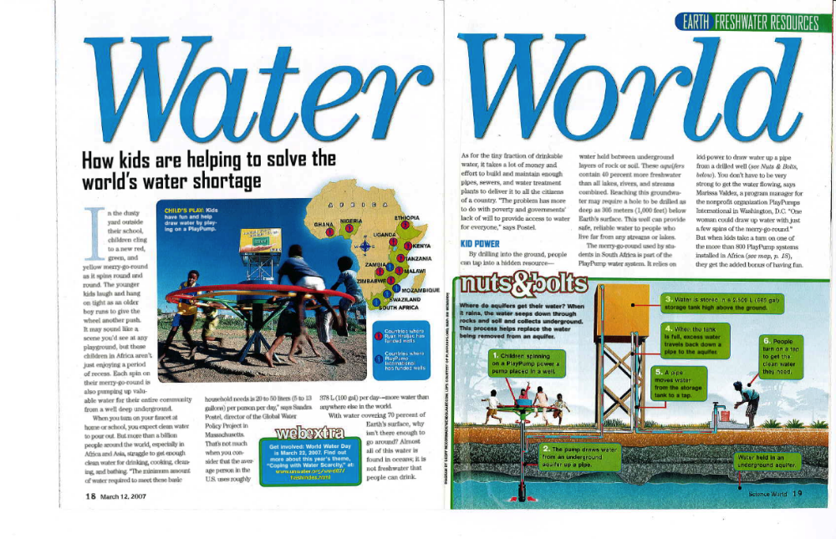
From SCIENCE WORLD, March 12, 2007 issue. Copyright © 2007 by Scholastic Inc. Reprinted by permission of Scholastic Inc.
Three Big Pollutants
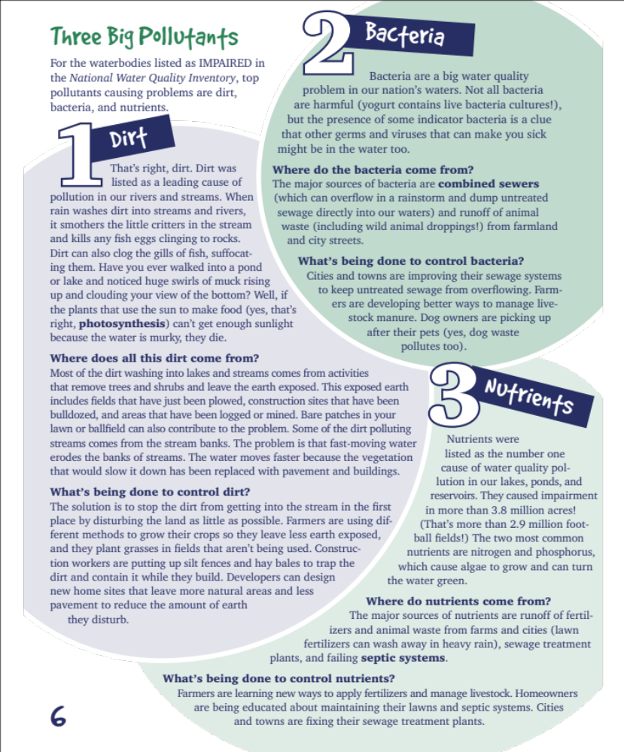

"Three Big Pollutants." United States Environmental Protection Agency. EPA, n.d. Web. http://water.epa.gov/learn/resources/bigpollutants.cfm
PlayPumps:
A New Invention Turns Work into Play

For kids in many rural parts of Africa, the colorful PlayPump is the first playground equipment they’ve ever seen. When they give a push and jump onboard for their first ride, smiles of wonder break out on their faces.

The fun of whirling in a circle is just part of the amazement. This incredible invention doesn’t just change their playtime, it changes their lives.

As the merry-go-round spins, it pumps clean water up from deep underground and stores it in a huge tank. People are welcome to come and help themselves to the water.

In rural Africa, clean water is a luxury. Most people don’t have plumbing in their homes. Instead, they often must walk long distances to wells and haul heavy containers of water back.

Patricia Molope, 17, explains that before her South African village got a PlayPump, people would pay a taxi driver to take them to a far-off well. “Sometimes the taxi drivers were busy, and we would have to go without bathing in order to save our water. It was too far to walk there. But now we have our own clean water in our village, and life is better.”

The exhausting chore of carrying water traditionally falls to women and girls. Hauling water for miles—and hours—each day is such a big job, it sometimes prevents girls from being able to attend school.

Thanks to the PlayPump, getting water is quick and easy—and even boys join in. The pumps have become a center of social activity where kids and adults gather to visit while collecting water.

Two sides of each tank carry educational messages that remind people about good health practices like battling germs through hand-washing. The other two sides carry advertisements, which help pay for the pump's upkeep.

So far, more than 800 PlayPumps are operating in schools and communities in four African countries, providing water for almost two million people. The pumps are made by a South African company called Outdoor Fabrication and Steelworks. Another company, Roundabout Outdoor, trains local teams who maintain the pumps. Each system costs U.S. $14,000.
PlayPumps:
A New Invention Turns Work into Play

Twelve-year-old Siyabulisiwe Khumalo lives in a South African community called Diepsloot. She says, “I have seen many kinds of water pumps where I grew up in the farmlands, but never one that stores the water. When I grow up, I want to be an inventor so I can invent clever things like the PlayPump that will help my community.”

Fast Facts:

- Many toilets use more water in one flush than most rural families in Africa have for one day of cleaning, cooking, drinking, and bathing.
- The average distance an African villager must walk to a water source is five miles (eight kilometers).
- A five-gallon (19-liter) container can weigh about 40 pounds (18 kilograms), and many women and girls suffer injuries carrying so much weight every day.
- A child dies somewhere in the world every 15 seconds from a water-borne illness.
- The PlayPump can pump up to 370 gallons (1,400 liters) of clean water an hour.

Ngs Staff/NatGeoCreative.com
Where Are These Pollutants Coming From
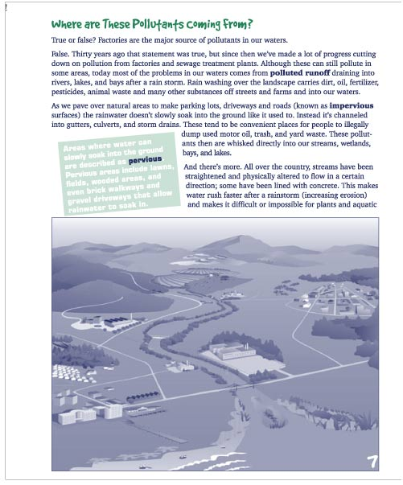

“Where Are These Pollutants Coming From?” United States Environmental Protection Agency. 6 Mar 2012. Web. http://water.epa.gov/learn/resources/where.cfm.
A World Thirsty for Clean Water

The water in the village where Maria and her family live is bad. Her younger brother got so sick from drinking it that he almost died. Maria's job is to collect clean water, and her family depends on it. She walks six miles to the river and back — twice a day! Seven-year-old Maria no longer attends school. She has no choice.

Can you imagine missing school because you had to spend all day collecting water? You probably don't even think about water. In the United States, as in any other developed country, water is safe and plentiful. But for millions of people from developing countries, finding clean water remains a major problem.

Unclean or unsafe water is dangerous to your health. Unlike clean, potable water that doesn't contain any pollutants, unsafe water has not gone through a purification process. It carries contaminants — bacteria. viruses, fungi, minerals, or man-made chemicals — that can cause serious disease. Countries with the least access to safe water are among the poorest in the world and are located in Asia and sub-Saharan Africa. These nations visually lack the means to build or buy specialized machines that purify water. As a result, their populations are left with no other choice but to use unsanitary water.

Unsafe water remains the most common cause of sickness and death in poor countries. Illnesses due to bad water are called "water-related diseases." Diarrheal disease is the most serious one. It spreads through water infected with human or animal feces. Individuals become sick by drinking such water or eating food washed with it.

Diarrheal diseases affect mostly children, particularly children under the age of five. Every year, more than a million children die after being exposed to water infected with feces. In general, children are more vulnerable than adults to water-related diseases because children's bodies are not fully developed, so they have less resistance to serious illness. Also, in proportion to their weight, children eat more, drink more, and breathe more than adults do, making the contaminants swallowed or breathed in more dangerous.

What happens when children get sick? They miss school and the opportunity to learn. Later on, when they are grownups. they may have difficulty finding a good job. They'll get poorer, their families will get poorer, and their country will get poorer. And so on it goes.

But there is some good news. The world is now taking action. International aid organizations, including the United Nations and the World Bank, are lending money for projects that clean water in some of the poorest areas of the world. Aid groups have pledged to cut the number of people living with unclean water in half by 2015. One important way to achieve this objective is through education.

A World Thirsty for Clean Water

Everyone needs to be aware of this worldwide problem, and everyone can be part of the solution. This includes you. Don't wait: Start spreading the news today.

PHOTO (COLOR): Clean water — plentiful here in the United States, but a rarity in too many places throughout the world.
PHOTO (COLOR): Dirty water carries diseases and Is a primary source of health problems in many places.
~~~~~~~~
By Brigitte Aftalo-Calderon
Brigitte Aftalo-Calderon divides her time between the United States and France. Before becoming a writer, she worked for the World Bank, an international organization that specializes in lending money to poor countries.

From Faces Issue: World Health, © 2007 Carus Publishing Company, published by Cobblestone Publishing, 30 Grove Street, Suite C, Peterborough, NH 03458. All Rights Reserved. Used by permission of the publisher. www.cobblestonepub.com.

Dry Run
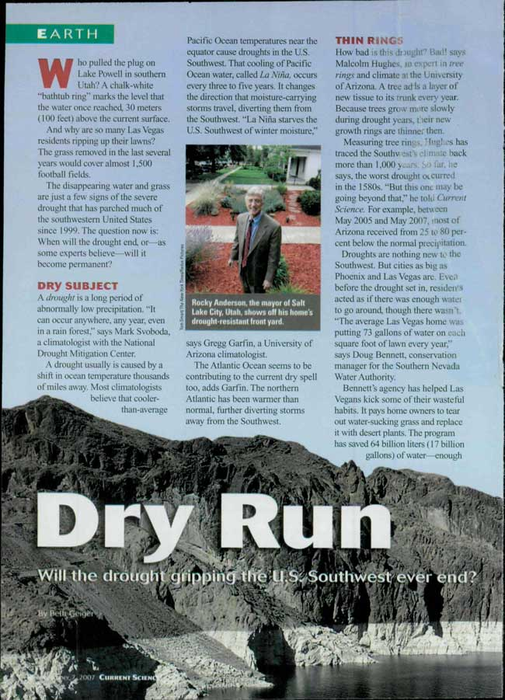

Dry Run
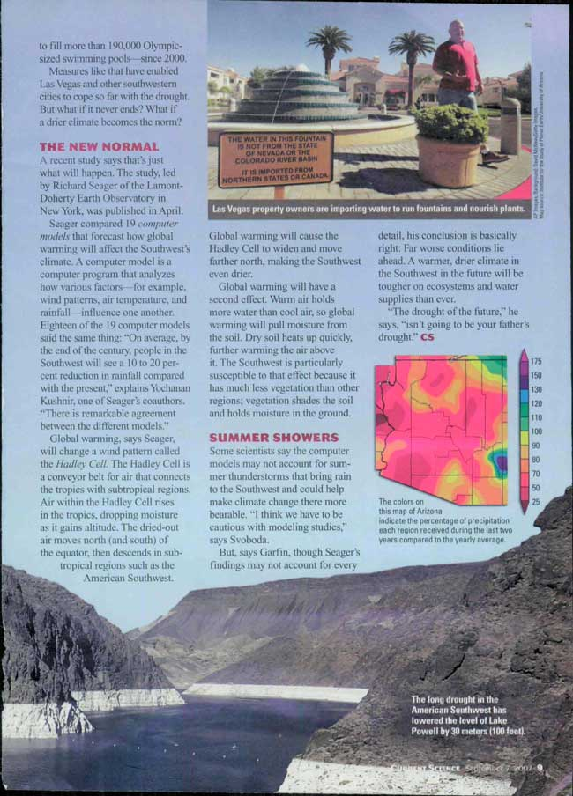

From Current Science, September 7, 2007. Copyright © 2007 by Scholastic Inc. Reprinted by permission of Scholastic Inc.
Dry Times

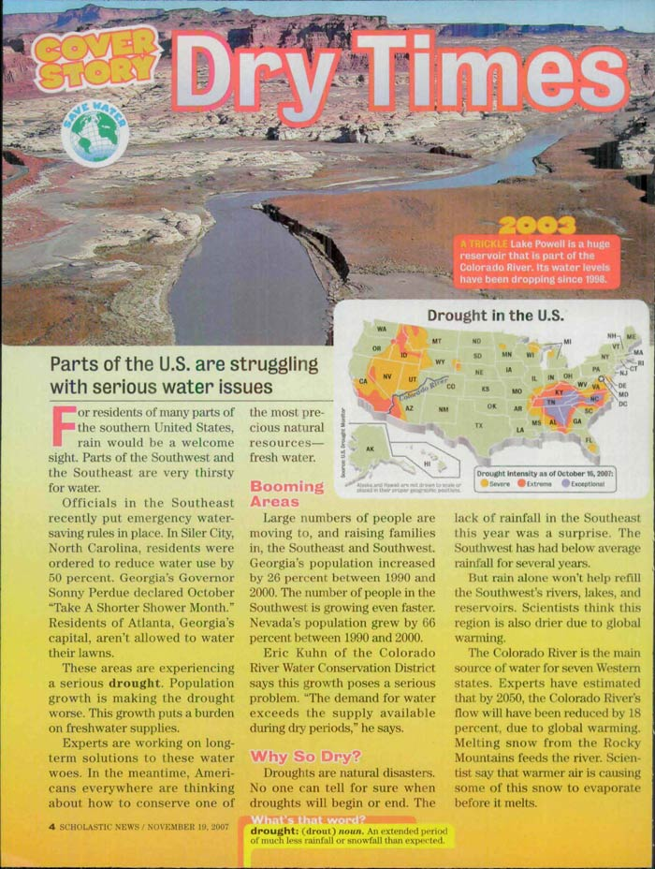
Dry Times
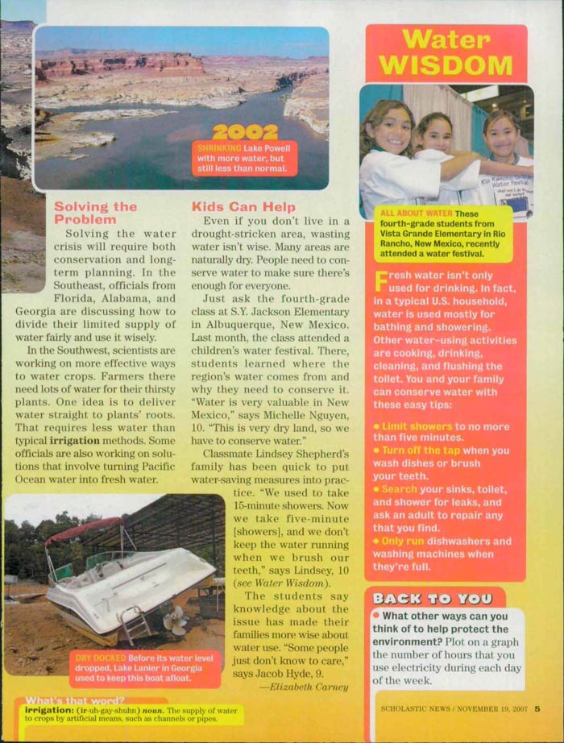

From Scholastic News, September 17, 2012. Copyright © 2012 by Scholastic Inc. Reprinted by permission of Scholastic Inc.

NEED: Future Clean Water Solutions

NEED: Future Clean Water Solutions
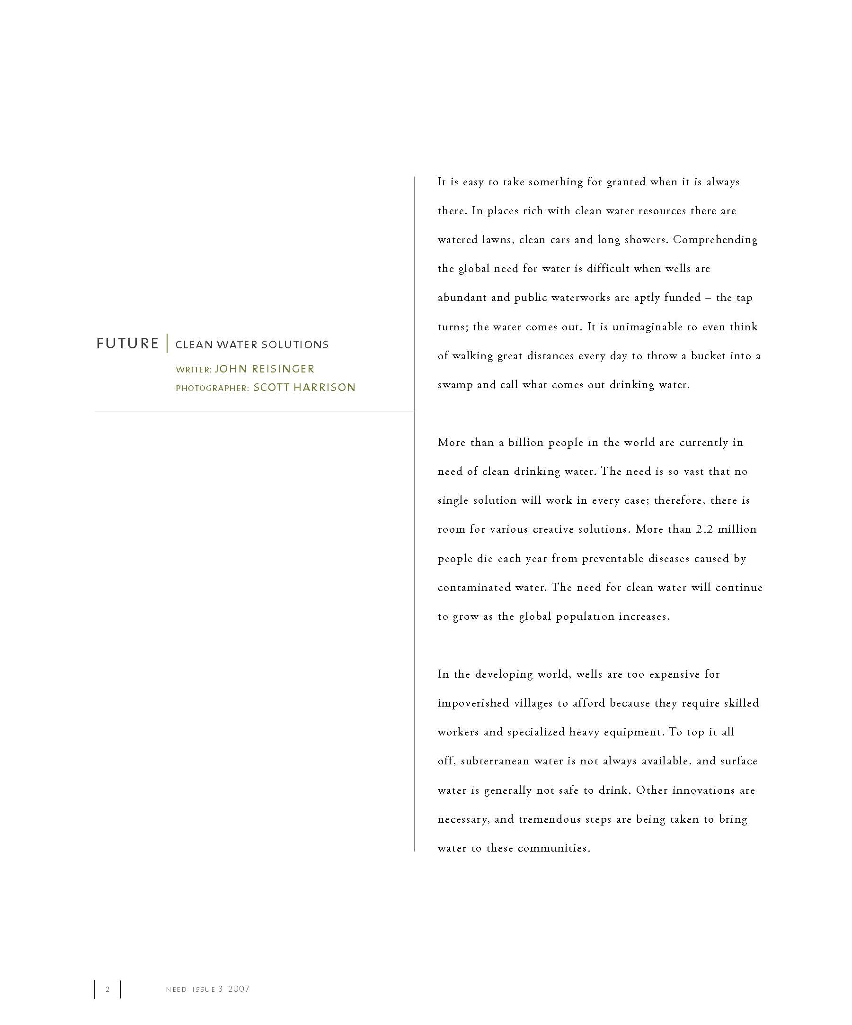
NEED: Future Clean Water Solutions
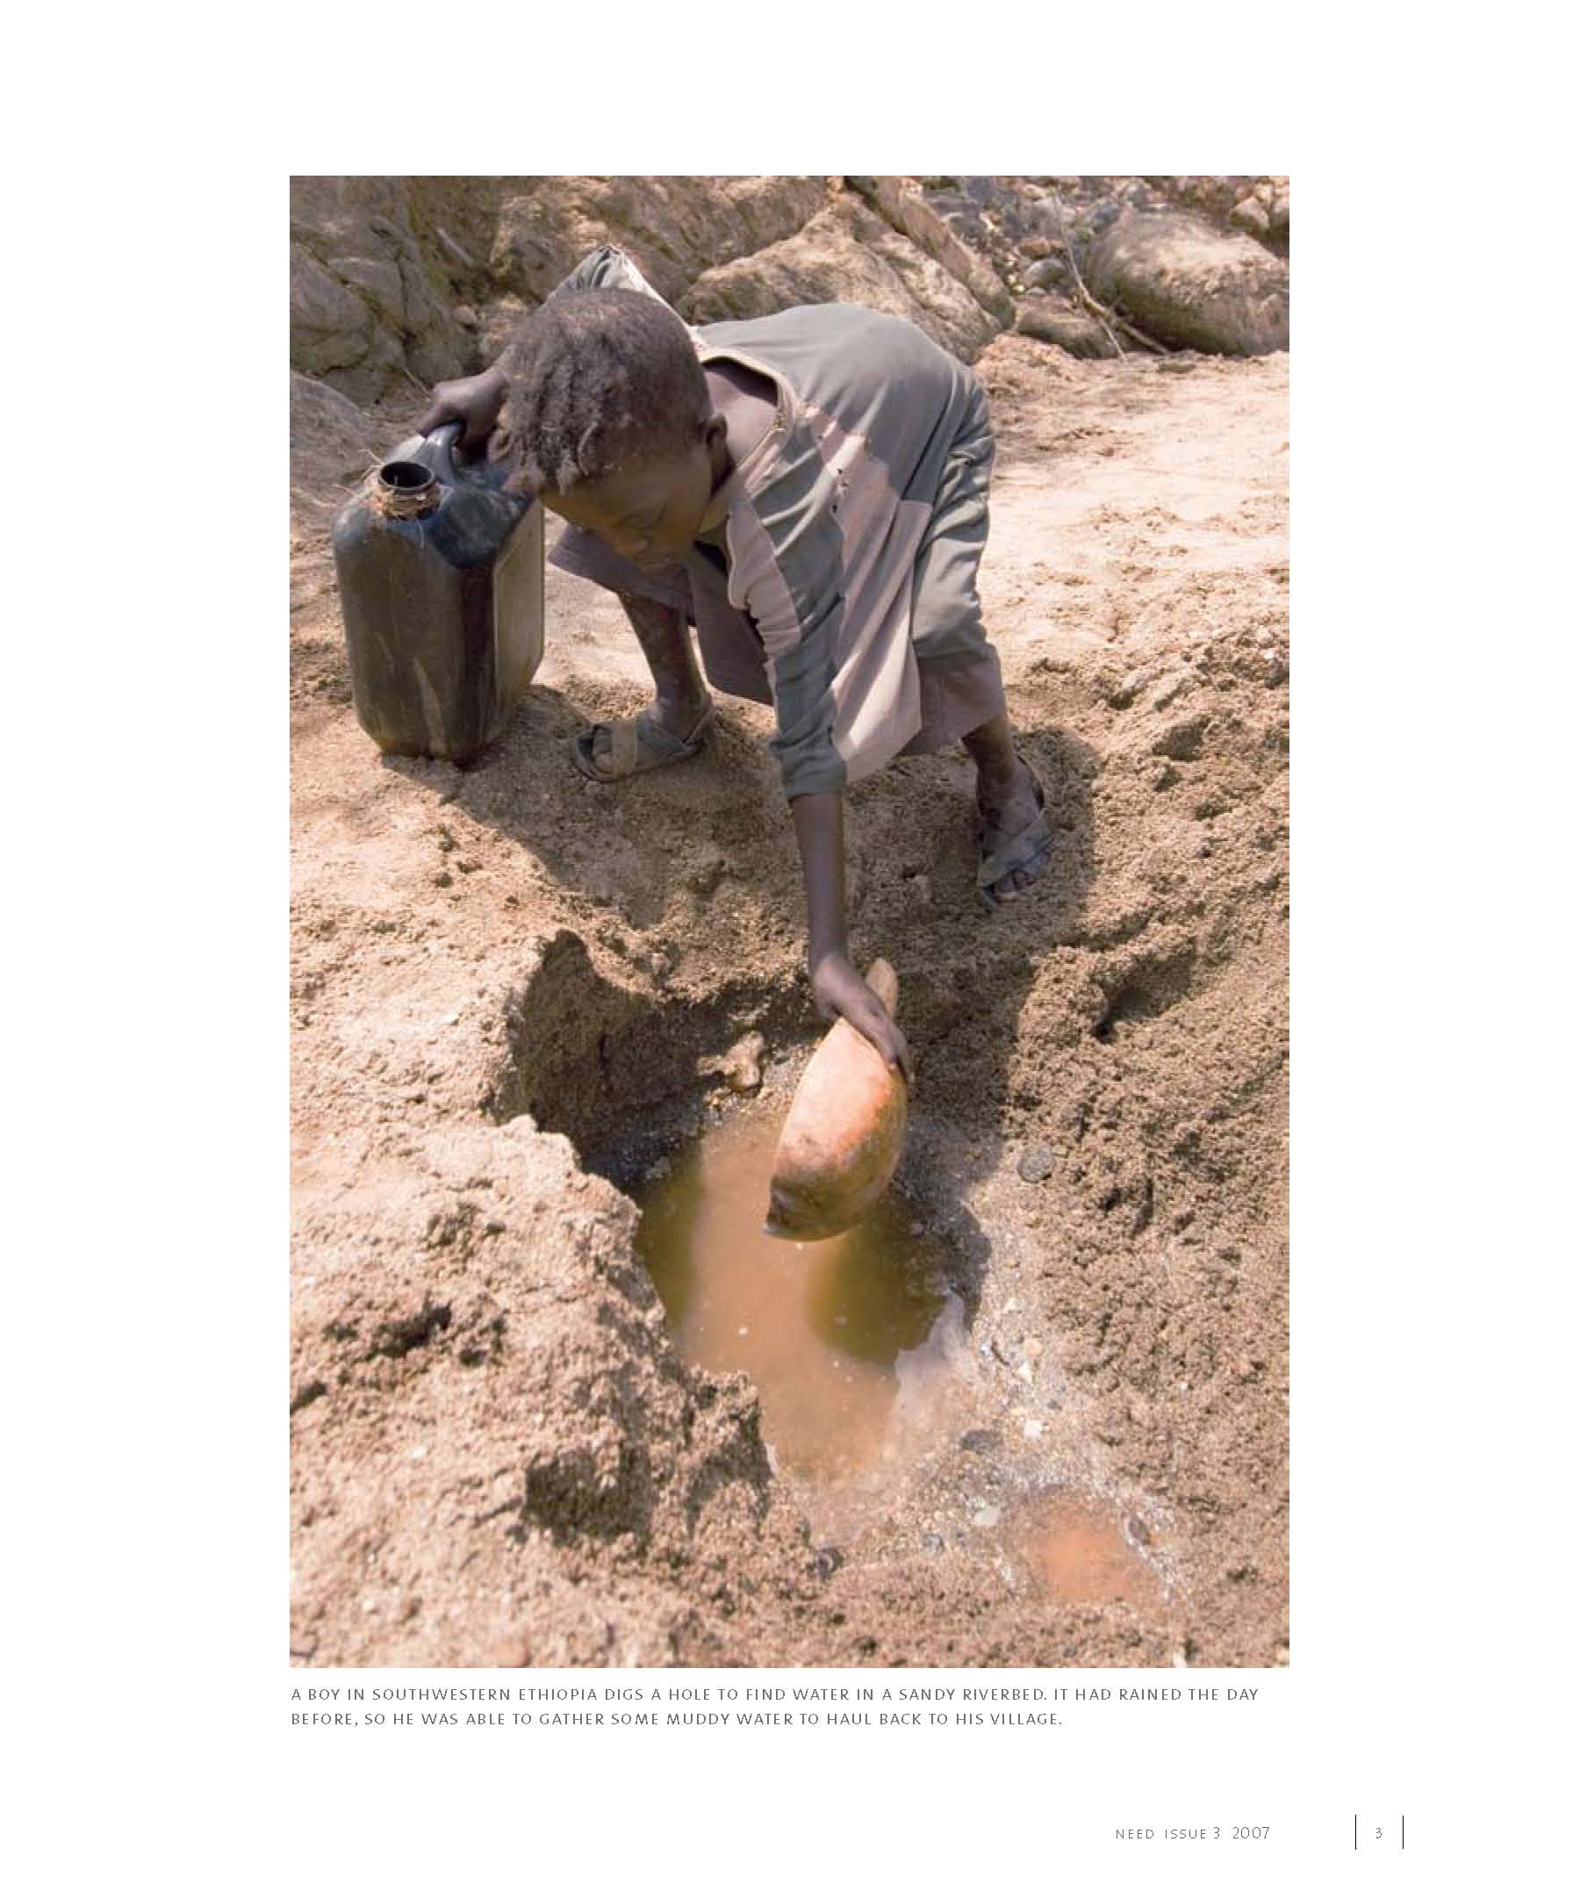
NEED: Future Clean Water Solutions
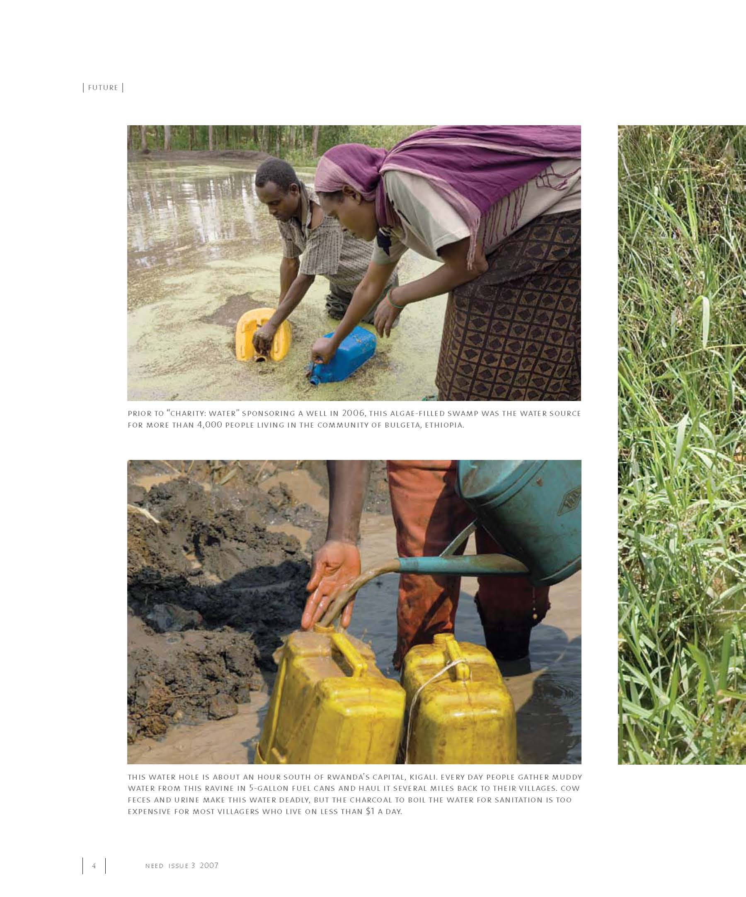
NEED: Future Clean Water Solutions
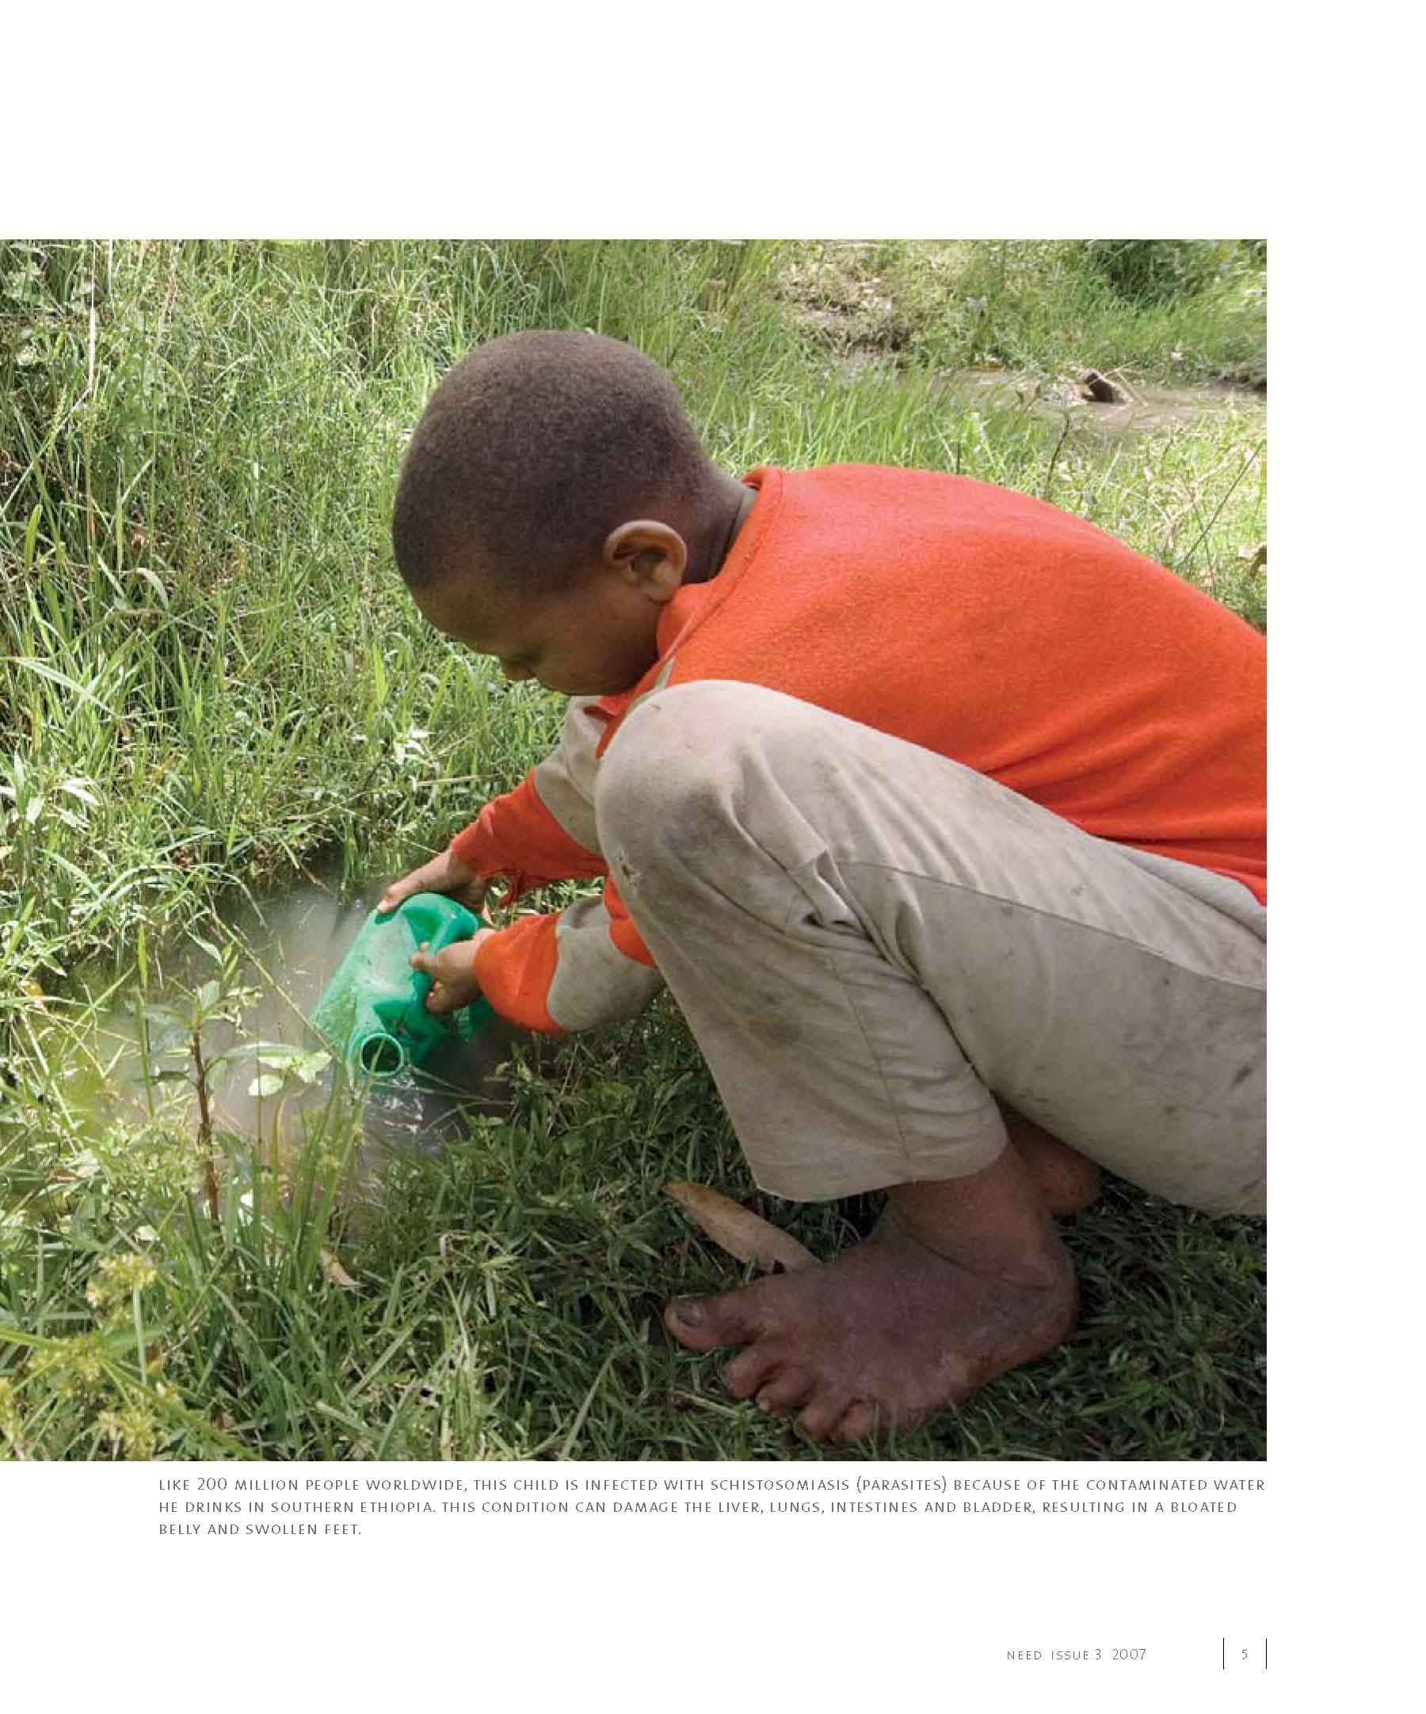
NEED: Future Clean Water Solutions
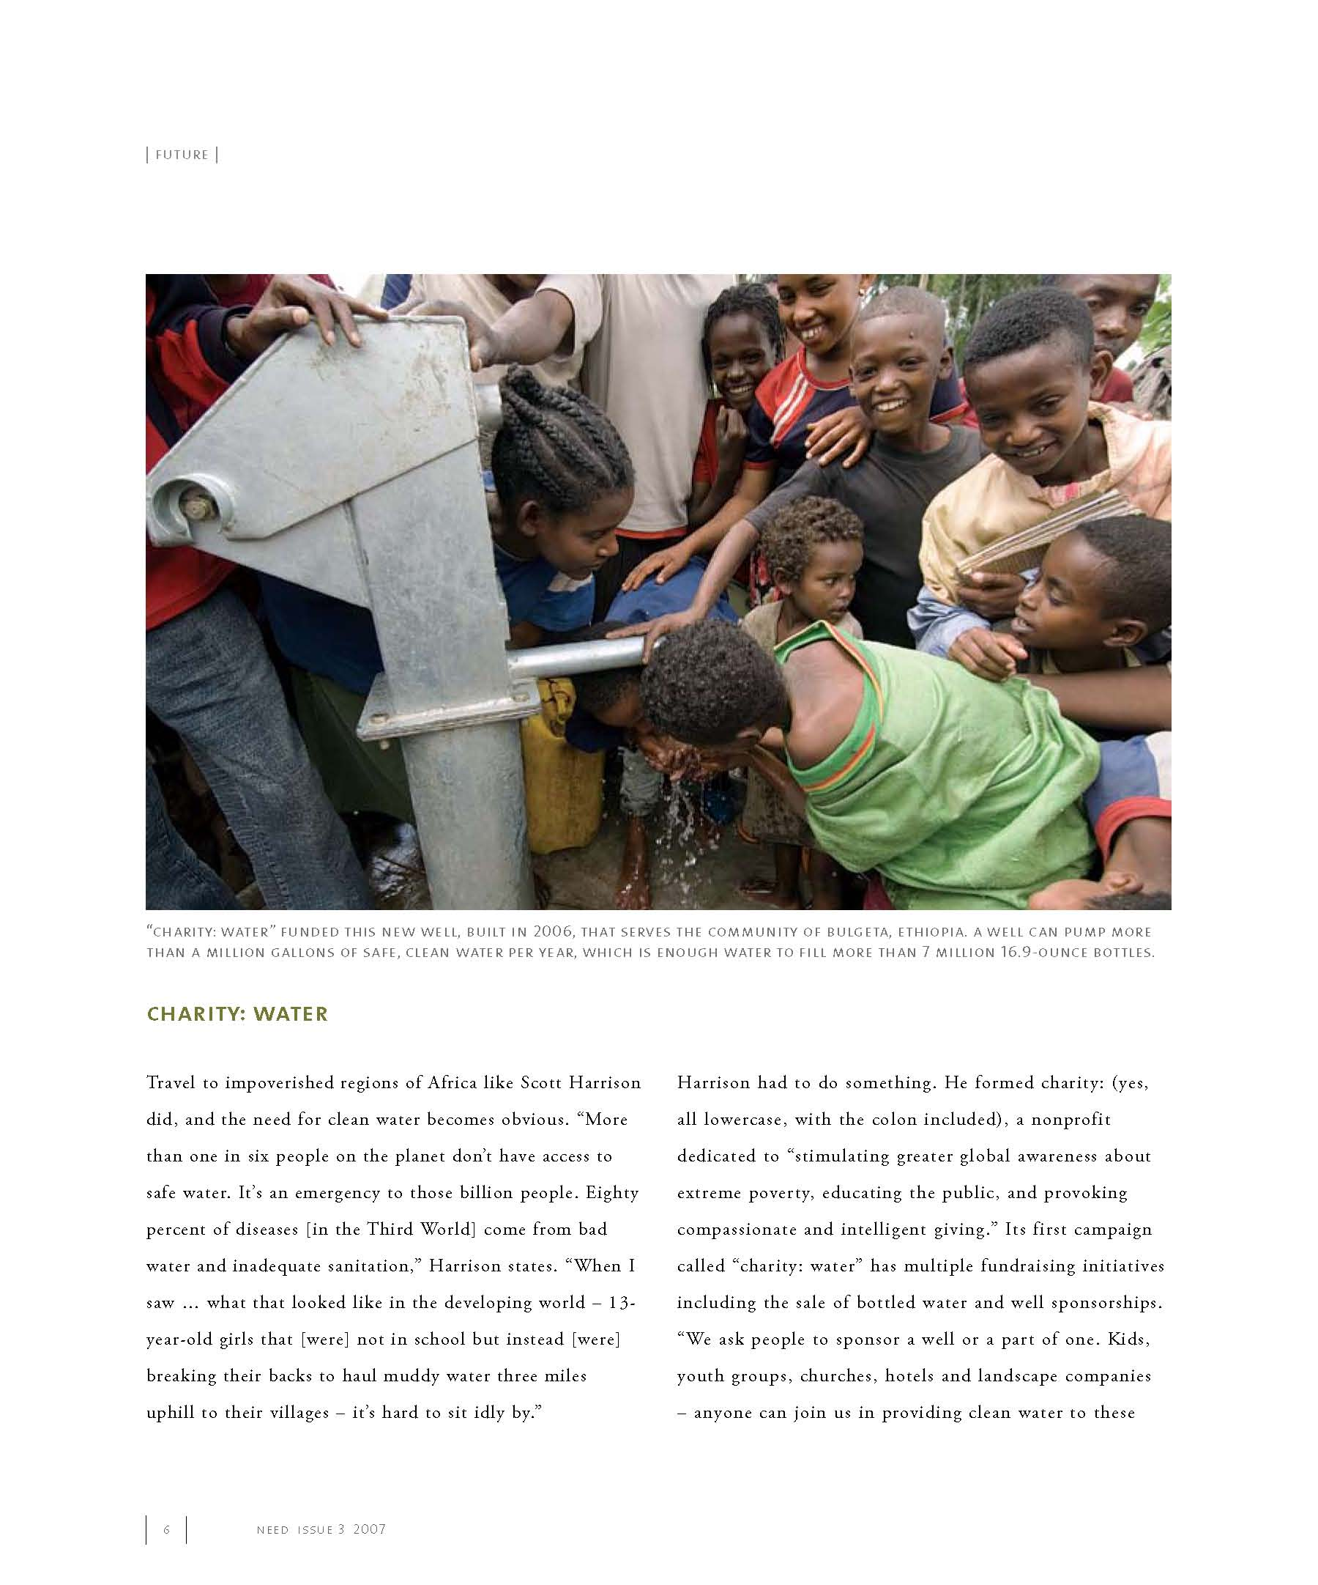
NEED: Future Clean Water Solutions
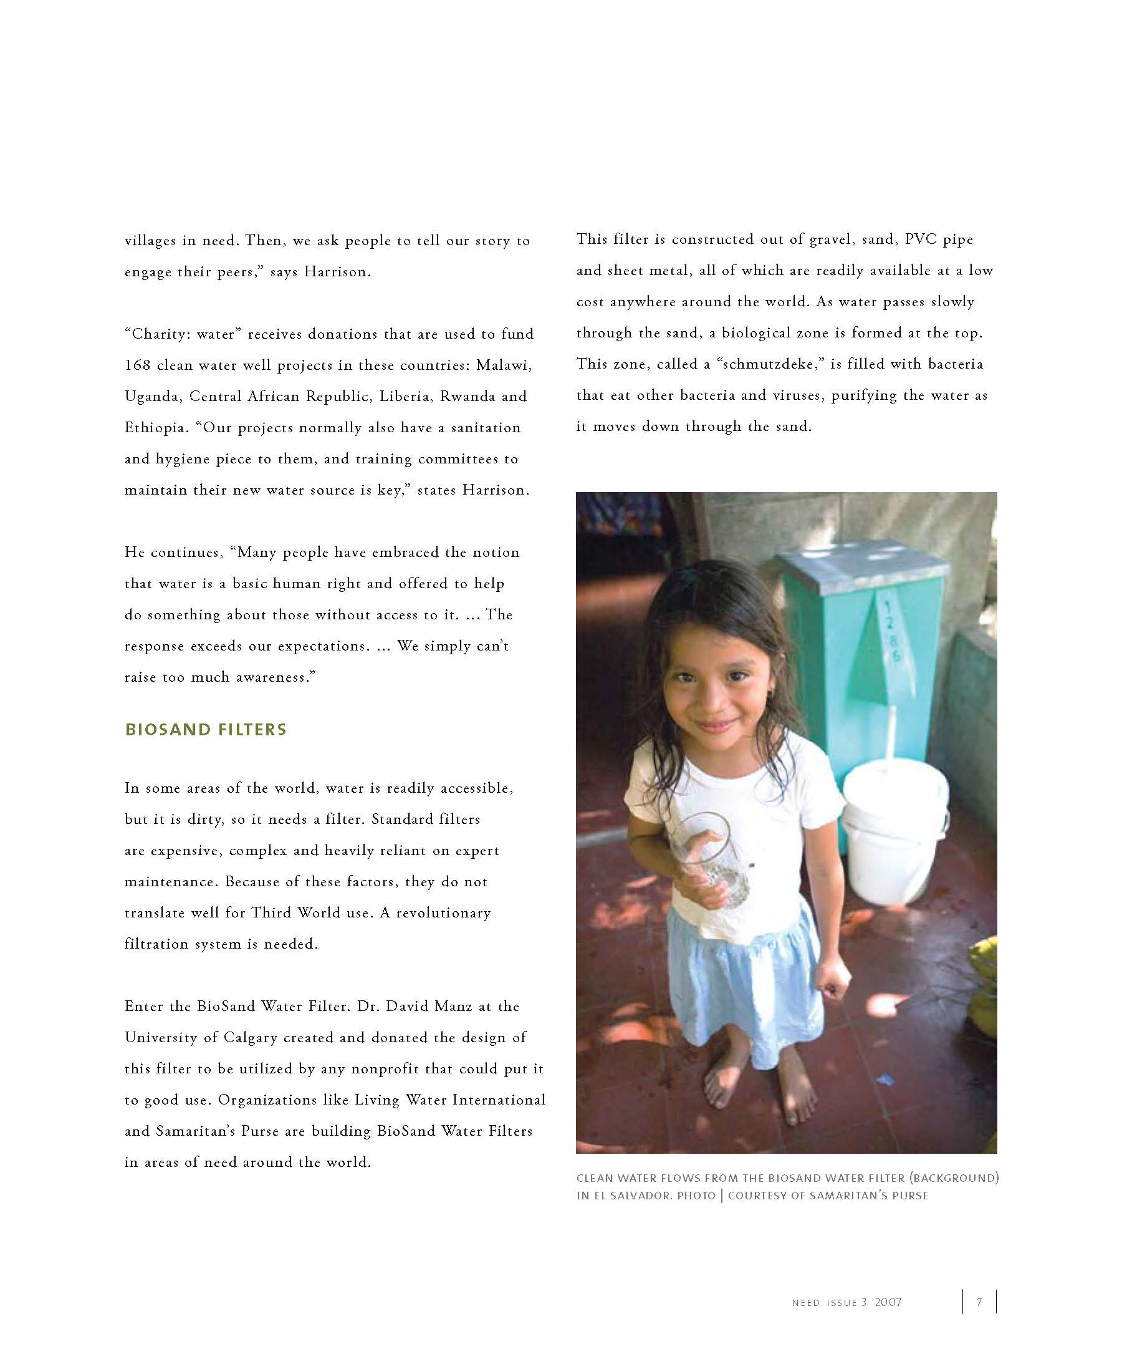
NEED: Future Clean Water Solutions
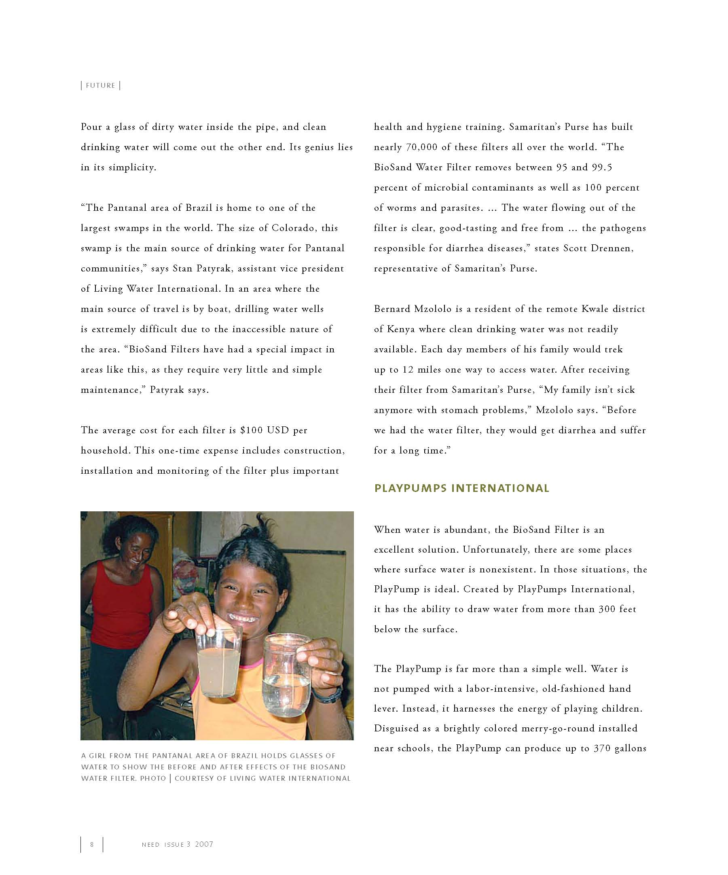
NEED: Future Clean Water Solutions
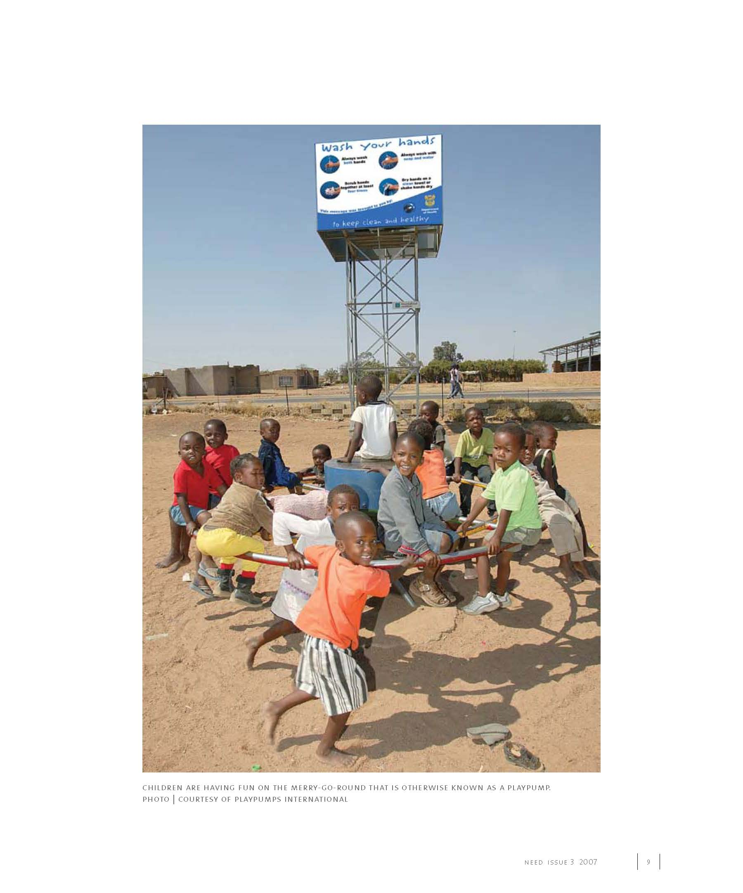
NEED: Future Clean Water Solutions
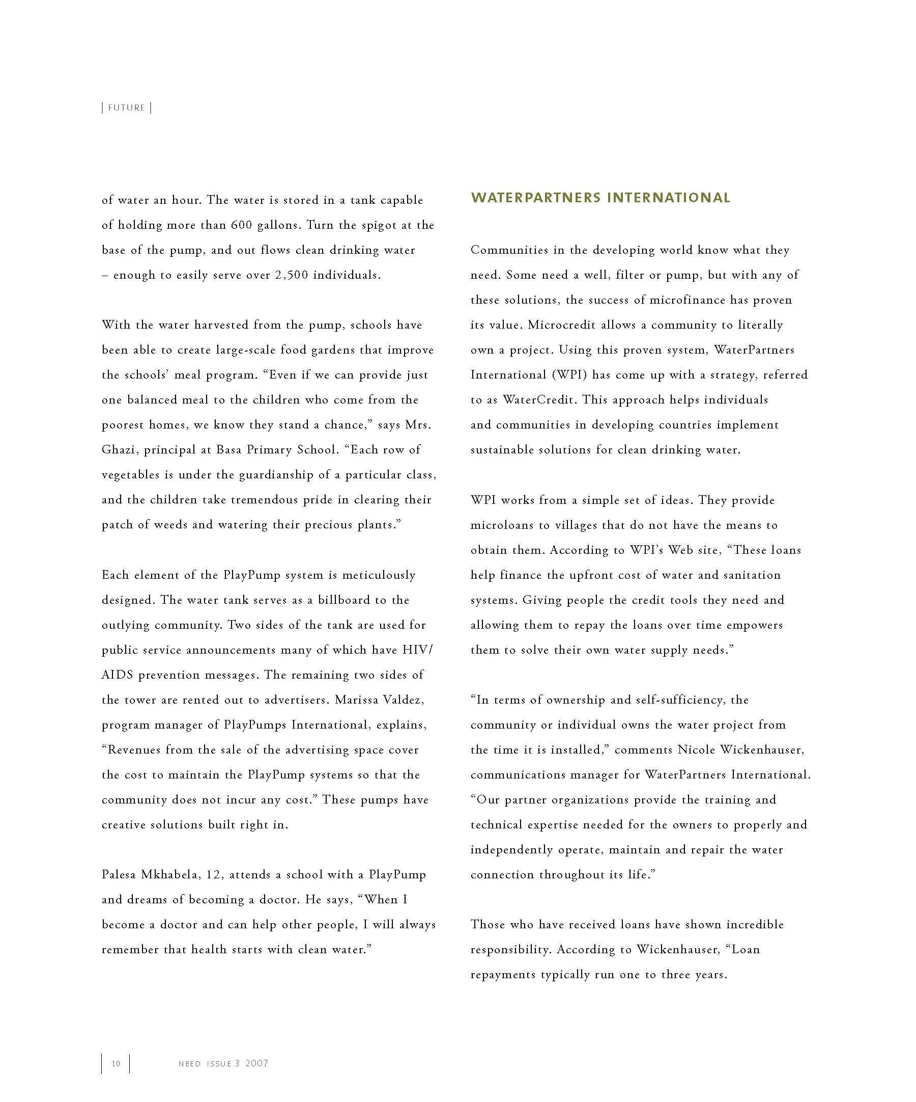
NEED: Future Clean Water Solutions
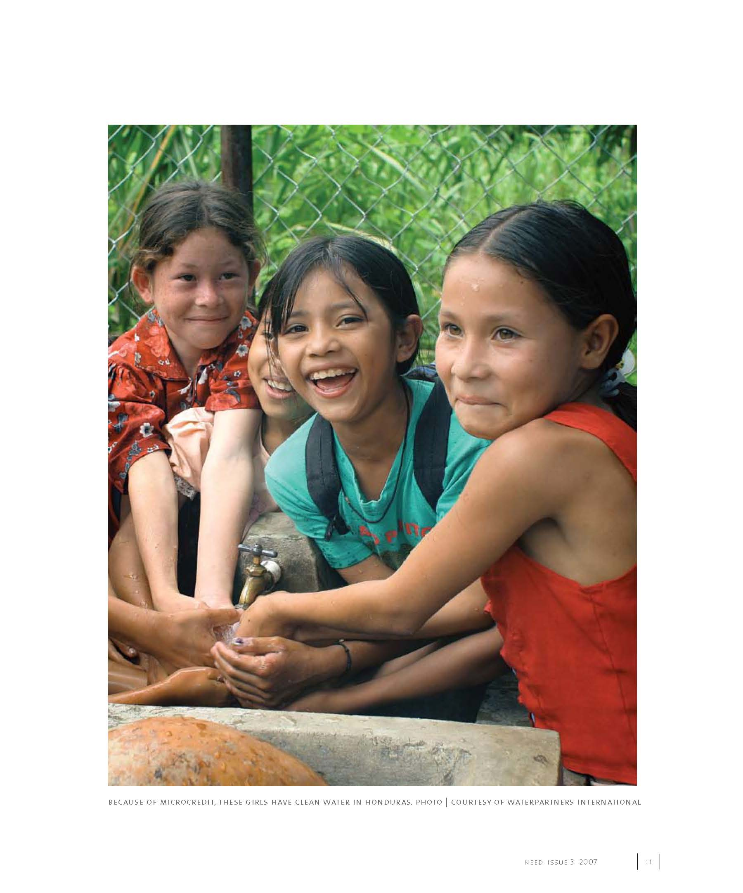
NEED: Future Clean Water Solutions
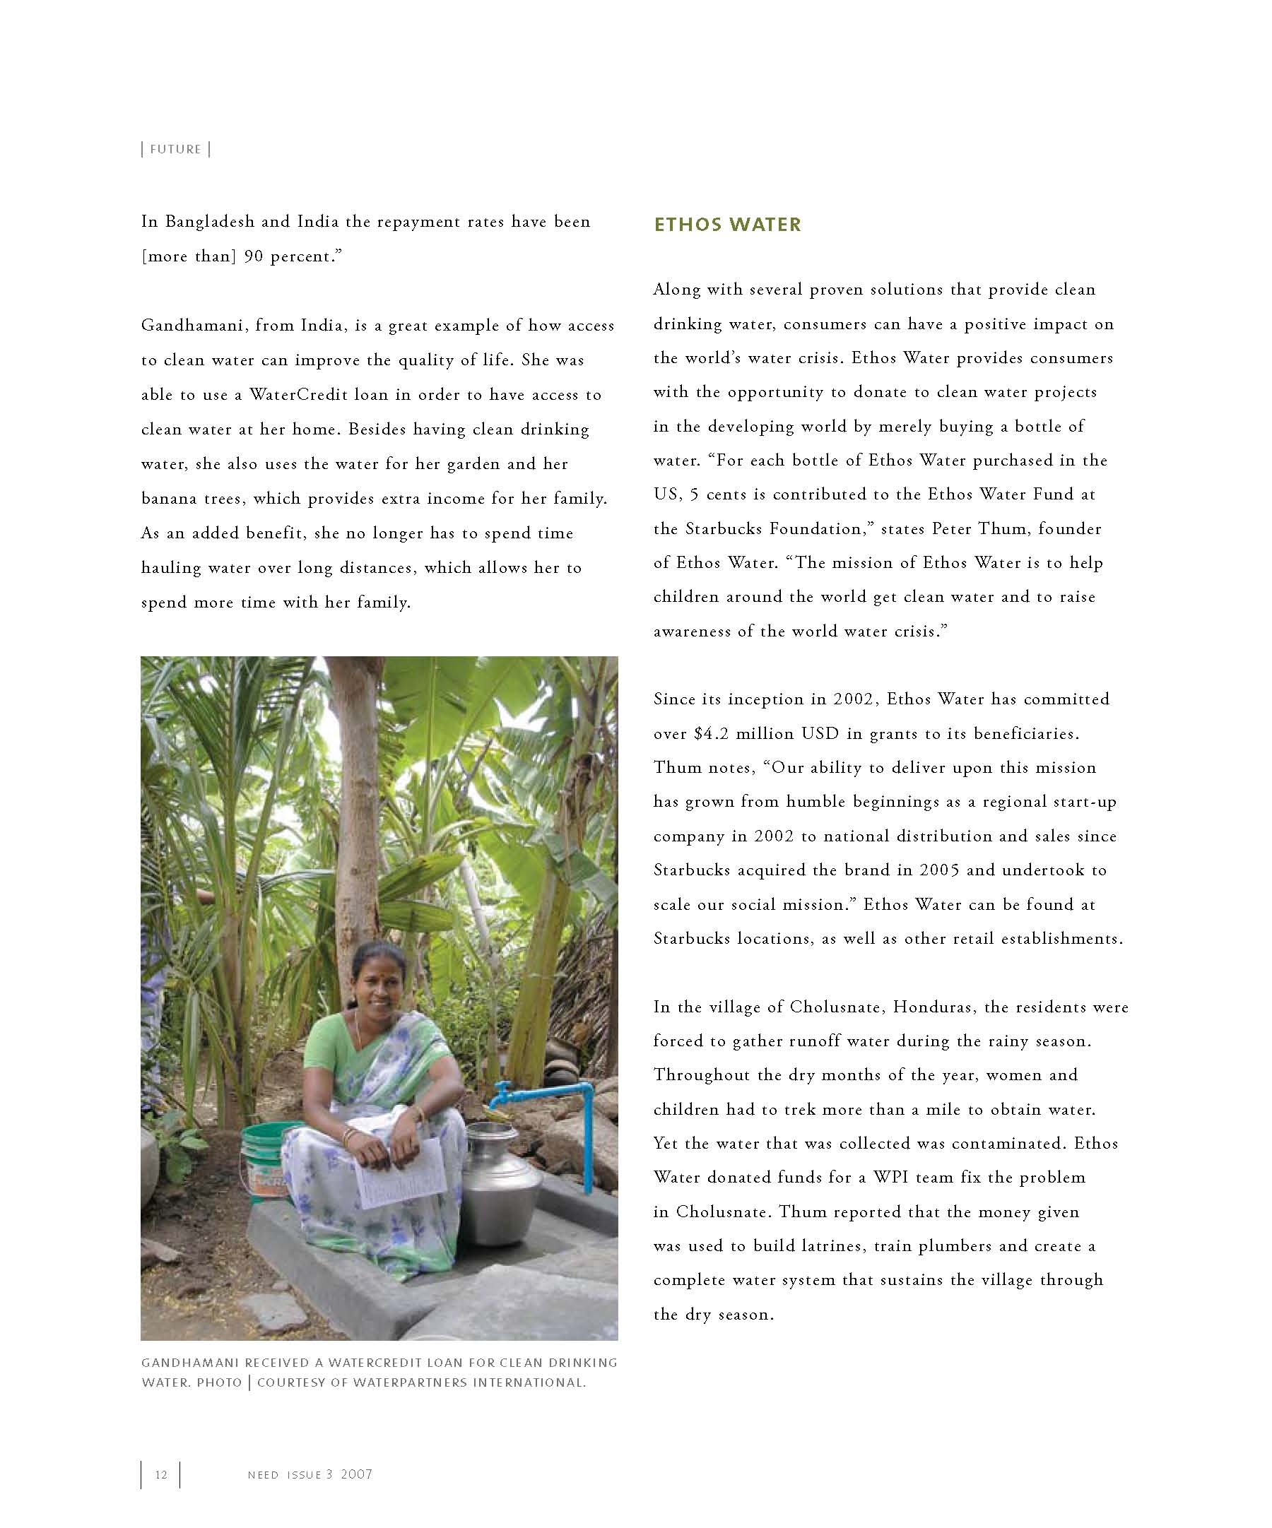
NEED: Future Clean Water Solutions
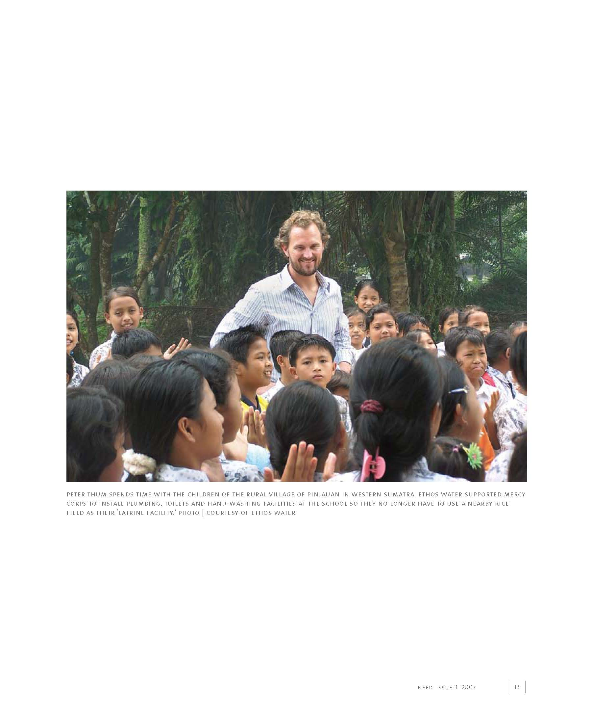
NEED: Future Clean Water Solutions
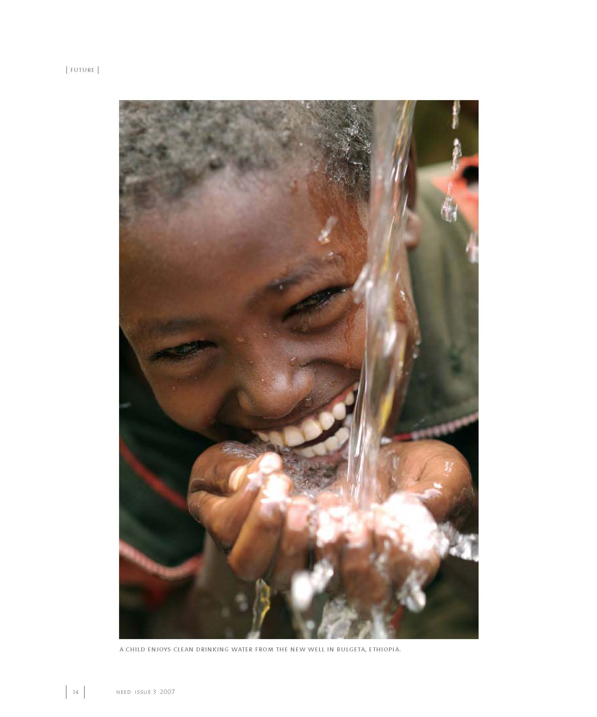
NEED: Future Clean Water Solutions
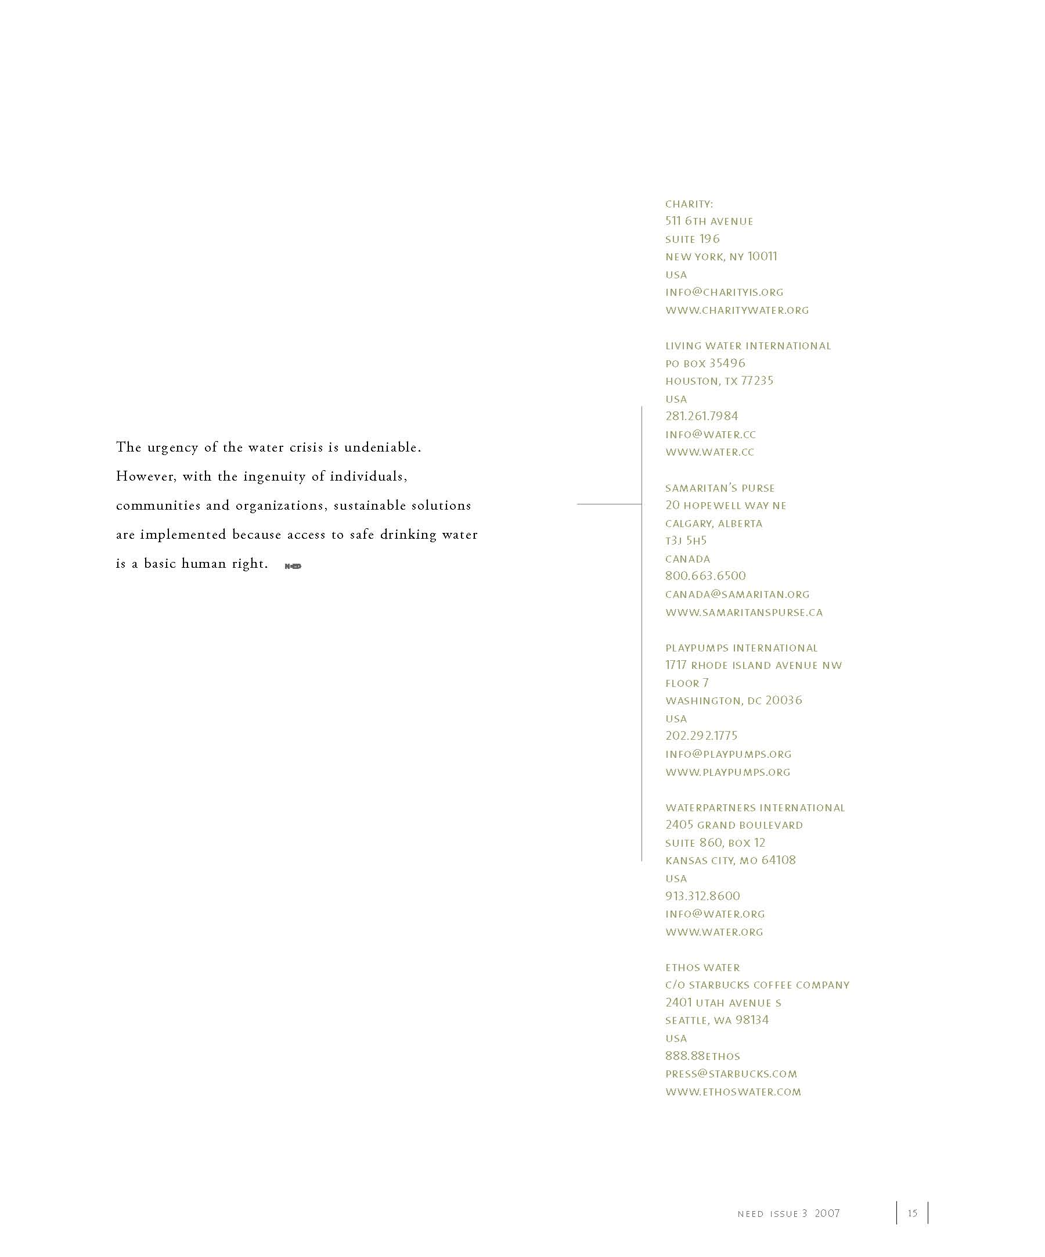

NEED: Future Clean Water Solutions
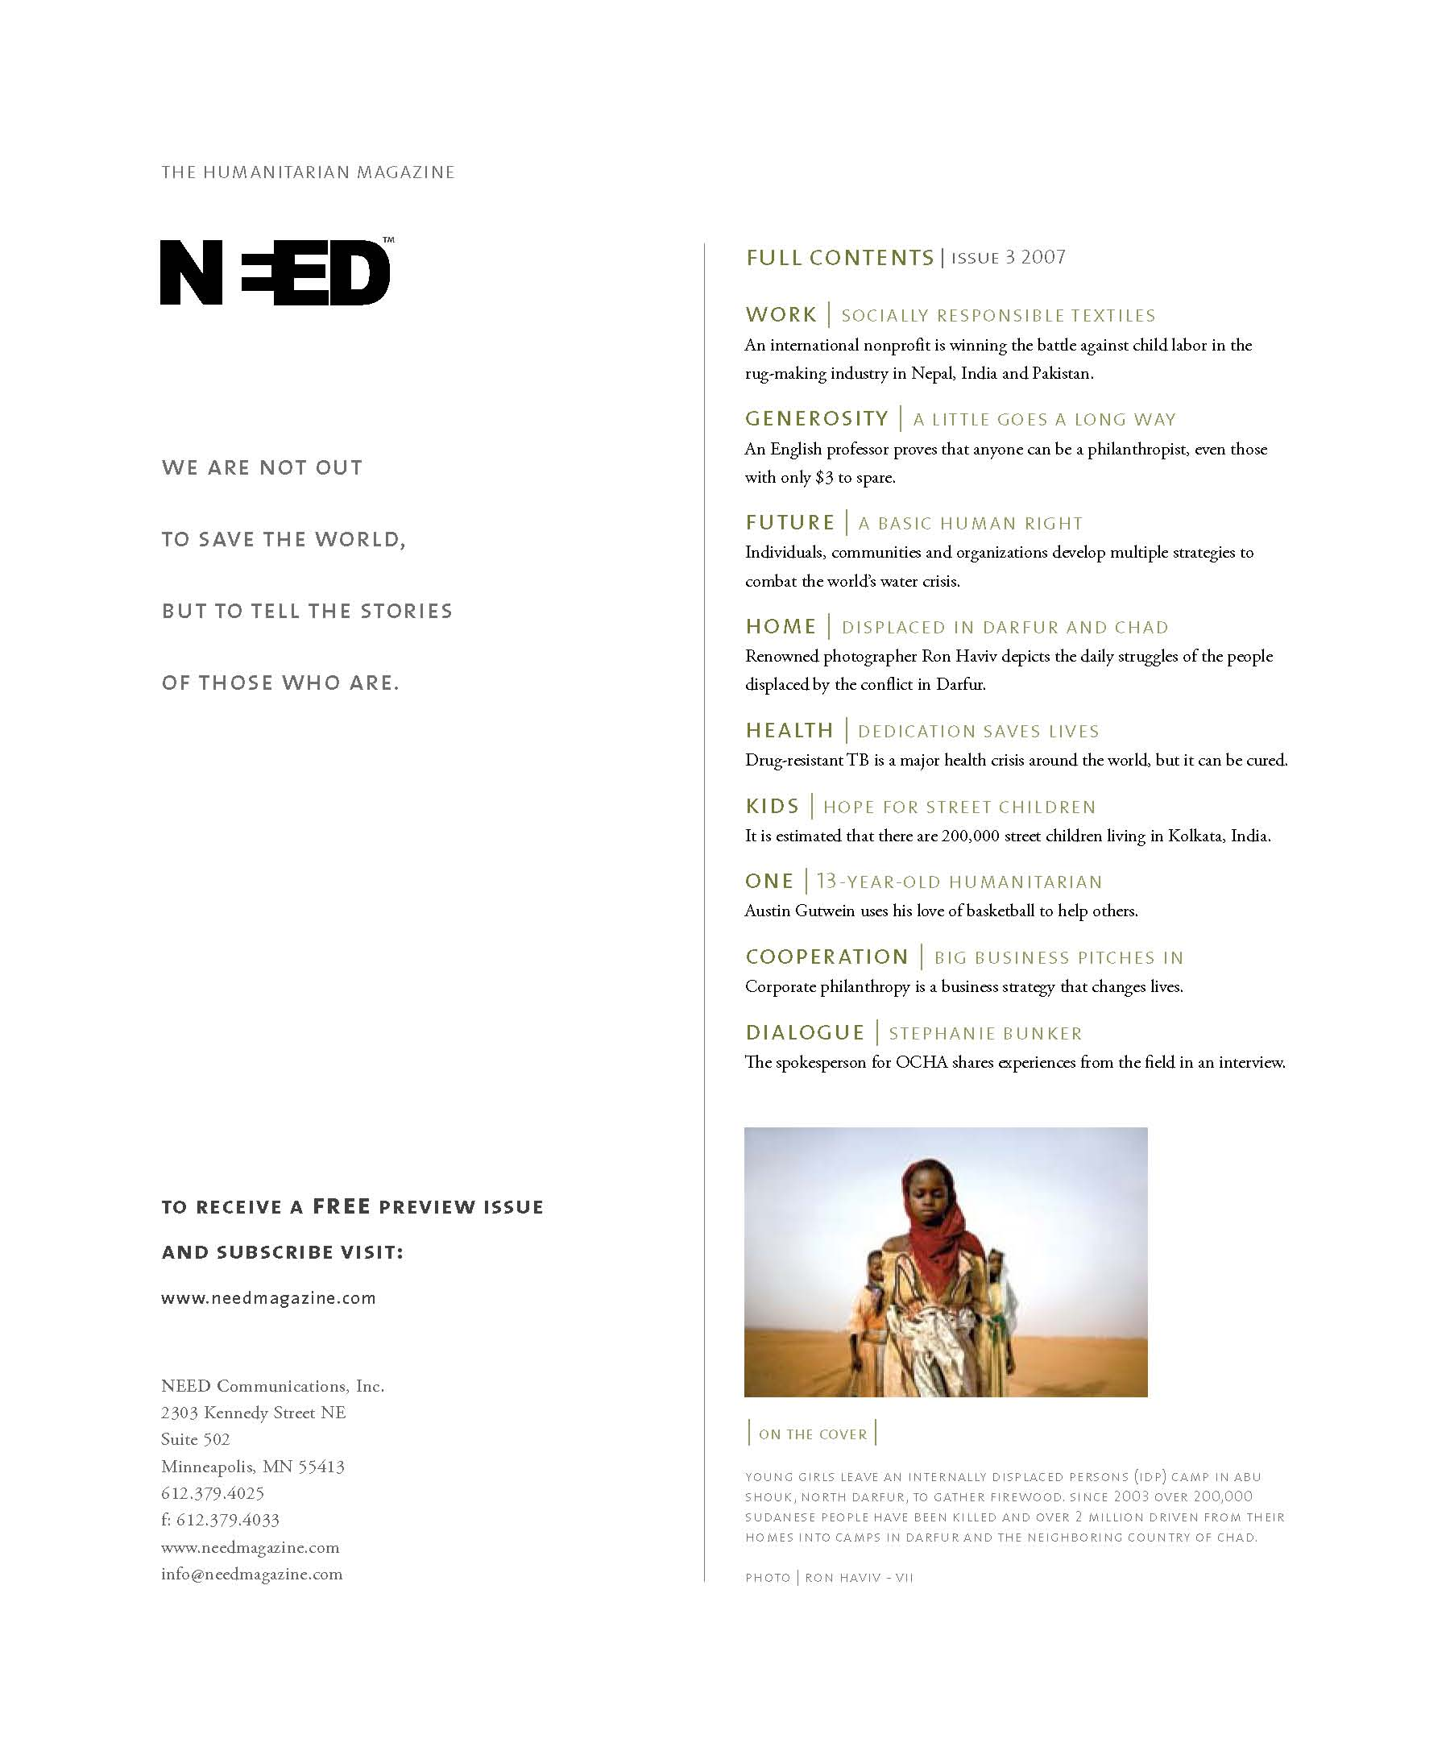

Reisinger, John. “Future Clean Water Solutions.” NEED 2007: 2-15. Print.
Keep Earth’s Water Clean
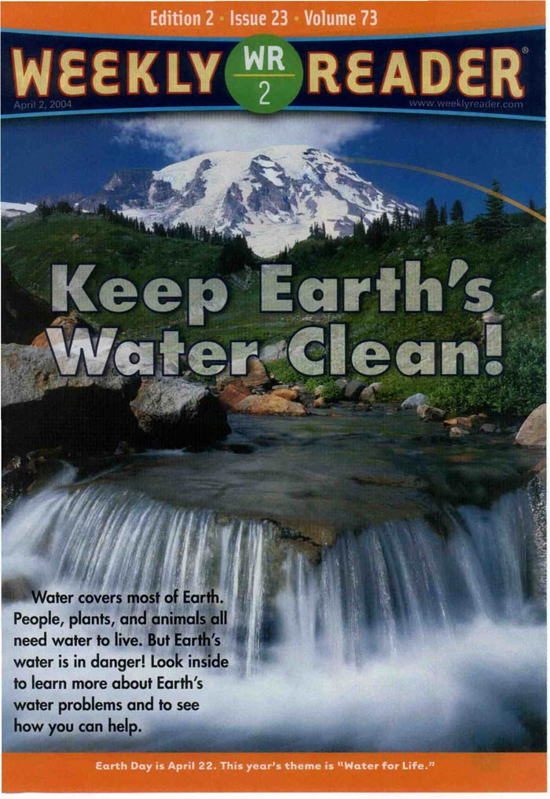
Keep Earth’s Water Clean
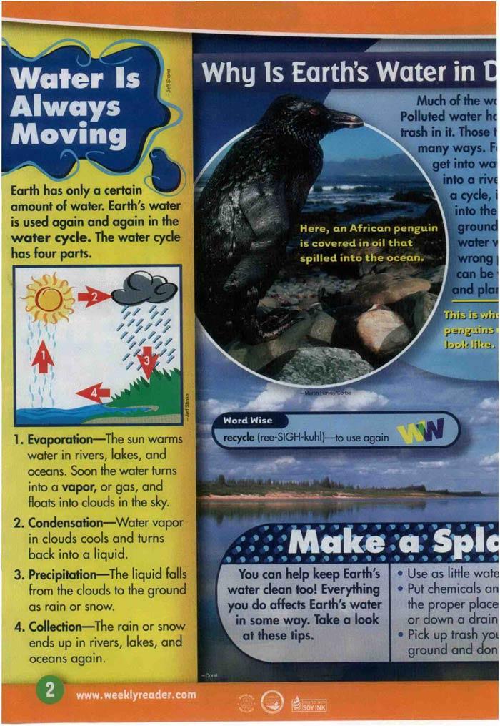
Keep Earth’s Water Clean
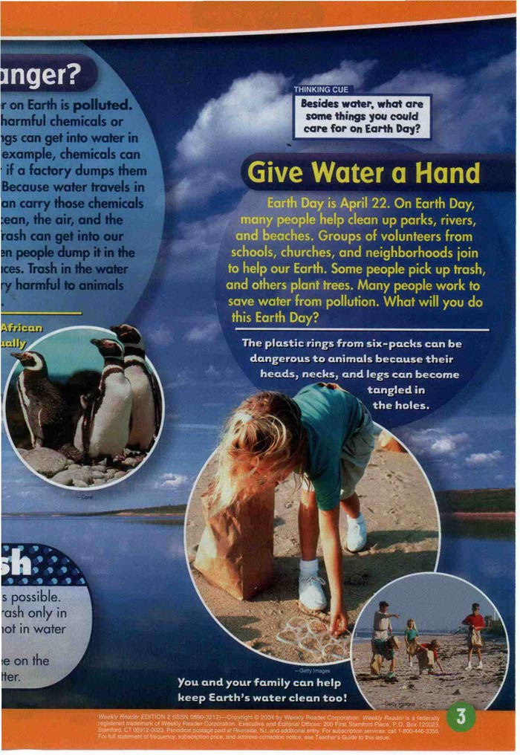

From Weekly Reader News Edition 2, April 2, 2004. Copyright © 2004 by The Weekly Reader Corporation. Reprinted by permission of Scholastic Inc.
Toxic Water is Poisoning the People of Bangladesh

Expeditionary Learning is seeking permission for this material. We will post an updated version of the lesson once permission is granted.
A River At Risk
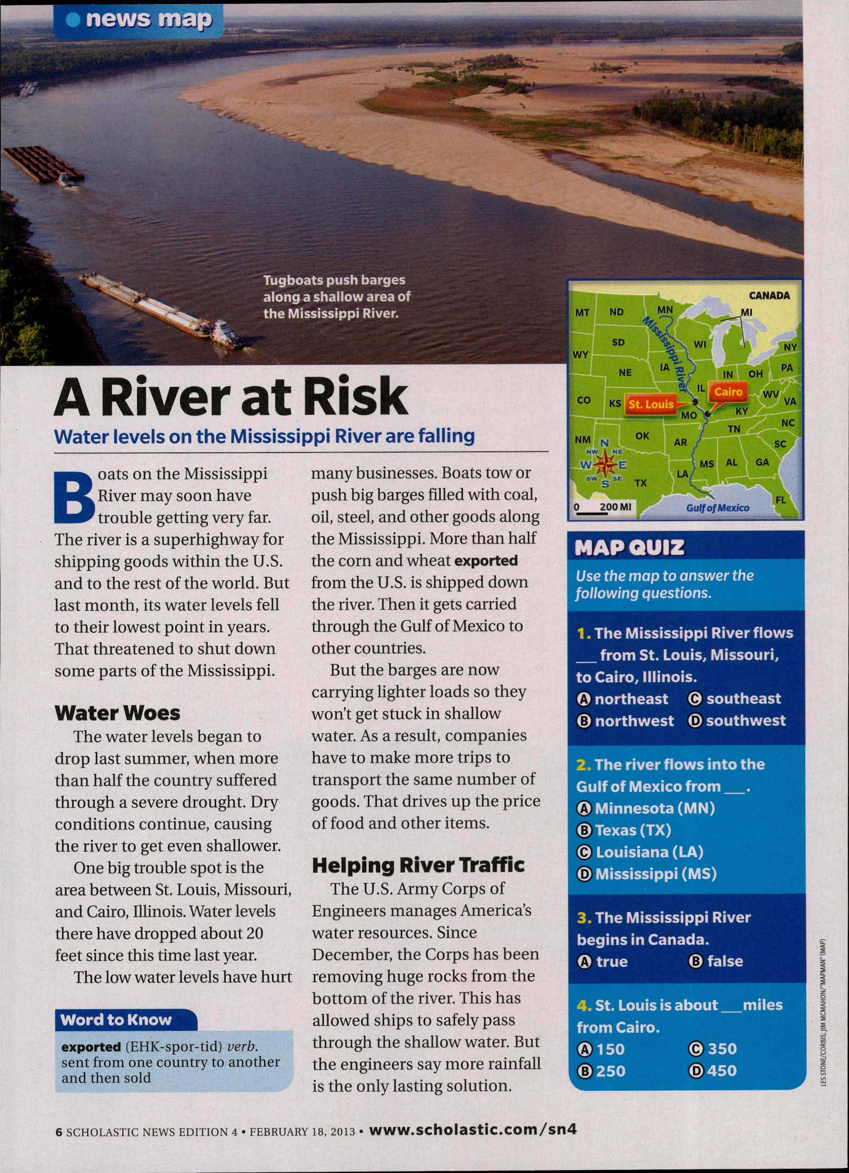

From Scholastic News, February 18, 2013. Copyright © 2013 by Scholastic Inc. Reprinted by permission of Scholastic Inc.
Crisis in East Africa
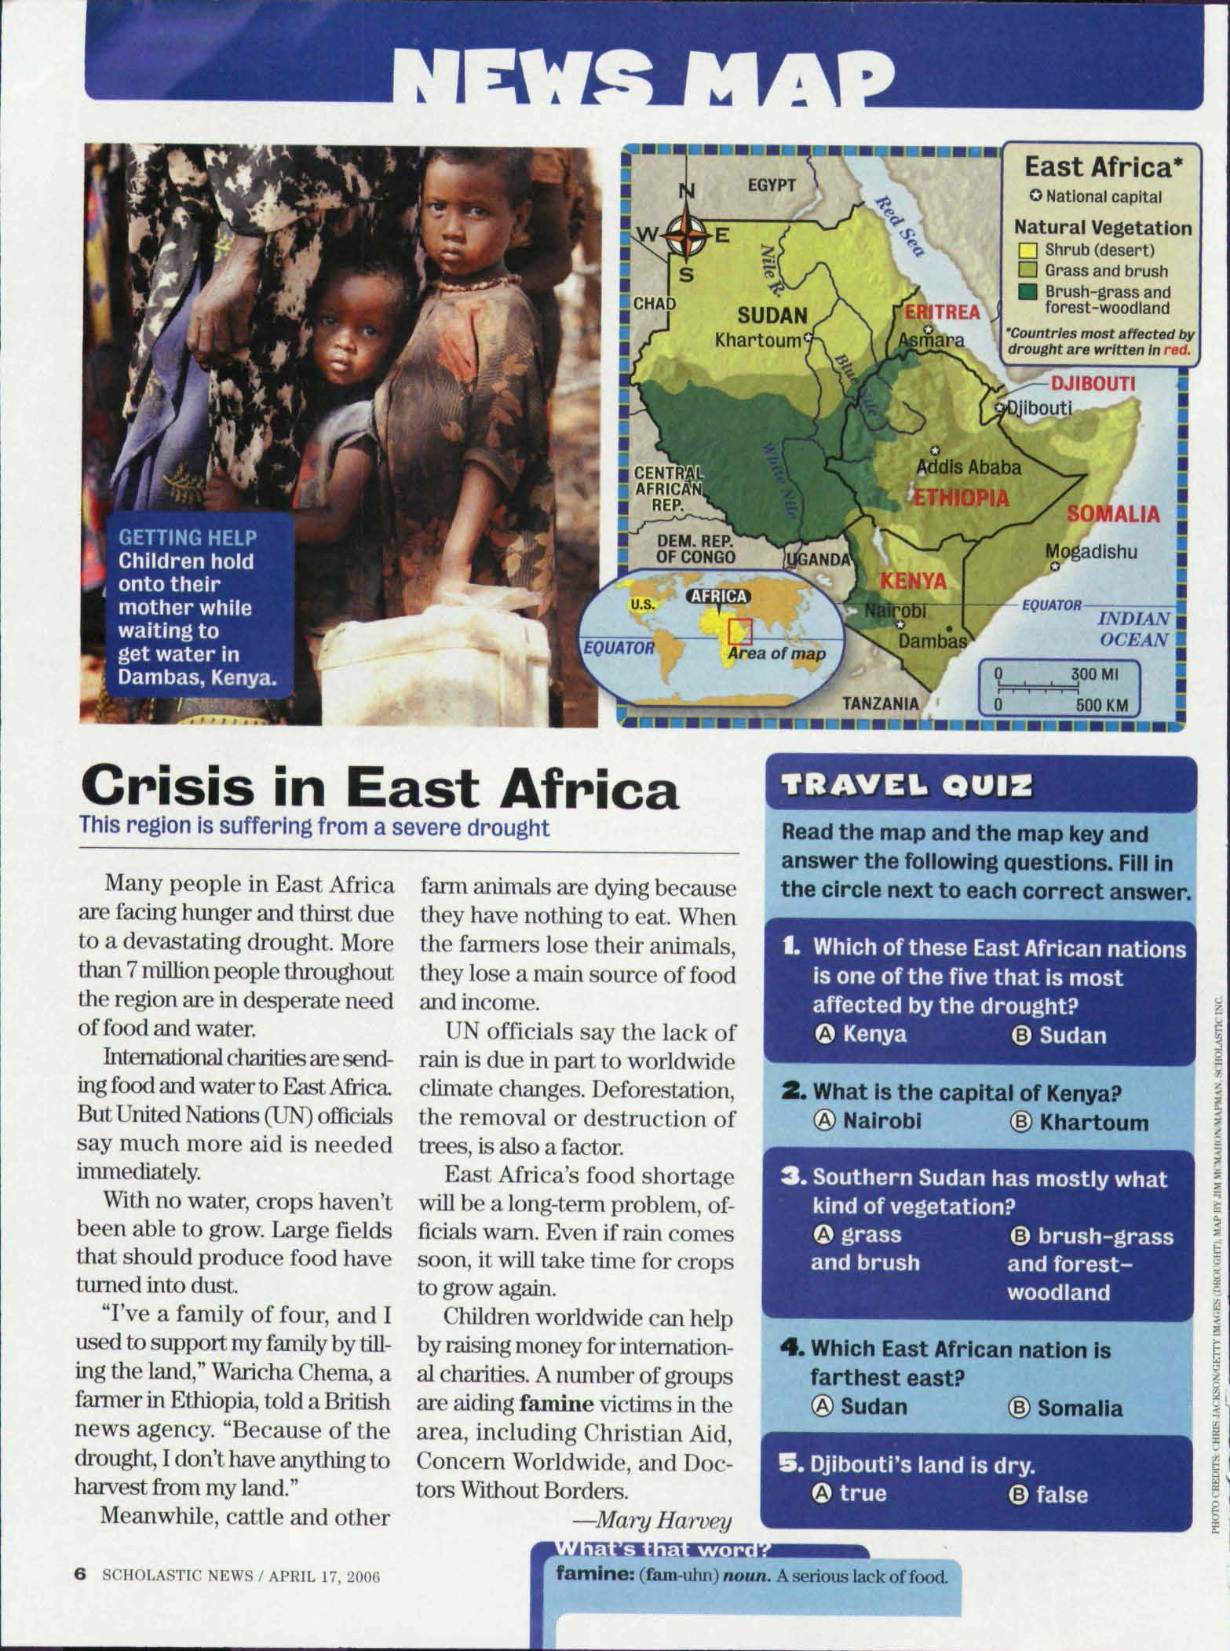

From Scholastic News, April 17, 2006. Copyright © 2006 by Scholastic Inc. Reprinted by permission of Scholastic Inc.
A Dwindling River
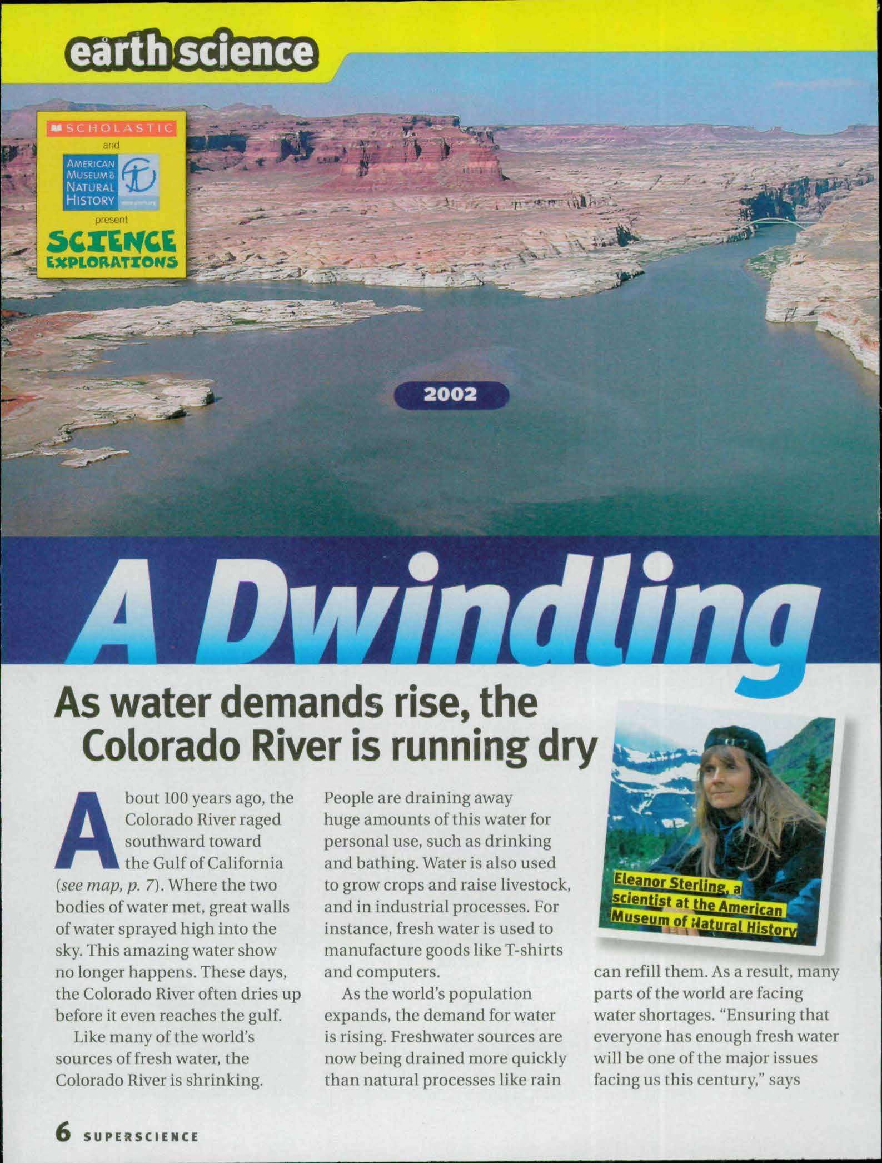

A Dwindling River
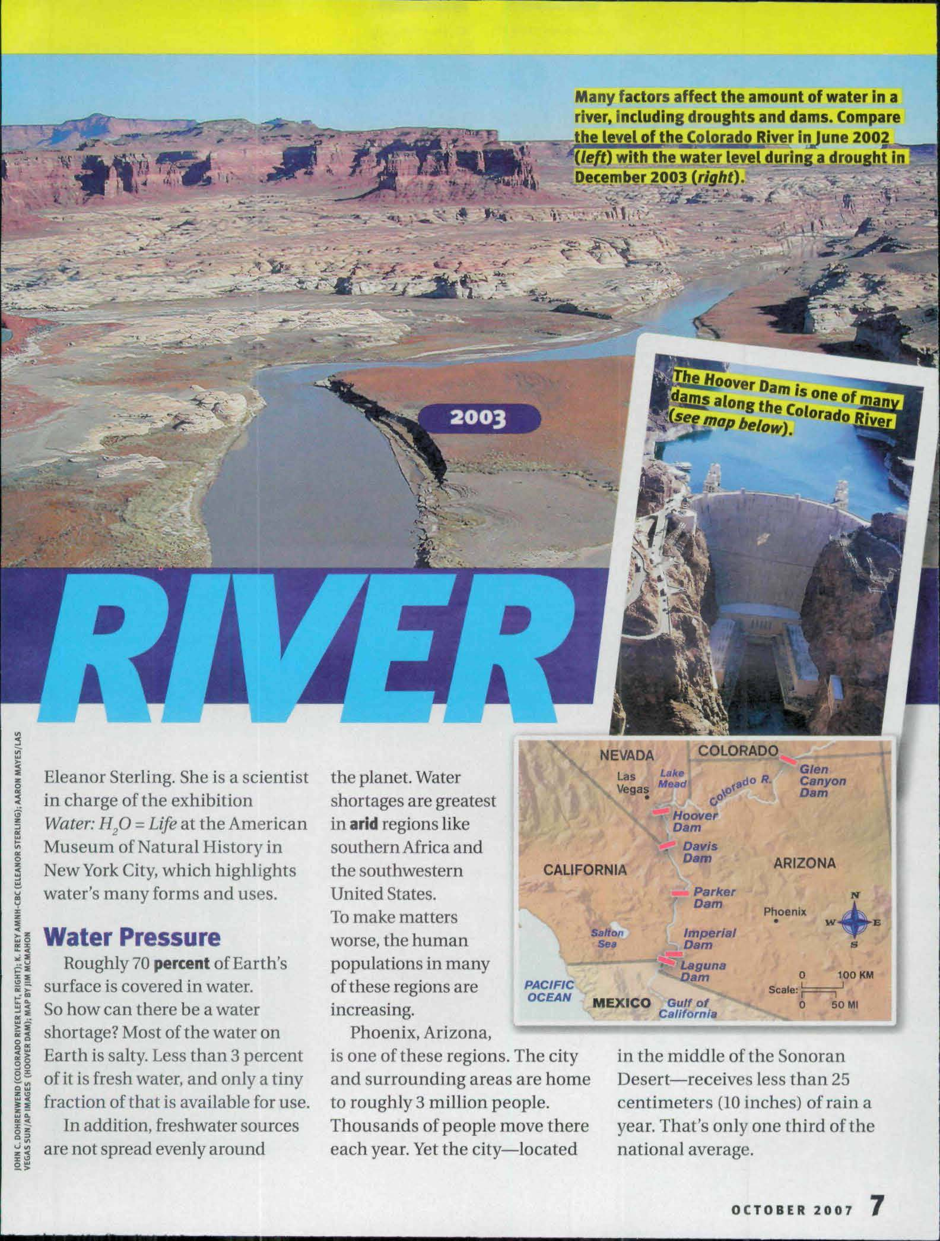

A Dwindling River

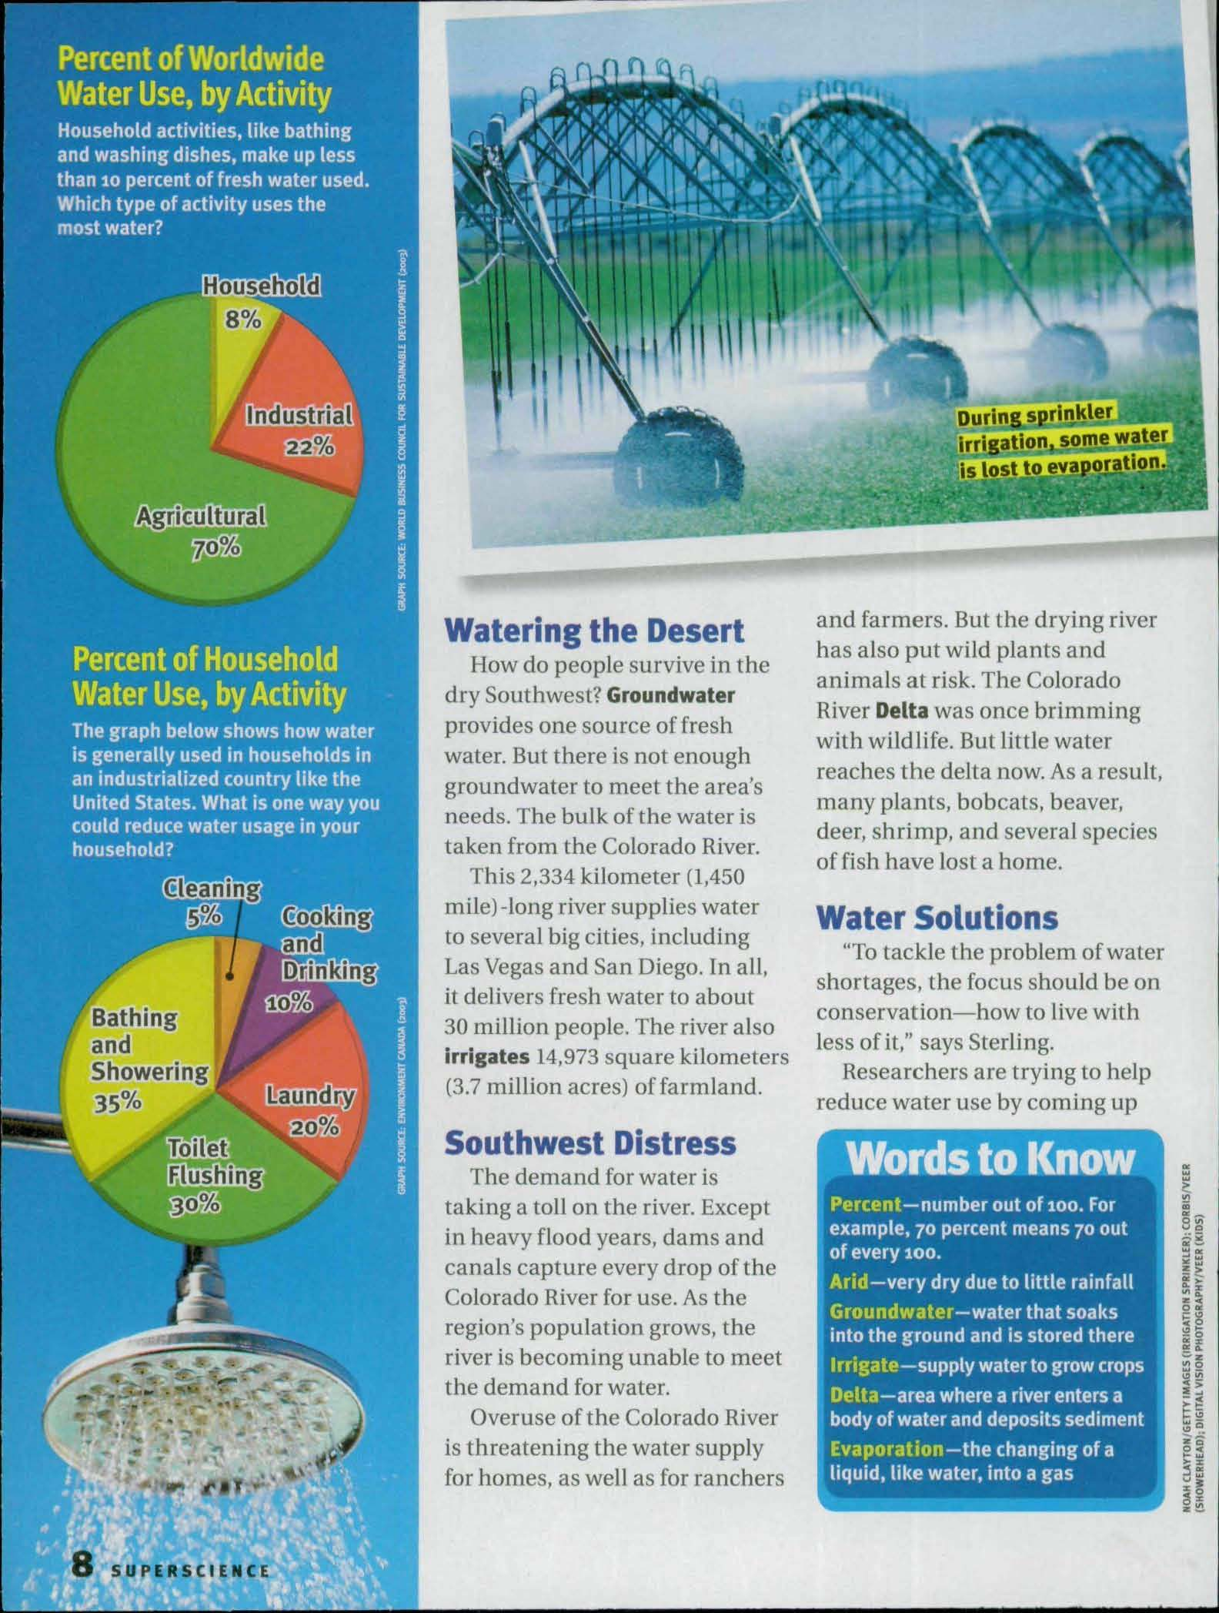

A Dwindling River
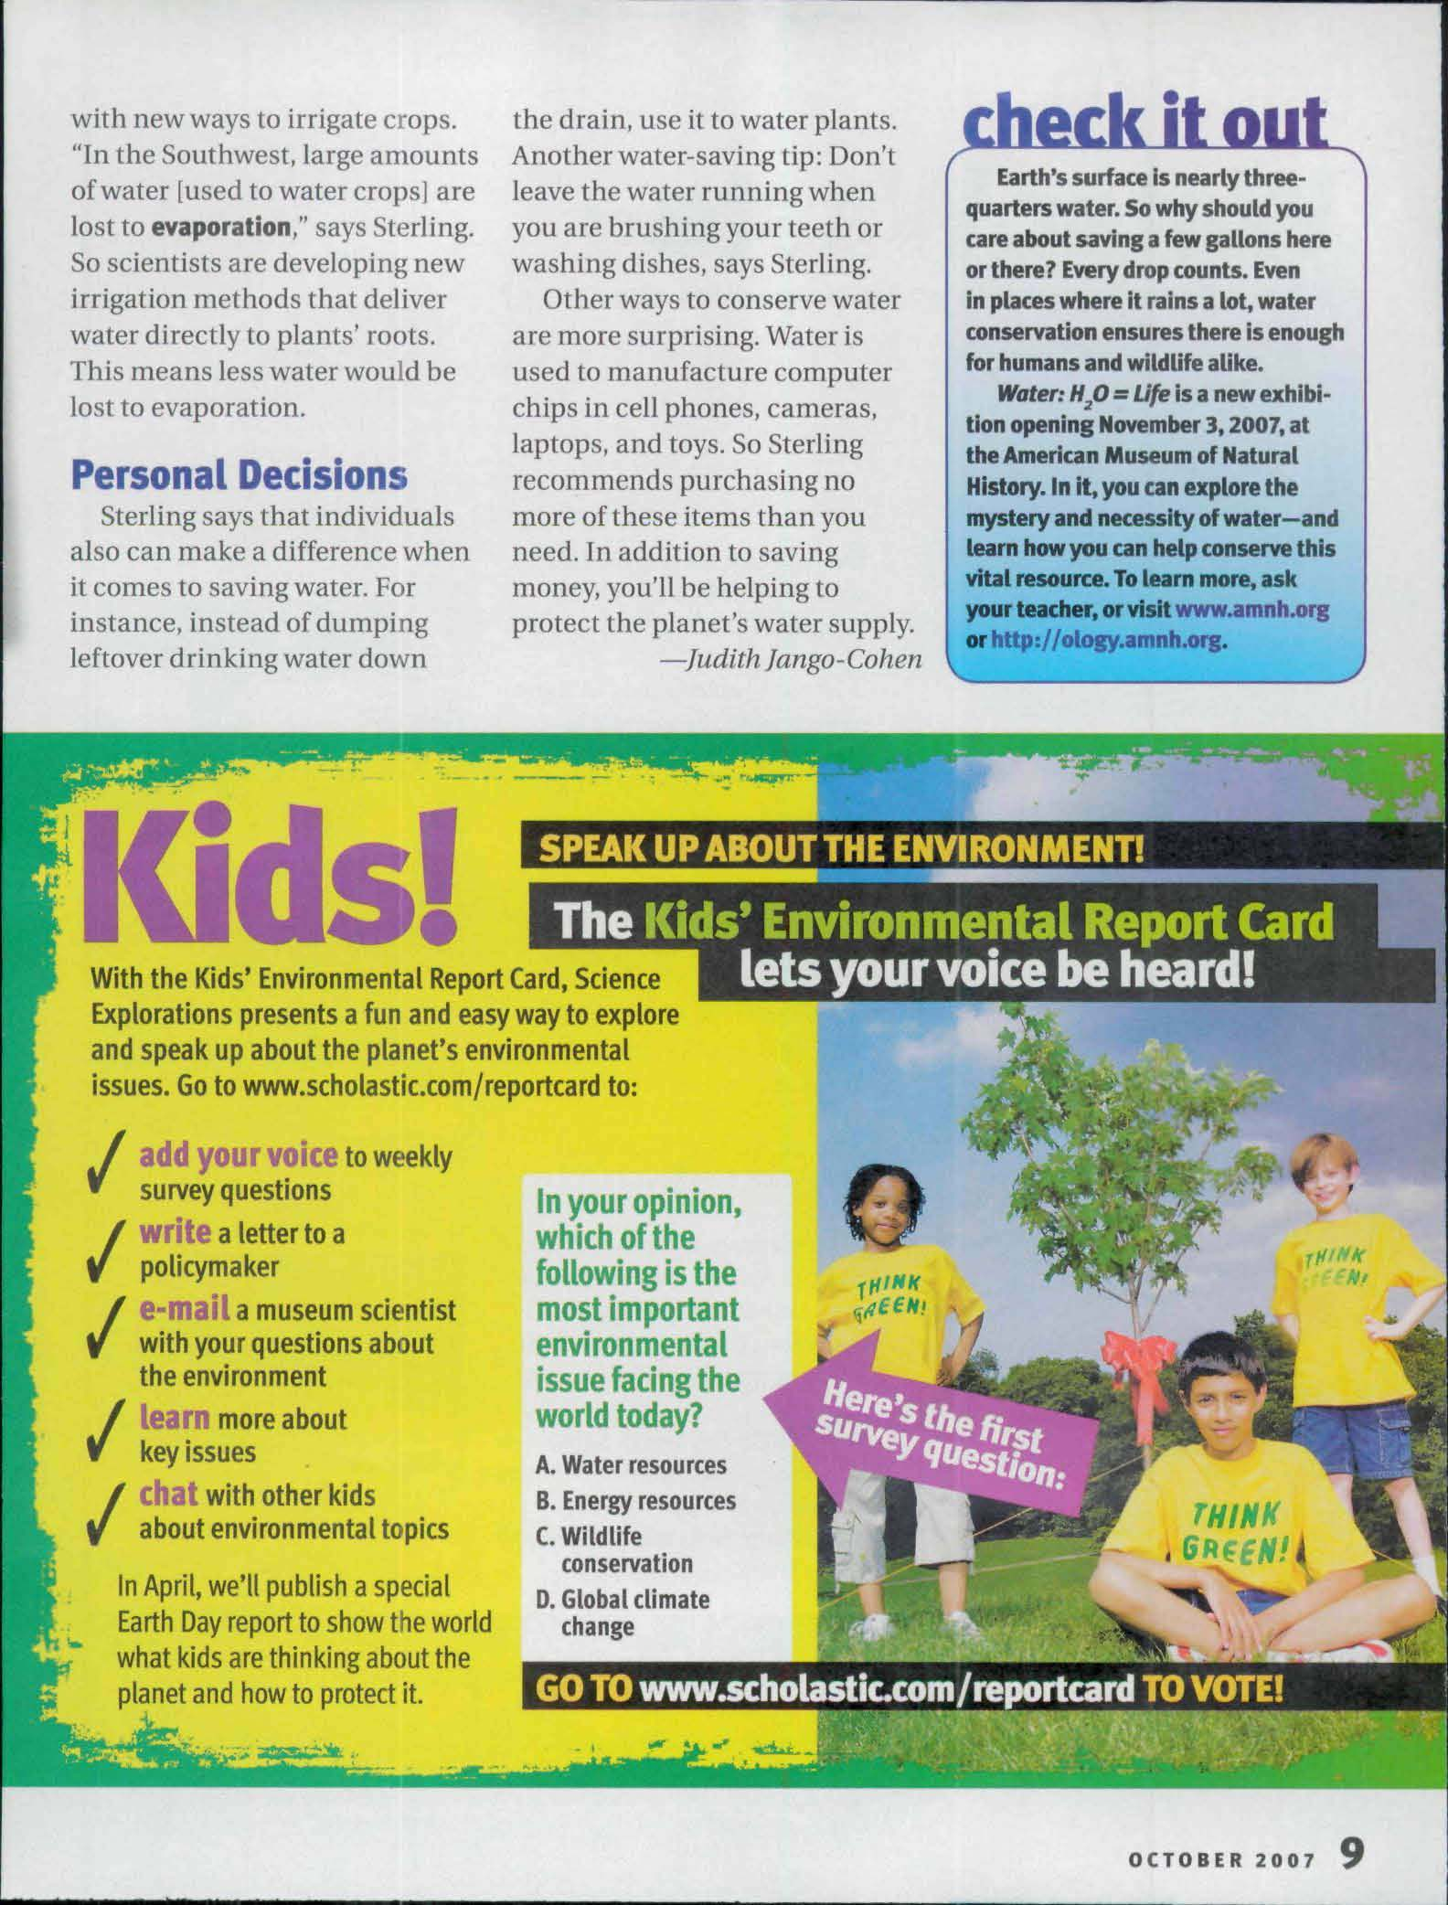

From Scholastic SuperScience, October 2007. Copyright © 2007 by Scholastic Inc. Reprinted by permission of Scholastic Inc.
Muddy Waters

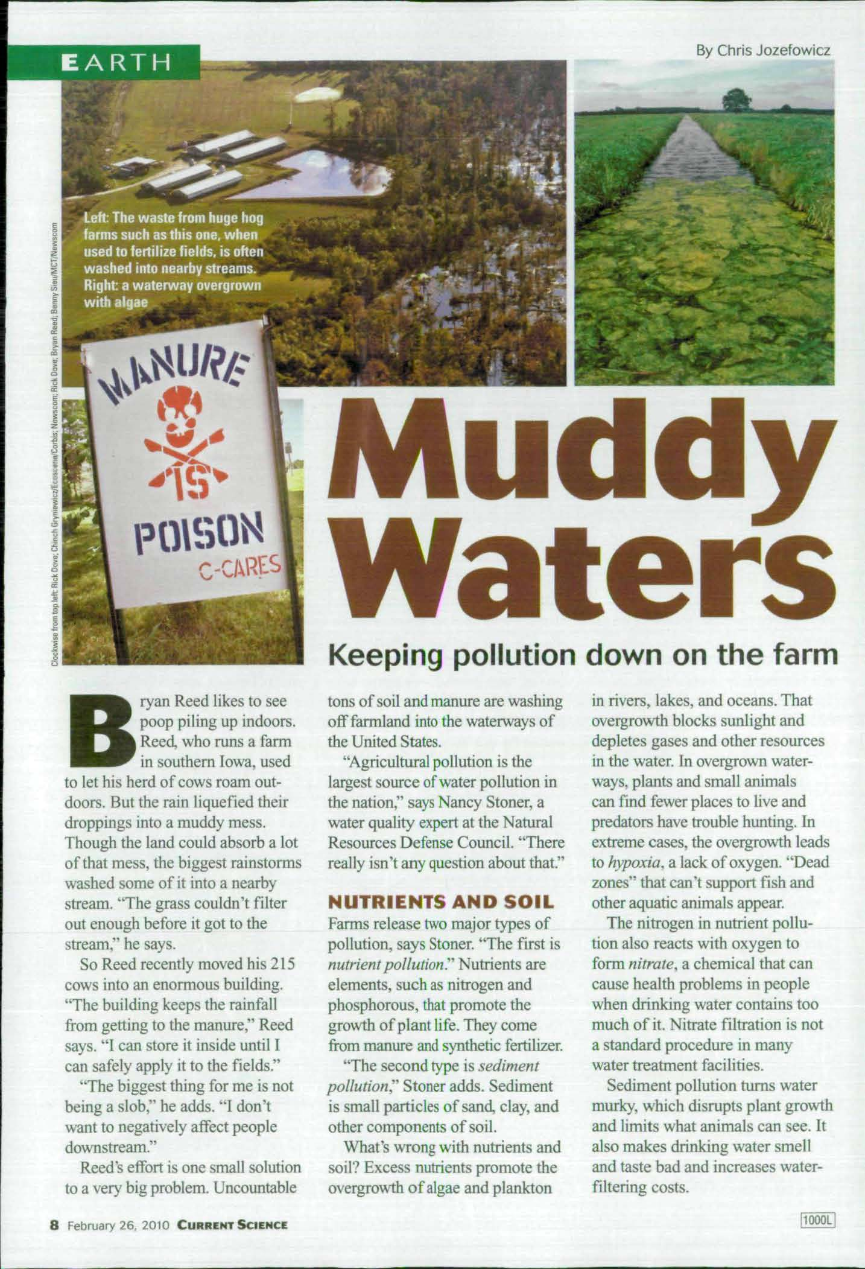

Muddy Waters
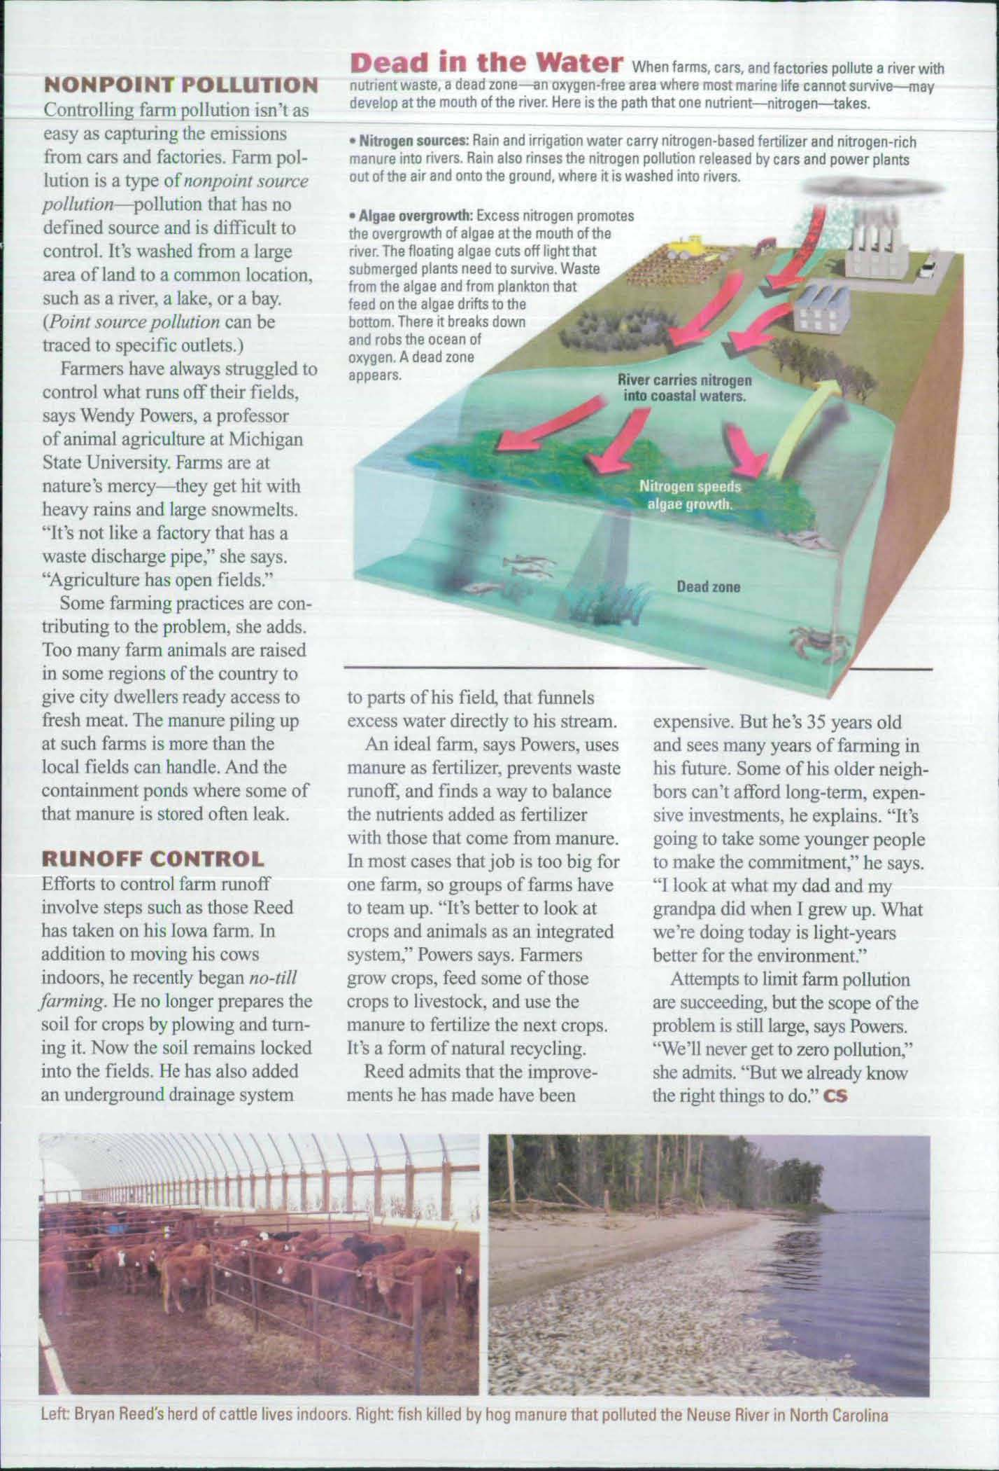

From Current Science, February 26, 2010. Copyright © 2010 by Scholastic Inc. Reprinted by permission of Scholastic Inc.
Independent Reading Recording Form
Homework

Name:
Date:

Title of Book:
Pages Read:

Read your independent reading book. Follow the direction in each section.
Use this chart to keep track of what you read.

Where | Who | What

Words
- Write one word that struck you because it was a precise word. This could be a verb, or it could be a good adjective, or a describing word.
I think this word is precise because ___________________________________________
Independent Reading Recording Form
Homework

- Write down any word or words you found that you are unsure about.

Words | I think this means

