Grade 6: Module 2A: Unit 2: Lesson 16
Introducing Research Folders and Generating a Research Question

Long-Term Targets Addressed (Based on NYSP12 ELA CCLS)
I can cite text-based evidence to support an analysis of an informational text. (RI.6.1)
I can summarize an informational text using only information from the text. (RI.6.2)
I can use several sources in my research. (W.6.7)
I can conduct short research projects to answer a question. (W.6.7)
Supporting Learning Targets | Ongoing Assessment
- I can identify norms to make group discussion more successful.  - I can determine the difference between a relevant and an irrelevant research question.  - I can write a research question for my topic. | - Research question on researcher’s notebook

Agenda | Teaching Notes
- Opening  - Unpacking Learning Targets (2 minutes)  - Work Time  - Introducing Research Teams and Creating Group Norms (8 minutes)  - Topic Chalk Talk: Rules to Live By (8 minutes)  - Evaluating Research Materials and Generating a Research Question (22 minutes)  - Closing and Assessment  - Recording Research Question (5 minutes)  - Homework  - Continue independent reading. Answer this question: “Who is the intended audience of your book? Why do you think that?” | - Although this lesson is in Unit 2, like Lesson 15 it is actually part of Unit 3. This is to give you time to look over the draft end of unit assessments before handing them back to the students with feedback in Lesson 17.  - Students begin their research with their teams using Research Folders that contain a small number of previously selected research materials for each of the countries identified (see supporting materials for the list of texts).  - Have these folders ready in advance. See the “Articles for Research Folders” list in the supporting materials of this lesson. Each team needs a Research Folder containing the materials relevant to the topic they have chosen to research, including a glossary of words they may not be familiar with. Have enough of each text for every student in the group, so students can self-select texts.  - In advance: Using the exit tickets from Lesson 15, divide students into groups of three or four according to the topic they chose to focus on (either ‘Healthy habits,’ ‘Reduce, reuse recycle,’ or ‘Bullying’). Mixed-ability grouping of students will provide a collaborative and supportive structure for reading complex texts.  - Review Chalk Talk protocol (Appendix 1)

Lesson Vocabulary | Materials
norms, irrelevant | - Articles for Research Folders (for Teacher Reference; see Teaching Notes above)  - Lined paper (three pieces per student)  - Chart paper (one per team)  - Markers (one per student)  - Research Folders (one per team according to the topic the team has chosen—see supporting materials)  - Discussion Tracker (from Lesson 15; one for display)  - Criteria for Research Questions anchor chart (new; co-created with students during Work Time C)  - Researcher’s Notebook (from Lesson 15)

Opening | Meeting Students’ Needs
A. Unpacking Learning Target (2 minutes)  - Invite students to read the learning targets with you:  - “I can identify norms to make group discussion more successful.”  - “I can determine the difference between a relevant and an irrelevant research question.”  - “I can write a research question for my topic.”  - Ask:  - “What are norms? Why are they important?”  - Listen for students to explain that norms are positive behaviors that we would like to follow and practice to make sure group work and discussion is productive and enjoyable.  - “How does adding the prefix ‘ir-’ to ‘relevant’ change the meaning?”  - Listen for students to explain that the prefix “ir-” means not, so irrelevant means not relevant. | - Posting learning targets for students allows them to reference them throughout the lesson to check their understanding. The learning targets also provide a reminder to students and teachers about the intended learning behind a given lesson or activity.

Work Time | Meeting Students’ Needs
A. Introducing Research Teams and Creating Group Norms (8 minutes)  - Post the research team assignments in a place where all students can read them. Ask students to get into their teams.  - Remind students that when they start working in a new group, it is a good idea to create some group norms to make sure group discussion is productive and enjoyable for everyone.  - Distribute lined paper.  - Display the Discussion Tracker from Lesson 15. Ask students to discuss in their research teams:  - “Looking at the Discussion Tracker and the skills you need to be working toward, what might some good norms be to make sure that you successfully practice all of those skills in your discussions?”  - “What other norms might it be useful to have that aren’t part of the Discussion Tracker?”  - Tell teams to record their ideas for norms on their lined paper to refer to in later lessons.  - Circulate to assist teams that are struggling. Based on the Discussion Tracker, suggestions could include:  - Listen carefully when someone is speaking.  - Ask questions when you aren’t sure, to get more information or to encourage the speaker to think more deeply about their ideas.  - Be respectful when asking questions and when comparing someone else’s ideas with your own.  - Acknowledge other people’s ideas and perspectives. | - Creating norms for conversation helps to establish a positive group dynamic and make clear the expectations for collaboration.
B. Topic Chalk Talk: Rules to Live By (8 minutes)
- Post the question:
  - “What rules to live by do you already have for the topic you have chosen?”
- Tell students that now they are in research teams they are going to have a Chalk Talk to brainstorm some rules to live by that they already have for the topic they have chosen.
- Remind students that this technique only works if everyone is writing and responding. Make it clear that everyone is responsible for writing, reading other people’s comments, and responding; there should be no talking; and no one should sit down until the time period is over. Opinions must be freely expressed and honored, and no personal attacks are allowed.
- Distribute chart paper and markers and invite students to begin their chalk talk.

Work Time (continued) | Meeting Students’ Needs
C. Evaluating Research Materials and Generating a Research Question (22 minutes)  - Distribute research folders to each team. Explain that students are going to spend some time familiarizing themselves with the informational texts in their folder before they actually dig into researching in the next lesson.  - Model the process of sifting through the research materials in one of the folders to evaluate the resources and get to know the texts they will be reading. Take a healthy habits research folder and flip through the pages.  - Pick out the glossary and model looking over that, discussing the organization. For example: “So, I can see that there is a glossary for each of the informational texts in the research folder, so if I am stuck on what a word means, I can use this to help me figure it out and move on with my research.”  - Pick out an informational text and skim the title. Then point out any tables, charts, or graphics that you can see and explain what they tell you at a glance about the content of the informational text.  - Invite students to pair up in their research teams to familiarize themselves with their research folders. Circulate and support students in their initial review of their material. Ask questions such as:  - “What do you think this text is going to be about?”  - “How might this specific material help you in your research?”  - Refocus students. Tell them that now they have chosen their research topic, generated some possible rules to live by and have an idea of the resources in their research folders, they need a question to guide their research so that they can narrow their focus on the research materials and choose the ones to read that are most relevant to their research question.  - Model generating questions about a topic that could be researched with student assistance. Do a think-aloud and record the questions you generate on the board: “So which of the healthy habits rules you have brainstormed seem like they might have supporting evidence in the research folder? What is important about my topic? How does my topic contribute to improving the lives of my peers? My topic is healthy habits, and it is important because it is about helping my peers to stay healthy. It looks like the rules about healthy eating and exercise might have supporting evidence in the research folder. I am particularly interested in exercise, so now that I have had a quick look through the informational texts in my research folder, some of the questions that come to mind as I think about exercise are:  - How often do I need to exercise to stay healthy? Why?  - Is running better than gymnastics?  - Why is exercising every day good for you?” | - Generating a research question is not a sixth-grade standard; however, this process is a good scaffold toward later grades. Consider providing select students with pre-generated questions to evaluate their potential as research questions. Other students may benefit from being provided the final research question they will work with throughout this process.

Work Time (continued) | Meeting Students’ Needs
- Invite students to look at the questions you have recorded on the board. Ask them to refer to their norms and discuss in research teams:
  - “Which of these questions do you think will be the most effective to research to write an evidence-based essay about a rule to live by? Why?”
- Select volunteers to share their suggestions with the whole group.
- Guide students to recognize that “Is running better than gymnastics?” is not a good research question because it is a very narrow question, which means it will be of interest only to people who like running and gymnastics. It will also require very specific resources to research.
- Record criteria on a new anchor chart: Criteria for Research Questions:
  - Broad question, the answer of which is of interest to many people.
- Guide students to recognize that “Why is exercising every day good for you?” already assumes that exercising every day is good for you, whereas research questions should not make assumptions—the research should help us make claims, not the other way around.
- Record criteria on a new Criteria for Research Questions anchor chart:
  - Questions to help us make claims rather than make assumptions.
- Guide students to recognize that the most effective research question in this list is “How often do I need to exercise to stay healthy? Why?” because the “why?” part of the question will lead us to find evidence to help us justify the rule.
- Record criteria on the anchor chart:
  - Leads us to find evidence to justify claims using words like “Why?”
- Ask students to discuss in their teams:
  - “What is important about your topic?”
  - “How does it contribute to improving the lives of your peers?”
- Distribute lined paper. Tell students to work in their research teams to generate questions for research about their topic. Give teams 5 minutes to record all of the questions that come to mind. Discourage them from evaluating the questions at this stage.

Work Time (continued) | Meeting Students’ Needs
- After 5 minutes, stop the group and encourage teams to spend time evaluating the questions using the criteria on the anchor chart to determine which of the questions would be the most effective for research. Emphasize at this stage they don’t have to evaluate the list down to one question—they just need to eliminate those questions that aren’t going to be as effective for research.
- Circulate to support students by asking:
  - “Would the answer to this question be of interest to many different people?”
  - “Do the questions make any assumptions?”
  - “Will the question lead you to find evidence to support a rule to live by?”

Closing and Assessment | Meeting Students’ Needs
A. Recording Research Question (5 minutes)  - Tell students that now that they have evaluated their original questions, and eliminated questions that aren’t going to be as successful for researching to write an evidence-based essay about a rule to live by, they need to choose one question to focus their research.  - Invite students to write their question on Part I of their Researcher’s Notebook. | - Developing self-assessment and reflection supports all learners, but research shows it supports struggling learners most.
Homework | Meeting Students’ Needs
- Continue independent reading. Answer this question: “Who is the intended audience of your book? Why do you think that?”
Note: Consider explaining what you mean by “intended audience.” Say something like: “Who do you think this book was written for? What kind of person do you think the author had in mind?”

Grade 6: Module 2A: Unit 2: Lesson 16
Supporting Materials
Articles for Research Folders
(For Teacher Reference)

Directions: Before Lesson 16, prepare folders for each research team with all texts plus a glossary for each team member. As described in the Teaching Notes for Lesson 16, students begin their research with their teams using Research Folders that contain a small number of previously selected research materials for each of the countries identified.

Reduce, Reuse, Recycle Research Folder
- Rainsford, Blair, “A Skateboarder Goes Green,” www.scholastic.comactionmag. April 16, 2012.
- “Live by Design, Not Default,” Skipping Stones, Sept.–Oct. 2009. Print.
- “Earth Day, Your Way: Celebrate Earth Day, April 22,” Current Health 1, The Weekly Reader Corporation, Apr.–May 2006. Print.
- “The Life of a Cell Phone,” United States Environmental Protection Agency.

Glossary for Healthy Habits Research Folder

Article: “A Skateboarder Goes Green”
activist | person who works to support a cause
asthma | an illness that makes breathing difficult
bird sanctuary | a place where birds are protected
spew | gush
slew | a large number of something
Articles for Research Folders
(For Teacher Reference)

Commentary: “Live by Design, Not Default”
advocate | a person who supports or promotes the interest of others
compassionate | sympathetic
controversial | relating to a topic that sparks opposing viewpoints
sustainable | a practice of using a resource that prevents the resource from being depleted or damaged
Article: “Earth Day, Your Way: Celebrate Earth Day, April 22”
conservation | planned management of a natural resource to prevent exploitation, destruction, or neglect
nutrient | a substance that provides nourishment
profit | a gain
renewable | capable of being replaced
Informational Poster: “The Life of a Cell Phone”
consume | to use goods
dematerialization | to use less stuff
resources | a source of supply
toxicity | containing poisonous material

A Skateboarder Goes Green
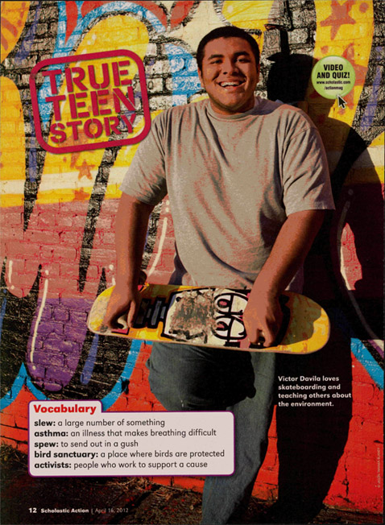

A Skateboarder Goes Green
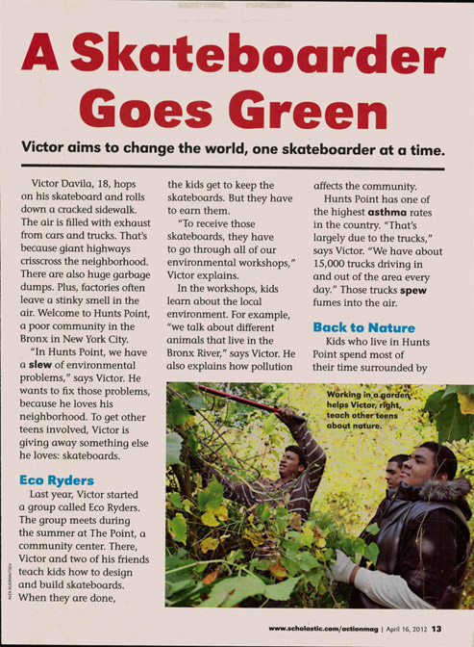

A Skateboarder Goes Green
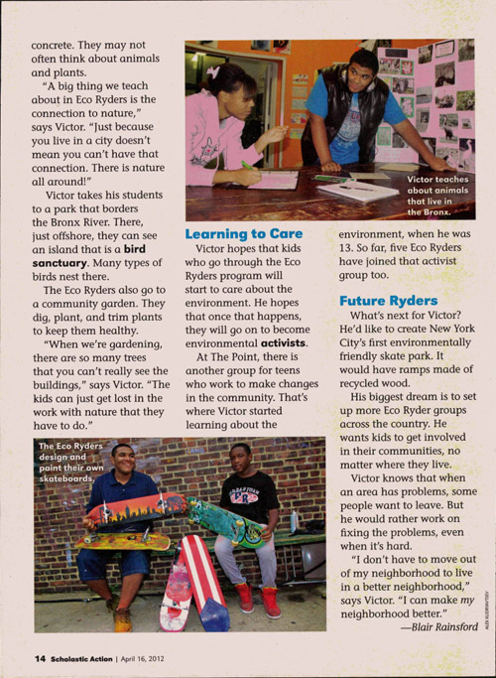

A Skateboarder Goes Green
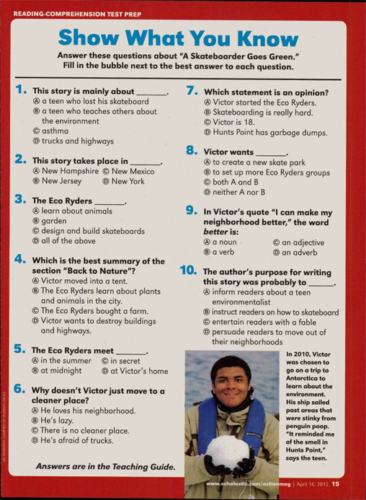

From Scholastic Action, April 16, 2012. Copyright © 2012 by Scholastic Inc. Reprinted by permission of Scholastic Inc.
Live by Design, Not Default
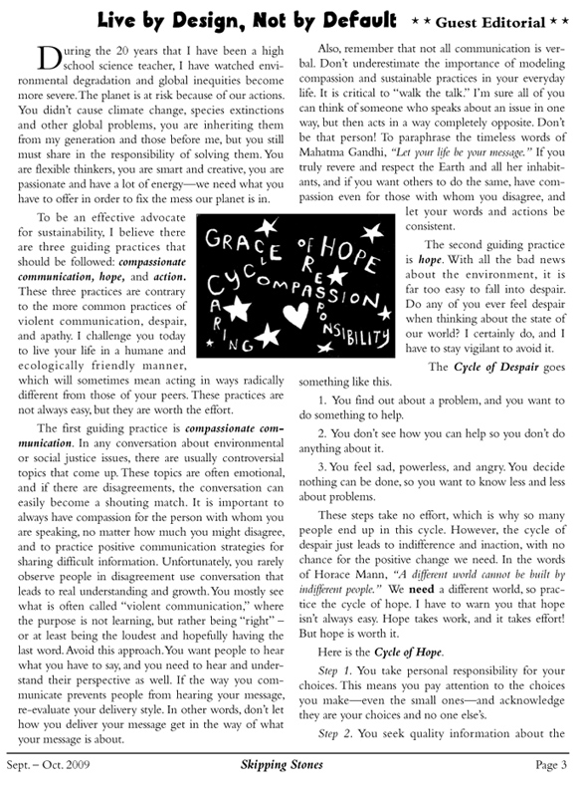

Live by Design, Not Default
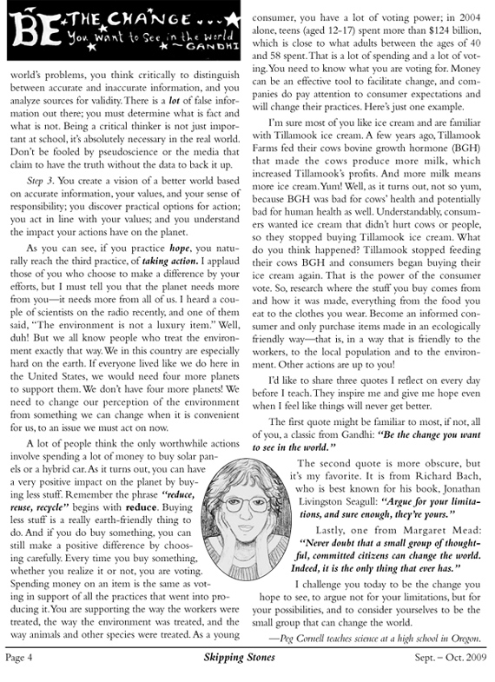

By Peg Cornell, from Skipping Stones, Sept. - Oct. 2009. Used by permission.
Earth Day, Your Way
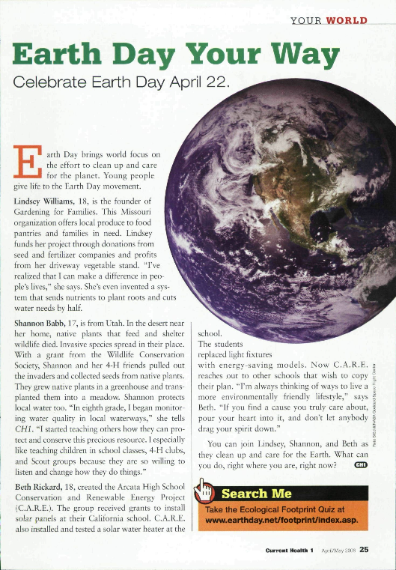

From CURRENT HEALTH, April - May 2007, Copyright © 2007 by The Weekly Reader Corporation. Reprinted by permission of Scholastic Inc.
The Life of a Cell Phone

You have one, your parents have one, your friends each have one—owning a cell phone has become as common as having a traditional land-line in your home. More than 156 million Americans now use cell phones—including about 20 percent of American teens! In a way, cell phones have become a necessity of everyday life—we use them to call home when we’re late, make plans with friends, or get directions when we’re lost. But have you ever thought about how cell phones are made and what happens to them when you don’t need them anymore?
Like any product, making a cell phone and its parts uses natural resources and energy, which can potentially impact the air, land, and water. Understanding the life cycle of a product can help you make environmental choices about the products you use, and how you dispose of them. You can help minimize your environmental impact of using a cell phone by:
±Keeping your phone longer. Choose your cell phone service provider carefully. Pick a phone with features you need and a style you like so you will keep it longer.
±Charging your battery correctly. Increase the life span of your phone and battery by following the manufacturer’s directions for charging the battery.
±Reusing or recycling your phone. Find ways to reuse or recycle your phone and accessories when you’re finished with them. Many companies recycle or reuse cell phones—visit the “Resources” section of this poster for a list of suggestions.
Follow the life-cycle diagram to learn more about cell phones, their parts, and their potential impact on the environment...
The Life of a Cell Phone

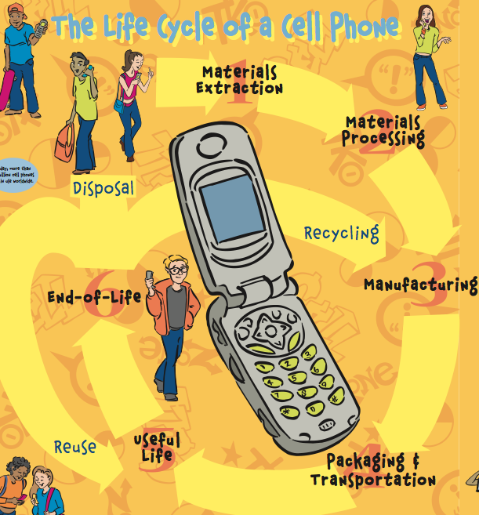

The Life of a Cell Phone

The Nine Lives of a Cell Phone
Cell phones consist of nine basic parts, each of which has its own life cycle:

- Circuit board/printed wiring board
- Liquid crystal display (LCD)
- Battery
- Antenna
- Keypad
- Microphone
- Speaker
- Plastic casing
- Accessories (such as adapters, headsets, carrying cases, and decorative face plates

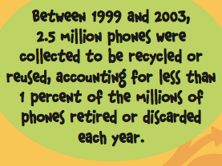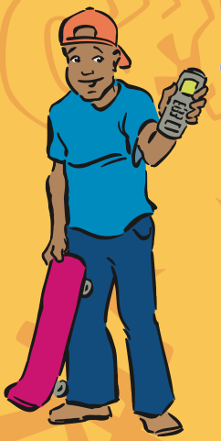

The Life of a Cell Phone

1) Material Extraction

A cell phone is made up of many materials. In general, the handset consists of 40 percent metals, 40 percent plastics and, and 20 percent ceramics and trace materials.

The circuit board (also called a printed wiring board) located in the handset, is the ‘brain’ of the cell phone because it controls all of its functions.

- Circuit boards are made from mined, raw materials including copper, gold, lead, nickel, zinc, beryllium, tantalum, coltan, and other metals. The manufacturing of these boards requires crude oil for plastic, and sand and limestone for fiberglass. Many of these materials are known as “persistent toxins” and can stay in the environment for long periods of time, even after disposal.

The liquid crystal display (LCD) is a low-power flat panel display on the front of your phone that shows information and images. It becomes opaque (hard to see through) when electric current passes through it. The contrast between the opaque and transparent (see-through) areas forms visible characters.

- Various liquid crystalline substances, either naturally occurring (such as mercury, a potentially dangerous substance) or human-made, are used to make LCDs. LCDs also require the use of glass or plastic.

The rechargeable battery is used to power the phone.

- Cell phones can use several types of batteries: nickel-metal hydride (Ni-MH), lithium-ion (Li-Ion), nickel-cadmium (Ni-Cd), or lead acid. Ni-MH and Ni-Cd batteries contain nickel, cobalt, zinc, cadmium, and copper. Li-Ion batteries use lithium metallic oxide and carbon-based materials, all mined from the earth.
The Life of a Cell Phone

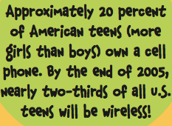

2) Materials Processing

Most raw materials must be processed before manufacturers can use them to make products. For example, in cell phones:

- Crude oil is combined with natural gas and chemicals in a processing plant to make plastic.

- Copper is mined, ground, heated, and treated with chemicals and electricity to isolate the pure metal used to make circuit boards and batteries. The resulting copper pieces are shipped to a manufacturer where they are formed into wires and sheets.

3) Manufacturing

Plastics and fiberglass are used to make the basic shape of the circuit board, which is then coated with gold plating. The board is also composed of several electronic components, connected with circuits and wires (primarily made of copper) that are soldered to the board and secured with protective glues and coatings.

LCDs are manufactured by sandwiching piqued crystal between layers of glass or plastic.

Batteries consist of two separate parts, called electronics, made from two different metals. A liquid substance, called electrolytes, touches each electrode. When an outside source of electricity such as an outlet is applied, chemical reactions between the electrodes and the electrolytes cause an electric current to flow, giving batteries their “juice” or power.
The Life of a Cell Phone

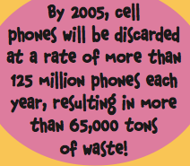

Using Less Stuff

Cell phone companies have made great strides in “dematerialization” (using less materials) as shown by the decreasing size of today’s cell phones. Years ago, the technology needed for a cell phone would have filled the entire floor of an office building; now everything needed for a cell phone weighs only 7.7 ounces!

4) Packaging and Transportation

Cell phone parts and the finished products need packaging and transportation to get from longer need or want them extends their useful one place to another. Transportation by plane, truck, or rail all require the use of fossil fuels for energy, which can contribute to global climate change.

While packaging protects products from damage, identifies contents, and provides information, excessive or decorative packaging can be wasteful. Packaging consumes valuable natural resources, such as paper (from trees), plastic (from crude oil in the earth), aluminum (from ore), or other materials, all of which use energy to produce and can result in waste. Some packaging, however can be made from recycled materials.
The Life of a Cell Phone

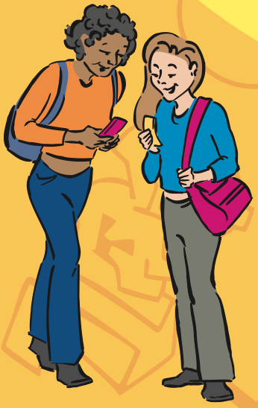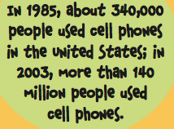

5) Useful Life

Unlike other countries, cell phone companies in the United States sell their own phones, which are usually not interchangeable from company to company. Even though regulations now allow consumers to transfer their phone number to a new phone company, most companies have unique technologies in their phones that only work in their own networks.

This means that switching cell phone companies can mean having to purchase a new phone. One way to extend the useful life of your phone and prevent waste, is to use the same company for continuing phone service. Always comparison-shop to be sure you get the service and phone that’s right for you.

You can also extend the life of your phone by taking care of it—protecting it from damage by storing it in a case, avoiding dropping it, and keeping it out of extreme heat and cold and away from water and other liquids.

The use of rechargeable batteries in cell phones reduces the amount of waste and toxicity that disposable batteries create. Be sure to follow the manufacturer’s instructions for charging your batteries so you can extend their lives as long as possible.
The Life of a Cell Phone

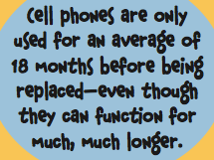

6) End-Of-Life

Donating or recycling cell phones when you no longer need or want them extends their useful lives, and prevents them from ending up in the trash where they can potentially cause environmental problems.

Reuse

Many organizations—including recyclers, charities, and electronics manufacturers—accept working cell phones and offer them to schools, community organizations, and individuals in need. Reuse gives people, who could not otherwise afford them, free or reduced cost access to new phones and their accessories. Plus, it extends the useful lifetime of a phone.

Take-Back Programs

Many cell phone manufacturers and service providers offer a “take-back” program. Under this system, manufacturers accept used cell phones and accessories and either recycle, re-manufacture, or dispose of them using systems designed to handle the specific types of waste cell phones produce. Contact your manufacturer by using the information that came with your phone or via the Internet.
The Life of a Cell Phone

Recycle

Electronics recyclers are springing up everywhere! Today, many stores, manufacturers, and recycling centers accept cell phones for recycling. While some electronics recyclers only accept large shipments, communities, schools, or groups can work together to collect used cell phones for shipment to electronics recyclers.

Some rechargeable batteries can also be recycled, as several retail stores and some communities have started collecting them. When rechargeable batteries are recycled, the recovered materials can be used to make new batteries and stainless steel products.

Check the “Resources” section of this poster for a list of organizations that will accept your phone and accessories for reuse or recycling. You can also use the Internet or phone book to search for local contacts that recycle and refurbish cell phones.

Disposal

By 2005, the rate at which cell phones are discarded is predicted to exceed 125 million phones each year, resulting in more than 65,000 tons of waste! Cell phones that are thrown in the trash end up in landfills (buried in the ground) or incinerators (burned). Because cell phones contain metals, plastics, chemicals, and other potentially hazardous substances, you should always recycle, donate, or trade in your old cell phone. It’s free and easy. Don’t throw it away! Phones that are thrown away waste energy and result in the loss of valuable resources.

Crank Up The Volume

A major cell phone manufacturer recently developed a way to recharge cell phone batteries using “muscle power.” This hand-powered device provides 20 minutes of talk time after just three minutes of squeezing a hand-held generator! Other new technologies, such as hydrogen fuel cells and zinc-air and solar-powered batteries, are under development and might ultimately replace current battery technology.
These new alternatives will conserve natural resources and reduce waste.

The Life of a Cell Phone
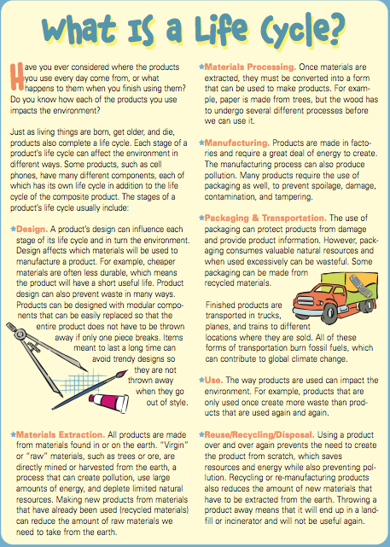
The Life of a Cell Phone

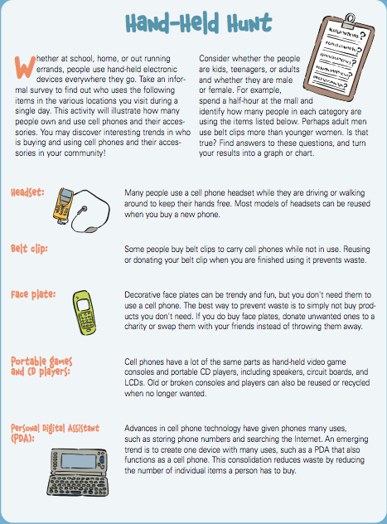
The Life of a Cell Phone

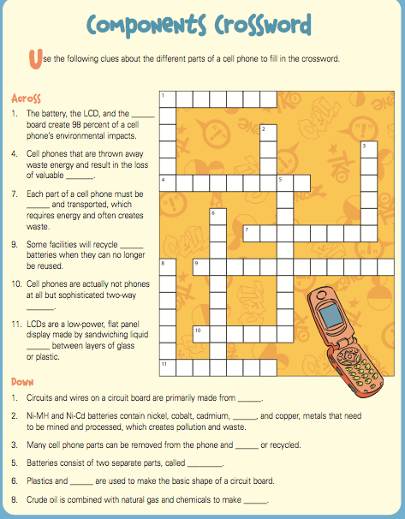

The Life of a Cell Phone

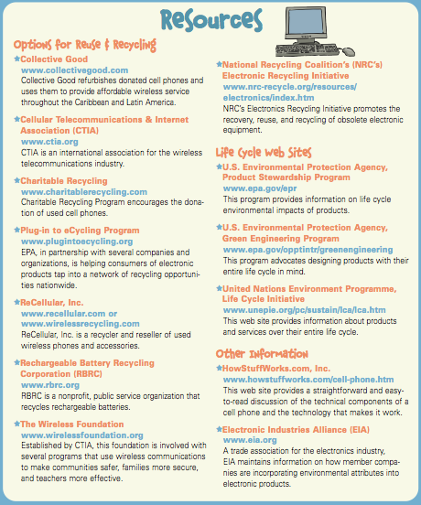
The Life of a Cell Phone

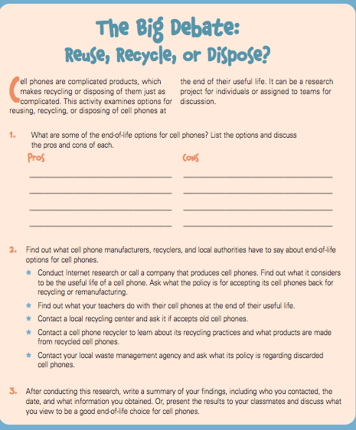
The Life of a Cell Phone

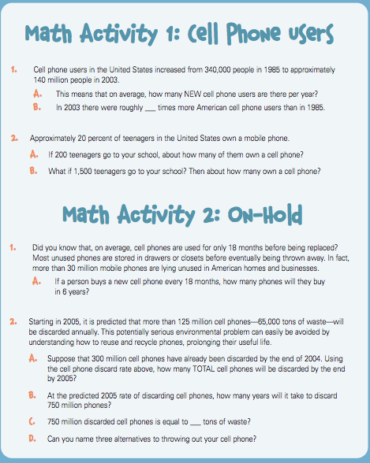
The Life of a Cell Phone



Some of the things that are part of your everyday life didn’t exist when your grandparents were your age. While we might think we need these things, many people hot along fine without them in the times past.

First, write down your views on whether the following items are necessary or optional, and why. Then interview an older relative or friend (more than 50 years old) to ask what they think about the same things. Compare and discuss your answers. How different or similar are they? Why? Discuss how new products reduce waste, and how new products increase waste.

Compare your thoughts on the following items with those of someone older than you.
Here’s how:

Item | Your Thoughts | Older Generation Thoughts
Microwave Oven
Cell Phone
Pager
Camera
Compact Disc
Video Game
Radio
Sport Utility Vehicle
Computer
VCR

Answering Machine

The Life of a Cell Phone

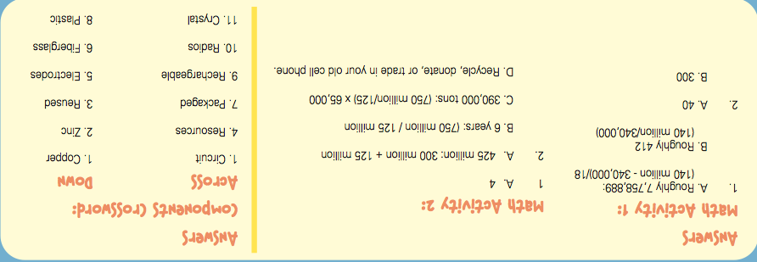

Environmental Protection Agency."The Life of a Cell Phone". http://www.epa.gov/osw/education/pdfs/life-cell.pdf.

Articles for Research Folders
(For Teacher Reference)

Healthy Habits Research Folder
“Health Rocks,” Skipping Stones, Jan./Feb. 2013. 23: Print.
Jennifer Marino-Walters, “Make Your Move,” Scholastic News Edition 4, May 10, 2010. Print.
Emily Sohn, “Recipe for Health,” Science News for Kids, April 2, 2008.
Susan Heavey, “Adults cut back fast food, but U.S. kids still eat too much fat: CDC,” Washington Post, February 21, 2013. Print.

Glossary for Healthy Habits Research Folder

Article: “Health Rocks”
affluent | having a generous supply of material possessions
immunity | being able to resist disease
obesity | excessive fat in the body
regulations | a rule or order issued by an authority
Article: “Make Your Move”
alliance | a relationship that benefits both parties
luxury | something that you don’t really need, but that is enjoyable to have
Article: “Recipe for Health”
health | the condition of being sound in mind, body, and spirit
nutrition | the act of taking in and using food substances
obese | having excessive body fat
pediatric nutritionist | a professional who helps children eat healthfully
Articles for Research Folders
(For Teacher Reference)

Article: “Adults cut back fast food, but U.S. kids still eat too much fat: CDC”
caloric intake | the number of calories a person eats
consume | to eat or drink, especially in a large quantity
obese | excess fat in the body
sedentary | not physically active

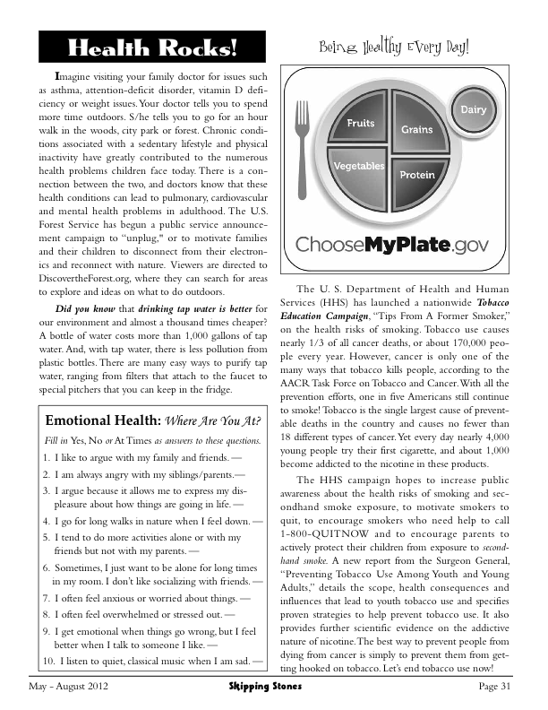
Health Rocks

Compiled by the editors of Skipping Stones, Reprinted from Skipping Stones,
Jan. - Feb. 2013. Used by permission.
Make Your Move
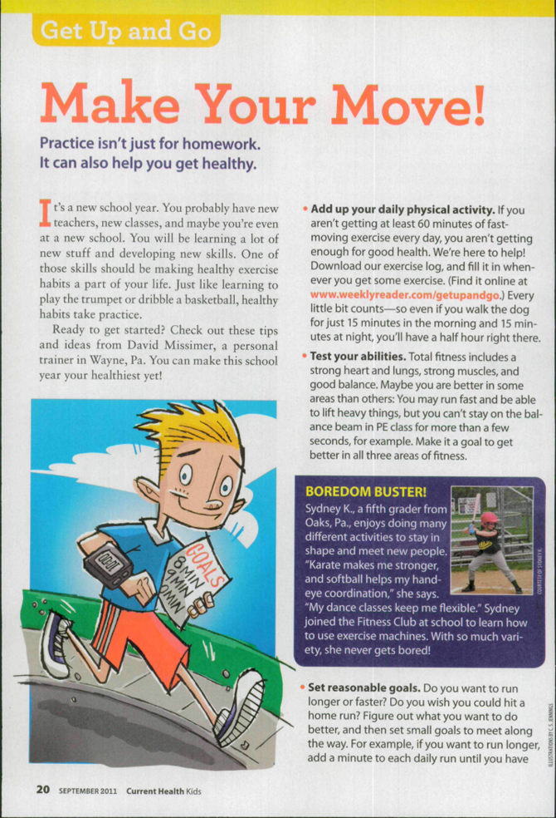

Make Your Move
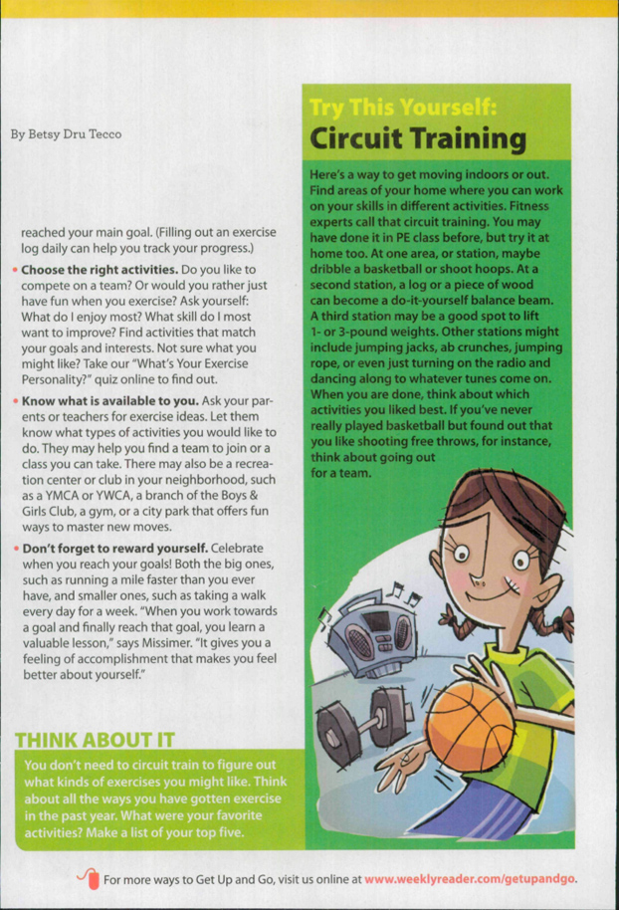

From Scholastic News, May 10, 2010. Copyright © 2010 by Scholastic Inc. Reprinted by permission of Scholastic Inc.
Recipe for Health

Everybody wants to be healthy, but today's world is full of roadblocks. You know you should eat broccoli, for example, but it's a lot easier to buy French fries (and they taste better). You know you should exercise, but your friends are playing video games.
For many people, the temptation to indulge is irresistible. But all of that indulging is catching up with us.
In the United States, two out of three adults now weigh more than they should, according to the Centers for Disease Control and Prevention (CDC). More than 30 percent of Americans over 20 have so much body fat that they're considered obese. Only half as many adults were obese in the 1980s.
Young people are also getting way too heavy. The proportion of overweight kids between the ages of 6 and 11 more than doubled in the past 2 decades, according to CDC data, from 7 percent to nearly 19 percent. Over the same period, the proportion of overweight teens more than tripled, from 5 percent to 17 percent. Healthy body weight is evaluated in terms of a number known as your body mass index, or BMI. You can check out whether you or a family member is overweight by plugging some numbers into a calculator at an online site (see sidebar: "Understanding Body Mass Index").
These statistics are alarming because weighing too much increases the risk for heart disease, diabetes, cancer, sleeping troubles, and other health problems (see "Packing Fat"). People form lifelong eating habits when they're still kids. And studies show that overweight children tend to become overweight adults. Indeed, some kids are already developing weight-related diseases such as type 2 diabetes, which used to show up only in adults.
"Children are primed to learn about eating," says Susan Johnson, a pediatric nutritionist at the University of Colorado-Denver School of Medicine. "We need to start young with healthy habits."
And it's not as hard as you may think. Research shows there are plenty of simple things you can do to eat better, control your weight, and improve your health, even while you're still a kid.
How do you start? Focus on three things: when, what, and how much.
The 'when'
There's no single explanation for why kids' waistlines have been expanding, according to experts. The problem is more complicated than that.
Recipe for Health

For one thing, food is everywhere, almost all the time: from candy in school vending machines to popcorn at the movies. Fast-food restaurants are convenient and cheap. All too often, one meal runs into the next.
"It is practically impossible to avoid opportunities to eat," Johnson says. "I'm only 49, but when I was a child, people did not eat all day long."
Johnson, who studies eating behaviors, recommends eating three solid meals every day, and adding no more than two or three snacks to that total. Keep in mind, she says, that snacks include not only solid foods but also beverages such as juice and soft drinks.
Eating should be part of your daily routine, she says, just like brushing your teeth, practicing an instrument, or doing homework. For eating, just as for each of these other activities, there should be a definite time to begin and end.
That routine should start with breakfast, suggests a recent study by researchers from the University of Minnesota School of Public Health. For a large number of kids, it doesn't. Between one in four and one in eight children and teenagers regularly skip the first meal of the day, these researchers estimate. Previous studies have linked skipping breakfast to poorer grades--possibly, in part, because it's hard to think well when you're low on energy.
To investigate the effects of breakfast on weight, the Minnesota researchers followed 2,200 adolescents for 5 years. At the end of their study, they found that kids who ate breakfast tended to gain the least weight. Breakfast diners also tended to eat healthier foods and to exercise more than kids who skipped breakfast.
Scientists haven't proved that eating breakfast causes people to stay slimmer. But starting the day with a bowl of cereal or eggs and toast is clearly linked to better health.
Studies suggest that if you skip breakfast, Johnson says, "you more than make up for it in the later part of the day."
The 'what'
What you eat matters as much as when you eat. You probably know that an apple is more nutritious than a cookie. But supposedly healthy foods, such as granola bars and yogurt, can also lead to weight gain if you don't pay attention to how much sugar they contain.
Recipe for Health
Sugar is full of calories. We need the energy those calories provide to fuel our activities and the bodily processes that keep us healthy. But our bodies turn excess calories into body fat.
Reading nutrition labels can help you find the right balance. Try not to eat too many foods that list sugar or corn syrup (a sweetener) as one of the first ingredients. And watch out for high carbohydrate counts (see sidebar: "Understanding Major Nutrients").
You might also want to cut down on potato chips and other salty snacks. In 1997, researchers recorded everything 2,000 kids ate and drank for a solid week. All the participants were between 4 and 18 years old at the time of the study. Recently, scientists from St. George's University in London analyzed records from that study.
The researchers found that kids who ate more salt also drank more soft drinks, which are full of sugar but empty of nutrition. One behavior doesn't necessarily cause the other. But by eating fewer salty foods, the researchers concluded, kids might be able to cut out lots of unnecessary--and potentially fattening--calories.
Thinking too much about ice cream, onion rings, and all the other things you shouldn't eat is a sure way to fuel cravings for those foods, according to researcher Brian Wansink, who is executive director of the U.S. Department of Agriculture's Center for Nutrition Policy and Promotion.
Focusing instead on what you can have is a better strategy, he says in his book Mindless Eating: Why We Eat More than We Think. Wansink encourages kids to have one fruit and one vegetable with every meal.
You can fit in only so much food at one sitting, he says. Adding healthy foods to your plate can keep you from filling up on the unhealthy stuff.
One of the best ways to avoid eating junk food, Wansink adds, is to stop keeping it in your house. That's something you might want to tell the adults you live with: Studies show that the person who buys and prepares food for a household controls 73 percent of what the family eats.
The 'how much'
Determining how much you need is the final piece of the eating-well puzzle. This is often easier said than done.
Recipe for Health
In a study published this year, Wansink and his colleagues asked more than 250 people how they decided when to stop eating at mealtime. Thinner people tended to stop when they were full. Heavier ones, however, said they generally stopped when they'd eaten everything on their plates.
That can be a big problem, Wansink notes, because we're often served far more food than we need--at home and in restaurants. And overeating can start early. In one study, 5-year olds ate 26 percent more food when they were given bigger servings.
Wansink has turned up similar results with grown-ups. He took a group of adults who had just finished a meal and offered to let them watch a movie. Popcorn was offered to everyone during the movie. It wasn't good popcorn--in fact, it was stale. Nevertheless, people ate 53 percent more popcorn when given a large bucket instead of a medium-size one. In other studies, he found that people served themselves more food and went on to eat more food when they were given larger plates or bowls.
Using smaller dishes is an easy way to prevent mindless overeating. So is turning off the television. Not only does watching TV automatically make many people want to start chowing down, Wansink says, but it also distracts them from paying attention to how much they've eaten.
The average person makes more than 200 decisions about food every day, according to Wansink's research. With a little thought and planning, you can make those decisions smart ones.
Junk food, like chips, candy, and cookies, are easy to snack on--and often yummy. But they can pile on the calories and lead kids to become overweight. iStockphoto
Choosing when to eat should become a routine, like brushing your teeth. Even a burger between meals can be bad for the waistline. And a burger alone--even at meal time--does not offer the proper balance of nutrients you need. iStockphoto
Food is everywhere, but the smart thing to do is snack on items that offer vitamins and fiber--like this apple--not just sugar, like cupcakes, or salty and fatty foods, like French fries. iStockphoto
Eating well means stopping when you're no longer hungry, and including a fruit and vegetable with every meal--even when you're out picnicking. iStockphoto
~~~~~~~~
By Emily Sohn

Reprinted with Permission of Science News for Kids

Adults cut back fast food, but U.S. kids still eat too much fat: CDC

Thu, Feb 21 2013
By Susan Heavey

WASHINGTON (Reuters) - American adults have made a little progress in recent years in cutting back on calories from fast food, but children are still consuming too much fat, U.S. health researchers say.

French fries, pizza and similar items accounted for about 11 percent of U.S. adults' caloric intake from 2007 to 2010, on average, down from about 13 percent between 2003 and 2006, the Centers for Disease Control and Prevention said in one of two reports released on Thursday.

Younger adults, black Americans and those who are already obese consumed the highest amounts of such food, which is often high in fat, salt and calories that can doom waistlines.

The CDC found in a separate report that while American children, on average, are consuming fewer calories overall than they used to, the percentage of their calories from artery-clogging saturated fat was still above optimal levels.

Recommended U.S. guidelines suggest that no more than 10 percent of one's daily calories should come from such fat, but American youth took in between 11 percent and 12 percent from 2009 to 2010, data from the CDC's National Center for Health Statistics showed.

Americans' diets and weight is a source of constant scrutiny and research in a country where two-thirds of the population is considered overweight or obese. According to the CDC, 36 percent of U.S. adults, or 78 million, and 17 percent of youth, or 12.5 million, are obese. Another third are overweight.

The slight decline in fast food consumption among adults reflects a growing trend toward healthier options. Many food and beverage companies have revamped their products or created new, healthier options to account for the shift in consumer tastes.

Still, Americans lead the world in calorie consumption. Portion sizes also have increased over the years, coupled with an increasingly sedentary lifestyle, have added up to extra pounds. Complications from obesity include diabetes, heart disease, arthritis and some cancers.

"Previous studies have reported that more frequent fast-food consumption is associated with higher energy and fat intake and lower intake of healthful nutrients," CDC wrote.
Adults cut back fast food, but U.S. kids still eat too much fat: CDC

Young black adults are especially a concern. Those aged 20 to 39 get more than one-fifth, or 21 percent, of their calories from fast food versus whites and Hispanics in the same age group who get about 15 percent from such foods, CDC found.

Obese and overweight adults also ate more fast food, it added.

Healthy weight is calculated by measuring body mass index, or BMI, using height and weight. For example, a 5-foot, 6-inch (1.7 meter) woman weighing 186 pounds (84 kilograms) would be considered obese as would a 6-foot (1.8 meter) man weighing 221 pounds (100 kilograms).

The CDC also said that American boys aged 2 to 19 took in about 2,100 calories daily during 2009 and 2010, a drop from 2,258 calories in 1999-2000. Girls saw their daily caloric intake fall to 1,755 from 1,831 during the same timeframe.

It is not yet clear how the recent change has affected childhood obesity rates, the agency added.
Among the other findings:

      - The consumption of calories from fast food "significantly decreased" with age;
      - Fast food consumption was about the same for low-income and higher-income adults;
      - More children are eating more protein, except for black girls;
      - Carbohydrate consumption is lower among white boys and girls as well as black boys.

(Editing by Doina Chiacu)

From reuters.com, February 21, 2013 © 2013 reuters.com. All rights reserved. Used by permission and protected by the Copyright Laws of the United States. The printing, copying, redistribution, or retransmission of this Content without express written permission is prohibited.
Articles for Research Folders
(For Teacher Reference)

Bullying Research Folder
- Carmen Morais, “Bullies Behind Bars,” Scholastic News Choices, October 2012. Print.
- “Cyberbullying Statistics,” www.bullyingstatistics.org.
- Elizabeth Larson and Justin O’Neill, “Is the Cafeteria Ruining Your Life?” Scholastic Scope, November 18, 2012. Print.

Glossary for Bullying Research Folder

Article: “Bullies Behind Bars”
cyberbullying | the electronic posting of mean-spirited messages
criminalize | to make illegal
empathetic | showing understanding
grappling | struggling through
torment | inflicting pain
Article: “Cyberbullying Statistics”
camaraderie | a spirit of friendly companionship
petition | a formal written request
tolerant | showing the capacity to endure pain or hardship

Bullies Behind Bars

Bullies Behind Bars
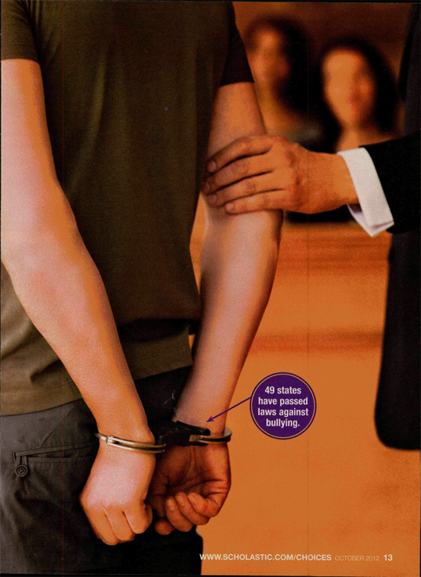
Bullies Behind Bars
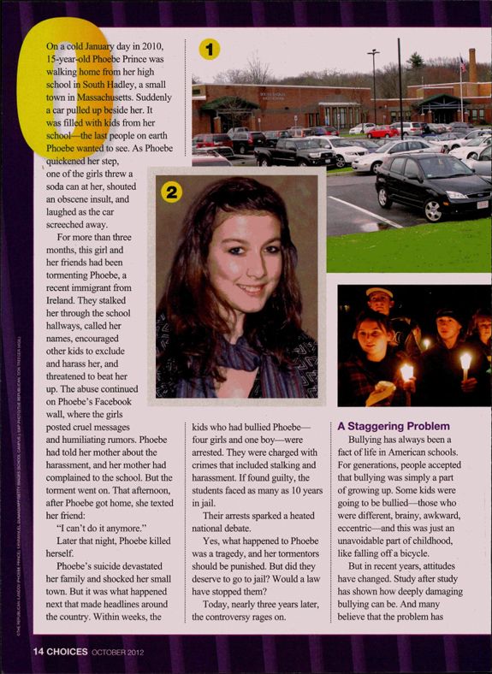
Bullies Behind Bars
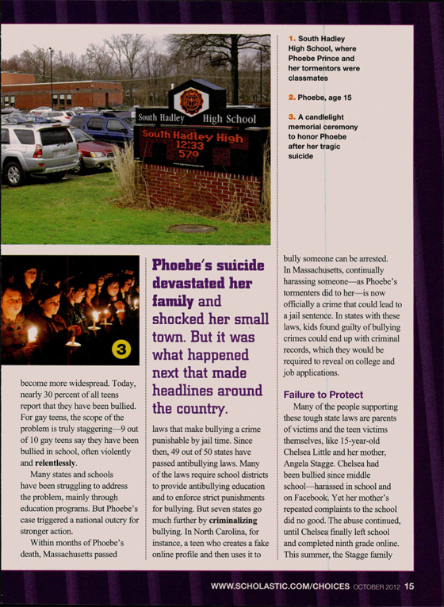
Bullies Behind Bars
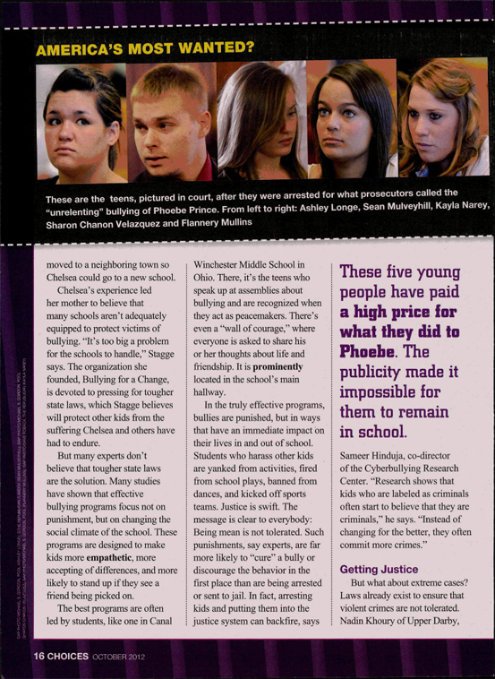
Bullies Behind Bars

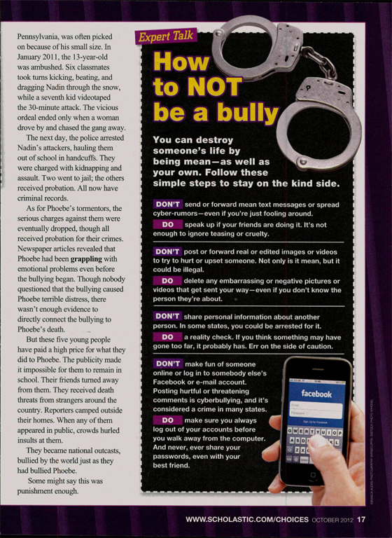

From Scholastic Choices, October © 2012. Copyright 2012 by Scholastic Inc. Reprinted by permission of Scholastic Inc.
Is the Cafeteria Ruining Your Life?
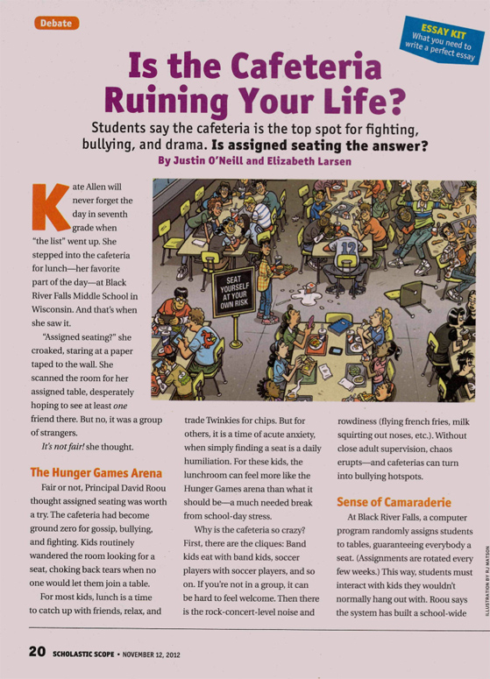
Is the Cafeteria Ruining Your Life?
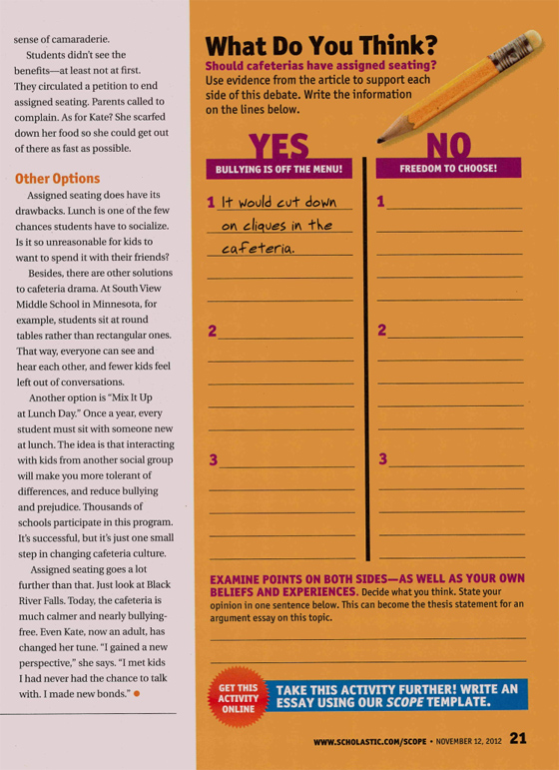

From Scholastic News, November 12, 2012. Copyright © 2012 by Scholastic Inc. Reprinted by permission of Scholastic Inc.

