Lesson 13
Objective: Multiply unit fractions by unit fractions.

Suggested Lesson Structure
 Fluency Practice (8 minutes)
 Concept Development (42 minutes)
 Student Debrief (10 minutes)
Total Time (60 minutes)
Fluency Practice (8 minutes)
- Multiply a Fraction and a Whole Number 5.NF.3 (4 minutes)
- Convert Measures 4.MD.1 (4 minutes)
Multiply a Fraction and a Whole Number (4 minutes)
Materials: (S) Personal white board
Note: This fluency activity reviews Lessons 9─11.
T: (Write $\frac{8}{4}$.) Say the division sentence with the answer.
S: 8 ÷ 4 = 2.
T: (Write $\frac{1}{4}$ × 8 = .) Say the multiplication sentence with the answer.
S: $\frac{1}{4}$ × 8 = 2.
T: (Write $\frac{3}{4}$ × 8 = .) On your personal white board, write the multiplication sentence and solve.
S: (Write $\frac{3}{4}$ × 8 = 6.)
T: (Write 8 × $\frac{3}{4}$ = .) Try this problem.
S: (Write 8 × $\frac{3}{4}$ = 6.)
Continue with the following possible sequence: $\frac{18}{6}$, $\frac{1}{6}$ × 18, $\frac{5}{6}$ × 18, 18 × $\frac{5}{6}$, $\frac{1}{8}$ × 16, 16 × $\frac{1}{8}$, 16 × $\frac{5}{8}$, $\frac{2}{3}$ × 15, and
20 × $\frac{3}{4}$.

Convert Measures (4 minutes)
Materials: (S) Personal white board, Grade 5 Mathematics Reference Sheet (Lesson 8 Reference Sheet)
Note: This fluency activity reviews Lesson 12 and prepares students for the present lesson. Allow students to use the conversion reference sheet if they are confused, but encourage them to answer questions without referring to it.
Convert the following. Draw a tape diagram, if necessary.
- $\frac{1}{3}$ yard = ________ feet = ________ inches
- $\frac{2}{3}$ yard = ________ feet = ________ inches
- $\frac{1}{3}$ hour = ________ minutes
- $\frac{2}{3}$ hour = ________ minutes
- $\frac{1}{4}$ year = ________ months
- $\frac{3}{4}$ year = ________ months
NOTES ON
MULTIPLE MEANS
OF ENGAGEMENT:
While the lesson moves to the pictorial level of representation fairly quickly, be aware that many students may need the scaffold of the concrete model (paper folding and shading) to fully comprehend the concepts. Make these materials available and model their use throughout the remainder of the module.
Concept Development (42 minutes)
Materials: (S) Personal white board, 4″ × 2″ rectangular paper (several pieces per student), scissors
Note: Today’s lesson is lengthy, so the time normally allotted for an Application Problem has been allocated to the Concept Development. The last problem in the sequence can be considered the Application Problem for today.
Problem 1
Jan has 4 pans of crispy rice treats. She sends $\frac{1}{2}$ of the pans to school with her children. How many pans of crispy rice treats does Jan send to school?
Note: To progress from finding a fraction of a whole number to a fraction of a fraction, the following sequence is then used: 2 pans, 1 pan, $\frac{1}{2}$ pan.
T: (Post Problem 1 on the board and read it aloud with the students.) Work with your partner to write a multiplication sentence that explains your thinking. Be prepared to share. (Allow students time to work.)
T: What fraction of the pans does Jan send to school?
S: One-half of them.
T: How many pans of crispy rice treats did Jan have at first?
S: 4 pans.
T: What is one-half of 4 pans?
S: 2 pans.
T: Show the multiplication sentence that you wrote to explain your thinking.
S: (Show $\frac{\text{1}}{\text{2}}$ × 4 pans = 2 pans or 4 × $\frac{\text{1}}{\text{2}}$ = 2 pans.)
T: Say the answer in a complete sentence.
S: Jan sent 2 pans of crispy rice treats to school.
T: (Erase the 4 in the text of the problem and replace it with a 2.) Imagine that Jan has 2 pans of treats. If she still sends half of the pans to school, how many pans will she send? Write a multiplication sentence to show how you know.
S: (Write $\frac{1}{2}$ × 2 pans = 1 pan.)
T: (Replace the 2 in the problem with a 1.) Now, imagine that she only has 1 pan. If she still sends half to school, how many pans will she send? Write the multiplication sentence.
S: (Write $\frac{1}{2}$ × 1 pan = $\frac{1}{2}$ pan.)
T: (Erase the 1 in the problem and replace it with$\frac{1}{2}$. Read the problem aloud with students.) What if Jan only has half a pan and wants to send half of it to school? What is different about this problem?
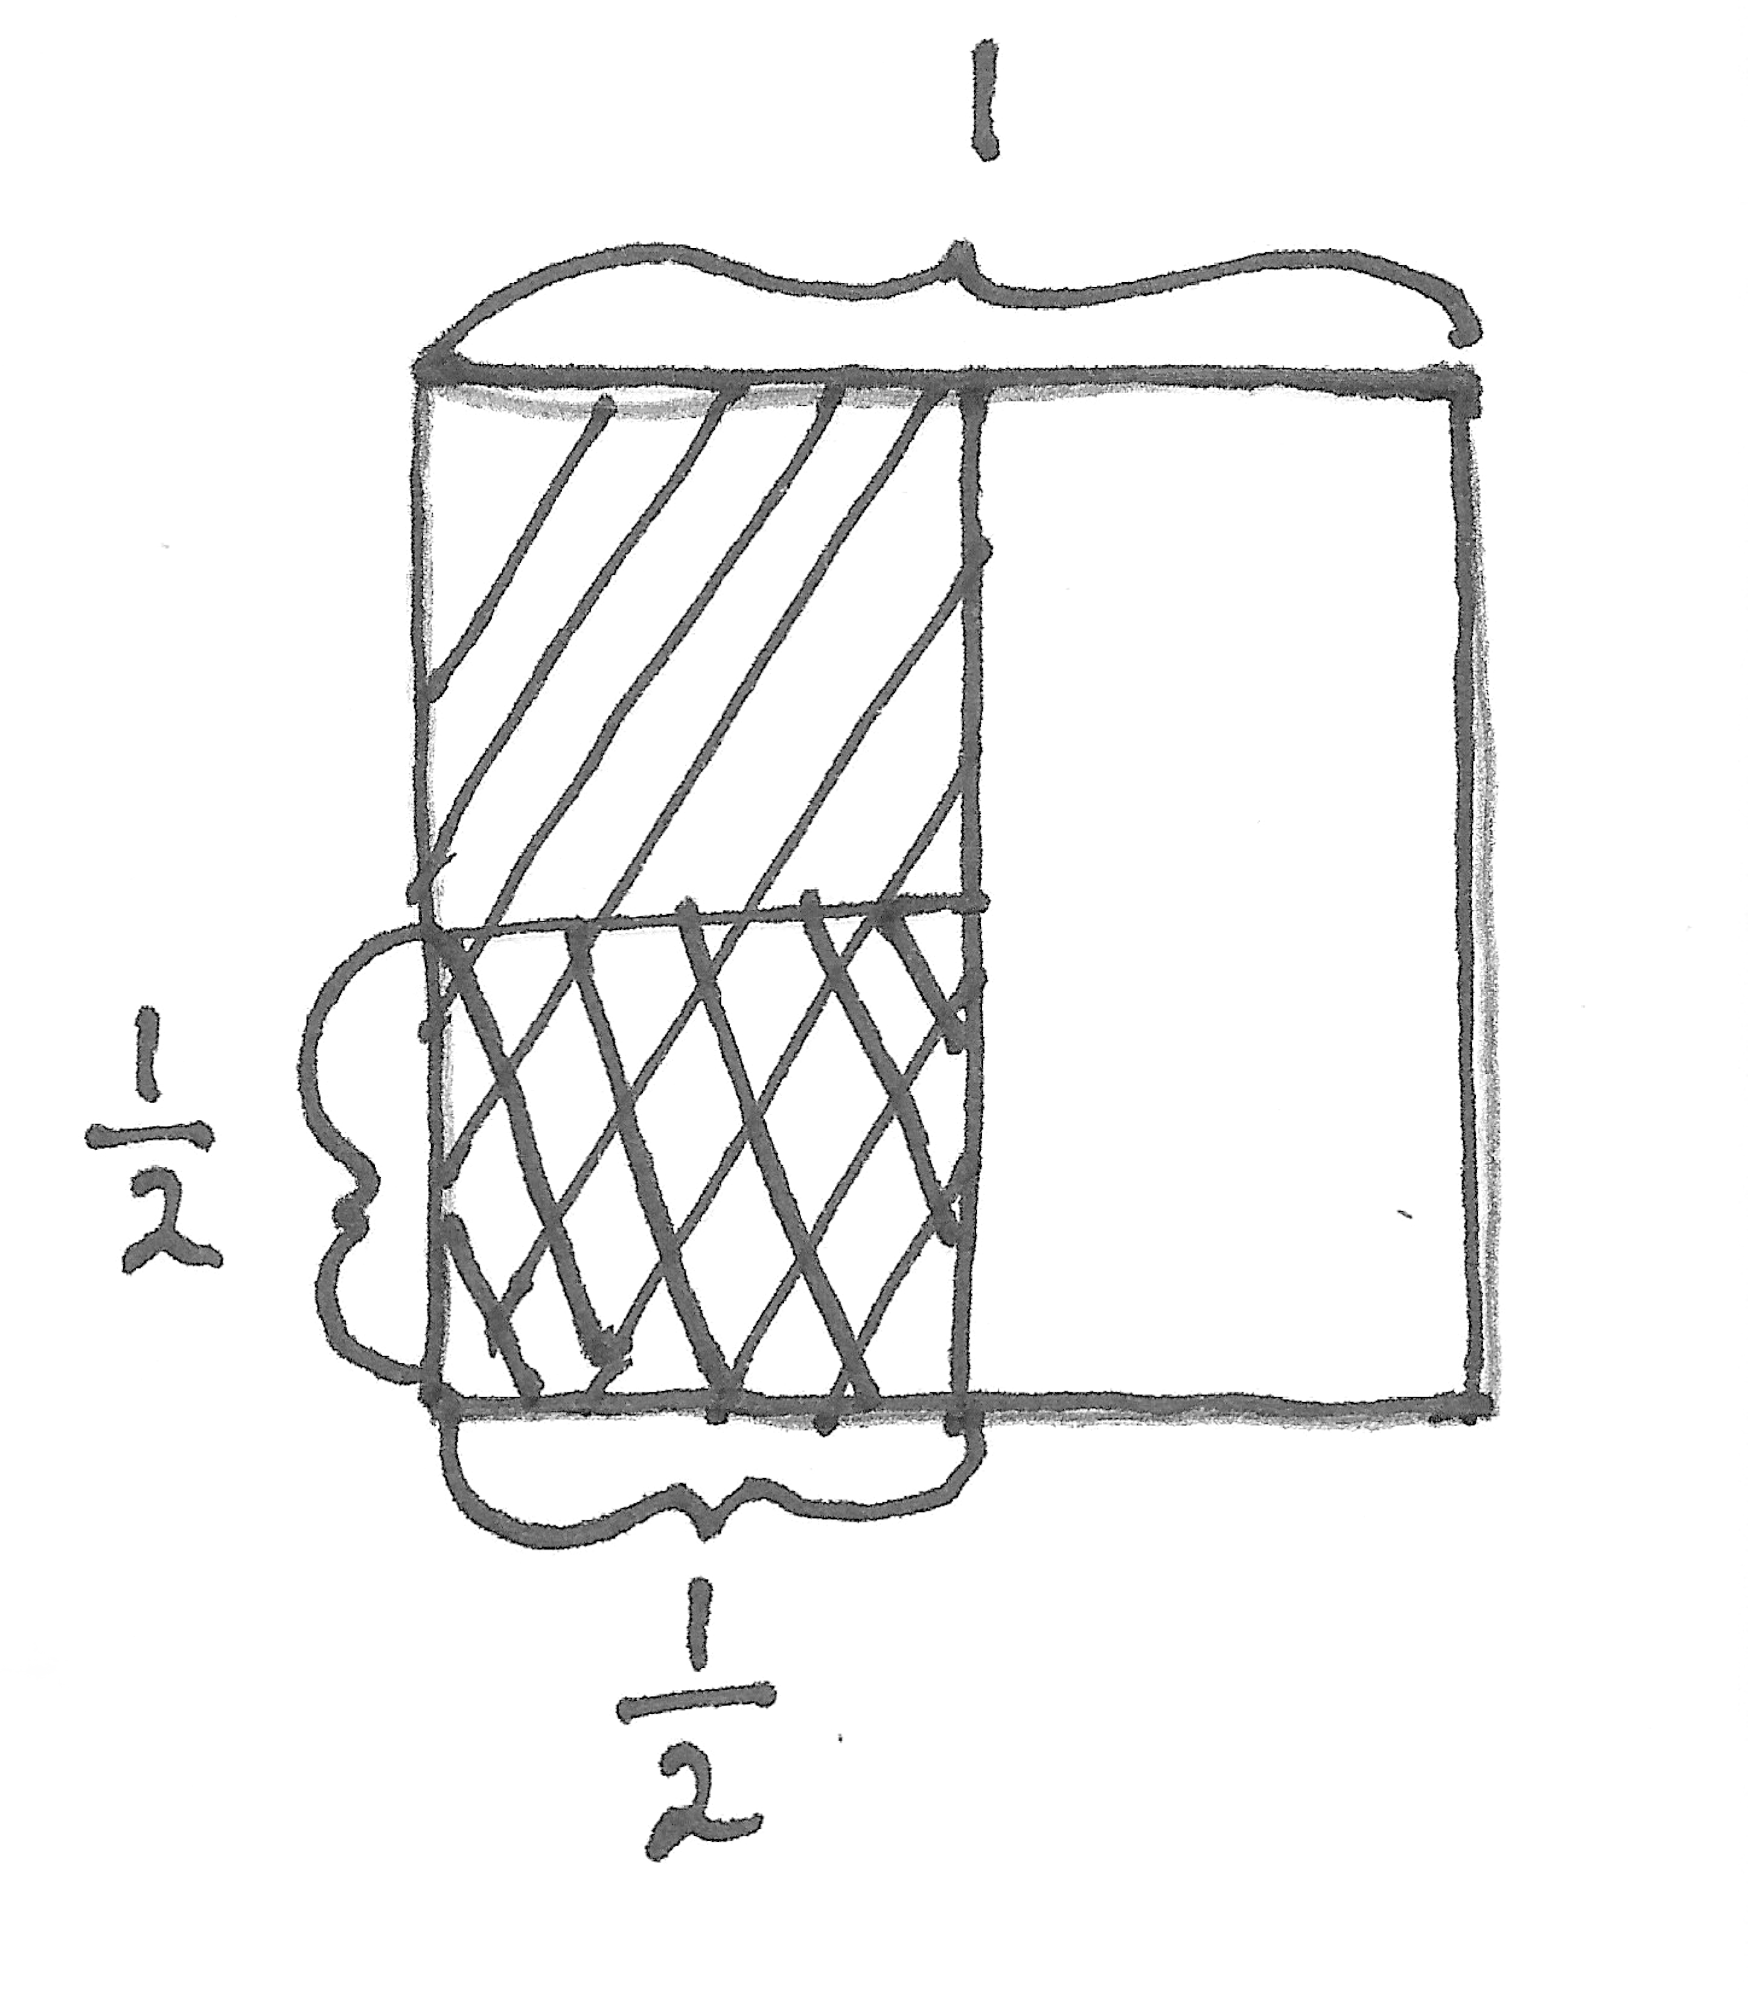
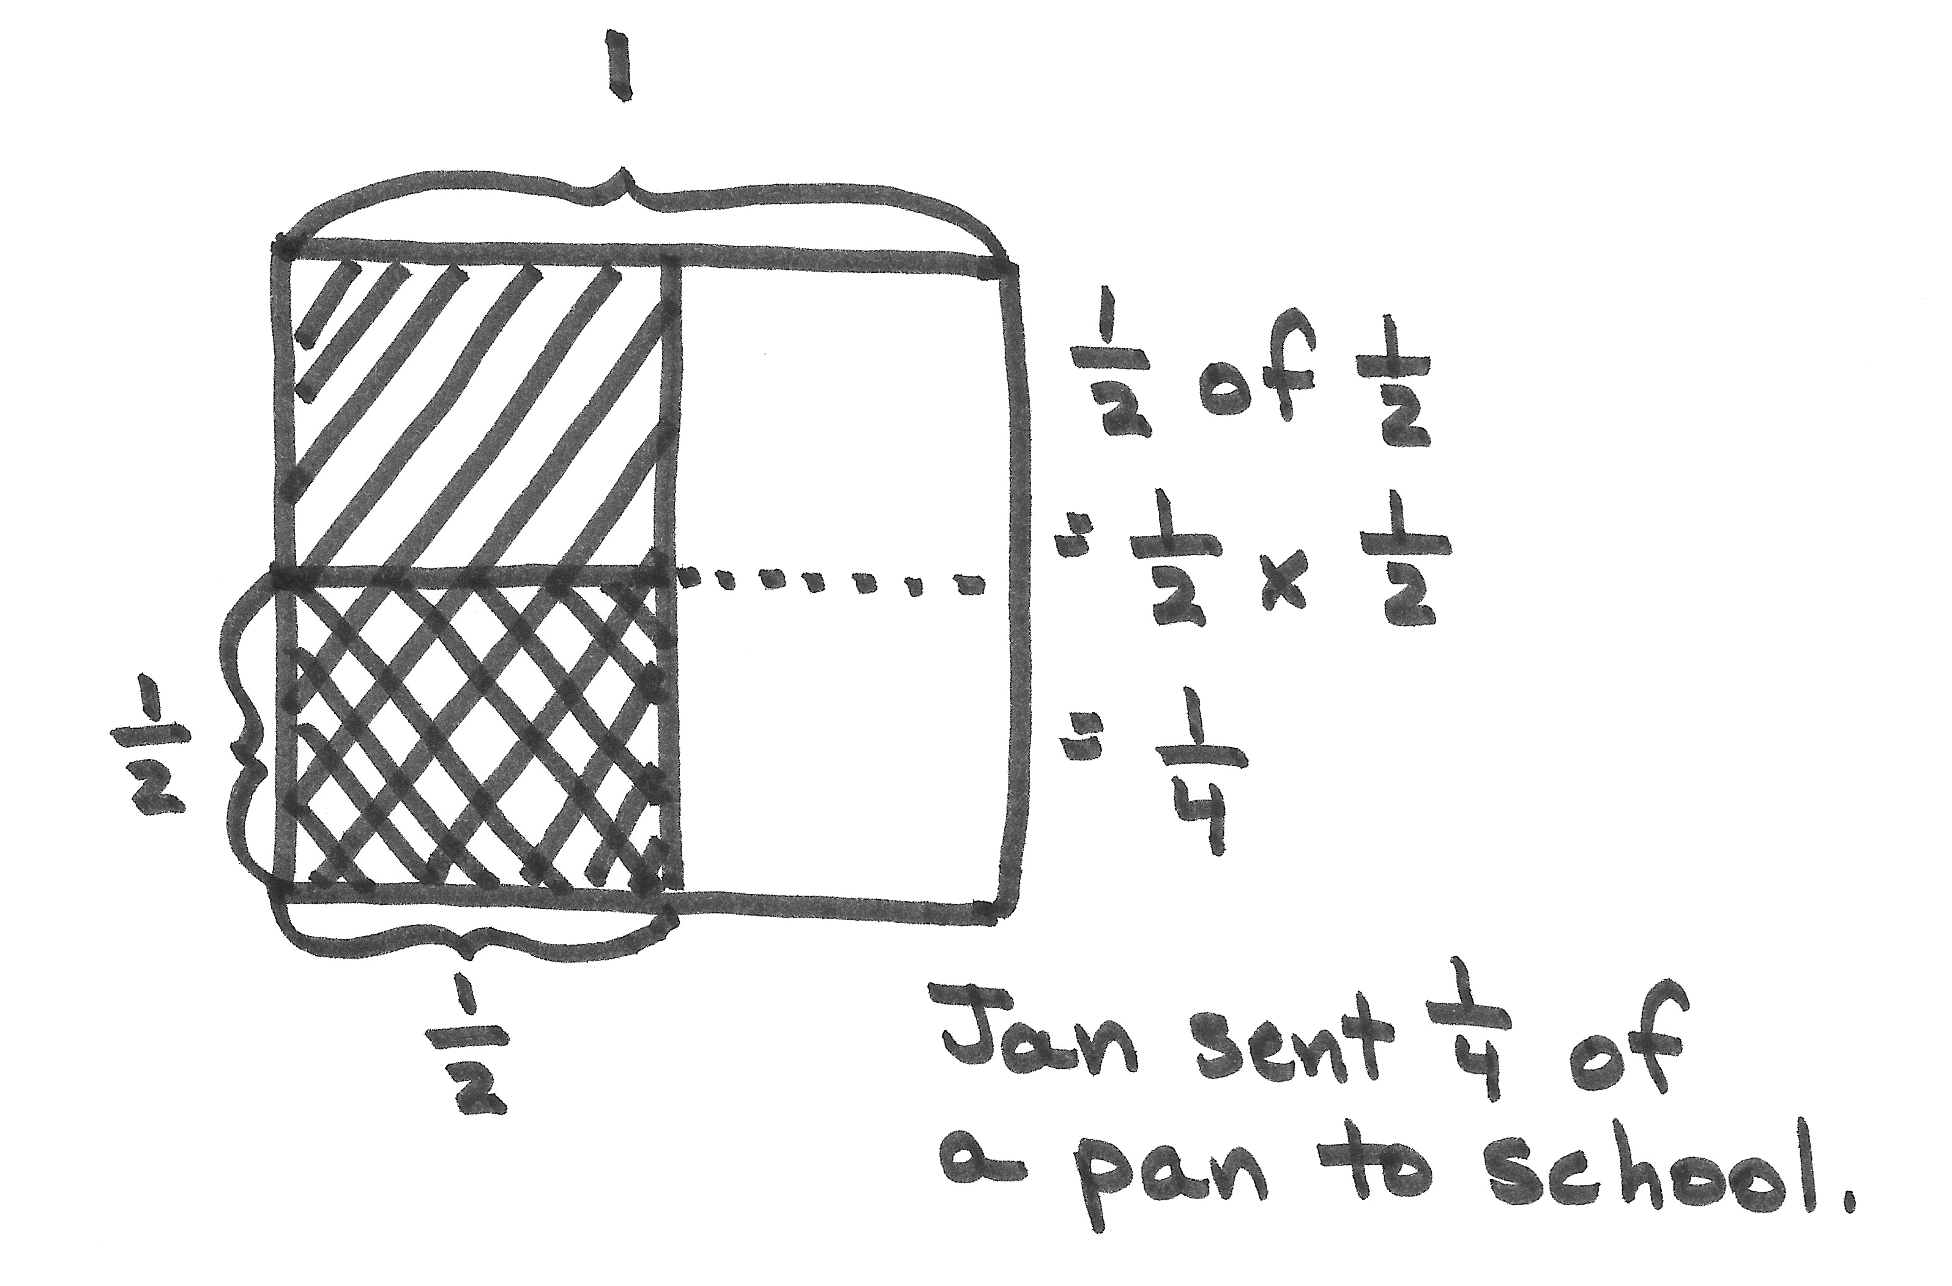
S: There’s only $\frac{1}{2}$ of a pan instead of a whole pan. Jan is still sending half the treats to school, but now we’ll find half of a half, not half of 1. The amount we have is less than a whole.
T: Let’s say that your piece of paper represents the pan of treats. Turn and talk to your partner about how you can use your rectangular paper to find out what fraction of the whole pan of treats Jan sent to school.
S: (May fold or shade the paper to show the problem.)
T: Many of you shaded half of your paper, and then partitioned that half into 2 equal parts and shaded one of them, like so. (Model as seen at the right.)
MP.4
T: We now have two different size units shaded in our model.
I can see the part that Jan sent to school, but I need to name this unit. To name the part she sent (point to the double-shaded unit), all of the units in the whole must be the same size as this one. Turn and talk to your partner about how we can split the rest of the pan so that all the units are the same as our double-shaded one. Use your paper to show your thinking.
S: We could cut the other half in half, too. That would make 4 units of the same size. We could keep cutting across the rest of the whole. That would make the whole pan cut into 4 equal parts.
Half of a half is a fourth.
T: Let me record that. (Partition the unshaded half using a dotted line.) Look at our model. What’s the name for the smallest units we have drawn now?
S: Fourths.
T: She sent half of the treats she had, but what fraction of the whole pan of treats did Jan send to school?
S: One-fourth of the whole pan.
T: Write a multiplication sentence that shows your thinking.
S: (Write $\frac{1}{2}\text{×}\frac{1}{2}\text{=}\frac{1}{4}$.)
Problem 2
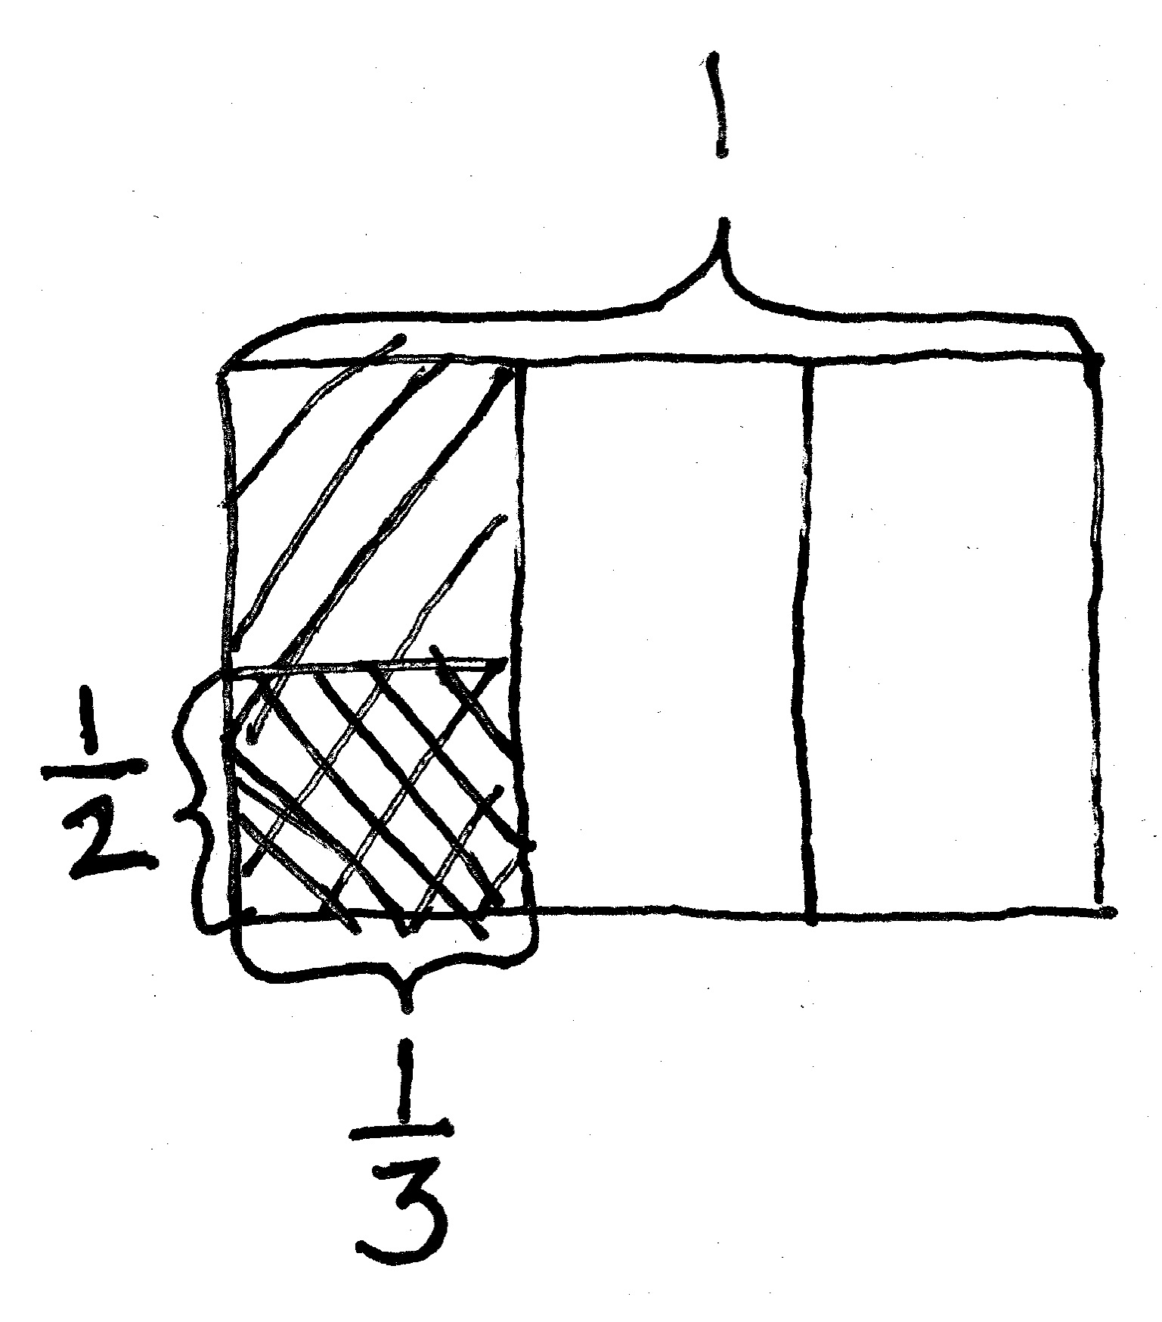
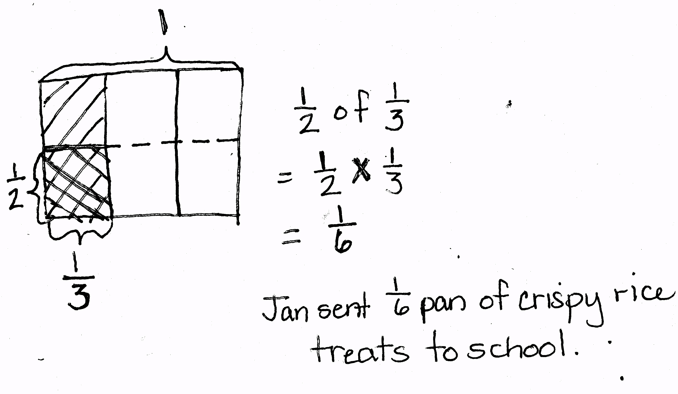
Jan has $\frac{1}{3}$ pan of crispy rice treats. She sends $\frac{1}{2}$ of the treats to school with her children. What fraction of a pan of crispy rice treats does Jan send to school?
T: (Erase $\frac{1}{2}$ in the text of Problem 1 and replace it with $\frac{1}{3}$.) Imagine that Jan only has a third of a pan, and she still wants to send half of the treats to school. Will she be sending a greater amount or a smaller amount of treats to school than she sent in our last problem? How do you know? Turn and discuss with your partner.
S: It will be a smaller part of a whole pan because she had half a pan before. Now, she only has 1 third of a pan. 1 third is less than 1 half, so half of a third is less than half of a half. 1 half is larger than 1 third, so she sent more in the last problem than this one.
T: We need to find $\frac{1}{2}$ of $\frac{1}{3}$ pan. (Write $\frac{1}{2}$ of $\frac{1}{3}$ = $\frac{1}{2}\text{×}\frac{1}{3}$on the board.) I’ll draw a rectangular fraction model to represent this problem while you use your paper to model it. (Draw a rectangle on the board.) This rectangle shows 1 whole pan. (Label 1 above the rectangle.) Fold your paper, and then shade it to show how much of this one pan Jan has at first.
NOTES ON
MULTIPLE MEANS
OF REPRESENTATION:
There will be students who notice the patterns within the algorithm quickly and want to use it to find the product. Be sure those students are questioned deeply and can articulate the reasoning and meaning of the product in relationship to the whole.
S: (Fold in thirds and shade 1 third of the whole.)
T: (On the board, partition the rectangle vertically into 3 parts, shade in 1 of them, and label $\frac{1}{3}$ below it.) What fraction of the treats did Jan send to school?
S: One-half.
T: Jan sends $\frac{1}{2}$ of this part to school. (Point to 1 shaded portion.) How can I show $\frac{1}{2}$ of this part? Turn and talk to your partner, and show your thinking with your paper.
S: We can draw a line to cut it in half. We need to split it into 2 equal parts and shade only 1 of them.
T: I hear you saying that I should partition the one-third into 2 equal parts, and then shade only 1. (Draw a horizontal line through the shaded third and shade the bottom half again to create a double shade. Label the double-shaded area as $\frac{1}{2}.$)
T: Again, now I have two different size shaded units. What do I need to do with this horizontal line to be able to name the units? Turn and talk.
S: We could cut the other thirds in half, too. That would make 6 units the same size. We could keep cutting across the rest of the whole. That would make the whole pan cut into 6 equal parts. 1 third is the same as 2 sixths. Half of 2 sixths is 1 sixth.
T: Let me record that. (Partition the un-shaded thirds using a dotted line.) What’s the name for the units we have drawn now?
S: Sixths.
T: What fraction of the pan of treats did Jan send to school?
S: One-sixth of the whole pan.
T: One-half of one-third is one-sixth. (Write $\frac{1}{2}\text{×}\frac{1}{3}\text{=}\frac{1}{6}$.)
Repeat a similar sequence with Problem 3, but have students draw a rectangular fraction model on their paper rather than folding their paper. Be sure that students articulate clearly the finding of a common unit, which will let them name the product.
Problem 3
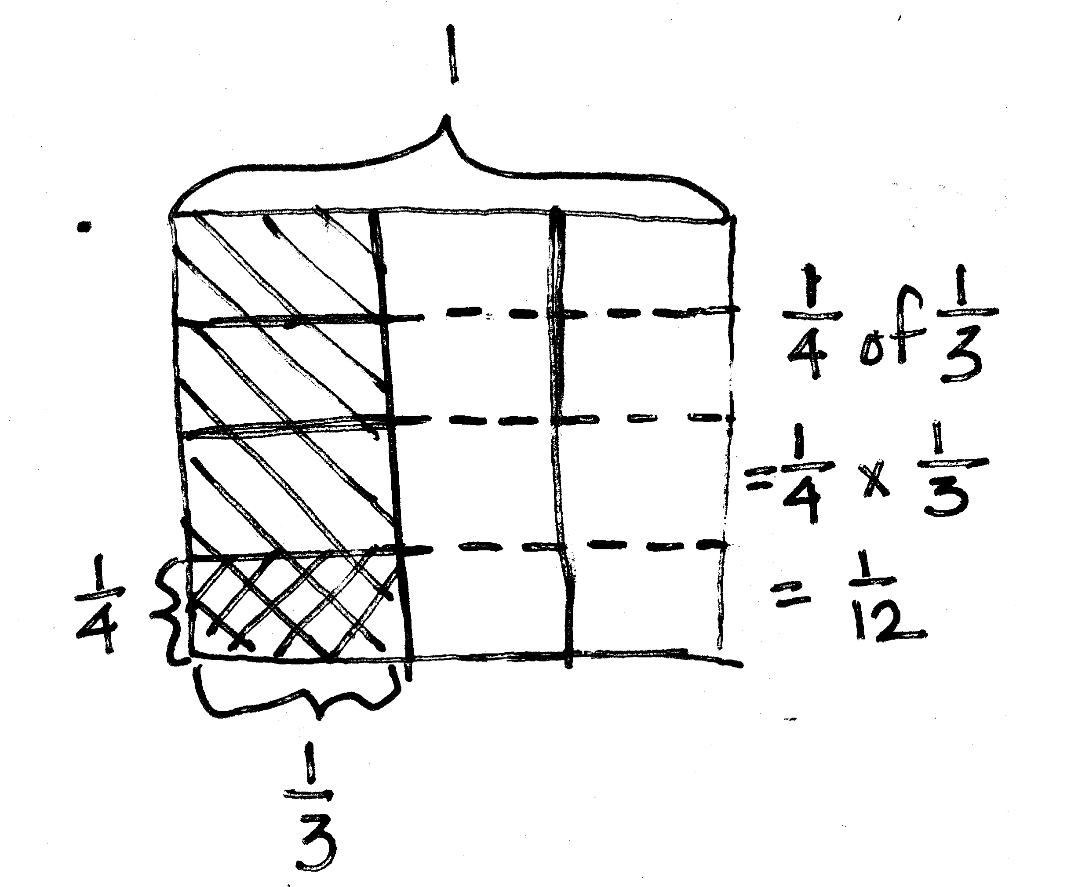
Jan has $\frac{1}{3}$ a pan of crispy rice treats. She sends $\frac{1}{4}$ of the treats to school with her children. What fraction of a pan of crispy rice treats does Jan send to school?
T: (Write $\frac{1}{4}$ of $\frac{1}{3}$ and $\frac{1}{3}$ of $\frac{1}{4}$ on the board.) Let’s compare finding 1 fourth of 1 third with finding 1 third of 1 fourth. What do you notice about these problems? Turn and talk.
S: They both have 1 fourth and 1 third in them, but they’re flip-flopped. They have the same factors, but they are in a different order.
T: Will the order of the factors affect the size of the product? Talk to your partner.
S: No, it doesn’t when we multiply whole numbers. But, is that true for fractions, too? That means 1 fourth of 1 third is the same as a third of a fourth.
T: We just drew the rectangular fraction model for $\frac{1}{4}$ of $\frac{1}{3}$. Let’s now draw it for $\frac{1}{3}$ of $\frac{1}{4}$ to find out if we will have the same answer. In $\frac{1}{3}$ of $\frac{1}{4}$, the amount we start with is 1 fourth of the pan. Draw a rectangle, shade $\frac{1}{4}$, and label it. (Draw a rectangular box and cut it vertically into 4 equal parts and label $\frac{1}{4}$. Point to the shaded part.) How do I take a third of this fourth?
S: Cut the fourth into 3 parts.
T: How will we name this new unit?
S: To name this new unit, we need to cut the other fourths into 3 equal parts, too.
T: (Partition each unit into thirds, double shade the portion showing $\frac{1}{3}$ of $\frac{1}{4}$, and label $\frac{1}{3}$.) How many of these units make our whole?
S: Twelve.
T: What is their name?
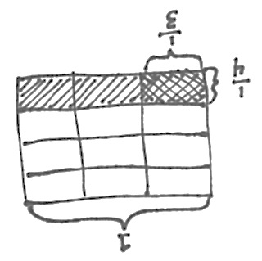
S: Twelfths.
T: What’s $\frac{1}{3}$ of $\frac{1}{4}$?
S: 1 twelfth.
T: (Write $\frac{1}{3}\text{×}\frac{1}{4}\text{=}\frac{1}{12}$.) These multiplication sentences have the same answer, but the shape of the twelfth is different. How do you know that 12 equal parts can be different shapes, yet the same fraction?
S: What matters is that they are 12 equal parts of the same whole.
The same applies to a square; there are a lot of ways to show a half, or 2 equal parts. The area has to be the same, not the shape.
T: True. What matters is that the parts have the same area. We can prove $\frac{1}{3}\text{×}\frac{1}{4}\text{=}\frac{1}{4}\text{×}\frac{1}{3}$ with another drawing. Start with the same brownie pan. Draw fourths horizontally, and shade 1 fourth. Now, let’s double-shade 1 third of that fourth (extend the units with dotted lines). Is the exact same amount shaded in the two pans?
S: Yes!
T: So, we see in another way that $\frac{1}{4}$ of $\frac{1}{3}$ = $\frac{1}{3}$ of $\frac{1}{4}$. Review how to prove that with our rectangles. Turn and talk.
S: We shade a fourth of a third, drawing the thirds vertically first. Then, we shaded a third of a fourth, drawing the fourths horizontally first. They were exactly the same part of the whole. I can shade a fourth, and then take a third of it, or I can shade a third, and then take a fourth of it. I get $\frac{1}{12}$ either way.
T: What do we know about multiplication that supports the truth of the number sentence $\frac{1}{3}\text{×}\frac{1}{4}\text{=}\frac{1}{4}\text{×}\frac{1}{3}$?
S: The commutative property works with fractions the same as whole numbers. The order of the factors doesn’t change the product. Taking a fourth of a third is like taking a smaller part of a larger unit, while taking a third of a fourth is like taking a larger part of a smaller unit. Either way, you’re finding the same size share.
T: We can express $\frac{1}{4}$ of $\frac{1}{3}$ as $\frac{1}{4}\text{×}\frac{1}{3} \text{or}\frac{1}{3}\text{×}\frac{1}{4}.$ (Write $\frac{1}{4}\text{×}\frac{1}{3}\text{=}\frac{1}{3}\text{×}\frac{1}{4}$.) They are equivalent expressions.

Problem 4
A sales lot is filled with vehicles for sale. $\frac{1}{3}$ of the vehicles are pickup trucks. $\frac{1}{3}$ of the trucks are white. What fraction of all the vehicles are white pickup trucks?
T: (Post Problem 4 on the board and read it aloud with students.) Work with your partner to draw a rectangular fraction model and solve. Write a multiplication sentence to show your thinking. (Allow students time to work.)
T: What is a third of one-third?
S: $\frac{1}{9}$.
T: Say the answer to the question in a complete sentence.
S: One-ninth of the vehicles in the lot are white pickup trucks.
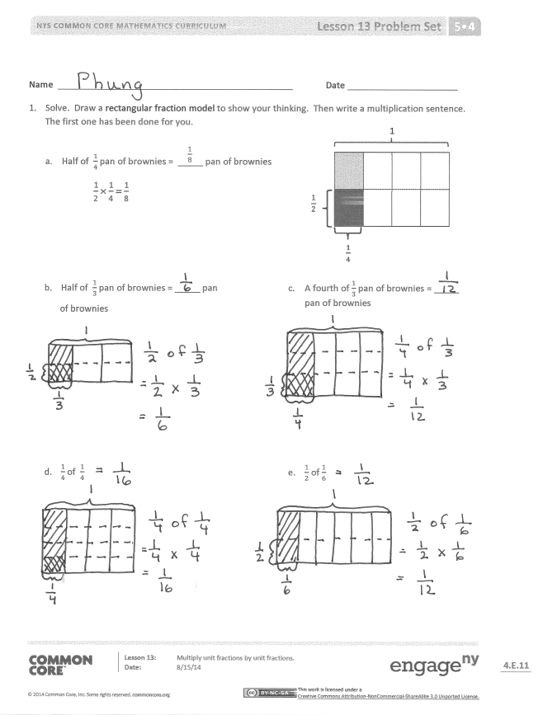
Problem Set (10 minutes)
Students should do their personal best to complete the Problem Set within the allotted 10 minutes. For some classes, it may be appropriate to modify the assignment by specifying which problems they work on first. Some problems do not specify a method for solving. Students should solve these problems using the RDW approach used for Application Problems.
Student Debrief (10 minutes)
Lesson Objective: Multiply unit fractions by unit fractions.
The Student Debrief is intended to invite reflection and active processing of the total lesson experience.
Invite students to review their solutions for the Problem Set. They should check work by comparing answers with a partner before going over answers as a class. Look for misconceptions or misunderstandings that can be addressed in the Debrief. Guide students in a conversation to debrief the Problem Set and process the lesson.
You may choose to use any combination of the questions below to lead the discussion.
- In Problem 1, what is the relationship between Parts (a) and (d)? (Part (a) is double Part (d).) Between Parts (b) and (c)? (Part (b) is double Part (c).) Between Parts (b) and (e)? (Part (b) is double Part (e).)
- Why is the product for Problem 1(d) smaller than 1(c)? Explain your reasoning to your partner.
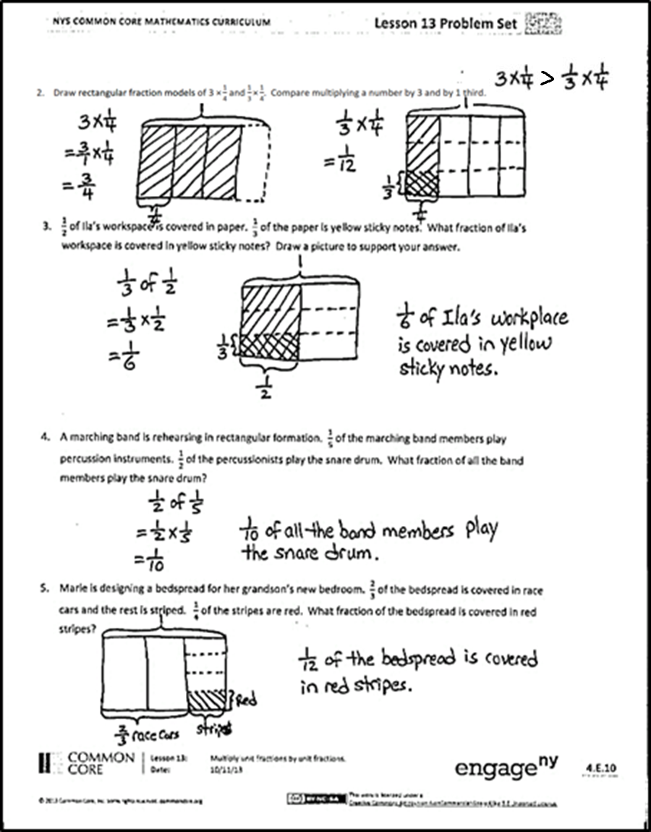
- Share and compare your solution with a partner for Problem 2.
- Compare and contrast Problem 3 and Problem 1(b). Discuss with your partner.
- How is solving for the product of a fraction and a whole number the same as or different from solving a fraction of a fraction? Can you use some of the similar strategies? Explain your thinking to a partner.
Exit Ticket (3 minutes)
After the Student Debrief, instruct students to complete the Exit Ticket. A review of their work will help you assess the students’ understanding of the concepts that were presented in the lesson today and plan more effectively for future lessons. You may read the questions aloud to the students.

Name Date
- Solve. Draw a rectangular fraction model to show your thinking. Then, write a multiplication sentence. The first one has been done for you.
1
$$\frac{1}{2}$$
$\frac{1}{4}$
$\frac{1}{8}$
  - Half of $\frac{1}{4}$ pan of brownies = _____ pan of brownies
$\frac{\text{1}}{\text{2}}\text{×}\frac{\text{1}}{\text{4}}\text{=}\frac{\text{1}}{\text{8}}$

- Half of $\frac{1}{3}$ pan of brownies = _____ pan  of brownies | - A fourth of $\frac{1}{3}$ pan of brownies = _____ pan of brownies
- $\frac{1}{4}$ of $\frac{1}{4}$ | - $\frac{1}{2}$ of $\frac{1}{6}$

- Draw rectangular fraction models of 3 $\text{×}\frac{\text{1}}{\text{4}}$ and $\frac{\text{1}}{\text{3}}\text{×}\frac{\text{1}}{\text{4}}$. Compare multiplying a number by 3 and by 1 third.

- $\frac{1}{2}$ of Ila’s workspace is covered in paper. $\frac{1}{3}$ of the paper is covered in yellow sticky notes. What fraction of Ila’s workspace is covered in yellow sticky notes? Draw a picture to support your answer.

- A marching band is rehearsing in rectangular formation. $\frac{1}{5}$ of the marching band members play percussion instruments. $\frac{1}{2}$ of the percussionists play the snare drum. What fraction of all the band members play the snare drum?

- Marie is designing a bedspread for her grandson’s new bedroom. $\frac{2}{3}$ of the bedspread is covered in race cars and the rest is striped. $\frac{1}{4}$ of the stripes are red. What fraction of the bedspread is covered in red stripes?

Name Date
- Solve. Draw a rectangular fraction model, and write a number sentence to show your thinking.

- $\frac{1}{3}$ $\text{×}\frac{\text{1}}{\text{3}}$ =

- Ms. Sheppard cuts $\frac{1}{2}$ of a piece of construction paper. She uses $\frac{1}{6}$ of the piece to make a flower. What fraction of the sheet of paper does she use to make the flower?

Name Date
  - Solve. Draw a rectangular fraction model to show your thinking.

- Half of $\frac{1}{2}$ cake = _____ cake b. One-third of $\frac{1}{2}$ cake = _____ cake

- $\frac{1}{4}$ of $\frac{1}{2}$ d. $\frac{1}{2}$ $\text{×}$ $\frac{1}{5}$

- $\frac{1}{3}$ $\text{×}$ $\frac{1}{3}$ f. $\frac{1}{4}$ $\text{×}$ $\frac{1}{3}$

- Noah mows $\frac{1}{2}$ of his property and leaves the rest wild. He decides to use $\frac{1}{5}$ of the wild area for a vegetable garden. What fraction of the property is used for the garden? Draw a picture to support your answer.

- Fawn plants $\frac{2}{3}$ of the garden with vegetables. Her son plants the remainder of the garden. He decides to use $\frac{1}{2}$ of his space to plant flowers, and in the rest, he plants herbs. What fraction of the entire garden is planted in flowers? Draw a picture to support your answer.

- Diego eats $\frac{1}{5}$ of a loaf of bread each day. On Tuesday, Diego eats $\frac{1}{4}$ of the day’s portion before lunch. What fraction of the whole loaf does Diego eat before lunch on Tuesday? Draw a rectangular fraction model to support your thinking.

