Lesson 12
Objective: Solve and create fraction word problems involving addition, subtraction, and multiplication.

Suggested Lesson Structure
 Fluency Practice (12 minutes)
 Application Problem (6 minutes)
 Concept Development (32 minutes)
 Student Debrief (10 minutes)
Total Time (60 minutes)
Fluency Practice (12 minutes)
- Convert Measures 4.MD.1 (4 minutes)
- Multiply a Fraction and a Whole Number 5.NF.3 (4 minutes)
- Write the Expression to Match the Diagram 5.NF.4 (4 minutes)
Convert Measures (4 minutes)
Materials: (S) Personal white board, Grade 5 Mathematics Reference Sheet (Lesson 8 Reference Sheet)
Note: This fluency activity reviews Lessons 9–11 and prepares students for Lesson 12 content. Allow students to use the conversion reference sheet if they are confused, but encourage them to answer questions without referring to it.
T: (Write 1 ft = __ in.) How many inches are in 1 foot?
S: 12 inches.
T: (Write 1 ft = 12 in. Below it, write 2 ft = __ in.) 2 feet?
S: 24 inches.
T: (Write 2 ft = 24 in. Below it, write 4 ft = __ in.) 4 feet?
S: 48 inches.
T: Write the multiplication equation you used to solve it.
S: (Write 4 ft × 12 = 48 in.)
Continue with the following possible sequence: 1 pint = 2 cups, 2 pints = 4 cups, 7 pints = 14 cups,
1 yard = 3 ft, 2 yards = 6 ft, 6 yards = 18 ft, 1 gal = 4 qt, 2 gal = 8 qt, and 9 gal = 36 qt.
T: (Write 2 c = __ pt.) How many pints are in 2 cups?
S: 1 pint.
T: (Write 2 c = 1 pt. Below it, write 4 c = __ pt.) 4 cups?

NOTES ON
MULTIPLE MEANS
OF ENGAGEMENT:
For English language learners and struggling students, provide the conversion reference sheet included in Lesson 8.
S: 2 pints.
T: (Write 4 c = 2 pt. Below it, write 10 c = __ pt.) 10 cups?
S: 5 pints
T: Write the division equation you used to solve it.
S: (Write 10 c ÷ 2 = 5 pt.)
Continue with the following possible sequence: 12 in = 1 ft, 36 in = 3 ft, 3 ft = 1 yd, 12 ft = 4 yd, 4 qt = 1 gal, and 28 qt = 7 gal.
Multiply a Fraction and a Whole Number (4 minutes)
Materials: (S) Personal white board
Note: This fluency activity reviews Lessons 9–11.
T: (Write 9 ÷ 3 =__.) Say the division sentence.
S: 9 ÷ 3 = 3.
T: (Write $\frac{1}{3}$ $\text{×}$ 9 =__.) Say the multiplication sentence.
S: $\frac{1}{3}$ $\text{×}$ 9 = 3.
T: (Write $\frac{2}{3}$ $\text{×}$ 9 =__.) On your personal white boards, write the multiplication sentence.
S: (Write $\frac{2}{3}$ $\text{×}$ 9 = 6.)
T: (Write 9 $\text{×}$ $\frac{2}{3}$=__.) On your personal white boards, write the multiplication sentence.
S: (Write 9 $\text{×}$ $\frac{2}{3}$= 6.)
Continue with the following possible sequence: 12 ÷ 6, $\frac{1}{6}$ $\text{×}$ 12, $\frac{5}{6}$ $\text{×}$ 12, 12 $\text{×}$ $\frac{5}{6}$, $\frac{1}{8}$ $\text{×}$ 24, 24 $\text{×}$ $\frac{1}{8}$, 24 $\text{×}$ $\frac{3}{8}$ , $\frac{2}{3}$ $\text{×}$12, and 12 $\text{×}$ $\frac{3}{4}$.
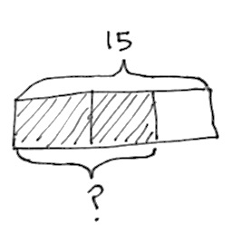
Write the Expression to Match the Diagram (4 minutes)
Materials: (S) Personal white boards
Note: This fluency activity reviews Lessons 10─11.
T: (Project a tape diagram partitioned into 3 equal units with 15 as the whole and 2 units shaded.) Say the value of the whole.
S: 15.
T: On your personal white boards, write an expression to match the diagram using a fraction.
S: (Write $\frac{2}{3} \text{× 15 or 15 ×} \frac{2}{3}.)$
T: To solve, we can write 15 divided by 3 to find the value of one unit, times 2. (Write $\frac{15}{3} \text{× 2}$ while saying the words.)
T: Find the value of the expression.
S: (Write $\frac{15}{3}\text{ × 2} \text{=} \text{10.)}$
Continue this process with the following suggested problems: $\frac{3}{5} \text{× 45}$, $\frac{3}{4} \text{× 32,}$ $\frac{5}{6} \text{× 54}$, and $\frac{7}{8} \text{× 64}$.
Application Problem (6 minutes)
Complete the table.
$\frac{2}{3}$ yds | _______ feet
4 pounds | _______ ounces
8 tons | _______ pounds
$\frac{3}{4}$ gallon | _______ quarts
$\frac{5}{12}$ year | _______ months
$\frac{4}{5}$ hour | _______ minutes
Note: The chart requires students to work within many customary systems reviewing the work of Lesson 9. Students may need a conversion chart (Lesson 8) to scaffold this problem.

Concept Development (32 minutes)
Materials: (S) Problem Set
Suggested Delivery of Instruction for Solving Lesson 12 Word Problems
- Model the problem.
Have two pairs of student who can successfully model the problem work at the board while the others work independently or in pairs at their seats. Review the following questions before beginning the first problem:
- Can you draw something?
- What can you draw?
- What conclusions can you reach from your drawing?
As students work, circulate. Reiterate the questions above. After two minutes, have the two pairs of students share only their labeled diagrams. For about one minute, have the demonstrating students receive and respond to feedback and questions from their peers.
- Calculate to solve and write a statement.

NOTES ON
MULTIPLE MEANS
OF ENGAGEMENT:
The complexity of the language involved in today’s problems may pose significant challenges to English language learners or students with learning differences that affect language processing. Consider pairing these students with students in the class who are adept at drawing clear models. These visuals and the peer interaction they generate can be invaluable bridges to making sense of the written word.
Give students two minutes to finish their work on that question, sharing their work and thinking with a peer. All students should then write their equations and statements of the answer.
- Assess the solution for reasonableness.
Give students one to two minutes to assess and explain the reasonableness of their solution.
A general instructional note on today’s problems: Today’s problems are more complex than those found in Lesson 11. All are multi-step problems. Students should be strongly encouraged to draw before attempting to solve. As in Lesson 11, multiple approaches to solving all of the problems are possible. Students should be given time to share and compare thinking during the Debrief.
Problem 1
A baseball team played 32 games and lost 8. Katy was the catcher in $\frac{5}{8}$ of the winning games and $\frac{1}{4}$ of the losing games.
- What fraction of the games did the team win?
- In how many games did Katy play catcher?
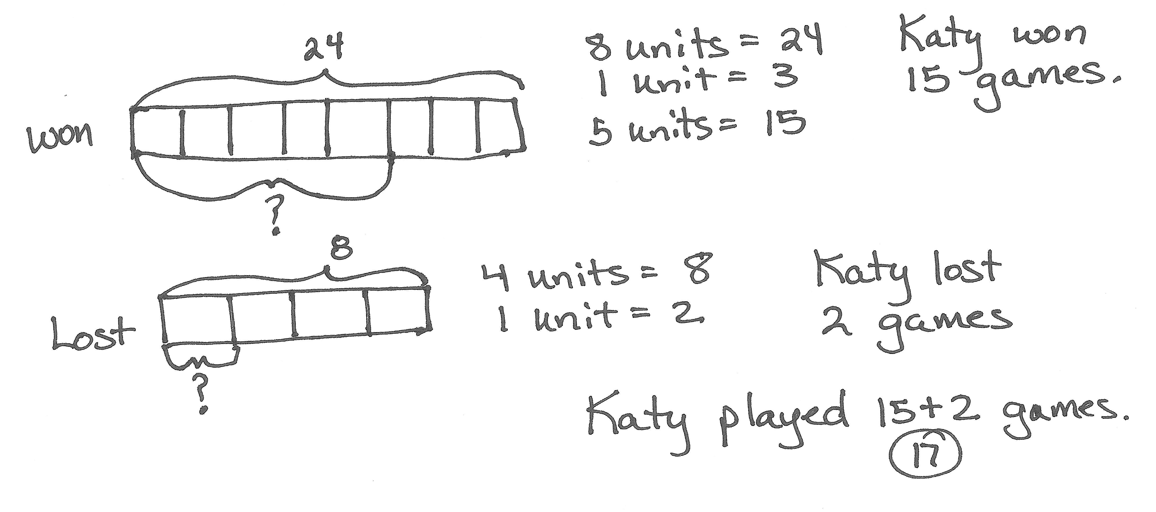
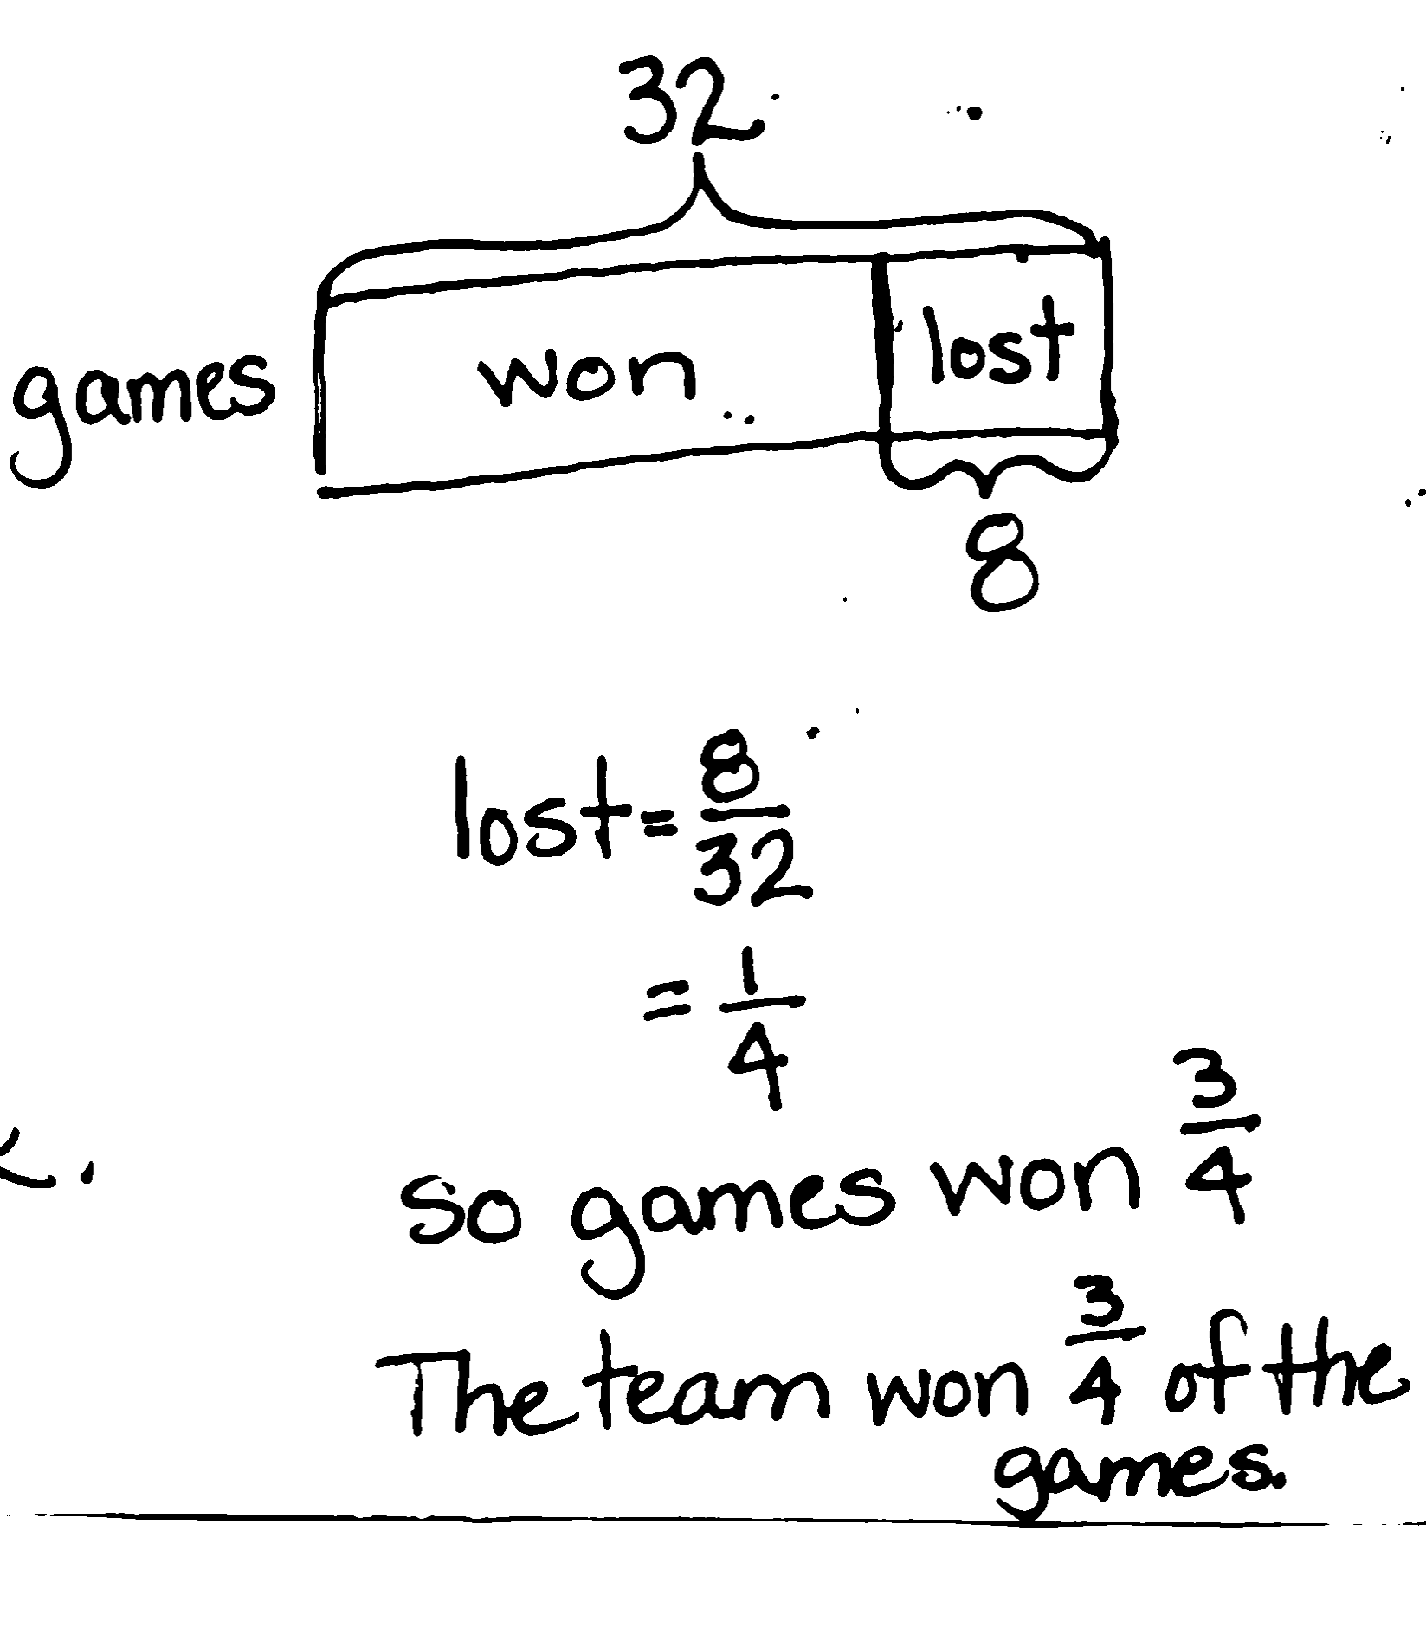
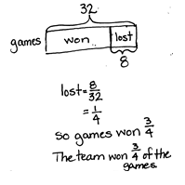

While Part A is relatively straightforward, there are still various approaches for solving. Students may find the difference between the number of games played and lost to find the number of games won (24), expressing this difference as a fraction ($\frac{24}{32}$). Alternatively, they may conclude that the losing games are $\frac{1}{4}$ of the total and deduce that winning games must constitute $\frac{3}{4}$. Watch for students distracted by the fractions $\frac{5}{8}$ and $\frac{1}{4}$ written in the stem and try to involve them in the solution to Part (a). Complexity increases as students must use the fraction of a set strategy twice, carefully matching each fraction with the appropriate number of games and finally combining the number of games that Katy played to find the total.

Problem 2
In Mrs. Elliott’s garden, $\frac{1}{8}$ of the flowers are red, $\frac{1}{4}$ of them are purple, and $\frac{1}{5}$ of the remaining flowers are pink. If there are 128 flowers, how many flowers are pink?
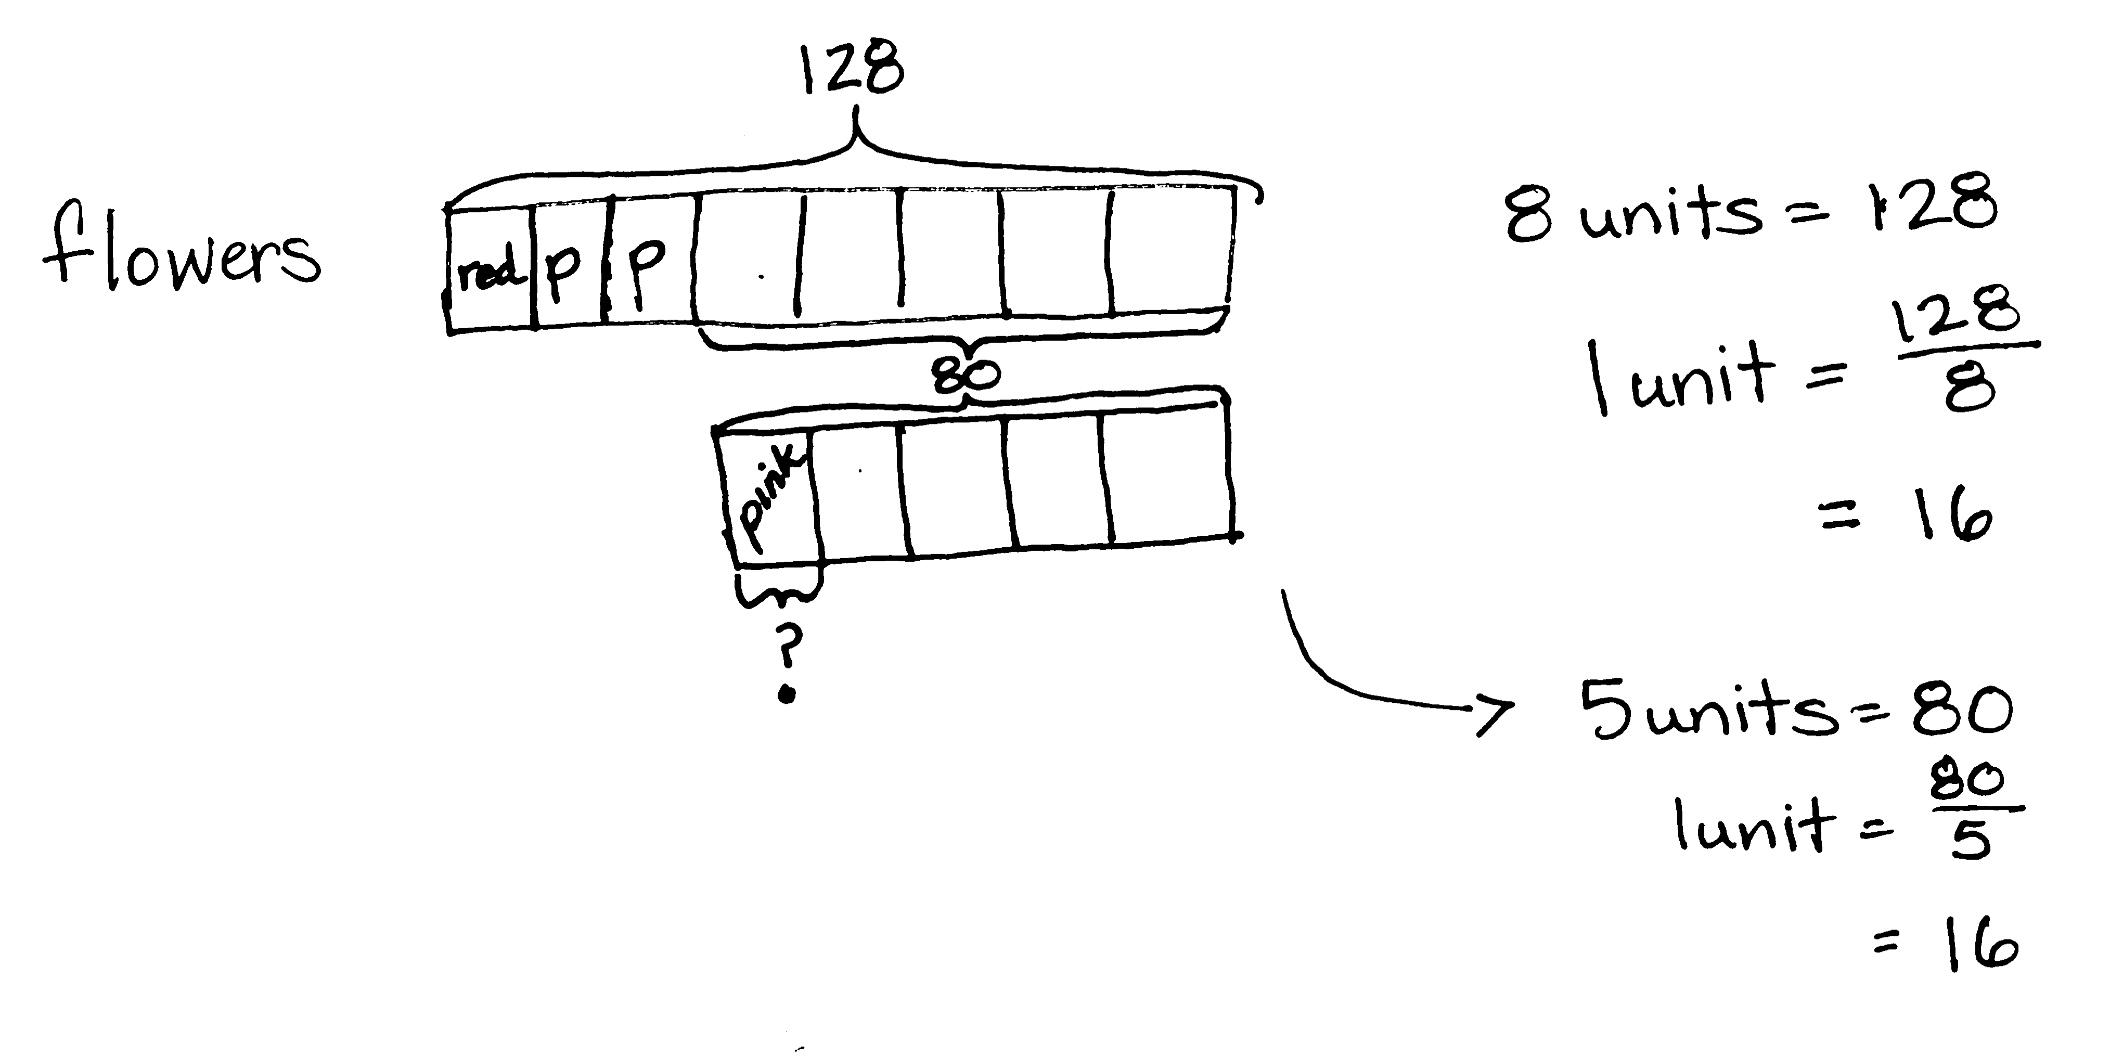
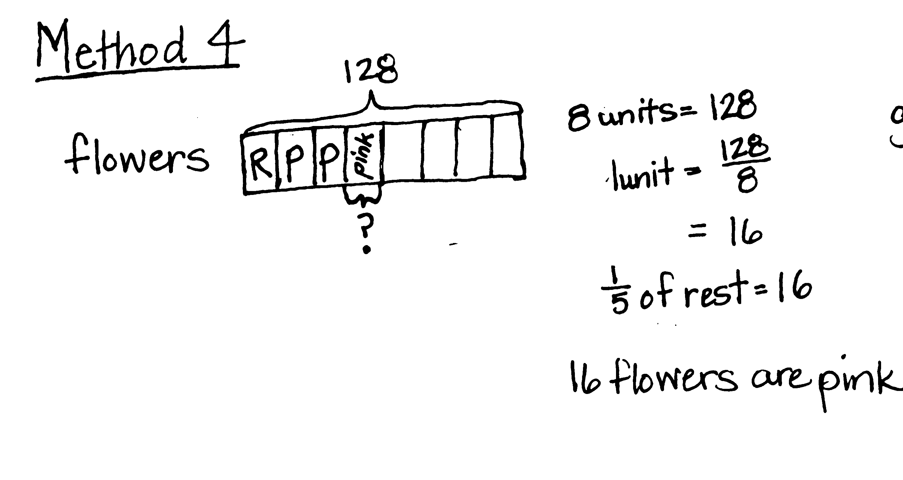

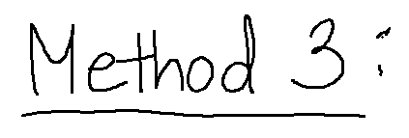
The complexity for this problem increases as students are asked to find the number of pink flowers in the garden. This portion of the flowers refers to 1 fifth of the remaining flowers (i.e., 1 fifth of those that are not red or purple), not 1 fifth of the total. Some students may realize (as in Method 4) that 1 fifth of the remainder is simply equal to 1 unit or 16 flowers. Multiple methods of drawing and solving are possible. Some of the possibilities are pictured above.

Problem 3
Lillian and Darlene plan to get their homework finished within one hour. Darlene completes her math homework in $\frac{3}{5}$ hour. Lillian completes her math homework with $\frac{5}{6}$ hour remaining. Who completes her homework faster and by how many minutes?
Bonus: Give the answer as a fraction of an hour.
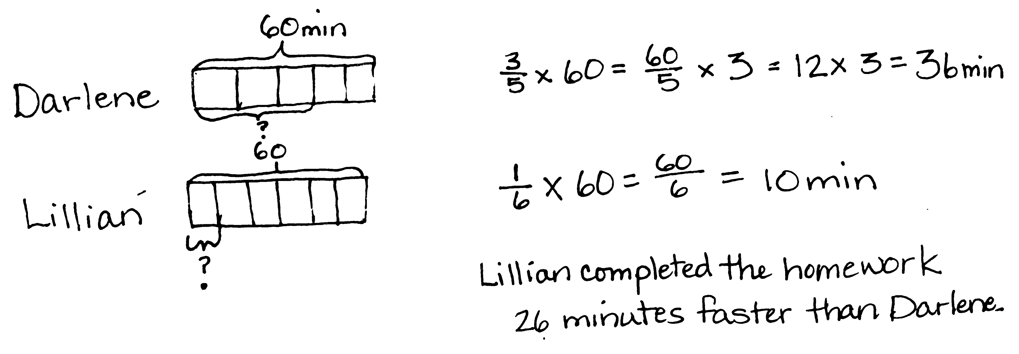
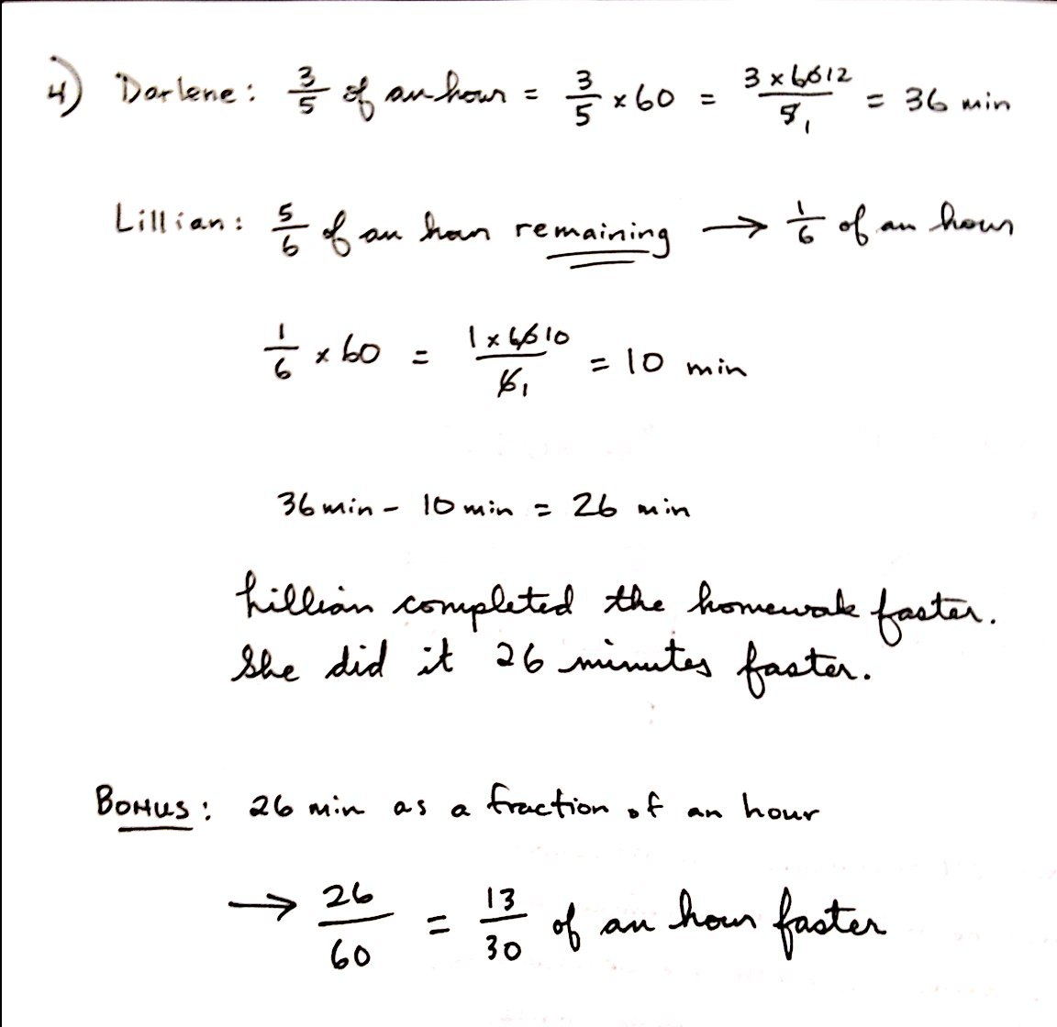
The way in which Lillian’s time is expressed establishes some complexity in this problem. Students must recognize that she only took $\frac{1}{6}$ hour to complete the assignment. Many students may quickly recognize that Lillian worked faster as $\frac{1}{6}$ $\text{<} \frac{3}{5}$. However, students must proceed further to find exactly how many minutes faster. The bonus requires them to give the fraction of an hour. Simplification of this fraction should not be required, but may be discussed.

Problem 4
Create and solve a story problem about a baker and some flour whose solution is given by the expression$\frac{1}{4}\text{×} \text{(3} \text{+} \text{5)}$.
Working backwards from expression to story may be challenging for some students. Since the expression given contains parentheses, the story created must first involve the addition or combining of 3 and 5. For students who require assistance, drawing a tape diagram first may help. Then, asking the simple prompt, “What would a baker add together or combine?” may be enough to help students begin. Evaluating $\frac{1}{4}\text{×} \text{(3} \text{+} \text{5)}$ should pose no significant challenge to students. Note that the story of the chef interprets the expression as repeated addition of a fourth where the story of the baker interprets the expression as a fraction of a set.
Problem 5
Create and solve a story problem about a baker and 36 kilograms of an ingredient that is modeled by the following tape diagram. Include at least one fraction in your story.
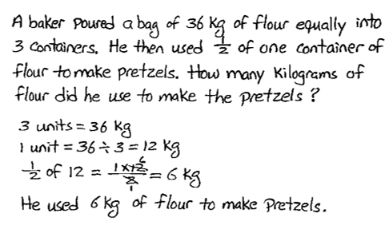
36 kg
?

Again, students are asked to both create and then solve a story problem, this time using a given tape diagram. The challenge here is that this tape diagram implies a two-step word problem. The whole, 36, is first partitioned into thirds, and then one of those thirds is divided in half. The story students create should reflect this two-part drawing. Students should be encouraged to share aloud, as well as discuss their stories and thought process for solving.

Problem 6
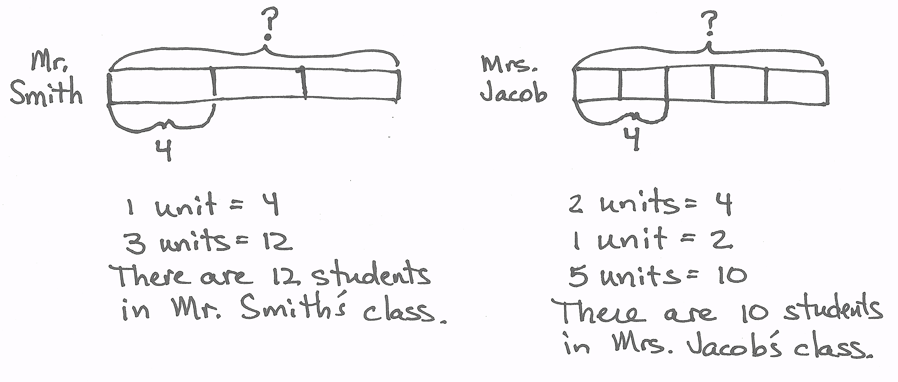
Of the students in Mr. Smith’s fifth grade class, $\frac{1}{3 }$ were absent on Monday. Of the students in Mrs. Jacobs’ class, $\frac{2}{5 }$ were absent on Monday. If there were 4 students absent in each class on Monday, how many students are in each class?
For this problem, students need to find the whole. An interesting aspect of this problem is that fractional amounts of different wholes can be the same amount. In this case, two-fifths of 10 is the same as one-third of 12. This should be discussed with students.
Student Debrief (10 minutes)
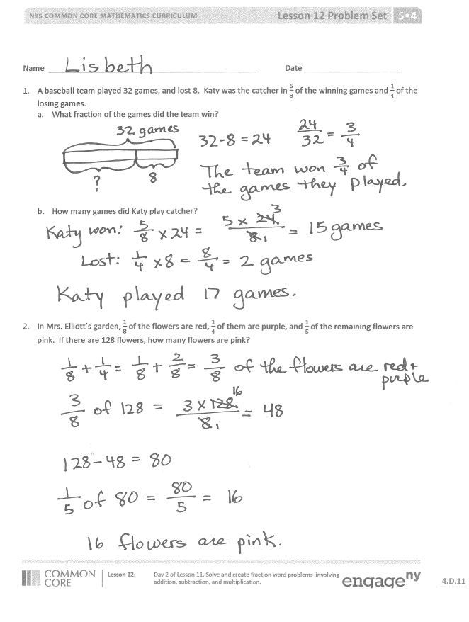
Lesson Objective: Solve and create fraction word problems involving addition, subtraction, and multiplication.
The Student Debrief is intended to invite reflection and active processing of the total lesson experience.
Invite students to review their solutions for the Problem Set. They should check work by comparing answers with a partner before going over answers as a class. Look for misconceptions or misunderstandings that can be addressed in the Debrief. Guide students in a conversation to debrief the Problem Set and process the lesson.
You may choose to use any combination of the questions below to lead the discussion.
- How are the problems similar? How are they different?
- How many strategies can you use to solve the problems?
- How was your solution the same and different from those that were demonstrated?
- Did you see other solutions that surprised you or made you see the problem differently?
- How many different story problems can you create for Problems 5 and 6?

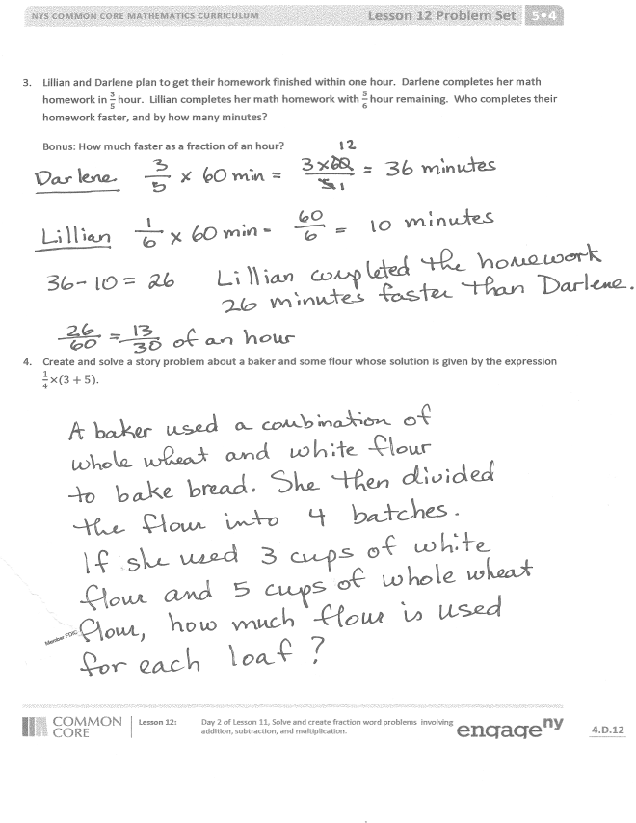
Exit Ticket (3 minutes)
After the Student Debrief, instruct students to complete the Exit Ticket. A review of their work will help you assess the students’ understanding of the concepts that were presented in the lesson today and plan more effectively for future lessons. You may read the questions aloud to the students.

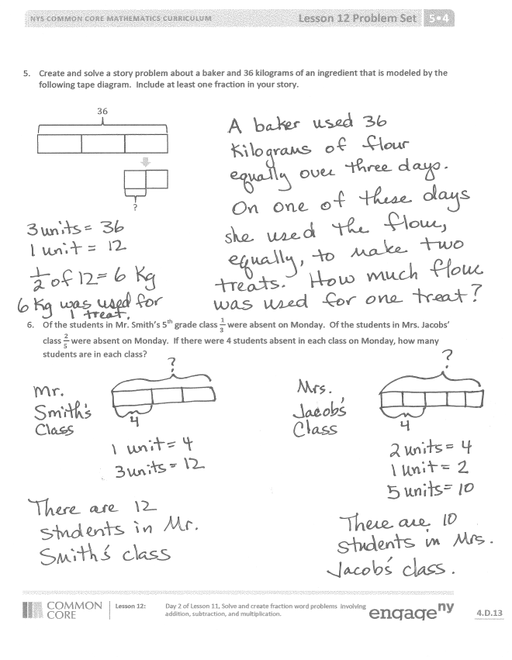

Name Date
- A baseball team played 32 games and lost 8. Katy was the catcher in $\frac{5}{8}$ of the winning games and $\frac{1}{4}$ of the losing games.
- What fraction of the games did the team win?

- In how many games did Katy play catcher?

- In Mrs. Elliott’s garden, $\frac{1}{8}$ of the flowers are red, $\frac{1}{4}$ of them are purple, and $\frac{1}{5}$ of the remaining flowers are pink. If there are 128 flowers, how many flowers are pink?

- Lillian and Darlene plan to get their homework finished within one hour. Darlene completes her math homework in $\frac{3}{5}$ hour. Lillian completes her math homework with $\frac{5}{6}$ hour remaining. Who completes her homework faster and by how many minutes?

Bonus: Give the answer as a fraction of an hour.

- Create and solve a story problem about a baker and some flour whose solution is given by the expression $\frac{1}{4}\text{×} \text{(3} \text{+} \text{5)}$.

- Create and solve a story problem about a baker and 36 kilograms of an ingredient that is modeled by the following tape diagram. Include at least one fraction in your story.

36 kg
?

- Of the students in Mr. Smith’s fifth grade class, $\frac{1}{3 }$ were absent on Monday. Of the students in Mrs. Jacobs’ class, $\frac{2}{5 }$ were absent on Monday. If there were 4 students absent in each class on Monday, how many students are in each class?

Name Date
In a classroom, $\frac{1}{6}$ of the students are wearing blue shirts and $\frac{2}{3}$ are wearing white shirts. There are 36 students in the class. How many students are wearing a shirt other than blue or white?

Name Date
- Terrence finished a word search in $\frac{3}{4}$ the time it took Frank. Charlotte finished the word search in $\frac{2}{3}$ the time it took Terrence. Frank finished the word search in 32 minutes. How long did it take Charlotte to finish the word search?

- Ms. Phillips ordered 56 pizzas for a school fundraiser. Of the pizzas ordered, $\frac{2}{7}$ of them were pepperoni, 19 were cheese, and the rest were veggie pizzas. What fraction of the pizzas was veggie?

- In an auditorium, $\frac{1}{6}$ of the students are fifth graders, $\frac{1}{3}$ are fourth graders, and $\frac{1}{4}$ of the remaining students are second graders. If there are 96 students in the auditorium, how many second graders are there?

- At a track meet, Jacob and Daniel compete in the 220-m hurdles. Daniel finishes in $\frac{3}{4}$ of a minute. Jacob finishes with $\frac{5}{12}$ of a minute remaining. Who ran the race in the faster time?

Bonus: Express the difference in their times as a fraction of a minute.

- Create and solve a story problem about a runner who is training for a race. Include at least one fraction in your story.

48 km
?

- Create and solve a story problem about two friends and their weekly allowance whose solution is given by the expression $\frac{1}{5}$ × (12 + 8).

