Lesson 11
Objective: Solve and create fraction word problems involving addition, subtraction, and multiplication.

Suggested Lesson Structure
 Fluency Practice (12 minutes)
 Concept Development (38 minutes)
 Student Debrief (10 minutes)
Total Time (60 minutes)
Fluency Practice (12 minutes)
- Convert Measures 4.MD.1 (5 minutes)
- Multiply Whole Numbers by Fractions Using Two Methods 5.NF.4 (3 minutes)
- Write the Expression to Match the Diagram 5.NF.4 (4 minutes)
Convert Measures (5 minutes)
Materials: (S) Personal white board, Grade 5 Mathematics Reference Sheet (Lesson 8 Reference Sheet)
Note: This fluency activity reviews Lessons 9–10 and prepares students for Lessons 11─12 content. Allow students to use the conversion reference sheet if they are confused, but encourage them to answer questions without referring to it.
T: (Write 2 c = __ pt.) How many pints are in 2 cups?
S: 1 pint.
T: (Write 2 c = 1 pt. Below it, write 4 c = __ pt.) 4 cups?
S: 2 pints.
T: (Write 4 c = 2 pt. Below it, write 6 c = __ pt.) 6 cups?
S: 3 pints.
T: (Write 6 c = 3 pt. Below it, write 20 c = __ pt.) On your personal white boards, write the equation.
S: (Write 20 c = 10 pt.)
T: (Write 20 c ÷ __ = __ pt.) Write the division equation you used to solve it.
S: (Write 20 c ÷ 2 = 10 pt.)
Continue with the following possible sequence: 12 in = 1 ft, 24 in = 2 ft, 48 in = 4 ft, 3 ft = 1 yd, 6 ft = 2 yd,
9 ft = 3 yd, 24 ft = 8 yd, 4 qt = 1 gal, 8 qt = 2 gal, 12 qt = 3 gal, and 36 qt = 9 gal.
Multiply Whole Numbers by Fractions Using Two Methods (3 minutes)
Materials: (S) Personal white board
Note: This fluency activity reviews Lesson 8.
T: (Write $\frac{1}{2}$ $\text{×}$ 8 = $\frac{ ____ × _____ }{2}$.) On your personal white boards, write the equation and fill in the multiplication expression for the numerator.
S: (Write $\frac{1}{2}$ × 8 = $\frac{ 1 × 8 }{2}$.)
T: (Write $\frac{1}{2}$ $\text{×}$8 = $\frac{ 1 × 8 }{2}$ = $\frac{}{}\text{=}$ .) Fill in the missing numbers.
S: (Write $\frac{1}{2}$ $\text{×}$ 8 = $\frac{ 1 × 8 }{2}$ = $\frac{8}{2}\text{=}$ 4.)
T: (Write $\frac{1}{2}$ × 8 = $\frac{ 1 × 8 }{2}$.) Divide by a common factor and solve.
⁴
¹
S: (Write $\frac{1}{2}$ $\text{×}$ 8 = $\frac{ 1 × 8 }{2}$ = 4.)
T: Did you reach the same answer using both methods?
S: Yes.
Continue with the following possible sequence: 12 × $\frac{ 1 }{4}$, 12 × $\frac{ 3 }{4}$, $\frac{ 2 }{3}$× 15, and 18 × $\frac{5}{6}$.
Write the Expression to Match the Diagram (4 minutes)
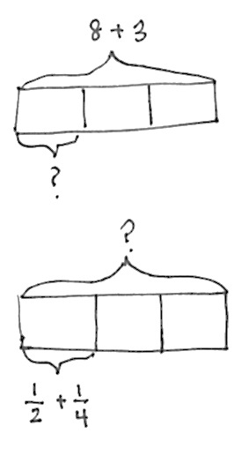
Materials: (S) Personal white board
Note: This fluency activity reviews Lesson 10.
T: (Project a tape diagram partitioned into 3 equal parts with 8 + 3 as the whole.) Say the value of the whole.
S: 11.
T: On your personal white boards, write an expression to match the diagram.
S: (Write (8 + 3) ÷ 3.)
T: Solve the expression.
S: (Beneath (8 + 3) ÷ 3, write $\frac{11}{3}$. Beneath $\frac{11}{3}$, write $\text{3}\frac{1}{3}$.)
Repeat this sequence with the following suggested problem: (5 + 6) ÷ 3.
T: (Project a tape diagram partitioned into 3 equal parts. Beneath one of the units, write $\frac{1}{2} \text{+} \frac{1}{4}$.) On your personal white boards, write an expression to match the diagram.
S: (Write $\left(\frac{1}{2} \text{+} \frac{1}{4}\right)\text{ × 3.)}$
T: Solve the expression.
S: (Beneath $\frac{1}{2} \text{+} \frac{1}{4} \text{× 3, write} \frac{3}{4} \text{× 3.}$ Beneath it, write $\frac{9}{4}$. Also, beneath that, write $\text{2}\frac{1}{4}$.)
Continue with the following possible suggested problem: $\left(\frac{1}{2} \text{+} \frac{2}{3}\right)\text{× 5}.$
Concept Development (38 minutes)
Materials: (S) Problem Set
Note: Because today’s lesson involves solving word problems, time allocated to the Application Problem has been allotted to the Concept Development.
Suggested Delivery of Instruction for Solving Lesson 11 Word Problems

NOTES ON
MULTIPLE MEANS
OF ENGAGEMENT:
When a task offers varied approaches for solving, an efficient way to have all students’ work shared is to hold a Museum Walk. Using this approach, student work is displayed, and then the students walk around from one piece to the next. This approach is similar to how one would view art in a gallery.
This method for sharing works best when a purpose for the observing is provided. For example, students might be asked to note similarities and differences in the drawing of a model or approach to a calculation. Students can indicate the similarities or differences by using color-coded sticky notes that are attached to the displays. Another way to react to the Museum Walk is to write about what they notice in journals.
- Model the problem.
Have two pairs of students who can successfully model the problem work at the board while the other students work independently or in pairs at their seats. Review the following questions before beginning the first problem:
- Can you draw something?
- What can you draw?
- What conclusions can you make from your drawing?
As students work, circulate. Reiterate the questions above. After two minutes, have the two pairs of students share only their labeled diagrams. For about one minute, have the demonstrating students receive and respond to feedback and questions from their peers.
- Calculate to solve and write a statement.
Give students two minutes to finish their work on that question, sharing their work and thinking with a peer. All students should then write their equations and statements of the answer.
- Assess the solution for reasonableness.
Give students one to two minutes to assess and explain the reasonableness of their solutions.
A general instructional note on today’s problems: The problem solving in today’s lesson requires that students combine their previous knowledge of adding and subtracting fractions with new knowledge of multiplying to find fractions of a set. The problems have been designed to encourage flexibility in terms of thinking by offering many avenues for solving each one. Be sure to conclude the work with plenty of time for students to present and compare approaches.

Problem 1
Kim and Courtney share a 16-ounce box of cereal. By the end of the week, Kim has eaten $\frac{3}{8}$ of the box, and Courtney has eaten $\frac{1}{4}$ of the box of cereal. What fraction of the box is left?

To complete Problem 1, students must find fractions of a set and use skills learned in Module 3 to add or subtract fractions.
As exemplified, students may solve this multi-step word problem using different methods. Consider demonstrating these two methods of solving Problem 1 if both methods are not mentioned by students. Point out that the rest of today’s Problem Set can be solved using multiple strategies as well.
If desired, this problem’s complexity may be increased by changing the amount of the cereal in the box to 20 ounces and Courtney’s fraction to $\frac{1}{3}$. This will produce a mixed number for both girls. Kim’s portion becomes $\text{7}\frac{1}{2}$ ounces, and Courtney’s becomes $\text{6}\frac{2}{3}$.

Problem 2
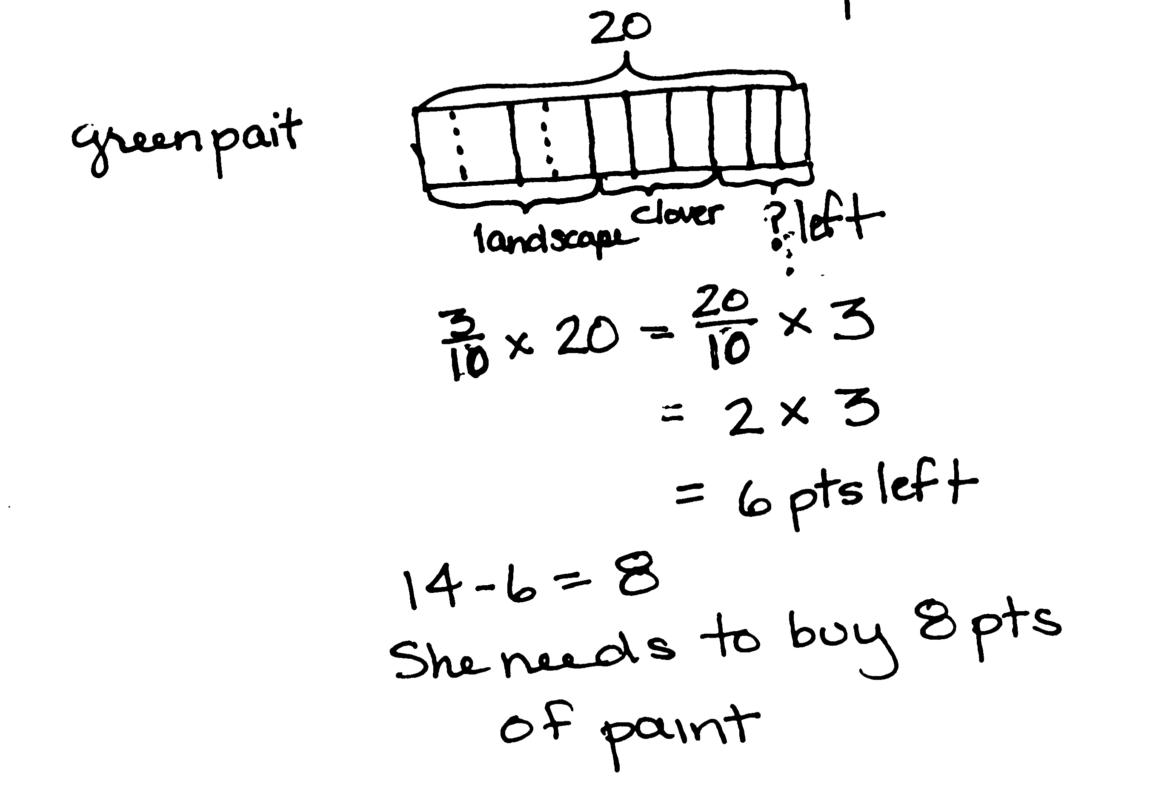
Mathilde has 20 pints of green paint. She uses $\frac{2}{5}$ of it to paint a landscape and $\frac{3}{10}$ of it while painting a clover. She decides that, for her next painting, she will need 14 pints of green paint. How much more paint will she need to buy?

Complexity is increased here because students are called on to maintain a high level of organization as they keep track of the attribute of paint used and not used. Multiple approaches should be encouraged. For Methods 1 and 2, the used paint is the focus of the solution. Students may choose to find the fractions of the whole (fraction of a set) Mathilde has used on each painting; they may also first add the separate fractions before finding the fraction of the whole. Subtracting that portion from the 14 pints she’ll need for her next project yields the answer to the question. Method 3 finds the leftover paint and simply subtracts it from the 14 pints needed for the next painting.

Problem 3
Jack, Jill, and Bill each carried a 48-ounce bucket full of water down the hill. By the time they reached the bottom, Jack’s bucket was only $\frac{3}{4}$ full, Jill’s was $\frac{2}{3}$ full, and Bill’s was $\frac{1}{6}$ full. How much water did they spill altogether on their way down the hill?
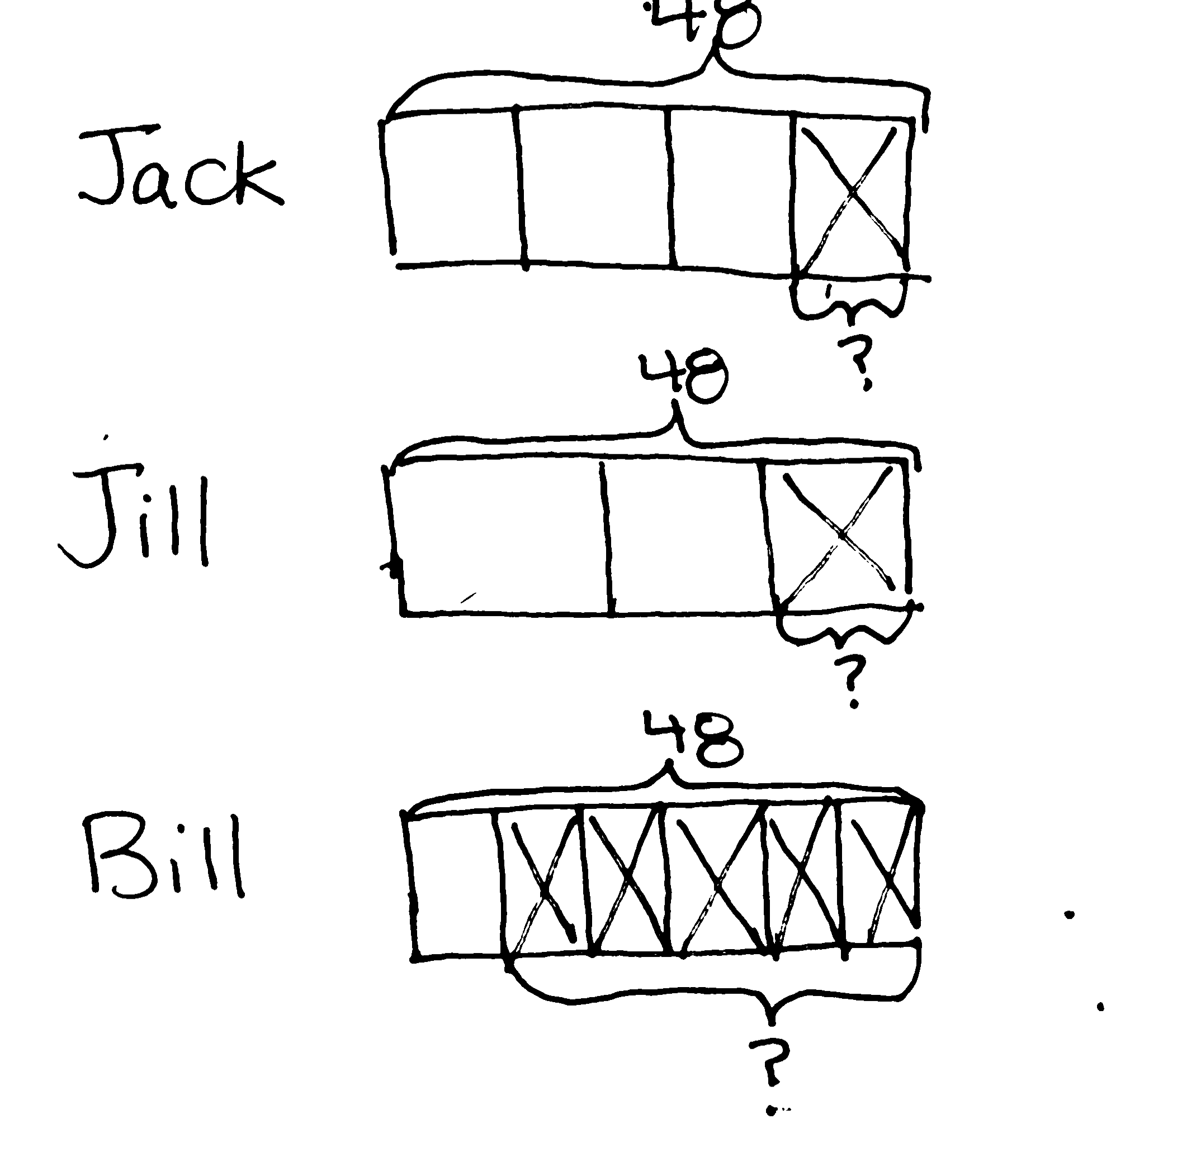

This problem is very similar to Problem 2 in that students keep track of one attribute—spilled water or un-spilled water. However, the inclusion of a third person, Bill, requires that students keep track of more information. In Method 1, a student may opt to find the fraction of water remaining in each bucket. This process requires the students to then subtract those portions from the 48 ounces that each bucket held originally. In Method 2, students may decide to find what fraction of the water has been spilled by counting on to a whole (e.g., if 3 fourths remain in Jack’s bucket, then only 1 fourth has been spilled). This is a more direct approach to the solution because subtraction from 48 is not necessary.

Problem 4
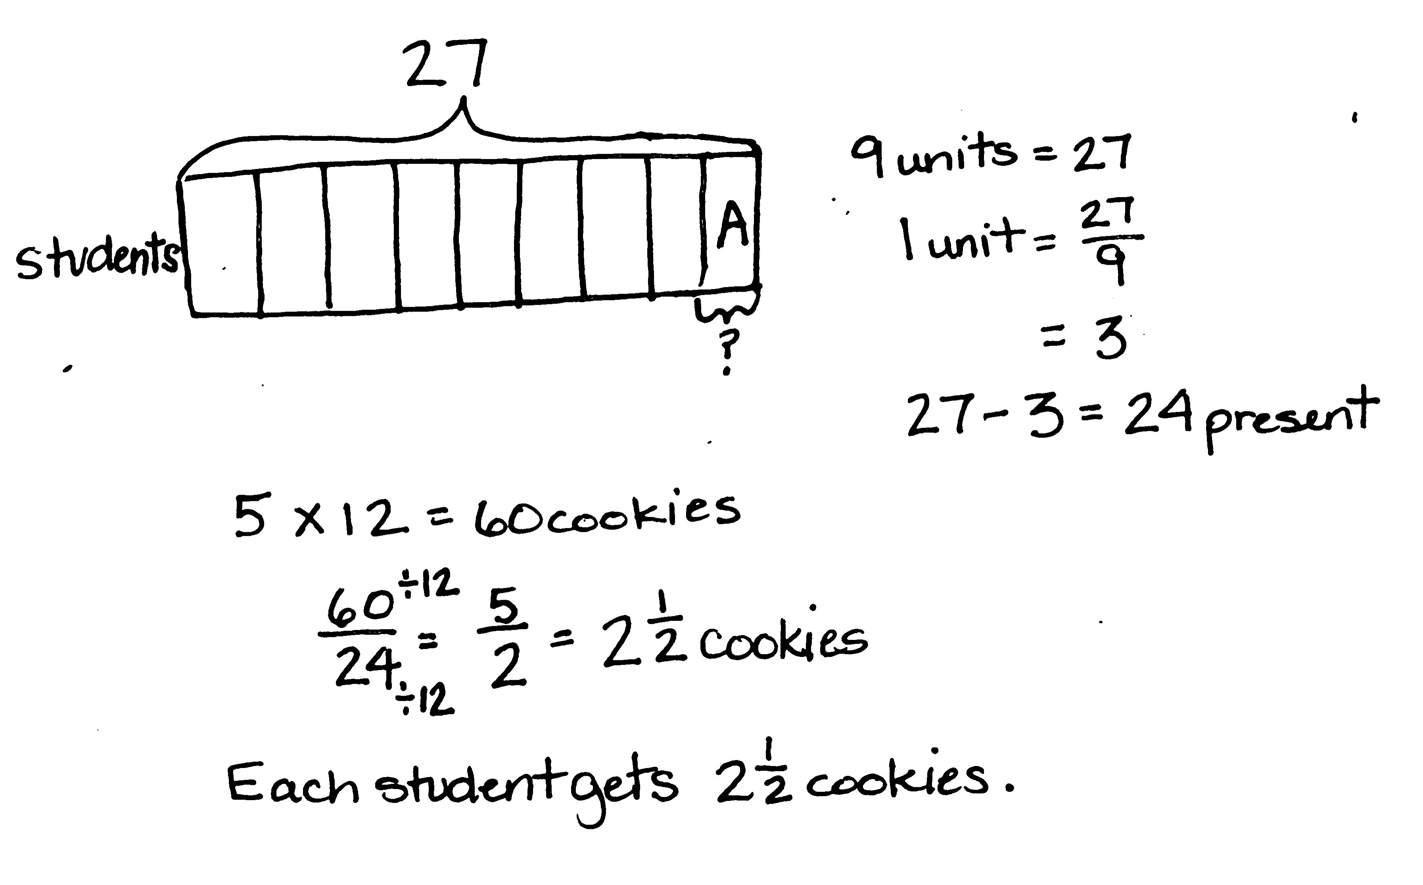
Mrs. Diaz makes 5 dozen cookies for her class. One-ninth of her 27 students are absent the day she brings the cookies. If she shares the cookies equally among the students who are present, how many cookies will each student get?

This problem is straightforward, yet the division of the cookies at the end provides an opportunity to call out the division interpretation of a fraction. With quantities such as 60 and 24, students will likely lean toward the long division algorithm, so using fraction notation to show the division may need to be discussed as an alternative. Using the fraction and renaming using larger units may be the more efficient approach given the quantities. The similarities and differences of these approaches certainly bear a moment’s discussion. Additionally, the practicality of sharing cookies in twenty-fourths can result in a discussion of renaming
$\text{2}\frac{12}{24}$ as $\text{2}\frac{1}{2}$.

Problem 5
Create a story problem about a fish tank for the tape diagram below. Your story must include a fraction.
84
?

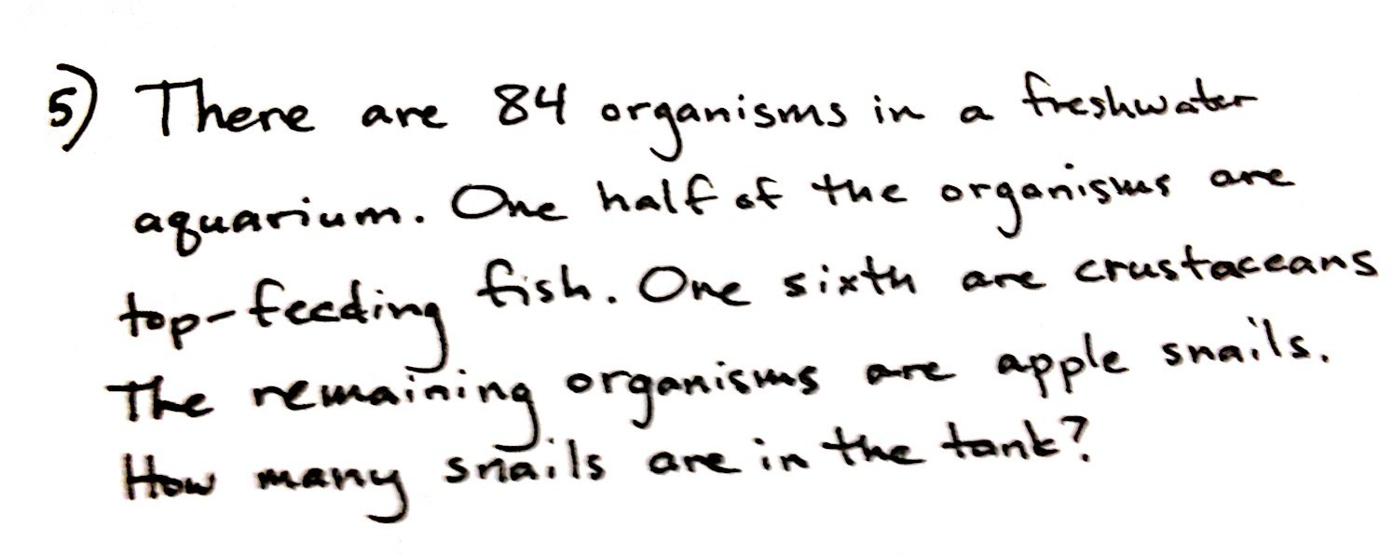

In this problem, students are shown a tape diagram marking 84 as the whole and partitioned into 6 equal units (or sixths). The question mark should signal students to find $\frac{2}{6}$ of the whole.

NOTES ON
MULTIPLE MEANS
OF ACTION AND EXPRESSION:
Generally, early finishers for this lesson will be students who use an abstract, more procedural approach to solving. These students might be asked to work the problems again using well-drawn tape diagrams that explain why their calculations are valid. These models could be displayed in hallways or placed in a class book.
Students are asked to create a word problem about a fish tank. Students should be encouraged to use their creativity while generating a word problem, but remain mathematically sound. Two sample stories are included here, but this is a good opportunity to have students share their own word problems aloud.

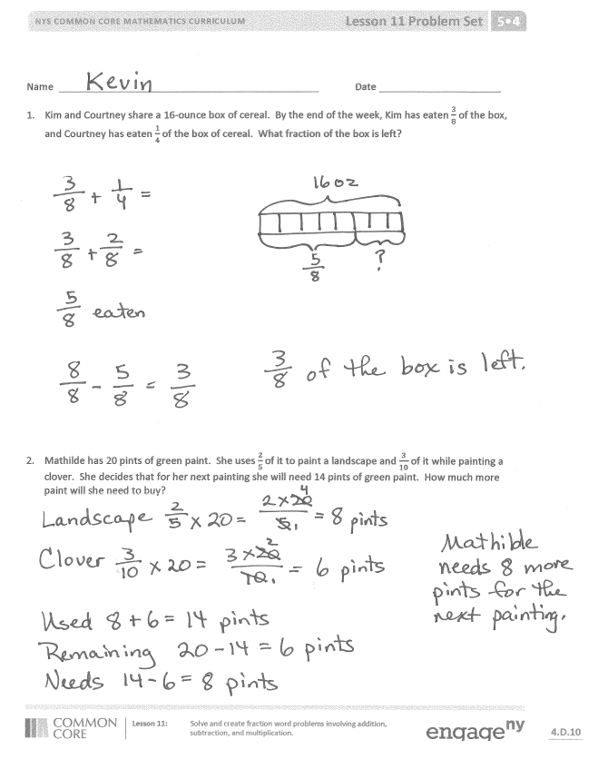
Student Debrief (10 minutes)
Lesson Objective: Solve and create fraction word problems involving addition, subtraction, and multiplication.
The Student Debrief is intended to invite reflection and active processing of the total lesson experience.
Invite students to review their solutions for the Problem Set. They should check work by comparing answers with a partner before going over answers as a class. Look for misconceptions or misunderstandings that can be addressed in the Debrief. Guide students in a conversation to debrief the Problem Set and process the lesson.
You may choose to use any combination of the questions below to lead the discussion.
- How are the problems alike? How are they different?
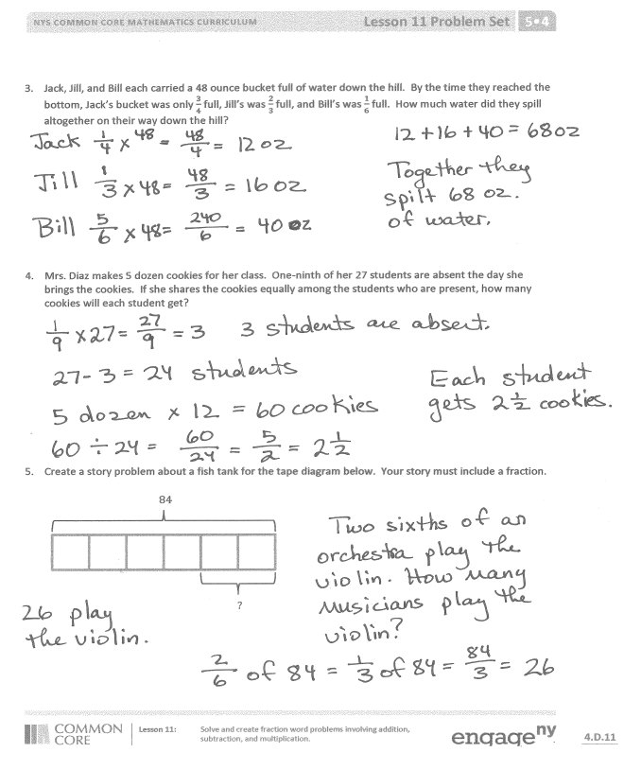
- How many strategies can you use to solve the problems?

- How was your solution the same and different from those that were demonstrated?
- Did you see other solutions that surprised you or made you see the problem differently?
- How many different story problems can you create for Problem 5?
Exit Ticket (3 minutes)
After the Student Debrief, instruct students to complete the Exit Ticket. A review of their work will help you assess the students’ understanding of the concepts that were presented in the lesson today and more effectively for future lessons. You may read the questions aloud to the students.

Name Date
- Kim and Courtney share a 16-ounce box of cereal. By the end of the week, Kim has eaten $\frac{3}{8}$ of the box, and Courtney has eaten $\frac{1}{4}$ of the box of cereal. What fraction of the box is left?

- Mathilde has 20 pints of green paint. She uses $\frac{2}{5}$ of it to paint a landscape and $\frac{3}{10}$ of it while painting a clover. She decides that, for her next painting, she will need 14 pints of green paint. How much more paint will she need to buy?

- Jack, Jill, and Bill each carried a 48-ounce bucket full of water down the hill. By the time they reached the bottom, Jack’s bucket was only $\frac{3}{4}$ full, Jill’s was $\frac{2}{3}$ full, and Bill’s was $\frac{1}{6}$ full. How much water did they spill altogether on their way down the hill?

- Mrs. Diaz makes 5 dozen cookies for her class. One-ninth of her 27 students are absent the day she brings the cookies. If she shares the cookies equally among the students who are present, how many cookies will each student get?

- Create a story problem about a fish tank for the tape diagram below. Your story must include a fraction.
84
?

Name Date
Use a tape diagram to solve.
$\frac{2}{3}$ of 5

Name Date
- Jenny’s mom says she has an hour before it’s bedtime. Jenny spends $\frac{1}{3}$ of the hour texting a friend and $\frac{1}{4}$ of the time brushing her teeth and putting on her pajamas. She spends the rest of the time reading her book. How many minutes did Jenny read?

- A-Plus Auto Body is painting designs on a customer’s car. They had 18 pints of blue paint on hand. They used $\frac{1}{2}$ of it for the flames, and $\frac{1}{3}$of it for the sparks. They need $\text{7}\frac{3}{4}$ pints of blue paint to paint the next design. How many more pints of blue paint will they need to buy?

- Giovanna, Frances, and their dad each carried a 10-pound bag of soil into the backyard. After putting soil in the first flower bed, Giovanna’s bag was $\frac{5}{8}$ full, Frances’ bag was $\frac{2}{5}$ full, and their dad’s was $\frac{3}{4}$ full. How many pounds of soil did they put in the first flower bed altogether?

- Mr. Chan made 252 cookies for the Annual Fifth Grade Class Bake Sale. They sold $\frac{3}{4}$ of them, and $\frac{3}{9}$ of the remaining cookies were given to P.T.A. members. Mr. Chan allowed the 12 student helpers to divide the cookies that were left equally. How many cookies will each student get?

- Using the tape diagram below, create a story problem about a farm. Your story must include a fraction.
105
?

