Lesson 10
Objective: Compare and evaluate expressions with parentheses.

Suggested Lesson Structure
 Fluency Practice (12 minutes)
 Application Problem (5 minutes)
 Concept Development (33 minutes)
 Student Debrief (10 minutes)
Total Time (60 minutes)
Fluency Practice (12 minutes)
- Convert Measures from Small to Large Units 4.MD.1 (5 minutes)
- Multiply a Fraction and a Whole Number 5.NF.4 (3 minutes)
- Find the Unit Conversion 5.MD.2 (4 minutes)
Convert Measures from Small to Large Units (5 minutes)
Materials: (S) Personal white board, Grade 5 Mathematics Reference Sheet (Lesson 8 Reference Sheet)
Note: This fluency activity reviews Lesson 9 and prepares students for Lessons 10–12 content. Allow students to use the conversion reference sheet if they are confused, but encourage them to answer questions without referring to it.
T: (Write 12 in = __ ft.) How many feet are in 12 inches?
S: 1 foot.
T: (Write 12 in = 1 ft. Below it, write 24 in = __ ft.) 24 inches?
S: 2 feet.
T: (Write 24 in = 2 ft. Below it, write 36 in = __ ft.) 36 inches?
S: 3 feet.
T: (Write 36 in = 3 ft. Below it, write 48 in = __ ft.) 48 inches?
S: 4 feet.
T: (Write 48 in = 4 ft. Below it, 120 in = __ ft.) On your boards, write the equation.
S: (Write 120 in = 10 ft.)
T: (Write 120 in ÷ __ = __ ft.) Write the division equation you used to solve it.
S: (Write 120 in ÷ 12 = 10 ft.)
Continue with the following possible sequence: 2 c = 1 pt, 4 c = 2 pt, 6 c = 3 pt, 16 c = 8 pt, 3 ft = 1 yd,
6 ft = 2 yd, 9 ft = 3 yd, 27 ft = 9 yd, 4 qt = 1 gal, 8 qt = 2 gal, 12 qt = 3 gal, and 24 qt = 6 gal.
Multiply a Fraction and a Whole Number (3 minutes)
Materials: (S) Personal white board
Note: This fluency activity reviews Lesson 8.
T: ( $\frac{1}{2}\text{× 6} \text{=} \frac{_____×_____ }{2}$.) On your personal white boards, fill in the multiplication expression for the numerator.
S: (Write $\frac{1}{2}$ × 6 = $\frac{ 1 × 6 }{2}$.)
T: (Write $\frac{1}{2}$ × 6 = $\frac{ 1 × 6 }{2}$ = $\frac{}{}\text{=}$ .) Fill in the missing numbers.
S: (Write $\frac{1}{2}$ × 6 = $\frac{ 1 × 6 }{2}$ = $\frac{6}{2}\text{=}$ 3.)
T: (Write $\frac{1}{2}$ × 6 = $\frac{ 1 × 6 }{2}$ = .) Find a common factor to simplify. Then, multiply.
³
S: (Write $\frac{1}{2}$ × 6 = $\frac{ 1 × 6 }{2}$ = $\frac{3}{1}$ = 3.)
¹
Continue with the following possible suggestions: 6 × $\frac{1}{3 }$, 9 × $\frac{2}{3 }$, $\frac{3}{4}$× 12, and 12 × $\frac{5}{6}$.
Find the Unit Conversion (4 minutes)
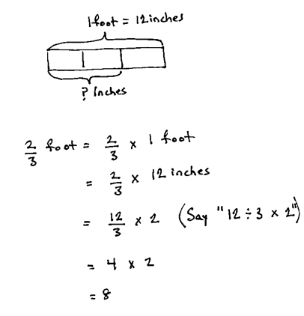
Materials: (S) Personal white board
Note: This fluency activity reviews Lesson 9.
T: 1 foot is equal to how many inches?
S: 12 inches.
T: (Write 1 ft = 12 inches to label the tape diagram. Below it, write $\frac{2}{3}$ ft = $\frac{2}{3}$ × 1 ft.) Rewrite the expression on the right of the equation on your personal white board, substituting 12 inches for 1 foot.
S: (Write $\frac{2}{3}$ × 12 inches.)
T: How many inches in each third? Represent the division using a fraction.
S: $\frac{12}{3}$.
T: How many inches in 2 thirds of a foot? Keep the division as a fraction.
S: (Write $\frac{12}{3}$ × 2 = 8 inches.)
T: Let’s read it. 12 divided by 3 times 2.
T: How many inches are equal to $\frac{2}{3}$ foot?
S: 8 inches.
Continue with the following possible sequence: $\frac{1}{4}$ lb = __ oz, $\frac{5}{6}$ yr = __ months, $\frac{7}{8}$ lb = __ oz, and $\frac{3}{4}$ hr = __ min.
Application Problem (5 minutes)
Bridget has $240. She spent $\frac{3}{5}$ of her money and saved the rest. How much more money did she spend than save?
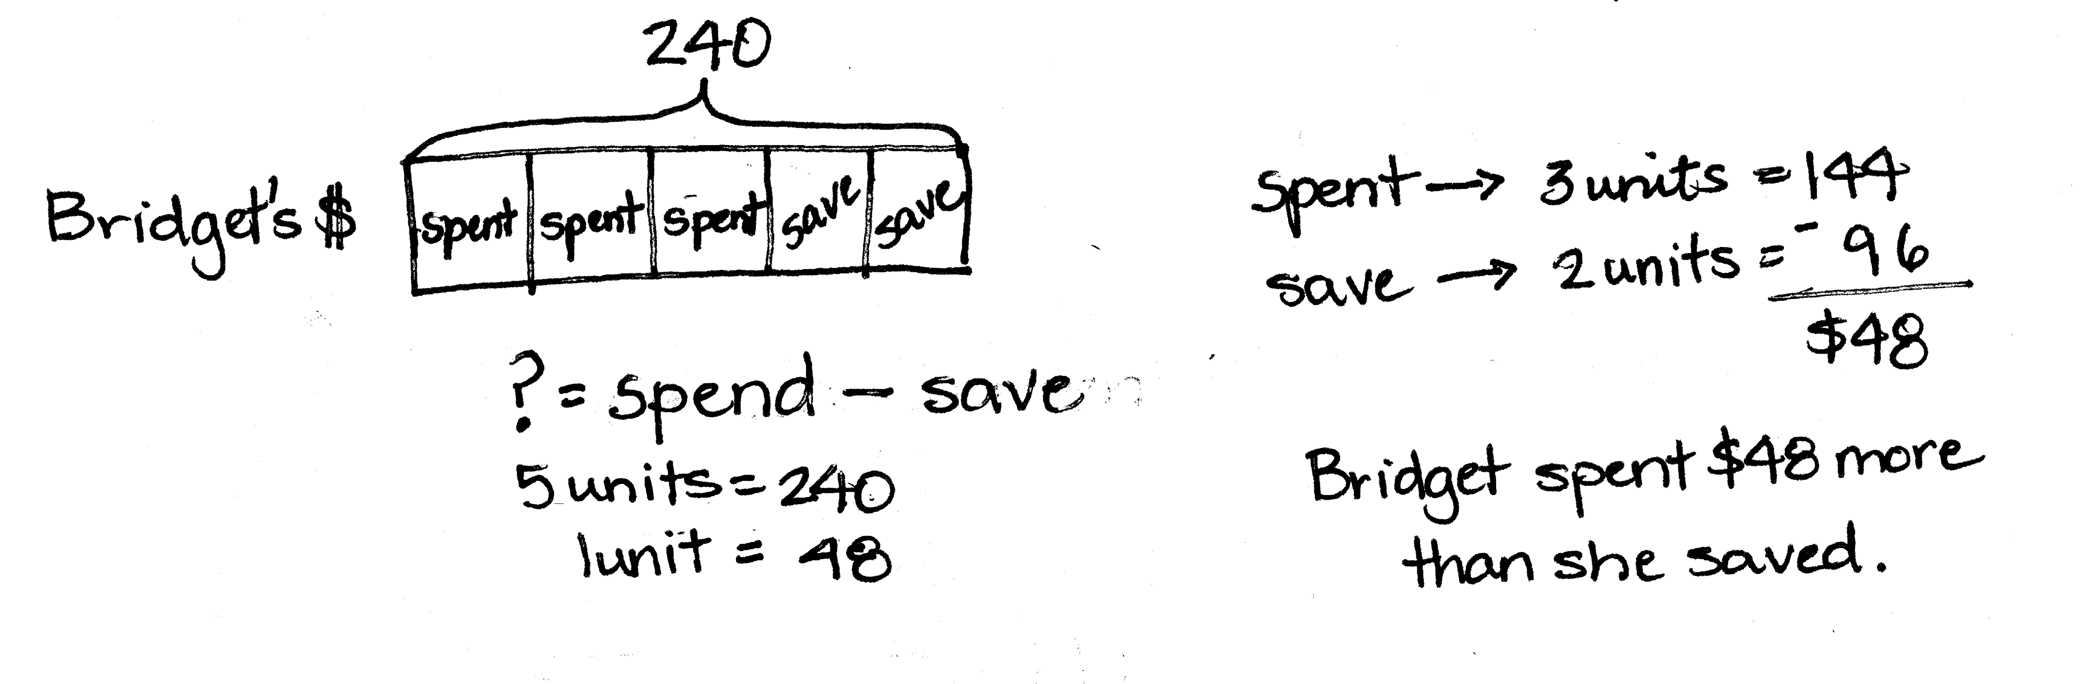
Note: This Application Problem provides a quick review of fraction of a set, which students who have been working on in Topic C, and provides a bridge to the return to this work in Lesson 11. It is also a multi-step problem.
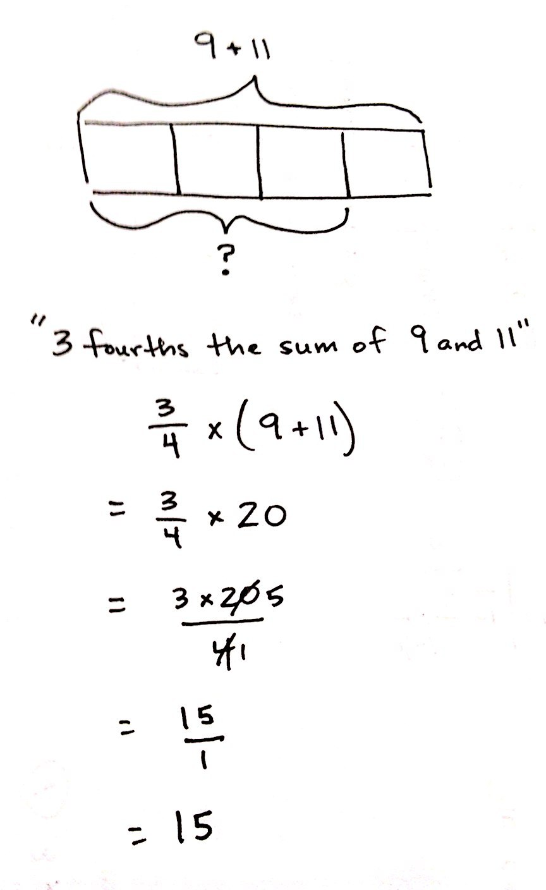
Concept Development (33 minutes)
Materials: (S) Personal white boards
Problem 1: Write an expression to match a tape diagram. Then, evaluate.
a.

T: (Post the first tape diagram.) Read the expression that names the whole.
S: 9 + 11.
T: What do we call the answer to an addition sentence?

NOTES ON
MULTIPLE MEANS
OF REPRESENTATION:
If students have difficulty understanding the value of a unit as a subtraction sentence, write a whole number on one side of a small piece of construction paper and the equivalent subtraction expression on the other side. Place the paper on the model with the whole number facing up, and ask what must be done to find the whole. (Most will understand the process of multiplying to find the whole.) Write the multiplication expression using the paper, whole number side up. Then, flip the paper over and show the parallel expression using the subtraction sentence.
S: A sum.
T: So, our whole is the sum of 9 and 11. (Write the sum of 9 and 11 next to the tape diagram.) How many units is the sum being divided into?
S: Four.
T: What is the name of that fractional unit?
S: Fourths.
T: How many fourths are we trying to find?
S: 3 fourths.
T: So, this tape diagram is showing 3 fourths of the sum of 9 and 11. (Write 3 fourths next to the sum of 9 and 11.) Work with a partner to write a numerical expression to match these words.
S: $\left(\text{9} \text{+} \text{11}\right)\text{ ×} \frac{3}{4}$. $\frac{3}{4} \text{× (9} \text{+} \text{11)}$. $\frac{9 + 11}{4}$ $\text{×}$ 3.
T: I noticed that many of you put parentheses around
9 + 11. Explain to a neighbor why that is necessary.
S: The parentheses tell us to add 9 and 11 first, and then multiply. If the parentheses weren’t there, we would have to multiply first. We want to find the sum first, and then multiply. We can find the sum of 9 and 11 first, and then divide the sum by 4 to find the value of one unit.
T: Work with a partner to evaluate or simplify this expression.
S: (Work to find 15.)
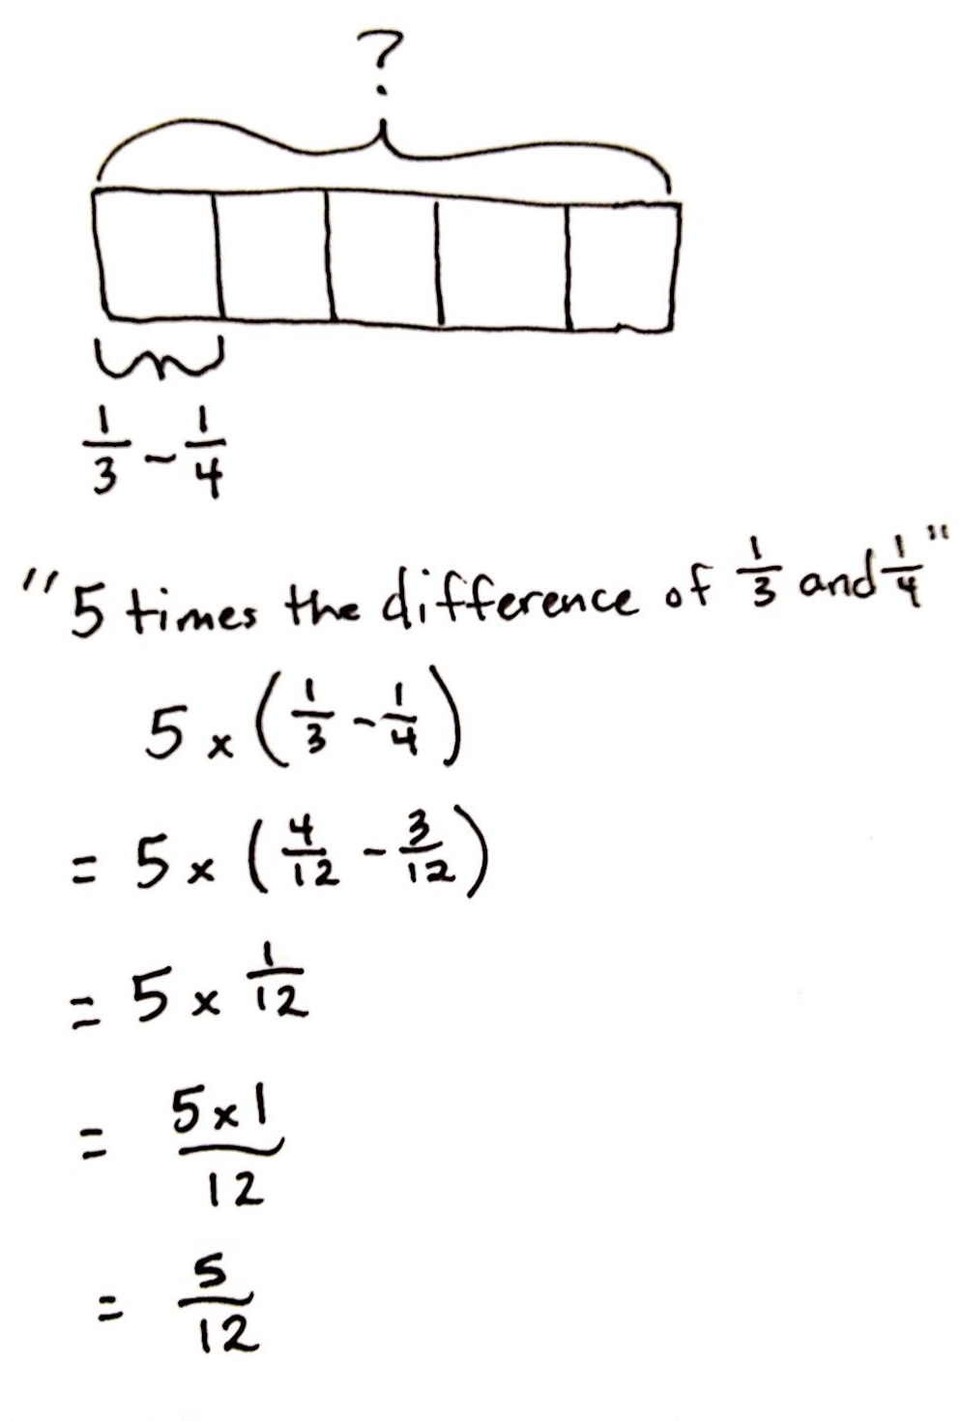
b.

T: (Post the second tape diagram.) Look at this model. How is it different from the previous example?
S: This time, we don’t know the whole. In this diagram, the whole is being divided into fifths, not fourths. Here, we know what 1 fifth is. We know it is the difference of $\frac{1}{3}$ and $\frac{1}{4}$. We have to multiply the difference of $\frac{1}{3}$ and $\frac{1}{4}$ by 5 to find the whole.
T: Read the subtraction expression that tells the value of one unit (or 1 fifth) in the model. (Point to$\frac{1}{3}-\frac{1}{4}$.)
S: One-third minus one-fourth.
T: What is the name for the answer to a subtraction problem?
S: A difference.
T: This unit is the difference of one-third and one-fourth. (Write the difference of $\frac{1}{3}$ and $\frac{1}{4}$ next to the tape diagram.) How many of these $\left(\frac{1}{3}-\frac{1}{4}\right)$ units does our model show?
S: 5 units of $\frac{1}{3}-\frac{1}{4}$.
T: Work with a partner to write a numerical expression to match these words.
S: $\text{5 ×}\left(\frac{1}{3}-\frac{1}{4}\right)$ or $\left(\frac{1}{3}-\frac{1}{4}\right)\text{× 5}$.
T: Do we need parentheses for this expression?
S: Yes, we need to subtract first before multiplying.
T: Evaluate this expression independently. Then, compare your work with a neighbor.
Problem 2: Write and evaluate an expression from word form.
T: (Write the product of 4 and 2, divided by 3 on the board.) Read the expression.
S: The product of 4 and 2, divided by 3.
T: Work with a partner to write a matching numerical expression.
S: (4 × 2) ÷ 3. $\frac{4 × 2}{3}$. 4 × 2 ÷ 3.
T: Were the parentheses necessary here? Why or why not?

NOTES ON
MULTIPLE MEANS
OF REPRESENTATION:
It may be necessary to prompt students to use fraction notation for the division portion of the expression. Pointing out the format of the division sign—dot over dot—may serve as a good reminder. Reminding students of problems from the beginning of Module 4 may also be helpful (e.g.,
2 ÷ 3 = $\frac{2}{3}$ ).
S: No. Because the product came first, and we can do multiplication and division left to right. We didn’t need them. I wrote it as a fraction. I didn’t use parentheses because I knew before I could divide by 3 that I needed to find the product in the numerator.
T: Work independently to evaluate your expression. Express your answer as both a fraction greater than one and a mixed number. Check your work with a neighbor when you’re finished.
S: (Work to find $\frac{8}{3}$ and $2\frac{2}{3}$. Then, check.)

Problem 3: Evaluate and compare equivalent expressions.
a. 2 $\text{÷}$ 3 × 4 b. 4 thirds doubled
c. 2 $\text{÷}$ (3 × 4) d. $\frac{2}{3}$ × 4
e. 4 copies of the sum of one-third and one-third f. (2 $\text{÷}$ 3) × 4

T: Evaluate these expressions with your partner. Continue working until I call time. Be prepared to share.
S: (Work.)
T: Share your work with someone else’s partner. What do you notice?
S: The answer is 8 thirds every time, except (c). All of the expressions are equivalent, except (c). These are just different ways of expressing $\frac{8}{3}$.
T: What was different about (c)?
S: Since the expression had parentheses, we had to multiply first, and then divide. It was equal to 2 twelfths. It’s tricky. In expression C, all of the numbers, digits, and operations are the same as the other expressions, but the order of the numbers and parentheses resulted in a different value.
T: Work with a partner to find another way of expressing $\frac{3}{5}\text{×} \text{6}$.
S: (Work. Possible expressions include: 3 × (6 ÷ 5). 3 × 6 ÷ 5. 3 $\text{×}$ $\frac{6}{5}$. 6 times the value of 3 divided by 5.)
Invite students to share their expressions on the board and to discuss.
Problem 5: Compare expressions in word and numerical forms.
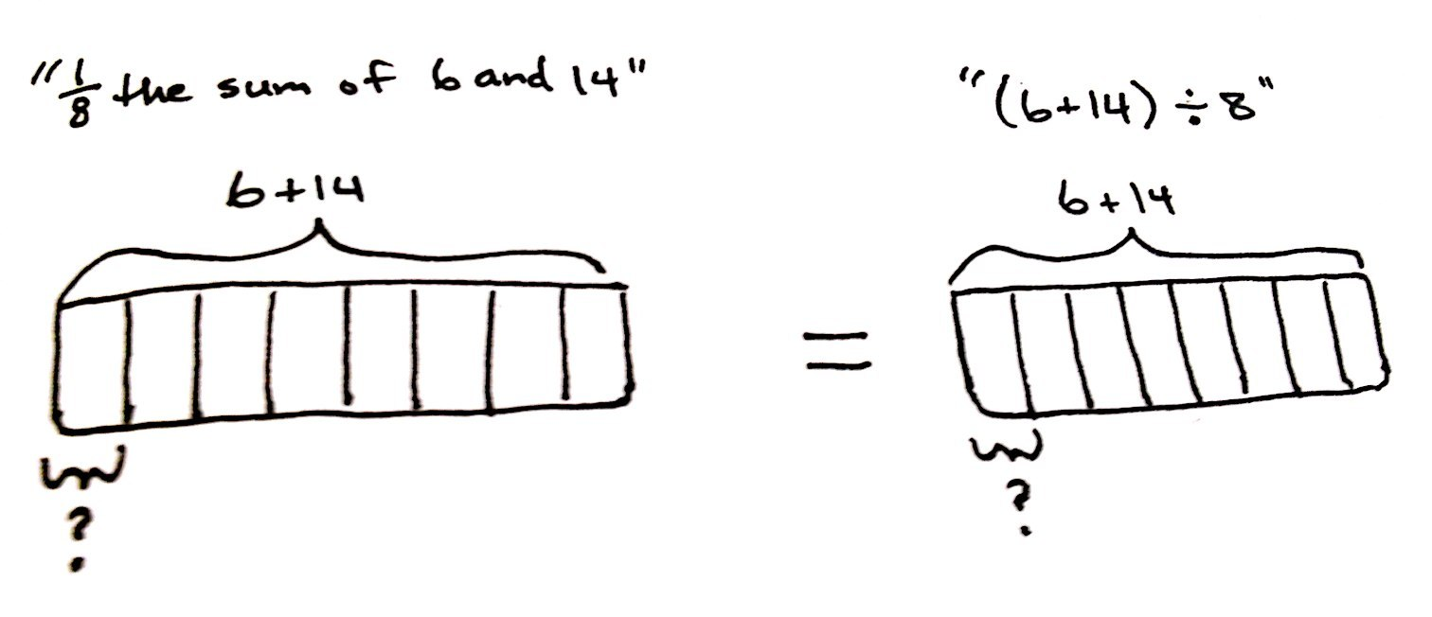
a. $\frac{1}{8}$ the sum of 6 and 14 (6 + 14) $\text{÷}$ 8
b. 4 × $\frac{8}{3}$ 4 times the quotient of 3 and 8
c. Subtract 2 from $\frac{1}{2}$ of 9 (11 $\text{÷}$ 2) – 2

T: Let’s use <, >, or = to compare expressions. (Write $\frac{1}{8}$ the sum of 6 and 14 and (6 + 14) $÷$ 8 on the board.) Draw a tape diagram for each expression and compare them.
S: (Write $\frac{1}{8}$ the sum of 6 and 14 = (6 + 14) $÷$8.)
T: What do you notice about the diagrams?
S: They are drawn exactly the same way. We don’t even need to evaluate the expressions to compare them. You can see that they will simplify to the same quantity. I knew it would be the same before I drew it because finding 1 eighth of something and dividing by 8 are the same thing.
T: Look at the next pair of expressions. Work with your partner to compare them without calculating.
S: (Work and write 4 × $\frac{8}{3}$ $\text{>}$4 times the quotient of 3 and 8.)
T: How did you compare these expressions without calculating?
S: They both multiply something by 4. Since 8 thirds is greater than 3 eighths, the expression on the left is larger. Since both expressions multiply with a factor of 4, the fraction that shows the smaller amount results in a product that is also less.
T: Compare the final pair of expressions independently without calculating. Be prepared to share your thoughts.
S: (Work and write subtract 2 from $\frac{1}{2}$ of 9 $\text{<}$(11 $÷$ 2) – 2.)
T: How did you know which expression was greater? Turn and talk.
S: 11 divided by 2 is 11 halves, and 11 halves is greater than 9 halves. Half of 9 is less than half of 11, and since we’re subtracting 2 from both of them, the expression on the right is greater.
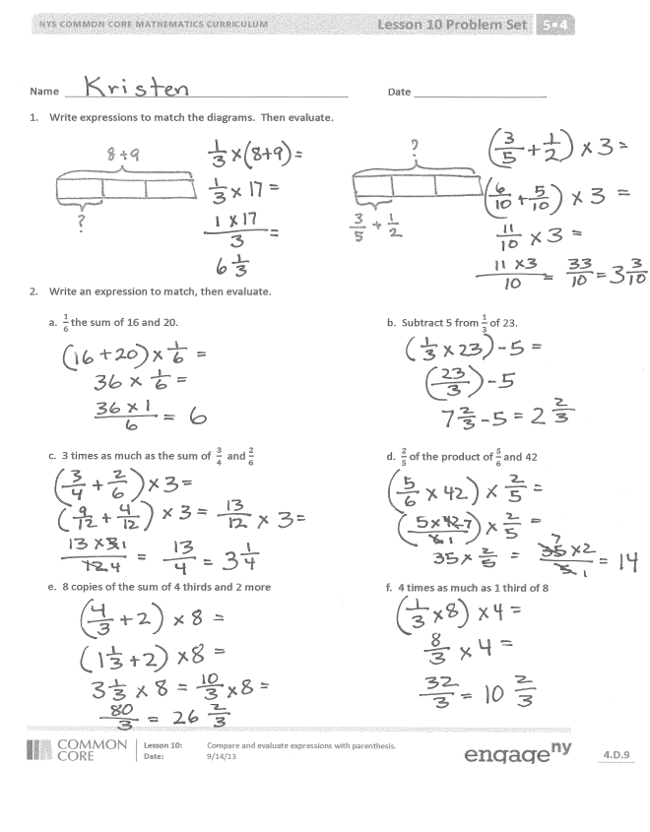
Problem Set (10 minutes)
Students should do their personal best to complete the Problem Set within the allotted 10 minutes. For some classes, it may be appropriate to modify the assignment by specifying which problems they work on first. Some problems do not specify a method for solving. Students solve these problems using the RDW approach used for Application Problems.
Student Debrief (10 minutes)
Lesson Objective: Compare and evaluate expressions with parentheses.
The Student Debrief is intended to invite reflection and active processing of the total lesson experience.
Invite students to review their solutions for the Problem Set. They should check work by comparing answers with a partner before going over answers as a class. Look for misconceptions or misunderstandings that can be addressed in the Debrief. Guide students in a conversation to debrief the Problem Set and process the lesson.
You may choose to use any combination of the questions below to lead the discussion.
- What relationships did you notice between the two tape diagrams in Problem 1?
- Share and explain your solution for Problem 3 with your partner.
- What were your strategies of comparing Problem 4? Explain it to your partner.
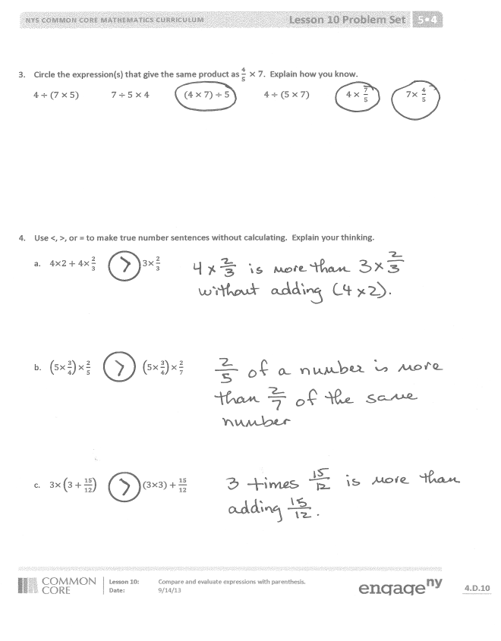
- How does the use of parentheses affect the answer in Problems 4(b) and 4(c)?
- Were you able to compare the expressions in Problem 4(c) without calculating? What made it more difficult than (a) and (b)?
- Explain to your partner how you created the line plot in Problem 5(d)? Compare your line plot to your partner’s.
Exit Ticket (3 minutes)
After the Student Debrief, instruct students to complete the Exit Ticket. A review of their work will help you assess the students’ understanding of the concepts that were presented in the lesson today and plan more effectively for future lessons. You may read the questions aloud to the students.
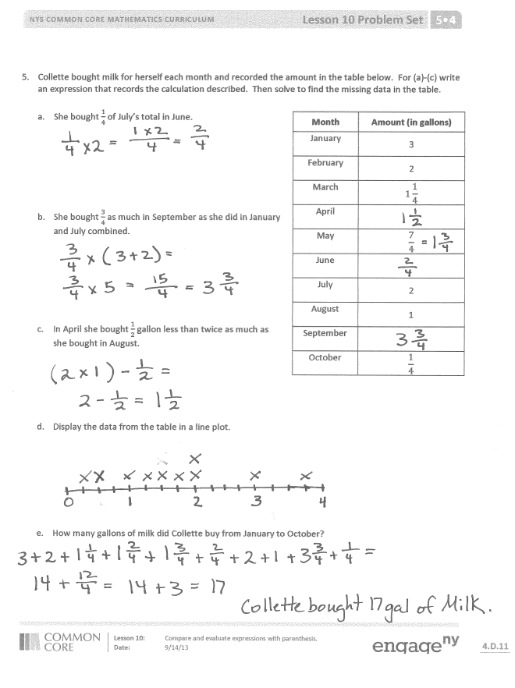

Name Date
- Write expressions to match the diagrams. Then, evaluate.

- Write an expression to match, then evaluate.

a. $\frac{1}{6}$ the sum of 16 and 20. b. Subtract 5 from $\frac{1}{3}$ of 23.

c. 3 times as much as the sum of $\frac{3}{4}$ and $\frac{2}{6}$. d. $\frac{2}{5}$ of the product of $\frac{5}{6}$ and 42.

e. 8 copies of the sum of 4 thirds and 2 more. f. 4 times as much as 1 third of 8.

- Circle the expression(s) that gives the same product as $\frac{4}{5}×7$. Explain how you know.
$4÷(7 × 5)$ $7÷5 × 4$ $(4 × 7)÷5$ $4÷(5 × 7)$ $4 × \frac{7}{5}$ $7× \frac{4}{5}$

- Use <, >, or = to make true number sentences without calculating. Explain your thinking.

- $4×2+4×\frac{2}{3}$ $3×\frac{2}{3}$

- $\left(5×\frac{3}{4}\right)×\frac{2}{5}$ $\left(5×\frac{3}{4}\right)×\frac{2}{7}$

- $3×\left(3+\frac{15}{12}\right)$ $(3×3)+\frac{15}{12}$

- Collette bought milk for herself each month and recorded the amount in the table below. For (a–c), write an expression that records the calculation described. Then, solve to find the missing data in the table.
Month | Amount (in gallons)
January | 3
February | 2
March | 1 $\frac{1}{4}$
April
May | $\frac{7}{4}$
June
July | 2
August | 1
September
October | $\frac{1}{4}$

  - She bought $\frac{1}{4}$ of July’s total in June.

  - She bought $\frac{3}{4}$ as much in September as she did in January and July combined.

  - In April, she bought $\frac{1}{2}$ gallon less than twice as much as she bought in August.

  - Display the data from the table in a line plot.

  - How many gallons of milk did Collette buy from January to October?

Name Date
- Rewrite these expressions using words.

- $\frac{3}{4}×\left(2\frac{2}{5}-\frac{5}{6}\right)$ b. $2\frac{1}{4}+\frac{8}{3}$

- Write an expression, and then solve.
Three less than one-fourth of the product of eight thirds and nine.

Name Date
- Write expressions to match the diagrams. Then, evaluate.

- Circle the expression(s) that give the same product as 6 ×$\frac{3}{8}$. Explain how you know.
$8÷(3 × 6)$ $3÷8 × 6$ $(6 × 3)÷8$ $(8 ÷6) × 3$ $6×\frac{8}{3}$ $\frac{3}{8}$ × 6

- Write an expression to match, and then evaluate.
a. $\frac{1}{8}$ the sum of 23 and 17. b. Subtract 4 from $\frac{1}{6}$ of 42.

c. 7 times as much as the sum of $\frac{1}{3}$ and $\frac{4}{5}$. d. $\frac{2}{3}$ of the product of $\frac{3}{8}$ and 16.

e. 7 copies of the sum of 8 fifths and 4. f. 15 times as much as 1 fifth of 12.

- Use <, >, or = to make true number sentences without calculating. Explain your thinking.

- $\frac{2}{3}$ $×$ (9 + 12) 15 $×$ $\frac{2}{3}$

- $\left(3×\frac{5}{4}\right)×\frac{3}{5}$ $\left(3×\frac{5}{4}\right)×\frac{3}{8}$

- $6×(2+\frac{32}{16} )$ $(6×2)+\frac{32}{16}$

Month | Amount (in pounds)
January | 3
February | 2
March | 1 $\frac{1}{4}$
April
May | $\frac{9}{8}$
June
July | 1 $\frac{1}{4}$
August
September | $\frac{11}{4}$
October | $\frac{3}{4}$
- Fantine bought flour for her bakery each month and recorded the amount in the table to the right. For (a–c), write an expression that records the calculation described. Then, solve to find the missing data in the
table.

- She bought $\frac{3}{4}$ of January’s total in August.

- She bought $\frac{7}{8}$ as much in April as she did in October and July combined.

- In June, she bought $\frac{1}{8}$ pound less than three times as much as she bought in May.

- Display the data from the table in a line plot.

- How many pounds of flour did Fantine buy from January to October?

