Lesson 18: Analyzing Residuals

Classwork
The previous lesson shows that when data is fitted to a line, a scatter plot with a curved pattern produces a residual plot that shows a clear pattern. You also saw that when a line is fit, a scatter plot where the points show a straight-line pattern results in a residual plot where the points are randomly scattered.

Example 1: The Relevance of the Pattern in the Residual Plot
Our previous findings are summarized in the plots below:
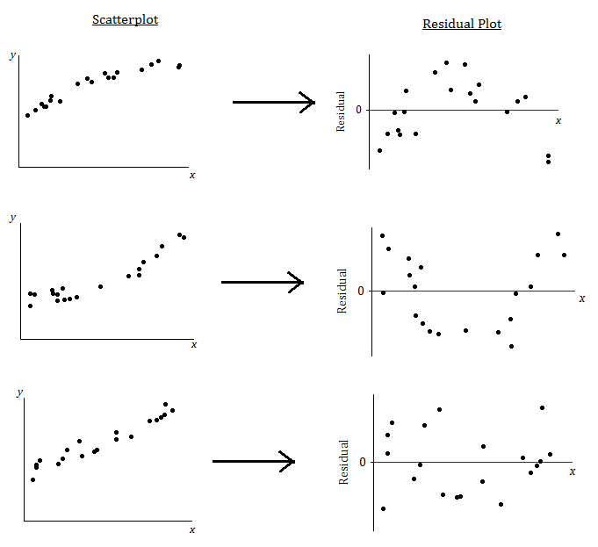
What does it mean when there is a curved pattern in the residual plot?

What does it mean when the points in the residual plot appear to be scattered at random with no visible pattern?

Why not just look at the scatter plot of the original data set? Why was the residual plot necessary? The next example answers these questions.

Example 2: Why Do You Need the Residual Plot?
The temperature (in degrees Fahrenheit) was measured at various altitudes (in thousands of feet) above Los Angeles. The scatter plot (below) seems to show a linear (straight line) relationship between these two quantities.
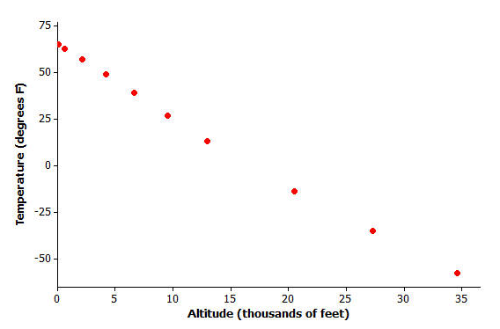
Data source: Core Math Tools, www.nctm.org

However, look at the residual plot:
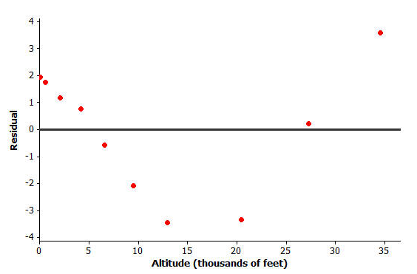
There is a clear curve in the residual plot. So what appeared to be a linear relationship in the original scatter plot was, in fact, a nonlinear relationship.
How did this residual plot result from the original scatter plot?

Exercises 1–3: Volume and Temperature
Water expands as it heats. Researchers measured the volume (in milliliters) of water at various temperatures. The results are shown below.
Temperature (°C) | Volume (ml)
$$20$$ | $$100.125$$
$$21$$ | $$100.145$$
$$22$$ | $$100.170$$
$$23$$ | $$100.191$$
$$24$$ | $$100.215$$
$$25$$ | $$100.239$$
$$26$$ | $$100.266$$
$$27$$ | $$100.290$$
$$28$$ | $$100.319$$
$$29$$ | $$100.345$$
$$30$$ | $$100.374$$
- Using a graphing calculator, construct the scatter plot of this data set. Include the least squares line on your graph. Make a sketch of the scatter plot including the least-squares line on the axes below.
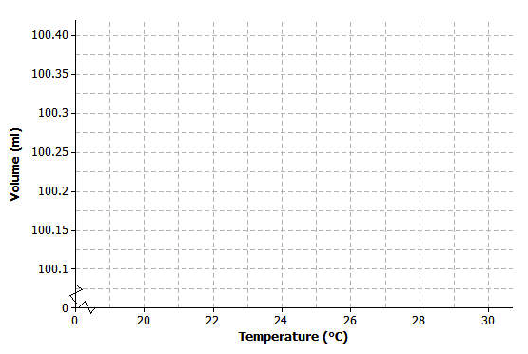
- Using the calculator, construct a residual plot for this data set. Make a sketch of the residual plot on the axes given below.

- Do you see a clear curve in the residual plot? What does this say about the original data set?

Lesson Summary
- After fitting a line, the residual plot can be constructed using a graphing calculator.
- A curve or pattern in the residual plot indicates a nonlinear relationship in the original data set.
- A random scatter of points in the residual plot indicates a linear relationship in the original data set.

Problem Set

- For each of the following residual plots, what conclusion would you reach about the relationship between the variables in the original data set? Indicate whether the values would be better represented by a linear or a nonlinear relationship.
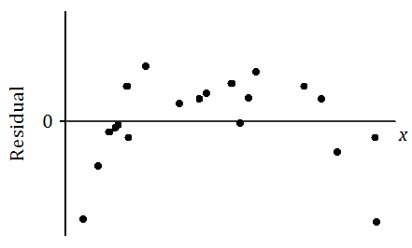

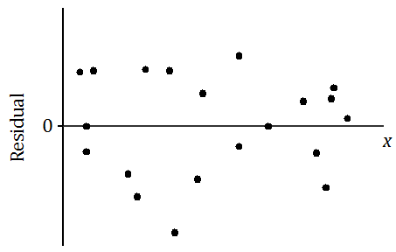

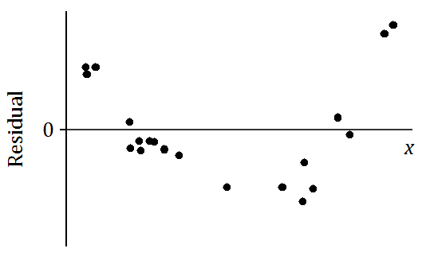

- Suppose that after fitting a line, a data set produces the residual plot shown below.

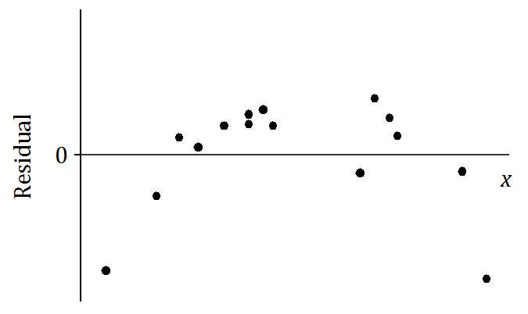

An incomplete scatter plot of the original data set is shown below. The least squares line is shown, but the points in the scatter plot have been erased. Estimate the locations of the original points and create an approximation of the scatter plot below.

