Lesson 9
Objective: Find a fraction of a measurement, and solve word problems.

Suggested Lesson Structure
 Fluency Practice (12 minutes)
 Application Problem (8 minutes)
 Concept Development (30 minutes)
 Student Debrief (10 minutes)
Total Time (60 minutes)
Fluency Practice (12 minutes)
- Multiply Whole Numbers by Fractions with Tape Diagrams 5.NF.4 (4 minutes)
- Convert Measures 4.MD.1 (4 minutes)
- Multiply a Fraction and a Whole Number 5.NF.4 (4 minutes)
Multiply Whole Numbers by Fractions with Tape Diagrams (4 minutes)
Materials: (S) Personal white board
Note: This fluency exercise reviews Lesson 7 content.
T: (Project a tape diagram of 8 partitioned into 2 equal units. Shade in 1 unit.) What fraction of 8 is shaded?
S: 1 half.
T: Read the tape diagram as a division equation.
S: 8 ÷ 2 = 4.
T: (Write 8 $\text{×}$ ____ = 4.) On your personal white board, write the equation, filling in the missing fraction.
S: (Write 8 $\text{×}$ $\frac{1}{2}$ = 4.)
Continue with the following possible sequence: $\text{35} \text{×} \frac{1}{7}, \frac{1}{4} \text{×} \text{16,} \frac{3}{4} \text{×} \text{16,} \frac{1}{8} \text{×} \text{48,} \text{and}\frac{5}{8} \text{×} \text{48}$.
Convert Measures (4 minutes)
Materials: (S) Personal white board, Grade 5 Mathematics Reference Sheet (Lesson 8 Reference Sheet)
Note: This fluency activity prepares students for Lessons 9–12. Allow students to use the conversion reference sheet if they are confused, but encourage them to answer questions without referring to it.
T: (Write 1 pt = ____ c.) How many cups are in one pint?
S: 2 cups.
T: (Write 1 pt = 2 c. Below it, write 2 pt = ____ c.) 2 pints?
S: 4 cups.
T: (Write 2 pt = 4 c. Below it, write 3 pt = ____ c.) 3 pints?
S: 6 cups.
T: (Write 3 pt = 6 c. Below it, write 7 pt = ____ c.) On your personal white board, write the equation.
S: (Write 7 pt = 14 c.)
T: Write the multiplication equation you used to solve it.
S: (Write 7 × 2 c = 14 c.)
Continue with the following possible sequence: 1 ft = 12 in, 2 ft = 24 in, 4 ft = 48 in, 1 yd = 3 ft, 2 yd = 6 ft,
3 yd = 9 ft, 9 yd = 27 ft, 1 gal = 4 qt, 2 gal = 8 qt, 3 gal = 12 qt, and 6 gal = 24 qt.
Multiply a Fraction and a Whole Number (4 minutes)
Materials: (S) Personal white board
Note: This fluency activity reviews Lesson 8 content.
T: (Write $\frac{1}{2}$ $\text{×}$ 4 = ____.) On your personal white board, write the equation as a repeated addition sentence and solve.
S: (Write $\frac{1}{2} \text{+} \frac{1}{2} \text{+} \frac{1}{2} \text{+} \frac{1}{2} \text{=} \frac{4}{2} \text{=} \text{2}$.)
T: (Write $\frac{1}{2} \text{×} \text{4 =}\frac{ ___ × ____ }{2}$.) On your personal white board, fill in the multiplication expression for the numerator.
S: (Write $\frac{1}{2} \text{×}$ 4 = $\frac{ 1 × 4 }{2}$.)
T: (Write $\frac{1}{2} \text{×}$ 4 = $\frac{ 1 × 4 }{2}$ = $\frac{}{}\text{=}$ ____.) Fill in the missing numbers.
S: (Write $\frac{1}{2} \text{×}$ 4 = $\frac{ 1 × 4 }{2}$ = $\frac{4}{2}\text{=}$ 2.)
T: (Write $\frac{1}{2} \text{×}$ 4 = $\frac{ 1 × 4 }{2}$ = ____.) Find a common factor to simplify, and then multiply.
²
¹
S: (Write $\frac{1}{2} \text{×}$ 4 = $\frac{ 1 × 4 }{2}$ = $\frac{2}{1}$ = 2.)
Continue with the following possible sequence: 6 $\text{×}\frac{1}{3}$, 6 $\text{×}\frac{2}{3 }$, $\frac{3}{4}\text{×}$ 8, and 9 $\text{×}\frac{2}{3}$.

Application Problem (8 minutes)
There are 42 people at a museum. Two-thirds of them are children. How many children are at the museum?
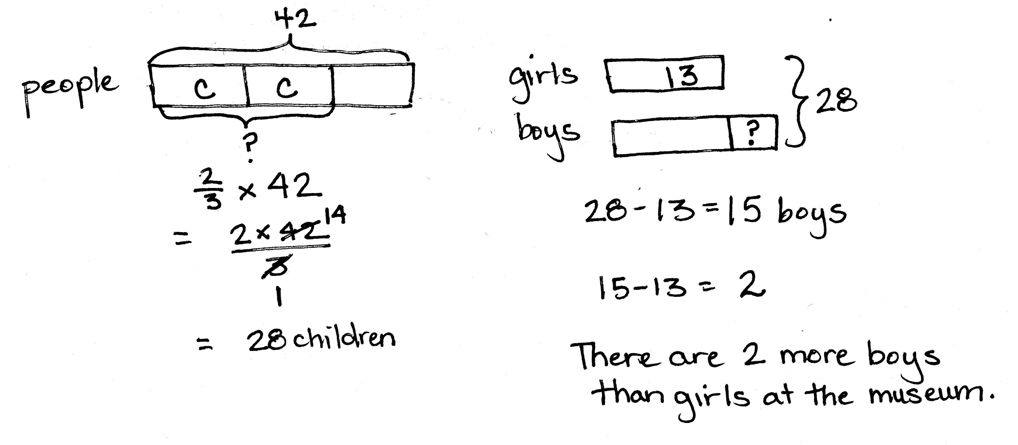
Extension: If 13 of the children are girls, how many more boys than girls are at the museum?
Note: Today’s Application Problem is a multi-step problem. Students must find a fraction of a set, and then use that information to answer the question. The numbers are large enough to encourage simplifying strategies as taught in Lesson 8 without being overly burdensome for students who prefer to multiply, and then simplify, or students who still prefer to draw their solution using a tape diagram.
Concept Development (30 minutes)
Materials: (T) Grade 5 Mathematics Reference Sheet (Lesson 8 Reference Sheet, posted)
(S) Personal white board, Grade 5 Mathematics Reference Sheet (Lesson 8 Reference Sheet)
Problem 1
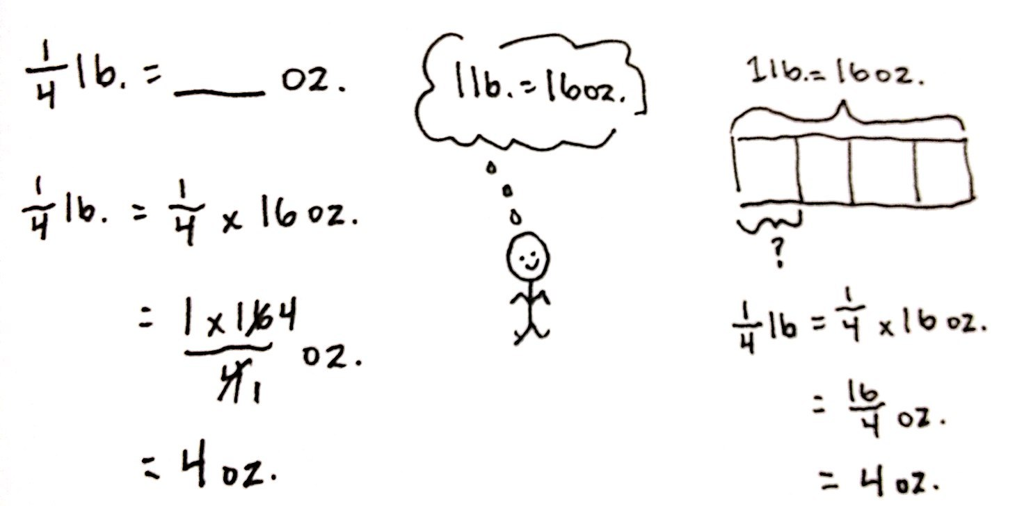
$\frac{1}{4}$ lb = ____ oz
T: (Post Problem 1 on the board.) Which is a larger unit, pounds or ounces?
S: Pounds.
T: So, we are expressing a fraction of a larger unit as the smaller unit. We want to find $\frac{1}{4}$ of 1 pound. (Write $\frac{1}{4}$ × 1 lb.) We know that 1 pound is the same as how many ounces?
S: 16 ounces.
T: Let’s rename the pound in our expression as ounces. Write it on your personal white board.
S: (Write $\frac{1}{4}$ × 16 ounces.)
T: (Write $\frac{1}{4}$ × 1 pound = $\frac{1}{4}$ × 16 ounces.) How do you know this is true?
S: It’s true because we just renamed the pound as the same amount in ounces. One pound is the same amount as 16 ounces.
T: How will we find how many ounces are in a fourth of a pound? Turn and talk.
S: We can find $\frac{1}{4}$ of 16. We can multiply $\frac{1}{4}$ × 16. It’s a fraction of a set. We’ll just multiply 16 by a fourth. We can draw a tape diagram and find one-fourth of 16.
T: Choose one with your partner and solve.
S: (Work.)
T: How many ounces are equal to one-fourth of a pound?
S: 4 ounces. (Write $\frac{1}{4}$ lb = 4 oz.)
T: So, each fourth of a pound in our tape diagram is equal to 4 ounces. How many ounces in two-fourths of a pound?
S: 8 ounces.
T: Three-fourths of a pound?
S: 12 ounces.
Problem 2
$\frac{3}{4}$ ft = ____ in
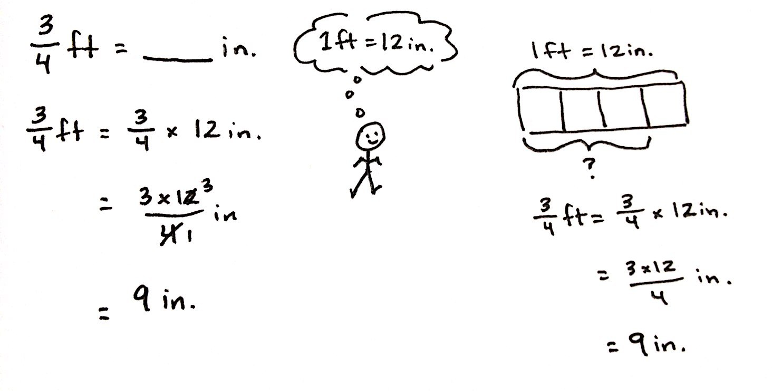
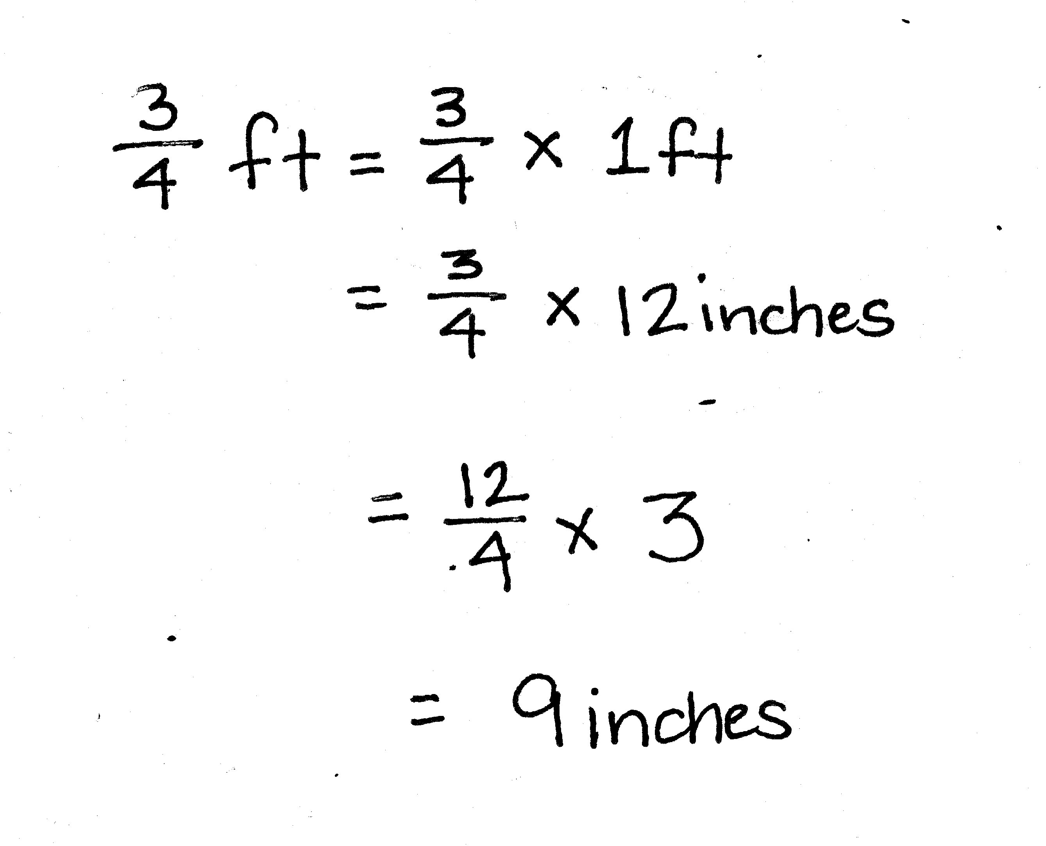
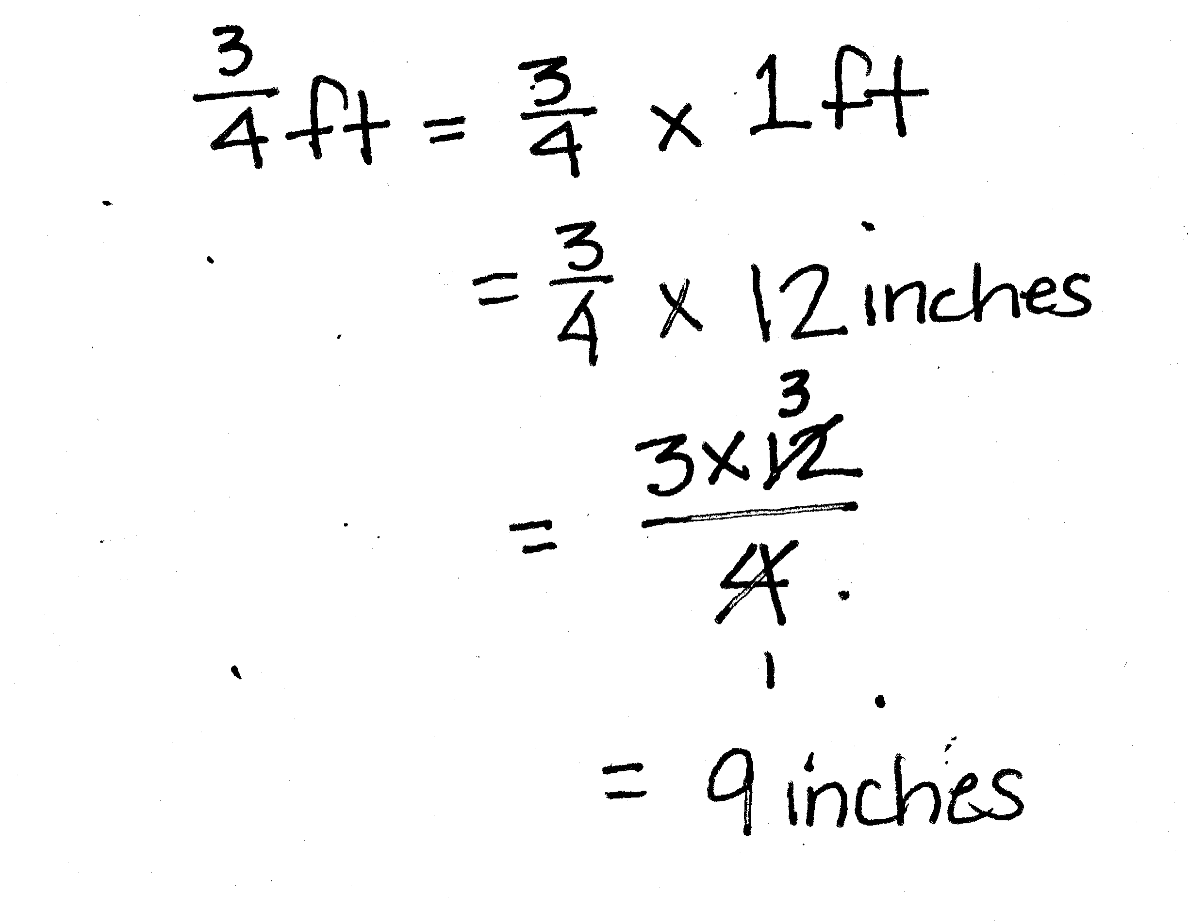
T: Compare this problem to the first one. Turn and talk.
S: We’re still renaming a fraction of a larger unit as a smaller unit. This time, we’re changing feet to inches, so we must think about 12 instead of 16. We were only finding 1 unit last time; this time, we must find 3 units.
T: (Write $\frac{3}{4}$ × 1 foot.) We know that 1 foot is the same as how many inches?
S: 12 inches.
T: Let’s rename the foot in our expression as inches. Write it on your personal white board.
S: (Write $\frac{3}{4}$ × 12 inches.)
T: (Write $\frac{3}{4}$ × 1 ft = $\frac{3}{4}$ × 12 inches.) Is this true? How do you know?
S: This is just like last time. We didn’t change the amount that we have in the expression. We just renamed the 1 foot using 12 inches. Twelve inches and one foot are exactly the same length.
T: Before we solve this, let’s estimate our answer. We are finding part of 1 foot. Will our answer be more than 6 inches or less than 6 inches? How do you know? Turn and talk.
S: Six inches is half a foot. We are looking for 3 fourths of a foot. Three-fourths is greater than one- half, so our answer will be more than 6. It will be more than 6 inches. 6 is only half, and 3 fourths is almost a whole foot.

T: Work with a neighbor to solve this problem. One of you can use multiplication to solve, and the other can use a tape diagram to solve. Check your neighbor’s work when you’re finished.

NOTES ON
MULTIPLE MEANS
OF ENGAGEMENT:
Challenge students to make conversions between fractions of gallons to pints or cups, or fractions of a day to minutes or seconds.

S: (Work and share.)
T: Reread the problem and fill in the blank.
S: $\frac{3}{4}$ feet = 9 inches.
T: How can 3 fourths be equal to 9? Turn and talk.
S: Because the units are different, the numbers will be different,
but show the same amount. Feet are larger than inches, so it needs more inches than feet to show the same amount. If you measured 3 fourths of a foot with a ruler, and then measured 9 inches with a ruler, they would be exactly the same length. If you measure the same length using feet, and then using inches, you will always have more inches than feet because inches are smaller.
Problem 3
Mr. Corsetti spends $\frac{2}{3}$ of every year in Florida. How many months does he spend in Florida each year?
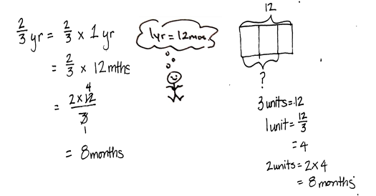
T: Work independently. You may use either a tape diagram or a multiplication sentence to solve.
T: Use your work to answer the question.
S: Mr. Corsetti spends 8 months in Florida each year.
Repeat this sequence with $\frac{2}{3}$ yard = ____ feet and
$\frac{2}{5}$ hour = ____ minutes.
Problem Set (10 minutes)
Students should do their personal best to complete the Problem Set within the allotted 10 minutes. For some classes, it may be appropriate to modify the assignment by specifying which problems they work on first. Some problems do not specify a method for solving. Students should solve these problems using the RDW approach used for Application Problems.
Student Debrief (10 minutes)
Lesson Objective: Find a fraction of a measurement, and solve word problems.
The Student Debrief is intended to invite reflection and active processing of the total lesson experience.
Invite students to review their solutions for the Problem Set. They should check work by comparing answers with a partner before going over answers as a class. Look for misconceptions or misunderstandings that can be addressed in the Debrief. Guide students in a conversation to debrief the Problem Set and process the lesson.
You may choose to use any combination of the questions below to lead the discussion.
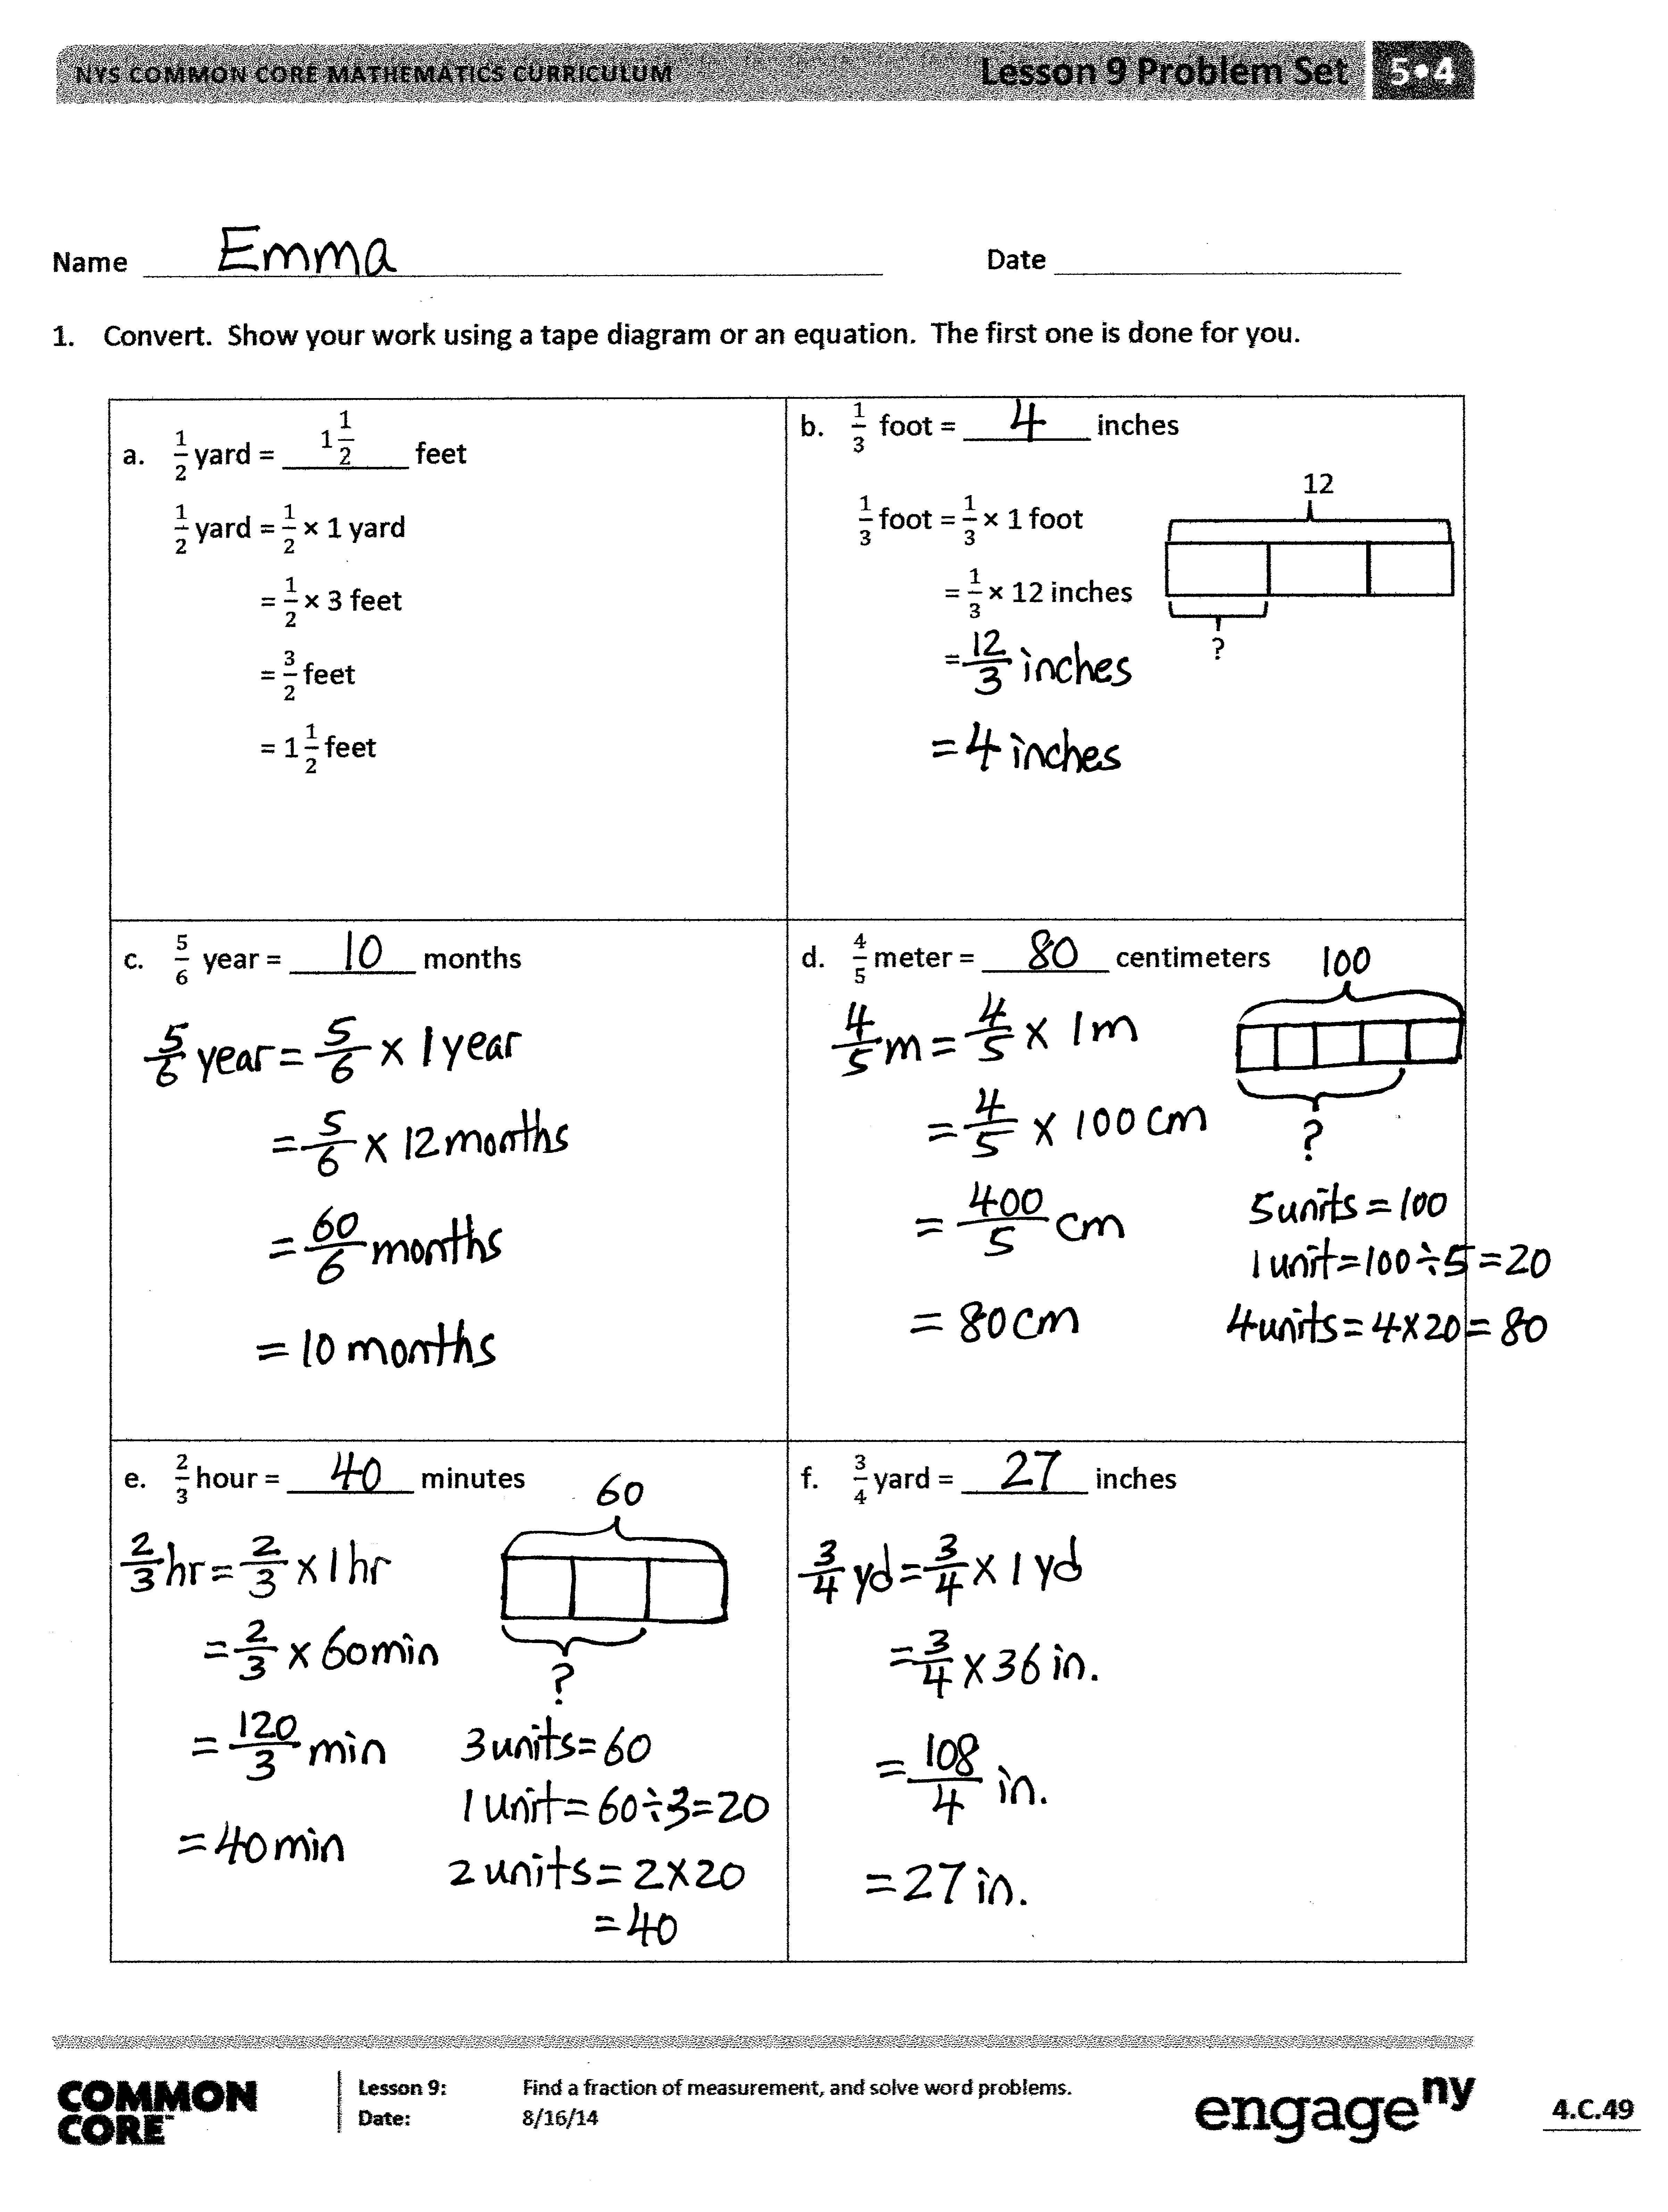
- Share and explain your solution for Problem 3 with your partner.
- In Problem 3, could you tell, without calculating, whether Mr. Paul bought more cashews or walnuts? How did you know?
- How did you solve Problem 3(c)? Is there more than one way to solve this problem? (Yes, there is more than one way to solve this problem, i.e., finding $\frac{7}{8}$ of 16 and $\frac{3}{4}$ of 16, and then subtracting, versus subtracting $\frac{7}{8}-\frac{3}{4}$, and then finding the fraction of 16.) Share your strategy with a partner.
- How did you solve Problem 3(d)? Share and explain your strategy with a partner.
Exit Ticket (3 minutes)
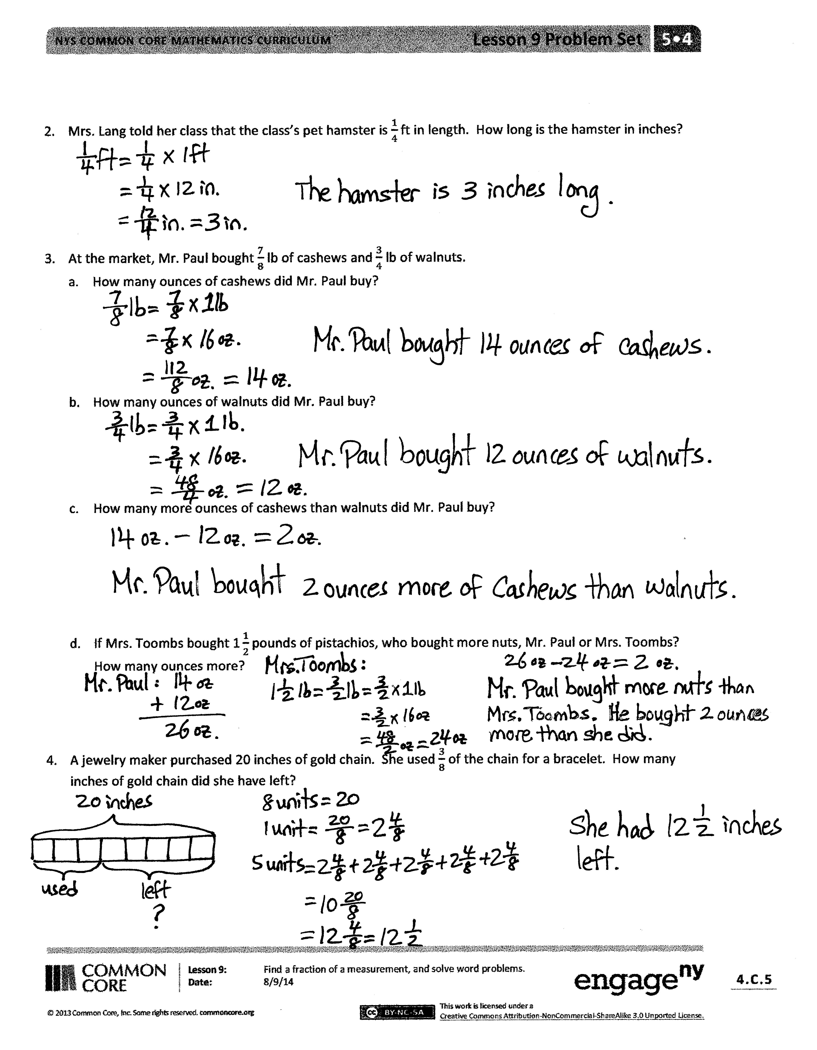
After the Student Debrief, instruct students to complete the Exit Ticket. A review of their work will help you assess the students’ understanding of the concepts that were presented in the lesson today and plan more effectively for future lessons. You may read the questions aloud to the students.

Name Date
- Convert. Show your work using a tape diagram or an equation. The first one is done for you.

$$1\frac{1}{2}$$  - $\frac{1}{2}$ yard = ________ feet  $\frac{1}{2}$ yard = $\frac{1}{2}$ × 1 yard  = $\frac{1}{2}$ × 3 feet  = $\frac{3}{2}$ feet  = $\text{1}\frac{1}{2}$ feet | - $\frac{1}{3}$ foot = ________ inches  ?  12  $\frac{1}{3}$ foot =$\frac{1}{3}$ × 1 foot  = $\frac{1}{3}$ × 12 inches  =
- $\frac{5}{6}$ year = ________ months | - $\frac{4}{5}$ meter = ________ centimeters
- $\frac{2}{3}$ hour = ________ minutes | - $\frac{3}{4}$ yard = ________ inches
- Mrs. Lang told her class that the class’s pet hamster is $\frac{1}{4}$ ft in length. How long is the hamster in inches?

- At the market, Mr. Paul bought $\frac{7}{8}$ lb of cashews and $\frac{3}{4}$ lb of walnuts.
- How many ounces of cashews did Mr. Paul buy?

- How many ounces of walnuts did Mr. Paul buy?

- How many more ounces of cashews than walnuts did Mr. Paul buy?

- If Mrs. Toombs bought $\text{1}\frac{1}{2}$ pounds of pistachios, who bought more nuts, Mr. Paul or Mrs. Toombs? How many ounces more?

- A jewelry maker purchased 20 inches of gold chain. She used $\frac{3}{8}$ of the chain for a bracelet. How many inches of gold chain did she have left?

Name Date
- Express 36 minutes as a fraction of an hour: 36 minutes = _______ hour

- Solve.

a. $\frac{2}{3}$ feet = _______ inches b. $\frac{2}{5}$ m = _______ cm c. $\frac{5}{6}$ year = _______ months

Name Date
- Convert. Show your work using a tape diagram or an equation. The first one is done for you.
a. $\frac{1}{4}$ yard = ________ inches  9  $\frac{1}{4}$ yard = $\frac{1}{4}$ × 1 yard  = $\frac{1}{4}$ × 36 inches  = $\frac{36}{4}$ inches  = 9 inches | b. $\frac{1}{6}$ foot = ________ inches  $\frac{1}{6}$ foot =$\frac{1}{6}$ × 1 foot  = $\frac{1}{6}$ × 12 inches  ?  12  =
c. $\frac{3}{4}$ year = ________ months | d. $\frac{3}{5}$ meter = ________ centimeters
e. $\frac{5}{12}$ hour = ________ minutes | f. $\frac{2}{3}$ yard = ________ inches

- Michelle measured the length of her forearm. It was $\frac{3}{4}$ of a foot. How long is her forearm in inches?

- At the market, Ms. Winn bought $\frac{3}{4}$ lb of grapes and $\frac{5}{8}$ lb of cherries.
- How many ounces of grapes did Ms. Winn buy?

- How many ounces of cherries did Ms. Winn buy?

- How many more ounces of grapes than cherries did Ms. Winn buy?

- If Mr. Phillips bought $\text{1}\frac{3}{4}$ pounds of raspberries, who bought more fruit, Ms. Winn or Mr. Phillips? How many ounces more?

- A gardener has 10 pounds of soil. He used $\frac{5}{8}$ of the soil for his garden. How many pounds of soil did he use in the garden? How many pounds did he have left?

