Lesson 8

Objective: Relate a fraction of a set to the repeated addition interpretation of fraction multiplication.

Suggested Lesson Structure

 Fluency Practice (12 minutes)

 Application Problem (8 minutes)

 Concept Development (30 minutes)

 Student Debrief (10 minutes)

**Total Time (60 minutes)**

Fluency Practice (12 minutes)

* Convert Measures **4.MD.1** (5 minutes)
* Fractions as Whole Numbers **5.NF.3** (3 minutes)
* Multiply a Fraction Times a Whole Number **5.NF.4** (4 minutes)

Convert Measures (5 minutes)

Materials: (S) Personal white board, Grade 5 Mathematics Reference Sheet (Reference Sheet)

Note: This fluency activity prepares students for Lessons 9–12 content. Allow students to use the Grade 5 Mathematics Reference Sheet if they are confused, but encourage them to answer questions without referring to it.

T: (Write 1 ft = ____ in.) How many inches are in 1 foot?

S: 12 inches.

T: (Write 1 ft = 12 in. Below it, write 2 ft = ____ in.) 2 feet?

S: 24 inches.

T: (Write 2 ft = 24 in. Below it, write 3 ft = ____ in.) 3 feet?

S: 36 inches.

T: (Write 3 ft = 36 in. Below it, write 4 ft = ____ in.) 4 feet?

S: 48 inches.

T: (Write 4 ft = 48 in. Below it, write 10 ft = ____ in.) On your boards, write the equation.

S: (Write 10 ft = 120 in.)

T: (Write 10 ft × ____ = ____ in.) Write the multiplication equation you used to solve it.

S: (Write 10 ft × 12 = 120 in.)

Continue with the following possible sequence: 1 pint = 2 cups, 2 pints = 4 cups, 3 pints = 6 cups, 9 pints = 18 cups, 1 yd = 3 ft, 2 yd = 6 ft, 3 yd = 9 ft, 7 yd = 21 ft, 1 gal = 4 qt, 2 gal = 8 qt, 3 gal = 12 qt, and 8 gal = 32 qt.

Fractions as Whole Numbers (3 minutes)

Materials: (S) Personal white board

Note: This fluency activity reviews Lesson 5 and reviews denominators equivalent to hundredths. Instruct students to use their personal white boards for calculations that they cannot do mentally.

T: I’ll say a fraction. You say it as a division problem. 4 halves.

S: 4 ÷ 2 = 2.

Continue with the following possible sequence:

Multiply a Fraction Times a Whole Number (4 minutes)

Materials: (S) Personal white board

Note: This fluency activity reviews Lesson 7 content.



12 × = 4

T: (Project a tape diagram of 12 partitioned into 3 equal units. Shade in 1 unit.) What fraction of 12 is shaded?

S: 1 third.

T: Read the tape diagram as a division equation.

S: 12 ÷ 3 = 4.

T: (Write 12 × ____ = 4.) On your personal white board, write the equation, filling in the missing fraction.

S: (Write 12 × = 4.)

Continue with the following possible sequence:

Application Problem (8 minutes)

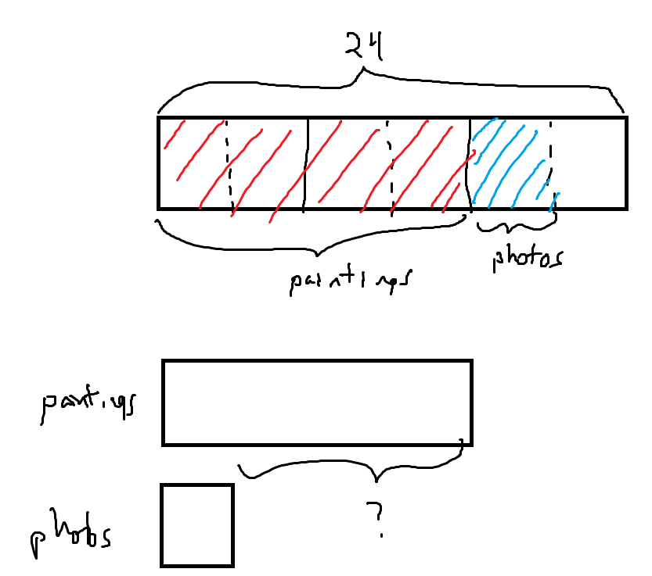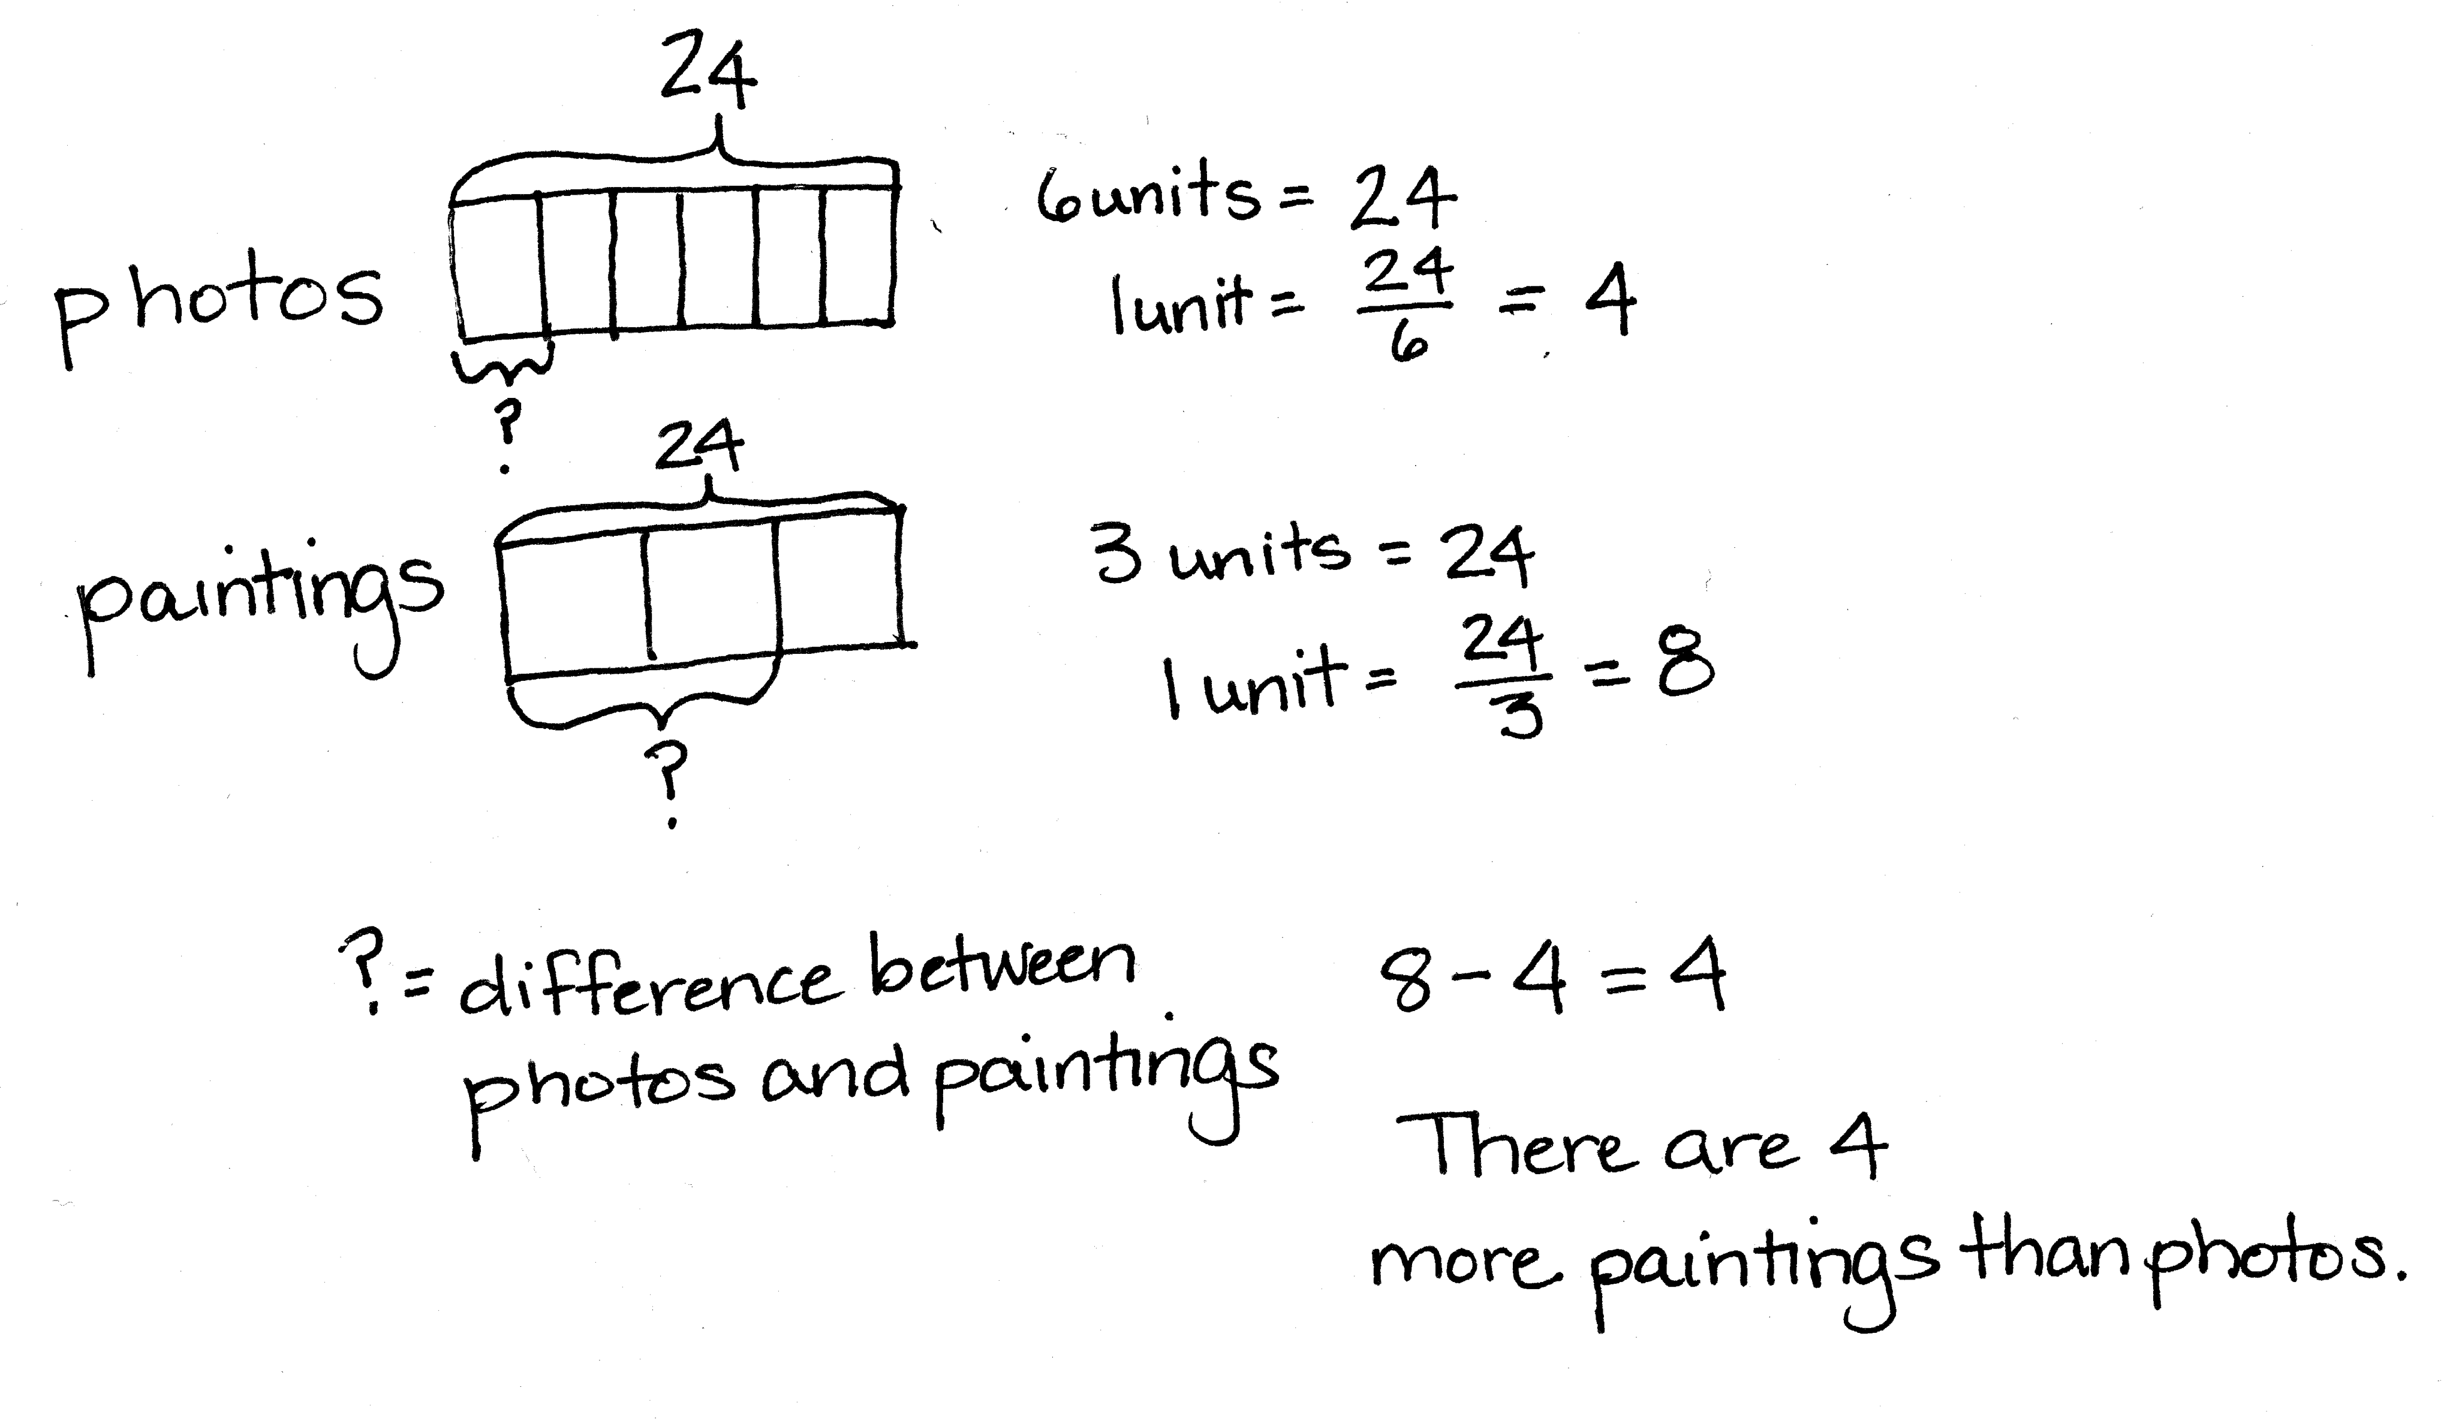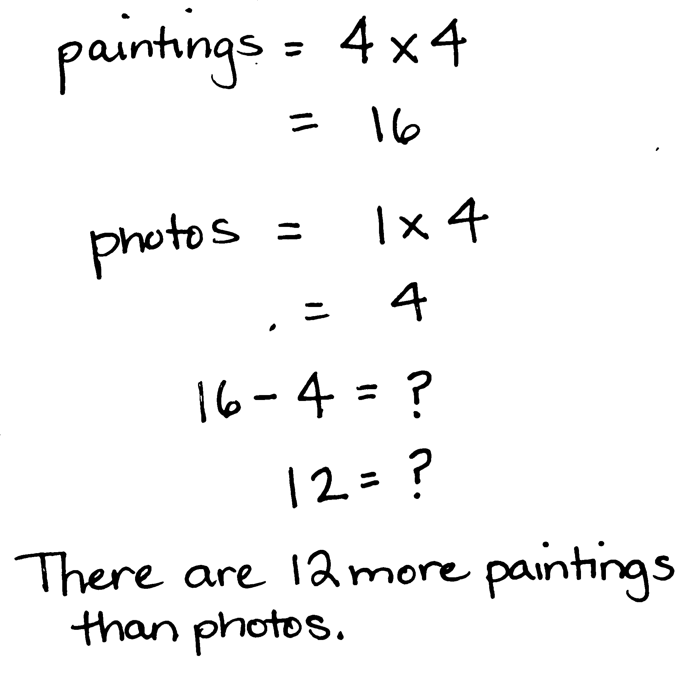

Sasha organizes the art gallery in her town’s community center. This month, she has 24 new pieces to add to the gallery.

Of the new pieces, of them are photographs, and of them are paintings. How many more paintings are there than photos?

Note: This Application Problem requires students to find two fractions of the same set—a recall of the concepts from Lessons 6–7 in preparation for today’s lesson.

Concept Development (30 minutes)

Materials: (S) Personal white board

Problem 1

× 6 = ____

T: (Write 2 × 6 on the board.) Read this expression out loud.

S: 2 times 6.

T: In what different ways can we interpret the meaning of this expression? Discuss with your partner.

S: We can think of it as 6 times as much as 2. 🡪 6 + 6. 🡪 We could think of 6 copies of 2.   
🡪 2 + 2 + 2 + 2 + 2 + 2.

T: True, we can find 2 copies of 6, and we can also think about 2 added 6 times. What is the property that allows us to multiply the factors in any order?

S: Commutative property.

T: (Write × 6 on the board.) How can we interpret this expression? Turn and talk.

S: 2 thirds of 6. 🡪 6 copies of 2 thirds. 🡪 2 thirds added together 6 times.

T: This expression can be interpreted in different ways, just as the whole number expression. We can say it’s of 6 or 6 groups of . (Write on the board as shown below.)

T: Use a tape diagram to find 2 thirds of 6. (Point to .)

S: (Solve.)

|  |  |
| --- | --- |
|  |  |

T: Let me record our thinking. In the diagram, we see that 3 units is 6. (Write 3 units = 6.) We divide 6 by 3 to find 1 unit. (Write .) So, 2 units is 2 times 6 divided by 3. (Write 2 × and the rest of the thinking in the table as shown above.)

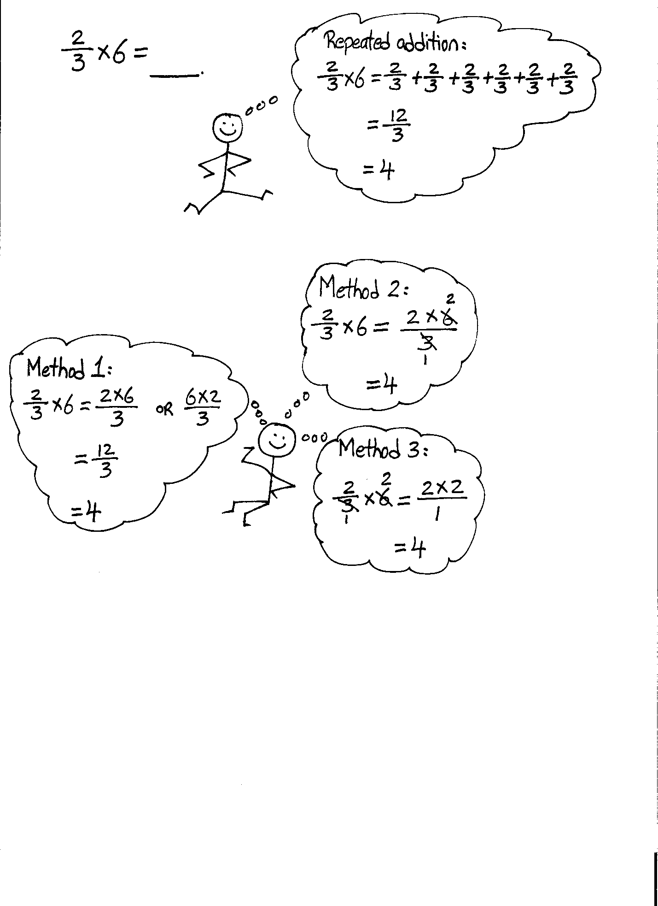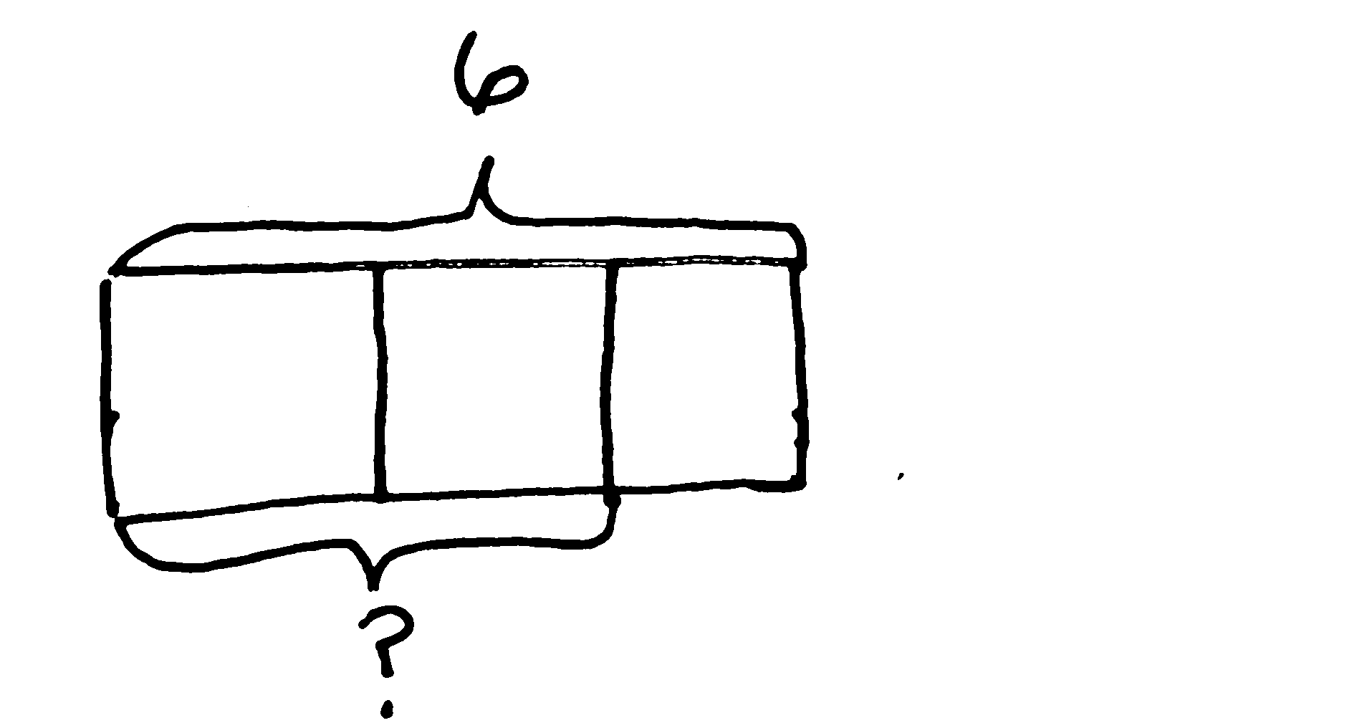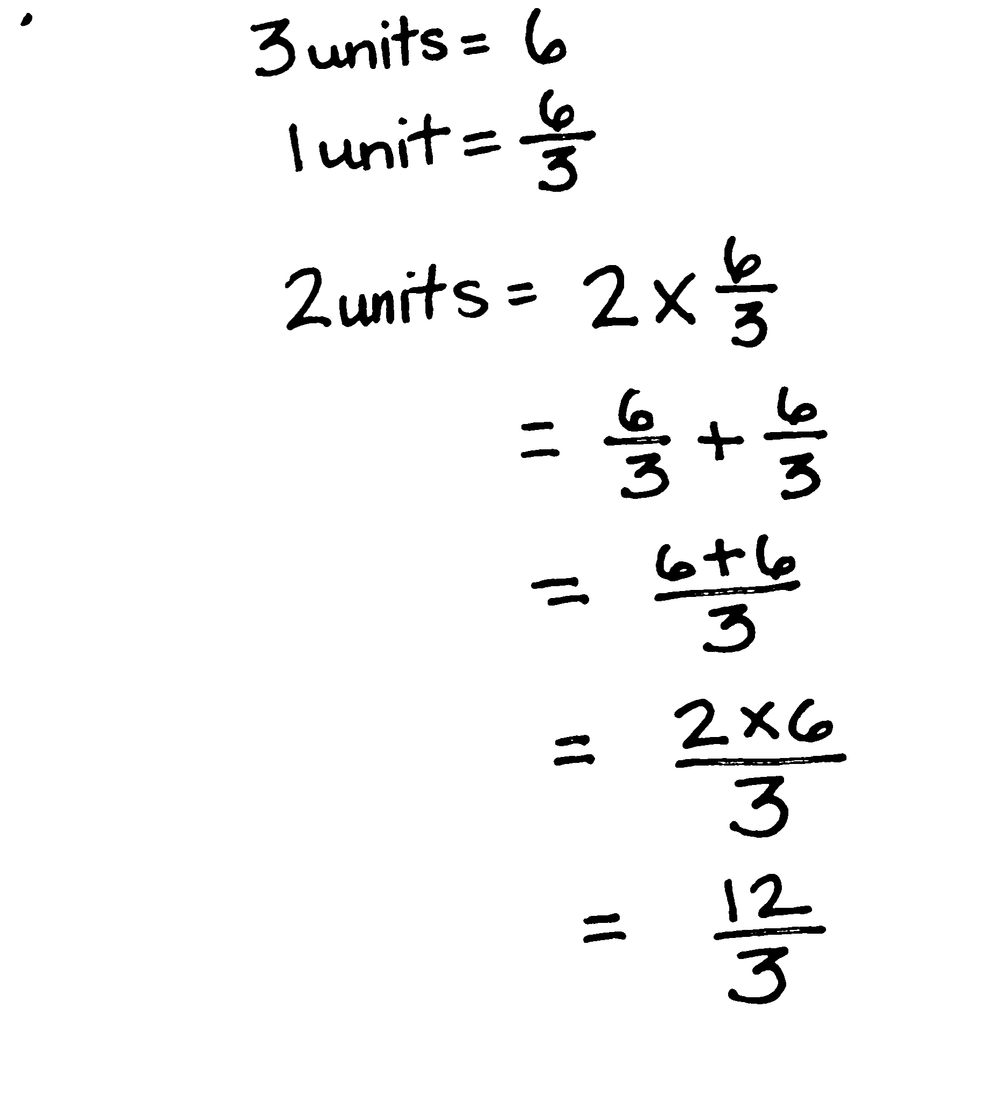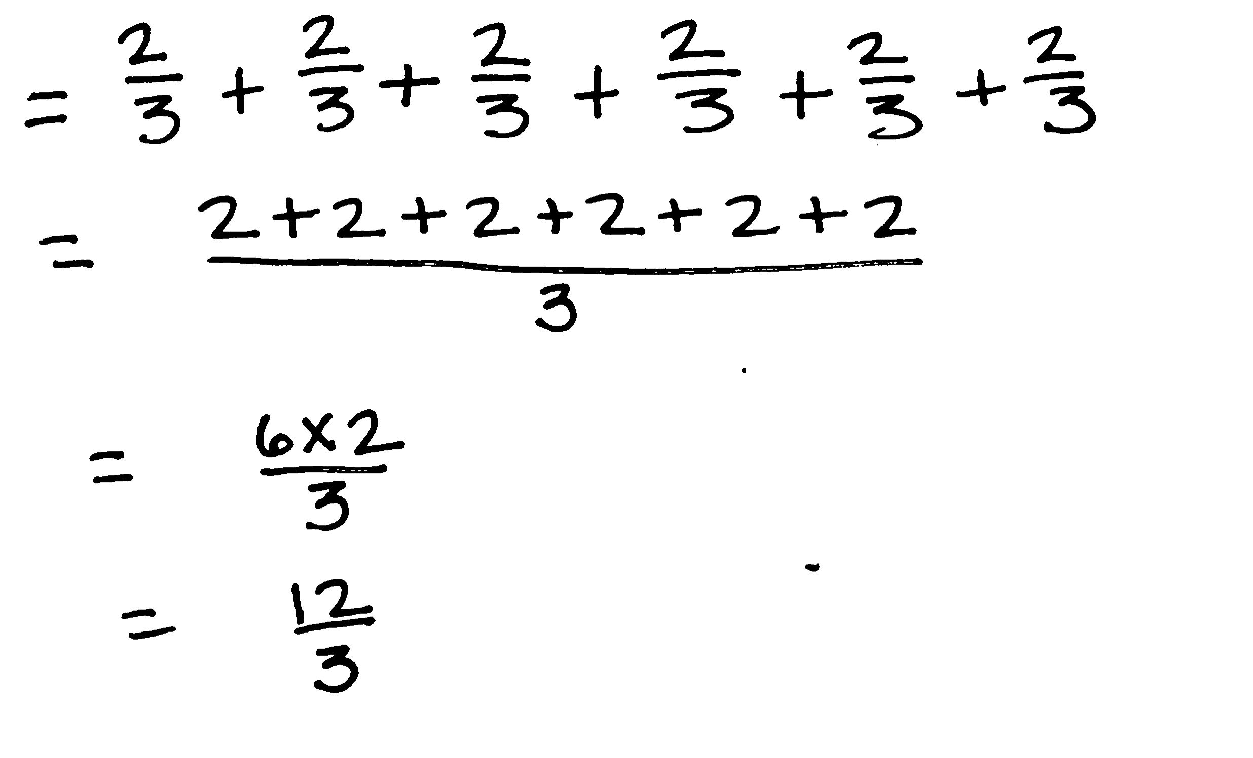

T: Now, let’s think of it as 6 groups (or copies) of like you did in Grade 4. Solve it using repeated addition on your board.

S: (Solve.)

T: (Write on the board.)

T: What multiplication expression gave us 12?

S: 6 × 2.

|  |  |
| --- | --- |
|  | NOTES ON  MULTIPLE MEANS  OF REPRESENTATION: |

If students have difficulty remembering that dividing by a common factor allows a fraction to be renamed, consider a return to the Grade 4 notation for finding equivalent fractions as follows:

.

The decomposition in the numerator makes the common factor of 3 apparent. Students may also be reminded that multiplying by is the same as multiplying by 1.

T: (Write on the board.) What unit are we counting?

S: Thirds.

T: Let me write what I hear you saying. (Write (6 × 2) thirdson the board.) Now, let me write it another way. (Write = .) 6 times 2 thirds.

T: In both ways of thinking, what is the product? Why is it the same?

S: It’s 12 thirds because 2 × 6 thirds is the same as 6 × 2 thirds. 🡪 It’s the commutative property again. It doesn’t matter what order we multiply; it’s the same product.

T: How many wholes is 12 thirds? How much is 12 divided by 3?

S: 4.

T: Let’s use something else we learned in Grade 4 to   
rename this fraction using larger units before we multiply.   
(Point to .) Look for a factor that is shared by the numerator and denominator. Turn and talk.

S: Two and 3 only have a common factor of 1, but 3 and 6 have a common factor of 3. 🡪 I know the numerator of 6 can be divided by 3 to get 2, and the denominator of 3 can be divided by 3 to get 1.

T: We can rename this fraction just like in Grade 4 by dividing both the numerator and denominator by 3. Watch me. 6 divided by 3 is 2. (Cross out 6, and write 2 above 6.) 3 divided by 3 is 1. (Cross out 3, and write 1 below 3.)



T: What does the numerator show now?

S: 2 × 2.

T: What’s the denominator?

S: 1.

T: (Write = .) This fraction was 12 thirds; now, it is 4 wholes. Did we change the amount of the fraction by naming it using larger units? How do you know?

S: It is the same amount. Thirds are smaller than wholes, so it requires 12 thirds to show the same amount as 4 wholes. 🡪 It is the same. The unit got larger, so the number we needed to show the amount got smaller. 🡪 There are 3 thirds in 1 whole, so 12 thirds makes 4 wholes. It is the same. 🡪 When we divide the numerator and denominator by the same number, it’s like dividing by 1, and dividing by 1 doesn’t change the number’s value.

Problem 2

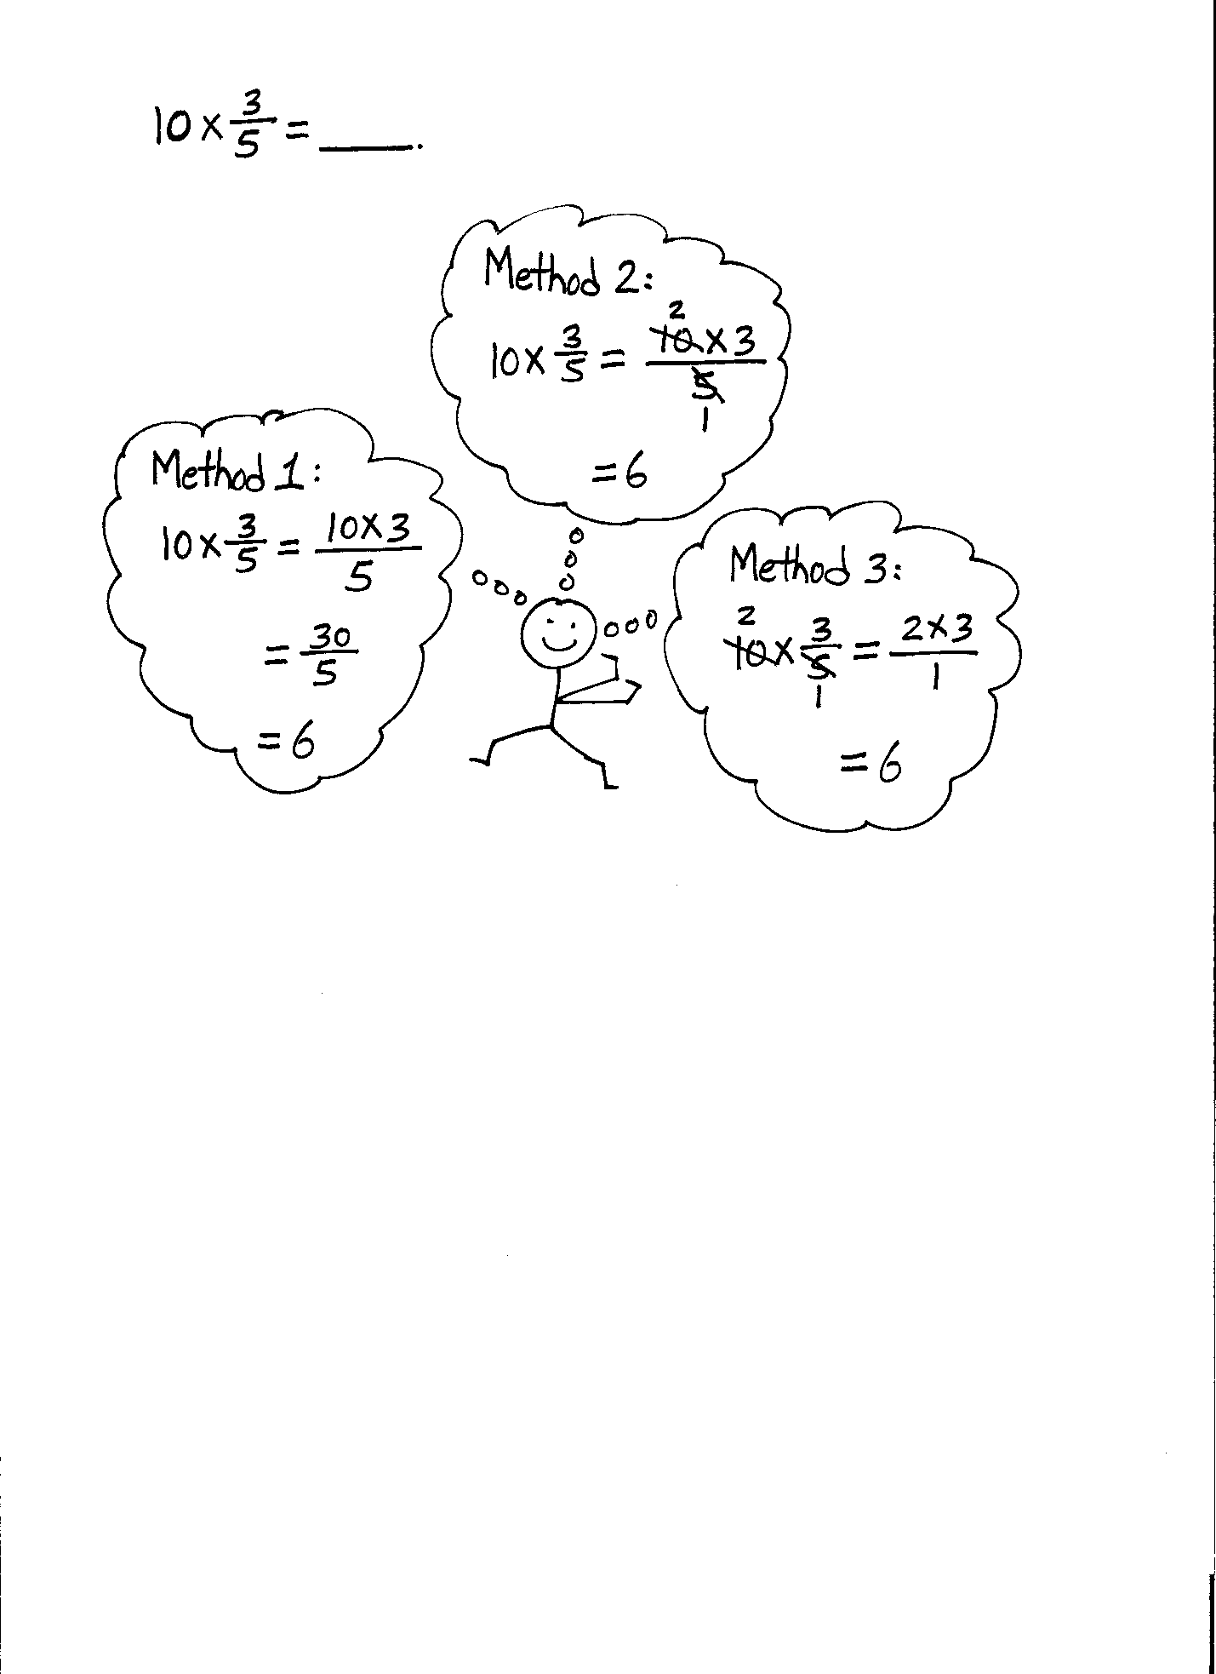

× 10 = ____

T: Finding of 10 is the same as finding the product of 10 copies of . I can rewrite this expression in unit form as   
(10 × 3) fifths or a fraction. (Write .) 10 times 3 fifths*.* Multiply in your head and say the product.

S: 30 fifths.

T: is equivalent to how many wholes?

S: 6 wholes.

T: So, if 10 × is equal to 6, is it also true that 3 fifths of 10 is 6? How do you know?

S: Yes, it is true. 1 fifth of 10 is 2, so 3 fifths would be 6. 🡪 The commutative property says we can multiply in any order. This is true of fractional numbers, too. So, the product would be the same. 🡪 3 fifths is a little more than half, so 3 fifths of 10 should be a little more than 5. 6 is a little more than 5.

|  |  |
| --- | --- |
|  | NOTES ON  MULTIPLE MEANS  OF ACTION AND EXPRESSION: |

While the focus of today’s lesson is the transition to a more abstract understanding of fraction of a set, do not hastily drop pictorial representations. Tape diagrams are powerful tools that help students make connections to the abstract. Throughout the lesson, continue to ask, “Can you draw something?”

These drawings also provide formative assessment opportunities for teachers and allow a glimpse into the thinking of students in real time.

T: Now, let’s work this problem again, but this time, let’s find a common factor and rename it before we multiply. (Follow the sequence from Problem 1.)

S: (Work.)

T: Did dividing the numerator and denominator by the same common factor change the quantity? Why or why not?

S: (Share.)

Problem 3

× 24= ____

× 27= ____

T: Before we solve, what do you notice that is different this time?

S: The fraction of the set that we are finding is more than a whole this time. All of the others were fractions less than 1.

T: Let’s estimate the size of our product. Turn and talk.

S: This is like the one from the Problem Set yesterday. We need more than a whole set, so the answer will be more than 24. 🡪 We need 1 sixth more than a whole set of 24, so the answer will be a little more than 24.

T: (Write on the board.) 24 times 7 sixths. Can you multiply 24 times 7 in your head?

S: You could, but it’s a lot to think about to do it mentally.

T: Because this one is harder to calculate mentally, let’s use the renaming strategies we’ve seen to solve this problem. Turn and share how we can begin.

S: We can divide the numerator and denominator by the same common factor.

Continue with the sequence from Problem 2, having students name the common factor and rename as shown previously. Then, proceed to × 27= ____.

T: Compare this problem to the last one.

S: The whole is a little more than last time. 🡪 The fraction we are looking for is the same, but the whole is larger. 🡪 We probably need to rename this one before we multiply like the last one, because 7 × 27 is harder to do mentally.

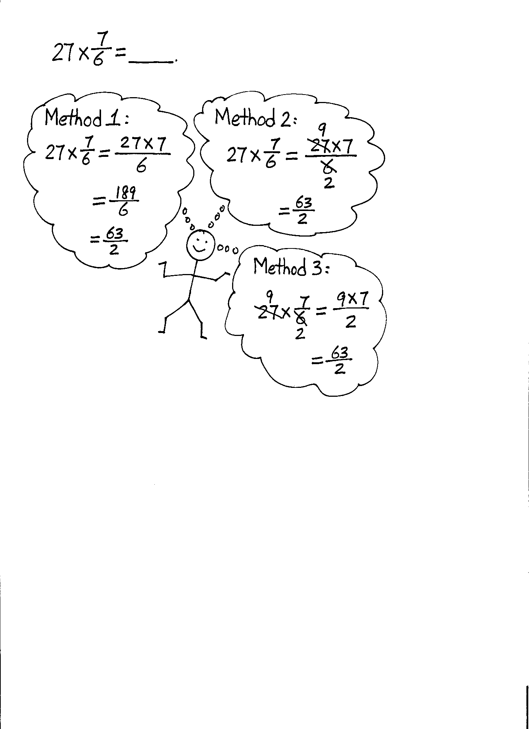

T: Let’s rename first. Name a factor that 27 and 6 share.

S: 3.

T: Let’s divide the numerator and denominator by this common factor. 27 divided by 3 is 9. (Cross out 27, and write 9 above 27.) 6 divided by 3 is 2. (Cross out 6, and write 2 below 6.) We’ve renamed this fraction. What’s the new name?

S: . (9 times 7 divided by 2.)

T: Has this made it easier for us to solve this mentally? Why?

S: Yes, the numbers are easier to multiply now. 🡪 The numerator is a basic fact now, and I know   
9 × 7!

T: Have we changed the amount that is represented by this fraction? Turn and talk.

S: No, it’s the same amount. We just renamed it using a larger unit. 🡪 We renamed it just like any other fraction by looking for a common factor. This doesn’t change the amount.

T: Say the product as a fraction greater than one.

S: 63 halves. (Write = .)

T: We could express as a mixed number, but we don’t have to.

T: (Point to .) To compare, let’s multiply without renaming and see if we get the same product.

T: What’s the fraction?

S: .

T: (Write = .) Rewrite that as a fraction greater than 1 using the largest units that you can. What do you notice?

S: (Work to find .) We get the same answer, but it was harder to find it. 🡪 189 is a large number, so it’s harder for me to find the common factor with 6. 🡪 I can’t do it in my head. I needed to use paper and pencil to simplify.

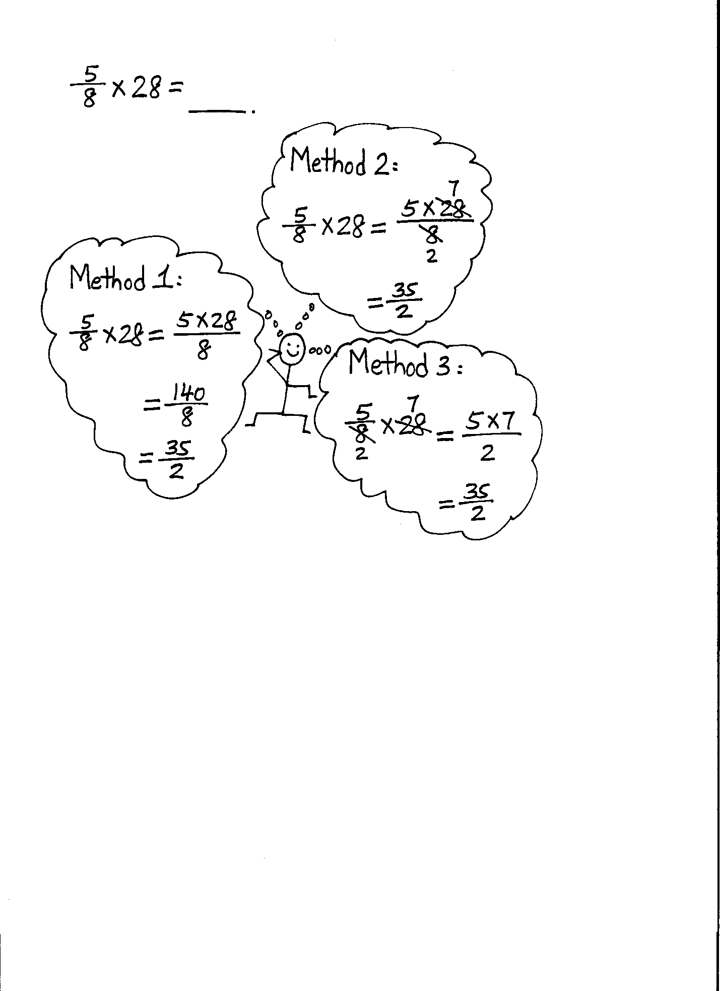

T: So, sometimes, it makes our work easier and more efficient to rename with larger units, or simplify, first and then multiply.

Repeat this sequence with × 28 = ____.

Problem 4

hour = ____ minutes

T: We are looking for part of an hour. Which part?

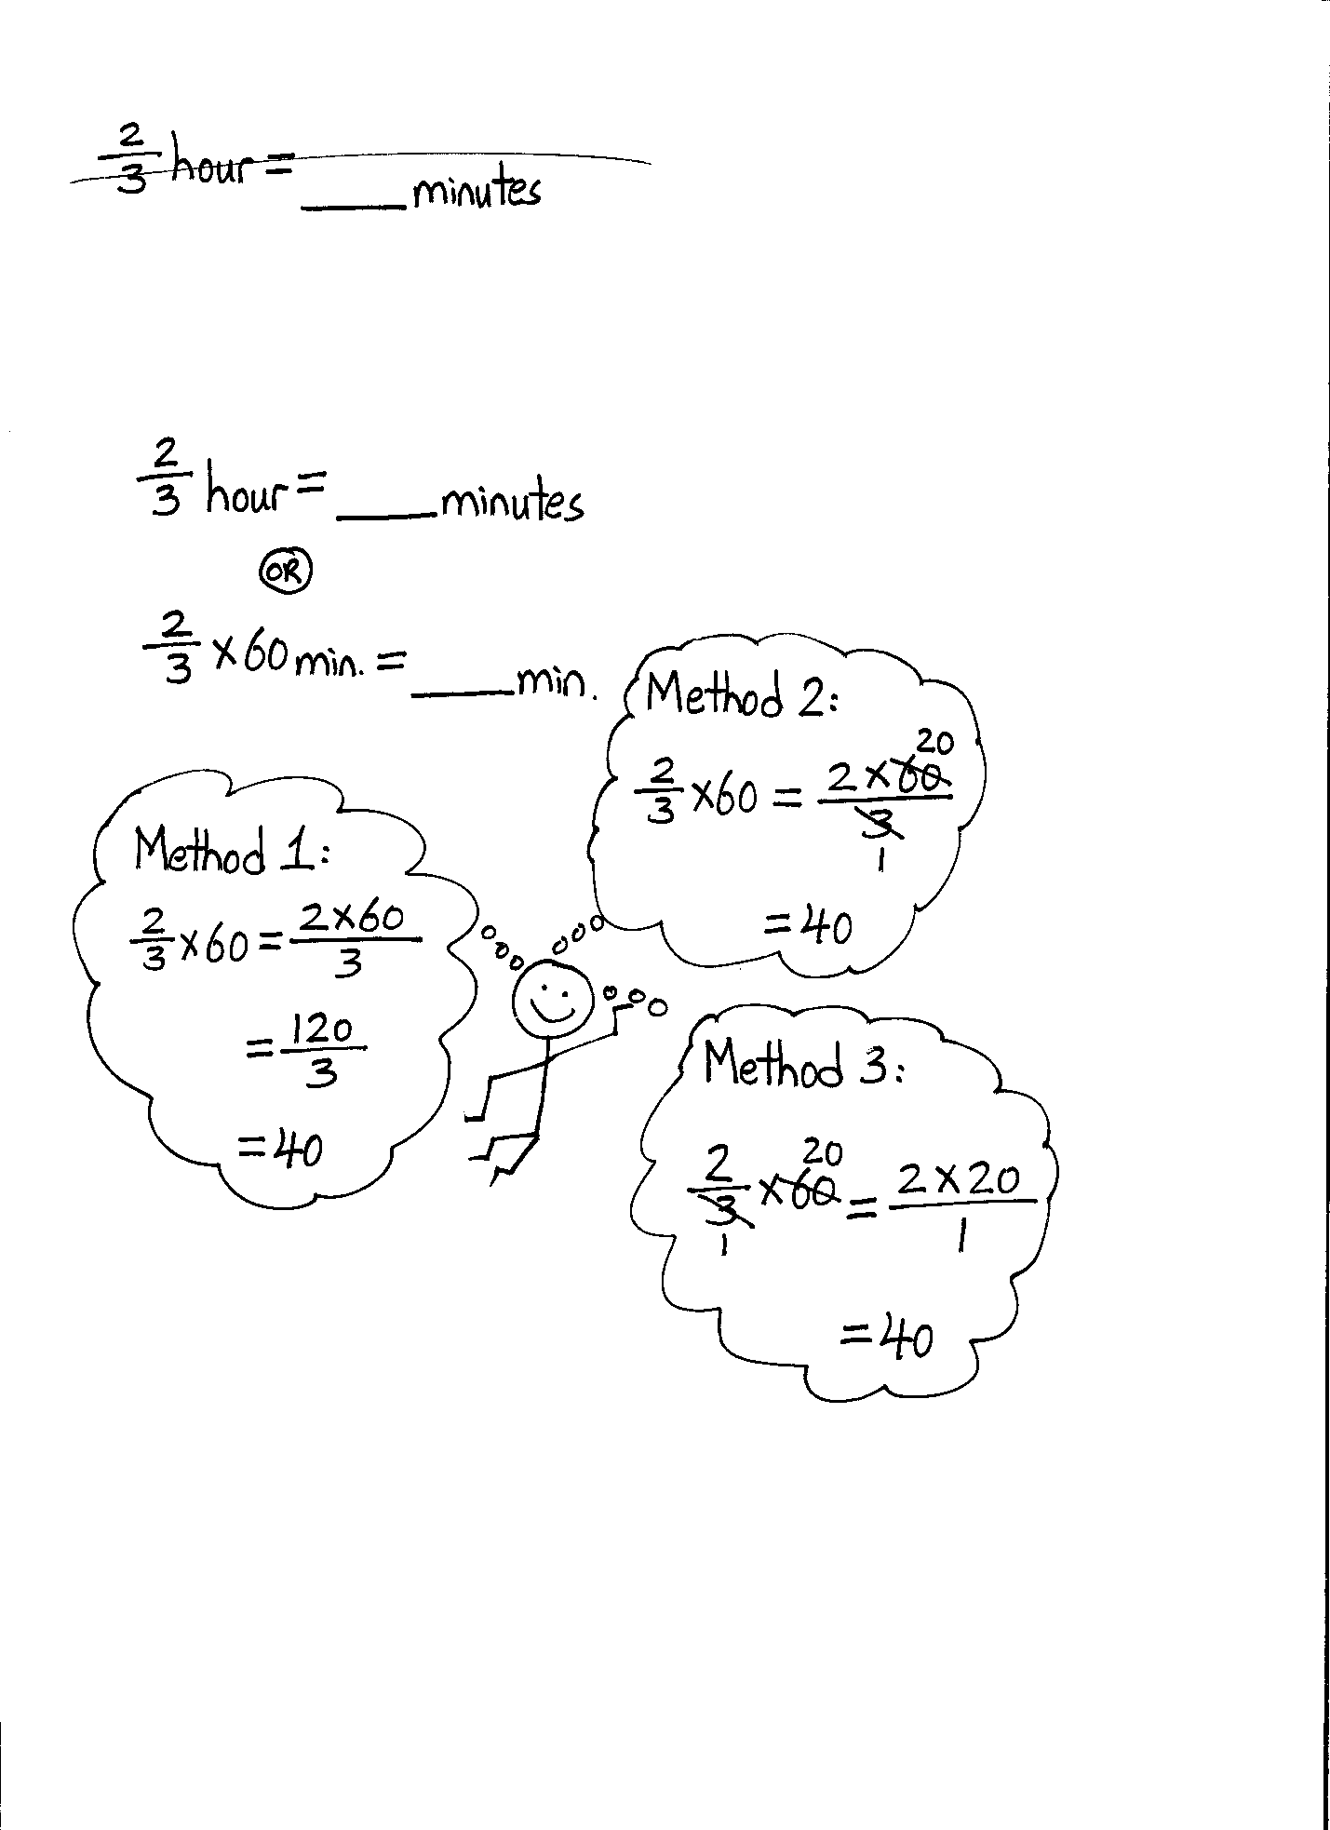

S: 2 thirds of an hour.

T: Will 2 thirds of an hour be more than 60 minutes or less? Why?

S: It should be less because it isn’t a whole hour. 🡪 A whole hour, 60 minutes, would be 3 thirds. We only want 2 thirds, so it should be less than 60 minutes.

T: Turn and talk with your partner about how you might find 2 thirds of an hour.

S: I know the whole is 60 minutes, and the fraction I want is . 🡪 We have to find what’s of 60.

T: (Write × 60 min = ____ min.) Solve this problem independently. You may use any method you prefer.

S: (Solve.)

T: (Select students to share their solutions with the class.)

Repeat this sequence with of a foot.

Problem Set (10 minutes)

Students should do their personal best to complete the Problem Set within the allotted 10 minutes. For some classes, it may be appropriate to modify the assignment by specifying which problems they work on first. Some problems do not specify a method for solving. Students should solve these problems using the RDW approach used for Application Problems.

Today’s Problem Set is lengthy. Students may benefit from additional guidance. Consider solving one problem from each section as a class before instructing students to solve the remainder of the problems independently.

Student Debrief (10 minutes)

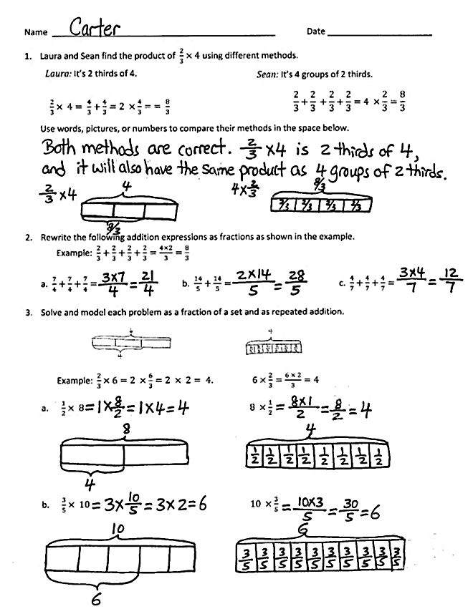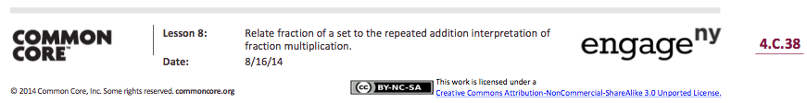

**Lesson Objective:** Relate a fraction of a set to the repeated addition interpretation of fraction multiplication.

The Student Debrief is intended to invite reflection and active processing of the total lesson experience.

Invite students to review their solutions for the Problem Set. They should check work by comparing answers with a partner before going over answers as a class. Look for misconceptions or misunderstandings that can be addressed in the Debrief. Guide students in a conversation to debrief the Problem Set and process the lesson.

You may choose to use any combination of the questions below to lead the discussion.

* Share and explain your solution for Problem 1 with a partner.
* What do you notice about Problems 2(a) and 2(c)? (Problem 2(a) is 3 groups of , which is equal to , and 2(c) is 3 groups of , which is equal to .)

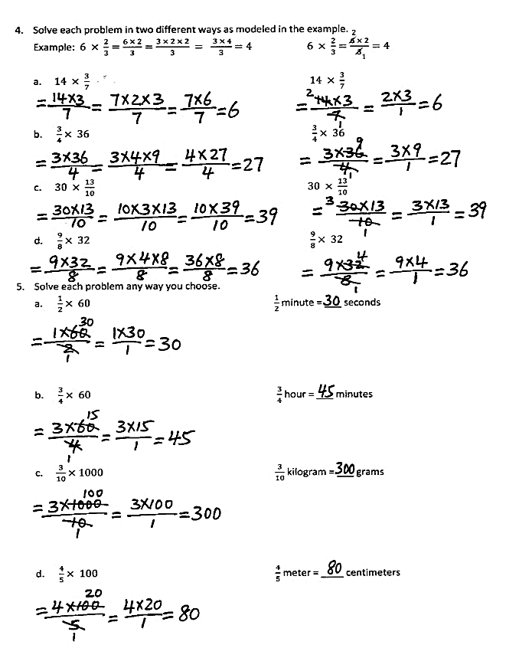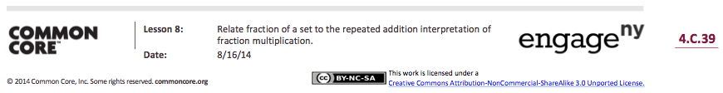

* What do you notice about the solutions in Problems 3 and 4? (All of the products are whole numbers.)
* We learned to solve fraction of a set problems using the repeated addition strategy and multiplication and simplifying strategies today. Which one do you think is the most efficient way to solve a problem? Does it depend on the problems?
* Why is it important to learn more than one strategy to solve a problem?

Exit Ticket (3 minutes)

After the Student Debrief, instruct students to complete the Exit Ticket. A review of their work will help you assess the students’ understanding of the concepts that were presented in the lesson today and plan more effectively for future lessons. You may read the questions aloud to the students.

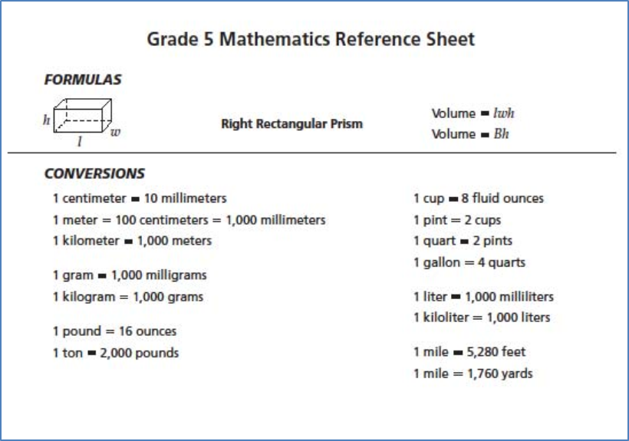

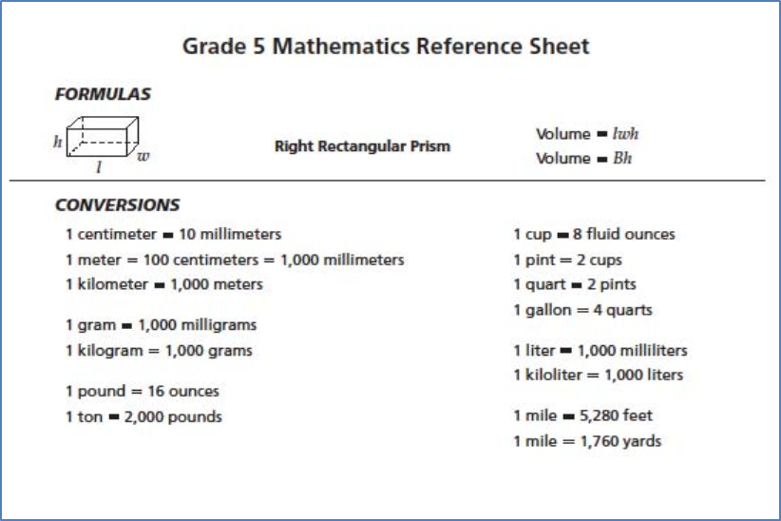

Name Date

1. Laura and Sean find the product of using different methods.

*Laura:* It’s 2 thirds of 4.

*Sean:* It’s 4 groups of 2 thirds.

Use words, pictures, or numbers to compare their methods in the space below.

1. Rewrite the following addition expressions as fractions as shown in the example.

Example:

a. b. c.

1. Solve and model each problem as a fraction of a set and as repeated addition.

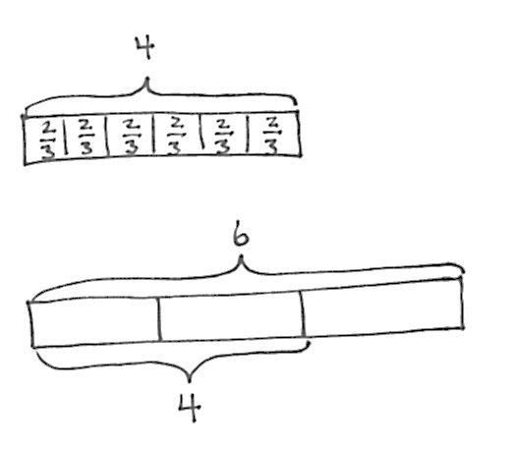

Example: . 6

3. Solve each problem in two different ways as modeled in the example.

2

Example:

1

5. Solve each problem any way you choose.
6. minute = __________ seconds
7. hour = __________ minutes
8. kilogram = __________ grams
9. meter = __________ centimeters

Name Date

Solve each problem in two different ways as modeled in the example.

2

Example:

1



Name Date

1. Rewrite the following expressions as shown in the example.

Example:

a. b. c.

1. Solve each problem in two different ways as modeled in the example.

2

Example:

1

8. Solve each problem any way you choose.
9. minute = _________ seconds
10. hour = _________ minutes
11. kilogram = _________ grams

1. meter = _________ centimeters