Lesson 7
Objective: Multiply any whole number by a fraction using tape diagrams.

Suggested Lesson Structure
 Fluency Practice (12 minutes)
 Application Problem (5 minutes)
 Concept Development (33 minutes)
 Student Debrief (10 minutes)
Total Time (60 minutes)
Fluency Practice (12 minutes)
- Read Tape Diagrams 5.NF.4 (4 minutes)
- Half of Whole Numbers 5.NF.4 (4 minutes)
- Fractions as Whole Numbers 5.NF.3 (4 minutes)
Read Tape Diagrams (4 minutes)
Materials: (S) Personal white board
Note: This fluency activity prepares students to multiply fractions by whole numbers during the Concept Development.
T: (Project a tape diagram with 10 partitioned into 2 equal units.) Say the whole.
S: 10.
T: On your personal white board, write the division sentence.
S: (Write 10 ÷ 2 = 5.)
Continue with the following possible sequence: 6 ÷ 2, 9 ÷ 3, 12 ÷ 3, 8 ÷ 4, 12 ÷ 4, 25 ÷ 5, 40 ÷ 5, 42 ÷ 6, 63 ÷ 7, 64 ÷ 8, and 54 ÷ 9.
Half of Whole Numbers (4 minutes)
Materials: (S) Personal white board
Note: This fluency activity reviews content from Lesson 6 and prepares students for multiplying fractions by whole numbers during the Concept Development using tape diagrams.
T: Draw 4 counters. What’s half of 4?
S: 2.
T: (Write $\frac{1}{2}$ of 4 = 2.) Say a division sentence that helps you find the answer.
S: 4 ÷ 2 = 2.
Continue with the following possible sequence: 1 half of 10, 1 half of 8, 1 half of 30, 1 half of 54, 1 fourth of 20, 1 fourth of 16, 1 third of 9, and 1 third of 18.
Fractions as Whole Numbers (4 minutes)
Materials: (S) Personal white board
Note: This fluency activity reviews Lesson 5, as well as denominators that are equivalent to hundredths. Instruct students to use their personal white boards for calculations that they cannot do mentally.
T: I’ll say a fraction. You say it as a division problem. 4 halves.
S: 4 ÷ 2 = 2.
Continue with the following possible suggestions: $\frac{6}{2}, \frac{14}{2}, \frac{54}{2}, \frac{40}{20}, \frac{80}{20}, \frac{180}{20}, \frac{960}{20}, \frac{10}{5}, \frac{15}{5}, \frac{35}{5}, \frac{85}{5}, \frac{100}{50}, \frac{150}{50}, \frac{300}{50}, \frac{900}{50}, \frac{8}{4}, \frac{12}{4}, \frac{24}{4}, \frac{96}{4}, \frac{50}{25}, \frac{75}{25}, \text{and} \frac{800}{25}.$
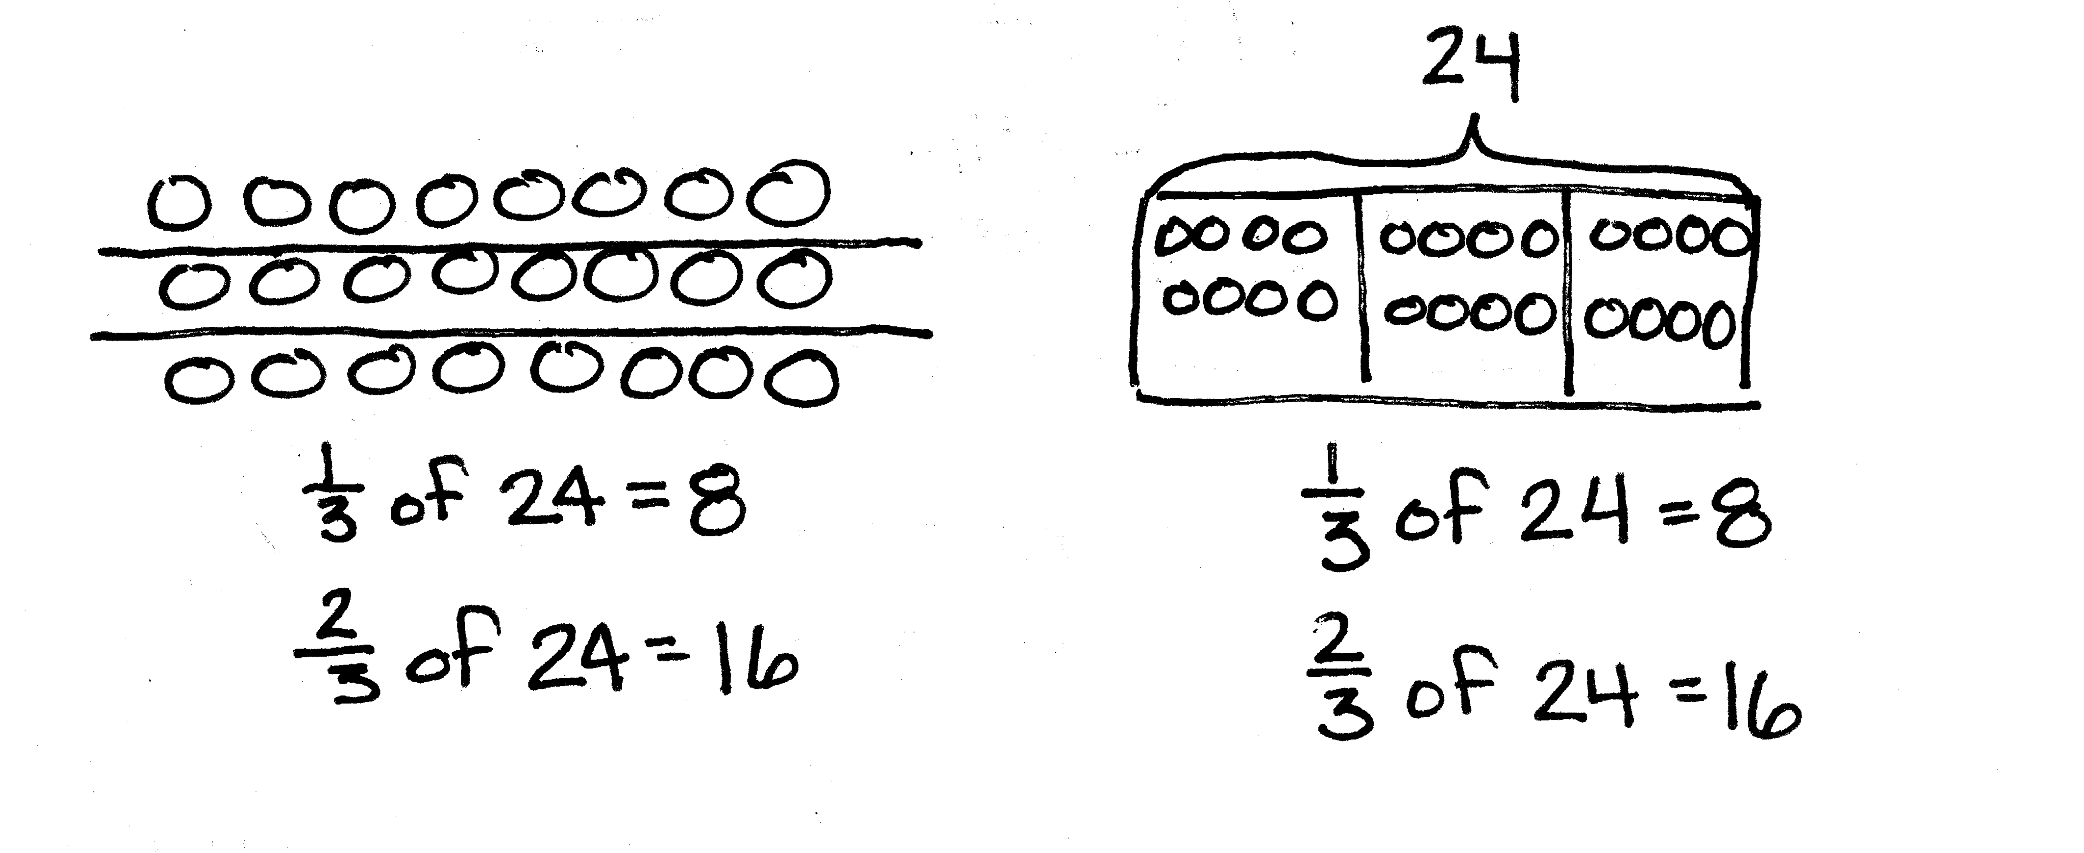
Application Problem (5 minutes)
Mr. Peterson bought a case (24 boxes) of fruit juice.
One-third of the drinks were grape, and two-thirds were cranberry. How many boxes of each flavor did Mr. Peterson buy? Show your work using a tape diagram or an array.
Note: This Application Problem requires students to use skills explored in Lesson 6. Students are finding fractions of a set and showing their thinking with models.
Concept Development (33 minutes)

NOTES ON
MULTIPLE MEANS
OF REPRESENTATION:
Please note that, throughout the lesson, division sentences are written as fractions to reinforce the interpretation of a fraction as division. When reading the fraction notation, the language of division should be used. For example, in Problem 1,
1 unit = $\frac{35}{5}$ should be read as 1 unit equals 35 divided by 5.
Materials: (S) Personal white board
Problem 1
What is $\frac{3}{5}$ of 35?
T: (Write $\frac{3}{5}$ of 35 = ___ on the board.) We used two different models (counters and arrays) yesterday to find fractions of sets. We will use tape diagrams to help us today.
T: We must find 3 fifths of 35. Draw a bar to represent our whole. What’s our whole?
S: (Draw.) 35.
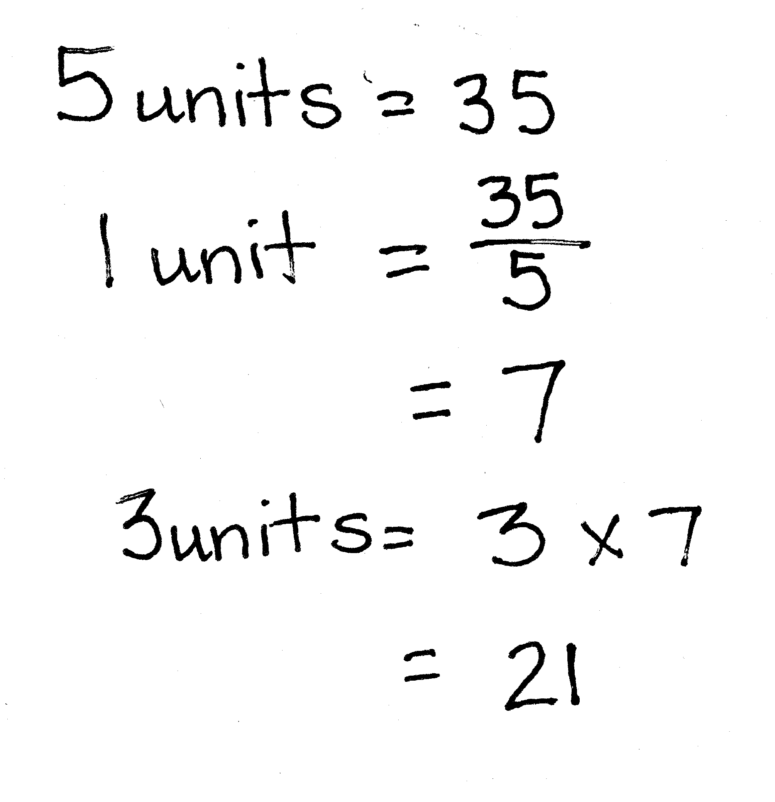
T: (Draw a bar and label it as 35.) How many units should we cut the whole into?
S: 5.
T: How do you know?
S: The denominator tells us we want fifths. That is the unit being named by the fraction. We are asked about fifths, so we know we need 5 equal parts.
T: Divide your bar into fifths.
S: (Work.)
T: (Cut the bar into 5 equal units.) We know 5 units are equal to 35. How do we find the value of 1 unit? Say the division sentence.
S: 35 ÷ 5 = 7.

NOTES ON
MULTIPLE MEANS
OF ACTION AND EXPRESSION:
Students with fine motor deficits may find drawing tape diagrams difficult. Graph paper may provide some support. Online sources, such as the Thinking Blocks website, may also be helpful.
T: (Write 5 units = 35, 1 unit = 35 ÷ 5 = 7.) Have we answered our question?
S: No, we found 1 unit is equal to 7, but the question is to find 3 units. We need 3 fifths. When we divide by 5, that’s just 1 fifth of 35.
T: How will we find 3 units?
S: Multiply 3 and 7 to get 21. We could add 7 + 7 + 7. We could put 3 of the 1 fifths together. That would be 21.
T: What is $\frac{3}{5}$ of 35?
S: 21.
Problem 2
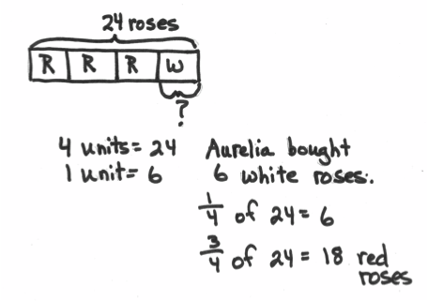
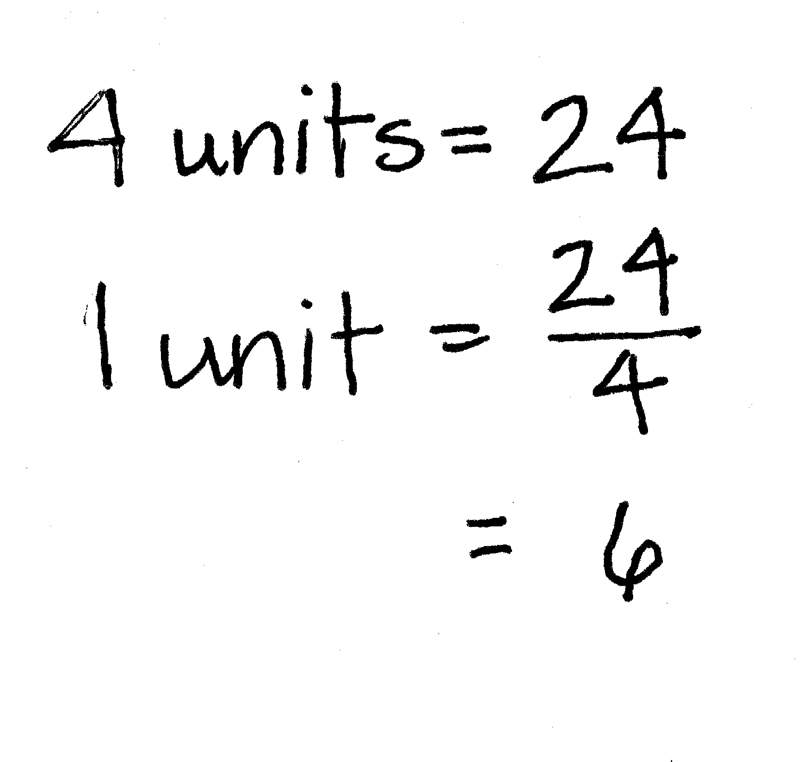
Aurelia buys 2 dozen roses. Of these roses, $\frac{3}{4}$ are red, and the rest are white. How many white roses did she buy?
T: What do you know about this problem? Turn and share with your partner.
S: I know the whole is 2 dozen, which is 24. $\frac{3}{4}$ are red roses, and $\frac{1}{4}$ are white roses. The total is 24 roses. The information in the problem is about red roses, but the question is about the other part—the white roses.
T: Discuss with your partner how you’ll solve this problem.
S: We can first find the total red roses, and then subtract from 24 to get the white roses. Since I know $\frac{1}{4}$ of the whole is white roses, I can find $\frac{1}{4}$ of 24 to find the white roses. That’s faster.
T: Work with a partner to draw a tape diagram and solve.
S: (Work.)
T: Answer the question for this problem.
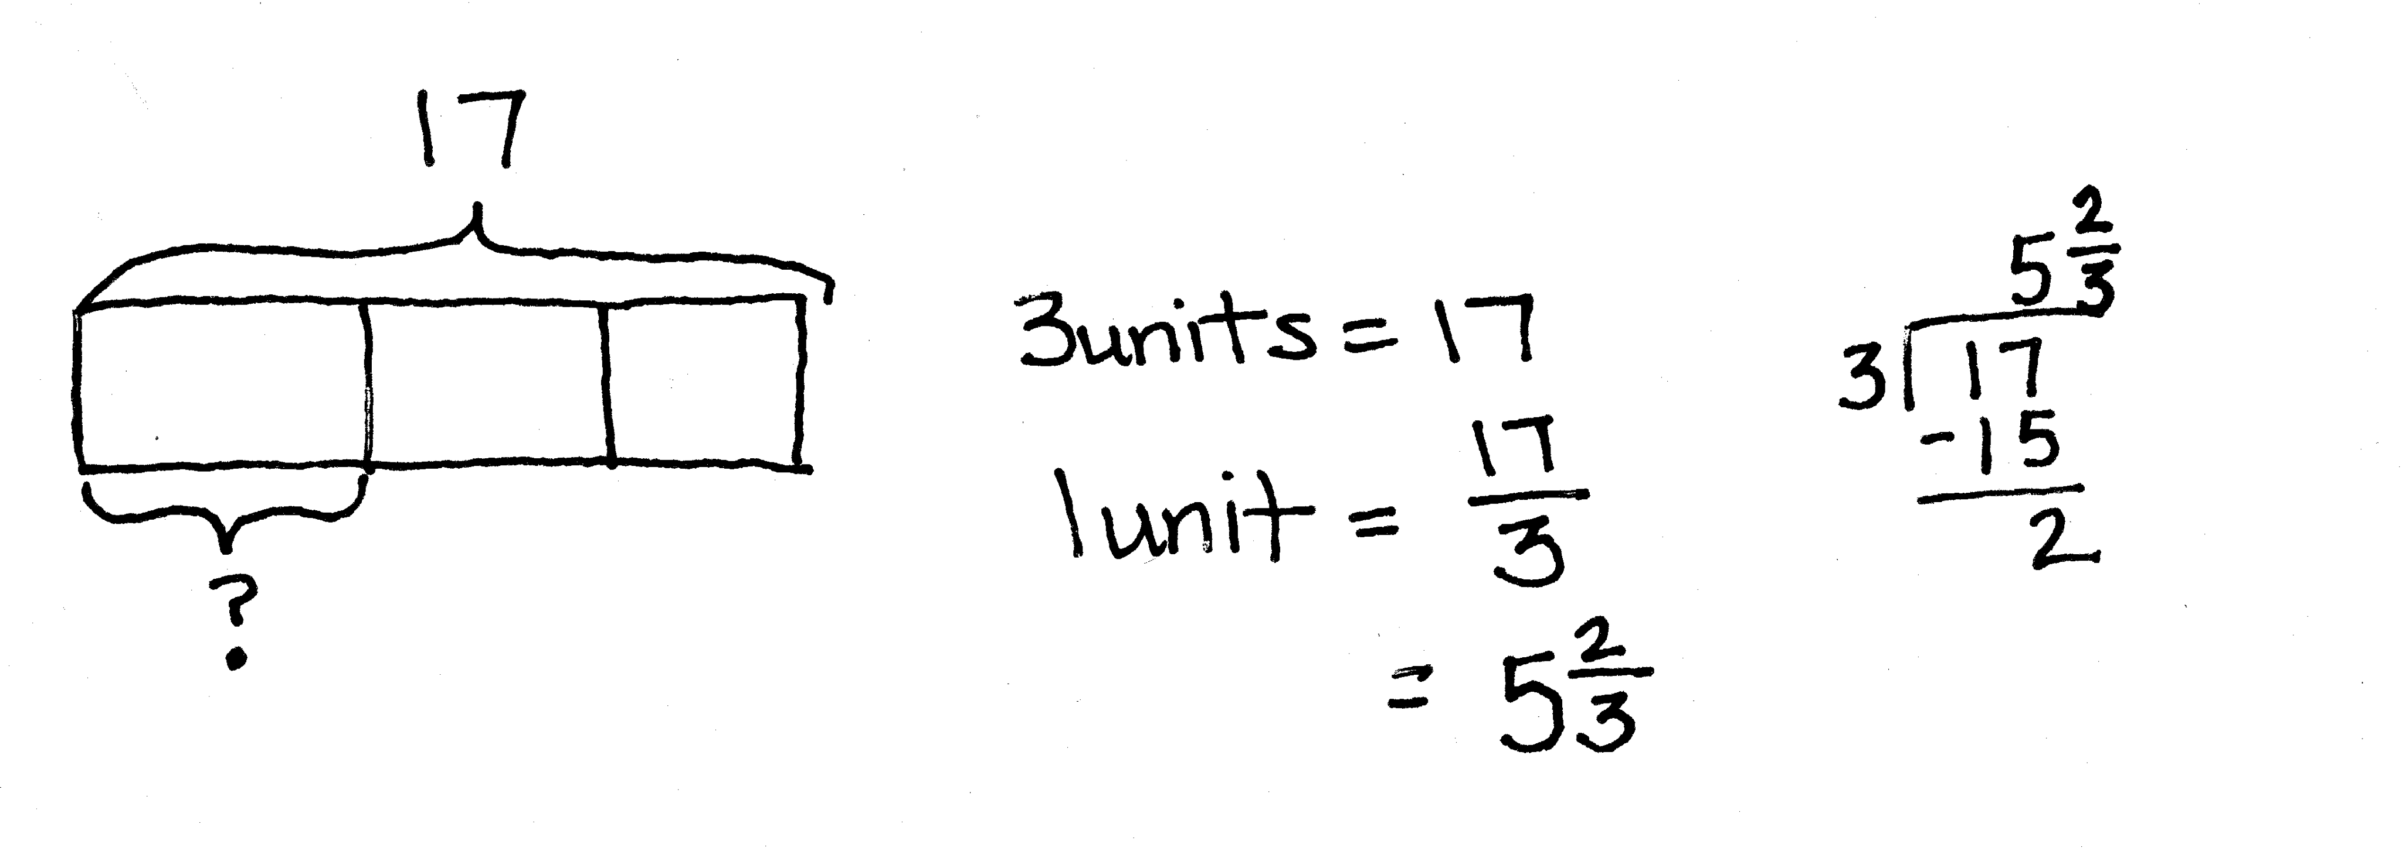
S: She bought 6 white roses.
Problem 3
Rosie had 17 yards of fabric. She used one-third of it to make a quilt. How many yards of fabric did Rosie use for the quilt?
T: What can you draw? Turn and share with your partner.
T: Compare this problem to the others we’ve done today.

NOTES ON
MULTIPLE MEANS
OF REPRESENTATION:
The added complexity of finding a fraction of a quantity that is not a multiple of the denominator may require a return to concrete materials for some students. Allow them access to materials that can be folded and cut to model Problem 3 physically. Five whole squares can be distributed into each unit of 1 third. Then, the remaining whole squares can be cut into thirds and distributed among the units of thirds. Be sure to make the connection to the fraction form of the division sentence and the written recording of the division algorithm.
S: The answer is not a whole number. The quotient is not a whole number. We were still looking for fractional parts, but the answer isn’t a whole number.
T: We can draw a bar that shows 17 and divide it into thirds. How do we find the value of one unit?
S: Divide 17 by 3.
T: How much fabric is one-third of 17 yards?
S: $\frac{17}{3}$ yards. $\text{5}\frac{2}{3}$yards.
T How would you find 2 thirds of 17?
S: Double$\text{5}\frac{2}{3}$. Multiply$\text{5}\frac{2}{3}$times 2. Subtract$\text{5}\frac{2}{3}$from 17.
Repeat this sequence with $\frac{2}{5}$ of 11, if necessary.
Problem 4
$\frac{2}{3}$ of a number is 8. What is the number?
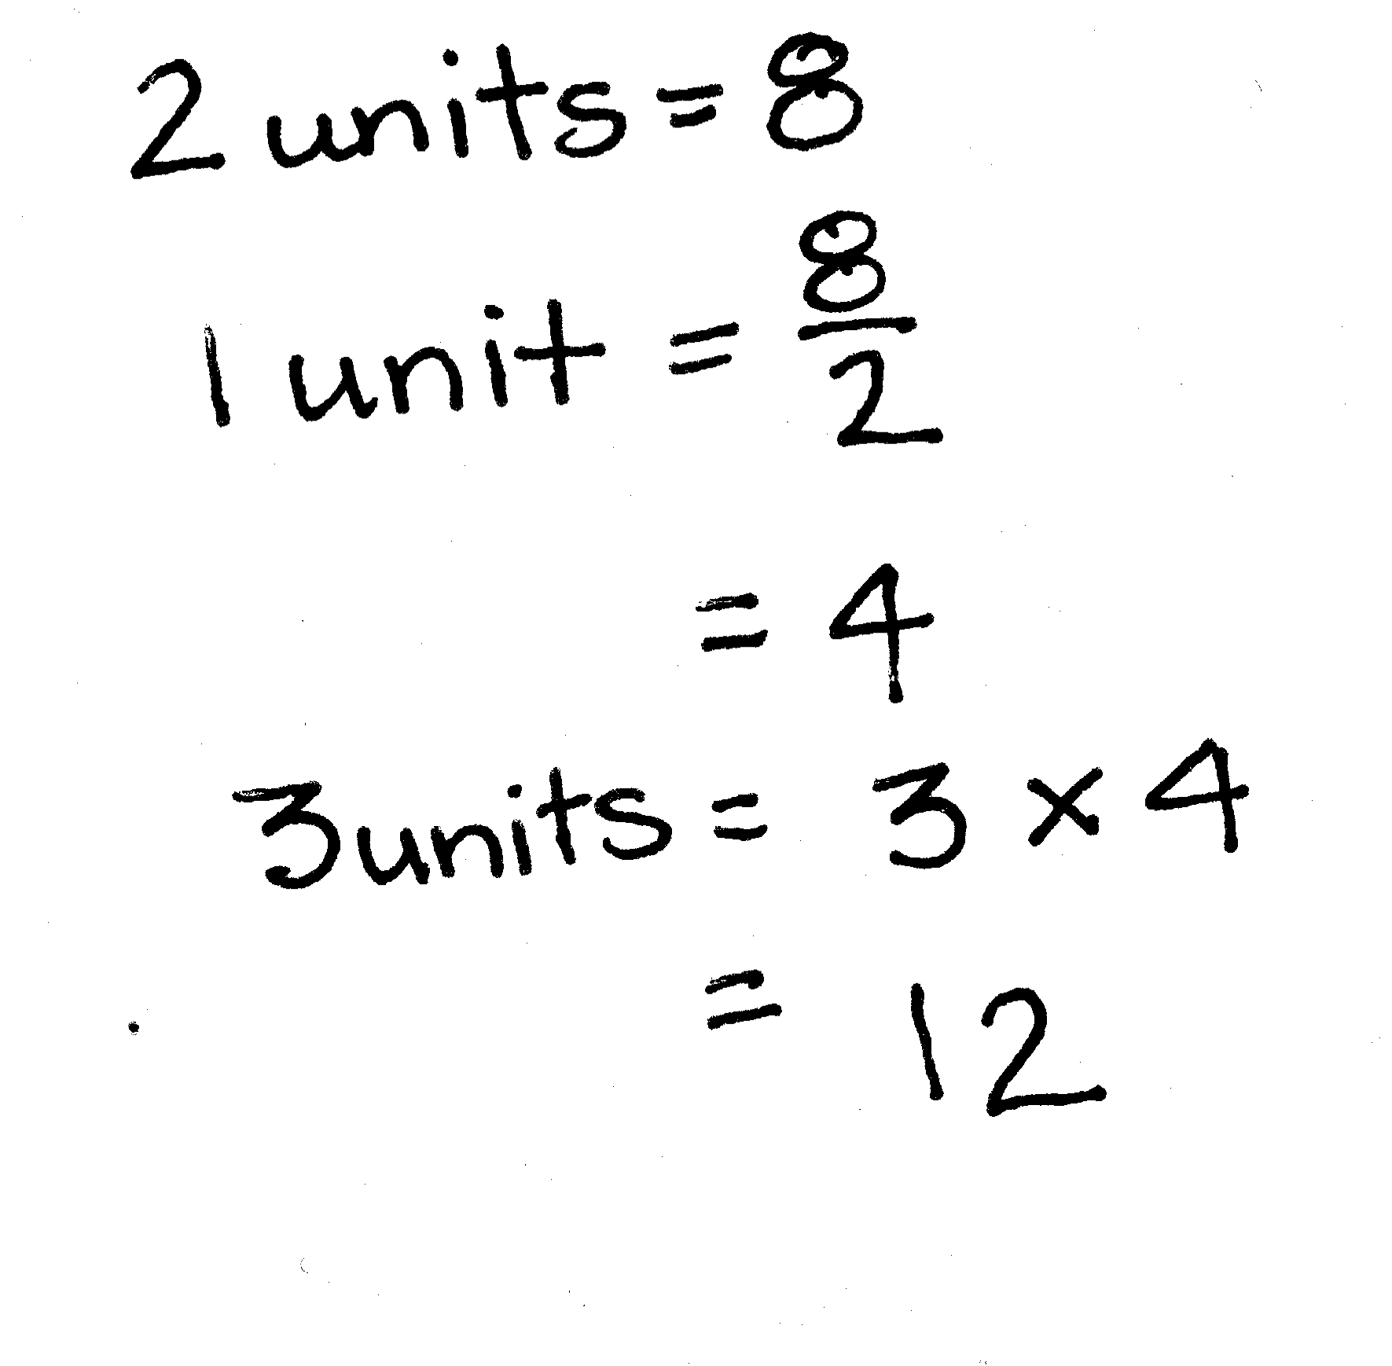
T: How is this problem different from the ones we just solved?
S: In the first problem, we knew the total and wanted to find a part of it. In this one, we know how much 2 thirds is, but not the whole. Last time, they told us the whole and asked us about a part. This time, they told us about a part and asked us to find the whole.
T: Draw a bar to represent the whole. What kind of units will we need to divide the whole into?
S: (Draw.) Thirds.
T: (Draw the bar divided into thirds.) What else do we know? Turn and tell your partner.
S: We know that 2 thirds is the same as 8, so it means we can label 2 of the units with a bracket and 8. The units are thirds. We know about 2 of them. They are equal to 8 together. We don’t know what the whole bar is worth, so we have to put a question mark there.
T: (Draw to show the labeling.) Label your bars.
S: (Label their bars.)
T: How can knowing what 2 units are worth help us find the whole?
S: Since we know that 2 units = 8, we can divide to find that 1 unit is equal to 4.
T: (Write 1 unit = 8 ÷ 2 = 4.) Let’s record 4 inside each unit. (Show the recording.)
S: (Record the 4 inside each unit.)
T: Can we find the whole now?
S: Yes. We can add 4 + 4 + 4 =12. We can multiply 3 times 4, which is equal to 12.
T: (Write 3 units = 3 × 4 = 12.) Answer the question for this problem.
S: The number is 12.
T: Let’s think about it and check to see if it makes sense. (Write $\frac{2}{3}$ of 12 = 8.) Work independently on your personal white board, and solve to find what 2 thirds of 12 is.
Problem 5
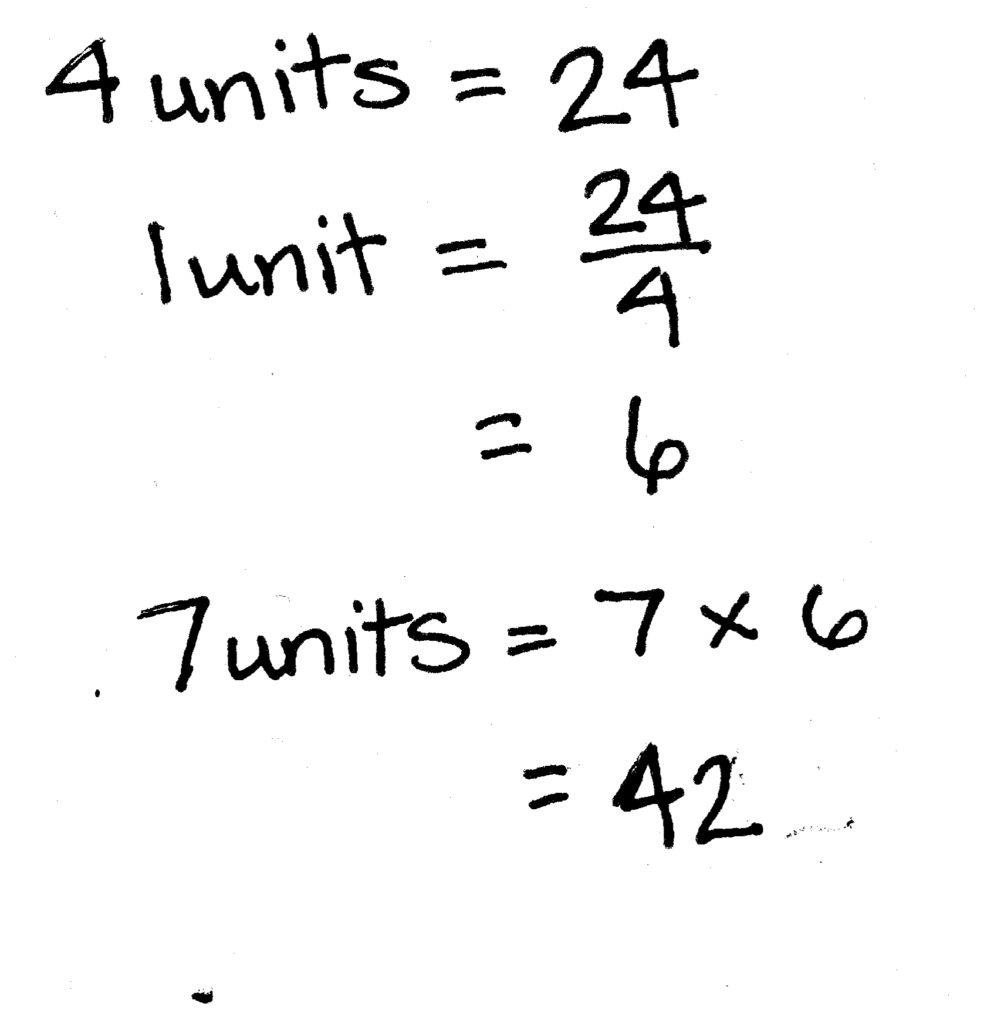
Tiffany spent $\frac{4}{7}$ of her money on a teddy bear. If the teddy bear cost $24, how much money did she have at first?
T: Which problem that we’ve worked on today is most similar to this one?
S: This one is just like Problem 4. We have information about a part, and we have to find the whole.
T: What can you draw? Turn and share with your partner.
S: We can draw a bar for all of the money. We can show what the teddy bear costs. It costs $24, and it’s $\frac{4}{7}$ of her total money. We can put a question mark over the whole bar.
T: Do we have enough information to find the value of 1 unit?
S: Yes.
T: How much is one unit?
S: 4 units = $24, so 1 unit = $6.
T: How will we find the amount of money she had at first?
S: Multiply $6 by 7.
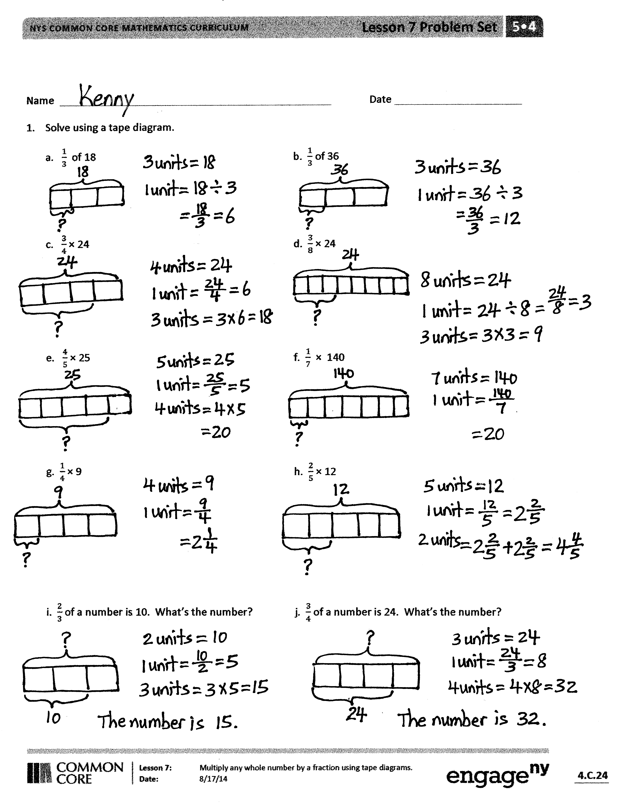
T: Say the multiplication sentence, starting with 7.
S: 7 × $6 = $42.
T: Answer the question in this problem.
S: Tiffany had $42 at first.
Problem Set (10 minutes)
Students should do their personal best to complete the Problem Set within the allotted 10 minutes. For some classes, it may be appropriate to modify the assignment by specifying which problems they work on first. Some problems do not specify a method for solving. Students should solve these problems using the RDW approach used for Application Problems.
Student Debrief (10 minutes)
Lesson Objective: Multiply any whole number by a fraction using tape diagrams.
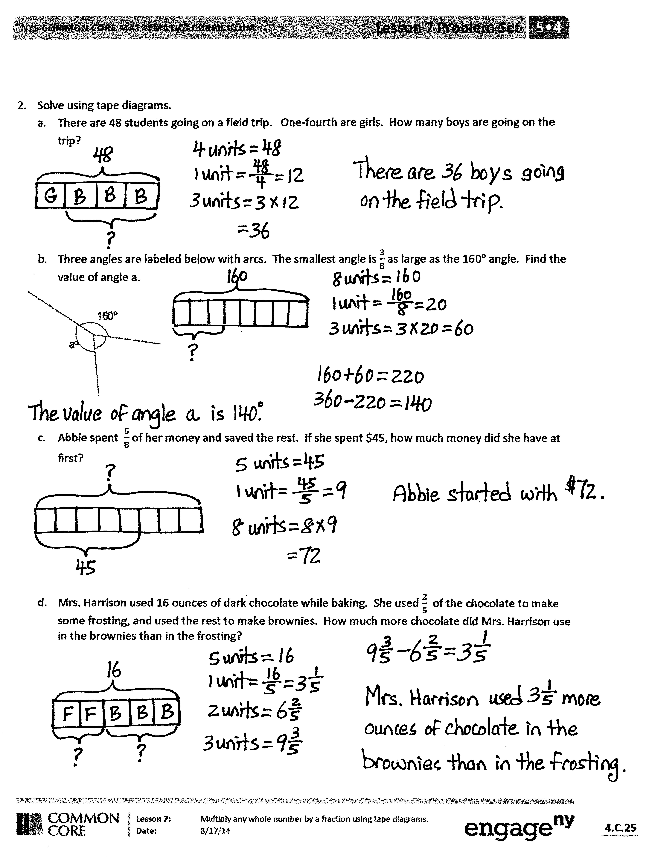
The Student Debrief is intended to invite reflection and active processing of the total lesson experience.
Invite students to review their solutions for the Problem Set. They should check work by comparing answers with a partner before going over answers as a class. Look for misconceptions or misunderstandings that can be addressed in the Debrief. Guide students in a conversation to debrief the Problem Set and process the lesson.
You may choose to use any combination of the questions below to lead the discussion.
- What pattern relationships did you notice between Problems 1(a) and 1(b)? (The whole of 36 is twice as much as the whole of 18. 1 third of 36 is twice as much as 1 third of 18. 12 is twice as much as 6.)
- What pattern did you notice between Problems 1(c) and 1(d)? (The wholes are the same. The fraction of 3 eighths is half of 3 fourths. That is why the answer of 9 is also half of 18.)
- Look at Problems 1(e) and 1(f). We know that 4 fifths and 1 seventh aren’t equal, so how did we get the same answer?
- Compare Problems 1(c) and 1(j). How are they similar, and how are they different? (The questions involve the same numbers, but in Problem 1(c), 3 fourths is the unknown quantity, and in Problem 1(j), it is the known quantity. In Problem 1(c), the whole is known, but in Problem 1(j), the whole is unknown.)
- How did you solve for Problem 2(b)? Explain your strategy or solution to a partner.
- There are a couple of different methods to solve Problem 2(c). Find someone who used a different approach from yours and explain your thinking.
Exit Ticket (3 minutes)
After the Student Debrief, instruct students to complete the Exit Ticket. A review of their work will help you assess the students’ understanding of the concepts that were presented in the lesson today and plan more effectively for future lessons. You may read the questions aloud to the students.

Name Date
- Solve using a tape diagram.
a. $\frac{1}{3}$ of 18 b. $\frac{1}{3}$ of 36

c. $\frac{3}{4}$ × 24 d. $\frac{3}{8}$ × 24

e. $\frac{4}{5}$ × 25 f. $\frac{1}{7}$ × 140

g. $\frac{1}{4}$ × 9 h. $\frac{2}{5}$ × 12

i. $\frac{2}{3}$ of a number is 10. What’s the number? j. $\frac{3}{4}$ of a number is 24. What’s the number?

- Solve using tape diagrams.
  - There are 48 students going on a field trip. One-fourth are girls. How many boys are going on the trip?
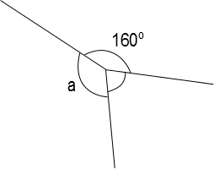
  - Three angles are labeled below with arcs. The smallest angle is $\frac{3}{8}$ as large as the $\text{160}°$ angle. Find the value of angle a.
°

- Abbie spent $\frac{5}{8}$ of her money and saved the rest. If she spent $45, how much money did she have at first?

- Mrs. Harrison used 16 ounces of dark chocolate while baking. She used $\frac{2}{5}$ of the chocolate to make some frosting and used the rest to make brownies. How much more chocolate did Mrs. Harrison use in the brownies than in the frosting?
Name Date
Solve using a tape diagram.
a. $\frac{3}{5}$ of 30 b. $\frac{3}{5}$ of a number is 30. What’s the number?

- Mrs. Johnson baked 2 dozen cookies. Two-thirds of the cookies were oatmeal. How many oatmeal cookies did Mrs. Johnson bake?

Name Date
  - Solve using a tape diagram.
a. $\frac{1}{4}$ of 24 b. $\frac{1}{4}$ of 48

c. $\frac{2}{3}$ × 18 d. $\frac{2}{6}$ × 18

e. $\frac{3}{7}$ × 49 f. $\frac{3}{10}$ × 120

g. $\frac{1}{3}$ × 31 h. $\frac{2}{5}$ × 20

i. $\frac{1}{4}$ × 25 j. $\frac{3}{4}$ × 25

k. $\frac{3}{4}$ of a number is 27. What’s the number? l. $\frac{2}{5}$ of a number is 14. What’s the number?

  - Solve using tape diagrams.
  - A skating rink sold 66 tickets. Of these, $\frac{2}{3}$ were children’s tickets, and the rest were adult tickets. What total number of adult tickets were sold?

  - A straight angle is split into two smaller angles as shown. The smaller angle’s measure is $\frac{1}{6}$ that of a straight angle. What is the value of angle a?

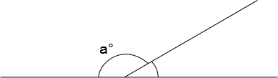

- Annabel and Eric made 17 ounces of pizza dough. They used $\frac{5}{8}$ of the dough to make a pizza and used the rest to make calzones. What is the difference between the amount of dough they used to make pizza, and the amount of dough they used to make calzones?

- The New York Rangers hockey team won $\frac{3}{4}$ of their games last season. If they lost 21 games, how many games did they play in the entire season?

