Lesson 16: More on Modeling Relationships with a Line

Classwork
Example 1: Calculating Residuals
The curb weight of a car is the weight of the car without luggage or passengers. The table below shows the curb weights (in hundreds of pounds) and fuel efficiencies (in miles per gallon) of five compact cars.
Curb Weight  ($100$ lb.) | Fuel Efficiency  (miles per gallon)
$$25.33$$ | $$43$$
$$26.94$$ | $$38$$
$$27.79$$ | $$30$$
$$30.12$$ | $$34$$
$$32.47$$ | $$30$$
Using a calculator, the least squares line for this data set was found to have the equation:
$$y=78.62-1.5290x,$$
where $x$is the curb weight (in hundreds of pounds) and$y$ is the predicted fuel efficiency (in miles per gallon).

The scatter plot of this data set is shown below, and the least squares line is shown on the graph.
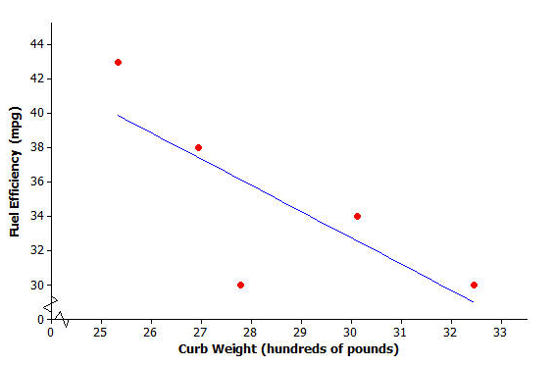
You will calculate the residuals for the five points in the scatter plot. Before calculating the residual, look at the scatter plot.
Exercises 1–2
- Will the residual for the car whose curb weight is $25.33$ be positive or negative? Roughly what is the value of the residual for this point?

- Will the residual for the car whose curb weight is $27.79$ be positive or negative? Roughly what is the value of the residual for this point?

The residuals for both of these curb weights are calculated as follows:
Substitute $x=25.33$ into the equation of the least squares line to find the predicted fuel efficiency.  $$y=78.62-1.5290(25.33) \\ =39.9$$  Now calculate the residual.  residual $=$ actual $y$-value $-$ predicted $y$-value  $$=43-39.9$$  $=3.1 mpg$ | Substitute $x=27.79$ into the equation of the least squares line to find the predicted fuel efficiency.  $$y=78.62-1.5290(27.79) \\ =36.1$$  Now calculate the residual.  residual $=$ actual $y$-value $-$ predicted $y$-value  $=30-36.1$  $=-6.1 mpg$

These two residuals have been written in the table below.
Curb Weight  ($100$ lb) | Fuel Efficiency  (miles per gallon) | Residual
$$25.33$$ | $$43$$ | $$3.1$$
$$26.94$$ | $$38$$
$$27.79$$ | $$30$$ | $$-6.1$$
$$30.12$$ | $$34$$
$$32.47$$ | $$30$$
Exercises 3–4
Continue to think about the car weights and fuel efficiencies from Example 1.
- Calculate the remaining three residuals and write them in the table.

- Suppose that a car has a curb weight (in hundreds of pounds) of $31$.
  - What does the least squares line predict for the fuel efficiency of this car?

  - Would you be surprised if the actual fuel efficiency of this car was $29$ miles per gallon? Explain your answer.

Example 2: Making a Residual Plot to Evaluate a Line
It is often useful to make a graph of the residuals, called a residual plot. You will make the residual plot for the compact car data set.
Plot the original $x$ variable (curb weight in this case) on the horizontal axis and the residuals on the vertical axis. For this example, you need to draw a horizontal axis that goes from $25$ to $32$ and a vertical axis with a scale that includes the values of the residuals that you calculated. Next, plot the point for the first car. The curb weight of the first car is $25.33$ and the residual is $3.1$. Plot the point $(25.33, 3.1)$.

The axes and this first point are shown below.
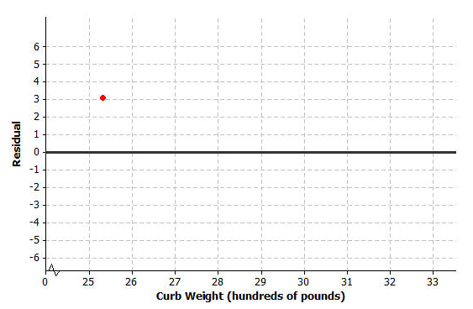

Exercise 5–6
- Plot the other four residuals in the residual plot started in Example 3.

- How does the pattern of the points in the residual plot relate to pattern in the original scatter plot? Looking at the original scatter plot, could you have known what the pattern in the residual plot would be?

Lesson Summary
- The predicted $y$-value is calculated using the equation of the least squares line.
- The residual is calculated using
residual $=$ actual $y$-value $-$ predicted $y$-value.
- The sum of the residuals provides an idea of the degree of accuracy when using the least squares line to make predictions.
- To make a residual plot, plot the $x$-values on the horizontal axis and the residuals on the vertical axis.

Problem Set

Four athletes on a track team are comparing their personal bests in the 100- and 200-meter events. A table of their best times is shown below.
Athlete | 100 m time  (seconds) | 200 m time  (seconds)
$$1$$ | $$12.95$$ | $$26.68$$
$$2$$ | $$13.81$$ | $$29.48$$
$$3$$ | $$14.66$$ | $$28.11$$
$$4$$ | $$14.88$$ | $$30.93$$

A scatter plot of these results (including the least squares line) is shown below.

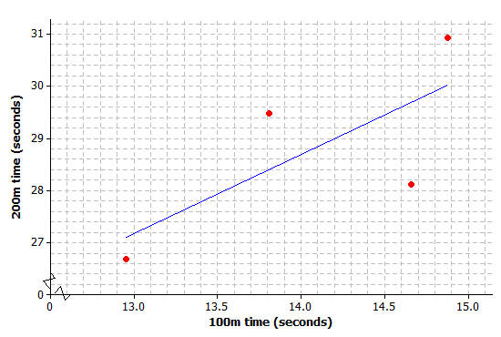
- Use your calculator or computer to find the equation of the least squares line.

- Use your equation to find the predicted 200-meter time for the runner whose 100-meter time is $12.95$. What is the residual for this athlete?

- Calculate the residuals for the other three athletes. Write all the residuals in the table given below.

Athlete | 100 m time  (seconds) | 200 m time  (seconds) | Residual
$$1$$ | $$12.95$$ | $$26.68$$
$$2$$ | $$13.81$$ | $$29.48$$
$$3$$ | $$14.66$$ | $$28.11$$
$$4$$ | $$14.88$$ | $$30.93$$

- Using the axes provided below, construct a residual plot for this data set.
