Lesson 16: More on Modeling Relationships with a Line

Student Outcomes
- Students use the least squares line to predict values for a given data set.
- Students use residuals to evaluate the accuracy of predictions based on the least squares line.

Lesson Notes
Students continue their exploration of residuals. In this lesson, students build on their knowledge of calculating residuals and expand their practice by creating residual plots. Additionally, students reason abstractly by thinking about how a particular pattern in a scatter plot will be represented in the residual plot. Students do not use residual plots as an indication of the appropriateness of fit for a model until Lesson 17.

Classwork
Example 1 (3 minutes): Calculating Residuals
Introduce the data and model for this example. Ask students to examine the scatter plot.
Example 1: Calculating Residuals
The curb weight of a car is the weight of the car without luggage or passengers. The table below shows the curb weights (in hundreds of pounds) and fuel efficiencies (in miles per gallon) of five compact cars.
Curb Weight  ($100$ lb.) | Fuel Efficiency  (miles per gallon)
$$25.33$$ | $$43$$
$$26.94$$ | $$38$$
$$27.79$$ | $$30$$
$$30.12$$ | $$34$$
$$32.47$$ | $$30$$

Using a calculator, the least squares line for this data set was found to have the equation:
$$y=78.62-1.5290x,$$
where $x$is the curb weight (in hundreds of pounds) and$y$ is the predicted fuel efficiency (in miles per gallon).

The scatter plot of this data set is shown below, and the least squares line is shown on the graph.
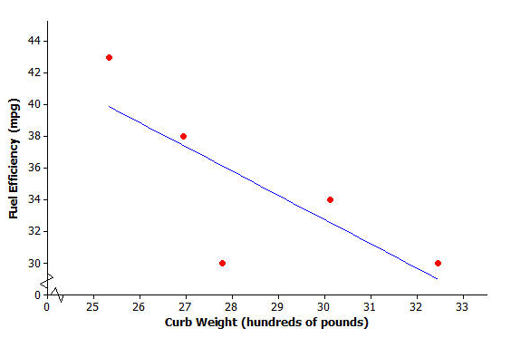
You will calculate the residuals for the five points in the scatter plot. Before calculating the residual, look at the scatter plot.

Exercises 1–2 (8 minutes)
Ask the students to examine the plot, and answer Exercises 1–2 as a class.
Exercises 1–2
- Will the residual for the car whose curb weight is $25.33$ be positive or negative? Roughly what is the value of the residual for this point?
Positive residual of $3$; the actual value is approximately $3$ units above the line.

- Will the residual for the car whose curb weight is $27.79$ be positive or negative? Roughly what is the value of the residual for this point?
Negative residual of $-6$; the actual value is $6$ units below the line.
MP.4
Now confirm the estimated residuals by calculating the exact residuals using the least squares line as shown in the text.
The residuals for both of these curb weights are calculated as follows:
Substitute $x=25.33$ into the equation of the least squares line to find the predicted fuel efficiency.  $$y=78.62-1.5290(25.33) \\ =39.9$$  Now calculate the residual.  residual $=$ actual $y$-value $-$ predicted $y$-value  $$=43-39.9$$  $$=3.1 mpg$$ | Substitute $x=27.79$ into the equation of the least squares line to find the predicted fuel efficiency.  $$y=78.62-1.5290(27.79) \\ =36.1$$  Now calculate the residual.  residual $=$ actual $y$-value $-$ predicted $y$-value  $$=30-36.1$$  $$=-6.1 mpg$$
These two residuals have been written in the table below.
Curb Weight  ($100$ lb.) | Fuel Efficiency  (miles per gallon) | Residual
$$25.33$$ | $$43$$ | $$3.1$$
$$26.94$$ | $$38$$
$$27.79$$ | $$30$$ | $$-6.1$$
$$30.12$$ | $$34$$
$$32.47$$ | $$30$$

Exercises 3–4 (12 minutes)
Let students work in small groups on Exercises 3–4. Then, discuss Exercise 4(b) as a class.
Exercises 3–4
Continue to think about the car weights and fuel efficiencies from Example 1.
- Calculate the remaining three residuals and write them in the table.
The residuals are shown in the table below.
Curb weight  ($100$ lb.) | Fuel Efficiency  (miles per gallon) | Residual
$$25.33$$ | $$43$$ | $$3.1$$
$$26.94$$ | $$38$$ | $$0.6$$
$$27.79$$ | $$30$$ | $$-6.1$$
$$30.12$$ | $$34$$ | $$1.4$$
$$32.47$$ | $$30$$ | $$1.0$$

- Suppose that a car has a curb weight (in hundreds of pounds) of $31$.
  - What does the least squares line predict for the fuel efficiency of this car?
$y=78.62-1.5290\left(31\right)=31.2$

  - Would you be surprised if the actual fuel efficiency of this car was $29$ miles per gallon? Explain your answer.
No. The residual for this point would be $29-31.2$, or $-2.2$. This is within the range of the residuals for the table above.

Example 2 (6 minutes): Making a Residual Plot to Evaluate a Line
Explain that a residual plot is made by plotting the $x$-values on the horizontal axis and the corresponding residuals on the vertical axis.
MP.6
Graph the residual in the first row of the table $(25.33, 3.1)$.
Then ask students:
- What is the next ordered pair that you would graph?
  - It should be$(26.94, 0.6)$
If students are unclear, remind them they are plotting the $x$-values with the corresponding residuals.
Example 2: Making a Residual Plot to Evaluate a Line
It is often useful to make a graph of the residuals, called a residual plot. You will make the residual plot for the compact car data set.
Plot the original $x$ variable (curb weight in this case) on the horizontal axis and the residuals on the vertical axis. For this example, you need to draw a horizontal axis that goes from $25$ to $32$ and a vertical axis with a scale that includes the values of the residuals that you calculated. Next, plot the point for the first car. The curb weight of the first car is $25.33$ and the residual is $3.1$. Plot the point $(25.33, 3.1)$.
The axes and this first point are shown below.
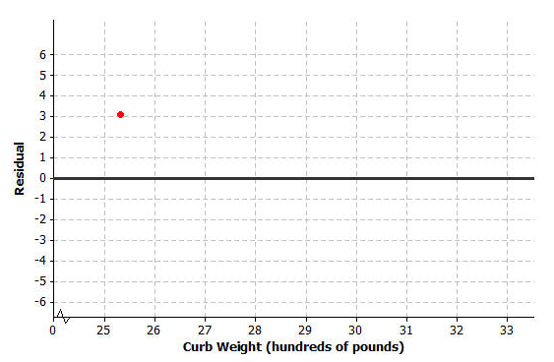

Exercises 5–6 (8 minutes)
Let students work in small groups on Exercises 5–6. Then compare answers for Exercise 6 as a class.
Exercises 5–6
- Plot the other four residuals in the residual plot started in Example 3.
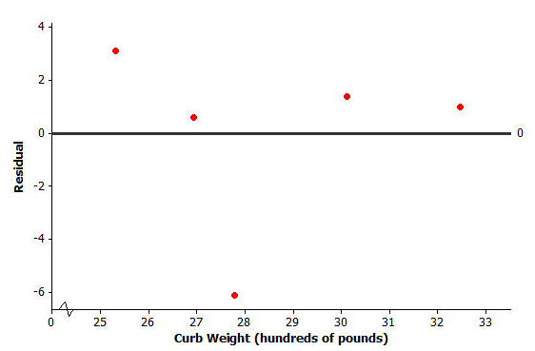
The completed residual plot is shown below.

- How does the pattern of the points in the residual plot relate to pattern in the original scatter plot? Looking at the original scatter plot, could you have known what the pattern in the residual plot would be?
The first point in the scatter plot is quite a long way above the least squares line (compared to the distances above or below the line of most of the other points), so it has a relatively large positive residual. The second point is a relatively small distance above the line, so it has a small positive residual. The third point is a long way below the line, so it has a large negative residual. The fourth point is a somewhat small distance above the line, so it has a somewhat small positive residual. Likewise, the fifth point has a relatively small positive residual. Looking at the original scatter plot, there were four points above the least squares line and only one point below, so I would have expected to have four points above the zero line in the residual plot and only one point below. Since the points above the line in the original scatter plot were closer to the line than the one point below it, I would have expected the points above the zero line in the residual plot to be closer to the zero line than the one point below.

Closing (3 minutes)
Review the Lesson Summary with students.

Lesson Summary
- The predicted $y$-value is calculated using the equation of the least squares line.
- The residual is calculated using
residual $=$ actual $y$-value $-$ predicted $y$-value.
- The sum of the residuals provides an idea of the degree of accuracy when using the least squares line to make predictions.
- To make a residual plot, plot the $x$-values on the horizontal axis and the residuals on the vertical axis.

Exit Ticket (5 minutes)

Name ___________________________________________________ Date____________________
Lesson 16: More on Modeling Relationships with a Line

Exit Ticket

- Suppose you are given a scatter plot (with least squares line) that looks like this:
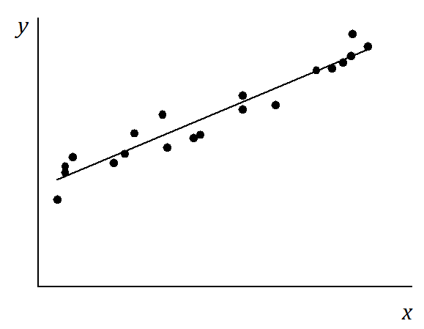

What would the residual plot to look like? Make a quick sketch on the axes given below. (There’s no need to plot the points exactly.)

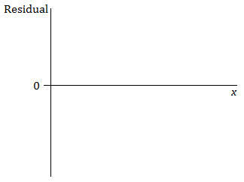

- Suppose the scatter plot looked like this:
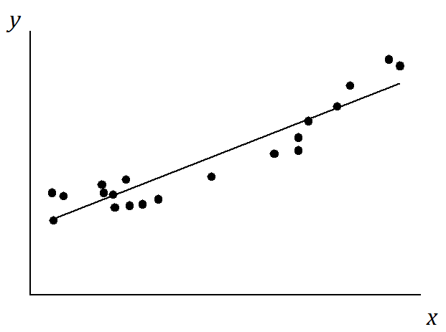

Make a quick sketch on the axes below of how the residual plot would look.

Exit Ticket Sample Solutions

- Suppose you are given a scatter plot (with least squares line) that looks like this:

What would the residual plot to look like? Make a quick sketch on the axes given below. (There’s no need to plot the points exactly.)

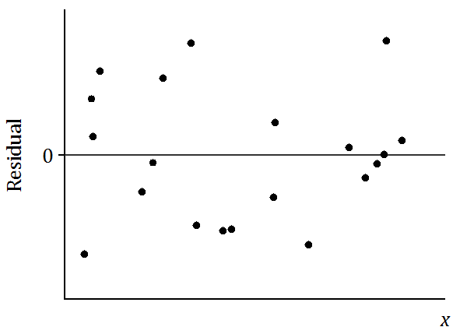

- Suppose the scatter plot looked like this:

Make a quick sketch on the axes below of how the residual plot would look.
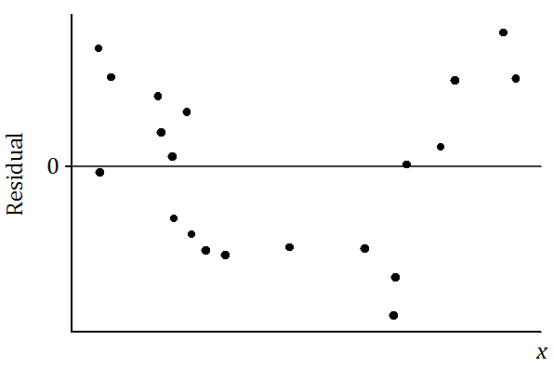

Note: It’s important that students begin to see the general shape of the pattern in the residual plot; a random scatter of points in question 1 and a U-shape in question 2. Beyond that, the details of the residual plots are not of concern at this point in the study of residuals.

Problem Set Sample Solutions

Four athletes on a track team are comparing their personal bests in the 100- and 200-meter events. A table of their best times is shown below.
Athlete | 100 m time  (seconds) | 200 m time  (seconds)
$$1$$ | $$12.95$$ | $$26.68$$
$$2$$ | $$13.81$$ | $$29.48$$
$$3$$ | $$14.66$$ | $$28.11$$
$$4$$ | $$14.88$$ | $$30.93$$

A scatter plot of these results (including the least squares line) is shown below.

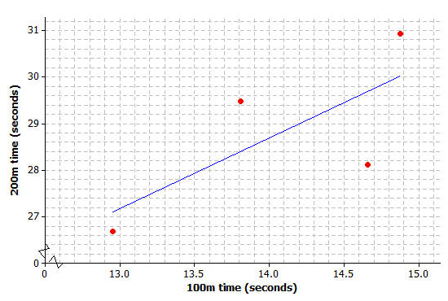

- Use your calculator or computer to find the equation of the least squares line.
$y=7.526+1.5115x$, where $x=100$m time and $y=200$m time.

- Use your equation to find the predicted 200-meter time for the runner whose 100-meter time is $12.95$. What is the residual for this athlete?
$y=7.526+1.5115\left(12.95\right)≈27.10$ sec. (nearest hundredth).
Residual $=26.68-27.10=-0.42$

- Calculate the residuals for the other three athletes. Write all the residuals in the table given below.

Athlete | 100m time  (seconds) | 200m time  (seconds) | Residual
$$1$$ | $$12.95$$ | $$26.68$$ | $$-0.42$$
$$2$$ | $$13.81$$ | $$29.48$$ | $$1.08$$
$$3$$ | $$14.66$$ | $$28.11$$ | $$-1.57$$
$$4$$ | $$14.88$$ | $$30.93$$ | $$0.91$$

- Using the axes provided below, construct a residual plot for this data set.
