Lesson 6
Objective: Relate fractions as division to fraction of a set.

Suggested Lesson Structure
 Application Problem (6 minutes)
 Fluency Practice (12 minutes)
 Concept Development (32 minutes)
 Student Debrief (10 minutes)
Total Time (60 minutes)
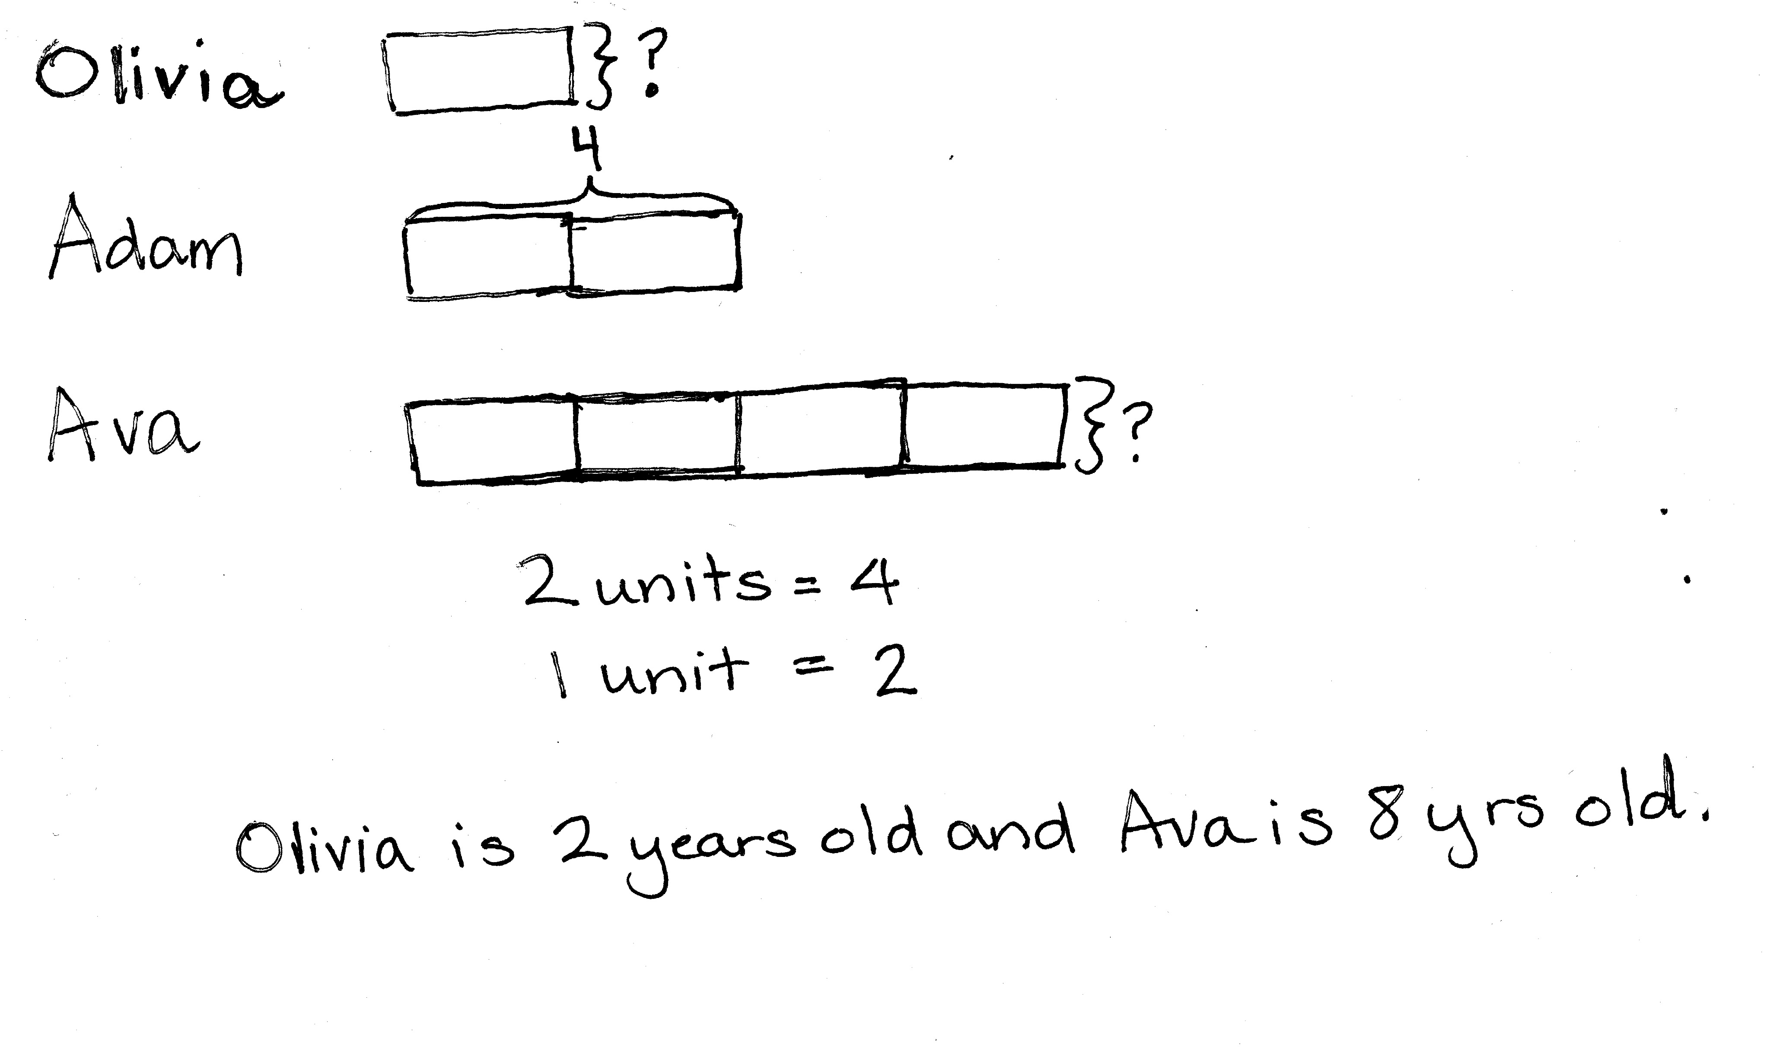
Application Problem (6 minutes)
Olivia is half the age of her brother, Adam. Olivia’s sister, Ava, is twice as old as Adam. Adam is 4 years old. How old is each sibling? Use tape diagrams to show your thinking.
Note: This Application Problem is intended to activate students’ prior knowledge of half of in a simple context as a precursor to today’s more formalized introduction to fraction of a set.
Fluency Practice (12 minutes)
- Sprint: Divide Whole Numbers 5.NF.3 (8 minutes)
- Fractions as Division 5.NF.3 (4 minutes)
Sprint: Divide Whole Numbers (8 minutes)
Materials: (S) Divide Whole Numbers Sprint
Note: This Sprint reviews Lessons 2–4.
Fractions as Division (4 minutes)
Materials: (S) Personal white board
Note: This fluency activity reviews Lesson 5.
T: I’ll say a division sentence. You write it as a fraction. 4 ÷ 2.
S: $\frac{4}{2}$.
T: 6 ÷ 4.
S: $\frac{6}{4}$.
T: 3 ÷ 4.
S: $\frac{3}{4}$.
T: 2 ÷ 10.
S: $\frac{2}{10}$.
T: Rename this fraction using fifths.
S: $\frac{1}{5}$.
T: (Write $\frac{56}{2}$.) Write the fraction as a division equation and solve.
S: 56 ÷ 2 = 28.
T: Now, I’ll say the fraction, and you say the division expression.
Continue with the following possible sequence: 6 thirds,
9 thirds, 18 thirds, $\frac{54}{3}$, 8 fourths, 12 fourths, 28 fourths, and $\frac{72}{4}$.

NOTES ON
MULTIPLE MEANS
OF ACTION AND EXPRESSION:
If students struggle with the set model of this lesson, consider allowing them to fold a square of paper into the desired fractional parts. Then, have them place the counters in the sections created by the folding.
Concept Development (32 minutes)
Materials: (S) Two-sided counters, drinking straws, personal white board
Problem 1
$\frac{1}{3}$ of 6
$\frac{2}{3}$ of 6
T: Make an array with 6 counters turned to the red side, and use your straws to divide your array into 3 equal parts.
T: Write a division sentence for what you just did.
S: 6 ÷ 3 = 2.
T: Rewrite your division sentence as a fraction, and say it aloud as you write it.
S: (Write $\frac{6}{3}.$) 6 divided by 3 equals 2.
T: If I want to show 1 third of this set, how many counters should I turn over to yellow? Turn and talk.
S: Two counters. Each group is 1 third of all the counters, so we would have to turn over 1 group of 2 counters. Six divided by 3 tells us there are 2 in each group.
T: 1 third of 6 is equal to…?
S: 2.
T: (Write $\frac{1}{3}$ of 6 = 2.) How many counters should be turned over to show 2 thirds? Whisper to your partner how you know.
S: I can count from our array. 1 third is 2 counters, so 2 thirds is 4 counters. 6 divided by 3 once is 2 counters. Double that is 4 counters. I know 1 group out of 3 groups is 2 counters, so 2 groups out of 3 would be 4 counters. Since $\frac{1}{3}$ of 6 is equal to 2, then $\frac{2}{3}$ of 6 is double that. 2 plus 2 is 4. (6 ÷ 3) $\text{×}$2, but I wrote 6 ÷ 3 as a fraction.
T: (Write $\frac{2}{3}$ of 6.) What is 2 thirds of 6 counters?
S: 4 counters.
T: (Write $\frac{3}{3}$ of 6 = ___.) What is 3 thirds of 6 counters?

NOTES ON
MULTIPLE MEANS
OF REPRESENTATION:
It is acceptable for students to orient their arrays in either direction. For example, in Problem 2, students may arrange their counters in the 3 × 4 arrangement pictured, or they may show a 4 × 3 array that is divided by the straws horizontally.
S: 6 counters.
T: How do you know? Turn and discuss with your partner.
S: I counted 2, 4, 6. $\frac{3}{3}$ is a whole, and our whole set is 6 counters.
T: Following this pattern, what is 4 thirds of 6?
S: It would be more than 6. It would be more than the whole set. We would have to add 2 more counters. It would be 8. 6 divided by 3 times 4 is 8.
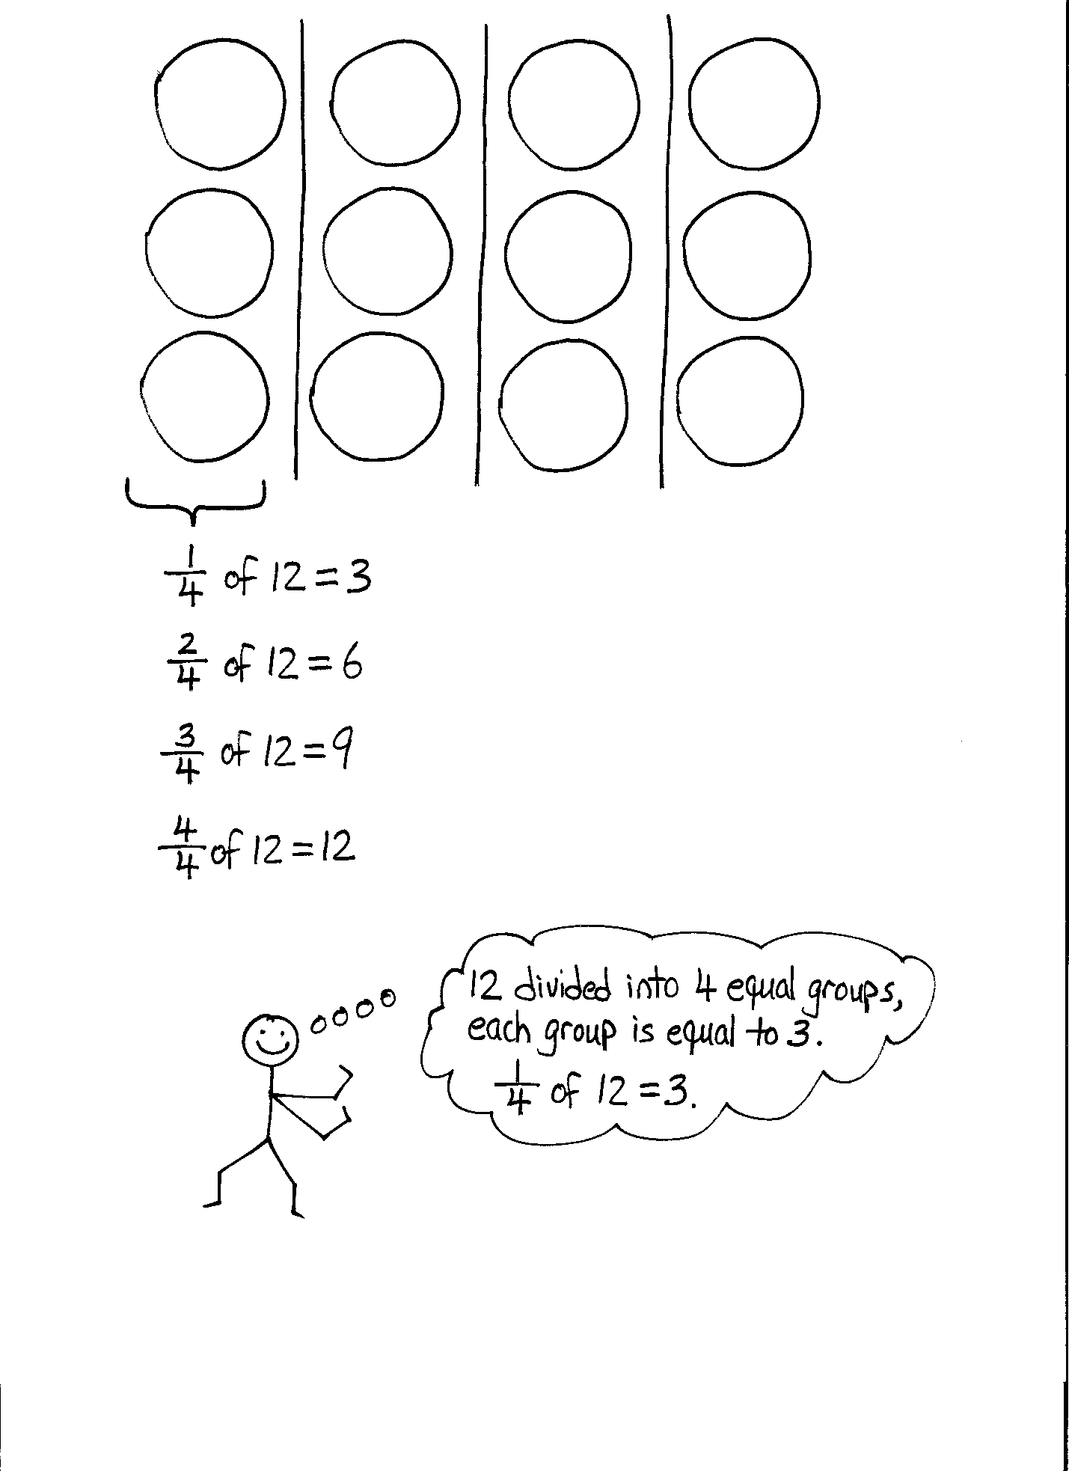
Problem 2
$\frac{1}{4}$ of 12
T: Make an array using 12 counters turned to the red side. Use your straws to divide the array into fourths. (Draw an array on the board.)
T: How many counters did you place in each fourth?
S: 3.
T: Write the division sentence as a fraction on your board.
S: $\frac{12}{4}$ = 3.
T: What is 1 fourth of 12?
S: 3.
T: (Write $\frac{1}{4}$ of 12 = 3.) 1 fourth of 12 is equal to 3. Look at your array. What fraction of 12 is equal to 6 counters? Turn and discuss with your partner.
S: I see 2 groups is equal to 6, so the answer is $\frac{2}{4}$. Since 1 fourth is equal to 3, and 6 is double that much, I can double 1 fourth to get 2 fourths.
T: (Write $\frac{2}{4}$ of 12 = 6.) 2 fourths of 12 is equal to 6. What is another way to say 2 fourths?
S: 1 half.
T: Is 1 half of 12 equal to 6?
S: Yes.
Continue with the following possible sequence: $\frac{1}{3 }$ of 9, $\frac{1}{6 }$ of 12, and $\frac{1}{5 }$ of 15.
Problem 3
Mrs. Pham has 8 apples. She wants to give $\frac{3}{4}$ of the apples to her students. How many apples will her students get?
T: Use your counters or draw an array to show how many apples Mrs. Pham has.
S: (Represent 8 apples.)
T: (Write $\frac{3}{4}$ of 8 = ___.) How will we find 3 fourths of 8? Turn and talk.
S: I divided my counters to make 4 equal parts. Then, I counted the number in 3 of those parts. I can draw 4 rows of 2 and count 2, 4, 6, so the answer is 6 apples. I need to make fourths. That’s 4 equal parts, but I only want to know about 3 of them. There are 2 in 1 part and 6 in 3 parts. I know if 1 fourth is equal to 2, then 3 fourths is 3 groups of 2. The answer is 6 apples.
Problem 4
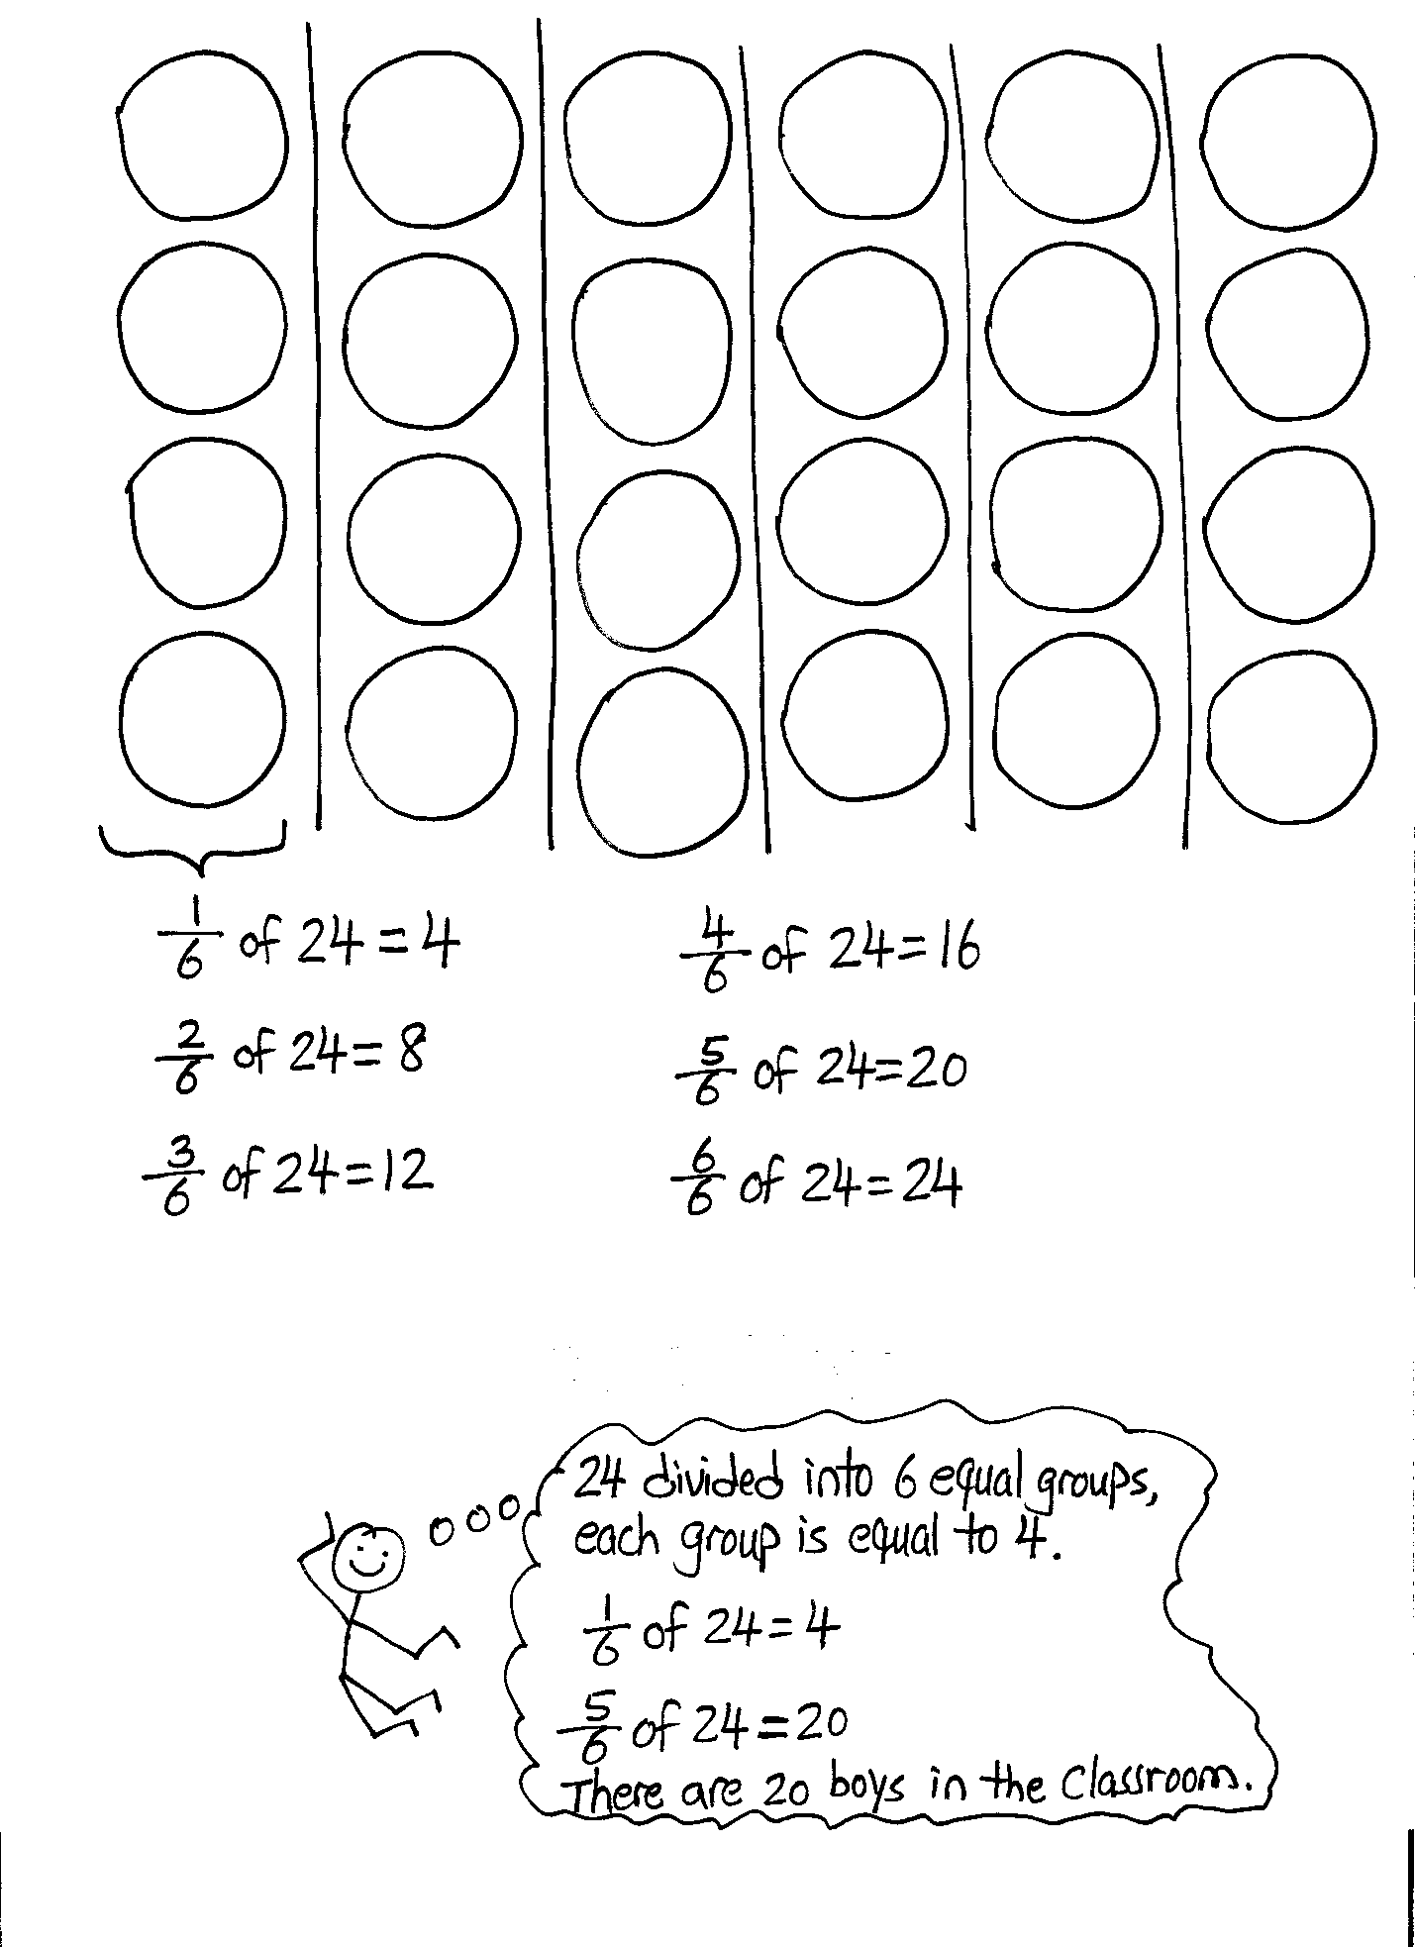
In a class of 24 students, $\frac{5}{6}$ are boys. How many boys are in the class?
T: How many students are in the whole class?
S: 24.
T: What is the question?
S: How many boys are in the class?
T: What fraction of the whole class of 24 are boys?
S: $\frac{5}{6}$.
T: Will our answer be more than half of the class or less than half? How do you know? Turn and talk.
S: 5 sixths is more than half, so the answer should be more than 12. Half of the class would be 12, which would also be 3 sixths. We need more sixths than that, so our answer will be more than 12.
T: (Write $\frac{5}{6}$ of 24 on the board.) Use your counters or draw to solve. Turn and discuss with a partner.
S: We should draw a total of 24 circles, and then split them into 6 equal groups. We will have 6 columns representing 6 groups, and each group will have 4 circles. We could draw 6 rows of 4 circles to show 6 equal parts. We only care how many are in 5 of the rows, and 5 × 4 is 20 boys. We need to find sixths, so we need to divide the set of 24 into 6 equal parts. We only need to know how many are in 5 of the equal parts. That’s 4, 8, 12, 16, 20. There are 20 boys in the class.
T: (Point to the drawing on the board.) Let’s think of this another way. What is $\frac{1}{6}$ of 24?
S: 4.
T: How do we know? Say the division sentence.
S: 24 ÷ 6 = 4.
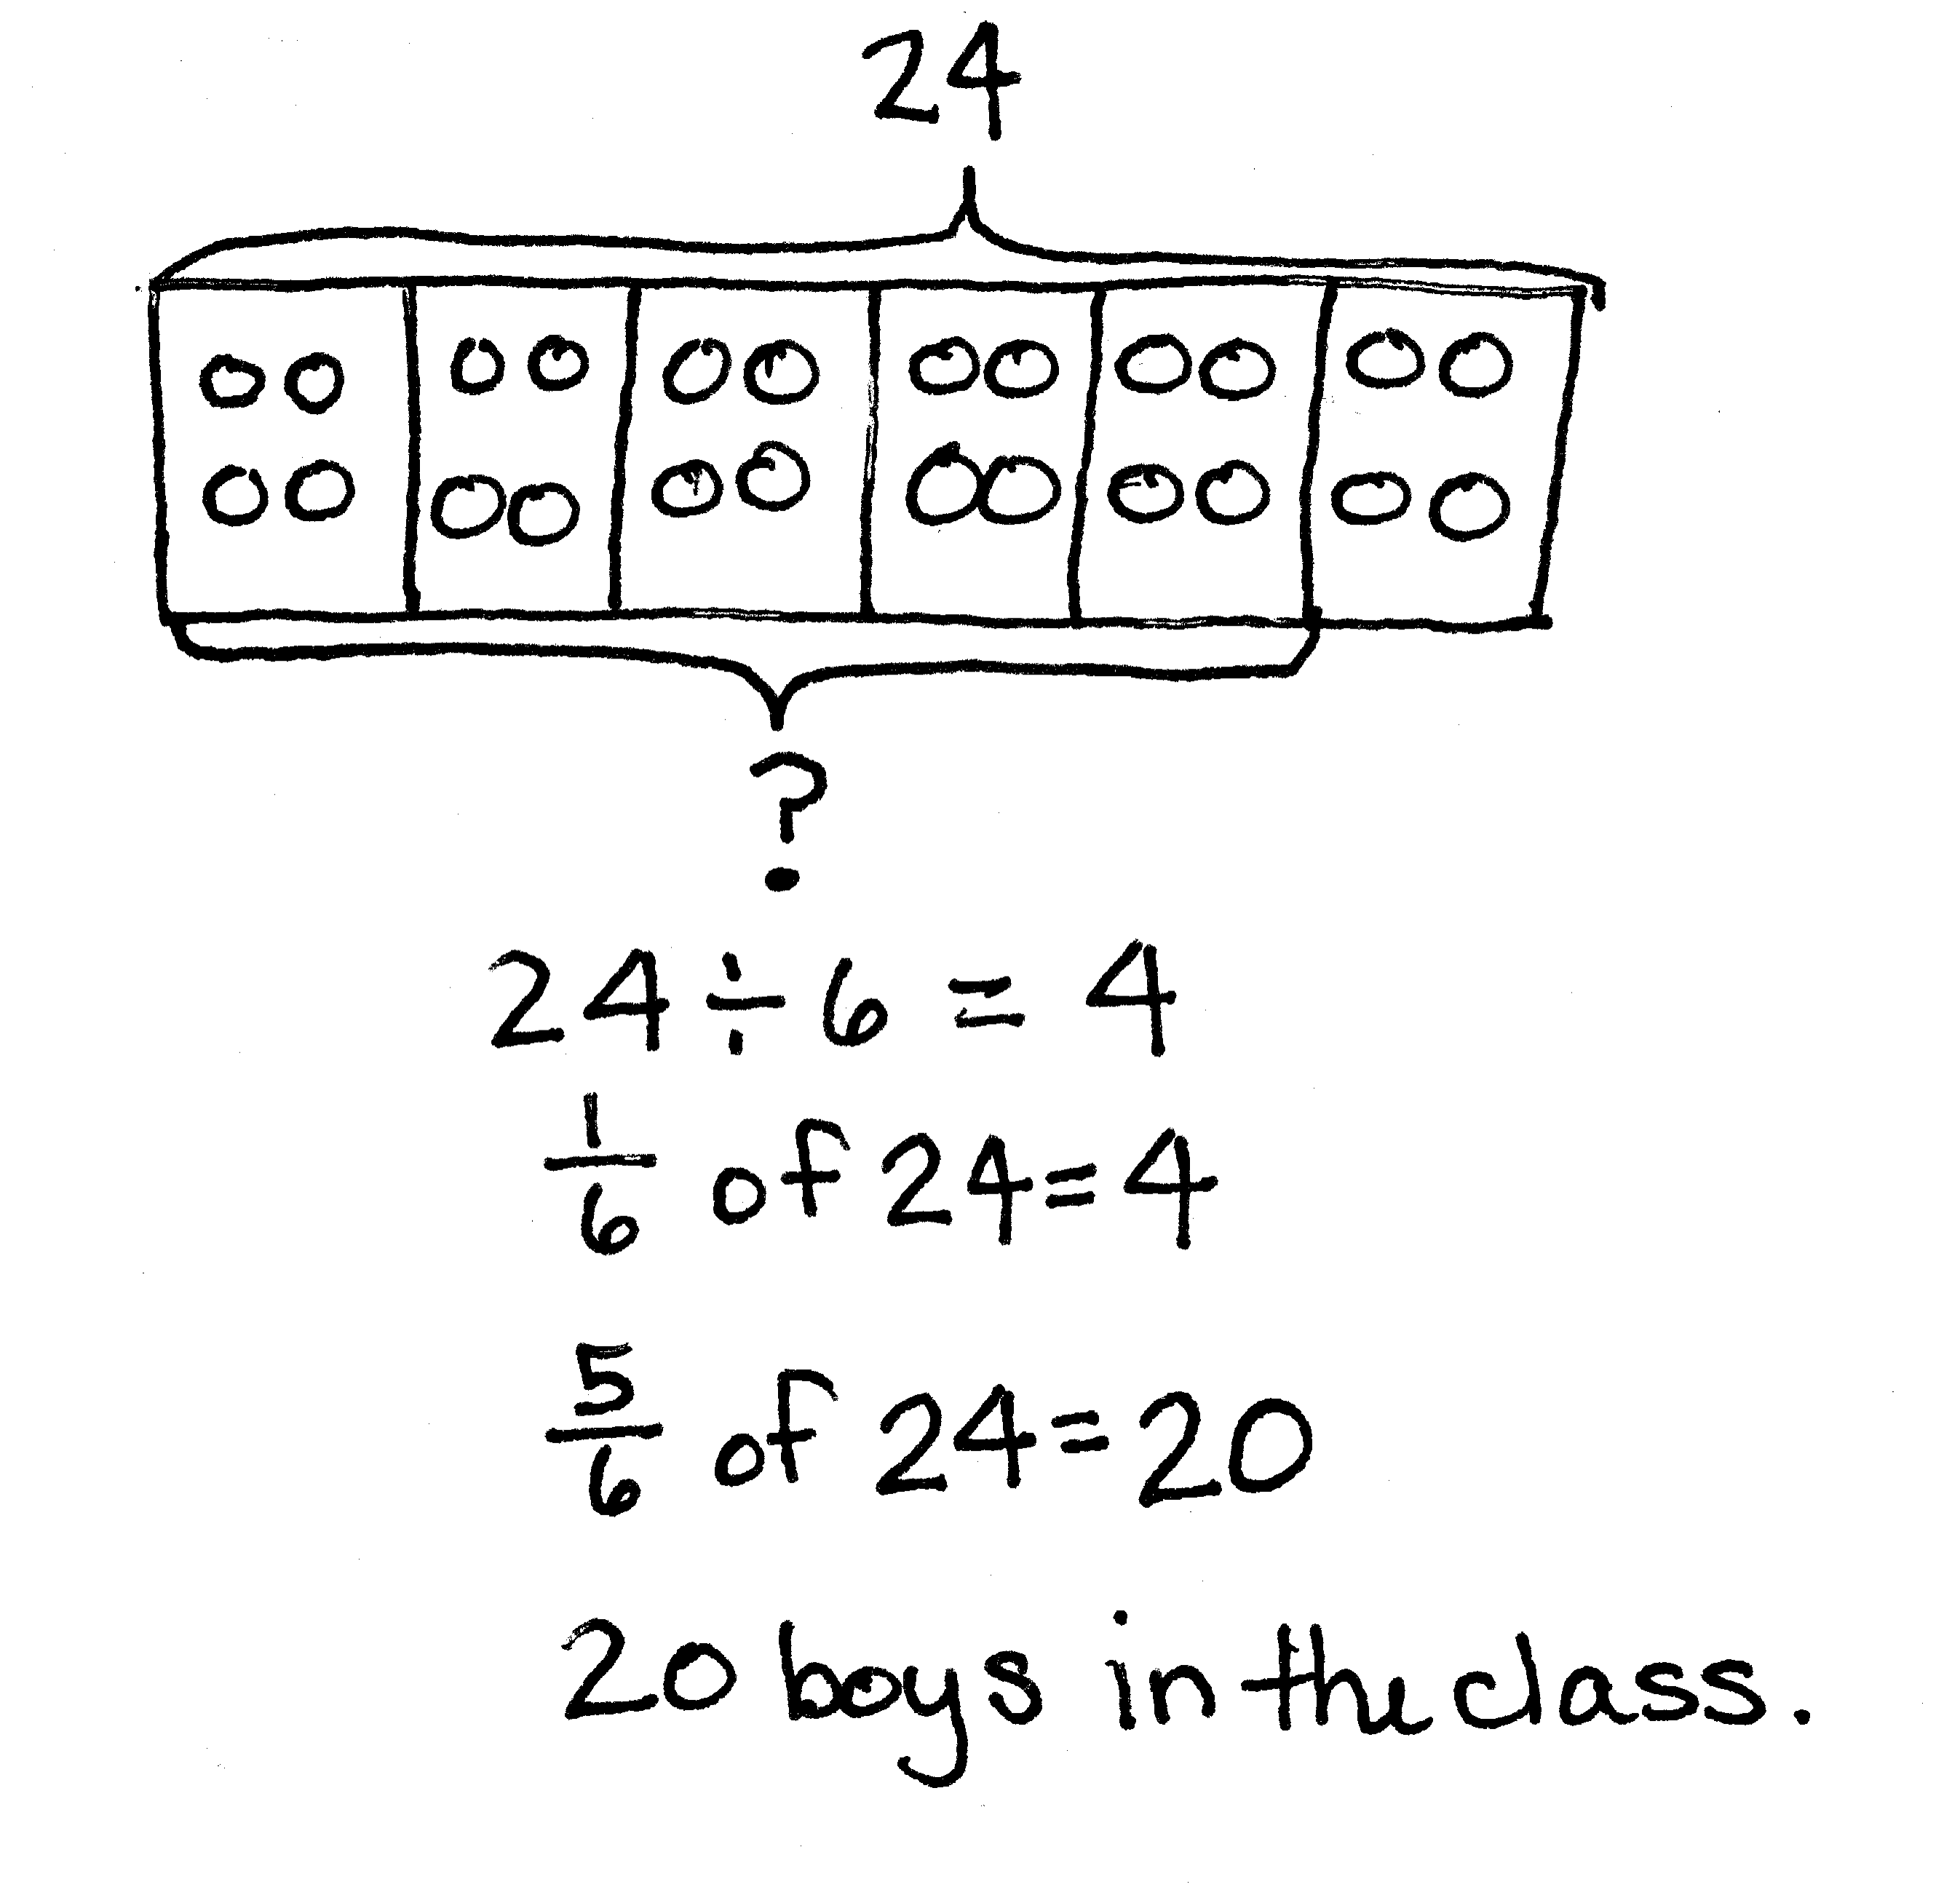
T: How can we use $\frac{1}{6}$ of 24 to help us solve for $\frac{5}{6}$ of 24? Whisper and tell your partner.
S: $\frac{1}{6}$ of 24 is equal to 4. $\frac{5}{6}$ of 24 is just 5 groups of 4. 4 + 4 + 4 + 4 + 4 = 20. I know each group is 4. To find 5 groups, I can multiply 5 × 4 = 20. $\frac{24}{6}$ (24 divided by 6) times 5 is 20.
T: I’m going to rearrange the circles a bit. (Draw a bar directly beneath the array and label 24.) We said we needed to find sixths, so how many units should I cut the whole into?
S: We need 6 units to be the same size.
T: (Cut the bar into 6 equal parts.) If 6 units are 24, how many circles are in one unit? How do you know?
S: 4 because 24 ÷ 6 is 4.
T: (Write $\frac{1}{6}$ of 24 = 4 under the bar.) Let me draw 4 counters into each unit. Count with me as I write.
S: 4, 8, 12, 16, 20, 24.
T: We are only interested in the part of the class that is boys. How many of these units represent the boys in the class?
S: 5 units. 5 sixths.
T: What are 5 units worth? Or, what is 5 sixths of 24? (Draw a bracket around 5 units and write
$\frac{5}{6}$ of 24.)
S: 20.
T: (Write the answer on the board.)
T: Answer the question with a sentence.
S: There are 20 boys in the class.
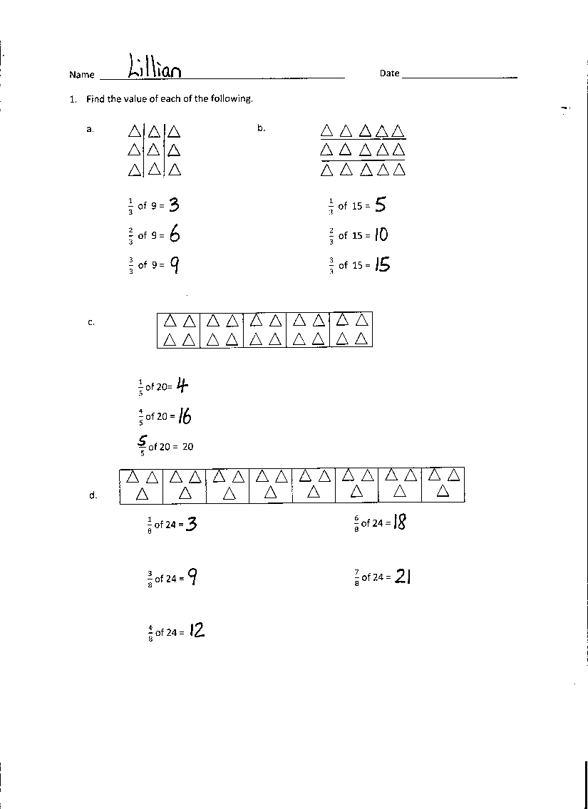
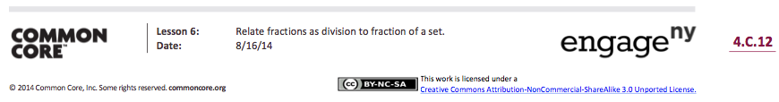
Problem Set (10 minutes)
Students should do their personal best to complete the Problem Set within the allotted 10 minutes. For some classes, it may be appropriate to modify the assignment by specifying which problems they work on first. Some problems do not specify a method for solving. Students should solve these problems using the RDW approach used for Application Problems.
Student Debrief (10 minutes)
Lesson Objective: Relate fractions as division to fraction of a set.
The Student Debrief is intended to invite reflection and active processing of the total lesson experience.
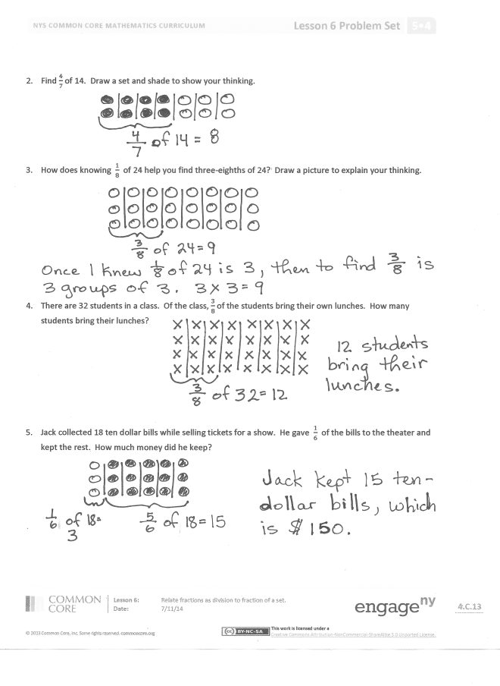
Invite students to review their solutions for the Problem Set. They should check work by comparing answers with a partner before going over answers as a class. Look for misconceptions or misunderstandings that can be addressed in the Debrief. Guide students in a conversation to debrief the Problem Set and process the lesson.
You may choose to use any combination of the questions below to lead the discussion.
- What pattern did you notice in Problem 1(a)? (Students may say it skip-counts by threes, or all the answers are multiples of 3.) Based on this pattern, what do you think the answer for $\frac{4}{3}$ of 9 is? Why is this more than 9? (Because 4 thirds is more than a whole, and 9 is the whole.)
- How did you solve for the last question in 1(c)? Explain to your partner.
- In Problem 1(d), what did you notice about the two fractions $\frac{4}{8}$ and $\frac{6}{8}$? Can you name either of them using larger units (simplify them)? What connections did you make about $\frac{4}{8}$ of 24 and $\frac{1}{2}$ of 24, as well as $\frac{6}{8}$ of 24 and $\frac{3}{4}$ of 24?
- When solving these problems (fraction of a set), how important is it to first determine how many are in each group (unit)? Explain your thinking to a partner.
- Is this a true statement? (Write $\frac{2}{3} \text{of 18} \text{=} \frac{18}{3} \text{× 2}.$) Is two-thirds of 18 the same as 18 divided by 3, times 2. Why or why not?
Exit Ticket (3 minutes)
After the Student Debrief, instruct students to complete the Exit Ticket. A review of their work will help you assess the students’ understanding of the concepts that were presented in the lesson today and plan more effectively for future lessons. You may read the questions aloud to the students.

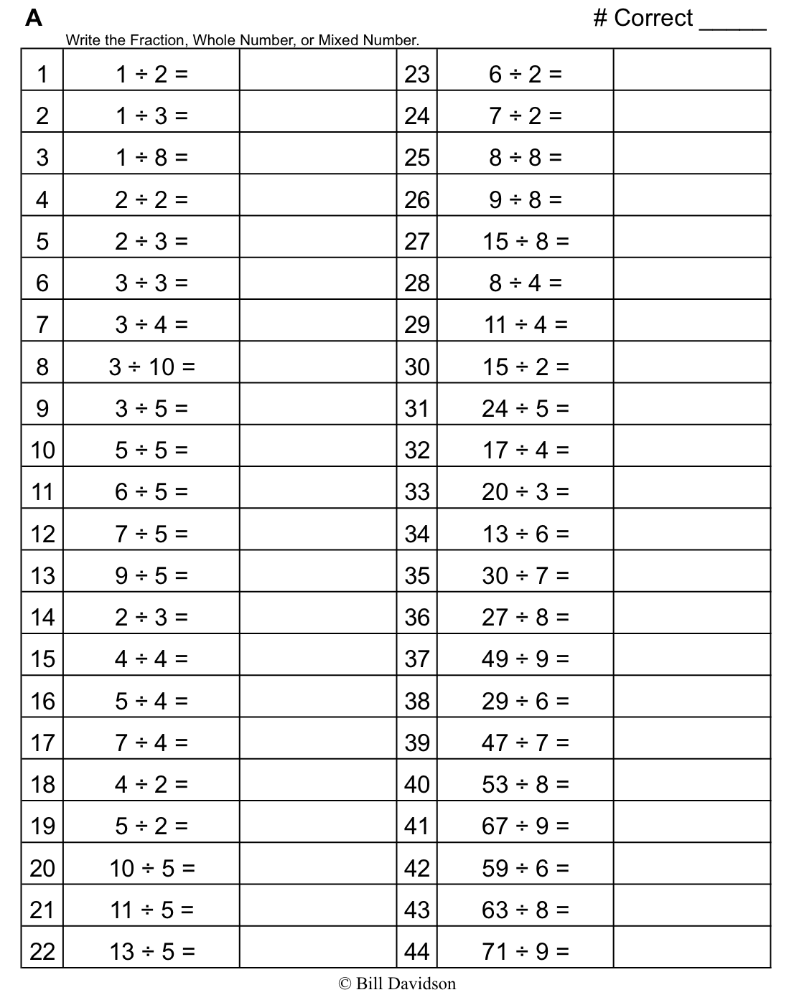
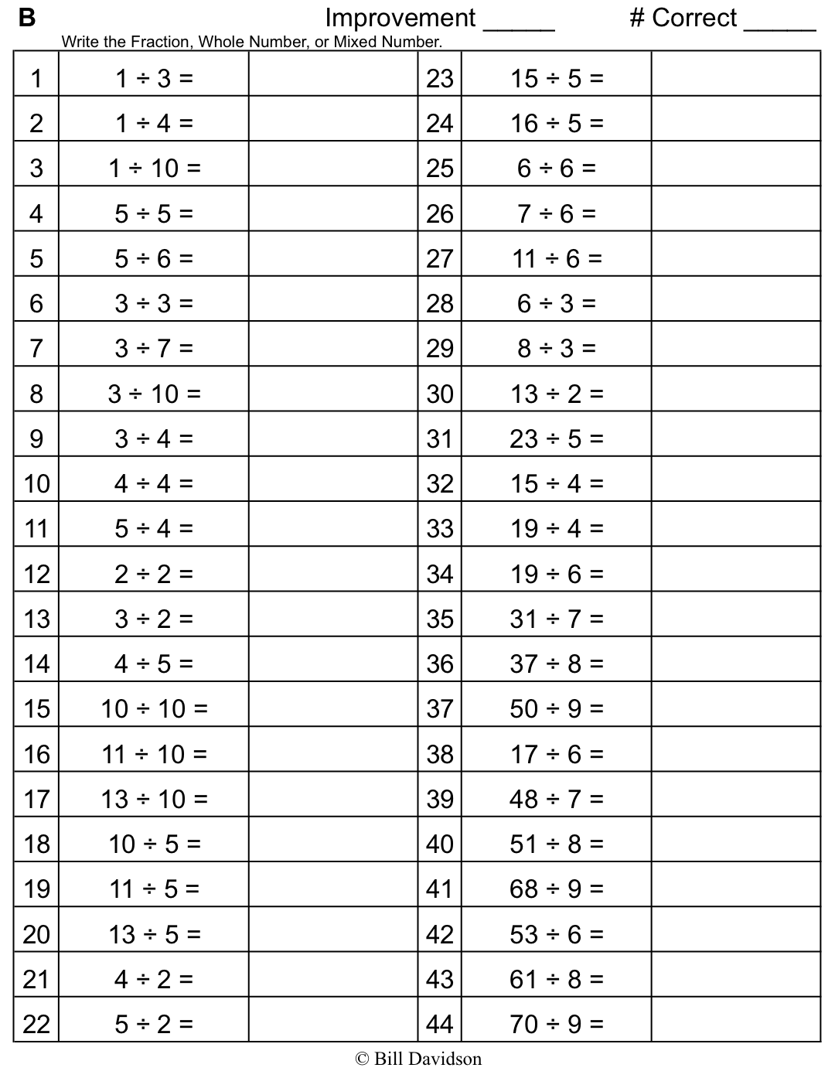

Name Date
- Find the value of each of the following.

a. b.
$\frac{1}{3}$ of 9 =
$\frac{2}{3}$ of 9 =
$\frac{3}{3}$ of 9 =

$\frac{1}{3}$ of 15 =
$\frac{2}{3}$ of 15 =
$\frac{3}{3}$ of 15 =

c.

$\frac{1}{5}$ of 20=
$\frac{4}{5}$ of 20 =
$\frac{}{5}$ of 20 = 20

$\frac{1}{8}$ of 24 = $\frac{6}{8}$ of 24 =

$\frac{3}{8}$ of 24 = $\frac{7}{8}$ of 24 =

$\frac{4}{8}$ of 24 =

- Find $\frac{4}{7}$ of 14. Draw a set and shade to show your thinking.

- How does knowing $\frac{1}{8}$ of 24 help you find three-eighths of 24? Draw a picture to explain your thinking.

- There are 32 students in a class. Of the class, $\frac{3}{8}$ of the students bring their own lunches. How many students bring their lunches?

- Jack collected 18 ten dollar bills while selling tickets for a show. He gave $\frac{1}{6}$ of the bills to the theater and kept the rest. How much money did he keep?

Name Date
- Find the value of each of the following.

♥ ♥  ♥ ♥ | ♥ ♥  ♥ ♥ | ♥ ♥  ♥ ♥ | ♥ ♥  ♥ ♥

- $\frac{1}{4}$ of 16 =

- $\frac{3}{4}$ of 16 =

- Out of 18 cookies, $\frac{2}{3}$ are chocolate chip. How many of the cookies are chocolate chip?

Name Date
- Find the value of each of the following.

♦ ♦  ♦ ♦ | ♦ ♦  ♦ ♦ | ♦ ♦  ♦ ♦

$\frac{1}{3}$ of 12 =

$\frac{2}{3}$ of 12 =

$\frac{3}{3}$ of 12 =

♦ ♦  ♦  ♦ ♦ | ♦ ♦  ♦  ♦ ♦ | ♦ ♦  ♦  ♦ ♦ | ♦ ♦  ♦  ♦ ♦

$\frac{1}{4}$ of 20 = $\frac{3}{4}$ of 20 =

$\frac{2}{4}$ of 20 = $\frac{4}{4}$ of 20 =

♦ ♦ ♦ ♦ ♦ ♦ ♦
♦ ♦ ♦ ♦ ♦ ♦ ♦
♦ ♦ ♦ ♦ ♦ ♦ ♦
♦ ♦ ♦ ♦ ♦ ♦ ♦
♦ ♦ ♦ ♦ ♦ ♦ ♦

$\frac{1}{5}$ of 35 = $\frac{3}{5}$ of 35 = $\frac{5}{5}$ of 35 =

$\frac{2}{5}$ of 35 = $\frac{4}{5}$ of 35 = $\frac{6}{5}$ of 35 =
- Find $\frac{2}{3}$ of 18. Draw a set and shade to show your thinking.

- How does knowing $\frac{1}{5}$of 10 help you find $\frac{3}{5}$ of 10? Draw a picture to explain your thinking.

- Sara just turned 18 years old. She spent $\frac{4}{9}$ of her life living in Rochester, NY. How many years did Sara live in Rochester?

- A farmer collected 12 dozen eggs from her chickens. She sold $\frac{5}{6}$ of the eggs at the farmers’ market, and gave the rest to friends and neighbors.
a. How many dozens did the farmer give away? How many eggs did she give away?

b. She sold each dozen for $4.50. How much did she earn from the eggs she sold?

