Lesson 5
Objective: Solve word problems involving the division of whole numbers with answers in the form of fractions or whole numbers.

Suggested Lesson Structure
 Fluency Practice (12 minutes)
 Concept Development (38 minutes)
 Student Debrief (10 minutes)
Total Time (60 minutes)
Fluency Practice (12 minutes)
- Fraction of a Set 4.NF.4 (4 minutes)
- Write Division Sentences as Fractions 5.NF.3 (3 minutes)
- Write Fractions as Mixed Numbers 5.NF.3 (5 minutes)
Fraction of a Set (4 minutes)
Materials: (S) Personal white board
Note: This fluency activity prepares students for Lesson 6.
T: (Write 10 × $\frac{1}{2}.$) 10 copies of one-half is…?
S: 5.
T: (Write 10 × $\frac{1}{5}$.) 10 copies of one-fifth is…?
S: 2.
Continue with the following possible sequence: 8 × $\frac{1}{2}$, 8 × $\frac{1}{4}$, 6 × $\frac{1}{3}$, 30 × $\frac{1}{6}$, 42 × $\frac{1}{7}$, 42 × $\frac{1}{6}$, 48 × $\frac{1}{8}$, 54 × $\frac{1}{9}$, and
54 × $\frac{1}{6}$.
Write Division Sentences as Fractions (3 minutes)
Materials: (S) Personal white board
Note: This fluency activity reviews Lesson 4.
T: (Write 9 ÷ 30 = ____.) Write the quotient as a fraction.
S: (Write 9 ÷ 30 = $\frac{9}{30}.$)
T: Express the fraction in its simplest form, and then write it as a decimal.
S: (Write 9 ÷ 30 = $\frac{3}{10}$ = 0.3.)
Continue with the following possible sequence: 28 ÷ 40, 18 ÷ 60, 63 ÷ 70, 24 ÷ 80, and 63 ÷ 90.
Write Fractions as Mixed Numbers (5 minutes)
Materials: (S) Personal white board
Note: This fluency activity reviews Lesson 4.
T: (Write $\frac{13}{2}$ = ____ ÷ ____ = ____.) Write the fraction as a division problem and mixed number.
S: (Write $\frac{13}{2}$ = 13 ÷ 2 = $\text{6}\frac{1}{2}$.)
Continue with the following possible sequence: $\frac{11}{2}$, $\frac{17}{2}$, $\frac{44}{2}$, $\frac{31}{10}$, $\frac{23}{10}$ , $\frac{47}{10}$, $\frac{89}{10}$, $\frac{8}{3}$ , $\frac{13}{3}$, $\frac{26}{3}$, $\frac{9}{4}$, $\frac{13}{4}$, $\frac{15}{4}$, and $\frac{35}{4}$.
Concept Development (38 minutes)
Materials: (S) Problem Set
Suggested Delivery of Instruction for Solving Lesson 5 Word Problems
1. Model the problem.
Have two pairs of students who can successfully model the problem work at the board while the others work independently or in pairs at their seats. Review the following questions before beginning the first problem:

NOTES ON
MULTIPLE MEANS
OF ENGAGEMENT:

Appropriate scaffolds help all students feel successful. Students may use translators, interpreters, or sentence frames to present their solutions and respond to feedback. Models shared may include concrete manipulatives.
If the pace of the lesson is a consideration, allow presenters to prepare beforehand.

- Can you draw something?
- What can you draw?
- What conclusions can you make from your drawing?
As students work, circulate. Reiterate the questions above. After two minutes, have the two pairs of students share only their labeled diagrams. For about one minute, have the demonstrating students receive and respond to feedback and questions from their peers.
2. Calculate to solve and write a statement.
Give everyone two minutes to finish their work on that question, sharing their work and thinking with a peer. All students should write their equations and statements of the answer.
3. Assess the solution for reasonableness.
Give students one to two minutes to assess and explain the reasonableness of their solution.
Problem 1
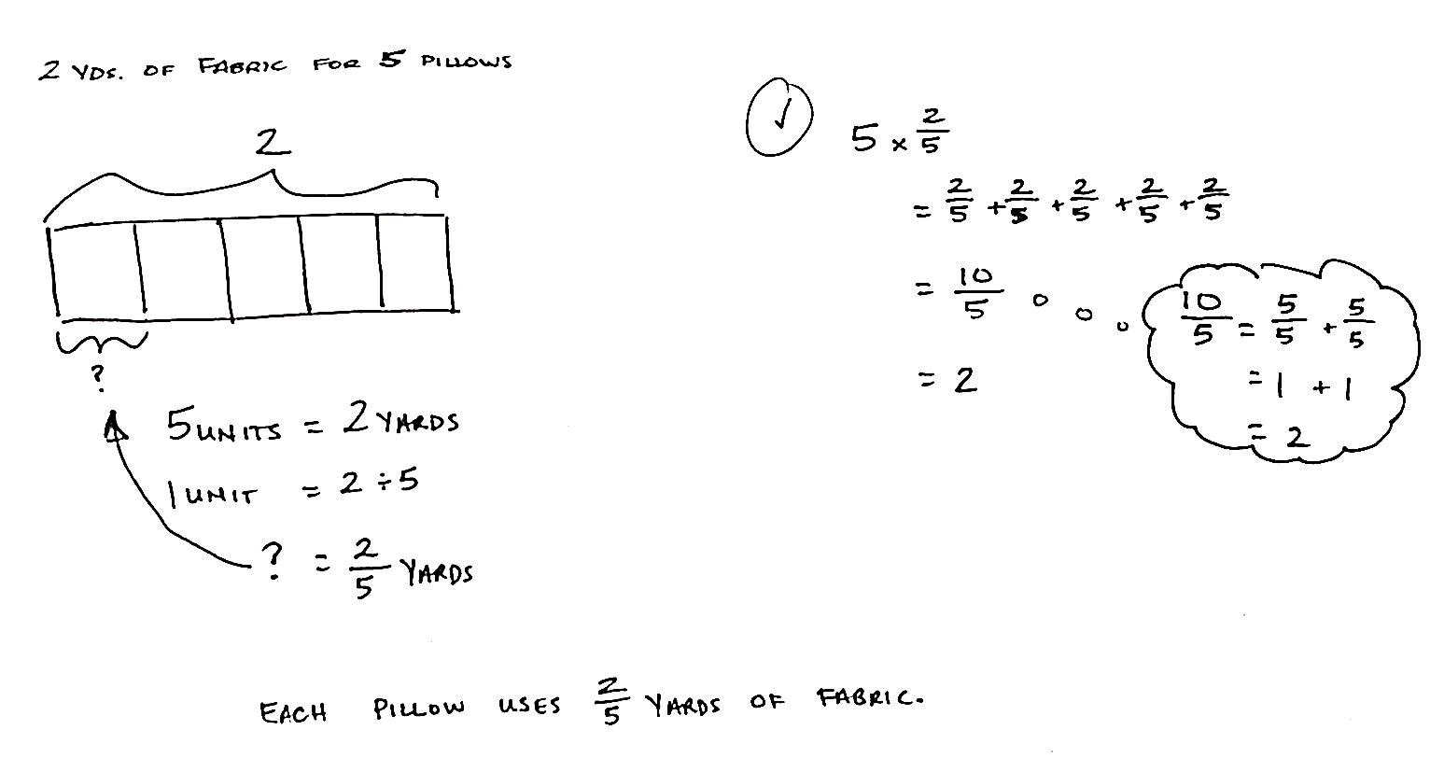
A total of 2 yards of fabric is used to make 5 identical pillows. How much fabric is used for each pillow?

This problem requires understanding of the whole and divisor. The whole of 2 is divided by 5, which results in a quotient of 2 fifths. Circulate, looking for different visuals (tape diagram and the region models from Lessons 2–3) to facilitate a discussion as to how these different models support the solution of $\frac{2}{5}$.
Problem 2
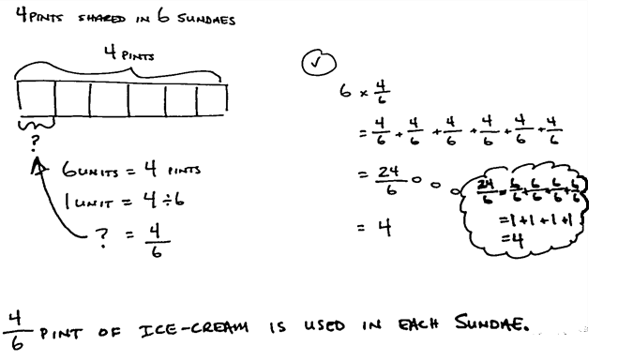
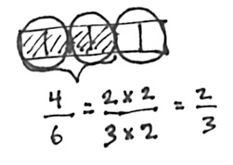
An ice-cream shop uses 4 pints of ice cream to make 6 sundaes. How many pints of ice cream are used for each sundae?
This problem also requires the students’ understanding of the whole versus the divisor. The whole is 4, and it is divided equally into 6 units with the solution of 4 sixths. Students should not have to use the standard algorithm to solve because they should be comfortable interpreting the division expression as a fraction and vice versa. Circulate, looking for alternate modeling strategies that can be quickly mentioned or explored more deeply, if desired. Students might express 4 sixths as 2 thirds. The tape diagram illustrates that larger units of 2 can be made. Quickly model a tape with 6 parts (now representing 1 pint), shade 4, and circle sets of 2.
Problem 3
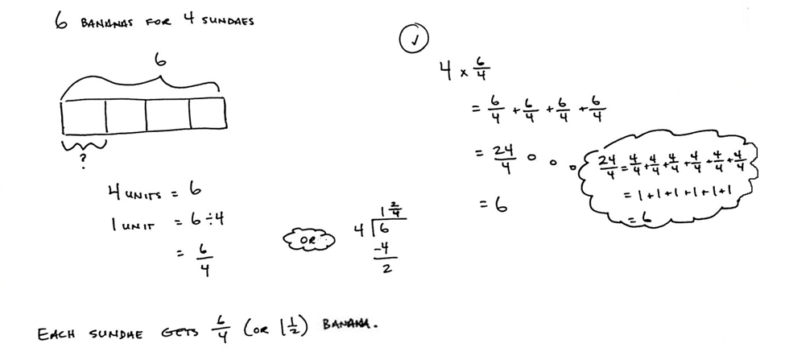
An ice-cream shop uses 6 bananas to make 4 identical sundaes. How many bananas are used in each sundae? Use a tape diagram to show your work.

This problem has the same two digits (4 and 6) as the previous problem. However, it is important for students to realize that the digits take on a new role, either as whole or divisor, in this context. Six wholes divided by 4 is equal to 6 fourths or 1 and 2 fourths. Although it is not required that students use the standard algorithm, it can be easily used to find the mixed number value of $\text{1}\frac{\text{2}}{\text{4}}$.

NOTES ON
MULTIPLE MEANS
FOR ACTION AND EXPRESSION:
Support English language learners as they explain their thinking. Provide sentence starters and a word bank. Examples are given below.
Sentence starters:
“I had ____ (unit) in all.”
“1 unit equals ____.”
Word bank:
fraction of divided by remainder
half as much twice as many

Students may also be engaged in a discussion about the practicality of dividing the remainder of the 2 bananas into fourths, and then giving each sundae 2 fourths. Many students may clearly see that the bananas can instead be divided into halves, and each sundae can be given 1 and 1 half. Facilitate a quick discussion with students about which form of the answer makes more sense given the story’s context (i.e., should the sundae maker divide all of the bananas in fourths, and then give each sundae 6 fourths, or should each sundae be given a whole banana, and then divide the remaining bananas?).

Problem 4
Julian has to read 4 articles for school. He has 8 nights to read them. He decides to read the same number of articles each night.
- How many articles will he have to read per night?
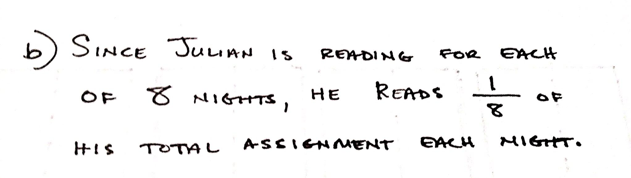
- What fraction of the reading assignment will he read each night?

In this problem, Julian must read 4 articles throughout the course of 8 nights. The solution of 4 eighths of an article each night might imply that Julian can simply divide each article into eighths and read any 4 articles on any of the 8 nights. Engage in a discussion allowing students to see that 4 eighths must be interpreted as 4 consecutive eighths or 1 half of an article. It would be most practical for Julian to read the first half of an article one night, and the remaining half the following night. In this manner, he will finish his reading assignment within the 8 days. Part (b) provides for deeper thinking about units being considered.
Students must differentiate between the article-as-unit and assignment-as-unit to answer. While 1 half of an article is read each night, the assignment has been split into eight parts. Take the opportunity to discuss with students whether the articles are all equal in length. Since the problem does not specify, a simplifying assumption is created to solve, which finds that, each night, 1 eighth of the total assignment must be read. Discuss how the answer would change if one article were twice the length of the other three.

Problem 5
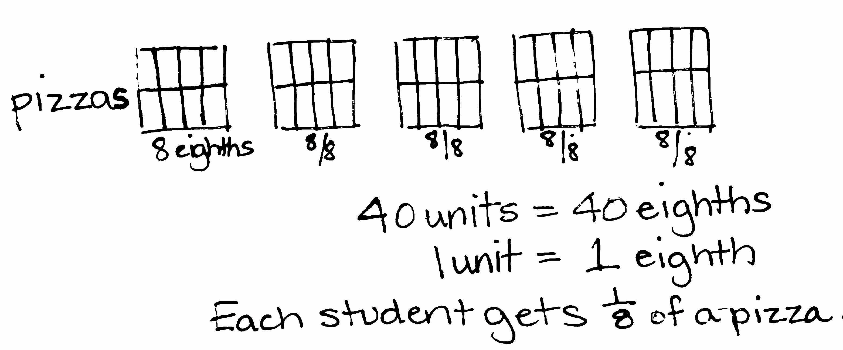
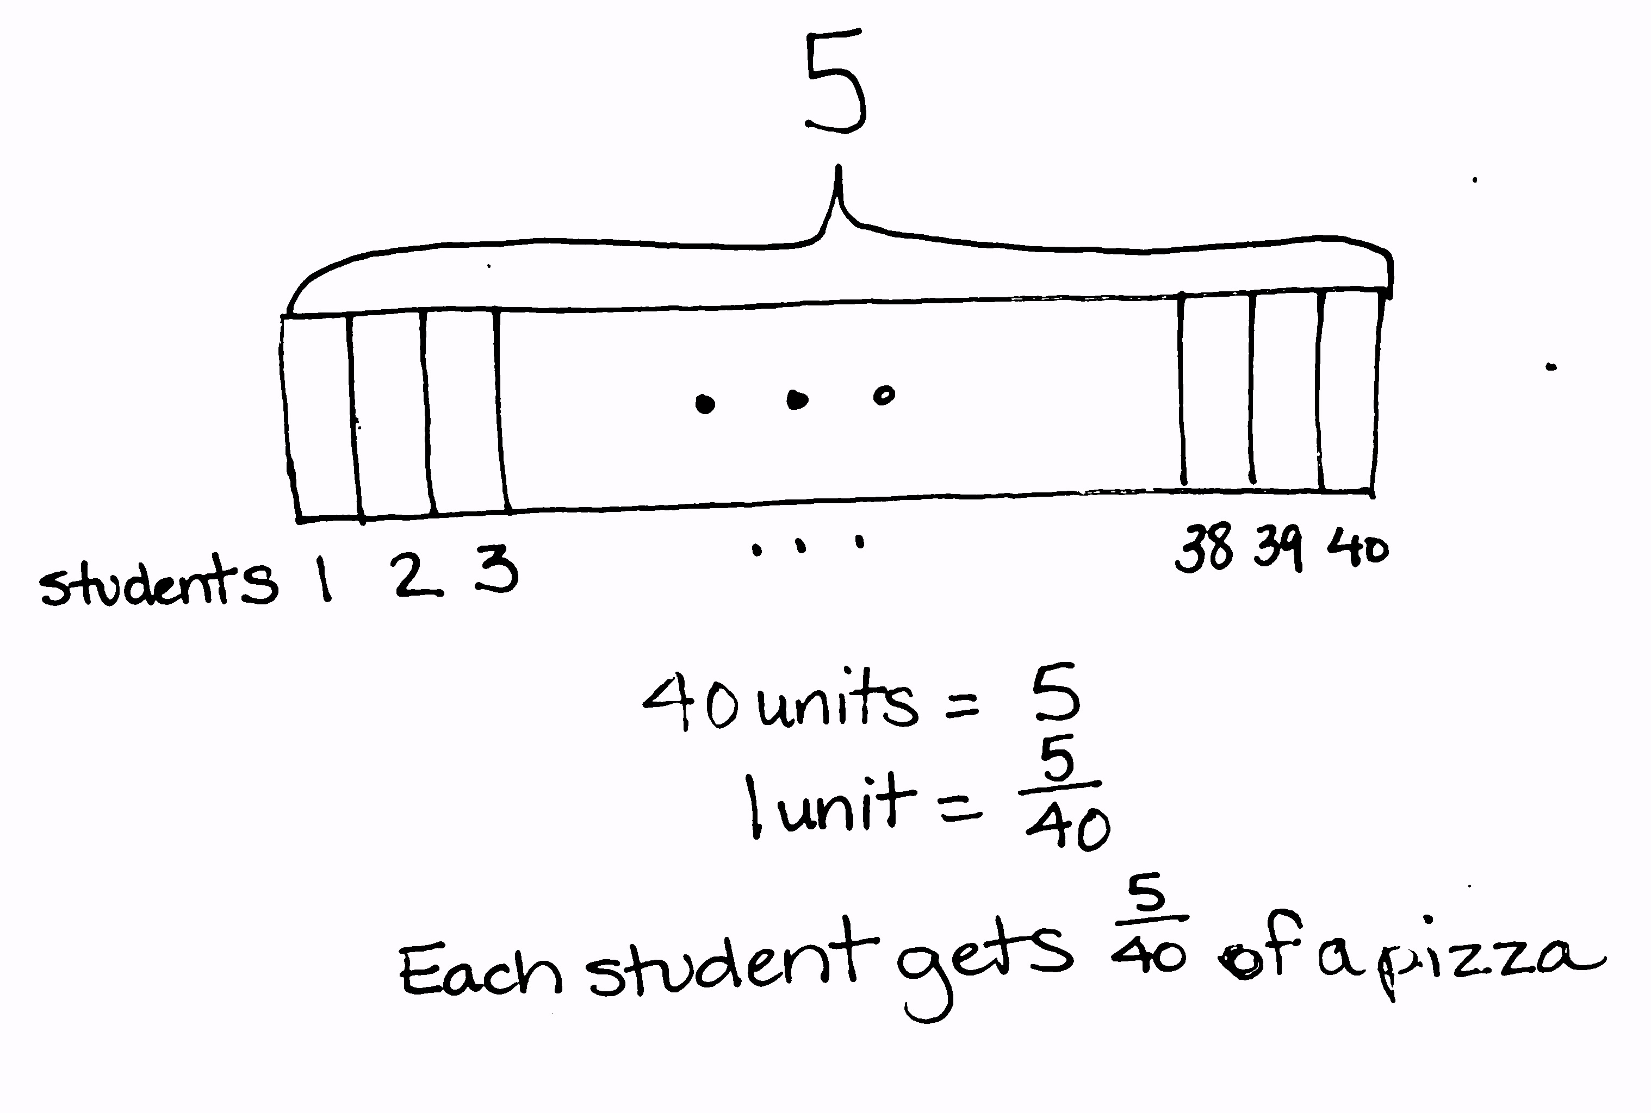
40 students shared 5 pizzas equally. How much pizza did each student receive? What fraction of the pizza did each student receive?
Because this is the fifth problem on the page, students may recognize the division expression very quickly and realize that 5 divided by 40 yields 5 fortieths of the pizza per student. However, in this context, it is interesting to discuss with students the practicality of serving the pizzas in fortieths. Here, one might better ask, “How can I make 40 equal parts out of 5 pizzas?” This question leads to thinking about making the least number of cuts to each pizza—eighths. Now, the simplified answer of 1 eighth of a pizza per student makes more sense. The follow-up question highlights the changing of the unit from how much pizza per student (1 eighth of a pizza) to what fraction of the total (1 fortieth of the total amount). Because there are so many slices to be made, students may use the dot, dot, dot format to show the smaller units in their tape diagram. Others may opt to simply show their work with an equation.
Problem 6
Lillian had 2 two-liter bottles of soda, which she distributed equally between 10 glasses.
- How much soda was in each glass? Express your answer as a fraction of a liter.
- Express your answer as a decimal number of liters.
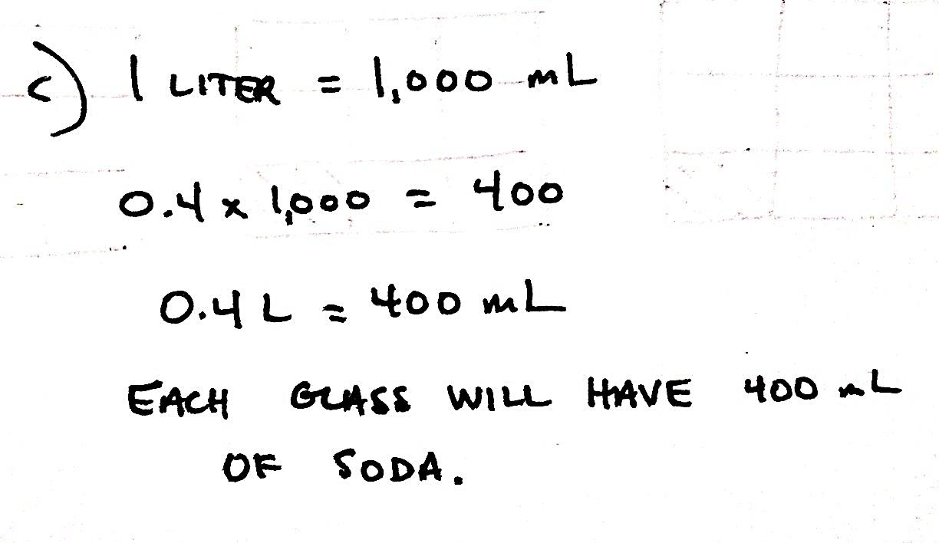
- Express your answer as a whole number of milliliters.

This is a three-part problem that asks students to find the amount of soda in each glass. Carefully guide students when reading the problem so they can interpret that 2 two-liter bottles are equal to 4 liters total. The whole of 4 liters is then divided by 10 glasses to obtain 4 tenths liters of soda per glass. To answer Part (b), students must remember how to express fractions as decimals (i.e., $\frac{1}{10}$ = 0.1, $\frac{1}{100}$ = 0.01, and $\frac{1}{1000}$ = 0.001). For Part (c), students may need to be reminded about the equivalency between liters and milliliters
(1 L = 1,000 mL).
Problem 7
The Calef family likes to paddle along the Susquehanna River.
- They paddled the same distance each day throughout the course of 3 days, traveling a total of 14 miles. How many miles did they travel each day? Show your thinking in a tape diagram.
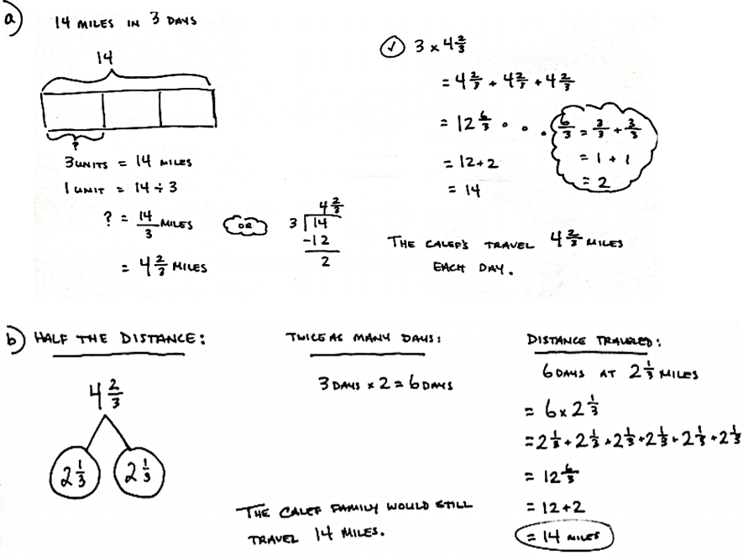
- If the Calefs went half their daily distance each day, but extended their trip to twice as many days, how far would they travel?
In Part (a), students can easily use the standard algorithm to solve 14 miles divided by 3 days and determine that it is equal to 4 and 2 thirds miles per day. Part (b) requires some deliberate thinking. Guide the students to read the question carefully before solving it.
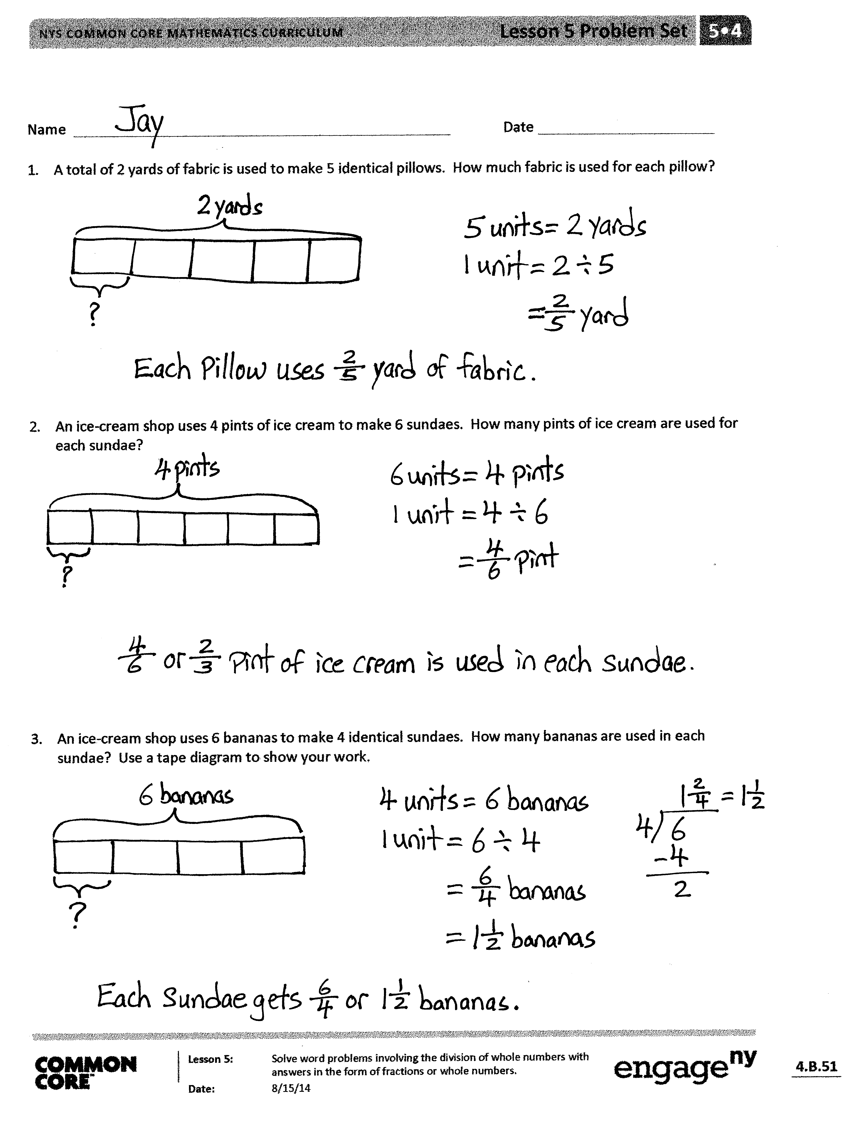
Student Debrief (10 minutes)
Lesson Objective: Solve word problems involving the division of whole numbers with answers in the form of fractions or whole numbers.
The Student Debrief is intended to invite reflection and active processing of the total lesson experience.
Invite students to review their solutions for the Problem Set. They should check work by comparing answers with a partner before going over answers as a class. Look for misconceptions or misunderstandings that can be addressed in the Debrief. Guide students in a conversation to debrief the Problem Set and process the lesson.
You may choose to use any combination of the questions below to lead the discussion.
- How are the problems similar? How are they different?
- How was your solution the same as and different from those that were demonstrated?
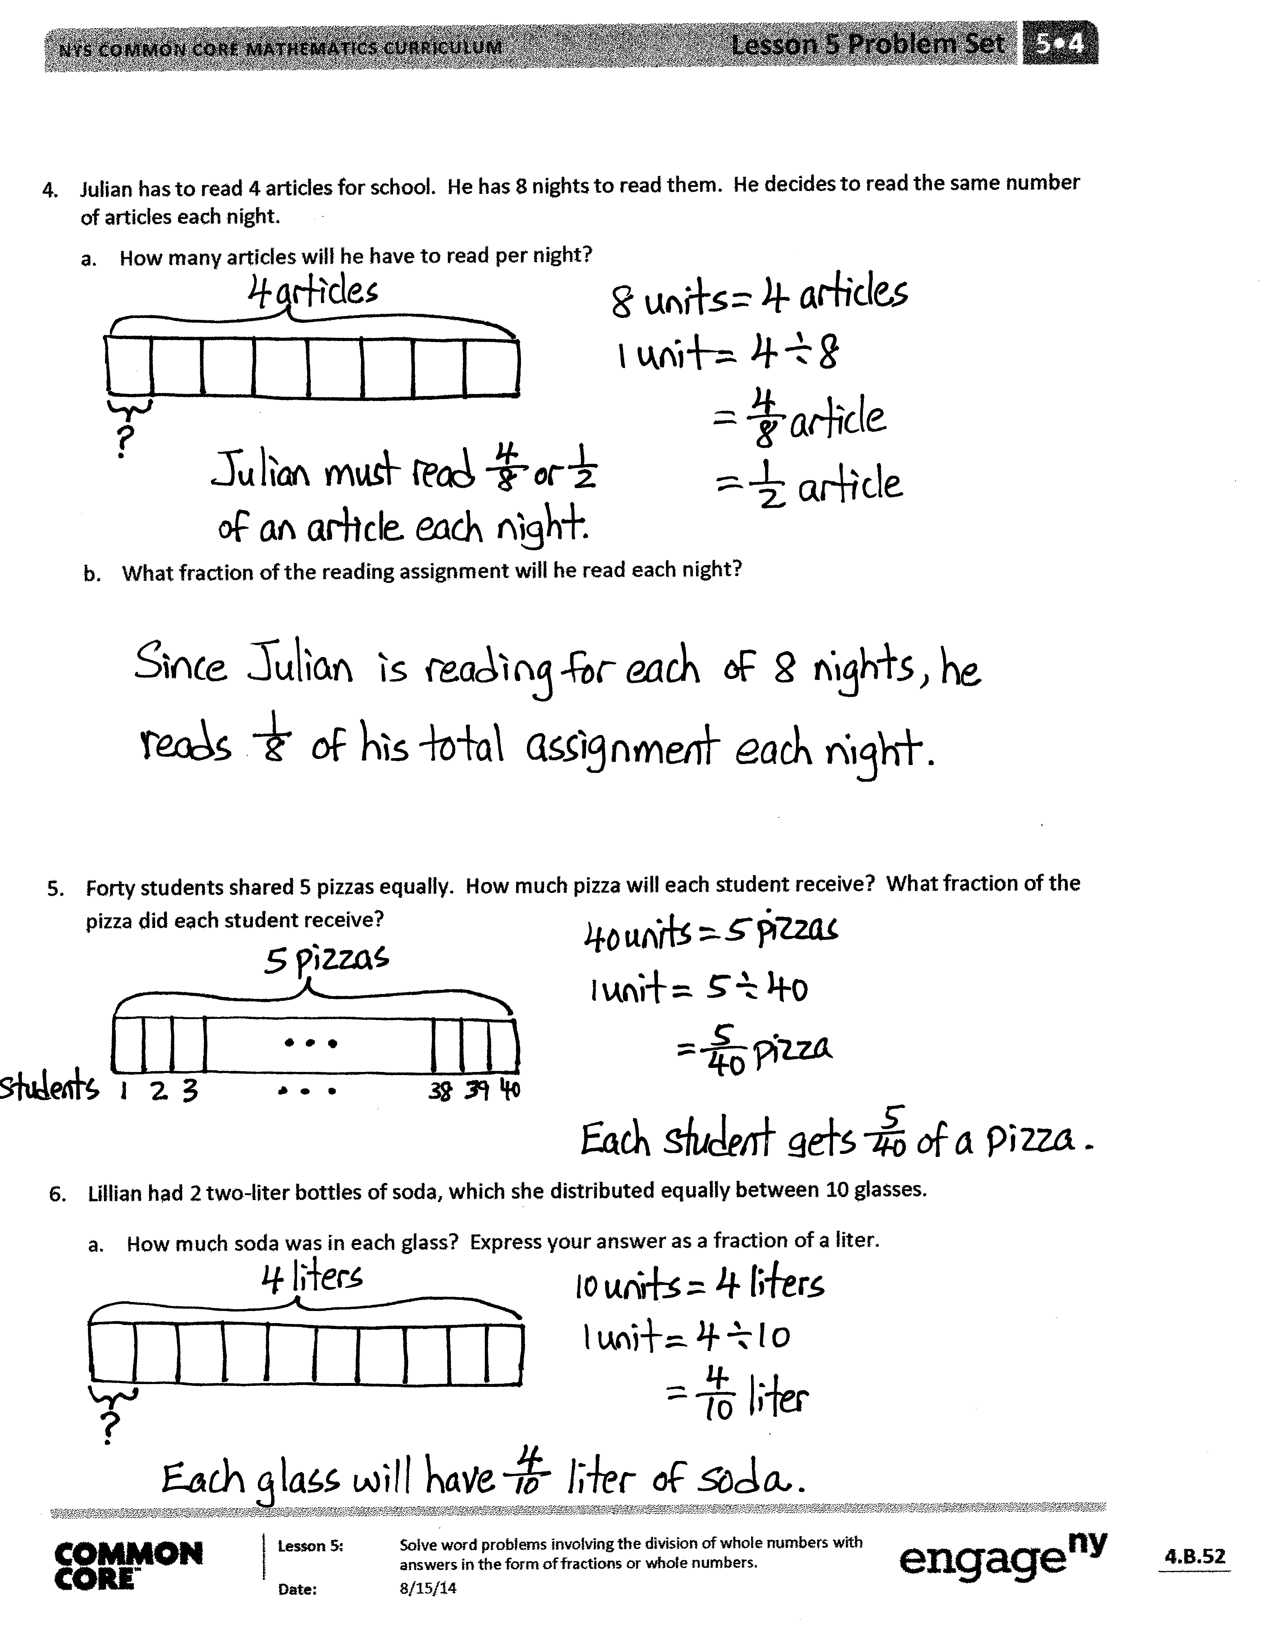
- Did you see other solutions that surprised you or made you see the problem differently?
- Why should we assess reasonableness after solving?
- Were there problems in which it made more sense to express the answer as a fraction rather than a mixed number and vice versa? Give examples.

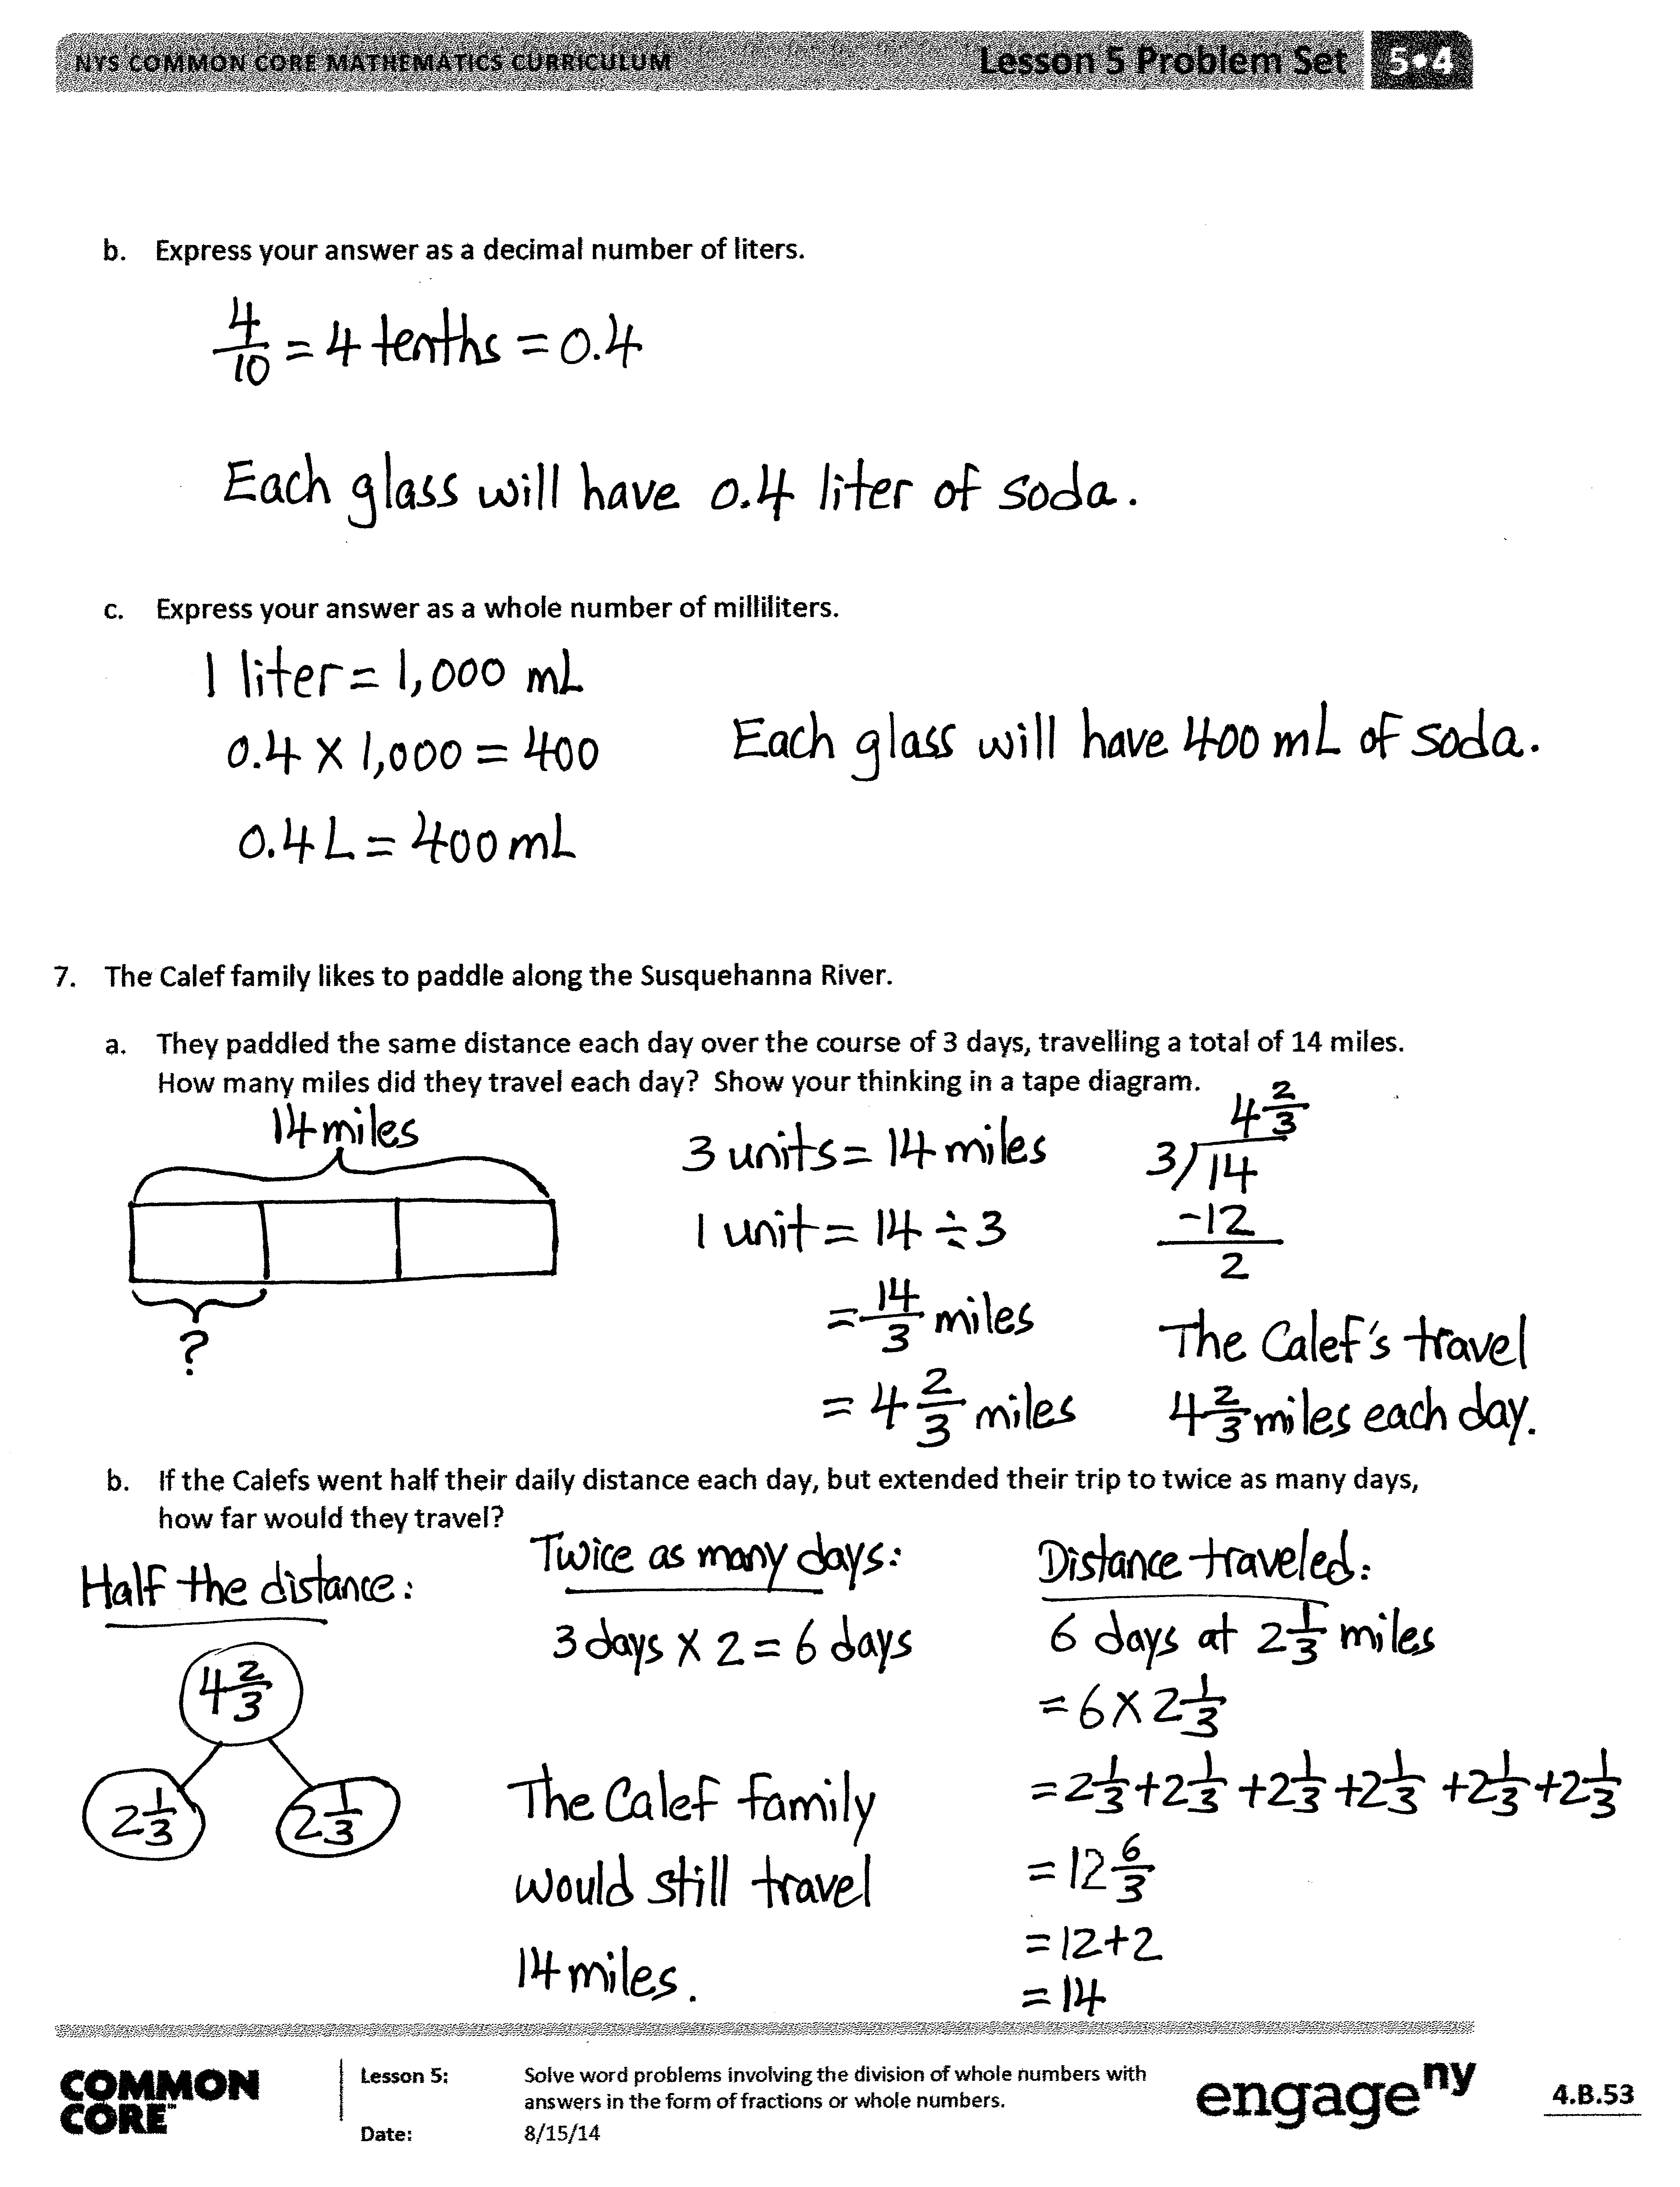
Exit Ticket (3 minutes)
After the Student Debrief, instruct students to complete the Exit Ticket. A review of their work will help you assess the students’ understanding of the concepts that were presented in the lesson today and plan more effectively for future lessons. You may read the questions aloud to the students.

Name Date
- A total of 2 yards of fabric is used to make 5 identical pillows. How much fabric is used for each pillow?

- An ice-cream shop uses 4 pints of ice cream to make 6 sundaes. How many pints of ice cream are used for each sundae?

- An ice-cream shop uses 6 bananas to make 4 identical sundaes. How many bananas are used in each sundae? Use a tape diagram to show your work.

- Julian has to read 4 articles for school. He has 8 nights to read them. He decides to read the same number of articles each night.
- How many articles will he have to read per night?

- What fraction of the reading assignment will he read each night?

- 40 students shared 5 pizzas equally. How much pizza will each student receive? What fraction of the pizza did each student receive?

- Lillian had 2 two-liter bottles of soda, which she distributed equally between 10 glasses.
- How much soda was in each glass? Express your answer as a fraction of a liter.

- Express your answer as a decimal number of liters.

- Express your answer as a whole number of milliliters.

- The Calef family likes to paddle along the Susquehanna River.
- They paddled the same distance each day over the course of 3 days, traveling a total of 14 miles. How many miles did they travel each day? Show your thinking in a tape diagram.

- If the Calefs went half their daily distance each day, but extended their trip to twice as many days, how far would they travel?

Name Date
A grasshopper covered a distance of 5 yards in 9 equal hops. How many yards did the grasshopper travel on each hop?
- Draw a picture to support your work.

- How many yards did the grasshopper travel after hopping twice?

Name Date
- When someone donated 14 gallons of paint to Rosendale Elementary School, the fifth-grade decided to use it to paint murals. They split the gallons equally among the four classes.
  - How much paint did each class have to paint their mural?

  - How much paint will three classes use? Show your thinking using words, numbers, or pictures.

  - If 4 students share a 30 square foot wall equally, how many square feet of the wall will be painted by each student?

  - What fraction of the wall will each student paint?

- Craig bought a 3-foot long baguette, and then made 4 equally sized sandwiches with it.
a. What portion of the baguette was used for each sandwich? Draw a visual model to help you solve this problem.

- How long, in feet, is one of Craig’s sandwiches?

- How many inches long is one of Craig’s sandwiches?

- Scott has 6 days to save enough money for a $45 concert ticket. If he saves the same amount each day, what is the minimum amount he must save each day in order to reach his goal? Express your answer in dollars.

