|  |
| --- |
|  |

Lesson 13: Relationships Between Two Numerical Variables

**Student Outcomes**

* Students distinguish between scatter plots that display a relationship that can be reasonably modeled by a linear equation and those that should be modeled by a nonlinear equation.
* Students use an equation given as a model for a nonlinear relationship to answer questions based on an understanding of the specific equation and the context of the data.

Lesson Notes

The work in this lesson builds on students’ work with bivariate data and its relationships. The models addressed in this lesson also build on the scatter plots presented in Lesson 12. Lesson 12 asked students to think about whether or not there was a relationship between variables. If there was, students identified that relationship as linear or nonlinear. Previous relationship studies focused primarily on linear models. In this lesson, students begin to analyze nonlinear relationships, specifically exponential and quadratic models.

Lesson 18 encourages students to select an example from this lesson or the next one to summarize on a poster. As students work with these examples, encourage them to consider each example as a possible problem for a poster or presentation. The poster provides an opportunity to explain a problem, the data presented with the problem, the relationship between the variables and what the relationship indicates. The focus for this project is numerical, bivariate data.

Classwork

Not all relationships between two numerical variables are *linear*. There are many situations where the pattern in the scatter plot would best be described by a curve. Two types of functions often used in modeling nonlinear relationships are *quadratic* and *exponential* functions.

Example 1 (7 minutes): Modeling Relationships

As a group, discuss the functions presented in this example and their graphs. Students’ previous work in algebra and functions used these functions. Ask students to describe the functions based on their graphs. For students unfamiliar with these functions, discuss the graphs of the quadratic and exponential functions, and explain how they are different from a linear function*.*

**Example 1: Modeling Relationships**

Sometimes the pattern in a scatter plot will look like the graph of a quadratic function (with the points falling roughly in the shape of a *U* that opens up or down), as in the graph below.

In other situations, the pattern in the scatter plot might look like the graphs of exponential functions that either are upward sloping (Graph 1) or downward sloping (Graph 2).

|  |  |
| --- | --- |
| Graph 1: Exponential – upward sloping | Graph 2: Exponential – downward sloping |

Exercises 1–6 (12 minutes)

Provide students time to work individually or in small groups on the questions of this exercise. Discuss the questions as a group after students have developed their responses.

Exercises 1–6

Consider again the five scatter plots discussed in the previous lesson.

|  |  |
| --- | --- |
| **Scatter Plot 1** | **Scatter Plot 2** |
| **Scatter Plot 3** | **Scatter Plot 4** |
| **Scatter Plot 5** |  |

1. Which of the five scatter plots from Lesson 12 show a pattern that could be reasonably described by a quadratic curve?

Scatter plot 4. Discuss with students how the pattern in the scatter plot fits the quadratic curve.

**MP.4**

1. Which of the five scatter plots show a pattern that could be reasonably described by an exponential curve?

Scatter plot 2. Discuss with students how the pattern of the data points fits the exponential curve.

Discuss how predictions can be found using a model. Ask the students:

* How can a graph be used to make a prediction?
  + *Estimate the value from the line or curve.*
* How can a model be used to make a prediction?
  + *A value can be substituted for a variable in the model to solve for the other variable.*

Let’s revisit the data on elevation (in feet above sea level) and mean number of clear days per year. The scatter plot of this data is shown below. The plot also shows a straight line that can be used to model the relationship between elevation and mean number of clear days. (In Grade 8, you informally fit a straight line to model the relationship between two variables. The next lesson shows a more formal way to fit a straight line.) The equation of this line is .

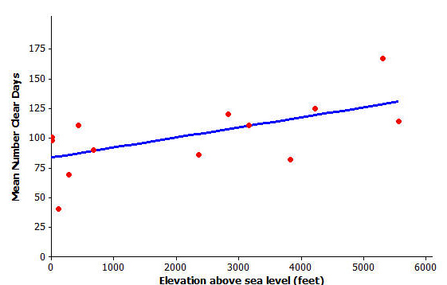

1. Assuming that the cities used in this scatter plot are representative of cities across the United States, should you see more clear days per year in Los Angeles, which is near sea level, or in Denver, which is known as the mile-high city? Justify your choice with a line showing the relationship between elevation and mean number of clear days.

Denver, since the number of clear days increases as elevation increases.

Provide data set from previous lesson. Using the data, students can see which city is plotted on the graph.

From the graph and data set, L.A. had about clear days; Denver had about clear days.

From the linear model, LA () had clear days, Denver () had clear days.

1. One of the cities in the data set was Albany, New York, which has an elevation of feet. If you did not know the mean number of clear days for Albany, what would you predict this number to be based on the line that describes the relationship between elevation and mean number of clear days?

Let and substitute the value into the model. The predicted number of clear days is days or about days.

1. Another city in the data set was Albuquerque, New Mexico. Albuquerque has an elevation of feet. If you did not know the mean number of clear days for Albuquerque, what would you predict this number to be based on the line that describes the relationship between elevation and mean number of clear days?

Let and substitute the value into the model. The predicted number of clear days is or about days.

1. Was the prediction of the mean number of clear days based on the line closer to the actual value for Albany with clear days or for Albuquerque with clear days? How could you tell this from looking at the scatter plot with the line shown above?

The prediction ( clear days) was closer for Albany, which had actual clear days. The distance from the predicted point on the line to the point representing Albany showed a smaller distance than the point corresponding to Albuquerque.

Example 2 (3 minutes): A Quadratic Model

Discuss the data presented in this exercise.

* Is fertilizer good for plants?
* Can a plant be “over-fertilized?”
* How can we find the amount of fertilizer that produces the most corn?

Example 2: A Quadratic Model

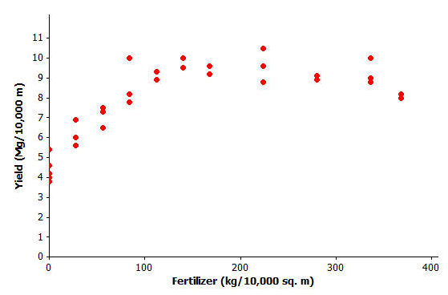Farmers sometimes use fertilizers to increase crop yield, but often wonder just how much fertilizer they should use. The data shown in the scatter plot below are from a study of the effect of fertilizer on the yield of corn.

Data Source: M.E. Cerrato and A.M. Blackmer, “Comparison of Models for Describing Corn Yield Response to Nitrogen Fertilizer” *Agronomy Journal,* 82 (1990): 138.

Exercises 7–9 (7 minutes)

Let students work in pairs on Exercises 7–9. Then discuss and confirm Exercises 8 and 9 as a class.

Exercises 7–9

1. The researchers who conducted this study decided to use a quadratic curve to describe the relationship between yield and amount of fertilizer. Explain why they made this choice.

In the beginning, as the amount of fertilizer () increases, so does the yield (). But then around kg, the yield begins to decrease as the amount of fertilizer increases.

1. The model that the researchers used to describe the relationship was , where represents the amount of fertilizer (kg per sq. m) and represents corn yield (Mg per sq. m). Use this quadratic model to complete the following table. Then sketch the graph of this quadratic equation on the scatter plot.

Encourage students to also use a graphing calculator or statistical software to construct the table and the curve. Students can also construct the curve by plotting the points in the table.

|  |  |  |  |  |  |  |  |  |  |  |  |  |  |
| --- | --- | --- | --- | --- | --- | --- | --- | --- | --- | --- | --- | --- | --- |
| |  |  | | --- | --- | |  |  | |  |  | |  |  | |  |  | |  |  | |  |  | |  |

1. Based on this quadratic model, how much fertilizer per square meters would you recommend that a farmer use on his cornfields in order to maximize crop yield? Justify your choice.

About – kg per square meters.

Example 3 (3 minutes): An Exponential Model

Discuss the data presented in the exercise. Ask students:

* What is meant by “regulating lobster trapping?”
  + *Preventing commercial fisherman from harvesting too many lobsters.*
* Why would biologists care about the age of a lobster?
  + *This information can be used to decide whether a lobster can be harvested or thrown back into the ocean.*

**Example 3: An Exponential Model**

How do you tell how old a lobster is? This question is important to biologists and to those who regulate lobster trapping. To answer this question, researchers recorded data on the shell length of lobsters that were raised in a laboratory and whose ages were known.

Data Source: Kerry E. Maxwell, Thomas R. Matthews, Matt R.J. Sheehy, Rodney D. Bertelsen, and Charles D. Derby, “Neurolipofuscin is a Measure of Age in *Panulirus argus*, the Caribbean Spiny Lobser, in Florida” *Biological Bulletin,* 213 (2007): 55.

Exercises 10–13 (8 minutes)

Let students work independently on Exercises 10–13. Then discuss and confirm as a class.

Exercises 10–13

1. The researchers who conducted this study decided to use an exponential curve to describe the relationship between age and exterior shell length. Explain why they made this choice.

As the length of the exterior shell increases, the age of the lobster tends to increase. The change in age is greater as the shell length increases, suggesting the exponential model.

1. The model that the researchers used to describe the relationship is , where represents the exterior shell length (mm) and represents the age of the lobster (years). The exponential curve is shown on the scatter plot below. Does this model provide a good description of the relationship between age and exterior shell length? Explain why or why not.

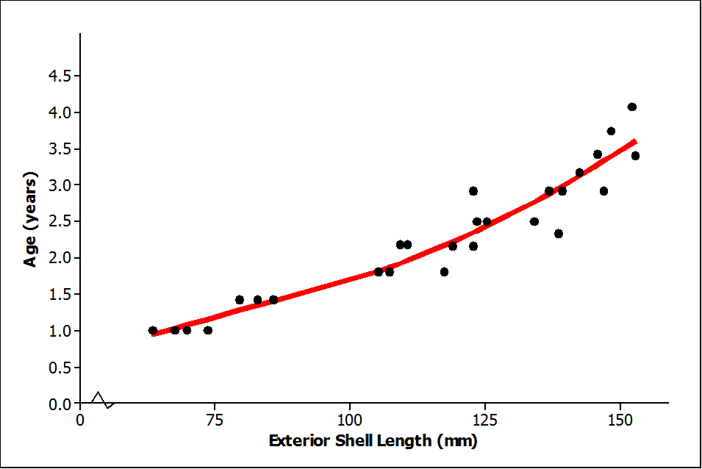

The model does a good job of describing the relationship; the data points lie reasonably close to the model.

1. Based on this exponential model, what age is a lobster with an exterior shell length of mm?

From the graph: About years old.

From the model:

Therefore, , or approximately years old.

1. Suppose that trapping regulations require that any lobster with an exterior shell length less than mm or more than mm must be released. Based on the exponential model, what are the ages of lobsters with exterior shell lengths less than mm? What are the ages of lobsters with exterior shell lengths greater than mm? Explain how you arrived at your answer.

Lobsters less than mm would be about year or less in age. Lobsters that are more than mm would be approximately years or older.

Students can use the model or estimate from the graph. Share with students that not only are lobsters released if they are too small (or young) but also if they are too large.

Closing (2 minutes)

Lesson Summary

* A scatter plot can be used to investigate whether or not there is a relationship between two numerical variables.
* Linear, quadratic, and exponential functions are common models that can be used to describe the relationship between variables.
* Models can be used to answer questions about how two variables are related.

Exit Ticket (3 minutes)

Name ___________________________________________________ Date____________________

Lesson 13: Relationships Between Two Numerical Variables

Exit Ticket

1. 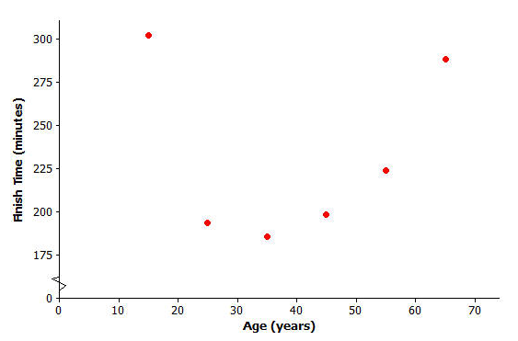Here is the scatter plot of age (in years) and finish time (in minutes) of the NY City Marathon that you first saw in an example. What type of model (linear, quadratic, or exponential) would best describe the relationship between age and finish time? Explain your reasoning.
2. 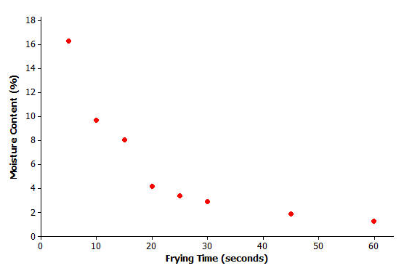Here is the scatter plot of frying time (in seconds) and moisture content (as a percentage) you first saw in Lesson 12. What type of model (linear, quadratic, or exponential) would best describe the relationship between frying time and moisture content? Explain your reasoning.

Exit Ticket Sample Solutions

1. Here is the scatter plot of age (in years) and finish time (in minutes) of the NY City Marathon that you first saw in an example. What type of model (linear, quadratic, or exponential) would best describe the relationship between age and finish time? Explain your reasoning.

The relationship between age and the finish time is best described by a quadratic model. As age increases, finish times decrease until they reach a minimum value and then begin to increase.

1. Here is the scatter plot of frying time (in seconds) and moisture content (as a percentage) you first saw in Lesson 12. What type of model (linear, quadratic, or exponential) would best describe the relationship between frying time and moisture content? Explain your reasoning.

The relationship between frying time and moisture content is exponential. As the frying time increases, the moisture content also decreases. The amount of decrease is slowing as the frying time increases; therefore, it is an exponential decrease.

Problem Set Sample Solutions

Biologists conducted a study of the nesting behavior of a type of bird called a flycatcher. They examined a large number of nests and recorded the latitude for the location of the nest and the number of chicks in the nest.

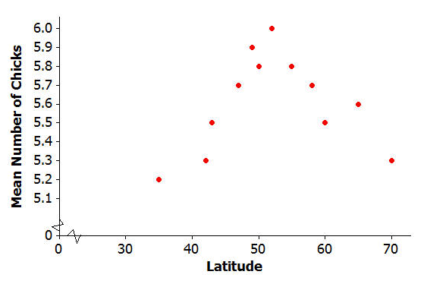

Data Source: Juan José Sanz, “Geographic variation in breeding parameters of the pied flycatcher Ficedula hypoleuca” *Ibis,* 139 (1997): 107.

1. What type of model (linear, quadratic or exponential) would best describe the relationship between latitude and mean number of chicks?

The relationship between latitude in degrees and mean number of chicks is best described by a quadratic model.

1. One model that could be used to describe the relationship between mean number of chicks and latitude is   
   , where represents the latitude of the location of the nest and represents the number of chicks in the nest. Use the quadratic model to complete the following table. Then sketch a graph of the quadratic curve on the scatter plot above.

|  |  |  |  |  |  |  |  |  |  |  |  |  |  |
| --- | --- | --- | --- | --- | --- | --- | --- | --- | --- | --- | --- | --- | --- |
| |  |  | | --- | --- | | (degrees) |  | |  |  | |  |  | |  |  | |  |  | |  |  | |  |

1. Based on this quadratic model, what is the best latitude for hatching the most flycatcher chicks? Justify your choice.

The best latitude is the highest point; that is, degrees latitude.

Suppose that social scientists conducted a study of senior citizens to see how the time (in minutes) required to solve a word puzzle changes with age. The scatter plot below displays data from this study.

Let equal the age of the citizen and equal the time (in minutes) required to solve a word puzzle for the seven study participants.

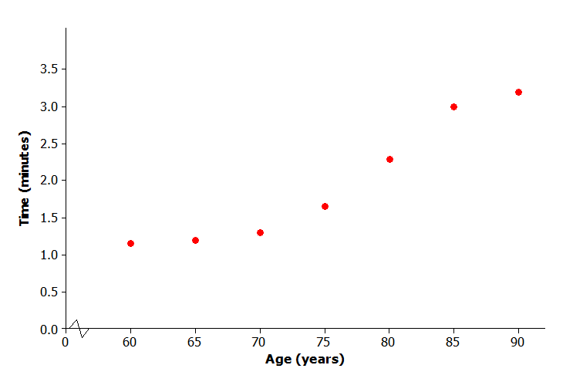

1. What type of model (linear, quadratic, or exponential) would you use to describe the relationship between age and time required to complete the word puzzle?

Exponential.

1. One model that could describe the relationship between age and time to complete the word puzzle is . This exponential curve is shown on the scatter plot below. Does this model do a good job of describing the relationship between age and time to complete the word puzzle? Explain why or why not.

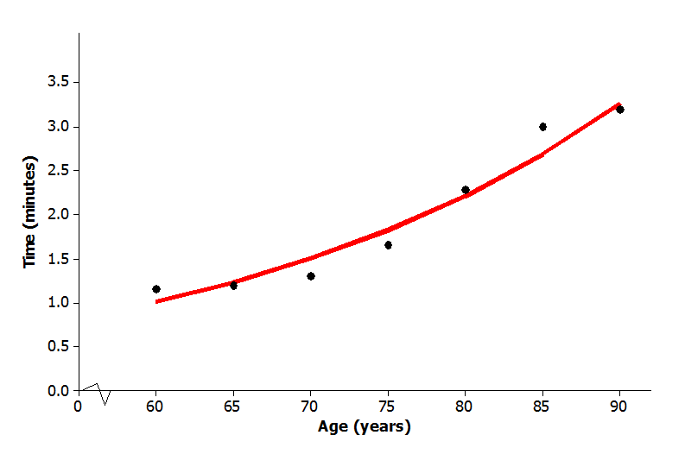

Evaluation is subjective; the data points are close to the model; therefore, it does a good job of describing the relationship between age and time to complete the word puzzle.

1. Based on this exponential model, what time would you predict for a person who is years old?

Based on the graph, an estimate of about minutes would be reasonable. Using the model equation,   
, or approximately minutes.