Lesson 4: Summarizing Deviations from the Mean

Classwork
Exercises 1–4
A consumers’ organization is planning a study of the various brands of batteries that are available. As part of its planning, it measures lifetime (i.e., how long a battery can be used before it must be replaced) for each of six batteries of Brand A and eight batteries of Brand B. Dot plots showing the battery lives for each brand are shown below.
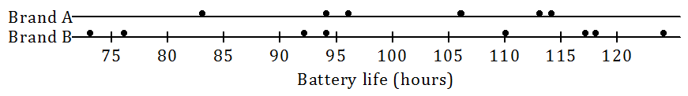

- Does one brand of battery tend to last longer, or are they roughly the same? What calculations could you do in order to compare the battery lives of the two brands?

- Do the battery lives tend to differ more from battery to battery for Brand A or for Brand B?

- Would you prefer a battery brand that has battery lives that do not vary much from battery to battery? Why or why not?

The table below shows the lives (in hours) of the Brand A batteries.
Life (Hours) | $$83$$ | $$94$$ | $$96$$ | $$106$$ | $$113$$ | $$114$$
Deviation from the Mean

- Calculate the deviations from the mean for the remaining values, and write your answers in the appropriate places in the table.

The table below shows the battery lives and the deviations from the mean for Brand B.
Life (Hours) | $$73$$ | $$76$$ | $$92$$ | $$94$$ | $$110$$ | $$117$$ | $$118$$ | $$124$$
Deviation from the Mean | $$-27.5$$ | $$-24.5$$ | $$-8.5$$ | $$-6.5$$ | $$9.5$$ | $$16.5$$ | $$17.5$$ | $$23.5$$

Exercises 5–10
The lives of five batteries of a third brand, Brand C, were determined. The dot plot below shows the lives of the Brand A and Brand C batteries.
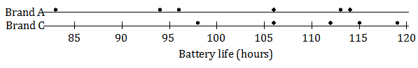
- Which brand has the greater mean battery life? (You should be able to answer this question without doing any calculations.)

- Which brand shows greater variability?

- Which brand would you expect to have the greater deviations from the mean (ignoring the signs of the deviations)?

The table below shows the lives for the Brand C batteries.
Life (Hours) | $$115$$ | $$119$$ | $$112$$ | $$98$$ | $$106$$
Deviation from the Mean

- Calculate the mean battery life for Brand C. (Be sure to include a unit in your answer.)

- Write the deviations from the mean in the empty cells of the table for Brand C.

- Ignoring the signs, are the deviations from the mean generally larger for Brand A or for Brand C? Does your answer agree with your answer to Exercise 7?

Exercises 11–15
The lives of $100$ batteries of Brand D and $100$ batteries of Brand E were determined. The results are summarized in the histograms below.
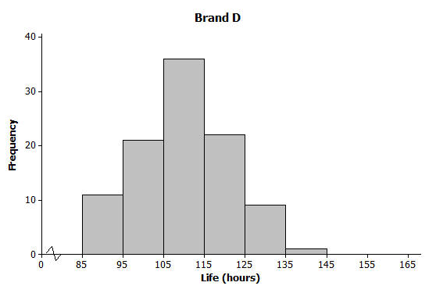

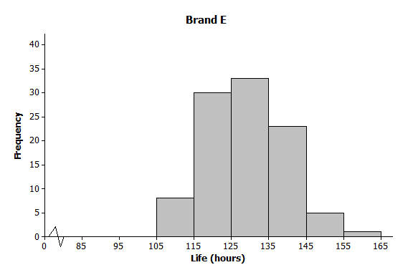

- Estimate the mean battery life for Brand D. (Do not do any calculations.)

- Estimate the mean battery life for Brand E. (Do not do any calculations.)

- Which of Brands D and E shows the greater variability in battery lives? Do you think the two brands are roughly the same in this regard?

- Estimate the largest deviation from the mean for Brand D.

- What would you consider a typical deviation from the mean for Brand D?

Lesson Summary
- For any given value in a data set, the deviation from the mean is the value minus the mean. Written algebraically, this is $x-\overline{x}$.
- The greater the variability (spread) of the distribution, the greater the deviations from the mean (ignoring the signs of the deviations).

Problem Set

- Ten members of a high school girls’ basketball team were asked how many hours they studied in a typical week. Their responses (in hours) were $20$, $13$, $10$,$6$,$13$, $10$, $13$,$11$, $11$, $10$.
  - Using the axis given below, draw a dot plot of these values. (Remember, when there are repeated values, stack the dots with one above the other.)

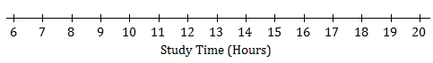

  - Calculate the mean study time for these students.
  - Calculate the deviations from the mean for these study times, and write your answers in the appropriate places in the table below.
Number of Hours Studied | $$20$$ | $$13$$ | $$10$$ | $$6$$ | $$13$$ | $$10$$ | $$13$$ | $$11$$ | $$11$$ | $$10$$
Deviation from the Mean
  - The study times for fourteen girls from the soccer team at the same school as the one above are shown in the dot plot below.
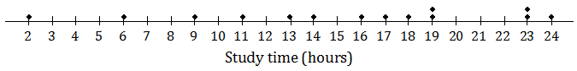
Based on the data, would the deviations from the mean (ignoring the sign of the deviations) be greater or less for the soccer players than for the basketball players?

- All the members of a high school softball team were asked how many hours they studied in a typical week. The results are shown in the histogram below.
(The data set in this question comes from Core Math Tools, www.nctm.org.)
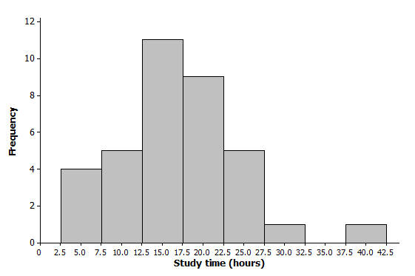

  - We can see from the histogram that four students studied around $5$ hours per week. How many students studied around $15$ hours per week?
  - How many students were there in total?
  - Suppose that the four students represented by the histogram bar centered at 5 had all studied exactly 5 hours, the five students represented by the next histogram bar had all studied exactly 10 hours, and so on. If you were to add up the study times for all of the students, what result would you get?
  - What is the mean study time for these students?
  - What would you consider to be a typical deviation from the mean for this data set?

