Lesson 1: Distributions and Their Shapes

Classwork
Statistics is all about data. Without data to talk about or to analyze or to question, statistics would not exist. There is a story to be uncovered behind all data—a story that has characters, plots, and problems. The questions or problems addressed by the data and their story can be disappointing, exciting, or just plain ordinary. This module is about stories that begin with data.

Example 1: Graphs
Data are often summarized by graphs; the graphs are the first indicator of variability in the data.
- Dot plots: A plot of each data value on a scale or number line.
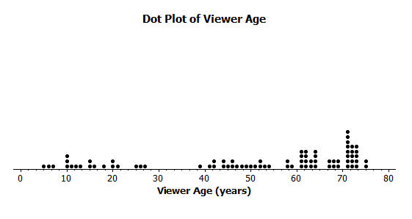

- Histograms: A graph of data that groups the data based on intervals and represents the data in each interval by a bar.
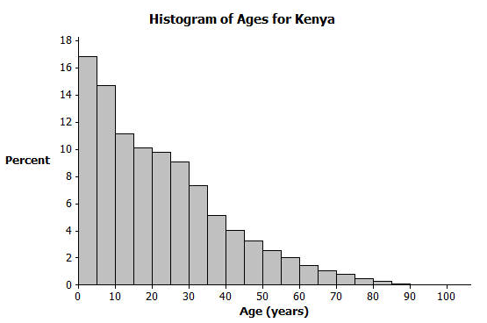

- Box plots: A graph that provides a picture of the data ordered and divided into four intervals that each contains approximately $25\%$ of the data.

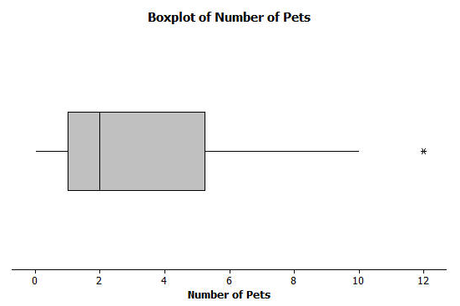

Exercises 1–15
Answer the questions that accompany each graph to begin your understanding of the story behind the data.
Transportation officials collect data on flight delays (the number of minutes past the scheduled departure time that a flight takes off).  Consider the dot plot of the delay times for sixty BigAir flights during December 2012.  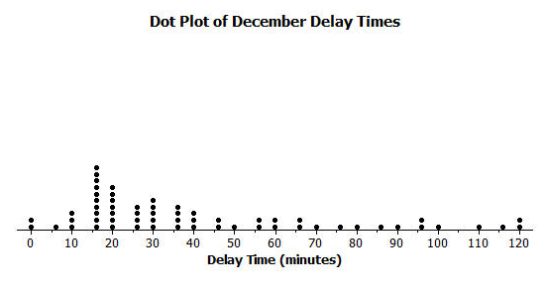 | - What do you think this graph is telling us about the flight delays for these sixty flights?  - Can you think of a reason why the data presented by this graph provides important information? Who might be interested in this data distribution?  - Based on your previous work with dot plots, would you describe this dot plot as representing a symmetric or a skewed data distribution? (Recall that a skewed data distribution is not mound shaped.) Explain your answer.
A random sample of eighty viewers of a television show was selected. The dot plot below shows the distribution of the ages (in years) of these eighty viewers.  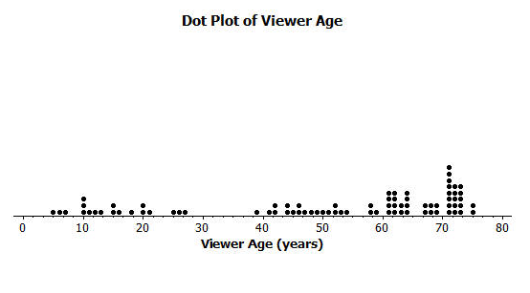 | - What do you think this graph is telling us about the ages of the eighty viewers in this sample?  - Can you think of a reason why the data presented by this graph provides important information? Who might be interested in this data distribution?  - Based on your previous work with dot plots, would you describe this dot plot as representing a symmetric or a skewed data distribution? Explain your answer.
The following histogram represents the age distribution of the population of Kenya in 2010.  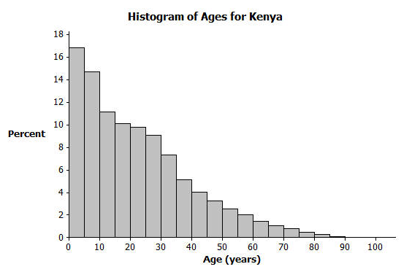 | - What do you think this graph is telling us about the population of Kenya?  - Why might we want to study the data represented by this graph?  - Based on your previous work with histograms, would you describe this histogram as representing a symmetrical or a skewed distribution? Explain your answer.
The following histogram represents the age distribution of the population of the United States in 2010.  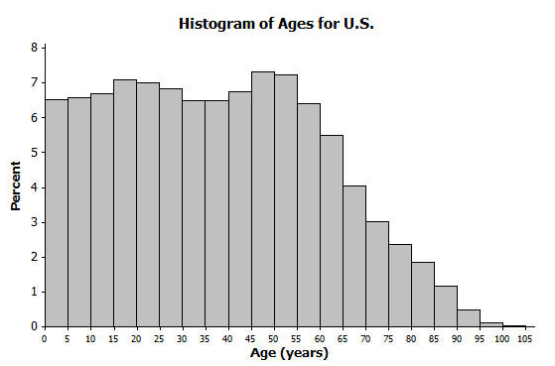 | - What do you think this graph is telling us about the population of the United States?  - Why might we want to study the data represented by this graph?
Thirty students from River City High School were asked how many pets they owned. The following box plot was prepared from their answers.  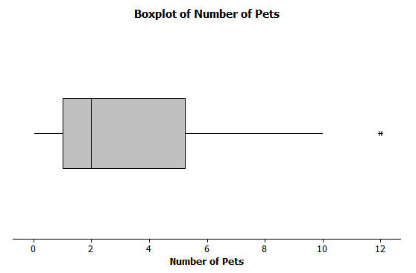 | - What does the box plot tell us about the number of pets owned by the thirty students at River City High School?  - Why might understanding the data behind this graph be important?
Twenty-two juniors from River City High School participated in a walkathon to raise money for the school band. The following box plot was constructed using the number of miles walked by each of the twenty-two juniors.  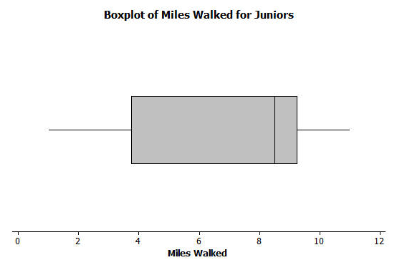 | - What do you think the box plot tells us about the number of miles walked by the twenty-two juniors?  - Why might understanding the data behind this graph be important?

Lesson Summary
Statistics is about data. Graphs provide a representation of the data distribution and are used to understand the data and to answer questions about the distribution.

Problem Set

- Twenty-five people were attending an event. The ages of the people are as follows:
$$3\text{,} 3\text{,} 4\text{,} 4\text{,} 4\text{,} 4\text{, }5\text{,} 6\text{,} 6\text{,} 6\text{,} 6\text{,} 6\text{,} 6\text{,} 6\text{,} 7\text{,} 7\text{,} 7\text{,} 7\text{,} 7\text{,} 7\text{,} 16\text{,} 17\text{,} 22\text{, }22\text{,} 25\text{.}$$
  - Create a histogram of the ages using the provided axes.

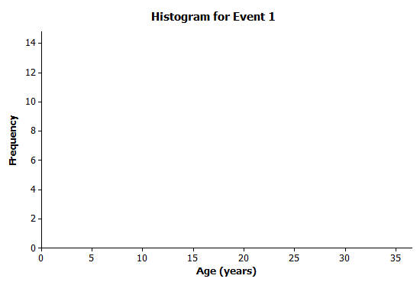
  - Would you describe your graph as symmetrical or skewed? Explain your choice.
  - Identify a typical age of the twenty-five people.
  - What event do you think the twenty-five people were attending? Use your histogram to justify your conjecture.

- A different forty people were also attending an event. The ages of the people are as follows:
$$6\text{,} 13\text{,} 24\text{,} 27\text{,} 28\text{,} 32\text{,} 32\text{, }34\text{,} 38\text{,} 42\text{,} 42\text{, }43\text{,} 48\text{,} 49\text{, }49\text{, }49\text{, }51\text{,} 52\text{,} 52\text{, }53\text{,}$$
$$53\text{,} 53\text{,} 54\text{,} 55\text{,} 56\text{,} 57\text{,} 57\text{, }60\text{,} 61\text{,} 61\text{,} 62\text{,} 66\text{,} 66\text{,} 66\text{,} 68\text{,} 70\text{,} 72\text{, }78\text{, }83\text{, }97\text{.}$$
  - Create a histogram of the ages using the provided axes.
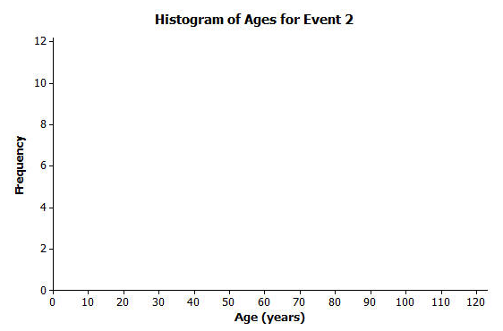
  - Would you describe your graph of ages as symmetrical or skewed? Explain your choice.
  - Identify a typical age of the forty people.
  - What event do you think the forty people were attending? Use your histogram to justify your conjecture.
  - How would you describe the differences in the two histograms?

