Lesson 24: Applications of Systems of Equations and Inequalities

Student Outcomes
- Students use systems of equations or inequalities to solve contextual problems and interpret solutions within a particular context.

Lesson Notes
This lesson introduces students to the idea of using systems to solve various application problems in order to prepare them for more extensive modeling tasks that they encounter in Topic D.

Classwork
Opening Exercise (8 minutes)
Have students brainstorm this problem in groups. Allow groups to share different approaches to solving the problem (i.e., guess and check, making a table, or algebraically). Encourage students to critique the various approaches.
MP.3
What were the advantages or disadvantages to the various approaches? Lead students through the algebraic approach. Then, discuss the following:
Opening Exercise
In Lewis Carroll’s Through the Looking Glass, Tweedledum says, “The sum of your weight and twice mine is $361$ pounds.” Tweedledee replies, “The sum of your weight and twice mine is $362$ pounds.” Find both of their weights.
Let $x=$ the number of pounds Tweedledee weighs, and let $y=$ the number of pounds Tweedledum weighs.
$$x+2y=361$$
$$y+2x=362$$
Tweedledum weighs $120$ pounds, and Tweedledee weighs $121$ pounds.

Discussion (5 minutes)
- Could we solve the problem above using only Tweedledum’s sentence?
  - No. There are two unknowns, and as we saw in earlier lessons, the equation $x+2y=361$ has an infinite number of solutions.
- In a situation where there are two unknowns, how many equations do we need to write in order to solve the system?
  - Two equations.

- If I told you I was holding $20$ coins that were some mix of dimes and quarters, could you tell me anything about how many of each I have?
  - You could only list possible combinations ($1$dime and $19$ quarters, $2$ dimes and $18$ quarters, etc.).
- What other piece of information would be useful in determining how many of each type of coin I was holding?
  - The total amount of money, how many more or fewer quarters than dimes, etc.

Example 1 (5 minutes)
Let the discussion lead into Example 1. Work through the example as a class. Make sure students specify the variables being used in the equations. Discuss the various ways of solving (i.e., graphically, making a table, algebraically). In the previous lesson, we did not solve systems by making a table. Demonstrate how this might be a useful technique in the following situation.
Example 1
Lulu tells her little brother, Jack, that she is holding $20$ coins all of which are dimes and quarters. They have a value of $\$4.10$. She says she will give him the coins if he can tell her how many of each she is holding. Solve this problem for Jack.
Let $d=$ the number of dimes, and let $q=$ the number of quarters.
Scaffolding:
Allow students to decide how they want to solve the problem. However, encourage them to look at other approaches. Discuss the limitations of the various methods.
$$d+q=20$$
$$0.10d+0.25q=4.10$$
Lulu is holding$6$dimes and $14$ quarters.

Exploratory Challenge (20 minutes)
Have students work in groups on part (a). Then, discuss responses as a class.
Emphasize that regardless of how each group chooses to solve the problem, every group should specify the variables and clearly label the graph.
MP.6
Then have students work in groups on part (b). Guide them through the problem as needed. This is a fairly complicated problem, so students may need assistance. Encourage the students to persevere and to break up the problem into manageable pieces.
MP.1
Exploratory Challenge
  - At a state fair, there is a game where you throw a ball at a pyramid of cans. If you knock over all of the cans, you win a prize. The cost is$3$ throws for $\$1$, but if have you an armband, you get 6 throws for $\$1$. The armband costs $\$10$.
    - Write two cost equations for the game in terms of the number of throws purchased, one without an armband and one with.
Let $x$ = number of throws, and let $C=$cost.
Without armband: $C=\frac{1}{3}x$
With armband: $C=\frac{1}{6}x+10$

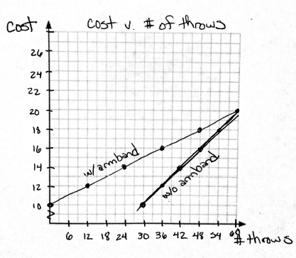
    - Graph the two cost equations on the same graph. Be sure to label the axes and show an appropriate scale.
See graph at right.

    - Does it make sense to buy the armband?
Only if you want$60$ or more throws

Point out the constraints of $x$. Without the armband, $x$ must be a multiple of $3$; with the armband, $x$ must be a multiple of $6$.
Remind students about discrete and continuous graphs. The graphs of each equation should actually be discrete rather than continuous. Discuss why other points on the graph would not make sense for this scenario.

  - A clothing manufacturer has $1,000$ yd. of cotton to make shirts and pajamas. A shirt requires $1$ yd. of fabric, and a pair of pajamas requires $2$ yd. of fabric. It takes $2$ hr. to make a shirt and $3$ hr. to make the pajamas, and there are $1,600$ hr. available to make the clothing.
    - What are the variables?
Scaffolding:
- Students may need help graphing the system. Point out that it is easier to find the $x$- and $y$-intercepts in this problem than to rearrange the inequality.
- This branch of mathematics is called linear programming. Have early finishers research it.
Number of shirts made and number of pajamas made.

    - What are the constraints?
How much time the manufacturer has and how much material is available.

    - Write inequalities for the constraints.
Let $x=$ number of shirts, and let $y=$number of pajamas.
$x≥0$ and $y≥0$
$$x+2y≤1000$$
$$2x+3y≤1600$$

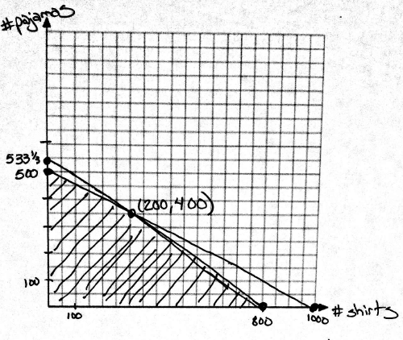
    - Graph the inequalities and shade the solution set.

    - What does the shaded region represent?
The various combinations of shirts and pajamas that it would be possible for the manufacturer to make.
    - Suppose the manufacturer makes a profit of $\$10$ on shirts and $\$18$ on pajamas. How would it decide how many of each to make?
The manufacturer wants to make as many as possible, so the maximum should be at one of the endpoints of the shaded region.

    - How many of each should the manufacturer make, assuming he will sell all the shirts and pajamas he makes?
Profit$=10x+18y$

Possible points Profit
$(0, 500)$ $\$9,000$
$(200, 400)$ $\$9,200$
$(800, 0)$ $\$8,000$
He should make $200$ shirts and $400$ pairs of pajamas for a maximum profit.

- Why does this scenario call for inequalities rather than equations?
  - He cannot exceed the amount of time or material available but does not necessarily have to use all of it.
- The shaded region in a problem of this type is sometimes called the feasible region. Why does this name make sense?
  - This is the region that represents the number of shirts and pajamas that he can feasibly make given the constraints.
Students should intuitively believe that the maximum profit should be at one of the endpoints of the shaded region (which is true because he is maximizing the given resources). However, you can have students test other points to prove that intersection point is, in fact, the maximum.

Closing (3 minutes)
Recap the steps followed in solving these problems. Do not have students copy the steps, just discuss the strategy, both specifically for this problem and then making generic descriptions (e.g., identified the variables, created equations or inequalities based on the constraints of the problem, decided on the best method for solving, interpreted the solution).

Exit Ticket (4 minutes)

Name ___________________________________________________ Date____________________
Lesson 24: Applications of Systems of Equations and Inequalities

Exit Ticket

Andy’s Cab Service charges a $\$6$ fee plus $\$0.50$ per mile. His twin brother Randy starts a rival business where he charges $\$0.80$ per mile but does not charge a fee.

- Write a cost equation for each cab service in terms of the number of miles.

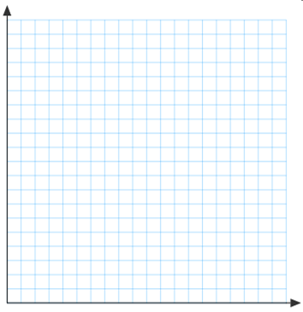

- Graph both cost equations.

- For what trip distances should a customer use Andy’s Cab Service? For what trip distances should a customer use Randy’s Cab Service? Justify your answer algebraically, and show the location of the solution on the graph.

Exit Ticket Sample Solutions

Andy’s Cab Service charges a $\$6$ fee plus $\$0.50$ per mile. His twin brother Randy starts a rival business where he
charges $\$0.80$ per mile but does not charge a fee.
- Write a cost equation for each cab service in terms of the number of miles.
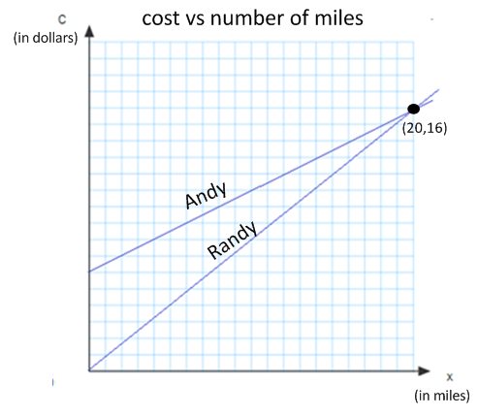
Let $x=$ number of miles, and let $C=$ cost.
Andy’s: $C=0.5x+6$
Randy’s: $C=0.8x$

- Graph both cost equations.
See graph.

- For what trip distances should a customer use Andy’s Cab Service? For what trip distances should a customer use Randy’s Cab Service? Justify your answer algebraically, and show the location of the solution on the graph.
$$0.5x+6=0.8x \\ x=20$$
If the trip is less than $20$ miles, use Randy’s. If the trip is more than $20$ miles use Andy’s. If the trip is exactly $20$ miles, either choice will result in the same cost.

Problem Set Sample Solutions

- Find two numbers such that the sum of the first and three times the second is $5$and the sum of second and two times the first is$8$.
The two numbers are $\frac{19}{5}$and$\frac{2}{5}$ .

- A chemist has two solutions: a $50\%$methane solution and an $80\%$ methane solution. He wants $100$ ml of a $70\%$ methane solution. How many ml of each solution does he need to mix?
The chemist should use $33\frac{1}{3}$ mL of the $50\%$ solution and $66\frac{2}{3}$ mL of the $80\%$ solution.

- Pam has two part time jobs. At one job, she works as a cashier and makes $\$8$ per hour. At the second job, she works as a tutor and makes $\$12$ per hour. One week she worked $30$ hours and made $\$268$. How many hours did she spend at each job?
She worked at the cashier job for$23$ hours and tutored for $7$hours.

- A store sells Brazilian coffee for$\$10$ per lb. and Columbian coffee for $\$14$ per lb. If the store decides to make a $150$-lb. blend of the two and sell it for $\$11$ per lb., how much of each type of coffee should be used?
They should use $112\frac{1}{2}$ lb. of Brazilian coffee and $37\frac{1}{2}$ lb. of Columbian coffee.

- A potter is making cups and plates. It takes her $6$ min. to make a cup and $3$ min. to make a plate. Each cup uses $\frac{3}{4}$ lb. of clay, and each plate uses $1$ lb. of clay. She has $20$ hr. available to make the cups and plates and has $250$ lb. of clay.
  - What are the variables?
$c=$# of cups made
$p=$ # of plates made
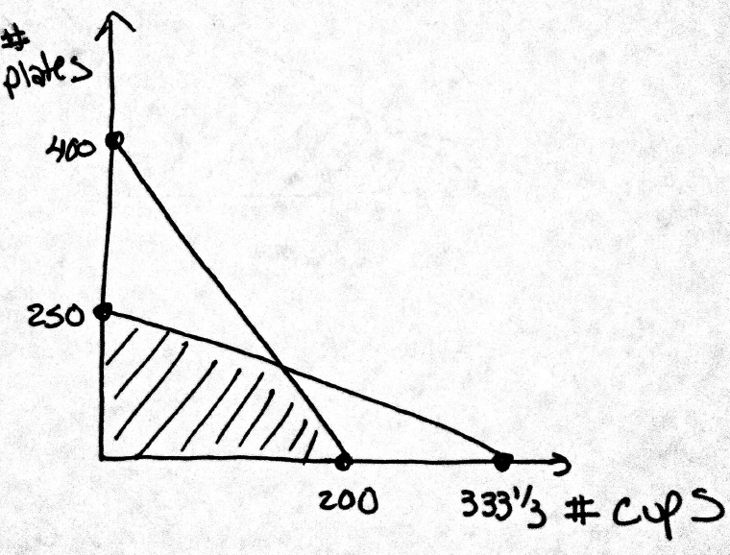
  - Write inequalities for the constraints.
$c≥0$ and $p≥0$ and $\frac{1}{10}c+\frac{1}{20}p≤20$ and $\frac{3}{4}c+p ≤250$

  - Graph and shade the solution set.
See graph at right.

  - If she makes a profit of $\$2$ on each cup and $\$1.50$on each plate, how many of each should she make in order to maximize her profit?
$120$ cups and $160$ plates

  - What is her maximum profit?
$$\$480$$

