Lesson 22: Solution Sets to Simultaneous Equations

Classwork
Opening Exercise
Consider the following compound sentence: $x+y>10$ and $y=2x+1$.
  - Circle all the ordered pairs $(x,y)$that are solutions to the inequality $x+y>10$ (below).

  - Underline all the ordered pairs $(x,y)$ that are solutions to the equation $y=2x+1$.

$\left(3,7\right)$ $\left(7, 3\right)$ $\left(-1,14\right)$ $\left(0,1\right)$ $\left(12,25\right)$

$\left(5,11\right)$ $\left(0, 12\right)$ $\left(1,8\right)$ $\left(12,0\right)$ $\left(-1,-1\right)$

  - List the ordered pair(s)$(x,y)$ from above that are solutions to the compound sentence $x+y>10$ and
$y=2x+1$.

  - List three additional ordered pairs that are solutions to the compound sentence $x+y>10$ and $y=2x+1$.

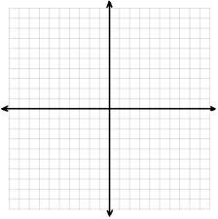

  - Sketch the solution set to the inequality $x+y>10$ and the solution set to $y=2x+1$ on the same set of coordinate axes. Highlight the points that lie in BOTH solution sets.

  - Describe the solution set to $x+y>10$ and $y=2x+1$.

Example 1
Solve the following system of equations.
$$\left\{\begin{aligned}y=2x+1 \\ x-y=7\end{aligned}\right.$$

Graphically: Algebraically:
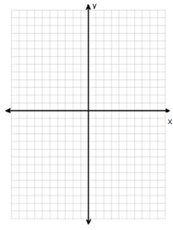
Exercise 1
Solve each system first by graphing and then algebraically.
  - $\left\{\begin{aligned} y = 4x-1 \\ y=-\frac{1}{2}x+8\end{aligned}\right.$

  - $\left\{\begin{aligned}2x+y=4 \\ 2x+3y=9\end{aligned}\right.$

  - $\left\{\begin{aligned}3x+y=5 \\ 3x+y=8\end{aligned}\right.$

Example 2
Now suppose the system of equations from Exercise 1(c) was instead a system of inequalities:
$\left\{\begin{aligned}3x+y≥5 \\ 3x+y≤8\end{aligned}\right.$
Graph the solution set.

Example 3
Graph the solution set to the system of inequalities.
$2x- y<3$and $4x+3y≥0$

Exercise 2
Graph the solution set to each system of inequalities.
  - $\left\{\begin{aligned}x-y>5 \\ x>-1\end{aligned}\right.$

  - $\left\{\begin{aligned}y≤x+4 \\ y≤4-x \\ y≥0\end{aligned}\right.$

Problem Set
- Solve the following system of equations first by graphing and then algebraically.
$$\left\{\begin{aligned}4x+y=-5 \\ x+4y=12\end{aligned}\right.$$

  - Without graphing, construct a system of two linear equations where $(0, 5)$ is a solution to the first equation but is not a solution to the second equation, and $(3, 8)$ is a solution to the system.

  - Graph the system and label the graph to show that the system you created in part (a) satisfies the given conditions.

- Consider two linear equations. The graph of the first equation is shown. A table of values satisfying the second equation is given. What is the solution to the system of the two equations?
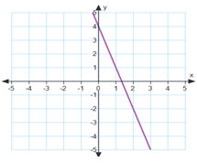
$$x$$ | $$-4$$ | $$-2$$ | $$0$$ | $$2$$ | $$4$$
$$y$$ | $$-26$$ | $$-18$$ | $$-10$$ | $$-2$$ | $$6$$

- Graph the solution to the following system of inequalities:
$$\left\{\begin{aligned}x≥0 \\ y<2 \\ x+3y>0\end{aligned}\right.$$

$$\left\{\begin{aligned}x≥0 \\ y<2 \\ x+3y>0\end{aligned}\right.$$

- Write a system of inequalities that represents the shaded region of the graph shown.

- For each question below, provide an explanation or an example to support your claim.
  - Is it possible to have a system of equations that has no solution?
  - Is it possible to have a system of equations that has more than one solution?
  - Is it possible to have a system of inequalities that has no solution?

