Lesson 22: Solution Sets to Simultaneous Equations

Student Outcomes
- Students identify solutions to simultaneous equations or inequalities; they solve systems of linear equations and inequalities either algebraically or graphically.

Classwork
Opening Exercise (8 minutes)
Allow students time to work on (a)–(d) individually. Then have students compare responses with a partner or share responses as a class.
Opening Exercise
Consider the following compound sentence: $x+y>10$ and $y=2x+1$.
  - Circle all the ordered pairs $(x,y)$that are solutions to the inequality $x+y>10$.

  - Underline all the ordered pairs $(x,y)$ that are solutions to the equation $y=2x+1$.
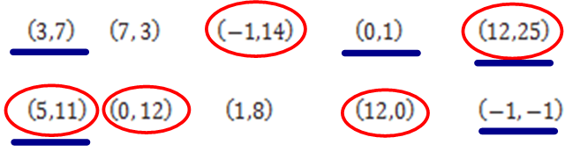

  - List the ordered pair(s)$(x,y)$ from above that are solutions to the compound sentence $x + y > 10$ and $y = 2x + 1.$
$$(5,11) \text{and} (12,25)$$

  - List three additional ordered pairs that are solutions to the compound sentence $x+y>10$ and $y=2x+1$.
$$(4,9)\text{, }(6,13)\text{, and }(7,15)$$
Ask:
- How many possible answers are there to part (d)?
- Can anyone come up with a non-integer solution?
Discuss that just as they saw with compound equations in one variable, solving pairs of equations in two variables linked by AND is given by common solution points.
- How does the solution set change if the inequality is changed to $x+y≥10$?
  - The point $(3, 7)$ would be added to the solution set.

Have students complete (e) and (f) in pairs and discuss responses.

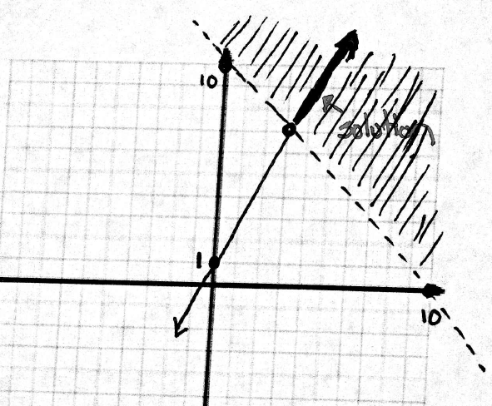
  - Sketch the solution set to the inequality $x+y>10$ and the solution set to $y=2x+1$ on the same set of coordinate axes. Highlight the points that lie in BOTH solution sets.

  - Describe the solution set to $x+y>10$ and $y=2x+1$.
All points that lie on the line $y=2x+1$ and above the line $y=-x+10$.

- Which gives a more clear idea of the solution set: the graph or the verbal description?
  - Answers could vary. The verbal description is pretty clear, but later in the lesson we will see systems with solution sets that would be difficult to describe adequately without a graph.

Example 1 (7 minutes)
In Grade 8, students solved systems of linear equations both graphically and algebraically (using both substitution and elimination techniques), so this should primarily be a review. Work through the example as a class, introducing the notation shown as indicating a system of equations, wherein the two or more equations given are understood to be compound statements connected with an “and”. Also convey that the word simultaneous from the title of the lesson is another way of saying that all equations must be true, simultaneously.
Example 1
Solve the following system of equations.
$$\left\{\begin{aligned}y=2x+1 \\ x-y=7\end{aligned}\right.$$
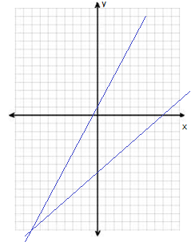
Graphically: Algebraically:
$$x-\left(2x+1\right)=7 \\ x=-8$$
$$y=2\left(-8\right)+1 \\ y=-15$$
Solution: $(-8,-15)$

Reinforce that even though the “and” is not stated explicitly, it is implied when given a system of equations. Problems written using this notation are asking one to find the solution(s) where $y=2x+1$ and $x-y=17.$ Work the problem using substitution. The elimination method is reviewed in the next lesson.
Exercise 1 (10 minutes)
Have students complete Exercise 1 individually.
Exercise 1
Solve each system first by graphing and then algebraically.
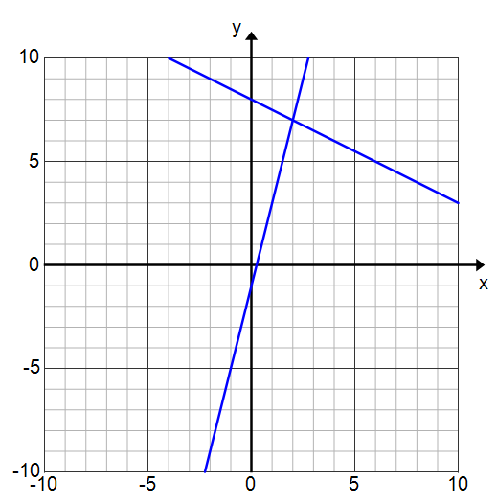
  - $\left\{\begin{aligned} y = 4x-1 \\ y=-\frac{1}{2}x+8\end{aligned}\right.$
$$y=4x-1$$
$$y=-\frac{1}{2}x+8$$
$$(2,7)$$

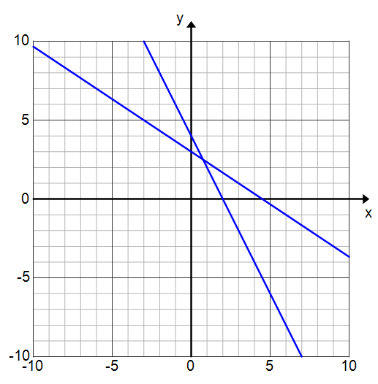
  - $\left\{\begin{aligned}2x + y = 4 \\ 2x+3y=9\end{aligned}\right.$
$$2x+y=4$$
$2x+3y=9$
Scaffolding:
In Algebra II, students will solve systems containing three unknowns. Challenge early finishers with this problem:
- If $x+y=1$ and $y+z=2$ and $x+z=3$, find $x, y$, and $z$.
  - Answer: $(1,0,2)$.
$$\left(\frac{3}{4},\frac{5}{2}\right)$$

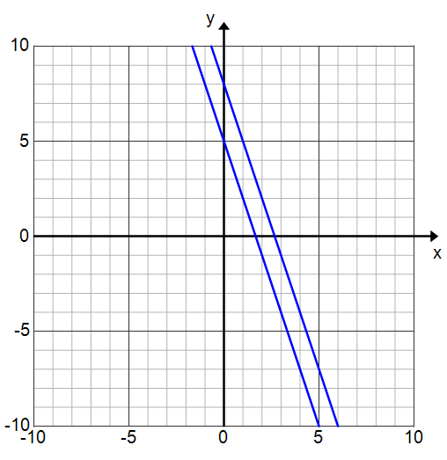
  - $\left\{\begin{aligned}3x+y=5 \\ 3x+y=8\end{aligned}\right.$
$$3x+y=5$$
$$3x+y=8$$
No solution

As students finish, have them put both the graphical and algebraic approaches on the board for parts (a)–(c) or display student work using a document camera. Discuss as a class.
- Were you able to find the exact solution from the graph?
  - Not for part (b).
- Solving by graphing sometimes only yields an approximate solution.
- How can you tell when a system of equations will have no solution from the graph?
  - The graphs do not intersect. For linear systems, this occurs when the lines have the same slope but have different $y$-intercepts, which means the lines will be parallel.
- What if a system of linear equations had the same slope and the same y-intercept?
  - There would be an infinite number of solutions (all points that lie on the line).
Example 2 (5 minutes)
Example 2
Now suppose the system of equations from Exercise 1(c) was instead a system of inequalities:
$\left\{\begin{aligned}3x+y≥5 \\ 3x+y≤8\end{aligned}\right.$
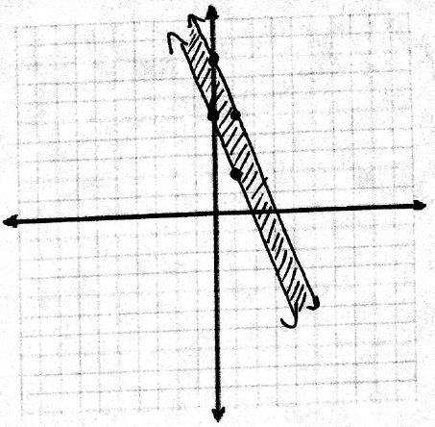
Graph the solution set.

- How did the solution set change from Exercise 1(c) to Example 2? What if we changed the problem to $3x+y≤5$ and $3x+y≥8$?
MP.7
  - There would be no solution.
The solution to a system of inequalities is where their shaded regions intersect. Let this idea lead into Example 3.

Example 3 (5 minutes)
Instruct students to graph and shade the solution set to each inequality in two different colored pencils. Give them a few minutes to complete this individually. Then discuss the solution to the system as a class.
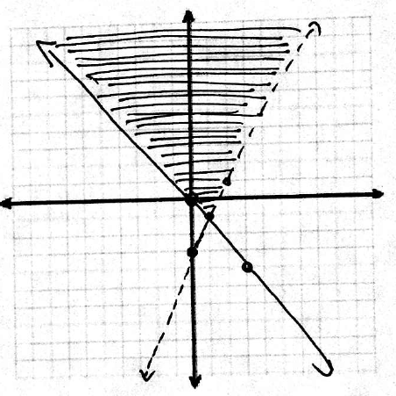
Example 3
Graph the solution set to the system of inequalities.
$2x-y<3$and $4x+3y≥0$

- Where does the solution to the system of inequalities lie?
  - Where the shaded regions overlap.
- What is true about all of the points in this region?
  - These points are the only ones that satisfy both inequalities.
Verify this by testing a couple of points from the shaded region and a couple of points that are not in the shaded region to confirm this idea to students.
Exercise 2 (8 minutes)
Have students complete Exercise 2 individually and then compare their answers with a neighbor.
Exercise 2
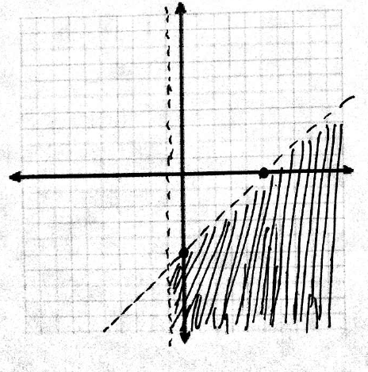
Graph the solution set to each system of inequalities.
  - $\left\{\begin{aligned}x-y>5 \\ x>-1\end{aligned}\right.$

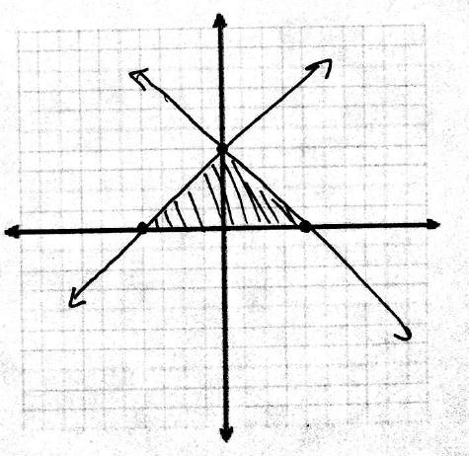
  - $\left\{\begin{aligned}y≤x+4 \\ y≤4-x \\ y≥0\end{aligned}\right.$

- Could you express the solution set of a system of inequalities without using a graph?
  - Yes, using set notation, but a graph makes it easier to visualize and conceptualize which points are in the solution set.
- How can you check your solution graph?
  - Test a few points to confirm that the points in the shaded region satisfy all the inequalities.

Closing (2 minutes)
- What are the different ways to solve a system of equations?
  - Graphically, algebraically, or numerically (using a table).
- Explain the limitations of solving a system of equations graphically.
  - It is always subject to inaccuracies associated with reading graphs, so we are only able to approximate an intersection point.
- Explain the limitations of expressing the solution to a system of inequalities without using a graph.
  - It is difficult to describe the solution set without simply restating the problem in set notation, which is hard to visualize or conceptualize.

Exit Ticket (5 minutes)
Name ___________________________________________________ Date____________________
Lesson 22: Solution Sets to Simultaneous Equations

Exit Ticket

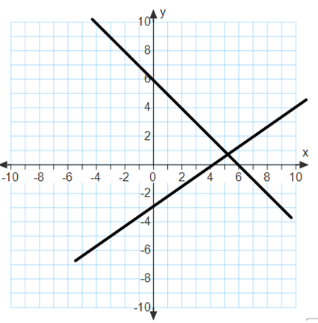
- Estimate the solution to the system of equations whose graph is shown to the right.

- Write the two equations for the system of equations and find the exact solution to the system algebraically.

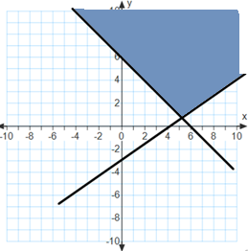
- Write a system of inequalities that represents the shaded region on the graph shown to the right.
Exit Ticket Sample Solutions

- Estimate the solution to the system of equations whose graph is shown.
$$(5.2, 0.9)$$

- Write the two equations for the system of equations and find the exact solution to the system algebraically.
$$\left\{\begin{aligned}y=-x+6 \\ y=\frac{3}{4}x-3\end{aligned}\right.$$
$$\frac{3}{4}x-3=-x+6 \\ \frac{7}{4}x=9 \\ x=\frac{36}{7}$$ | $$y=-\frac{36}{7}+6=\frac{6}{7}$$
$$\left(\frac{36}{7},\frac{6}{7}\right)$$

- Write a system of inequalities that represents the shaded region on the graph shown to the right.
$$\left\{\begin{aligned}y≥-x+6 \\ y≥\frac{3}{4}x-3\end{aligned}\right.$$

Problem Set Sample Solutions

- Solve the following system of equations first by graphing and then algebraically.
$$\left\{\begin{aligned}4x+y=-5 \\ x+4y=12\end{aligned}\right.$$
$$\left(\frac{-32}{15},\frac{53}{15}\right)$$

  - Without graphing, construct a system of two linear equations where $(0, 5)$ is a solution to the first equation but is not a solution to the second equation, and $(3, 8)$ is a solution to the system.
The first equation must be $y=x+5$; the second equation could be any equation that is different from $y=x+5$, and whose graph passes through $(3, 8)$; for example, $y=2x+2$will work.

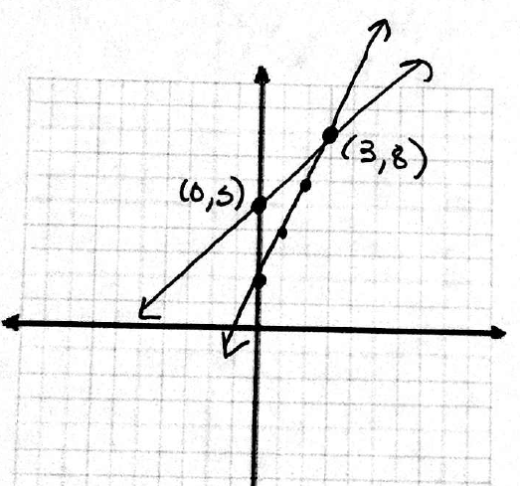
  - Graph the system and label the graph to show that the system you created in part (a) satisfies the given conditions.

- Consider two linear equations. The graph of the first equation is shown. A table of values satisfying the second equation is given. What is the solution to the system of the two equations?
$$x$$ | $$-4$$ | $$-2$$ | $$0$$ | $$2$$ | $$4$$
$$y$$ | $$-26$$ | $$-18$$ | $$-10$$ | $$-2$$ | $$6$$
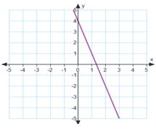

The form of the second equation can be determined exactly to be $y=4x-10$. Since the first equation is only given graphically, one can only estimate the solution graphically. The intersection of the two graphs appears to occur at $(2,-2)$. This may not be exactly right. Solving a system of equations graphically is always subject to inaccuracies associated with reading graphs.

- Graph the solution to the following system of inequalities: $\left\{\begin{aligned}x≥0 \\ y<2 \\ x+3y>0\end{aligned}\right.$
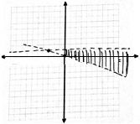

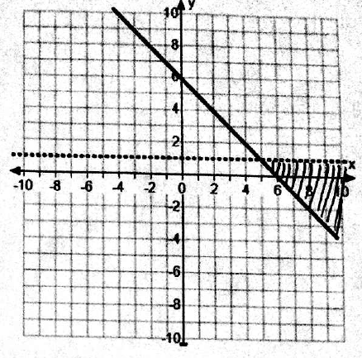
- Write a system of inequalities that represents the shaded
region of the graph shown.
$$\left\{\begin{aligned}y≥-x+6 \\ y<1\end{aligned}\right.$$

- For each question below, provide an explanation or an example to support your claim.
  - Is it possible to have a system of equations that has no solution?
Yes, for example, if the equations’ graphs are parallel lines.

  - Is it possible to have a system of equations that has more than one solution?
Yes, for example, if the equations have the same graph, or in general, if the graphs intersect more than once.

  - Is it possible to have a system of inequalities that has no solution?
Yes, for example, if the solution sets of individual inequalities, represented by shaded regions on the coordinate plane, do not overlap.

