Lesson 4
Objective: Use tape diagrams to model fractions as division.

Suggested Lesson Structure
 Fluency Practice (12 minutes)
 Application Problem (7 minutes)
 Concept Development (31 minutes)
 Student Debrief (10 minutes)
Total Time (60 minutes)
Fluency Practice (12 minutes)
- Write Fractions as Decimals 5.NF.3 (4 minutes)
- Convert to Hundredths 4.NF.5 (4 minutes)
- Fractions as Division 5.NF.3 (4 minutes)
Write Fractions as Decimals (4 minutes)
Note: This fluency activity prepares students for Topic G.
T: (Write $\frac{1}{10}$.) Say the fraction.
S: 1 tenth.
T: Say it as a decimal.
S: Zero point one.
Continue with the following possible sequence: $\frac{2}{10}$, $\frac{3}{10}$, $\frac{8}{10 }$, and $\frac{5}{10}$.
T: (Write $\frac{1}{100}$ = ____.) Say the fraction.
S: 1 hundredth.
T: Say it as a decimal.
S: Zero point zero one.
Continue with the following possible sequence: $\frac{2}{100}$, $\frac{3}{100 }$, $\frac{9}{100}$, and $\frac{13}{100}$.
T: (Write 0.01 = ____.) Say it as a fraction.
S: 1 hundredth.
T: (Write 0.01 = $\frac{1}{100}$.)
Continue with the following possible sequence: 0.02, 0.09, 0.11, and 0.39.
Convert to Hundredths (4 minutes)
Materials: (S) Personal white board
Note: This fluency activity prepares students for Topic G.
T: (Write $\frac{1}{4}$ = $\frac{}{100}$.) Write the equivalent fraction.
S: (Write $\frac{1}{4}$ = $\frac{25}{100}$.)
T: (Write $\frac{1}{4}$ = $\frac{25}{100}$ = ____.) Write 1 fourth as a decimal.
S: (Write $\frac{1}{4}$ = $\frac{25}{100}$ = 0.25.)
Continue with the following possible sequence: $\frac{3}{4}$, $\frac{1}{50}$, $\frac{7}{50}$, $\frac{12}{50}$, $\frac{1}{20}$, $\frac{7}{20}$, $\frac{11}{20}$, $\frac{1}{25}$ , $\frac{2}{25}$, $\frac{9}{25}$, and $\frac{11}{25}$.
Fractions as Division (4 minutes)
Materials: (S) Personal white board
Note: This fluency activity reviews content from Lessons 2 and 3.
T: (Write 1 ÷ 2.) Solve.

NOTES ON
MULTIPLE MEANS
OF ACTION AND EXPRESSION:
If students are comfortable with interpreting fractions as division, consider foregoing the written component of this fluency activity and ask students to visualize the fractions, making this activity more abstract.
S: (Write 1 ÷ 2 = $\frac{1}{2}$.)
Continue with the following possible sequence: 1 ÷ 5 and 3 ÷ 4.
T: (Write 7 ÷ 2.) Solve.
S: (Write 7 ÷ 2 = $\frac{7}{2}$ or 7 ÷ 2 = $\text{3}\frac{1}{2}$ .)
Continue with the following possible sequence: 12 ÷ 5, 11 ÷ 6, 19 ÷ 4, 31 ÷ 8, and 49 ÷ 9.
T: (Write $\frac{5}{3}$.) Write the fraction as a whole number division expression.
S: (Write 5 ÷ 3.)
Continue with the following possible sequence: $\frac{11}{2}$, $\frac{15}{4}$, and $\frac{24}{5}$.

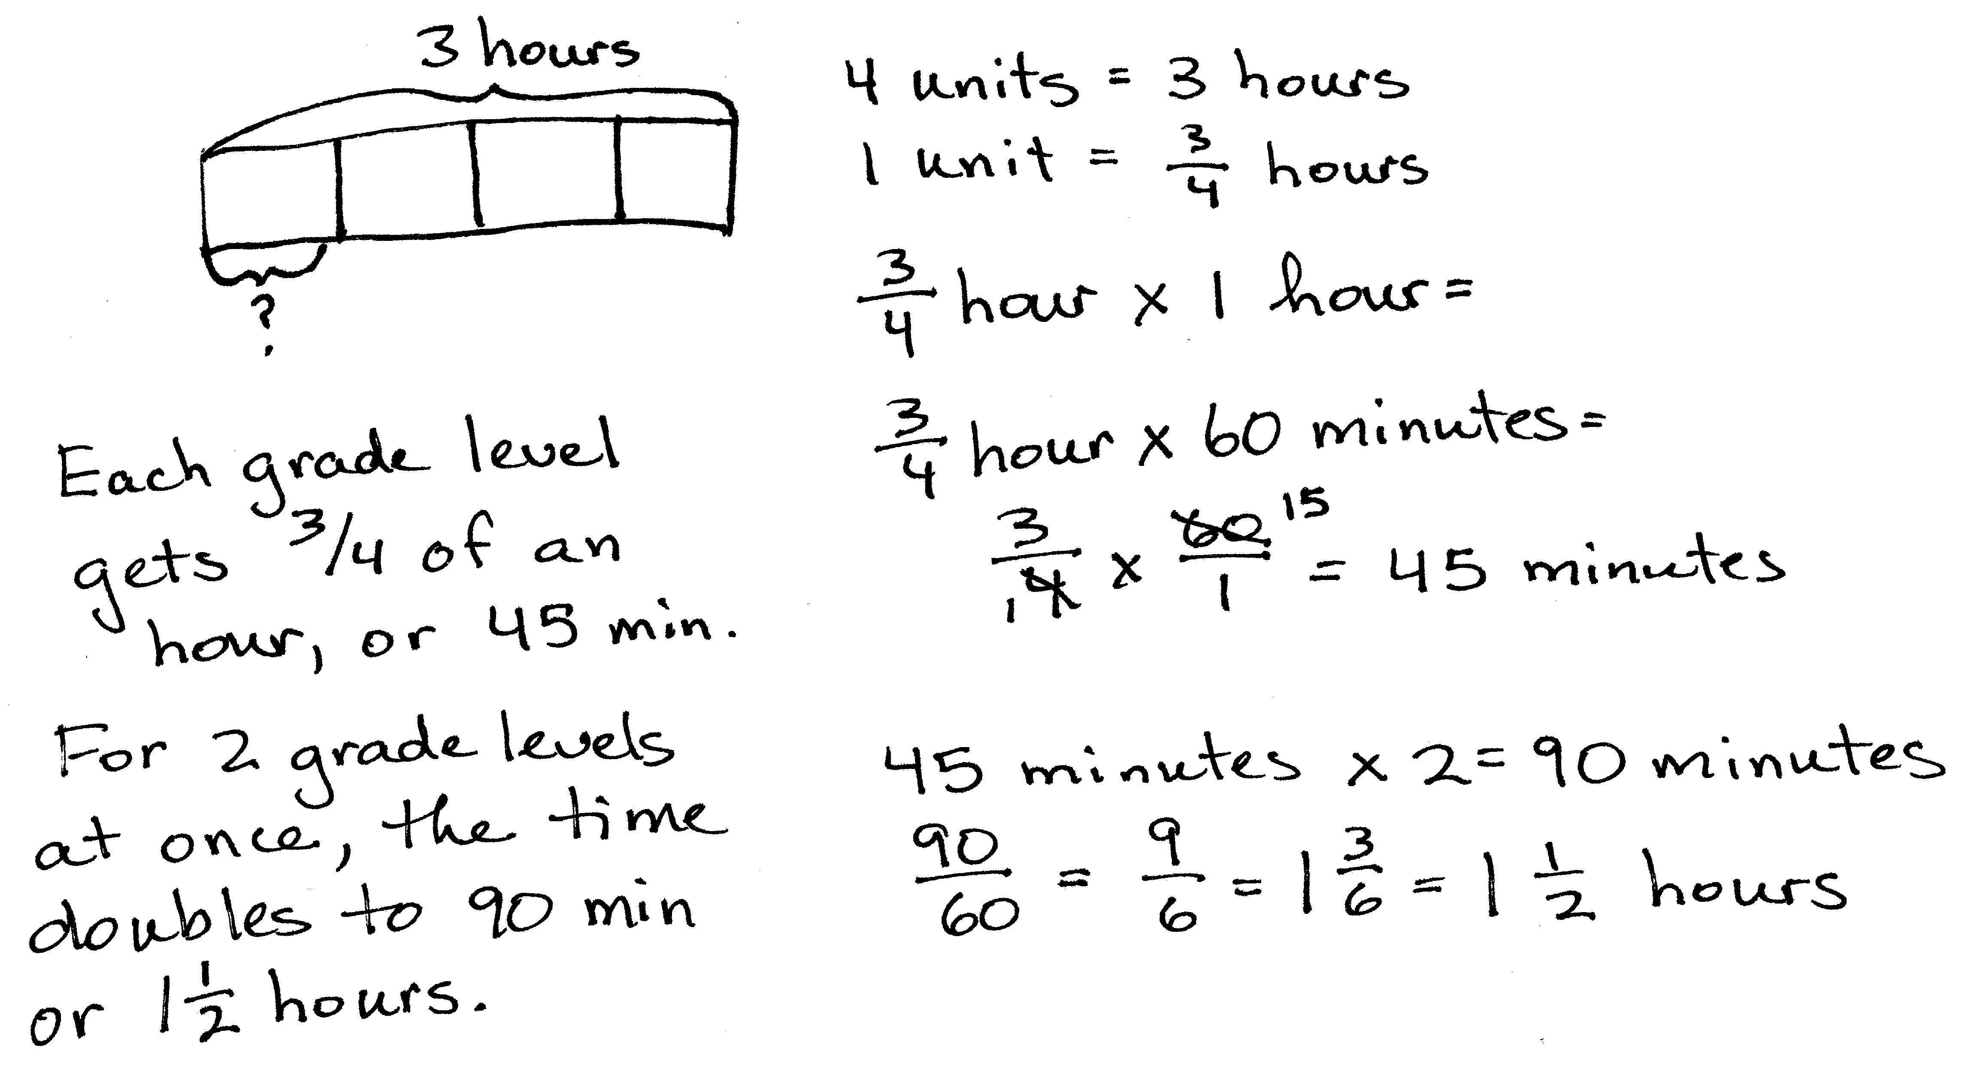
Application Problem (7 minutes)
Four grade levels need equal time for indoor recess, and the gym is available for three hours.
- How many hours of recess will each grade level receive? Draw a picture to support your answer.
- How many minutes?
- If the gym can accommodate two grade levels at once, how many hours of recess will each grade level receive?
Note: Students practice division with fractional quotients, which leads into today’s lesson. Note that the whole remains constant in (c), while the divisor is cut in half. Guide students to analyze the effect of this halving on the quotient as related to the doubling of the whole from previous problems.
Concept Development (31 minutes)
Materials: (S) Personal white board
Problem 1
Eight tons of gravel is equally divided between 4 dump trucks. How much gravel is in one dump truck?
T: Say a division sentence to solve the problem.
S: 8 ÷ 4 = 2.
T: Model this problem with a tape diagram. (Pause as students work.)
T: We know that 4 units are equal to 8 tons. (Write 4 units = 8.) We want to find what 1 unit is equal to.
T: (Write 1 unit = 8 ÷ 4.)
T: How many tons of gravel are in one dump truck?
S: 2.
T: Use your quotient to answer the question.
S: Each dump truck held 2 tons of gravel.

Problem 2
Five tons of gravel is equally divided between 4 dump trucks. How much gravel is in one dump truck?
T: (Change value from previous problem to 5 tons on the board.) How would our drawing be different if we had 5 tons of gravel?
S: Our whole would be different—5, and not 8. The tape diagram is the same, except for the value of the whole. We’ll still partition it into fourths because there are still 4 trucks.
T: (Partition a new bar into 4 equal parts labeled with 5 as the whole.)
T: We know that these 4 units are equal to 5 tons. (Write 4 units = 5.) We want to find what 1 unit is equal to. (Write a question mark beneath 1 fourth of the bar.) What is the division expression you’ll use to find what 1 unit is?
S: 5 ÷ 4.
T: (Write 1 unit = 5 ÷ 4.) 5 ÷ 4 is…?
S: 5 fourths.
T: So, each unit is equal to 5 fourths tons of gravel. Can we prove this using the standard algorithm?
T: What is 5 ÷ 4?
S: One and one-fourth.

NOTES ON
MULTIPLE MEANS
OF ACTION AND EXPRESSION:
Provide number lines with fractional markings for the students who still need support to visualize the placement of the fractions.
T: (Write 5 ÷ 4 = $1\frac{1}{4}$.) Use your quotient to answer the question.
S: Each dump truck held one and one-fourth tons of gravel.
T: Visualize a number line. Between which two adjacent whole numbers is 1 and one-fourth?
S: 1 and 2.
T: Check your work using repeated addition.
Problem 3
A 3-meter ribbon is cut into 4 equal pieces to make flowers. What is the length of each piece?
T: (Write the word problem on the board.) Work with a partner and draw a tape diagram to solve.
T: Say the division expression you solved.
S: 3 divided by 4.
T: Say the answer as a fraction.
S: Three-fourths.
T: (Write $\frac{3}{4}$ on the board.) In this case, does it make sense to use the standard algorithm to solve? Turn and talk.
S: No, it’s just 3 divided by 4, which is $\frac{3}{4}$. I don’t think so. It’s really easy. We could, but the quotient of zero looks strange. It’s just easier to say 3 divided by 4 equals 3 fourths.
T: Use your quotient to answer the question.
S: Each piece of ribbon is $\frac{3}{4}$ m long.
T: Let’s check the answer. Say the multiplication sentence, starting with 4.
S: 4 × $\frac{3}{4}$ $=$ $\frac{12}{4}$. 4 × $\frac{3}{4} =$3.
T: Our answer is correct. If we wanted to place our quotient of $\frac{3}{4}$ on a number line, between which two adjacent whole numbers would we place it?
S: 0 and 1.
Problem 4
14 gallons of water is used to completely fill 3 fish tanks. If each tank holds the same amount of water, how many gallons will each tank hold?
T: Let’s read this problem together. (All read.) Work with a partner to solve this problem. Draw a tape diagram and solve using the standard algorithm.
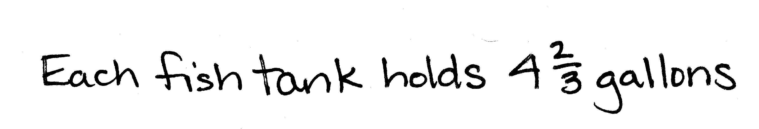
T: Say the division equation you solved.
S: 14 ÷ 3 = $\frac{14}{3}$.
T: Say the quotient as a mixed number.
S: $\text{4}\frac{2}{3}$.
T: Use your quotient to answer the question.
S: The volume of each fish tank is $\text{4}\frac{2}{3}$ gallons.
T: Between which two adjacent whole numbers does our answer lie?
S: Between 4 and 5.
T: Check your answers using multiplication.
S: (Check their answers.)

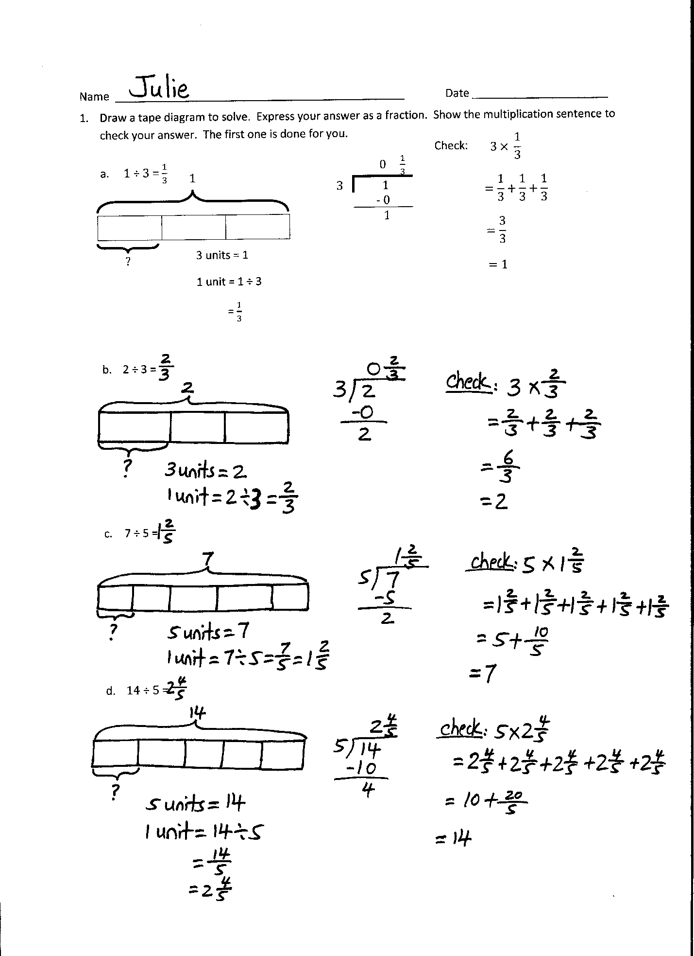
Problem Set (10 minutes)
Students should do their personal best to complete the Problem Set within the allotted 10 minutes. For some classes, it may be appropriate to modify the assignment by specifying which problems they work on first. Some problems do not specify a method for solving. Students should solve these problems using the RDW approach used for Application Problems.
Student Debrief (10 minutes)
Lesson Objective: Use tape diagrams to model fractions as division.
The Student Debrief is intended to invite reflection and active processing of the total lesson experience.
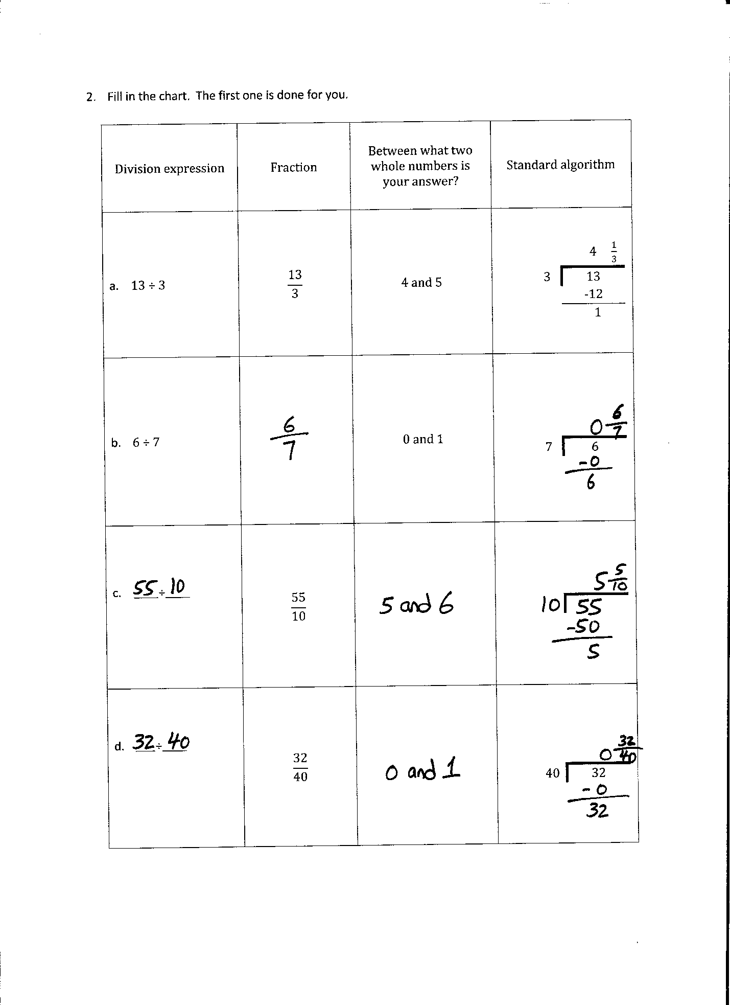
Invite students to review their solutions for the Problem Set. They should check work by comparing answers with a partner before going over answers as a class. Look for misconceptions or misunderstandings that can be addressed in the Debrief. Guide students in a conversation to debrief the Problem Set and process the lesson.
You may choose to use any combination of the questions below to lead the discussion.
- What pattern did you notice between Problem 1(a) and Problems 1(b), 1(c), and 1(d)? What did you notice about the wholes or dividends and the divisors?
- In Problem 2(c), can you name the fraction of $\frac{55}{10}$ using a larger fractional unit? In other words, can you simplify it? Are both fractions located at same point on the number line?
- Compare Problems 3 and 4. What’s the division sentence for each problem? What’s the whole and divisor for each problem? (Problem 3’s division expression is 4 ÷ 5, and Problem 4’s division expression is 5 ÷ 4.)

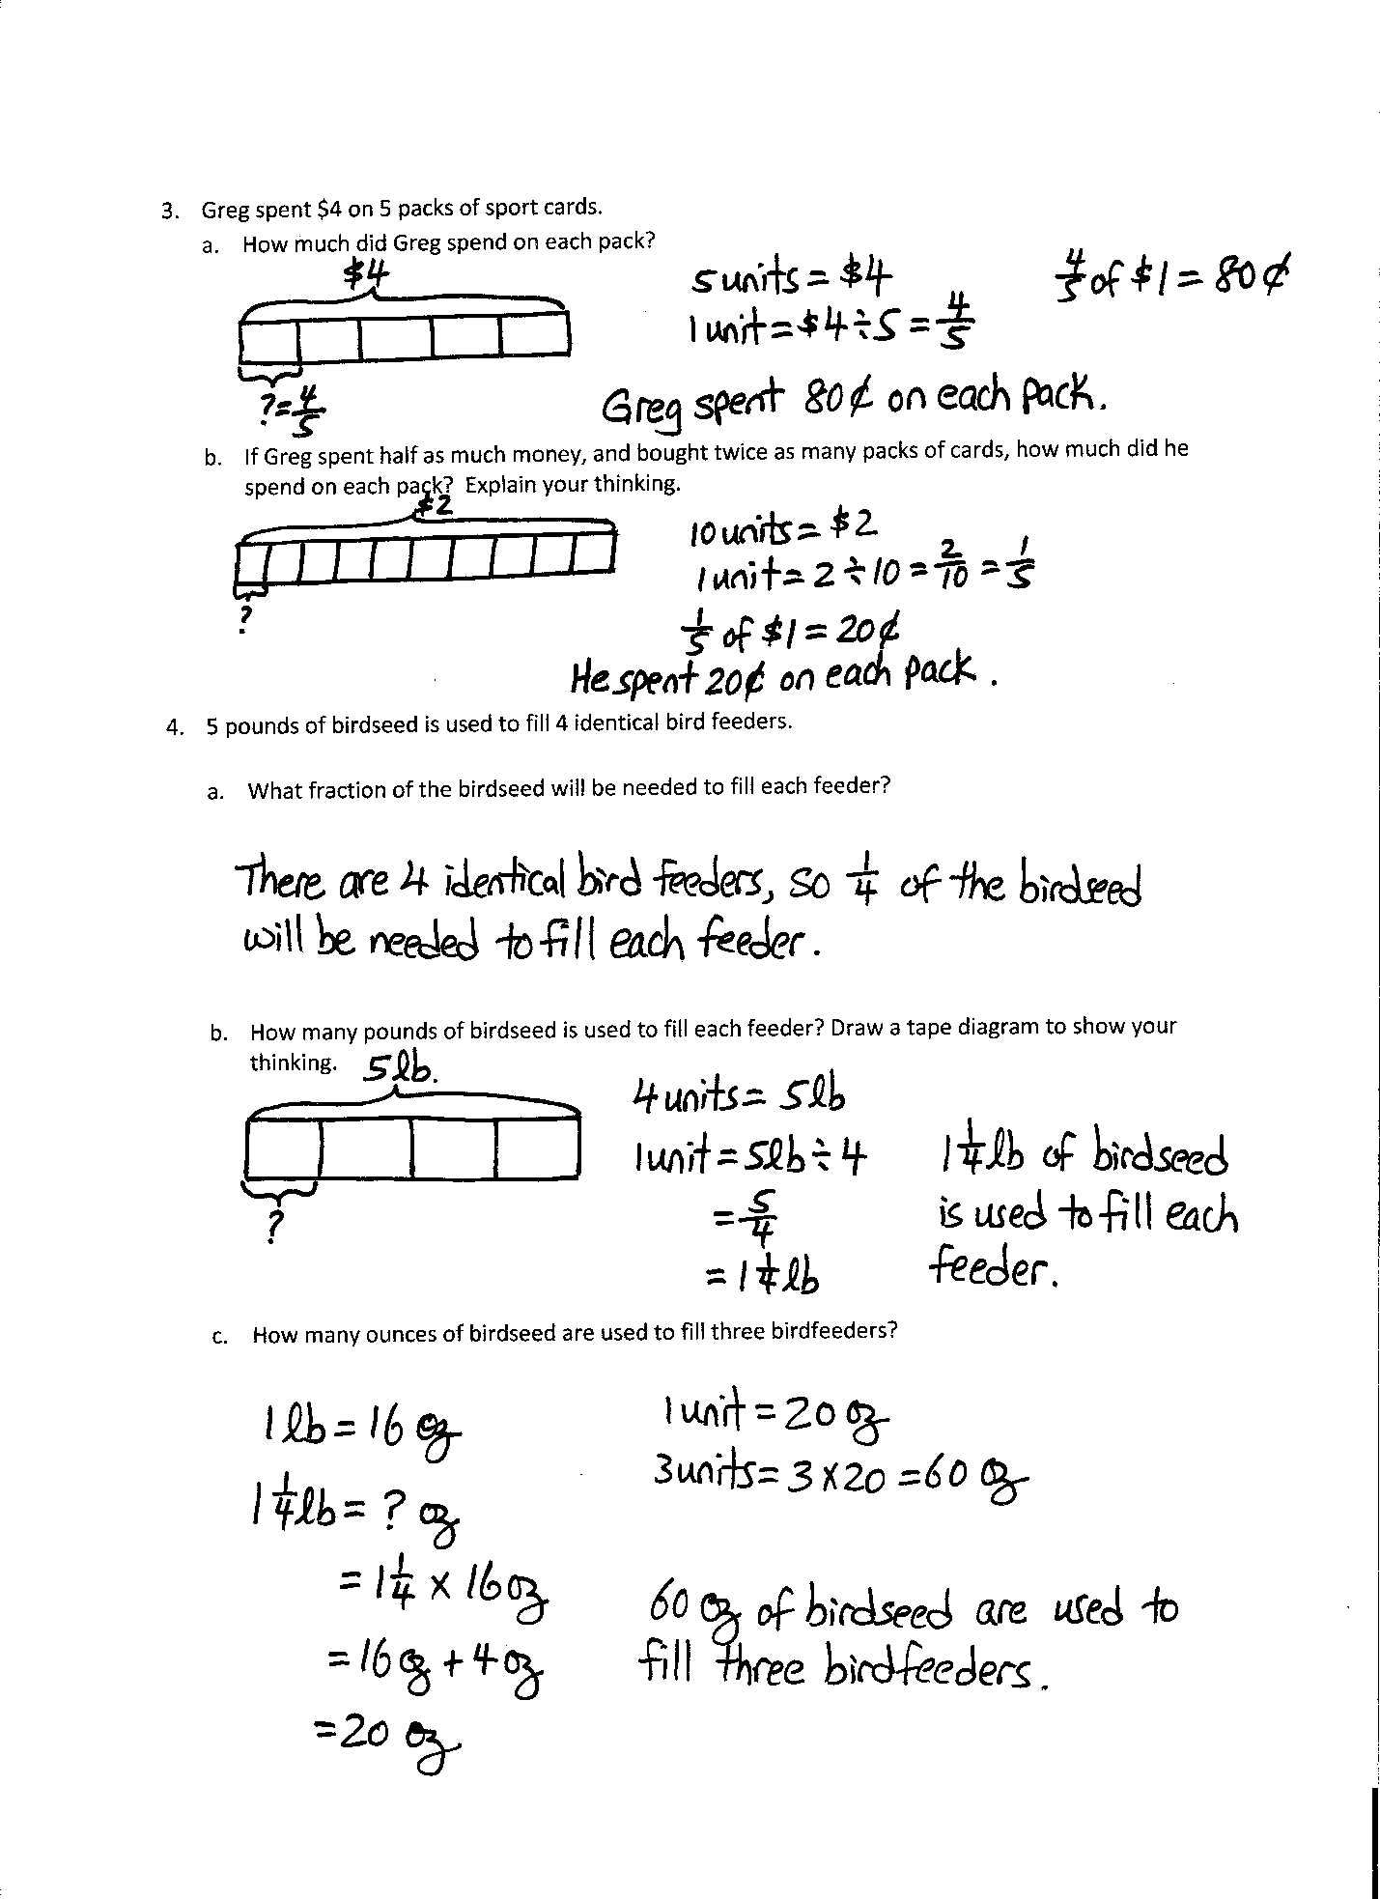
- Explain to your partner the difference between the questions asked in Problems 4(a) and 4(b). (Problem 4(a) is asking what fraction of the seed is in each feeder, while 4(b) is asking the number of pounds of seed in each feeder.)
- How was our learning today built on what we learned yesterday? (Students may point out that the models used today were more abstract than the concrete materials used previously. Students may also point out that it was easier to see the fractions as division when presented as equations than before.)
Exit Ticket (3 minutes)
After the Student Debrief, instruct students to complete the Exit Ticket. A review of their work will help you assess the students’ understanding of the concepts that were presented in the lesson today and plan more effectively for future lesson. You may read the questions aloud to the students.
Name Date
- Draw a tape diagram to solve. Express your answer as a fraction. Show the multiplication sentence to check your answer. The first one is done for you.
1

$$3 × \frac{1}{3}$$
$$=\frac{1}{3}+\frac{1}{3}+\frac{1}{3}$$
$$=\frac{3}{3}$$
$=1$

Check:

 | 0 $\frac{1}{3}$
3 | 1
 | - 0
 | 1

?

3 units = 1
1 unit = 1 ÷ 3
= $\frac{1}{3}$
- 1 ÷ 3 = $\frac{1}{3}$

- 2 ÷ 3 =

- 7 ÷ 5 =

- 14 ÷ 5 =

- Fill in the chart. The first one is done for you.
Division Expression | Fraction | Between which two whole numbers is your answer? | Standard Algorithm
- 13 ÷ 3 | $$\frac{13}{3}$$ | 4 and 5 | 4 $\frac{1}{3}$  3 13  -12  1
- 6 ÷ 7 |  | 0 and 1 | 7 6
- _____÷_____ | $$\frac{55}{10}$$
- ____÷_____ | $$\frac{32}{40}$$ |  | 40 32

- Greg spent $4 on 5 packs of sport cards.
- How much did Greg spend on each pack?

- If Greg spent half as much money and bought twice as many packs of cards, how much did he spend on each pack? Explain your thinking.

- Five pounds of birdseed is used to fill 4 identical bird feeders.
- What fraction of the birdseed will be needed to fill each feeder?

- How many pounds of birdseed are used to fill each feeder? Draw a tape diagram to show your thinking.

- How many ounces of birdseed are used to fill three birdfeeders?

Name Date
Matthew and his 3 siblings are weeding a flower bed with an area of 9 square yards. If they share the job equally, how many square yards of the flower bed will each child need to weed? Use a tape diagram to show your thinking.

Name Date
- Draw a tape diagram to solve. Express your answer as a fraction. Show the addition sentence to support your answer. The first one is done for you.

- 1 ÷ 4 = $\frac{1}{4}$
$$4 × \frac{1}{4}$$
$$=\frac{1}{4}+\frac{1}{4}+\frac{1}{4}+\frac{1}{4}$$
$$=\frac{4}{4}$$
$=1$

Check:

 | 0 $\frac{1}{4}$
4 | 1
 | - 0
 | 1

1

?

4 units = 1
1 unit = 1 ÷ 4
= $\frac{1}{4}$

- 4 ÷ 5 =

- 8 ÷ 5 =

- 14 ÷ 3 =

- Fill in the chart. The first one is done for you.
Division Expression | Fraction | Between which two whole numbers is your answer? | Standard Algorithm
- 16 ÷ 5 | $$\frac{16}{5}$$ | 3 and 4 | 3 $\frac{1}{5}$  5 16  -15  1
- _____÷_____ | $$\frac{3}{4}$$ | 0 and 1
- _____÷_____ | $$\frac{7}{2}$$ |  | 2 7
- _____÷_____ | $$\frac{81}{90}$$

- Jackie cut a 2-yard spool into 5 equal lengths of ribbon.
  - What is the length of each ribbon in yards? Draw a tape diagram to show your thinking.

  - What is the length of each ribbon in feet? Draw a tape diagram to show your thinking.

- Baa Baa, the black sheep, had 7 pounds of wool. If he separated the wool equally into 3 bags, how much wool would be in 2 bags?

- An adult sweater is made from 2 pounds of wool. This is 3 times as much wool as it takes to make a baby sweater. How much wool does it take to make a baby sweater? Use a tape diagram to solve.

