|  |
| --- |
|  |

Lesson 21: Solution Sets to Inequalities with Two Variables

**Student Outcomes**

* Students recognize and identify solutions to two-variable inequalities. They represent the solution set graphically. They create two-variable inequalities to represent a situation.
* Students understand that a half-plane bounded by the line is a visual representation of the solution set to a linear inequality, such as . They interpret the inequality symbol correctly to determine which portion of the coordinate plane is shaded to represent the solution.

Lesson Notes

Students explore an inequality related to the equation from the previous lesson’s Exercises 1–2. Using the same equation will help students to distinguish the differences between solution sets and graphs of two-variable equations versus two-variable inequalities.

Materials

* Graph paper

Classwork

Consider opening the lesson with the following:

* When working with inequalities in one variable, you learned to graph the solution set on a number line. When working with inequalities with two variables, the solutions are also represented visually but in two-dimensions in the coordinate plane.

Exercise 1 (5 minutes)

Discuss the two-variable equation in Exercise 1 and the possible solutions represented as ordered pairs.

Have students work independently, using their prior knowledge to verify which ordered pairs are solutions to an equation (make a true number sentence).

Exercise 1

* 1. Circle each ordered pair that is a solution to the equation .
  2. Plot each solution as a point in the coordinate plane.

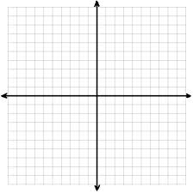

* 1. How would you describe the location of the solutions in the coordinate plane?

***(Students may struggle to describe the points. Here is one possible description.) The points do not all fall on any one line, but if you drew a line through any two of the points, the others are not too far away from that line.***

Ask students to compare their solutions with a partner. Briefly share answers and give students a chance to revise their work or add to their written response to part (a). Do not linger on part (c); the activity that follows will help to clarify their thinking.

*Scaffolding*

Pay attention to students who are still struggling to interpret the inequality symbols correctly. Perhaps creating a chart or adding terms to a word wall could serve as a reminder to the students.

Exercise 2 (10 minutes)

Students should work in groups on part (a) only. After about 4 minutes, have each group share their solutions and their solution strategies with the entire class. Highlight the different approaches to finding solutions. Most groups will likely start by picking a value for either or and then deciding what the other variable should equal to make the number sentence true.

**MP.1**

Exercise 2



* 1. Discover as many additional solutions to the inequality as possible. Organize your solutions by plotting each solution as a point in the coordinate plane. Be prepared to share the strategies used to find your solutions.

(There are an infinite number of correct answers, as well as an infinite number of incorrect answers. Some sample correct answers are shown.)

, , ,

* 1. Graph the line . What do you notice about the solutions  
     to the inequality and the graph of the line ?

All of the points are either on the line or to the left of (or above) the line.

* 1. Solve the inequality for .
  2. Complete the following sentence.

If an ordered pair is a solution to , then it will be located **on the line or above (or on the left side of)**  the line .

Explain how you arrived at your conclusion.

I observed that all the points were on one side of the line, and then I tested some points on the other side of the line and found that all the points I tested from that side of the line were not solutions to the inequality.

Next have the groups complete parts (b)–(d). As they work, circulate around the room answering questions and providing support. Make sure that students reversed the inequality symbol when solving for in part (c). Discuss the following:

* I noticed some of you wrote that all the points are on the left side of the line and others wrote that all the points are above the line. Are both of those descriptions correct?
* Now, look at your answer to part (c). When you solved the inequality for , what does that statement seem to tell you?
  + *It tells you all the -values have to be greater than or equal to something related to .*
* Then which description would you say best correlates to the inequality we wrote in part (c)? Points to the left of the line or points above the line? Why?
  + *Points above the line because when we solved for, we are describing where the -values are in relation to the line, and -values are plotted on the vertical axis; therefore, the words above and below are the accurate descriptors.*
* How can we depict the entire solution set of ALL the points above the line? When we worked with equations in one variable and graphed our solution set on the number line, how did we show what the solution set was?
  + *We colored it darker or shaded it. So we can just shade in the entire area above the line.*
* What about the line itself, is it part of the solution set?
  + *Yes.*
* What if it wasn’t? What if the inequality was ? How could we show that it is all the points except that line?
  + *We traditionally make the line a dashed line instead of a solid line to indicate that the points on the line are not part of the solution set.*

Before moving on, make sure students understand that any ordered pair in the solution set will be a point that is located on (or above) the line because that is the portion of the coordinate plane where is greater than or equal to the difference of and

**Example 1 (10 minutes)**

Example 1

The solution to is shown on the graph below.

|  |  |
| --- | --- |
| * 1. Graph the solution to .     All points below the line should be shaded.   * 1. Graph the solution to .     All points above the line should be shaded. | * 1. Graph the solution to .     The line should be dashed, and all points below the line should be shaded.   * 1. Graph the solution to .     The line should be dashed, and all points above the line should be shaded. |

Exercises 3–5 (15 minutes)

Students will need graph paper for this portion of the lesson. Have students work individually to complete as much of Exercise 3 as they can in 8 minutes, reserving the final 7 minutes for comparing with a neighbor and debating any conflicting answers. Alternatively, differentiate by assigning only a subset of the problems most appropriate for each student or group of students. In any case, make the assignments in pairs so that students have someone with whom to compare answers. Students may struggle as they work on parts (f)–(j), graphing solutions to equations like ; allow the students to struggle and discuss with each other. (Exercise 4 will revisit this idea with the entire class.) Students will rely on their experiences in Grade 8 as well as their explorations in Lessons 1–5 of this module to distinguish between the linear and non-linear inequalities and answer the question that concludes Exercise 3.

Allow students to debate and discuss. Guide them to the correct conclusion, and then review the definition of a half-plane that follows Exercise 3, clarifying for students that a **strict inequality** does not include the *or equal to* option. It must be either strictly *less than* or *greater than*.

Exercises 3–5

1. Using a separate sheet of graph paper, plot the solution sets to the following equations and inequalities:

|  |  |  |
| --- | --- | --- |
|  |  |  |

Which of the inequalities in this exercise are *linear* inequalities?

Parts (a)–(l) are linear. Parts (m)–(o) are not.

a–c: Parts (b) and (c) are identical. In part (a), the solution is the graph of the line.

d–e: Both solution sets include the line . Part (d) is the half-plane above the line, and part (e) is the half-plane below the line. When debriefing, ask students to share how they approached part (e).

f–i: These exercises focus on vertical and horizontal boundary lines. Emphasis should be placed on the fact that inequalities like part (h) are shaded to the left or to the right of the vertical line.

j–l: These exercises will help students to understand that is the -axis and is the -axis.

m–o: These exercises can serve as extension questions. For part (m), a curve separates the plane into two regions. In part (n), the solution is the entire coordinate plane except . In part (o), the solution is all points in quadrants 2 and 4, including both axes and the origin.

A half-planeis the graph of a solution set in the Cartesian coordinate plane of an inequality in two real number variables that is linear and strict.

1. Describe in words the half-plane that is the solution to each inequality.

The half-plane lying above the -axis and including the -axis.

The half plane to the left of the vertical line , not including the line .

The line and the half-plane lying above it.

The half-plane lying below the line .

1. [](http://www.google.com/imgres?imgurl&imgrefurl=http://www.crestviewlocal.k12.oh.us/chs/staff/mcc/cp10.html&h=0&w=0&sz=1&tbnid=r8ugDHFRf1kAzM&tbnh=225&tbnw=224&prev=/search?q=coordinate+plane&tbm=isch&tbo=u&zoom=1&q=coordinate%20plane&docid=bc5yn1XHt6D8NM&hl=en&ei=hny_Ua2aKumSiALt9YHoCw&ved=0CAEQsCU)Graph the solution set to , reading it as an inequality in *one* variable, and describe the solution set in words. Then graph the solution set to again, this time reading it as an inequality in *two* variables, and describe the solution set in words.

Read in one variable: All real numbers less than . The graph will have an open circle at the endpoint and extend as a ray to the left of on the number line.

Read in two variables: All ordered pairs such that is less than . The graph will be a dashed vertical line through , and all points to the left of the line will be shaded.

Closing (2 minutes)

* Why is it useful to represent the solution to an inequality with two variables graphically?
* How does graphing the solution set of a one-variable inequality compare to graphing the solution set to a two-variable inequality?

Lesson Summary

An ordered pair is a solution to a two-variable inequality if, when each number is substituted into its corresponding variable, it makes the inequality a true number sentence.

Each ordered pair of numbers in the solution set of the inequality corresponds to a point on the coordinate plane. The set of all such points in the coordinate plane is called the graph of the inequality*.*

The graph of a linear inequality in the coordinate plane is called a half-plane*.*

Exit Ticket (3 minutes)

Name ___________________________________________________ Date____________________

Lesson 21: Solution Sets to Inequalities with Two Variables

Exit Ticket

What pairs of numbers satisfy the statement: The sum of two numbers is less than ?

Create an inequality with two variables to represent this situation and graph the solution set.

[](http://www.google.com/imgres?imgurl&imgrefurl=http://www.crestviewlocal.k12.oh.us/chs/staff/mcc/cp10.html&h=0&w=0&sz=1&tbnid=r8ugDHFRf1kAzM&tbnh=225&tbnw=224&prev=/search?q=coordinate+plane&tbm=isch&tbo=u&zoom=1&q=coordinate%20plane&docid=bc5yn1XHt6D8NM&hl=en&ei=hny_Ua2aKumSiALt9YHoCw&ved=0CAEQsCU)Exit Ticket Sample Solution

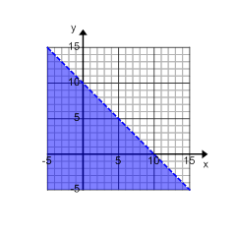What pairs of numbers satisfy the statement: The sum of two numbers is less than ?

Create an inequality with two variables to represent this situation and graph the solution set.

Let one number, and let a second number.

Inequality:

Graph the line using a dashed line and shade below the line.

Problem Set Sample Solutions

1. Match each inequality with its graph. Explain your reasoning.

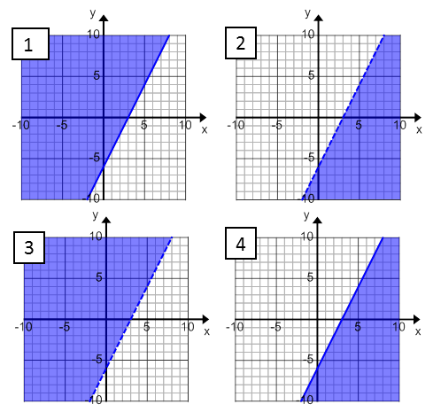

Graph 2

Graph 4

Graph 3

Graph 1

Student explanations will vary. Sample response:

I re-arranged each equation and found that they were all the same except for the inequality symbol. The strict inequalities are the dashed lines, and the others are solid lines. When solved for , you can decide the shading. Greater than is shaded above the line, and less than is shaded below the line.

1. Graph the solution set in the coordinate plane. Support your answer by selecting two ordered pairs in the solution set and verifying that they make the inequality true.

|  |  |  |
| --- | --- | --- |
|  |  |  |
|  |  |  |

Solutions are graphed below for parts (a), (c), and (e).

*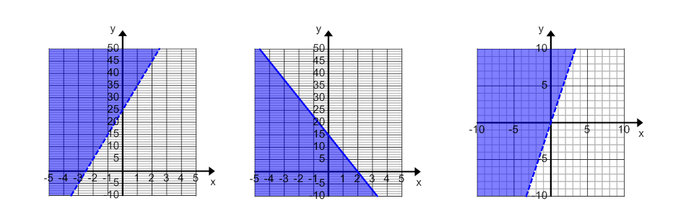a. c. e.*

1. Marti sells tacos and burritos from a food truck at the farmers market. She sells burritos for each and tacos for each. She hopes to earn at least at the farmers market this Saturday.
   1. Identify three combinations of tacos and burritos that will earn Marti more than .

Answers will vary. Answers to part (a) should be solutions to the inequality .

* 1. Identify three combinations of tacos and burritos that will earn Marti exactly .

Answers will vary. Answers to part (b) should be solutions to the equation .

* 1. Identify three combinations of tacos and burritos that will *not* earn Marti at least .

Answers will vary. Answers to part (c) should not be solutions to the inequality or equation.

* 1. Graph your answers to parts (a)–(c) in the coordinate plane and then shade a half-plane that contains all possible solutions to this problem.

The graph shown for part (d) is shown to the right. Answers to part (a) should lie in the shaded half-plane. Answers to part (b) should lie on the line, and answers to part (c) should lie in the un-shaded half-plane.

* 1. Create a linear inequality that represents the solution to this problem. Let equal the number of burritos that Marti sells, and let equal the number of tacos that Marti sells.
  2. Are the points a solution to inequality you created in part (e)? Explain your reasoning.

The point would not be valid because it would not make sense in this situation to sell a fractional amount of tacos or burritos.