Lesson 3
Objective: Interpret a fraction as division.

Suggested Lesson Structure
 Fluency Practice (12 minutes)
 Application Problem (5 minutes)
 Concept Development (33 minutes)
 Student Debrief (10 minutes)
Total Time (60 minutes)
Fluency Practice (12 minutes)
- Convert to Hundredths 4.NF.5 (3 minutes)
- Compare Fractions 4.NF.2 (4 minutes)
- Fractions as Division 5.NF.3 (3 minutes)
- Write Fractions as Decimals 4.NF.5 (2 minutes)
Convert to Hundredths (3 minutes)
Materials: (S) Personal white board
Note: This fluency activity prepares students for decimal fractions later in the module.
T: I’ll say a factor, and then you’ll say the factor you need to multiply it by to get 100. 50.
S: 2.
Continue with the following possible sequence: 25, 20, and 4.
T: (Write $\frac{1}{4}$ = $\frac{}{100}$.) How many fours are in 100?
S: 25.
T: Write the equivalent fraction.
S: (Write $\frac{1}{4}$ = $\frac{25}{100}$.)
Continue with the following possible sequence: $\frac{3}{4}$ = $\frac{}{100}$, $\frac{1}{50}$ = $\frac{}{100}$, $\frac{3}{50}$ = $\frac{}{100}$, $\frac{1}{20}$ = $\frac{}{100}$, $\frac{3}{20}$ = $\frac{}{100}$, $\frac{1}{25}$ = $\frac{}{100}$, and
$\frac{2}{25}$ = $\frac{}{100}$.

Compare Fractions (4 minutes)
Materials: (S) Personal white board
Note: This fluency activity reviews concepts from Grade 4 and G5─M3.
T: (Write $\frac{1}{2}$ __$\frac{1}{6}$.) Compare these fractions, and write a greater than or less than symbol.
S: (Write $\frac{1}{2}$ > $\frac{1}{6}$.)
T: Why is this true?
S: Both have 1 unit, but halves are larger than sixths.
Continue with the following possible sequence: $\frac{2}{3} \text{and} \frac{1}{8}, \frac{3}{4}\text{and}\frac{3}{8}, \frac{2}{5}\text{and}\frac{9}{10}, \text{and} \frac{5}{8}\text{and}\frac{5}{7}.$
Students should be able to reason about these comparisons without the need for common units. Reasoning, such as greater or less than half or the same number of different sized units, should be the focus.
Fractions as Division (3 minutes)
Materials: (S) Personal white board
Note: This fluency activity reviews Lesson 2 content.
T: (Write 1 ÷ 3.) Write a complete number sentence using the expression.
S: (Write 1 ÷ 3 = $\frac{1}{3}$.)
Continue with the following possible sequence: 1 ÷ 4 and 2 ÷ 3.
T: (Write 5 ÷ 2.) Write a complete number sentence using the expression.
S: (Write 5 ÷ 2 = $\frac{5}{2}$ or 5 ÷ 2 = $\text{2}\frac{1}{2}$.)
Continue with the following possible sequence: 13 ÷ 5, 7 ÷ 6, and 17 ÷ 4.
T: (Write $\frac{4}{3}$.) Say the fraction.
S: 4 thirds.
T: Write a complete number sentence using the fraction.
S: (Write 4 ÷ 3 = $\frac{4}{3}$ or 4 ÷ 3 = 1$\frac{1}{3}$.)
Continue with the following possible sequence: $\frac{13}{2}, \frac{23}{4}, \text{and} \frac{32}{5}$.
Write Fractions as Decimals (2 minutes)
Note: This fluency activity prepares students for fractions with denominators of 4, 20, 25, and 50 in Topic G.
T: (Write $\frac{1}{10}$.) Say the fraction.
S: 1 tenth.
T: Say it as a decimal.
S: Zero point one.
Continue with the following possible sequence: $\frac{2}{10},\frac{3}{10},\frac{7}{10},\frac{5}{10}, \text{and}\frac{9}{10}.$
T: (Write 0.1 = ____.) Write the decimal as a fraction.
S: (Write 0.1 = $\frac{1}{10}$.)
Continue with the following possible sequence: 0.2, 0.4, 0.8, and 0.6.
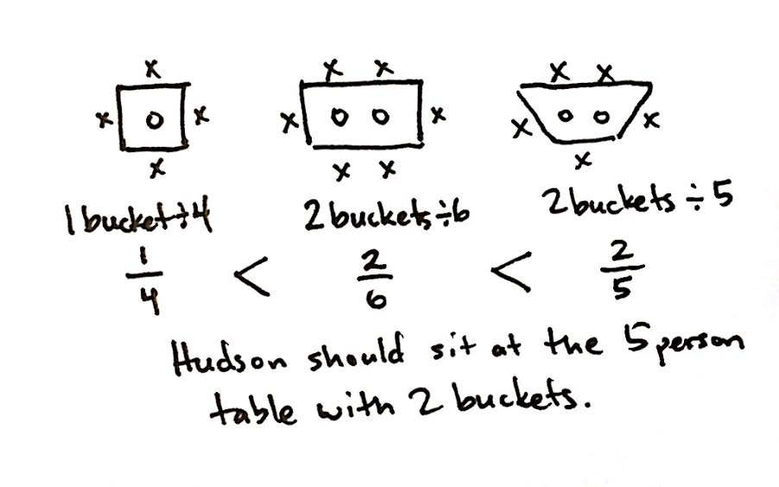
Application Problem (5 minutes)
Hudson is choosing a seat in art class. He scans the room and sees a 4-person table with 1 bucket of art supplies, a 6‐person table with 2 buckets of supplies, and a 5‐person table with 2 buckets of supplies. Which table should Hudson choose if he wants the largest share of art supplies? Support your answer with pictures.
Note: Students must first use division to see which fractional portion of art supplies is available at each table. Then, students compare the fractions and determine which one represents the largest value.
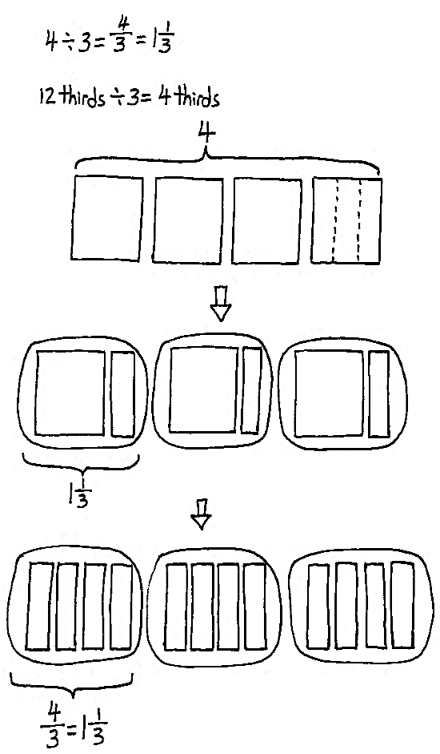
Concept Development (33 minutes)
Materials: (S) Personal white board
Problem 1
A baker poured 4 kilograms of oats equally into 3 bags. What is the weight of each bag of oats?
T: In our story, which operation is needed to find the weight of each bag of oats?
S: Division.
T: Turn and discuss with your partner how you know, as well as what the division sentence would be.
S: When you share equally, it means taking what you have and dividing it into equal groups. The total is
4 kg of oats being divided into 3 bags, so the division sentence is 4 divided by 3. The whole is 4, and the divisor is 3.
T: Say the division expression.
S: 4 ÷ 3.
T: (Write 4 ÷ 3 and draw 4 squares on the board.) Let’s represent the kilograms with squares like we did yesterday. Squares are easier to cut into equal shares than circles.
T: Turn and talk about how you’ll share the 4 kg of oats equally in 3 bags. Draw a picture to show your thinking.
S: Every bag will get a whole kilogram of oats, and then we will split the last kilogram equally into 3 thirds to share. So, each bag gets a whole kilogram and one-third of another one. I can cut all 4 kg into thirds, and then split them into the 3 bags. Each bag will get 4 thirds of a kg. I know the answer is 4 over 3, or 4 thirds, because that is just another way to write 4 divided by 3.
T: As we saw yesterday, there are two ways of dividing the oats. Let me record your approaches. (Draw the approaches on the board and restate.) Let’s say the division sentence with the quotient.
S: 4 ÷ 3 = 4 thirds. 4 ÷ 3 = 1 and 1 third.
T: (Point to the diagram on the board.) When we cut them all into thirds, how many thirds were there to share?
S: 12 thirds.
T: Say the division sentence in unit form, starting with 12 thirds.
S: 12 thirds ÷ 3 = 4 thirds.
T: (Write 12 thirds ÷ 3 = 4 thirds on the board.) What is 4 thirds as a mixed number?
S: 1 and 1 third.
T: (Write the algorithm on the board.) Let’s show how we divided the oats using the division algorithm.
T: How many groups of 3 can I make with 4 kilograms?
S: 1 group of three.
T: (Record 1 in the quotient.) What’s 1 group of three?
S: 3.
T: (Record 3 under 4.) How many whole kilograms are left to share?
S: 1.
T: What did we do with this last kilogram? Turn and discuss with your partner.
S: This one remaining kilogram was split into 3 equal parts to continue sharing it. I had to split the last kilogram into thirds to share it equally. The quotient is 1 whole kilogram, and the remainder is 1. The quotient is 1 whole kilogram and 1 third kilogram. Each of the 3 bags gets 1 and 1 third kilogram of oats.
T: Let’s record what you said. (Point to the remainder of 1.) This remainder is 1 kilogram. To keep sharing it, we split it into 3 parts (point to the divisor), so each bag gets 1 third. I’ll write 1 third next to the 1 in the quotient. (Write $\frac{1}{3}$ next to the quotient of 1.)
T: Use the quotient to answer the question.
S: Each bag of oats weighs $\text{1}\frac{1}{3}$ kilograms.
T: Let’s check our answer. How can we know if we put the right amount of oats in each bag?
S: We can total up the 3 parts that we put into each bag when we divided the kilograms. The total should be the same as our original whole. The sum of the equal parts should be the same as our dividend.
T: We have 3 groups of $\text{1}\frac{1}{3}$. Say the multiplication sentence.
S: 3 × $\text{1}\frac{1}{3}$.
T: Express 3 copies of $1\frac{1}{3}$ using repeated addition.
S: $1\frac{1}{3} \text{+} 1\frac{1}{3} \text{+} 1\frac{1}{3}$.
T: Is the total the same number of kilograms we had before we shared?
S: The total is 4 kilograms. It is the same as our whole before we shared. 3 ones plus 3 thirds is 3 plus 1. That’s 4.
T: We’ve seen more than one way to write down how to share 4 kilograms in 3 bags. Why is the quotient the same using the algorithm?
S: The same thing is happening to the oats. It is being divided into 3 parts. We are just using another way to write it.
T: Let’s use different strategies in our next problem as well.
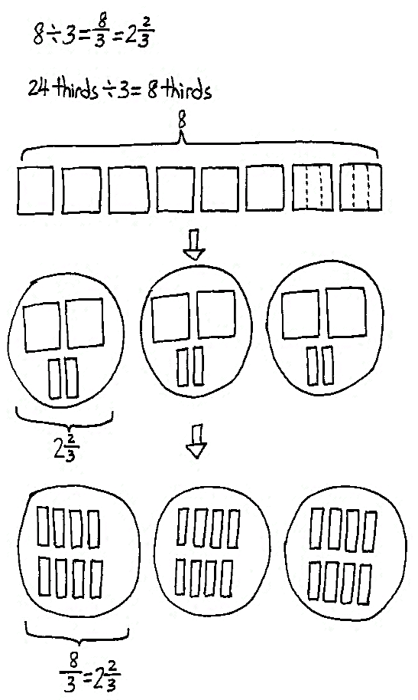
Problem 2
If the baker doubles the number of kilograms of oats to be poured equally into 3 bags, what is the weight of each bag of oats?
T: What’s the whole in this problem? Turn and share with your partner.
S: 4 doubled is 8. 4 times 2 is 8. The baker now has 8 kilograms of oats to pour into 3 bags.
T: Say the whole.
S: 8.
T: Say the divisor.
S: 3.
T: Say the division expression for this problem.
S: 8 ÷ 3.
T: Compare this expression with the one we just completed. What do you notice?
S: The whole is twice as much as the problem before. The number of shares is the same.
T: Using that insight, make a prediction about the quotient of this problem.

S: Since the whole is twice as much shared with the same number of bags, then the answer should be twice as much as the answer to the last problem. Two times 4 thirds is equal to 8 thirds. The answer should be double. So, it should be $\text{1}\frac{1}{3}$ + $\text{1}\frac{1}{3}$, and that is $\text{2}\frac{2}{3}$.
T: Work with your partner to solve, and confirm the predictions you made. Each partner should use a different strategy for sharing the kilograms and draw a picture of his or her thinking. Then, work together to solve using the standard algorithm.
Circulate as students work.
T: How many kilograms are in each bag this time? Whisper and tell your partner.
S: Each bag gets 2 whole kilograms and $\frac{2}{3}$ of another one. Each bag gets a third of each kilogram, which would be 8 thirds. 8 thirds is the same as $\text{2}\frac{2}{3}$ kilograms.
T: If we split all of the kilograms into thirds before we share, how many thirds are in all 8 kilograms?
S: 24 thirds.

NOTES ON
MULTIPLE MEANS
OF REPRESENTATION:
For students who need the support of concrete materials, continue to use square paper and scissors to represent the equal shares, as well as the pictorial and abstract representations.

T: Say the division sentence in unit form.
S: 24 thirds ÷ 3 = 8 thirds.
T: (Set up the standard algorithm on the board and solve it together.) The quotient is 2 wholes and 2 thirds. Use the quotient to answer the question.
S: Each bag of oats weighs $\text{2}\frac{2}{3}$ kilograms.
T: Let’s check it now. Say the addition sentence for 3 groups of $\text{2}\frac{2}{3}$.
S: $\text{2}\frac{2}{3} \text{+} \text{2}\frac{2}{3} \text{+} \text{2}\frac{2}{3}\text{=} \text{8}$.
T: So, 8 ÷ 3 = $\text{2}\frac{2}{3}$. How does this quotient compare to our predictions?
S: This answer is what we thought it would be. It was double the last quotient, which is what we predicted.
T: Great. Now, let’s change our whole one more time and see how it affects the quotient.
Problem 3
If the baker doubles the number of kilograms of oats again, and they are poured equally into 3 bags, what is the weight of each bag of oats?
Repeat the process used in Problem 2. When predicting the quotient for Problem 3, ensure students notice that, this time, the baker has four times the amount of oats as Problem 1, and twice as much as Problem 2. This is important for the scaling interpretation of multiplication.
The closing extension of the dialogue, in which students realize the efficiency of the algorithm, is detailed below.
T: Say the division expression for this problem.
S: 16 ÷ 3.
T: Say the answer as a fraction greater than 1.
S: 16 thirds.
T: Which strategy would be easier to use for solving this problem? Draw out 16 wholes to split into 3 groups, or use the standard algorithm? Turn and discuss with a partner.
S: (Share.)
T: Solve this problem independently using the standard algorithm. If you want, you may also draw.
S: (Work.)
T: Let’s solve using the standard algorithm. (Set up standard algorithm and solve on the board.) What is 16 thirds as a mixed number?

NOTES ON
MULTIPLE MEANS
OF REPRESENTATION:
Fractions are generally represented in student materials by equation editing software using a horizontal line to separate the numerator from denominator (e.g., $\frac{3}{5}$). However, it may be wise to expose students to other formats of notating fractions, such as formats that use a diagonal to separate the numerator from the denominator (e.g., ${\text{3}}/{\text{5}}$).

S: $\text{5}\frac{1}{3}$.
T: Use the quotient to answer the question.
S: Each bag of oats weighs $\text{5}\frac{1}{3}$ kilograms.
T: Let’s check with repeated addition. Say the entire addition sentence.
S: $\text{5}\frac{1}{3} \text{+} \text{5}\frac{1}{3} \text{+} \text{5}\frac{1}{3} \text{=} \text{16}$.
T: So 16 ÷ 3 = $\text{5}\frac{1}{3}$. How does this quotient compare to our predictions?
S: This answer is what we thought it would be. It was quadruple the first quotient. We were right; it was twice as much as the last quotient.
Problem Set (10 minutes)
Students should do their personal best to complete the Problem Set within the allotted 10 minutes. For some classes, it may be appropriate to modify the assignment by specifying which problems they work on first. Some problems do not specify a method for solving. Students should solve these problems using the RDW approach used for Application Problems.
Student Debrief (10 minutes)
Lesson Objective: Interpret a fraction as division.
The Student Debrief is intended to invite reflection and active processing of the total lesson experience.
Invite students to review their solutions for the Problem Set. They should check work by comparing answers with a partner before going over answers as a class. Look for misconceptions or misunderstandings that can be addressed in the Debrief. Guide students in a conversation to debrief the Problem Set and process the lesson.
You may choose to use any combination of the questions below to lead the discussion.
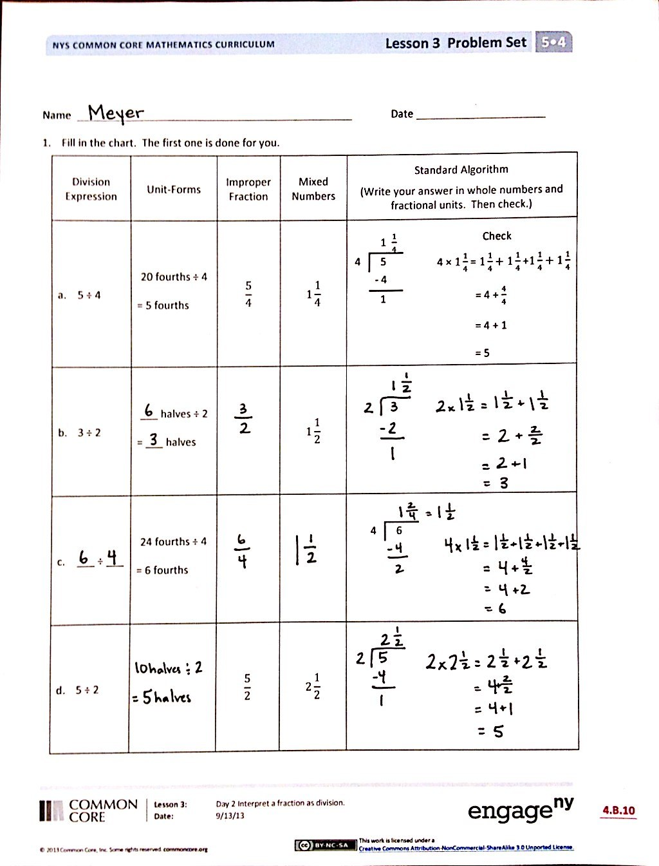
- What pattern did you notice between Problems 1(b) and 1(c)? Look at the whole and divisor. Is 3 halves greater than, less than, or equal to 6 fourths? What about the answers?
- What’s the relationship between the answers for Problems 2(a) and 2(b)? Explain it to your partner. (Students should note that Problem 2(b) is four times as much as Problem 2(a).) Can you generate a problem where the answer is the same as Problem 2(a), or the same as Problem 2(b)?
- Explain to your partner how you solved Problem 3(a)? Why do we need one more warming box than the actual quotient?
- We expressed our remainders today as fractions. Compare this with the way we expressed our remainders as decimals in Module 2. How is it similar? How is it different?
Exit Ticket (3 minutes)
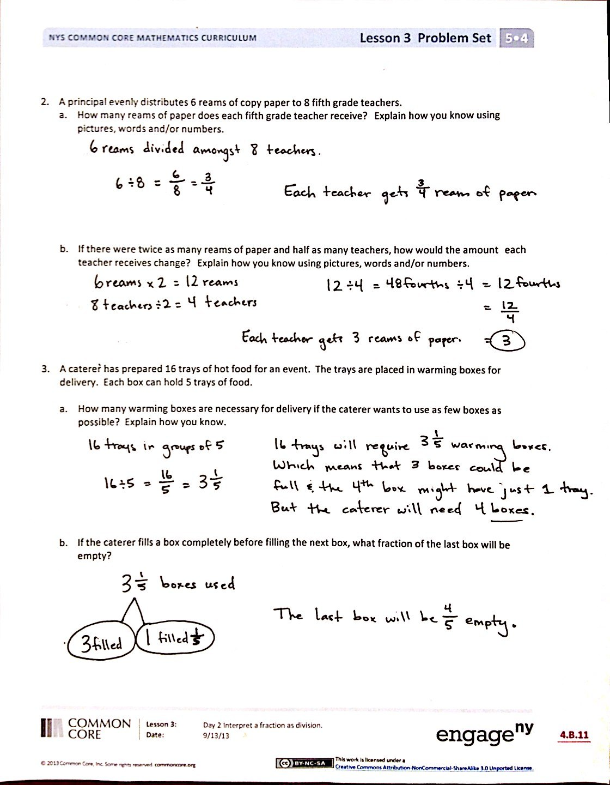
After the Student Debrief, instruct students to complete the Exit Ticket. A review of their work will help you assess the students’ understanding of the concepts that were presented in the lesson today and plan more effectively for future lessons. You may read the questions aloud to the students.

Name Date
- Fill in the chart. The first one is done for you.
Division Expression | Unit Forms | Improper Fraction | Mixed Numbers | Standard Algorithm  (Write your answer in whole numbers and fractional units. Then check.)
- 5 ÷ 4 | 20 fourths ÷ 4  = 5 fourths | $$\frac{\text{5}}{\text{4}}$$ | $$\text{1}\frac{\text{1}}{\text{4}}$$ | Check:  4 × $1\frac{1}{4}$ = $1\frac{1}{4}+1\frac{1}{4}$ +$1\frac{1}{4}+1\frac{1}{4}$  = 4 + $\frac{4}{4}$  = 4 + 1  = 5  1 $\frac{1}{4}$  4 5  - 4  1
- 3 ÷ 2 | ___ halves ÷ 2  = ___ halves |  | $$\text{1}\frac{\text{1}}{\text{2}}$$
- ___ ÷ ___ | 24 fourths ÷ 4  = 6 fourths |  |  | 4 6
- 5 ÷ 2 |  | $$\frac{\text{5}}{\text{2}}$$ | $$\text{2}\frac{\text{1}}{\text{2}}$$
- A principal evenly distributes 6 reams of copy paper to 8 fifth-grade teachers.
- How many reams of paper does each fifth-grade teacher receive? Explain how you know using pictures, words, or numbers.

- If there were twice as many reams of paper and half as many teachers, how would the amount each teacher receives change? Explain how you know using pictures, words, or numbers.

- A caterer has prepared 16 trays of hot food for an event. The trays are placed in warming boxes for delivery. Each box can hold 5 trays of food.
- How many warming boxes are necessary for delivery if the caterer wants to use as few boxes as possible? Explain how you know.

- If the caterer fills a box completely before filling the next box, what fraction of the last box will be empty?

Name Date
A baker made 9 cupcakes, each a different type. Four people want to share them equally. How many cupcakes will each person get?
Fill in the chart to show how to solve the problem.
Division Expression | Unit Forms | Fractions and Mixed numbers | Standard Algorithm
 | Draw to show your thinking:

Name Date
- Fill in the chart. The first one is done for you.
Division Expression | Unit Forms | Improper Fractions | Mixed Numbers | Standard Algorithm  (Write your answer in whole numbers and fractional units. Then check.)
- 4 ÷ 3 | 12 thirds ÷ 3  = 4 thirds | $$\frac{\text{4}}{\text{3}}$$ | $$\text{1}\frac{\text{1}}{\text{3}}$$ | Check:  3 × $1\frac{1}{3}$ = $1\frac{1}{3}+1\frac{1}{3}$ +$1\frac{1}{3}$  = 3 + $\frac{3}{3}$  = 3 + 1  = 4  1 $\frac{1}{3}$  3 4  - 3  1
- ___ ÷ ___ | ___ fifths ÷ 5  = ___ fifths |  | $$\text{1}\frac{\text{2}}{\text{5}}$$
- ___ ÷ ___ | ___ halves ÷ 2  = ___ halves |  |  | 2 7
- 7 ÷ 4 |  | $$\frac{\text{7}}{\text{4}}$$
- A coffee shop uses 4 liters of milk every day.
- If there are 15 liters of milk in the refrigerator, after how many days will more milk need to be purchased? Explain how you know.

- If only half as much milk is used each day, after how many days will more milk need to be purchased?

- Polly buys 14 cupcakes for a party. The bakery puts them into boxes that hold 4 cupcakes each.
- How many boxes will be needed for Polly to bring all the cupcakes to the party? Explain how you know.

- If the bakery completely fills as many boxes as possible, what fraction of the last box is empty? How many more cupcakes are needed to fill this box?

