|  |
| --- |
|  |

Lesson 20: Solution Sets to Equations with Two Variables

**Student Outcomes**

* Students recognize and identify solutions to two-variable equations. They represent the solution set graphically. They create two variable equations to represent a situation. They understand that the graph of the line is a visual representation of the solution set to the equation .

Classwork

*Scaffolding:*

* Circulate to make sure students are substituting the first coordinate for and the second one for .
* Create a class graph using a sheet of poster paper and give each student a sticky dot. Have them write the solution on the sticky dot and post theirs on the class graph. They can correct errors when their solution is not on the line.

Open the lesson with the following:

* When working with equations that contain more than one variable, there is often more than one solution. Solutions can be represented using ordered pairs when the equation contains two variables. All of the solutions to an equation are called the solution set.
* What do we know about the graph of equations of the form ?
  + *We know from Grade 8, the graph of is a line.*

Exercise 1 (5 minutes)

Exercise 1

* 1. Circle all the ordered pairs that are solutions to the equation .

* 1. How did you decide whether or not an ordered pair was a solution to the equation?

Most students will explain that they substituted and checked to see whether or not the equation was true.

Point out the two-variable equation in Exercise 1 and the possible solutions represented as ordered pairs. Working independently, students use their prior knowledge to verify which ordered pairs are solutions to an equation. Ask students to compare their solutions with a partner. Briefly share answers and give students a chance to revise their work or add to their written response to part (b).

Exercise 2 (15 minutes)

Students should work in groups on Exercise 2(a) only. After about minutes, have each group share their solutions and their solution strategies with the entire class. Highlight the different approaches to finding solutions. Most groups will likely start by picking a value for either or and then deciding what the other variable should equal to make the number sentence true. Value groups that began to organize their solutions in a meaningful way, such as by increasing -values. Groups may even organize their solutions in a graph.

Exercise 2

* 1. Discover as many additional solutions to the equation as possible. Consider the best way to organize all the solutions you have found. Be prepared to share the strategies you used to find your solutions.

Sample answers: ; ; ;

* 1. 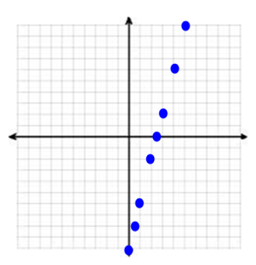Now, find five more solutions where one or more variables are negative numbers or non-integer values. Be prepared to share the strategies you used to find your solutions.

Sample answers: ; ; ; ;

* 1. How many ordered pairs will be in the solution set of the equation ?

Infinitely many.

* 1. Create a visual representation of the solution set by plotting each solution as a point in the coordinate plane.
  2. Why does it make sense to represent the solution to the equation as a line in the coordinate plane?

Drawing the line is the only way to include all possible solutions. It would be impossible to plot every point that is a solution to the equation since there are infinitely many solutions.

Next, have the groups complete parts (b) through (d). Debrief the entire class by having each group share their work, or if time permits, create a class graph. Parts (c) and (e) are the most important. Students need to realize that listing all the solutions is impossible. A visual representation of a curve (in this case a line) is a way to include ALL possible solutions including those with fractional or irrational values. You could prove this to students by letting and then solving for . Then use a graphing calculator or graphing software to graph the line and find the value when .

Exercises 3–5 (15 minutes)

These exercises ask students to create a linear equation in two variables that represents a situation. The equations in Exercises 3 and 4 are the same, but the domain of each variable is different due to the context. Require students to attend to precision in depicting answers that reflect the domain given the context. Are they using “let” statements to name each variable? Are they getting correct solutions to the equations? Notice whether or not they are using some of the strategies developed in the exercise to find their solutions. In Exercise 3, the graph should be a solid line that extends to the boundaries of the coordinate plane, but in Exercise 4, the graph should be discrete and only contain whole number values in the ordered pairs.

*Scaffolding:*

* Teach a method for getting solutions by selecting values for and substituting them into the equation to find . Have students organize the ordered pairs in a table.

**MP.2**

**&**

**MP.6**

Exercise 3–5

1. The sum of two numbers is . What are the numbers?
   1. **Create an equation using two variables to represent this situation. Be sure to explain the meaning of each variable**.

[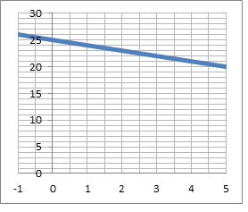](http://www.google.com/imgres?imgurl&imgrefurl=http://www.crestviewlocal.k12.oh.us/chs/staff/mcc/cp10.html&h=0&w=0&sz=1&tbnid=r8ugDHFRf1kAzM&tbnh=225&tbnw=224&prev=/search?q=coordinate+plane&tbm=isch&tbo=u&zoom=1&q=coordinate%20plane&docid=bc5yn1XHt6D8NM&hl=en&ei=hny_Ua2aKumSiALt9YHoCw&ved=0CAEQsCU)Let one number, and let another number.

Equation:

* 1. List at least six solutions to the equation you created in part (a).

Answers will vary but should be pairs of numbers whose sum is .

* 1. Create a graph that represents the solution set to the equation.

See graph to the right.

1. Gia had songs in a playlist composed of songs from her two favorite artists, Beyonce and Jennifer Lopez. How many songs did she have by each one in the playlist?
   1. Create an equation using two variables to represent this situation. Be sure to explain the meaning of each variable.

Let the number of Beyonce songs, and let the number of Jennifer Lopez songs. Equation:

[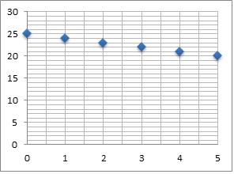](http://www.google.com/imgres?imgurl&imgrefurl=http://www.crestviewlocal.k12.oh.us/chs/staff/mcc/cp10.html&h=0&w=0&sz=1&tbnid=r8ugDHFRf1kAzM&tbnh=225&tbnw=224&prev=/search?q=coordinate+plane&tbm=isch&tbo=u&zoom=1&q=coordinate%20plane&docid=bc5yn1XHt6D8NM&hl=en&ei=hny_Ua2aKumSiALt9YHoCw&ved=0CAEQsCU)

* 1. List at least three solutions to the equation you created in part (a).

Answers will vary but should be limited to pairs of whole numbers whose sum is .

* 1. Create a graph that represents the solution set to the equation.

See graph to the right.

1. Compare your solutions to Exercises 3 and 4. How are they alike? How are they different?

The solution set to Exercise 3 is an infinite number of ordered pairs, and the graph is a solid line. The solution set to Exercise 4 is a finite set of ordered pairs that also happens to be in the solution set to Exercise 3. The graph is a discrete set of points that lie on the line .

When you debrief these exercises with the whole class, be sure to reinforce that the domain depends on the situation. Review expectations for making a complete graph (scaling, labeling, etc.). Emphasize the difference between a discrete and continuous graph.

Closing (5 minutes)

Review the lesson summary by reading closely and posing the questions below.

* Is the graph of the line the same as the solution set to the equation ? Explain your reasoning.
  + *Yes. According to the lesson summary, the set of points that forms the solution set will be points on the graph. Since the degree of and are both one, the resulting graph is a line.*
* Suppose I am using the equation to represent the following context: The number of trucks manufactured is always fewer than twice the number of cars manufactured. Does it still make sense that every point on the line is a solution to my equation considering the context of my problem?
  + *No, only the points that are in the domain of whole numbers (since they don’t manufacture of a car or truck) are solutions to the equation within this context.*
* Why is it useful to represent the solutions to a two-variable equation using a graph?
  + *If the domain of and are the real numbers, then it would be impossible to list all of the solutions as ordered pairs. A continuous graph implies that every -value in the domain of the graph has a corresponding -value that makes the equation true.*
  + *Even if the domain of and are integers or whole numbers or something other than the real numbers, it is helpful to extend a line along all the solution points and use that line to find other solutions within the domain (much more so than trying to draw out a bunch of dots along the ruler).*
  + *It is also cool and convenient that the graph of each class of equation has a distinctive shape on the   
    –**plane. The graphs of equations are usually visually striking and telling in a very efficient way. As we learn in future lessons, the -variable version of inequalities, solutions, systems, etc., each carries an interesting geometrical meaning in its D graph.*

Lesson Summary

An ordered pair is a solution to a two variable equation when each number substituted into its corresponding variable makes the equation a true-number sentence. All of the solutions to a two-variable equation are called the solution set.

Each ordered pair of numbers in the solution set of the equation corresponds to a point on the coordinate plane. The set of all such points in the coordinate plane is called the *graph of the equation.*

Exit Ticket (5 minutes)

Name ___________________________________________________ Date____________________

Lesson 20: Solution Sets to Equations with Two Variables

Exit Ticket

The Math Club sells hot dogs at a school fundraiser. The club earns and has a combination of five-dollar and one-dollar bills in its cash box. Possible combinations of bills are listed in the table below. Complete the table.

|  |  |  |
| --- | --- | --- |
| Number of five-dollar bills | Number of one-dollar bills | Total |
|  |  |  |
|  |  |  |
|  |  |  |
|  |  |  |

1. 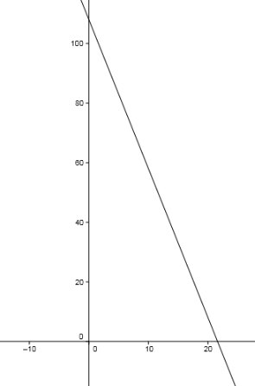Find one more combination of ones and fives that totals .
2. The equation represents this situation. A graph of the line is shown. Verify that each ordered pair in the table lies on the line.
3. What is the meaning of the variables ( and ) and the numbers (, , and ) in the equation ?

Exit Ticket Sample Solutions

The Math Club sells hot dogs at a school fundraiser. The club earns and has a combination of five-dollar and one-dollar bills in its cash box. Possible combinations of bills are listed in the table below. Complete the table.

|  |  |  |
| --- | --- | --- |
| Number of five-dollar bills | Number of one-dollar bills | Total |
|  |  |  |
|  |  |  |
|  |  |  |
|  |  |  |

1. Find one more combination of ones and fives that totals .

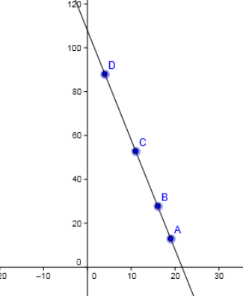

, which stands for fives and ones.

1. The equation represents this situation. A graph of the line is shown. Verify that each ordered pair in the table lies on the line.

Graph is shown with points plotted for the solutions. Verify by substituting the ordered pairs in the table into the equation for the line.

1. What is the meaning of the variables ( and ) and the   
   numbers (, and ) in the equation ?

is the number of -dollar bills; is the number of -dollar bills; is the value of a -dollar bill; is the value of a -dollar bill, and is the total dollar amount. If there are fives, then is the value of all the five-dollar bills.

Problem Set Sample Solutions

1. Match each equation with its graph. Explain your reasoning.

Justifications will vary. Sample response: I identified points on each graph and substituted them into the equations. Some graphs had the same points like , so I needed to check the solutions with at least one other point.



2

1

Graph 4

Graph 5

Graph 1

Graph 3



5

4

3

Graph 2

1. Graph the solution set in the coordinate plane. Label at least two ordered pairs that are solutions on your graph.

|  |  |  |  |
| --- | --- | --- | --- |
|  |  |  |  |

Solutions are shown below.

Graph a Graph b



(0,20)

(2,39)



(4,10)

(10,0)

Graph c Graph d

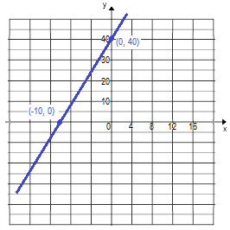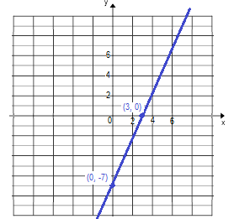

1. Mari and Lori are starting a business to make gourmet toffee. They gather the following information from another business about prices for different amounts of toffee. Which equation and which graph are most likely to model the price, , forpounds of toffee? Justify your reasoning.

Graph 1 Graph 2



|  |  |
| --- | --- |
| Pounds | Price for pounds |
|  | $ |
|  | $ |
|  | $ |
|  | $ |

Equation A:

Equation B:

Graph 1 is a non-linear function. It fits the table data better and seems to be the correct equation. I estimated a few ordered pairs on the graph, and they were close matches to the values in the table. The points on thesecond graph do not match the table values at all for -values larger than .