Lesson 15
Objective: Solve multi-step word problems; assess reasonableness of solutions using benchmark numbers.

Suggested Lesson Structure
 Fluency Practice (12 minutes)
 Concept Development (38 minutes)
 Student Debrief (10 minutes)
Total Time (60 minutes)
Fluency Practice (12 minutes)
- Sprint: Circle the Smallest Fraction 4.NF.2 (12 minutes)
Sprint: Circle the Smallest Fraction (12 minutes)
Materials: (S) Circle the Smallest Fraction Sprint
Note: Students practice analyzing fractions in preparation for today’s task of assessing the reasonableness of a solution.
Concept Development (38 minutes)
Materials: (S) Problem Set, personal white board
Note: For this lesson, the Problem Set comprises word problems from the Concept Development and is therefore to be used during the lesson itself.
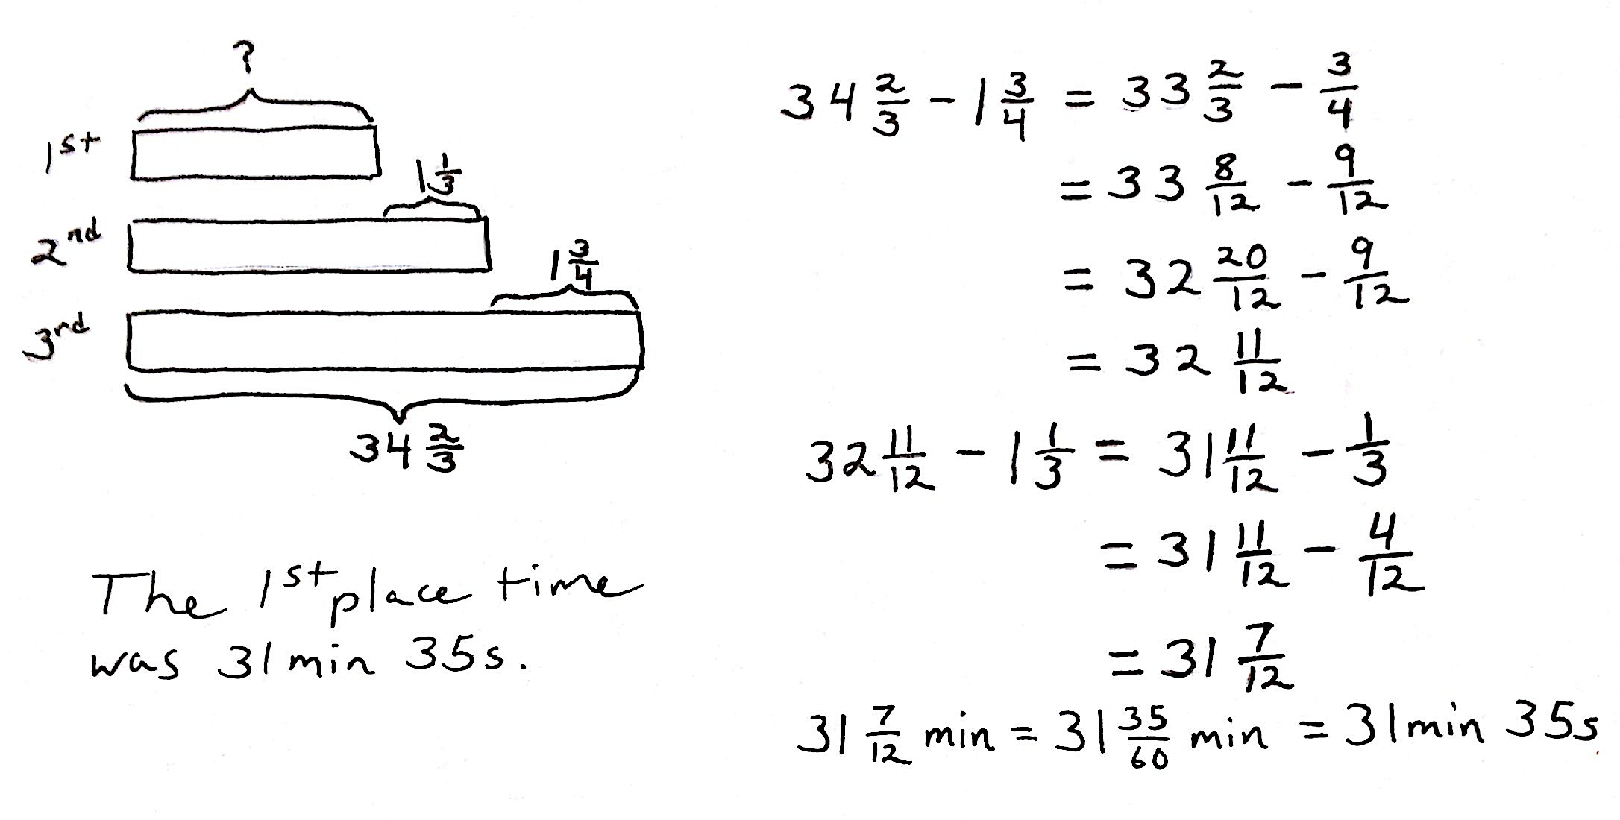
Problem 1
In a race, the second-place finisher crossed the finish line $1\frac{1}{3}$minutes after the winner. The third-place finisher was $1\frac{3}{4}$minutes behind the second-place finisher. The third-place finisher took $34\frac{2}{3}$minutes. How long did the winner take?
T: Let’s read the problem together.
S: (Read chorally.)
T: Now, share with your partner: What do you see when you hear the story? Explain how you are going to draw this problem.
NOTES ON
MULTIPLE MEANS
OF ENGAGEMENT:
When doing a word problem lesson, be sure to provide many opportunities for students to turn and talk, or repeat what a peer has said.
If possible, pair students that speak the same first language together. For example, a non-English language learner Chinese student with a strong math background can be paired with an English language learner Chinese student. Teachers can also encourage them to converse in Chinese.

S: (Share and explain.)
T: Ming, could you share your method of drawing?
S: The first sentence tells me that the second finisher took $1\frac{1}{3}$minutes longer than the winner. So, I’ll draw 2 bars. The second bar represents the second finisher with a longer bar and with the difference of $1\frac{1}{3}$minutes.
T: Betty, can you add more to Ming’s drawing?
S: The second sentence says the third finisher took $1\frac{3}{4}$ minutes longer than the second finisher. So, I’ll draw a longer bar for the third finisher, and label the difference of $1\frac{3}{4}$minutes.
T: Steven, can you add anything else to the drawing?
S: The third sentence tells us the third finisher’s time in minutes. So, I can label the third bar with $34\frac{2}{3}$minutes.
MP.5
T: Excellent. The question now is to find the winner’s time. How are you going to solve this problem? Turn and share with your partner.
S: We have to find the second finisher’s time first, and then we can find the winner’s time. We know the third finisher’s time, but don’t know the second finisher’s time. We can solve it by subtracting.
Use the third finisher’s time to subtract $1\frac{3}{4}$to find the second finisher’s time. Then, use the second finisher’s time to subtract $1\frac{1}{3}$to find the winner’s time.
T: Great. Let’s first find the second finisher’s time. What’s the subtraction sentence?
S: $34\frac{2}{3}-1\frac{3}{4}$
NOTES ON
MULTIPLE MEANS
OF ENGAGEMENT:
An extension activity can be used to convert the winner’s time into seconds.

$=34\frac{8}{12}-1\frac{9}{12}$
$=33\frac{20}{12}-1\frac{9}{12}$
$=32\frac{11}{12}$
T: What does $32\frac{11}{12}$mean?
S: The second finisher’s time is $32\frac{11}{12}$minutes.
T: Let’s now find the winner’s time. What’s the subtraction sentence?

S: $32\frac{11}{12}-1\frac{1}{3}$
$=32\frac{11}{12}-1\frac{4}{12}$
$=31\frac{7}{12}$
T: What’s the word sentence to answer the question?
S: The winner’s time was $31\frac{7}{12}$minutes.
T: How do I convert $31\frac{7}{12}$ minutes to minutes and seconds? Turn and share with your partner.
T: Alanzo, can you share your thinking with us?
S: $31\frac{7}{12}$minutes means there are 31 minutes and $\frac{7}{12}$ of a minute. I need to convert $\frac{7}{12}$into seconds.
T: Linda, what do you think?
S: I agree with Alanzo. I know there are 60 seconds in a minute, so I’ll convert $\frac{7}{12}$to $\frac{35}{60}$.
T: Very good. $\frac{7}{12}=\frac{35}{60}$. What’s the winner’s time in minutes and seconds?
S: The winner’s time was 31 minutes and 35 seconds.
Problem 2
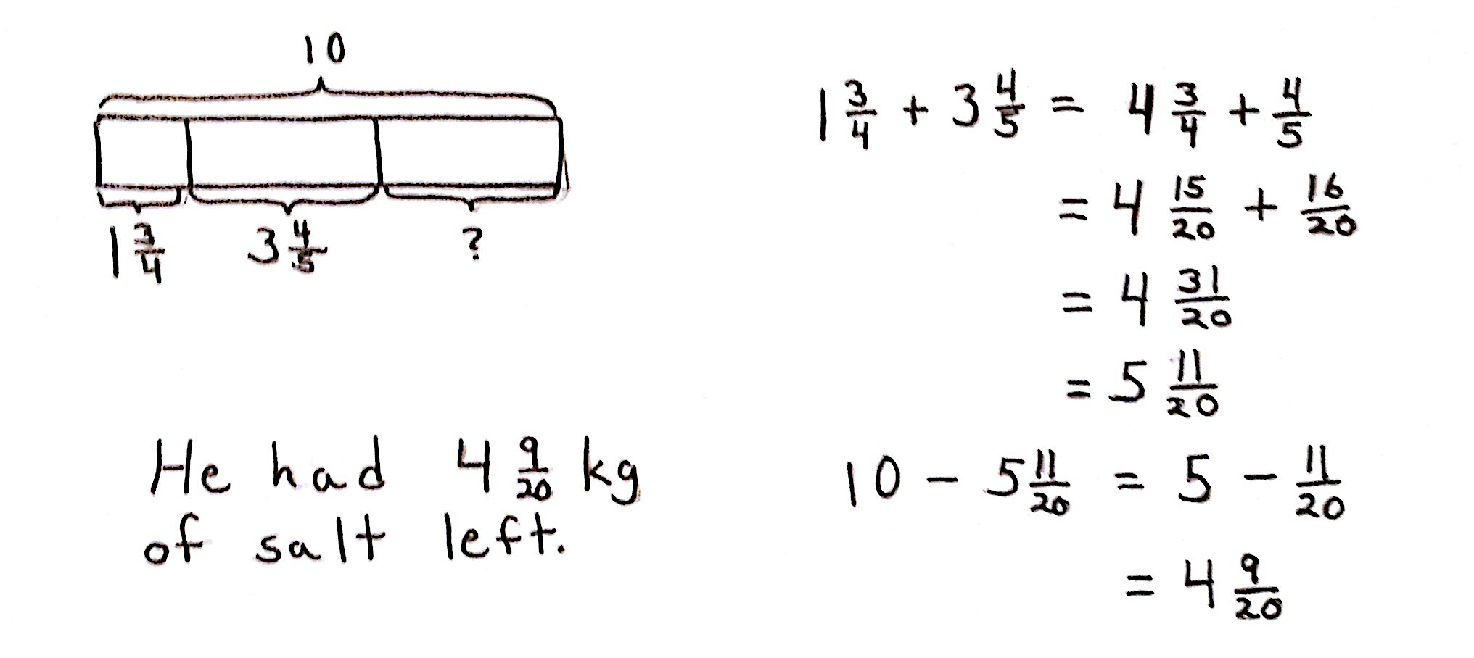
John used $1\frac{3}{4}$kg of salt to melt the ice on his sidewalk. He then used another $3\frac{4}{5}$ kg on the driveway. If he originally bought 10 kg of salt, how much does he have left?

T: Let’s read the problem together.
S: (Read chorally.)
T: What do you see when you hear the story? How you are going to draw this problem? Turn and share.
S: (Share.)
T: I’ll give you one minute to draw. Explain your conclusions to your partner based on your drawing.
S: (Discuss briefly.)
T: Student A, could you share your method of drawing?
S: Since I know he bought 10 kg of salt, I drew a whole bar and labeled it 10 kg. He used some salt for the sidewalk and some for the driveway. I drew two shorter bars under the whole bar and labeled them $1\frac{3}{4}$kg and $3\frac{4}{5}$kg.
T: How much salt does he have left? How do we solve this problem? Turn and share.
S: I can use the total of 10 kg to subtract the two parts to find the leftover part. I can add up the two parts to make them a larger part. Then I’ll subtract that from the whole of 10 kg.
T: You have four minutes to finish solving the problem.
Problem Set (20 minutes)
Students should do their personal best to complete the Problem Set within the allotted 20 minutes. For some classes, it may be appropriate to modify the assignment by specifying which problems they work on first. Some problems do not specify a method for solving. Students should solve these problems using the RDW approach used for Application Problems.
Problem 3
Sinister Stan stole $3\frac{3}{4}$oz of slime from Messy Molly, but his evil plans required $6\frac{3}{8}$ oz of slime. He stole another $2\frac{3}{5}$oz from Rude Ralph. How much more slime does Sinister Stan need for his evil plan?

Problem 4
Gavin had 20 minutes to do a three-problem quiz. He spent $9\frac{3}{4}$minutes on question 1 and $3\frac{4}{5}$minutes on question 2. How much time did he have left for question 3? Write the answer in minutes and seconds.

Problem 5
Matt wants to shave $2\frac{1}{2}$minutes off his 5K race time. After a month of hard training, he managed to lower his overall time from $21\frac{1}{5}$ minutes to $19\frac{1}{4}$minutes. By how many more minutes does Matt need to lower his race time?
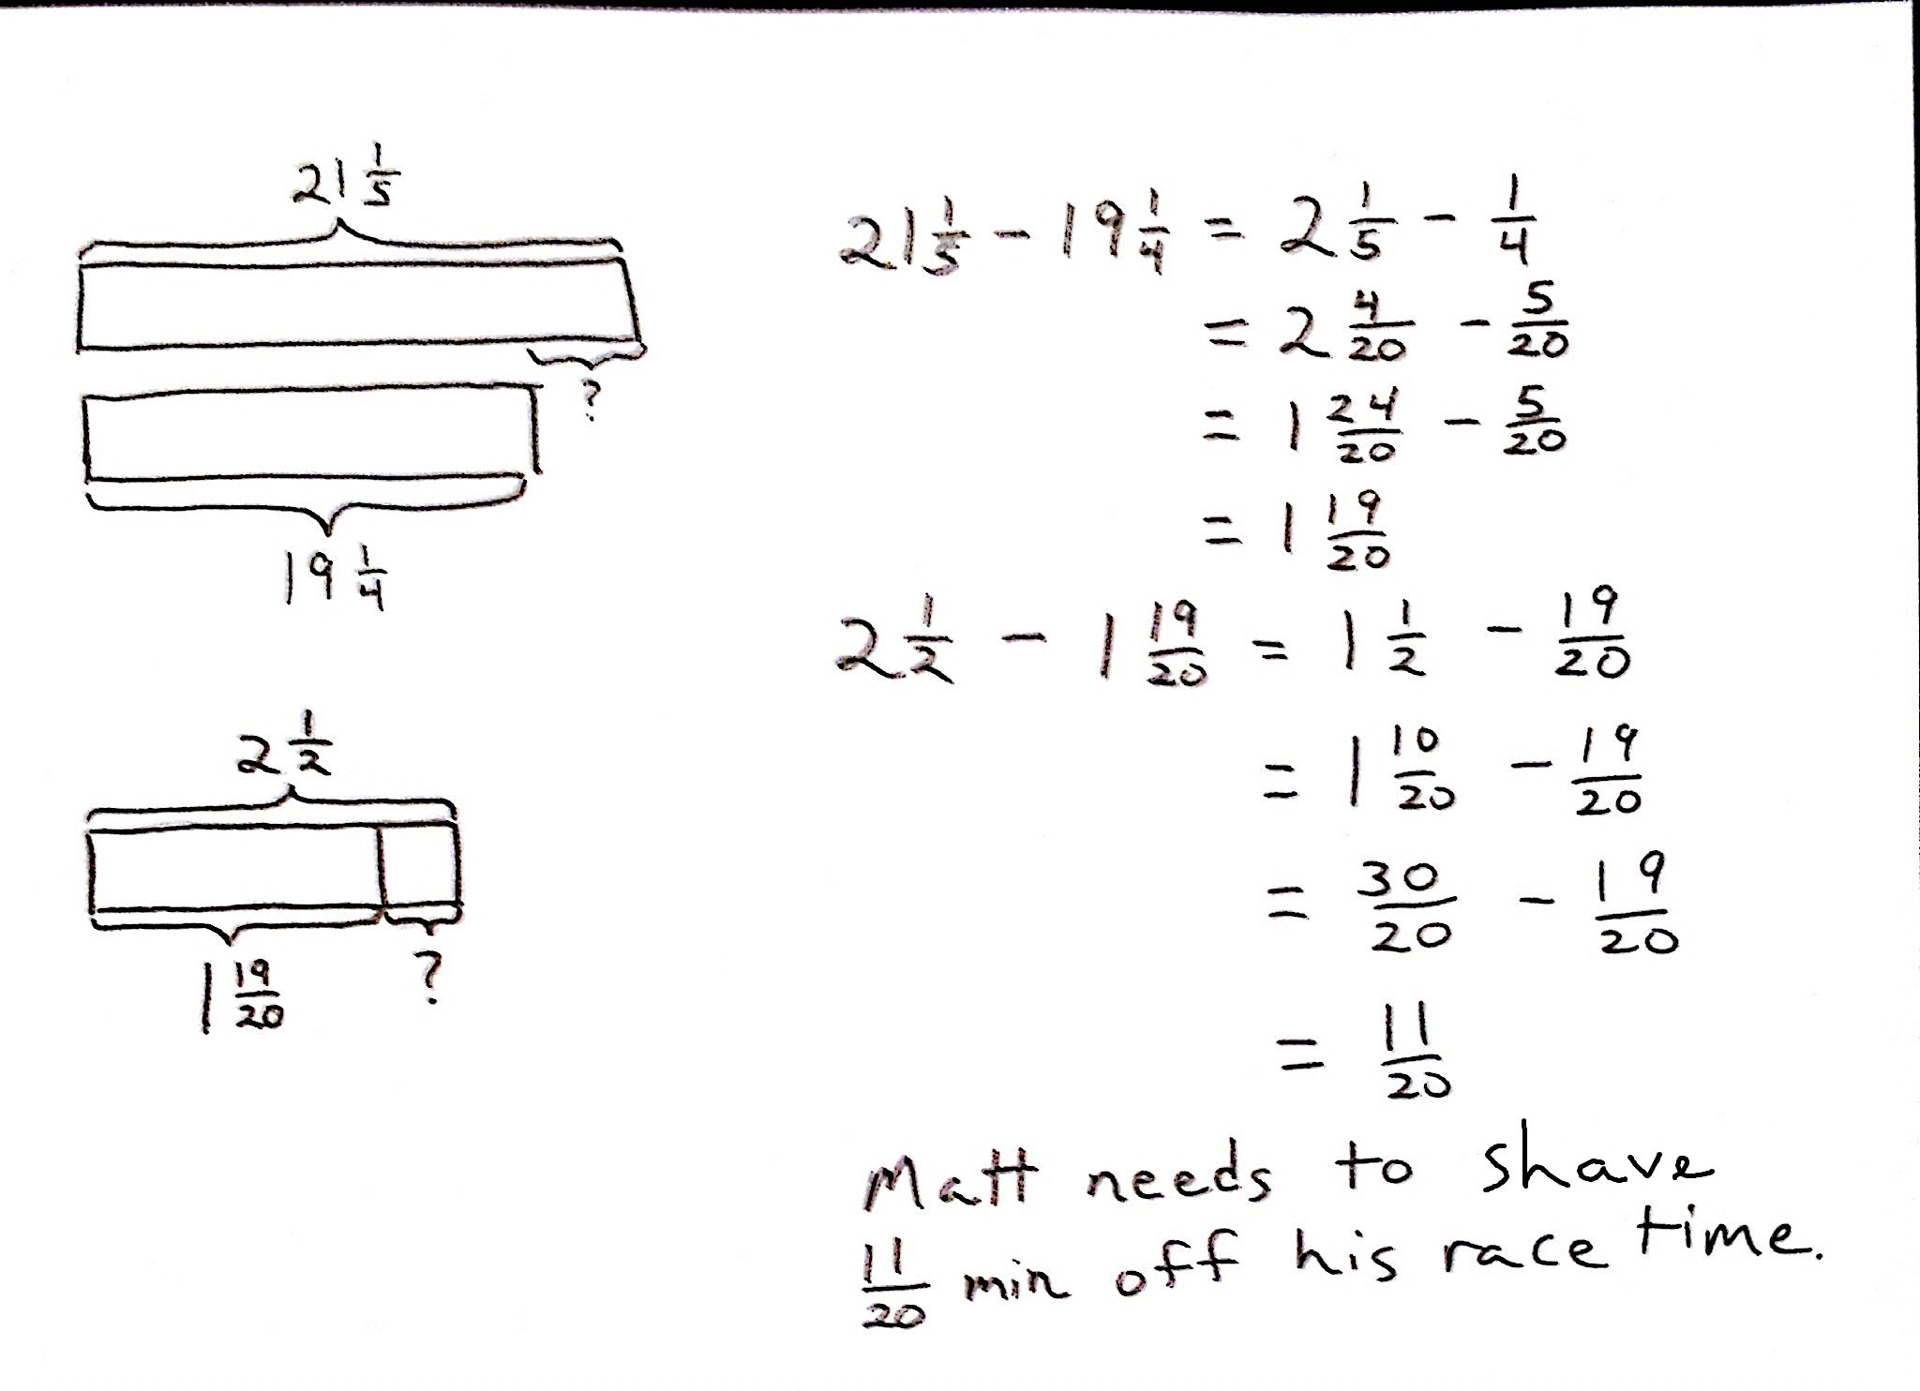

Student Debrief (10 minutes)
Lesson Objective: Solve multi-step word problems; assess reasonableness of solutions using benchmark numbers.
The Student Debrief is intended to invite reflection and active processing of the total lesson experience.
Invite students to review their solutions for the Problem Set. They should check work by comparing answers with a partner before going over answers as a class. Look for misconceptions or misunderstandings that can be addressed in the Debrief. Guide students in a conversation to debrief the Problem Set and process the lesson.
T: Bring your Problem Set to the Debrief. Share, check, and/or explain your answers to your partner.
S: (Work together for 2 minutes.)
T: (Circulate and listen to explanations. Analyze the work you see to determine which student solutions you will display to support your lesson objective.)
T: (Go over answers.) Let’s read Problem 4 together, and we’ll take a look at 2 different solution strategies.
S: Gavin had 20 minutes to do a three-problem quiz. He spent $9\frac{3}{4}$minutes on Problem 1 and $3\frac{4}{5}$minutes on Problem 2. How much time did he have left for Problem 3? Write the answer in minutes and seconds.
T: Discuss what you notice about the two different drawings. (Allow time for students to share.)
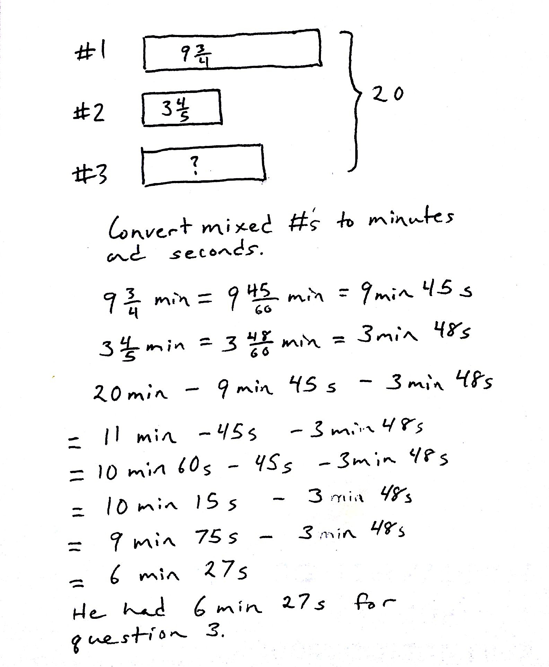
T: Jaron, would you share your thinking?
Student B’s Work
Student A’s Work
S: The first drawing labeled the whole on the bottom. The second drawing labeled it on the side.
T: How are the drawings similar? Turn and share.
S: (Share.)
T: Keri, what do you think?
S: Both drawings labeled the time for the 3 questions. They also labeled the total amount of time, which is 20 minutes.
T: Let’s look at them closely. How did Student A solve the problem? Turn and share.
S: Student A used the total of 20 minutes to subtract the time spent on Problems 1 and 2 to find the left over time. Then, the student converted $6\frac{9}{20}$to 6 minutes and 45 seconds.
T: How did Student B solve the problem? Turn and share.
S: Student B converted all the mixed numbers into minutes and seconds. Then, the student used the 20 minutes to subtract the time spent on question 1, which is 9 minutes 45 seconds, and the time spent for question 2, which is 3 minutes 48 seconds. 6 minutes 27 seconds were left over for question 3.
T: Which solution strategies did you like better?
S: The first one. The first one is a lot shorter than the second one. The second seems like it should be easy, but it took a long time to write it out with all of the minutes and seconds.
Because it was twentieths, it was really easy to change it to minutes and seconds from $6\frac{9}{20}$minutes: I just multiplied the fraction by 3 thirds.

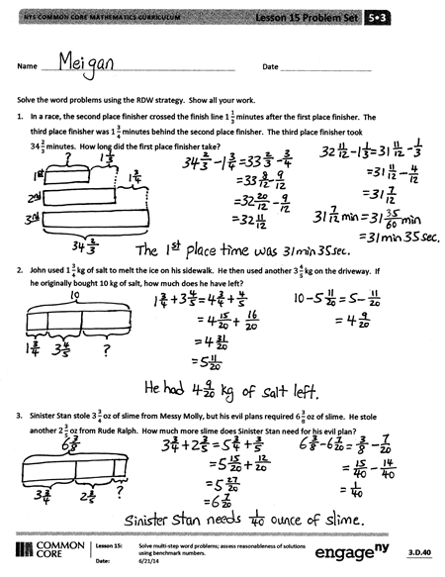
Optional as time allows: The following is a suggested list of questions to invite reflection and active processing of the total lesson experience. Use those that resonate with you as you consider what best supports your students’ ability to articulate the focus of the lesson.
- Did anyone else solve the problem differently? (Students come forward and explain their solution strategies to the class.)
- How did you improve your skills today?
Exit Ticket (3 minutes)
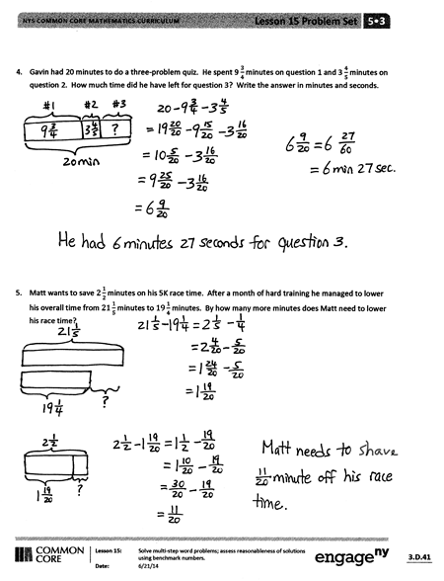
After the Student Debrief, instruct students to complete the Exit Ticket. A review of their work will help you assess the students’ understanding of the concepts that were presented in the lesson today and plan more effectively for future lessons. You may read the questions aloud to the students.
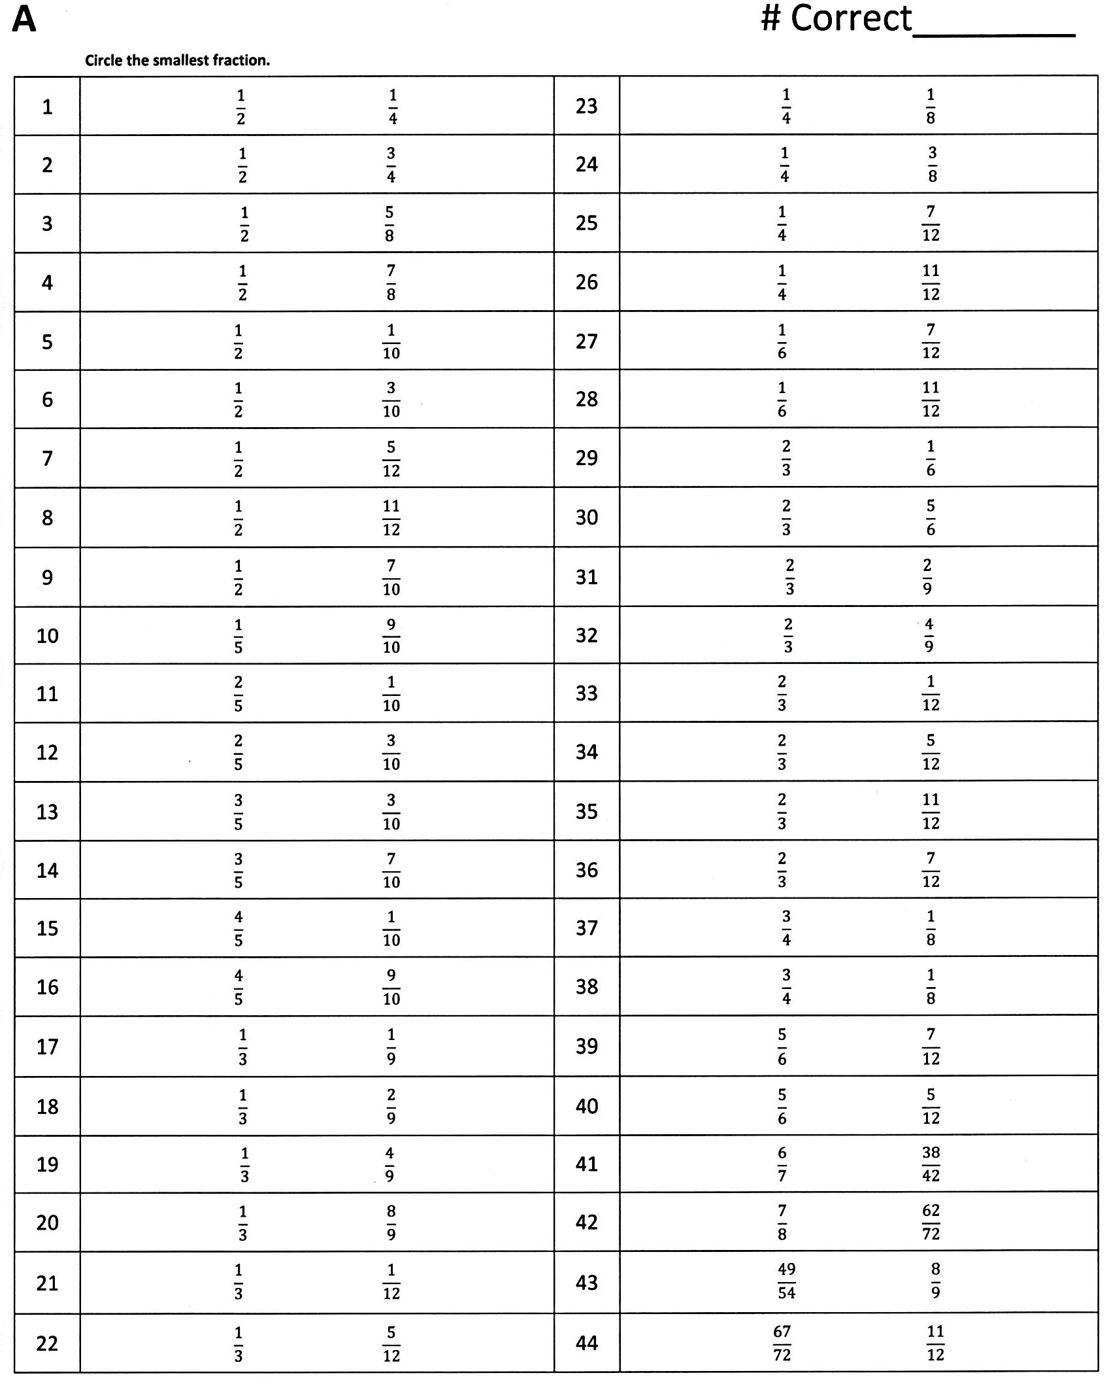
circle the smallest fraction

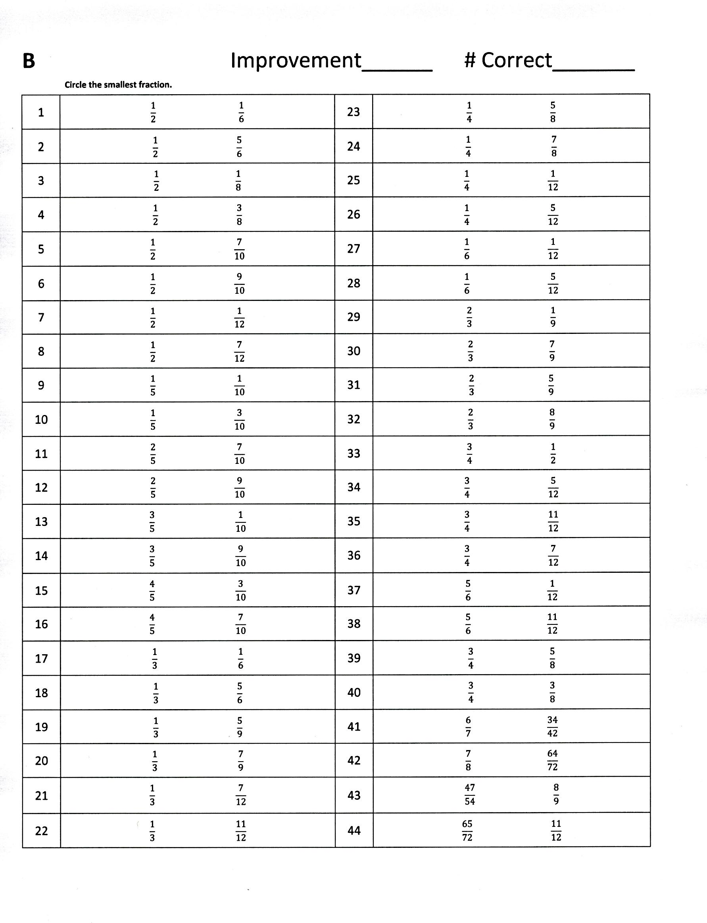
circle the smallest fraction

Name Date
Solve the word problems using the RDW strategy. Show all of your work.
- In a race, the-second place finisher crossed the finish line $1\frac{1}{3}$minutes after the first-place finisher. The third-place finisher was $1\frac{3}{4}$minutes behind the second-place finisher. The third-place finisher took $34\frac{2}{3}$minutes. How long did the first-place finisher take?

- John used $1\frac{3}{4}$kg of salt to melt the ice on his sidewalk. He then used another $3\frac{4}{5}$ kg on the driveway. If he originally bought 10 kg of salt, how much does he have left?

- Sinister Stan stole $3\frac{3}{4}$oz of slime from Messy Molly, but his evil plans require $6\frac{3}{8}$ oz of slime. He stole another $2\frac{3}{5}$oz of slime from Rude Ralph. How much more slime does Sinister Stan need for his evil plan?

- Gavin had 20 minutes to do a three-problem quiz. He spent 9 $\frac{3}{4}$ minutes on question 1 and 3 $\frac{4}{5}$ minutes on question 2. How much time did he have left for question 3? Write the answer in minutes and seconds.

- Matt wants to save $2\frac{1}{2}$minutes on his 5K race time. After a month of hard training, he managed to lower his overall time from $21\frac{1}{5}$minutes to $19\frac{1}{4}$ minutes. By how many more minutes does Matt need to lower his race time?

Name Date
Solve the word problem using the RDW strategy. Show all of your work.

Cheryl bought a sandwich for $5\frac{1}{2}$dollars and a drink for $2.60. If she paid for her meal with a $10 bill, how much money did she have left? Write your answer as a fraction and in dollars and cents.

Name Date
Solve the word problems using the RDW strategy. Show all of your work.
- A baker buys a 5 lb bag of sugar. She uses $1\frac{2}{3}$lb to make some muffins and $2\frac{3}{4}$lb to make a cake. How much sugar does she have left?

- A boxer needs to lose $3\frac{1}{2}$kg in a month to be able to compete as a flyweight. In three weeks, he lowers his weight from 55.5 kg to 53.8 kg. How many kilograms must the boxer lose in the final week to be able to compete as a flyweight?

- A construction company builds a new rail line from Town A to Town B. They complete $1\frac{1}{4}$ miles in their first week of work and $1\frac{2}{3}$ miles in the second week. If they still have $25\frac{3}{4}$ miles left to build, what is the distance from Town A to Town B?

- A catering company needs 8.75 lb of shrimp for a small party. They buy $3\frac{2}{3}$ lb of jumbo shrimp,
$2\frac{5}{8}$ lb of medium-sized shrimp, and some mini-shrimp. How many pounds of mini-shrimp do they buy?

- Mark breaks up a 9-hour drive into 3 segments. He drives $2\frac{1}{2}$hours before stopping for lunch. After driving some more, he stops for gas. If the second segment of his drive was $1\frac{2}{3}$hours longer than the first segment, how long did he drive after stopping for gas?

