Lesson 8
Objective: Add fractions to and subtract fractions from whole numbers using equivalence and the number line as strategies.

Suggested Lesson Structure
 Fluency Practice (6 minutes)
 Application Problem (7 minutes)
 Concept Development (35 minutes)
 Student Debrief (12 minutes)
Total Time (60 minutes)
Fluency Practice (6 minutes)
- Adding Whole Numbers and Fractions 4.NF.3a (3 minutes)
- Subtracting Fractions from Whole Numbers 4.NF.3a (3 minutes)
Adding Whole Numbers and Fractions (3 minutes)
NOTES ON
MULTIPLE MEANS
OF REPRESENTATION:
If necessary, show numbers with tape diagrams to create a visual and slow the pace of the activity.

Note: This fluency activity reviews decomposing a mixed number into two addends—a whole number plus a fraction.
T: I’ll say the answer. You say the addition problem as a whole number and a fraction. 3 and 1 half.
S: 3 + 1 half.
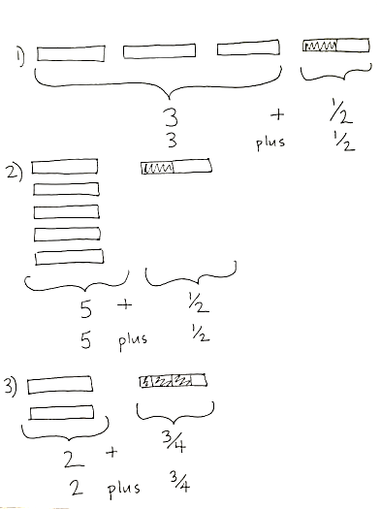
T: 5 and 1 half.
S: 5 + 1 half.
T: 2 and 3 fourths.
S: 2 + 3 fourths.
T: 1 and 5 sixths.
S: 1 + 5 sixths.
T: Let’s switch roles. I’ll say the addition problem. You say the answer. 2 + 1 fifth.
S: 2 and 1 fifth.
T: 2 + 4 fifths.
S: 2 and 4 fifths.
T: 5 + 7 eighths.
S: 5 and 7 eighths.
T: 3 + 7 twelfths.
S: 3 and 7 twelfths.
Subtracting Fractions from Whole Numbers (3 minutes)
Note: This fluency exercise reviews subtraction of fractions. If students struggle with this activity, the problems can be written as shown in unit form.
NOTES ON
MULTIPLE MEANS
OF ACTION AND EXPRESSION:
As with the addition activity, have students represent the subtraction sentence with a tape diagram and cross off the subtracted amount.

T: I’ll say a subtraction sentence. You repeat the sentence and give the answer. 1 – 1 half.
S: 1 – 1 half = 1 half.
T: 2 – 1 half.
S: 2 – 1 half = 1 and 1 half.
T: 2 and 1 half – 1 half.
S: 2 and 1 half – 1 half = 2.
T: 6 – 1 fourth.
S: 6 – 1 fourth = 5 and 3 fourths.
T: 6 and 3 fourths – 3 fourths.
S: 6 and 3 fourths – 3 fourths = 6.
Continue with the following possible sequence:
3 − $\frac{5}{6}$ , 3$\frac{5}{6}$ − $\frac{5}{6}$ 4 − $\frac{7}{8}$ , 4$\frac{7}{8}$ − $\frac{7}{8}$ 5 $\frac{7}{12}$ and 5$\frac{7}{12}$ − $\frac{7}{12} .$
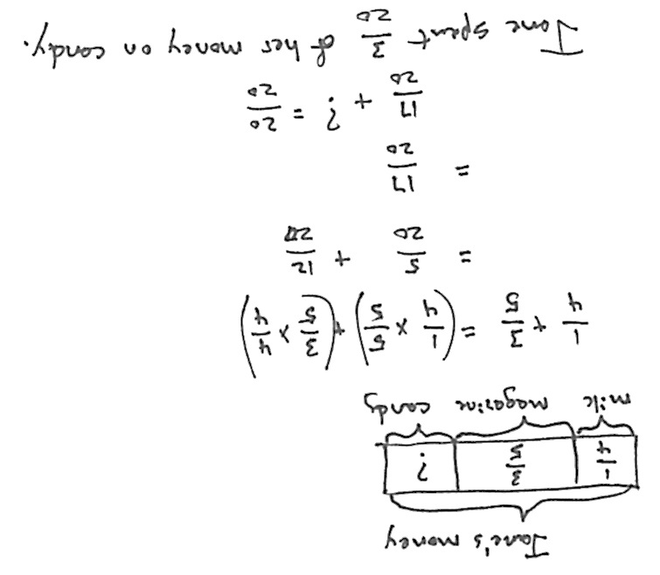
Application Problem (7 minutes)
Jane found money in her pocket. She went to a convenience store and spent $\frac{1}{4}$ of her money on chocolate milk, $\frac{3}{5}$ of her money on a magazine, and the rest of her money on candy. What fraction of her money did she spend on candy?
T: Let’s read the problem together.
S: (Read chorally.)
T: Quickly share with your partner how to solve this problem. (Circulate and listen.)
T: What do we need to do to solve this problem?
S: I have to find like units for the cost of the milk and magazine. Then, I can add them together. That way, I can see how much more I would need to make 1 whole.
T: You have 2 minutes to solve the problem.
NOTES ON
MULTIPLE MEANS
OF ENGAGEMENT:
Add the following question as an extension for students working above grade level:
How much does the magazine cost if she started with $10?
The question goes beyond the scope of the lesson, but may be an engaging challenge for students working above grade level.

T: What like units did you find for the milk and magazine?
S: Twentieths.
T: Say your addition sentence with these like units.
S: 5 twentieths plus 12 twentieths equals 17 twentieths.
T: How many more twentieths do you need to make a whole?
S: 3 twentieths.
T: Tell your partner the answer in the form of a sentence.
S: Jane spent 3 twentieths of her money on candy.
Note: This Application Problem reviews addition of addends with unlike units.
Concept Development (35 minutes)
Materials: (S) Personal white board, empty number line (Template), or lined paper
Problem 1: $1 + 1\frac{3}{4}$
T: (Project or draw the image below.) If one fully shaded bar represents one whole, what addition problem would match this drawing?
S: $1 + 1\frac{3}{4}$.
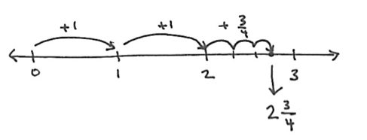T: (Write 1 + $1\frac{3}{4}$ on the board. Draw a line or project the number line template.) We’ll start at zero and travel 1 unit. (Model.)
$1+1\frac{3}{4}$
$=1+1+\frac{3}{4}$
$=2\frac{3}{4}$
T: Start at 1 and travel one more equal unit. (Model.) Where do we land?
S: 2.
T: How much more do I need to add?
S: 3 fourths.
T: Will that additional distance be less than or more than one whole unit?
S: Less than one whole unit.
T: Make 3 smaller equal units: 1 fourth, 2 fourths, 3 fourths. What is 2 plus 3 fourths? Turn and share.
S: 2 and 3 fourths. 1 plus 1 and 3 fourths equals 2 and 3 fourths.
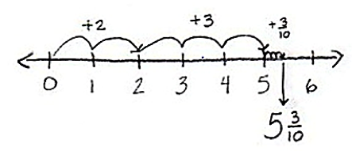Problem 2: $2\frac{3}{10}+3$
2 $\frac{3}{10}+3$
= 2 + 3 + $\frac{3}{10}$
= 5 $\frac{3}{10}$
T: (Write $2\frac{3}{10}+3$ on the board.) Talk to your partner. How should we solve this?
S: First, add 2. 3 tenths comes next, so add that.
Adding all the whole numbers first might be easier. Adding the numbers as they are written is best so you don’t forget the fractions or whole numbers. Adding the whole numbers first will make the number line easier to read, and it’s similar to how we add all the ones, then the tens, then the hundreds. Add like numbers or units first.
T: Let’s travel 2, and then 3 more units on our number line. (Show on the board.) Can someone explain how to travel 3 tenths?
S: 1 tenth is much smaller than a whole, so make 3 very small units. Label the final one $5\frac{3}{10}$.
T: Say your complete number sentence.
S: 2 and 3 tenths plus 3 equals 5 and 3 tenths.
T: What do you notice about the fractional units when adding them to a whole number?
S: The fraction amount doesn’t change. All we have to do is add the whole numbers.
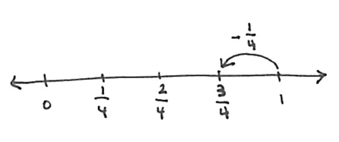Problem 3: $1- \frac{1}{4}$
$1- \frac{1}{4}$
$=\frac{4}{4} - \frac{1}{4}$
= $\frac{3}{4}$

T: (Write $1-\frac{1}{4}$ on the board.) Read the problem.
S: 1 minus 1 fourth.
T: On the number line, let’s start at 1 because that’s the whole.
T: When I subtract $\frac{1}{4}$ from 1, my answer is between which 2 whole numbers?
S: 0 and 1.
T: (Write 0 on the number line.) Because the answer is between 0 and 1, the whole number will be 0. Let’s partition the number line into fourths. Starting at 1, let’s travel back 1 fourth. (Mark the unit.) Say the complete number sentence.
S: 1 minus 1 fourth equals 3 fourths.

Problem 4: $2- \frac{3}{5}$
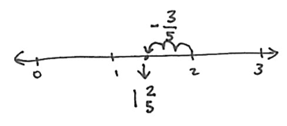T: (Write 2 $-\frac{3}{5}$on the board.) Discuss with your partner your strategy for solving this problem.
$2- \frac{3}{5}$
$=1+(1-\frac{3}{5})$
= 1 $\frac{2}{5}$

S: (Discuss.)
T: I will start at the whole number 2 on the number line. Am I subtracting a whole number?
S: No.
T: The answer will lie between what 2 whole numbers?
S: 1 and 2.
T: If the answer lies between 1 and 2, what is the whole number part of the answer?
S: 1.
T: With your partner, use your personal white board to subtract 3 fifths on the number line.
Allow students 1 minute to solve the problem with their partners using the number line. Review the problem, counting back 3 fifths on the number line. Elicit the answer from the students.
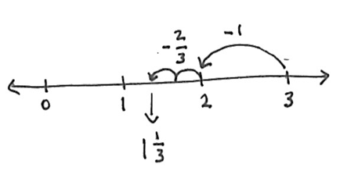Problem 5: $3-1\frac{2}{3}$
T: (Write 3 – $1\frac{2}{3}$ on the board.) Say this subtraction sentence.
S: 3 minus 1 and 2 thirds.
T: First, we will subtract the whole number 1, and then subtract the fraction 2 thirds. Start with 3 on the number line and subtract 1 whole. (Show the subtraction of the unit.)
$3-1\frac{2}{3}$
$=\left(3-1\right)-\frac{2}{3}$
= 2 – $\frac{2}{3}$
$=1 \frac{1}{3}$

T: When you subtract the fraction 2 thirds, what 2 whole numbers does the answer lie between?
S: Between 1 and 2.
T: You have 1 minute to complete this problem with your partner.
Problem Set (10 minutes)
Students should do their personal best to complete the Problem Set within the allotted 10 minutes. For some classes, it may be appropriate to modify the assignment by specifying which problems they work on first. Some problems do not specify a method for solving. Students should solve these problems using the RDW approach used for Application Problems.

Student Debrief (12 minutes)
NOTES ON
MULTIPLE MEANS
OF ENGAGEMENT:
Learning how to articulate complex thinking is a skill that develops over time. It is often beneficial to have students project or show their work visually as they describe their solution strategies. Teachers can scaffold students’ abilities to articulate their thoughts by questioning the projected strategies. Questions from classmates may also help students learn how to clearly articulate ideas. Ask students to retell particularly efficient strategies to a partner to help them internalize either language or content, depending on needs.

Lesson Objective: Add fractions to and subtract fractions from whole numbers using equivalence and the number line as strategies.
The Student Debrief is intended to invite reflection and active processing of the total lesson experience.
Invite students to review their solutions for the Problem Set. They should check work by comparing answers with a partner before going over answers as a class. Look for misconceptions or misunderstandings that can be addressed in the Debrief. Guide students in a conversation to debrief the Problem Set and process the lesson.
T: Please take two minutes to check your answers with your partner. Do not change any of your answers. (Allow students to work.)
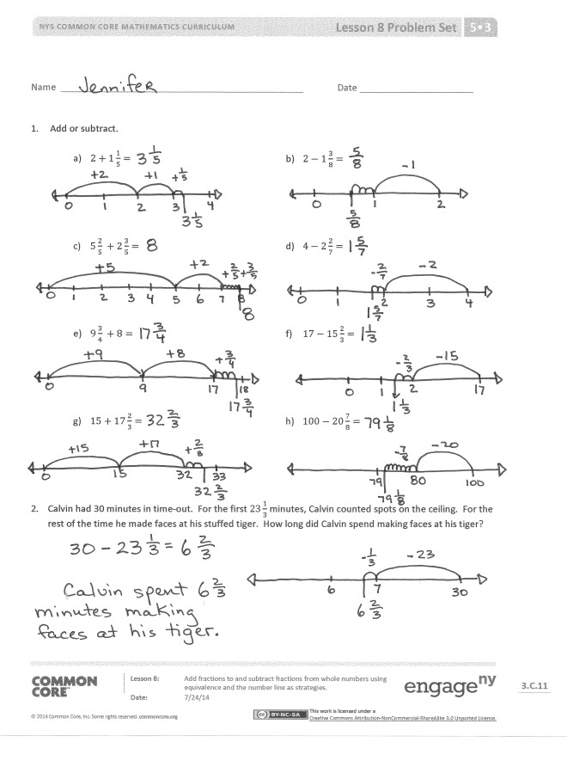
T: I will say the addition or subtraction problem. Share your answers out loud to check your work. Problem 1(a), 2 plus 1 and 1 fifth equals?
S: 3 and 1 fifth.
Continue with the sequence.
T: Take the next two minutes to discuss the Problem Set with your partner. Did you notice anything new? Are there any patterns? (Students discuss. Circulate and listen for conversations that can be shared with the whole class.)
T: Student A, will you tell us what you noticed about Problem 1(c)?
S: I added the whole numbers and got 7, but then I realized that the fractions added up to 5 fifths. That’s one whole, so I had to add that to 7 and got 8 for my answer.
T: Student B, what were you saying about the addition problems compared to the subtraction problems?
S: Addition takes less time and thinking. Just add the whole numbers and write in the fraction. But with subtraction, you have to think harder. First, you subtract the whole numbers, but that won’t be your whole number answer. You have to make it one number smaller. In Problem 1(e), for instance, 17 minus 15 equals 2, but the answer won’t be 2; it will be between 1 and 2. So, I write down the whole number 1, and then figure out the fraction.
MP.3
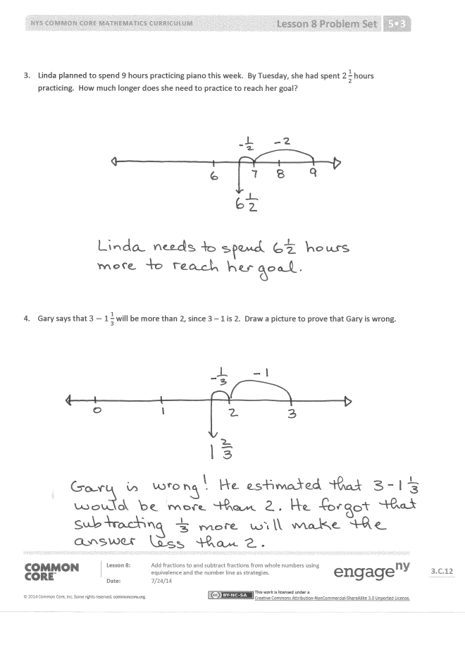
T: Student C, how did you find the fraction that Student B mentioned?
S: For finding the fraction part of subtraction, I like to count up. For example, in Problem 1(d), I found the whole number, and then said $\frac{3}{7}, \frac{4}{7}, \frac{5}{7}, \frac{6}{7}, \frac{7}{7}.$ That’s 5 groups of sevenths. So, the fraction is $\frac{5}{7}$.
T: Many of us are finding our own strategies for solving addition and subtraction of whole numbers and fractions. Share with your partner your own strategies. Listen carefully and see if you learn a new strategy to try.
S: (Discuss.)
T: (If time permits, ask for two students to share what they heard.)
Exit Ticket (3 minutes)
After the Student Debrief, instruct students to complete the Exit Ticket. A review of their work will help you assess the students’ understanding of the concepts that were presented in the lesson today and plan more effectively for future lessons. You may read the questions aloud to the students.

Name Date
- Add or subtract.
- $2+1\frac{1}{5}=$ | - $2-1\frac{3}{8}=$
- $5\frac{2}{5} +2\frac{3}{5}=$ | - $4-2\frac{2}{7}=$
- $9\frac{3}{4} +8=$ | - $17-15\frac{2}{3}=$
- $15+17\frac{2}{3}=$ | - $100-20\frac{7}{8}=$
- Calvin had 30 minutes in time-out. For the first $23\frac{1}{3}$ minutes, Calvin counted spots on the ceiling. For the rest of the time, he made faces at his stuffed tiger. How long did Calvin spend making faces at his tiger?

- Linda planned to spend 9 hours practicing piano this week. By Tuesday, she had spent $2\frac{1}{2}$ hours practicing. How much longer does she need to practice to reach her goal?

- Gary says that $3-1\frac{1}{3}$ will be more than 2, since 3 – 1 is 2. Draw a picture to prove that Gary is wrong.

Name Date
- Add or subtract.

- $5+1\frac{7}{8}=$ | - $3-1\frac{3}{4}=$
- $7\frac{3}{8} +4=$ | - $4-2\frac{3}{7}=$

Name Date
- Add or subtract.

- $3+1\frac{1}{4}=$ | - $2-1\frac{5}{8}=$
- $5\frac{2}{5} +2\frac{3}{5}=$ | - $4-2\frac{5}{7}=$
- $8\frac{4}{5} +7=$ | - $18-15\frac{3}{4}=$
- $16+18\frac{5}{6}=$ | - $100-50\frac{3}{8}=$
- The total length of two ribbons is 13 meters. If one ribbon is $7\frac{5}{8}$ meters long, what is the length of the other ribbon?

- It took Sandy two hours to jog 13 miles. She ran $7\frac{1}{2}$ miles in the first hour. How far did she run during the second hour?

- Andre says that $5\frac{3}{4} +2\frac{1}{4}=7\frac{1}{2}$ because $7\frac{4}{8}=7\frac{1}{2}$. Identify his mistake. Draw a picture to prove that he is wrong.

empty number line

