Lesson 7

Objective: Solve two-step word problems.

Suggested Lesson Structure

 Fluency Practice (12 minutes)

 Concept Development (38 minutes)

 Student Debrief (10 minutes)

**Total Time (60 minutes)**

Fluency Practice (12 minutes)

* Sprint: Circle the Equivalent Fraction **4.NF.2** (12 minutes)

Sprint: Circle the Equivalent Fraction (12 minutes)

Materials: (S) Circle the Equivalent Fraction Sprint

Note: Students rapidly recognize common equivalent fractions mentally (i.e., without performing the indicated multiplication).

Concept Development (38 minutes)

|  |  |
| --- | --- |
|  | NOTES ON  MULTIPLE MEANS  OF ENGAGEMENT: |

You might strategically pair English language learners and students working below grade level. For example, a student working below grade level who is accustomed to translating for a parent may blossom when asked to translate for a newcomer. The relationship may become mutually beneficial if the newcomer exhibits strong abilities and can help his or her partner with math concepts.

Materials: (S) Problem Set, personal white board

Note: For this lesson, the Problem Set comprises word problems from the Concept Development and is therefore to be used during the lesson itself.

Problem 1

George weeded of the garden, and Summer weeded some, too. When they were finished, of the garden still needed to be weeded. What fraction of the garden did Summer weed?

T: Let’s read the problem together.

S: (Read chorally.)

T: Share with your partner: What do you see when you hear the story? What can you draw?

S: (Share.)

T: I’ll give you one minute to draw.

S: (Draw.)

T: What fraction of the garden did Summer weed? Is it a part or the whole?

S: Part.

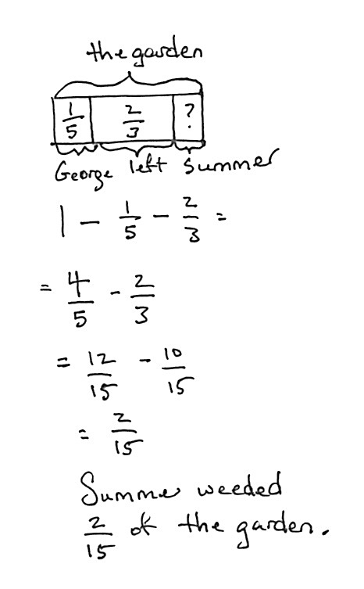

*Solution 1*

T: Do we know the whole?

S: Yes.

T: What is it?

S: 1.

T: From the whole, we separate for George, an unknown amount for Summer, and have a leftover part of . How do you solve for Summer’s part? Turn and share.

S: (Share.)

T: Solve the problem on your personal white board. (Pause.) Show your board.

T: Turn and explain to your partner how you got the answer.

S: (Share.)

T: Jason, please share.

S: After I drew the tape diagram, I just subtracted the part George weeded and the part that was left from the whole. (See Solution 1.)

T: Barbara, please share.

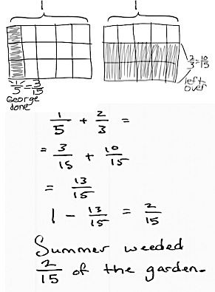

*Solution 2*

S: My way to solve this problem is to add up the 2 parts to create a larger part, and then subtract from the whole. (See Solution 2.)

T: What fraction of the garden did Summer weed?

S: Summer weeded of the garden.

T: Barbara and Jason have presented their solution strategies, which came directly from their drawings. With your partner, analyze their drawings. How are they the same, and how are they different?

S: (Compare and discuss.)

T: Are they both correct?

S: Yes.

T: How do you know?

S: They each make sense. 🡪 They each got the correct answer. 🡪 They each showed the same relationships, but in different ways.

Problem 2

Jing spent of her money on a pack of pens, of her money on a pack of markers, and of her money on a pack of pencils. What fraction of her money is left?

*Solution 1*

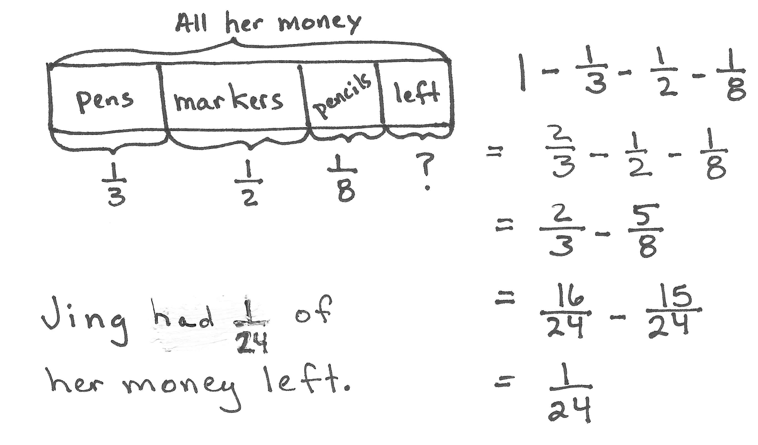

|  |  |
| --- | --- |
|  | NOTES ON  MULTIPLE MEANS  OF ACTION AND EXPRESSION: |

If students finish quickly, have them rework problems using a different strategy. Then, during the Student Debrief, take a moment to have them share which strategy they prefer and why.

Some students may realize they can find the number of like units using one rectangular fraction model. This is more efficient, and many students might benefit from this shortcut. In the Debrief of the problem, compare the methods and support the validity of this strategy.

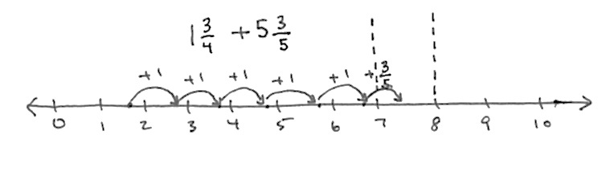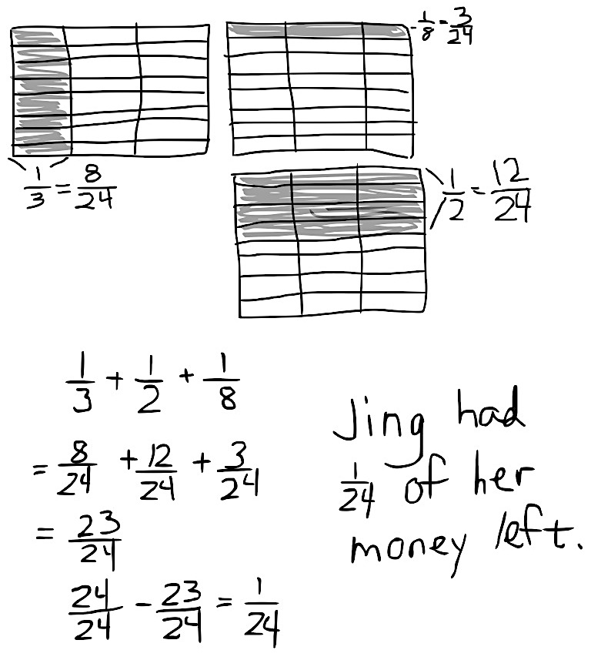

*Solution 2*

Problem 3

Shelby bought a 2-ounce tube of blue paint. She used ounce to paint the water, ounce to paint the sky, and some to paint a flag. After that, she had ounce left. How much paint did Shelby use to paint her flag?

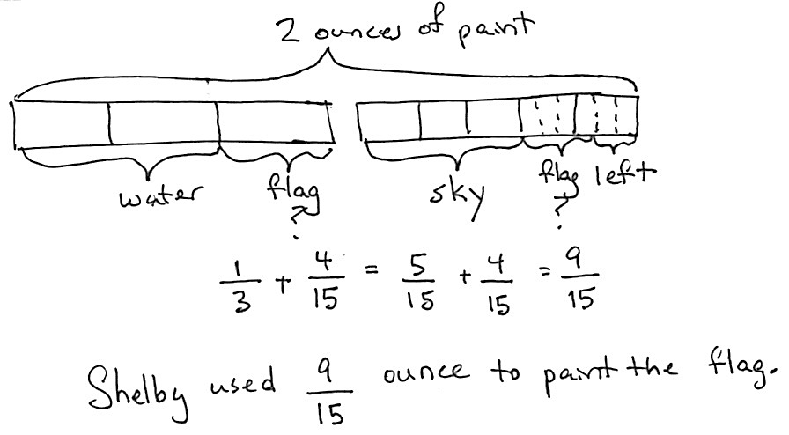

*Solution 1*

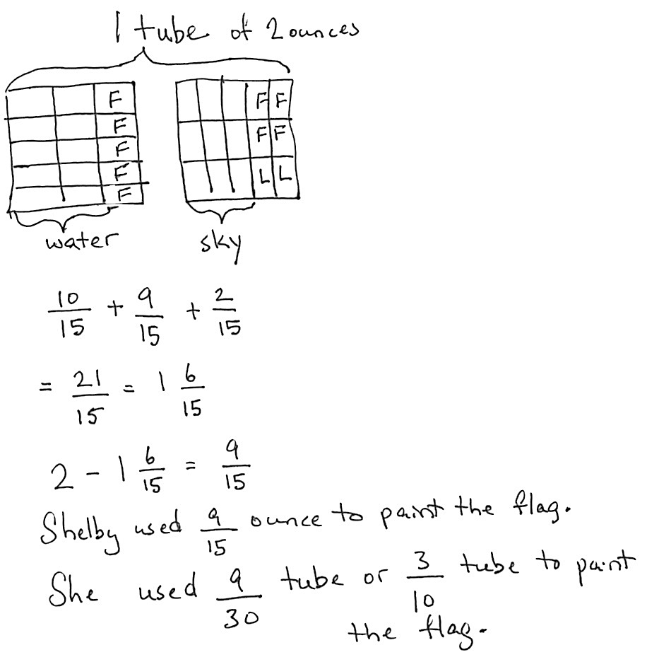

*Solution 2*



Problem 4

Jim sold gallon of lemonade. Dwight sold some lemonade, too. Together, they sold gallons. Who sold more lemonade, Jim or Dwight? How much more? (See the Student Debrief for student work samples.)

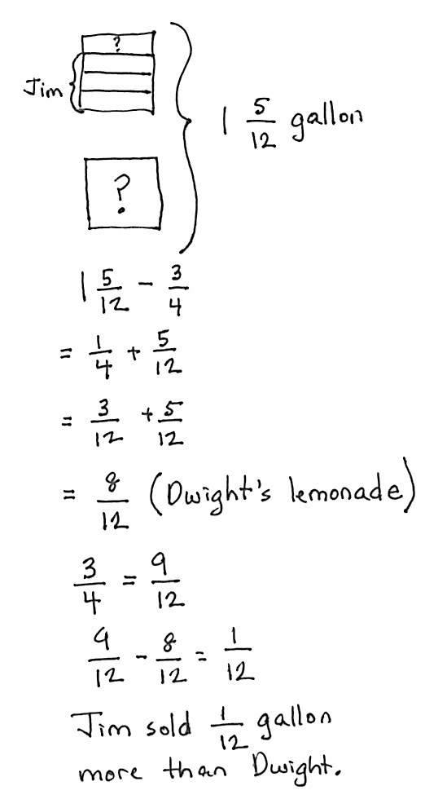

*Solution 1*

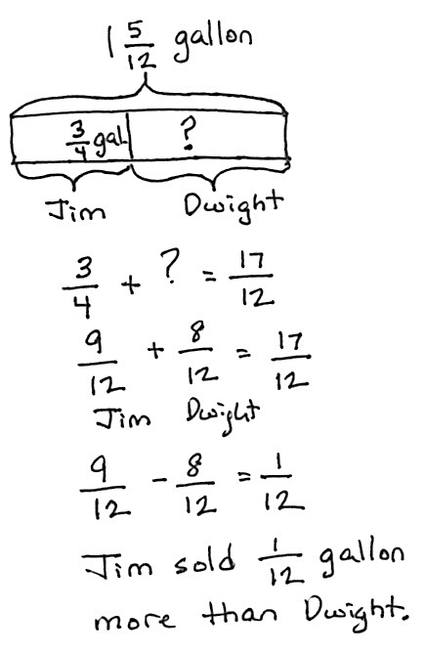

*Solution 2*

Problem 5

Leonard spent of his money on a sandwich. He spent 2 times as much on a gift for his brother as on some comic books. He had of his money left. What fraction of his money did he spend on the comic books?

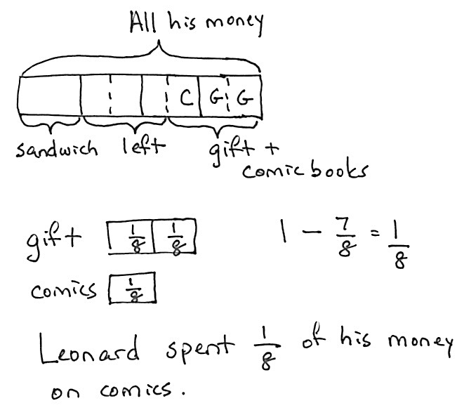

*Solution 1*

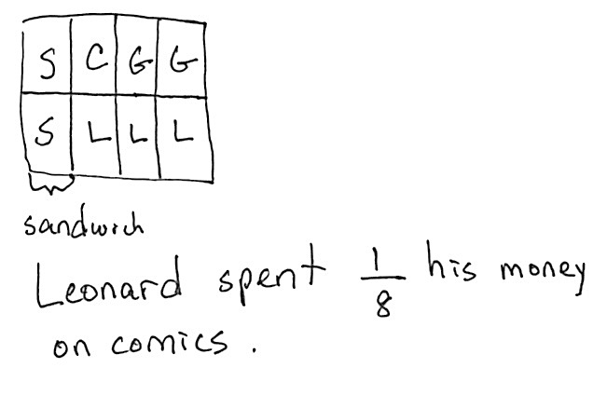

*Solution 2*

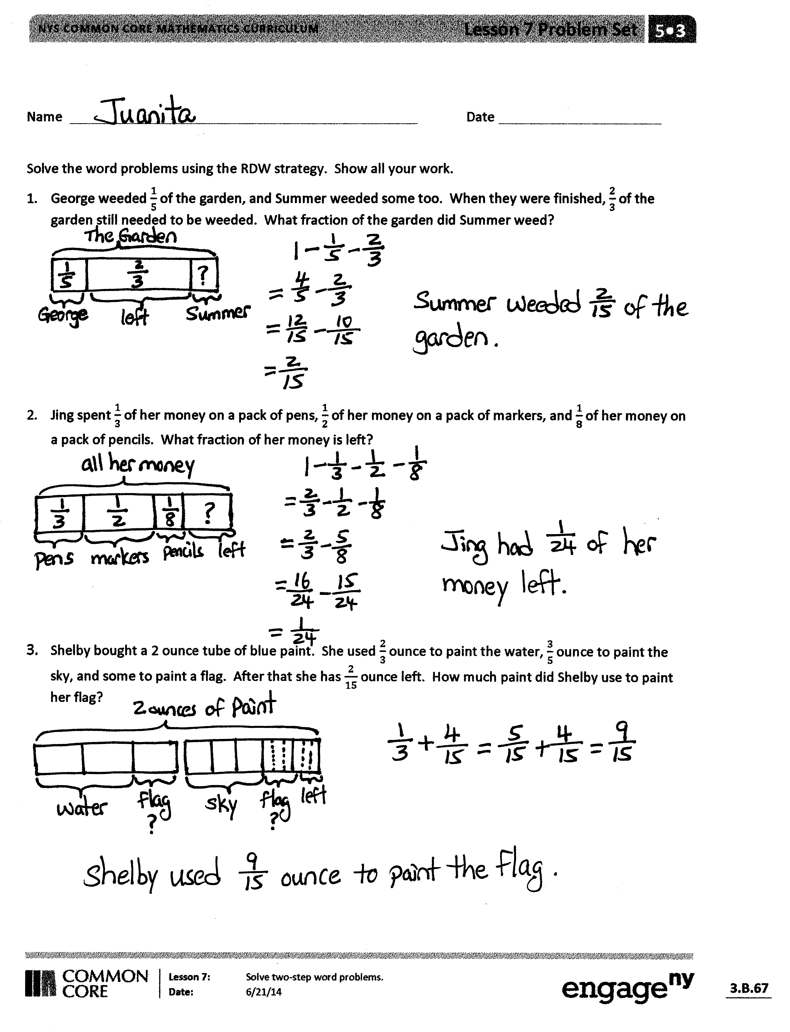Student Debrief (10 minutes)

**Lesson Objective:** Solve two-step word problems.

The Student Debrief is intended to invite reflection and active processing of the total lesson experience.

Invite students to review their solutions for the Problem Set. They should check work by comparing answers with a partner before going over answers as a class. Look for misconceptions or misunderstandings that can be addressed in the Debrief. Guide students in a conversation to debrief the Problem Set and process the lesson.

T: Bring your Problem Set to the Debrief. Share, check, and/or explain your answers to your partner.

S: (Work together for 2 minutes.)

T: (Circulate and listen to students’ explanations while they work, and then review answers.)

T: Let’s take a look at two different strategies for solving Problem 4.



*Solution 1*



*Solution 2*

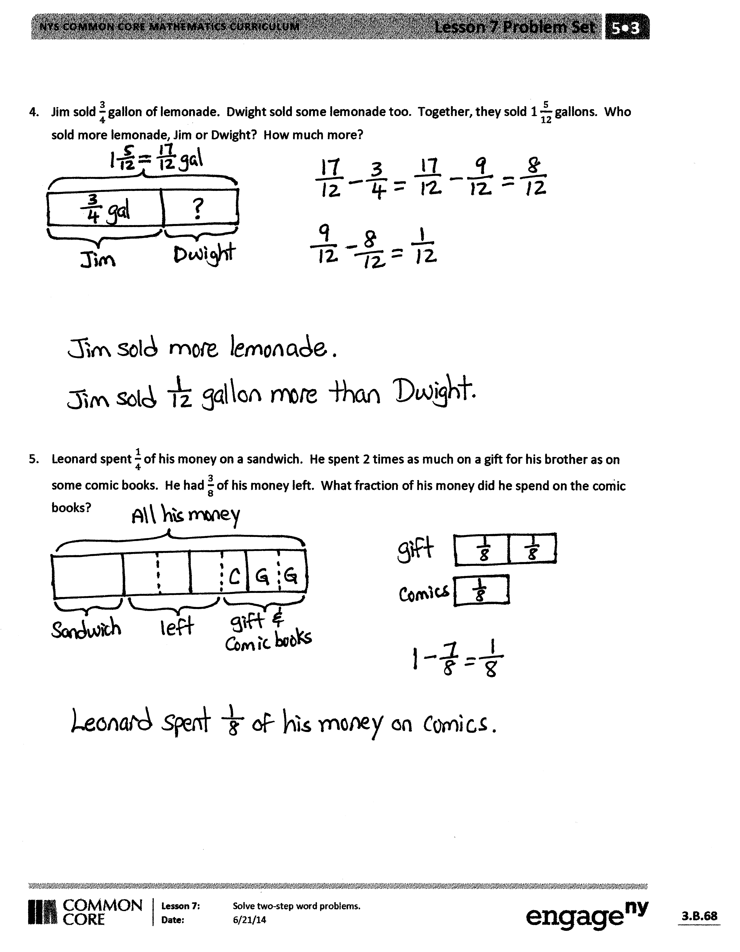T: What do you notice about the 2 different drawings?

S: The first one shows the containers of lemonade, and the second one shows a tape diagram. 🡪 Both drawings are different, but they both have the part–part–whole relationship.

T: Let’s look at them closely. How is Jim’s container of gallon of lemonade represented in the tape diagram? Turn and share.

S: Instead of drawing a container of gallon, Jim’s lemonade is now a part of a whole in the tape diagram.

T: How is Dwight’s container of lemonade represented in the tape diagram? Turn and share.

S: (Share.) Since we don’t know how much lemonade Dwight sold, we put a question mark in the container. But in the tape diagram, it’s a missing part of a whole.

T: Look at both drawings. How is the whole represented? Turn and share.

S: (Share.) The drawing on the left shows gallons of lemonade in the containers. The drawing on the right shows the whole in a tape diagram created by Jim and Dwight.

T: What if I change the numbers in this problem and make them into larger units? For example, Jim has gallon, and the total is gallon. Which drawing do you think is easier to draw and represent the new problem? Turn and share.

|  |  |
| --- | --- |
|  | NOTES ON  MULTIPLE MEANS  OF REPRESENTATION: |

Ensure English language learners are sitting close to the displayed work during the Debrief, so that even when they lose the conversation’s thread, they can analyze and learn from the student work.

English language learners may prefer the more concrete drawing of the gallons of lemonade. The explicit connection between the two representations is a strong bridge to understanding the tape diagram.

S: (Share.) That’s too many containers to draw. 🡪 It’s easier to draw the new problem using the tape diagram. 🡪 It’s faster to label the part–part–whole in the tape diagram than it is to draw all of the containers.

**MP.3**

T: The tape diagram is much easier to use, especially with larger numbers.

T: What do you notice about their methods of solving this problem?

S: The second one started with the addition sentence, but the first one started with the subtraction sentence .

T: Turn and share with your partner, and follow each solution strategy step by step. Share what is the same and different about them.

S: (Share.)

T: If you have to solve a similar problem again, what kind of drawing and solution strategy would you use? Turn and share.

S: (Share.)

Exit Ticket (3 minutes)

After the Student Debrief, instruct students to complete the Exit Ticket. A review of their work will help you assess the students’ understanding of the concepts that were presented in the lesson today and plan more effectively for future lessons. You may read the questions aloud to the students.

[1]

[2]

Name Date

Solve the word problems using the RDW strategy. Show all of your work.

1. George weeded of the garden, and Summer weeded some, too. When they were finished, of the garden still needed to be weeded. What fraction of the garden did Summer weed?
2. Jing spent of her money on a pack of pens, of her money on a pack of markers, and of her money on a pack of pencils. What fraction of her money is left?
3. Shelby bought a 2-ounce tube of blue paint. She used ounce to paint the water, ounce to paint the sky, and some to paint a flag. After that she has ounce left. How much paint did Shelby use to paint her flag?
4. Jim sold gallon of lemonade. Dwight sold some lemonade, too. Together, they sold gallons. Who sold more lemonade, Jim or Dwight? How much more?
5. Leonard spent of his money on a sandwich. He spent 2 times as much on a gift for his brother as on some comic books. He had of his money left. What fraction of his money did he spend on the comic books?

Name Date

Solve the word problem using the RDW strategy. Show all of your work.

Mr. Pham mowed of his lawn. His son mowed of it. Who mowed the most? How much of the lawn still needs to be mowed?

Name Date

Solve the word problems using the RDW strategy. Show all of your work.

1. Christine baked a pumpkin pie. She ate of the pie. Her brother ate of it and gave the leftovers to his friends. What fraction of the pie did he give to his friends?
2. Liang went to the bookstore. He spent of his money on a pen and of it on books. What fraction of his money did he have left?
3. Tiffany bought kg of cherries. Linda bought kg of cherries less than Tiffany. How many kilograms of cherries did they buy altogether?

1. Mr. Rivas bought a can of paint. He used of it to paint a bookshelf. He used of it to paint a wagon. He used some of it to paint a birdhouse and has of the paint left. How much paint did he use for the birdhouse?
2. Ribbon A is m long. It is m shorter than Ribbon B. What’s the total length of the two ribbons?

1. circle the equivalent fraction
2. circle the equivalent fraction