Lesson 6

Objective: Subtract fractions from numbers between 1 and 2.

Suggested Lesson Structure

 Fluency Practice (10 minutes)

 Application Problem (8 minutes)

 Concept Development (32 minutes)

 Student Debrief (10 minutes)

**Total Time (60 minutes)**

Fluency Practice (10 minutes)

* Name the Fraction to Complete the Whole **4.NF.3b** (4 minutes)
* Taking from the Whole **5.NF.7** (3 minutes)
* Fraction Units to Ones and Fractions **5.NF.7** (3 minutes)

Name the Fraction to Complete the Whole (4 minutes)

|  |  |
| --- | --- |
|  | NOTES ON  MULTIPLE MEANS  OF ACTION AND EXPRESSION: |
| As a variation to the Name the Fraction to Complete the Whole Fluency exercise, have students quiz each other. Homogeneous groups may be beneficial.  For students working below grade level, provide a bar diagram template in their personal white boards so that students can quickly draw each fraction and see the unknown, or missing, part.  For students working above grade level, give them as a target number. Their partner can give them any fraction less than one. They tell how much to add or subtract to arrive at one half, e.g., 🡪 Add , 🡪 Subtract . | |

Note: This fluency activity is a quick mental exercise of   
part–part–whole understanding as it relates to fractions.

T: I’ll say a fraction, and you say the missing part to make one whole. Ready? .

S: .

T: .

S: .

T: .

S: .

T: .

S: .

T: .

S: .

T: .

S: .

T: Share your strategy for making one whole with a partner.

T: With your partner, take turns giving each other problems to solve. You have one minute.

Taking from the Whole (3 minutes)

Materials: (S) Personal white board

Note: This fluency activity strengthens mental math and lays the foundation for today’s Concept Development in which students subtract from numbers between 1 and 2.

T: I’ll say a subtraction expression. You say the answer.   
1 – 1 half.

|  |  |
| --- | --- |
|  | NOTES ON  MULTIPLE MEANS  OF ACTION AND EXPRESSION: |
| If students struggle to answer chorally, write the subtraction sentences in numerical form on the board. Have students answer the problems on their personal white boards. | |

S: 1 half.

T: 1 – 1 third.

S: 2 thirds.

T: 1 – 2 thirds.

S: 1 third.

T: 1 – 2 fifths.

S: 3 fifths.

T: 1 – 4 fifths.

S: 1 fifth.

Continue with the following possible sequence:

Fraction Units to Ones and Fractions (3 minutes)

Note: Students rapidly and mentally generate mixed numbers that are equivalent to fractions greater than 1 in preparation for today’s Concept Development.

T: I’ll say a fraction; you say it as a mixed number. Three halves.

S: One and one half.

T: Five halves.

S: Two and one half.

T: Seven halves.

S: Three and one half.

T: Eleven halves.

S: Five and one half.

Continue with the following possible sequence:

Application Problem (8 minutes)

The Napoli family combined two bags of dry cat food in a plastic container. One bag had kg of cat food. The other bag had kg. What was the total weight of the container after the bags were combined?

T: Use the RDW process to solve the problem independently. Use your questions to support you in your work. What do you see? Can you draw something? What conclusions can you make from your drawing?

|  |  |
| --- | --- |
|  | NOTES ON  MULTIPLE MEANS  OF ACTION AND EXPRESSION: |
| At this point, some students may realize they can combine their drawings onto one model, rather than drawing them separately as in previous lessons. Students working above grade level should be encouraged to combine their drawings into one model. | |

T: We will analyze two solution strategies in four minutes.

After four minutes, lead students through a brief comparison of a more concrete strategy such as the one below, on the left, and the more abstract strategy below, on the right. Ensure students realize that both answers, and , are correct.

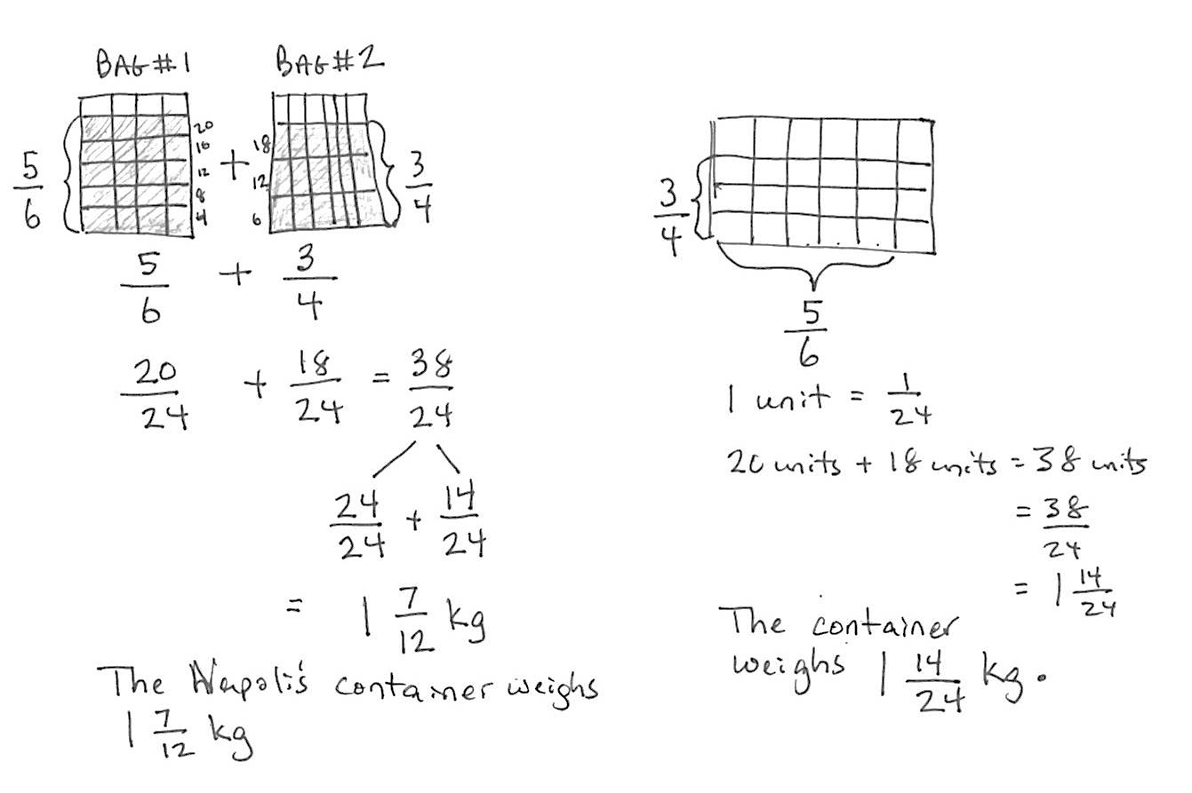

*Solution 1*

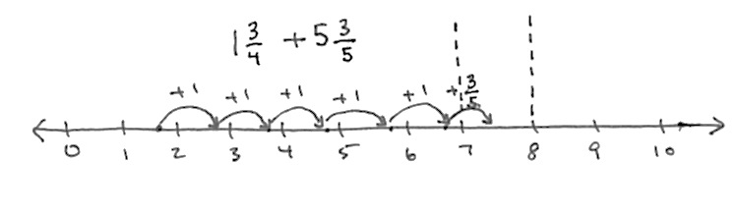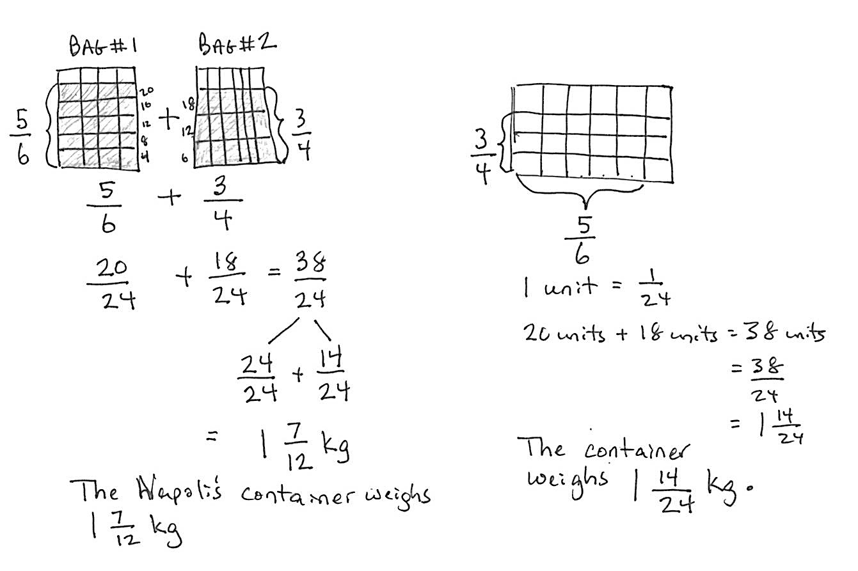

*Solution 2*



Note: This Application Problem reviews addition of fractions with unlike denominators, using visual models, and connects to today’s subtraction of unlike units (between 1 and 2).

Concept Development (32 minutes)

Materials: (S) Personal white board

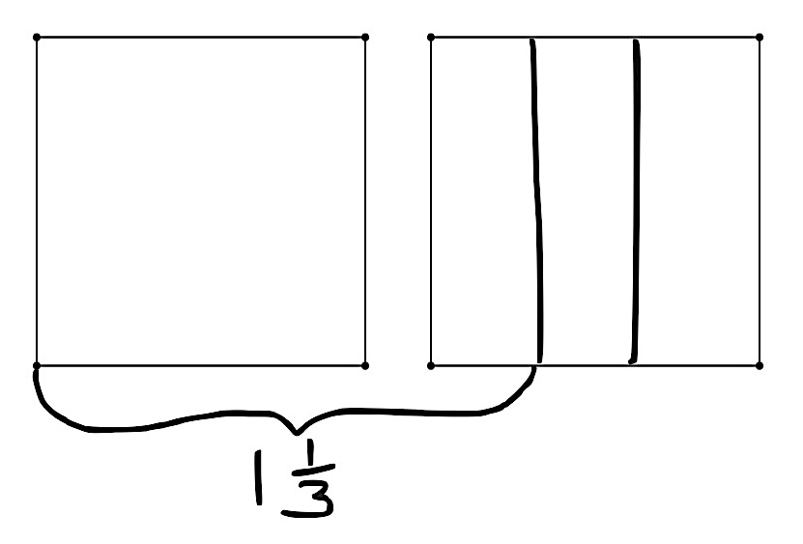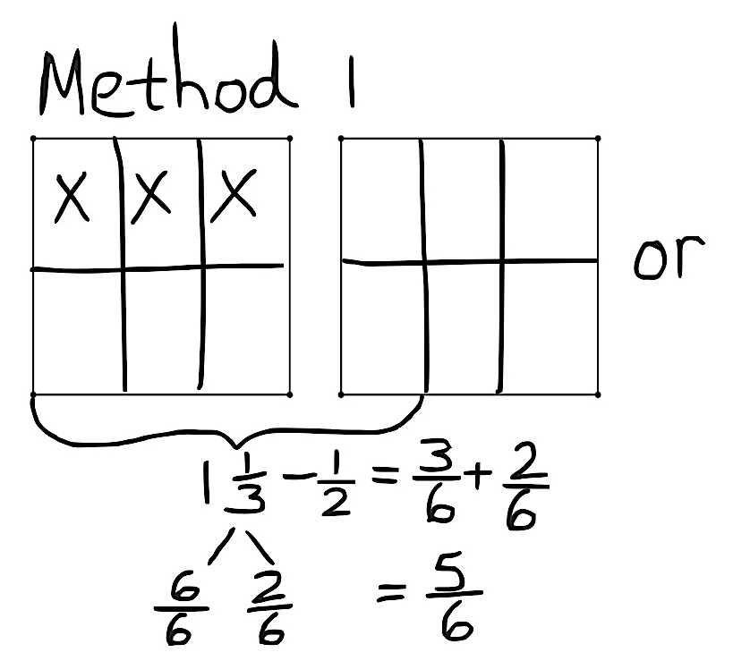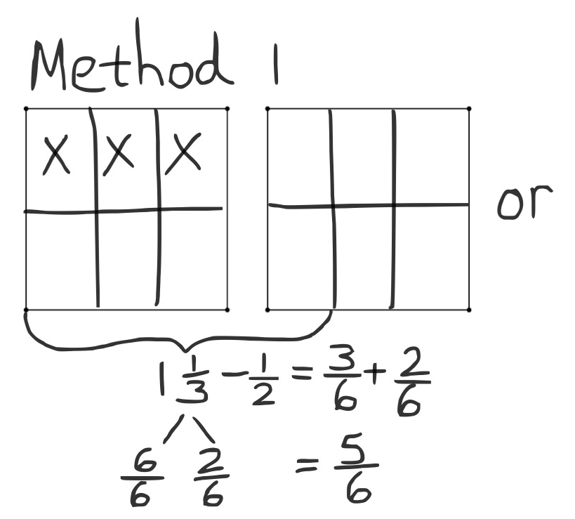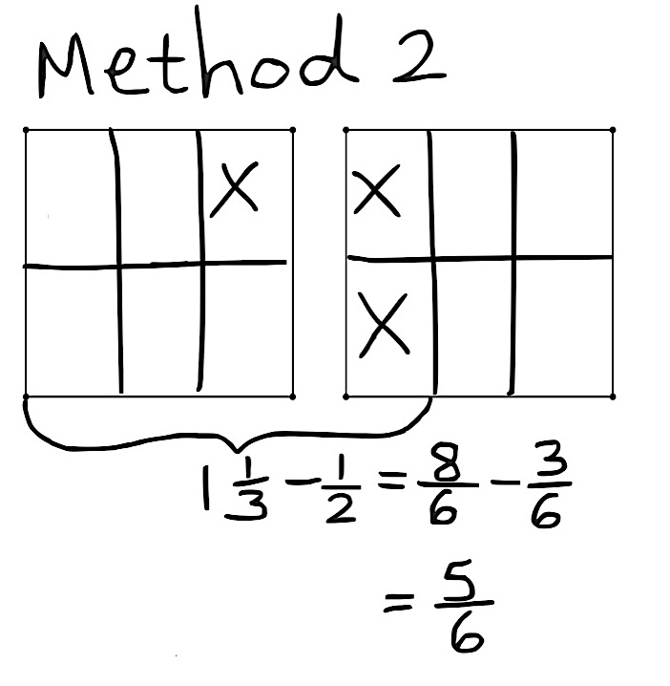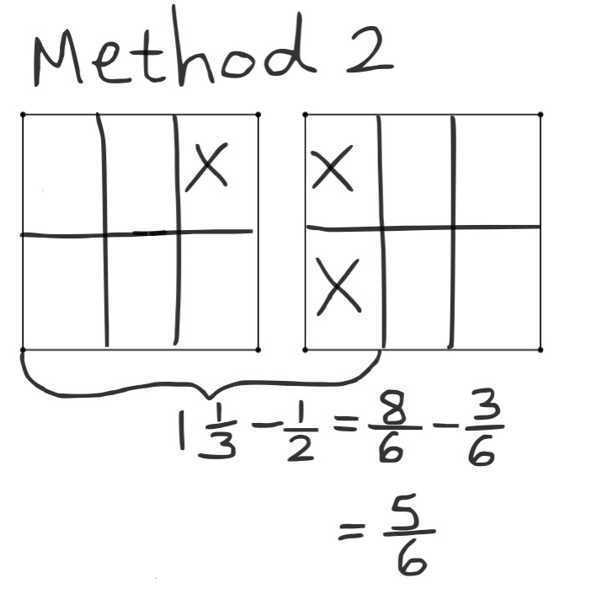

**Problem 1:**

T: (Write .) Read the subtraction expression.

S: 1 and 1 third minus 1 half.

T: How many thirds is 1 and 1 third?

S: 4 thirds.

|  |  |
| --- | --- |
|  | NOTES ON  MULTIPLE MEANS  OF ENGAGEMENT: |
| Have students use their personal white boards to follow along with the drawings that are demonstrated on the board, so they can match the language with the model and the steps of the process. At key moments, have students orally label the parts of the model to practice using language. | |

T: (Draw 1 whole and 1 third.) What should we do now? Turn and talk to your partner.

S: Make like units.

T: How many new smaller units are in each whole?

S: 6 units.

T: 4 thirds is how many sixths?

S: 8 sixths.

T: 1 half is how many sixths?

S: 3 sixths.

T: Looking at my drawing, how would you subtract 3 sixths or a half? Discuss this with your partner.

S: You can take the half from the whole and then add back the third. 🡪 Then, you are adding to subtract? 🡪 Yes, you are adding the part you had left after you take away. 🡪 It makes it easier because we know really well how to subtract any fraction from a one whole. 🡪 Yeah, but it’s just easier for me to take the 3 sixths from the 8 sixths. 🡪 For me, it’s easier to take it from the whole and add back the rest.

**MP.5**

T: It’s like subtracting 80 from 130. It’s easier for me to take 80 from 100 and add 20 and 30.

S: Can we subtract it either way?

T: Of course. Choose the way that is easiest for you.

T: Let’s call the different solution strategies Method 1 and Method 2. If you use Method 1, let’s record using a number bond. Solve and share your solution with a partner.

S: (Solve and share.) 8 sixths – 3 sixths = 5 sixths. 🡪 1 and 1 third – 1 half = 5 sixths.

Problem 2:

T: (Write .) I’ll draw one rectangle to show 1, and a second rectangle to show 1 fifth. (Model.)

T: Are these units the same? Can I use fifths to subtract thirds?

S: No.

T: Explain to your partner how to solve this problem. Use both methods.

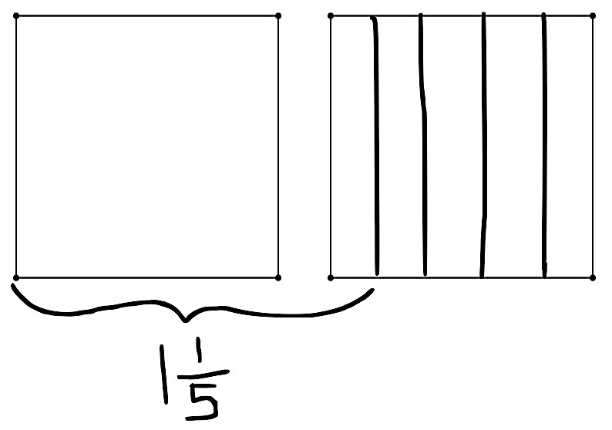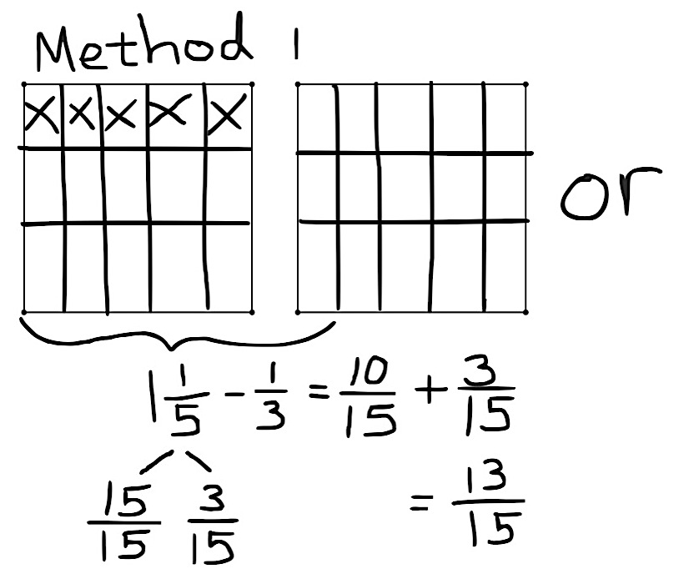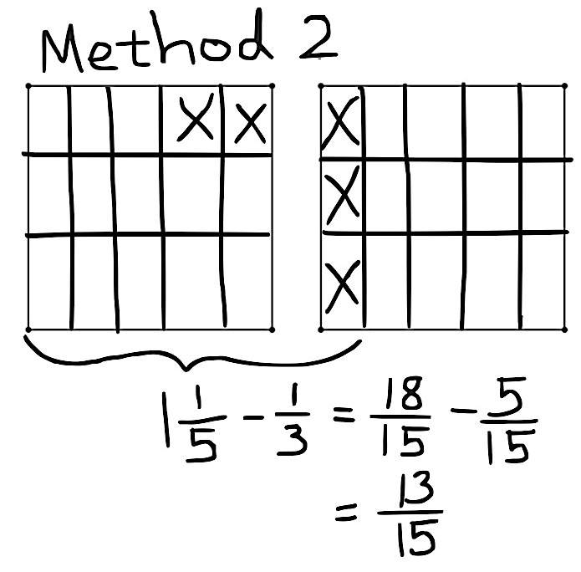

Problem 3:

The additional complexity here is the subtraction of a non-unit fraction.

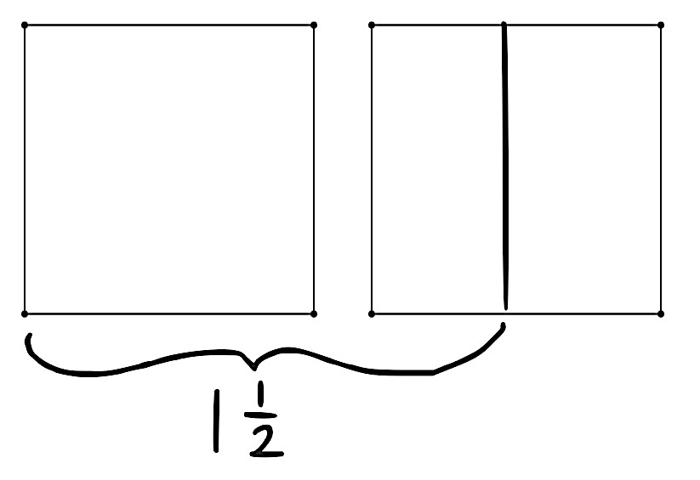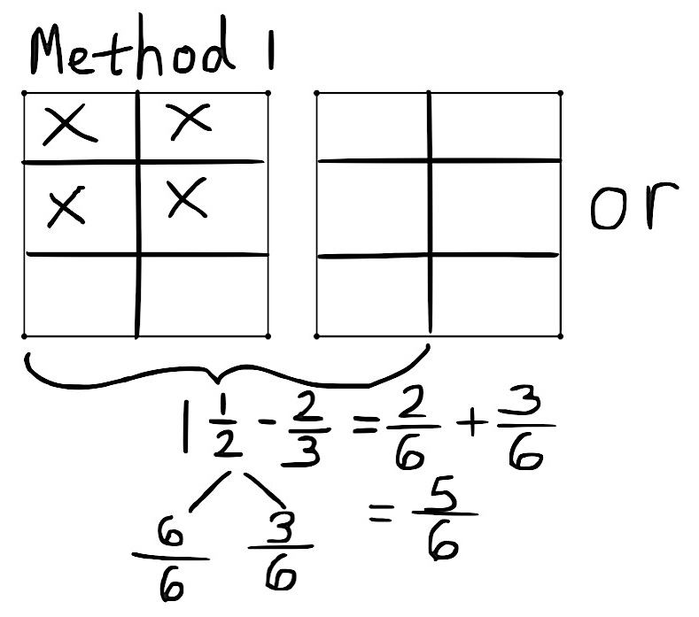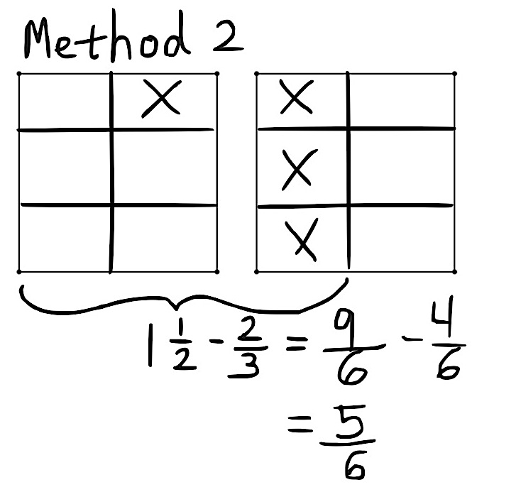

Problem 4:

In this problem, the new complexity is the use of two non-unit fractions.

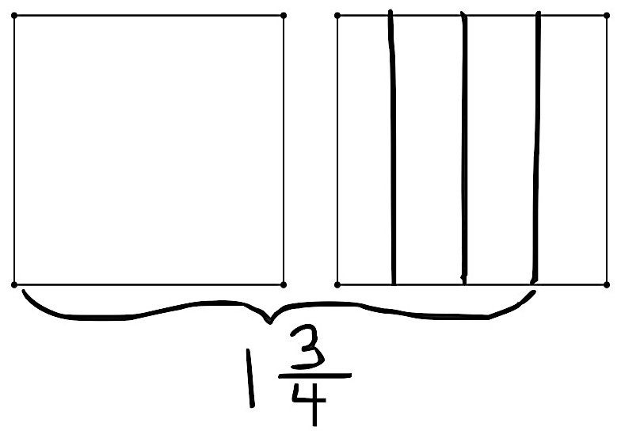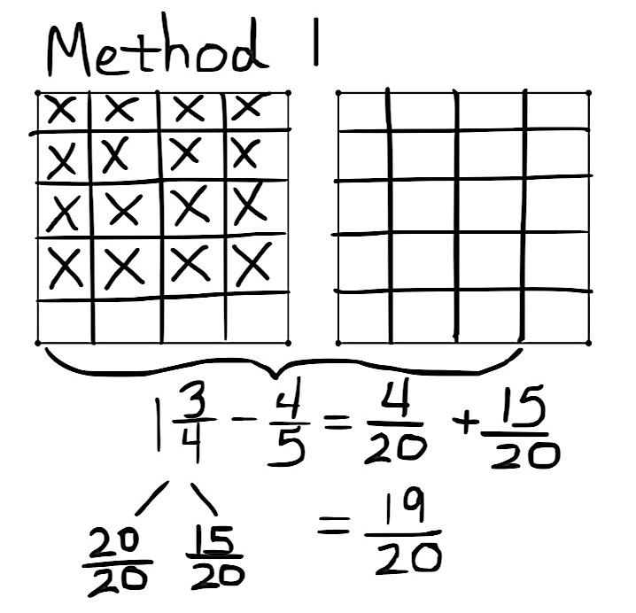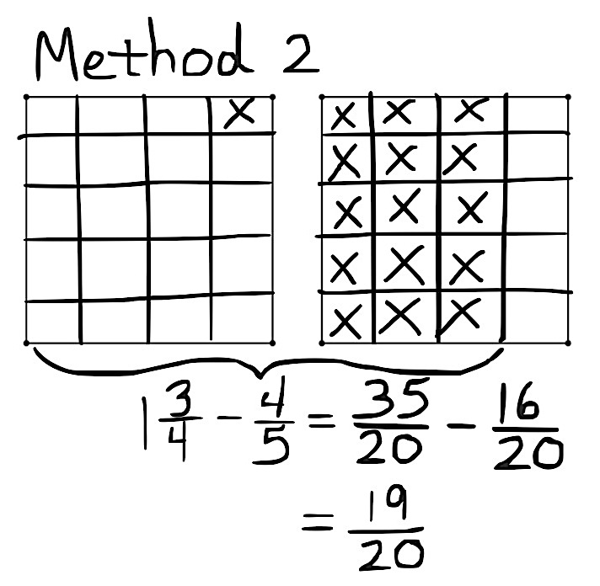

Problem 5:

T: (After students work, display Method 1 on the board.) Tell your neighbor what alternate strategy was used in this model.

S: (Share.)

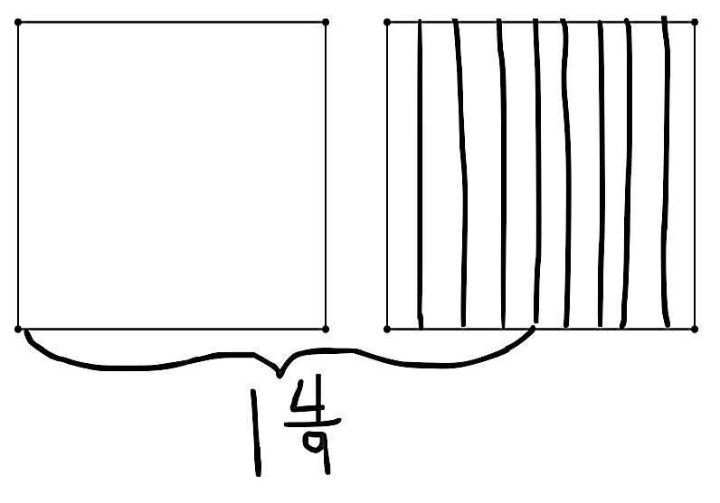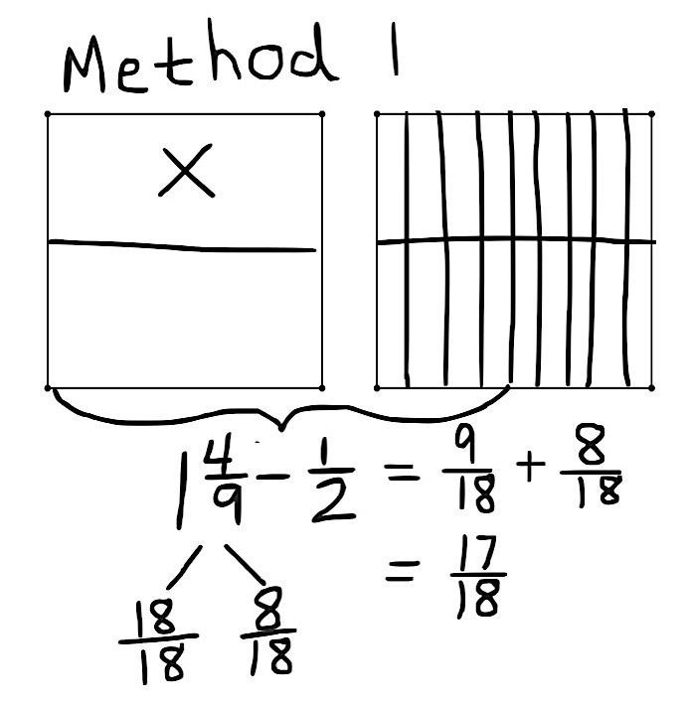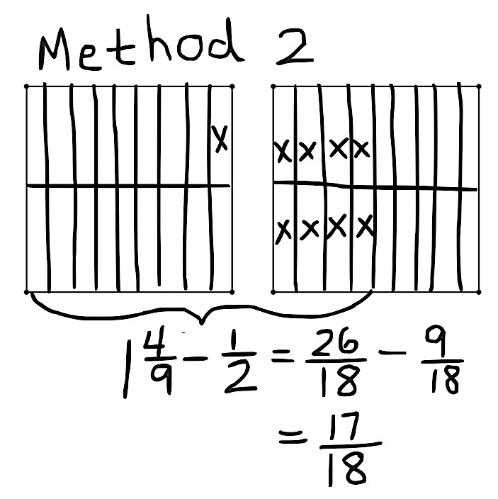

Problem Set (10 minutes)

|  |  |
| --- | --- |
|  | NOTES ON  MULTIPLE MEANS  OF ACTION AND EXPRESSION: |
| As students share out various strategies, use a modified text representation activity. Have the rest of the class demonstrate the ideas their peers orally express on personal white boards. | |

Students should do their personal best to complete the Problem Set within the allotted 10 minutes. For some classes, it may be appropriate to modify the assignment by specifying which problems they work on first. Some problems do not specify a method for solving. Students should solve these problems using the RDW approach used for Application Problems.

Student Debrief (10 minutes)

**Lesson Objective:** Subtract fractions from numbers between 1 and 2.

The Student Debrief is intended to invite reflection and active processing of the total lesson experience.

Invite students to review their solutions for the Problem Set. They should check work by comparing answers with a partner before going over answers as a class. Look for misconceptions or misunderstandings that can be addressed in the Debrief. Guide students in a conversation to debrief the Problem Set and process the lesson.

T: Take one minute to compare your work with a partner’s. (Circulate and look for common errors or student work to use instructionally.)

T: I’ll read the answers to Problems 1 and 2 now. (Read answers aloud.)

T: (Students correct their work for about 2 minutes.) If you had no errors, I will assign you to support a peer.

T: Compare these problems with a partner:

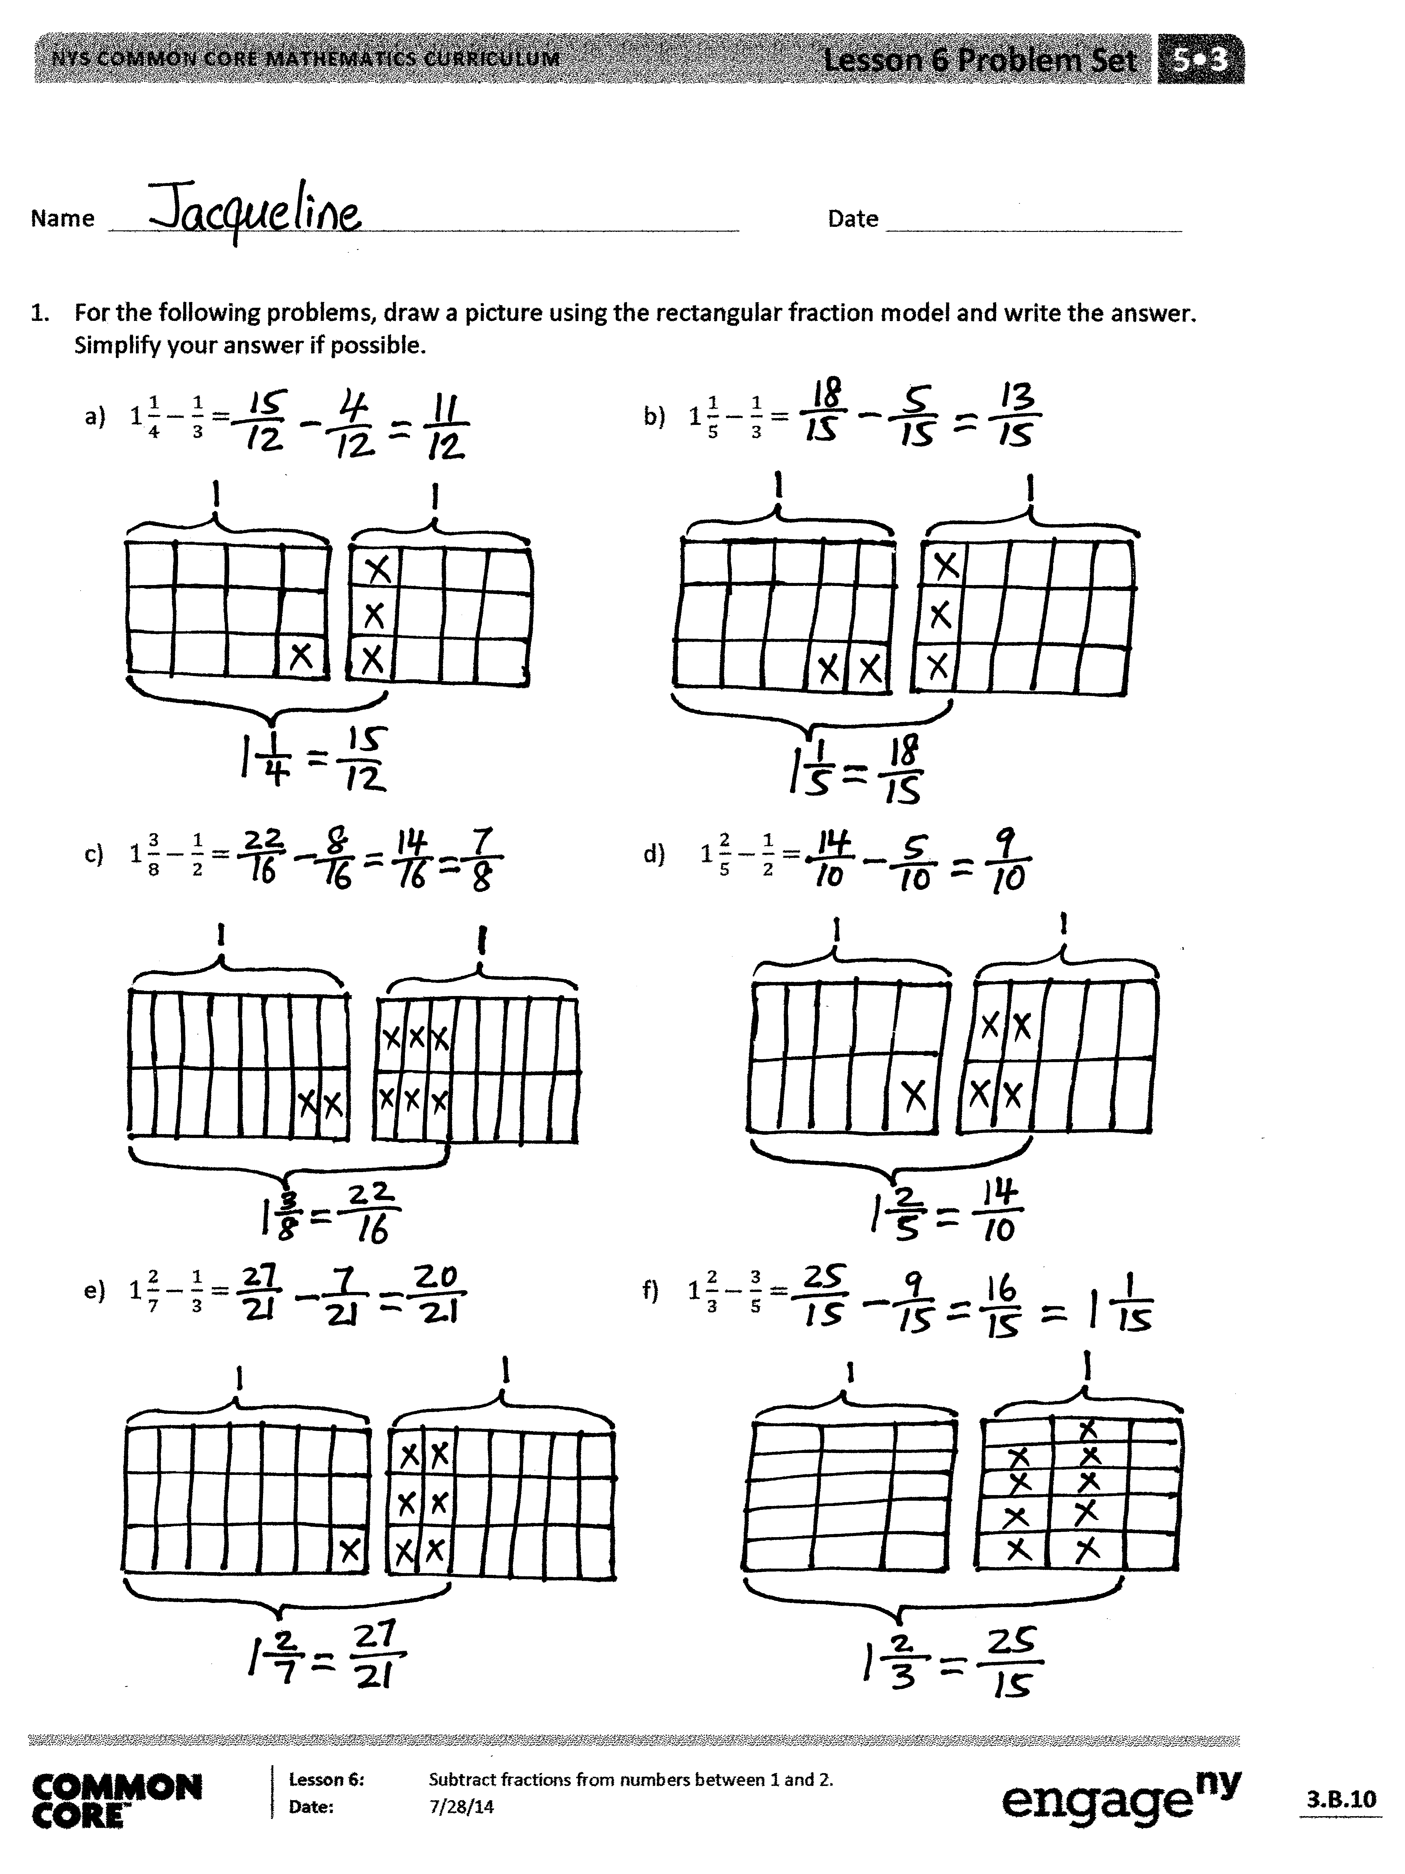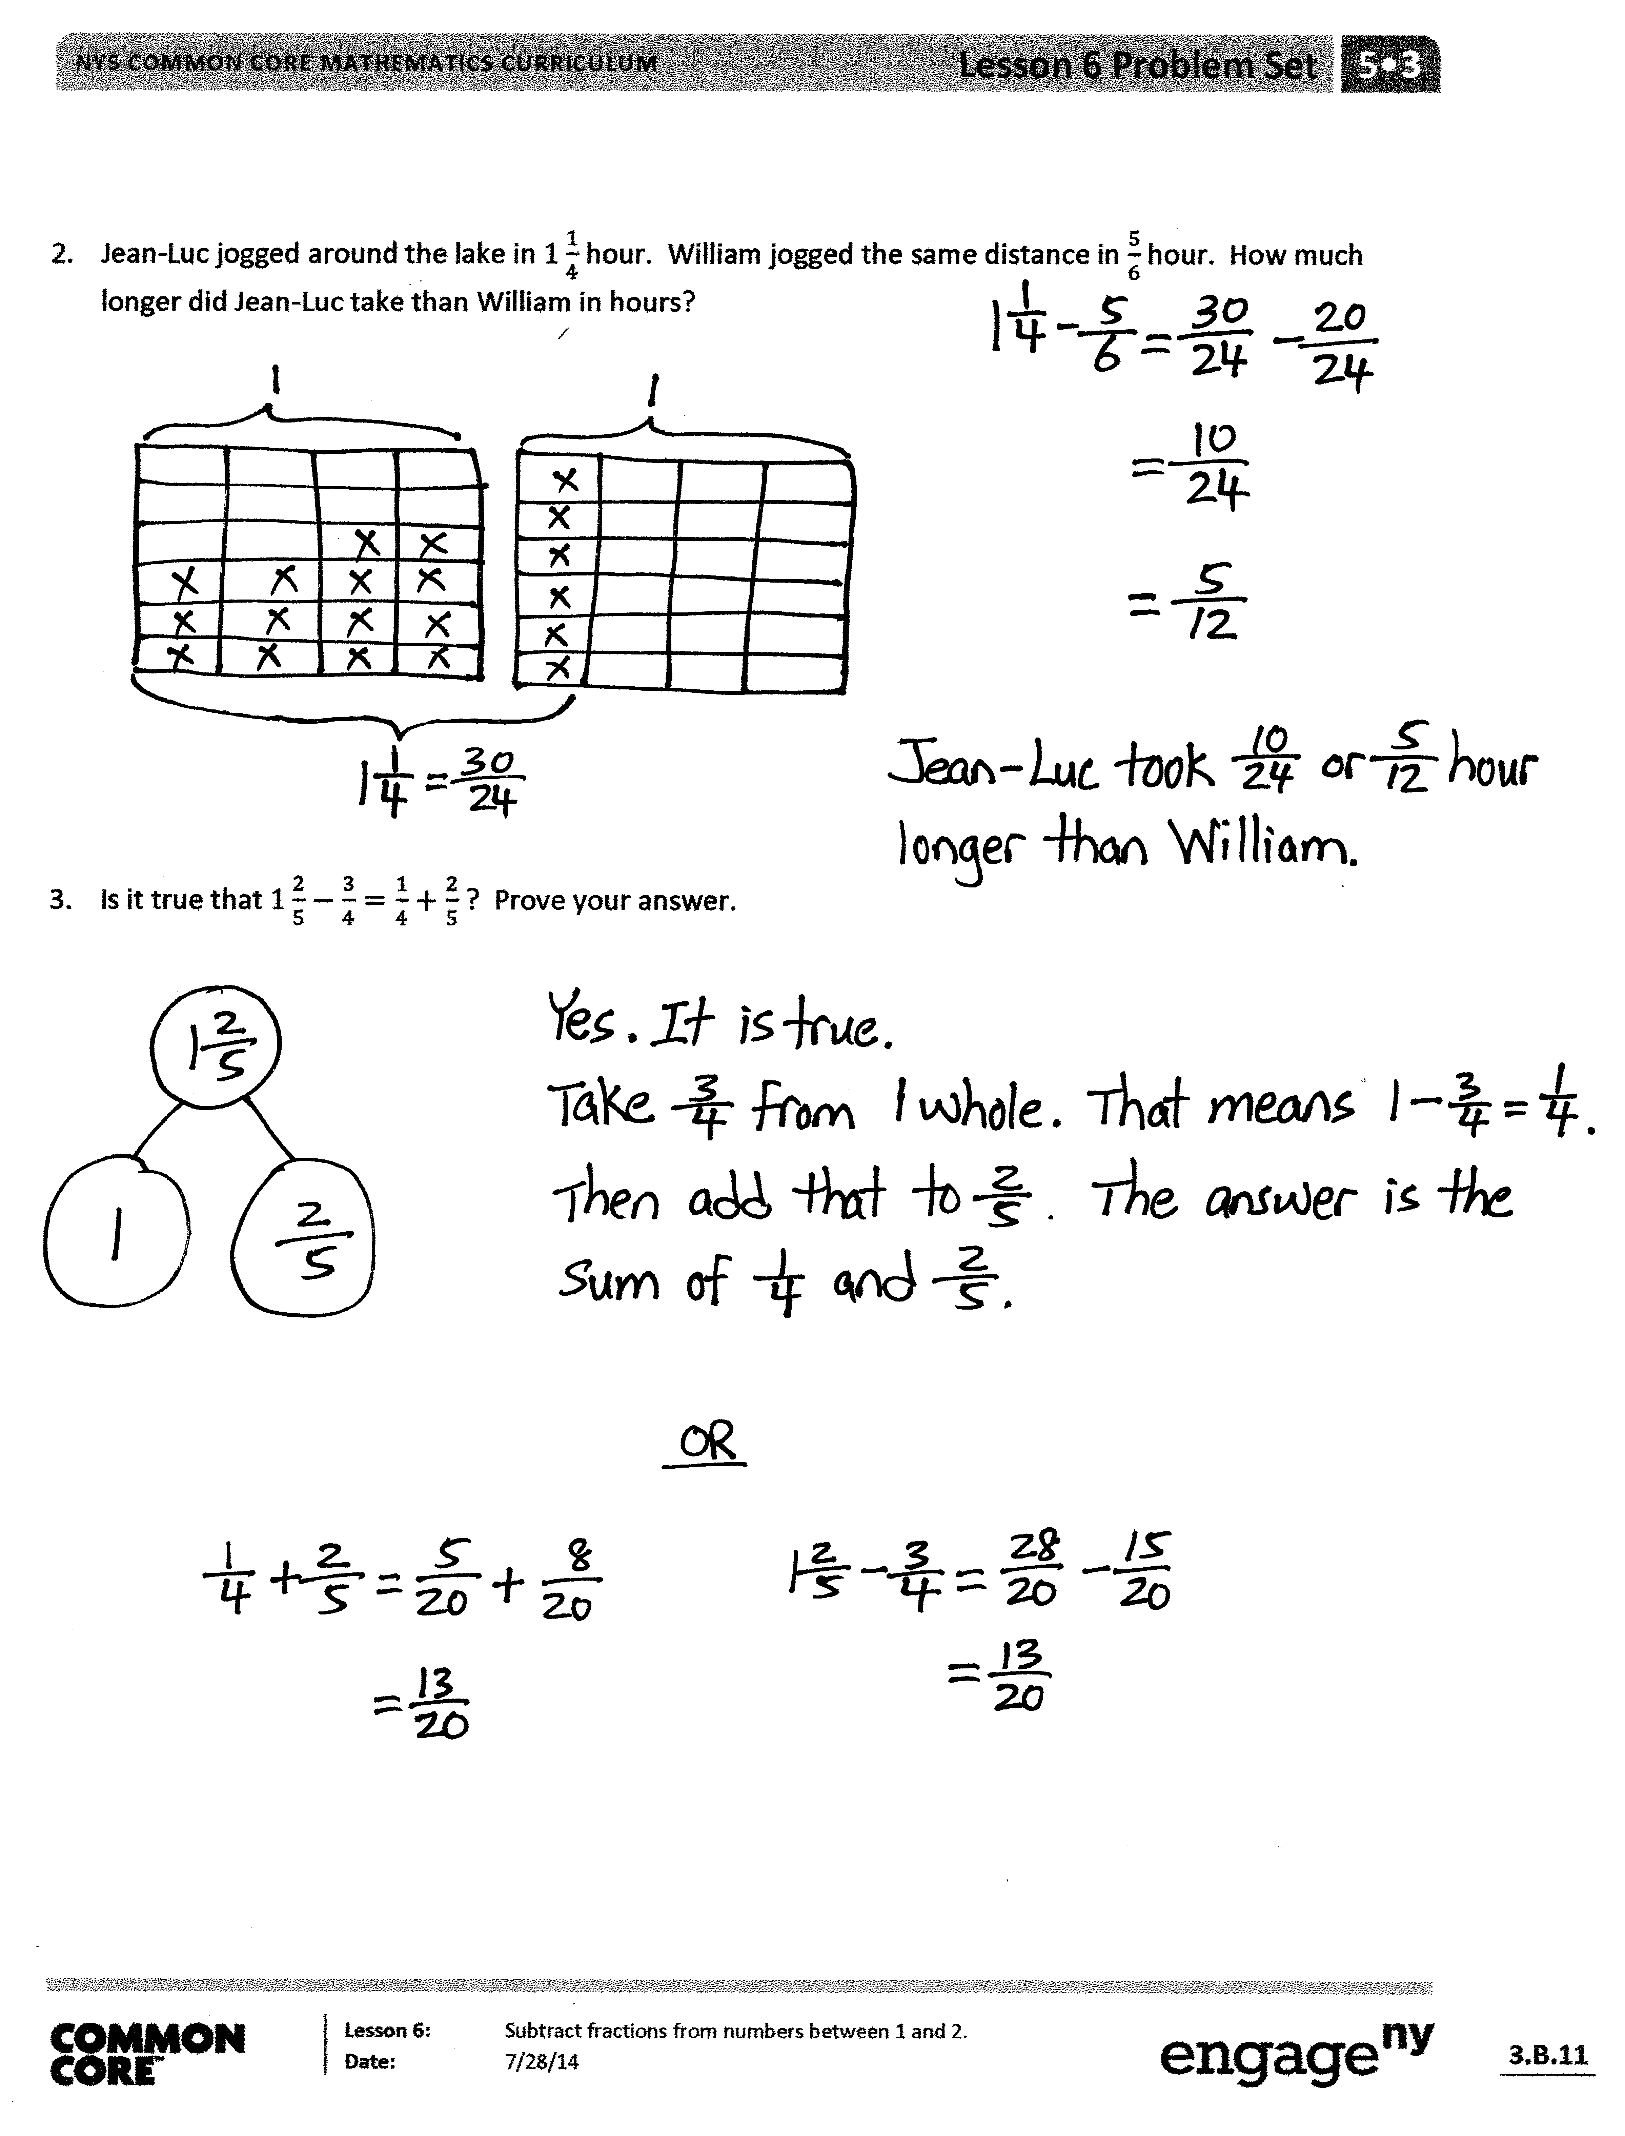

* 1(a) and (b)
* 1(c) and (d)
* 1(e) and (f)

S: I remember that is , so then   
is less than 1. 🡪 It’s the same with, the answer is less than 1. 🡪 You could use the same strategy on all of them.

T: Jacqueline, can you explain your solution to Problem 2?

S: I realized that the problem was really easy. It’s just subtraction. I could take from 1 and add it to. and are easy because they are just unit fractions and . So, the answer is   
10 twenty-fourths.

T: Did anyone solve it differently?

S: Yes. I just converted the fractions to like units and subtracted. So, it was 24 twenty-fourths and 6 twenty-fourths.   
30 twenty-fourths – 20 twenty-fourths = 10 twenty-fourths.

Exit Ticket (3 minutes)

After the Student Debrief, instruct students to complete the Exit Ticket. A review of their work will help you assess the students’ understanding of the concepts that were presented in the lesson today and plan more effectively for future lessons. You may read the questions aloud to the students.

Name Date

1. For the following problems, draw a picture using the rectangular fraction model and write the answer. Simplify your answer, if possible.

|  |  |
| --- | --- |
|  |  |
|  |  |
|  |  |

1. Jean-Luc jogged around the lake in hour. William jogged the same distance in hour. How much longer did Jean-Luc take than William in hours?
2. Is it true that ? Prove your answer.



Name Date

For the following problems, draw a picture using the rectangular fraction model and write the answer. Simplify your answer, if possible.

1. b.

Name Date

1. For the following problems, draw a picture using the rectangular fraction model and write the answer. Simplify your answer, if possible.

|  |  |
| --- | --- |
|  |  |
|  |  |
|  |  |
|  |  |

1. Sam had m of rope. He cut off m and used it for a project. How much rope does Sam have left?

1. Jackson had kg of fertilizer. He used some to fertilize a flower bed and he only had kg left. How much fertilizer was used in the flower bed?