Lesson 3
Objective: Add fractions with unlike units using the strategy of creating equivalent fractions.

Suggested Lesson Structure
 Fluency Practice (12 minutes)
 Application Problem (5 minutes)
 Concept Development (33 minutes)
 Student Debrief (10 minutes)
Total Time (60 minutes)
Fluency Practice (12 minutes)
- Sprint: Equivalent Fractions 5.NF.1 (8 minutes)
- Adding Like Fractions 5.NF.1 (2 minutes)
- Rename the Fractions 5.NF.3 (2 minutes)
Sprint: Equivalent Fractions (8 minutes)
Materials: (S) Equivalent Fractions Sprint
Note: Students generate common equivalent fractions mentally and with automaticity (i.e., without performing the indicated multiplication).
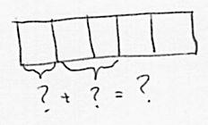
Adding Like Fractions (2 minutes)

NOTES ON
MULTIPLE MEANS
OF REPRESENTATION:
Rather than name the fraction, draw it, and ask students to write the corresponding equation on personal white boards. Use brackets to indicate the addends.

Note: This fluency activity reviews adding like units and lays the foundation for today’s task of adding unlike units.
T: Let’s add fractions mentally. Say answers as whole numbers when possible.
T: $\frac{1}{3}+\frac{1}{3}=$ ____?
S: $\frac{2}{3}$.
T: $\frac{1}{4}+\frac{1}{4}=$ ____?
S: $\frac{2}{4}$.
T: $\frac{1}{5}+\frac{2}{5}=$ ____?
S: $\frac{3}{5}$ .
T: $\frac{3}{7}+\frac{4}{7}=$ ____?
S: 1.
T: $\frac{1}{4}+\frac{1}{3}+\frac{3}{4}+\frac{2}{3}=$ ____?
S: 2.
Continue and adjust to meet student needs. Use a variety of fraction combinations.
Rename the Fractions (2 minutes)
Materials: (S) Personal white board
Note: This fluency activity is a quick review of generating equivalent fractions, which students use as a strategy to add unlike units during today’s Concept Development.
T: (Write $\frac{2}{4}$.) Rename the fraction by writing the largest units possible.
S: (Write $\frac{1}{2}$.)
T: (Write $\frac{3}{6}$.) Try this problem.
S: (Write $\frac{1}{2}$.)
Continue with the following possible sequence: $\frac{\text{6}}{\text{12}}\text{, }\frac{\text{3}}{\text{9}}\text{, }\frac{\text{2}}{\text{6}}\text{, }\frac{\text{4}}{\text{6}}\text{, }\frac{\text{6}}{\text{9}}\text{, }\frac{\text{2}}{\text{8}}\text{, }\frac{\text{3}}{\text{12}}\text{, }\frac{\text{4}}{\text{16}}\text{, }\frac{\text{12}}{\text{16}}\text{, }\frac{\text{9}}{\text{12}}\text{, and}\frac{\text{6}}{\text{8}}\text{.}$
Application Problem (5 minutes)
One ninth of the students in Mr. Beck’s class list red as their favorite color. Twice as many students call blue their favorite, and three times as many students prefer pink. The rest name green as their favorite color. What fraction of the students say green or pink is their favorite color?
Extension: If 6 students call blue their favorite color, how many students are in Mr. Beck’s class?

NOTES ON
MULTIPLE MEANS
OF ACTION AND EXPRESSION:
Students working above grade level may enjoy the challenge of an extension problem. If time permits, have one of the students model the extension problem on the board and share the solution with the class.

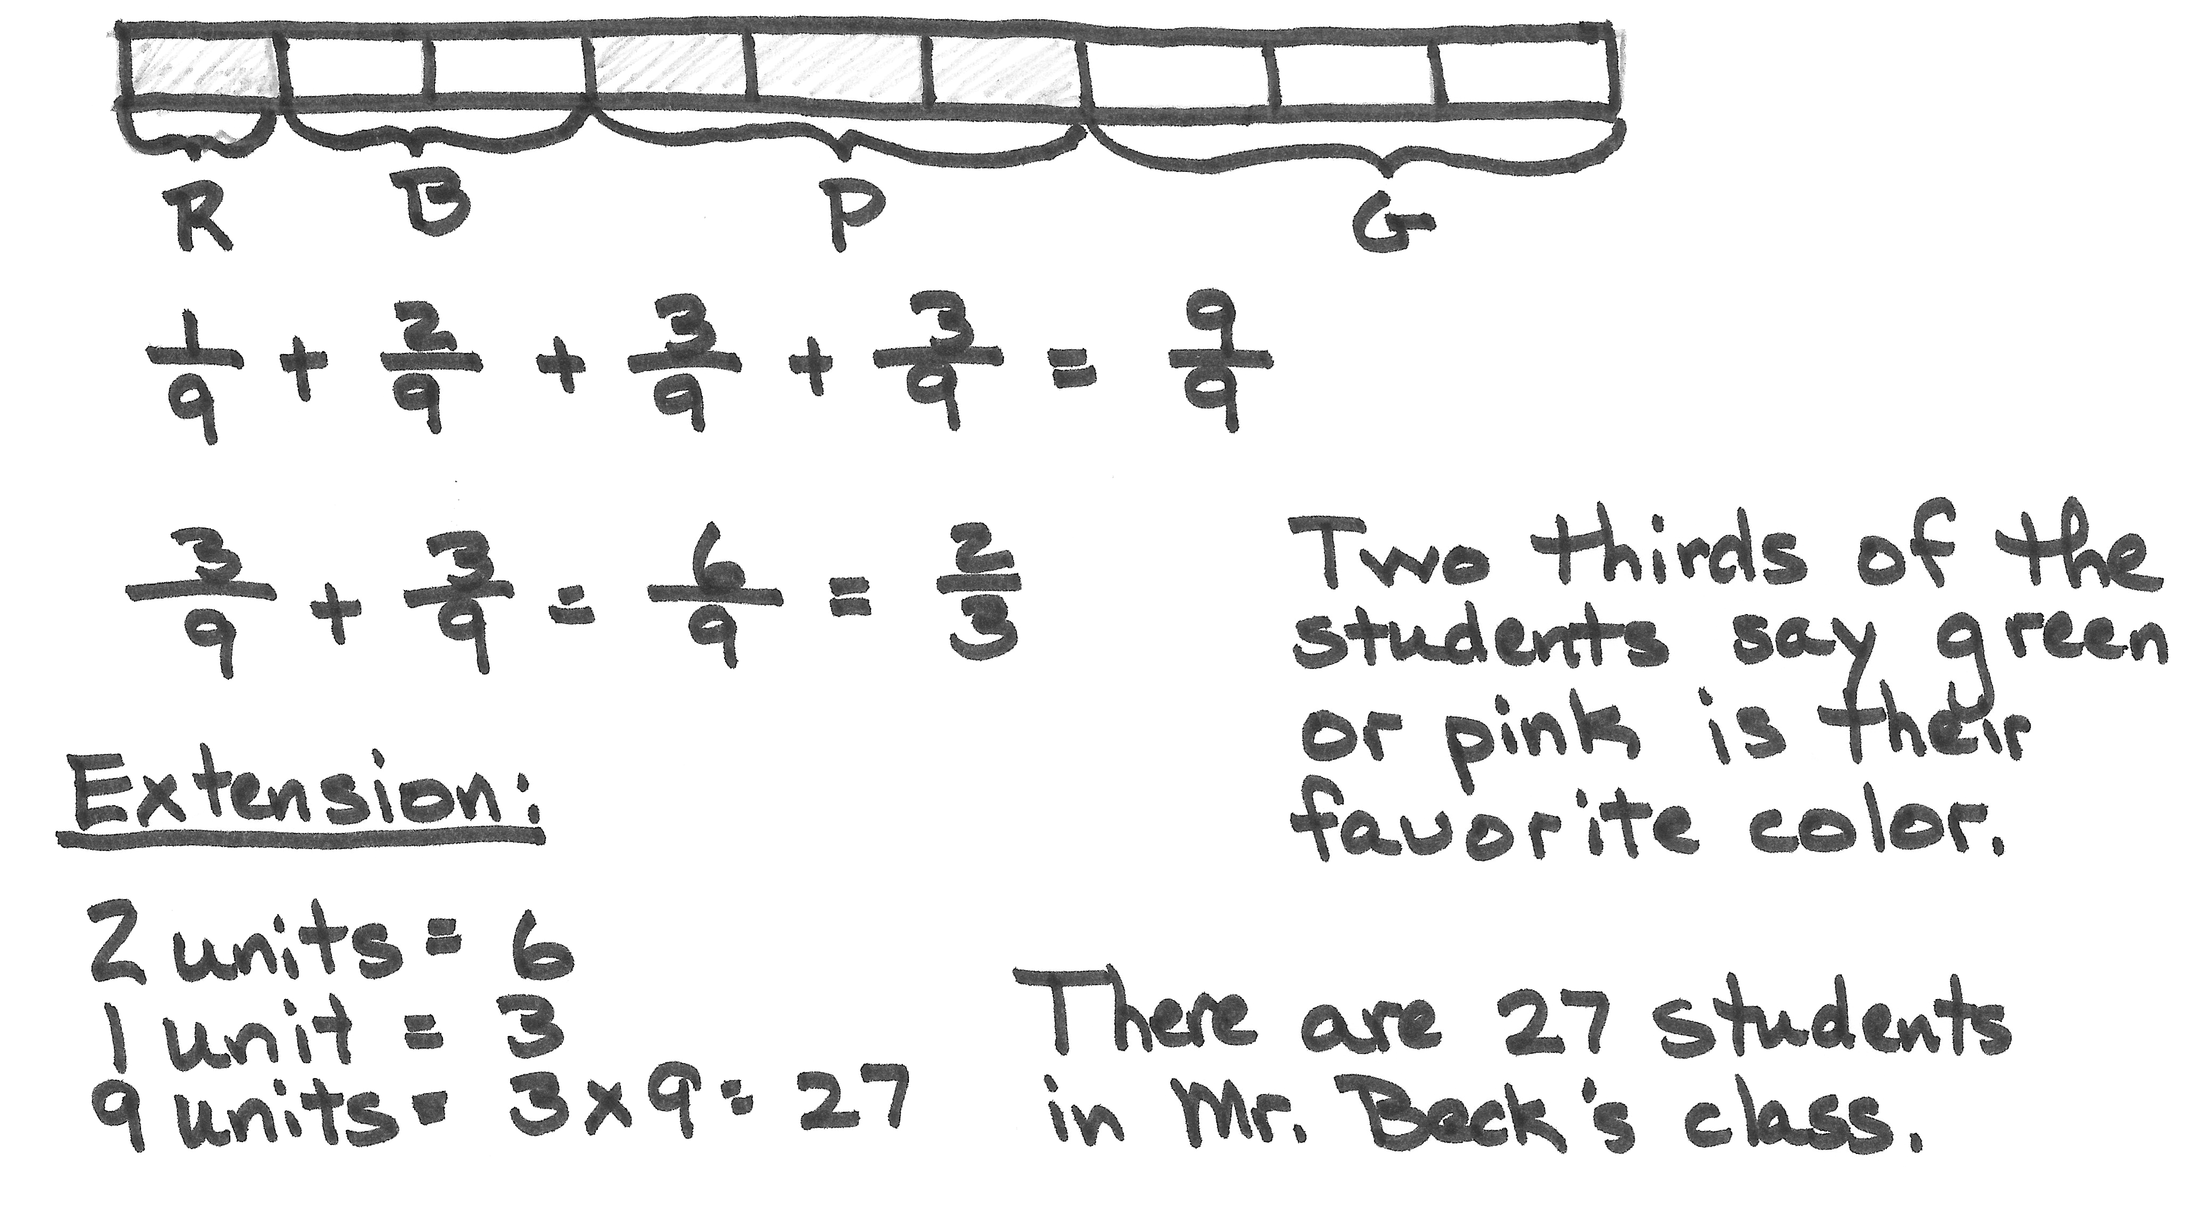

Concept Development (33 minutes)
Materials: (S) Personal white board, 2 pieces of $4\frac{1}{2}$" × $4\frac{1}{2}$" paper per student (depending on how the folding is completed before drawing the rectangular array model)
T: (Write 1 adult + 3 adults.) What is 1 adult plus 3 adults?
S: 4 adults.
T: 1 fifth plus 3 fifths?
S: 4 fifths.
T: We can add 1 fifth plus 3 fifths because the units are the same.
1 fifth + 3 fifths = 4 fifths.
$\frac{1}{5}+\frac{3}{5}=\frac{4}{5}$ .
T: (Write 1 child + 3 adults.) What is 1 child plus 3 adults?
S: We can’t add children and adults.

NOTES ON
MULTIPLE MEANS
OF ENGAGEMENT:
Folding paper is a concrete strategy that helps build conceptual understanding. This helps ease the hardest part of using a rectangular fraction model—recognizing the original fractions once the horizontal lines are drawn. Help students see
$\frac{1}{4}=\frac{2}{8}$ and $\frac{1}{2}=\frac{4}{8}$ by pointing and showing the following:
- $\frac{1}{4}=\frac{1}{8}+\frac{1}{8}$ .
- $\frac{1}{2}=\frac{1}{8}+\frac{1}{8}+\frac{1}{8}+\frac{1}{8}$ .

T: Why is that? Talk to your partner about that.
S: (Share.)
T: I heard Michael tell his partner that children and adults are not the same unit. We must replace unlike units with equivalent like units to add. What do children and adults have in common?
S: They are people.
T: Let’s add people, not children and adults. Say the addition sentence with people.
S: 1 person + 3 people = 4 people.
T: Yes. What about 1 one plus 4 ones?
S: 5 ones.
Problem 1: $\frac{1}{2}+\frac{1}{4}$
T: (Write $\frac{1}{2}+\frac{1}{4}$.) Can I add 1 half plus 1 fourth? Discuss with your partner. (Circulate and listen.) Pedro, could you share your thoughts?
S: I cannot add 1 half plus 1 fourth until the units are the same. We need to find like units.
T: Let’s first make like units by folding paper. (Lead students through the process of folding as shown.)
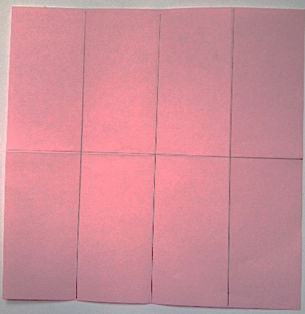
$\frac{1}{2}+\frac{1}{4} = \frac{4}{8}+\frac{2}{8}$

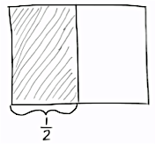
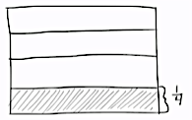
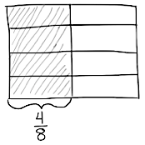
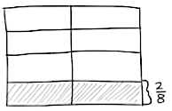
T: Now, let’s make like units by drawing. (Draw a rectangular fraction model.) How many units will I have if I partition 1 whole into smaller units of one half each?
S: 2 units.
T: (Partition the rectangle vertically into 2 equal units.) One half tells me to select how many of the 2 units?
S: One.
T: Let’s label our unit with $\frac{1}{2}$ and shade in one part. Now, let’s draw another whole rectangle. How many equal parts do I divide this whole into to make fourths?
S: Four.
T: (Partition the rectangle horizontally into 4 equal units.) One fourth tells me to shade how many units?
S: One.
T: Let’s label our unit with $\frac{1}{4}$ and shade in one part. Now, let’s partition our 2 wholes into the same size units. (Draw horizontal lines on the $\frac{1}{2}$ model and 1 vertical line on the $\frac{1}{4}$ model.) What fractional unit have we made for each whole?
S: Eighths.
T: How many shaded units are in $\frac{1}{2}$ ?
S: Four.
T: That’s right; we have 4 shaded units out of 8 total units. (Change the label from $\frac{1}{2}$ to $\frac{4}{8}$.) How many units are shaded on the $\frac{1}{4}$ model?
S: Two.
T: Yes, 2 shaded parts out of 8 total parts. (Change the label from $\frac{1}{4}$ to $\frac{2}{8}$ .) Do our models show like units now?
S: Yes!
T: Say the addition sentence now using eighths as our common denominator, or common unit.
S: 4 eighths + 2 eighths = 6 eighths.
T: We can make larger units within $\frac{6}{8}$ . Tell your partner how you might do that.
S: 6 and 8 can both be divided by 2. 6 ÷ 2 = 3 and 8 ÷ 2 = 4. The fraction is $\frac{3}{4}$. We can make larger units of 2 each. 3 twos out of 4 twos. That’s 3 out of 4 units or 3 fourths. $\frac{6}{8}$ is partitioned into 6 out of 8 smaller units. It can be made into 3 out of 4 larger, equal pieces by grouping in 2s.
1 half + 1 fourth = 4 eighths + 2 eighths = 6 eighths = 3 fourths.

$\frac{1}{2}+\frac{1}{4}=\frac{4}{8}+\frac{2}{8}=\frac{6}{8}=\frac{3}{4}$.

Problem 2: $\frac{1}{3}+\frac{1}{2}$
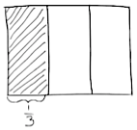
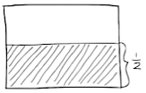
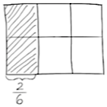
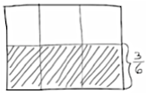
In this problem, students can fold a paper again to transition into drawing, or start directly with drawing. This is a simple problem involving two unit fractions, such as Problem 1. The primary purpose is to reinforce understanding of what is occurring to the units within a very simple context. Problem 3 moves forward to address a unit fraction plus a non-unit fraction.
T: Do our units get larger or smaller when we create like units? Talk to your partner.
S: The units get smaller. There are more units, and they are definitely getting smaller. The units get smaller. It is the same amount of space, but more parts. We have to cut them up to make them the same size.
We can also think how 1 unit will become 6 units. That’s what is happening to the half.
T: Let’s draw a diagram to solve the problem and verify your thinking.
S: (Draw.)
T: Did the half become 3 smaller units and each third become 2 smaller units?
S: Yes!
T: Tell me the addition sentence.
S: 2 sixths + 3 sixths = 5 sixths.
$\frac{1}{3}+\frac{1}{2}=\frac{2}{6}+\frac{3}{6}=\frac{5}{6}$.
Problem 3: $\frac{2}{3}+\frac{1}{4}$
T: When we partition a rectangle into thirds, how many units do we have in all?
S: 3.
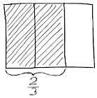
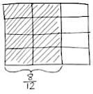
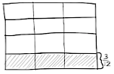
T: (Partition thirds vertically.) How many of those units are we shading?
S: 2.
T: (Shade and label 2 thirds.) To show 1 fourth, how many units do we draw?
S: 4.
T: (Make a new rectangle of the same size and partition fourths horizontally.)
T: How many total units does this new rectangle have?
S: 4.
T: (Shade and label the new rectangle.)
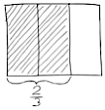
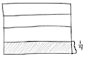
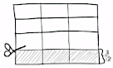
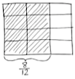
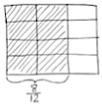
T: Let’s make these units the same size. (Partition the rectangles so the units are equal.)

NOTES ON
MULTIPLE MEANS
OF REPRESENTATION:
For students who are confused about adding the parts together, have them cut out the parts of the second model and place them inside the first. For example, as shown in the drawings below, have them cut out the three one-twelfths and add them to the model with $\frac{8}{12}$, as if a puzzle. Have them speak the sentence, “8 twelfths plus 3 twelfths equals 11 twelfths.” Repeat until students can visualize this process without the extra step.

T: What is the fractional value of 1 unit?
S: 1 twelfth.
T: How many twelfths are equal to 2 thirds?
S: 8 twelfths.
T: (Mark $\frac{8}{12}$ on the $\frac{2}{3}$ rectangle.) How many twelfths are equal to $\frac{1}{4}$?
S: 3 twelfths.
T: (Mark $\frac{3}{12}$ on the $\frac{1}{4}$ rectangle.) Say the addition sentence now using twelfths as our like unit or denominator.
S: 8 twelfths plus 3 twelfths equals 11 twelfths.
$\frac{2}{3}+\frac{1}{4}=\frac{8}{12}+\frac{3}{12}=\frac{11}{12}$ .
T: Read with me. 2 thirds + 1 fourth = 8 twelfths + 3 twelfths = 11 twelfths.
T: With your partner, review the process we used to solve $\frac{2}{3}+\frac{1}{4}$ step by step. Partner A goes first, and then partner B. Draw an area model to show how you make equivalent fractions to add unlike units.

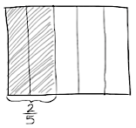
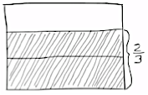
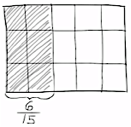
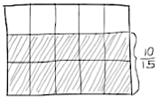
Problem 4: $\frac{2}{5}+\frac{2}{3}$
Note: This problem adds the complexity of finding the sum of two non-unit fractions, both with the numerator of 2. Working with fractions with common numerators invites healthy reflection on the size of fifths as compared to thirds. Students can reason that, while there are the same number of units (2), thirds are larger than fifths because the whole is broken into 3 parts instead of 5 parts. Therefore, there are more in each part. Additionally, it can be reasoned that 2 thirds is larger than 2 fifths because when fifteenths are used for both, the number of units in 2 thirds (10) is more than the number used in 2 fifths (6).
This problem also presents an opportunity to remind students about the importance of attending to precision (MP.6). When comparing fractions, care is taken to talk about the same whole amount as demonstrated by the rectangle. Such attention to precision also leads students to understand that 2 thirds of a cup is not larger than 2 fifths of a gallon.
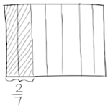
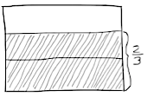
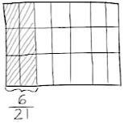
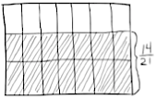
Problem 5: $\frac{2}{7}+\frac{2}{3}$
T: (Write $\frac{2}{7}+\frac{2}{3}.$) Work with your partner to solve this problem.
S: (Work.) 2 sevenths + 2 thirds = 6 twenty-firsts + 14 twenty-firsts = 20 twenty-firsts.
$\frac{2}{7}+\frac{2}{3}=\frac{6}{21}+\frac{14}{21}=\frac{20}{21}$ .

Problem Set (10 minutes)
Students should do their personal best to complete the Problem Set within the allotted 10 minutes. For some classes, it may be appropriate to modify the assignment by specifying which problems they work on first. Some problems do not specify a method for solving. Students should solve these problems using the RDW approach used for Application Problems.
Student Debrief (10 minutes)
Lesson Objective: Add fractions with unlike units using the strategy of creating equivalent fractions.
The Student Debrief is intended to invite reflection and active processing of the total lesson experience.
Invite students to review their solutions for the Problem Set. They should check work by comparing answers with a partner before going over answers as a class. Look for misconceptions or misunderstandings that can be addressed in the Debrief. Guide students in a conversation to debrief the Problem Set and process the lesson.
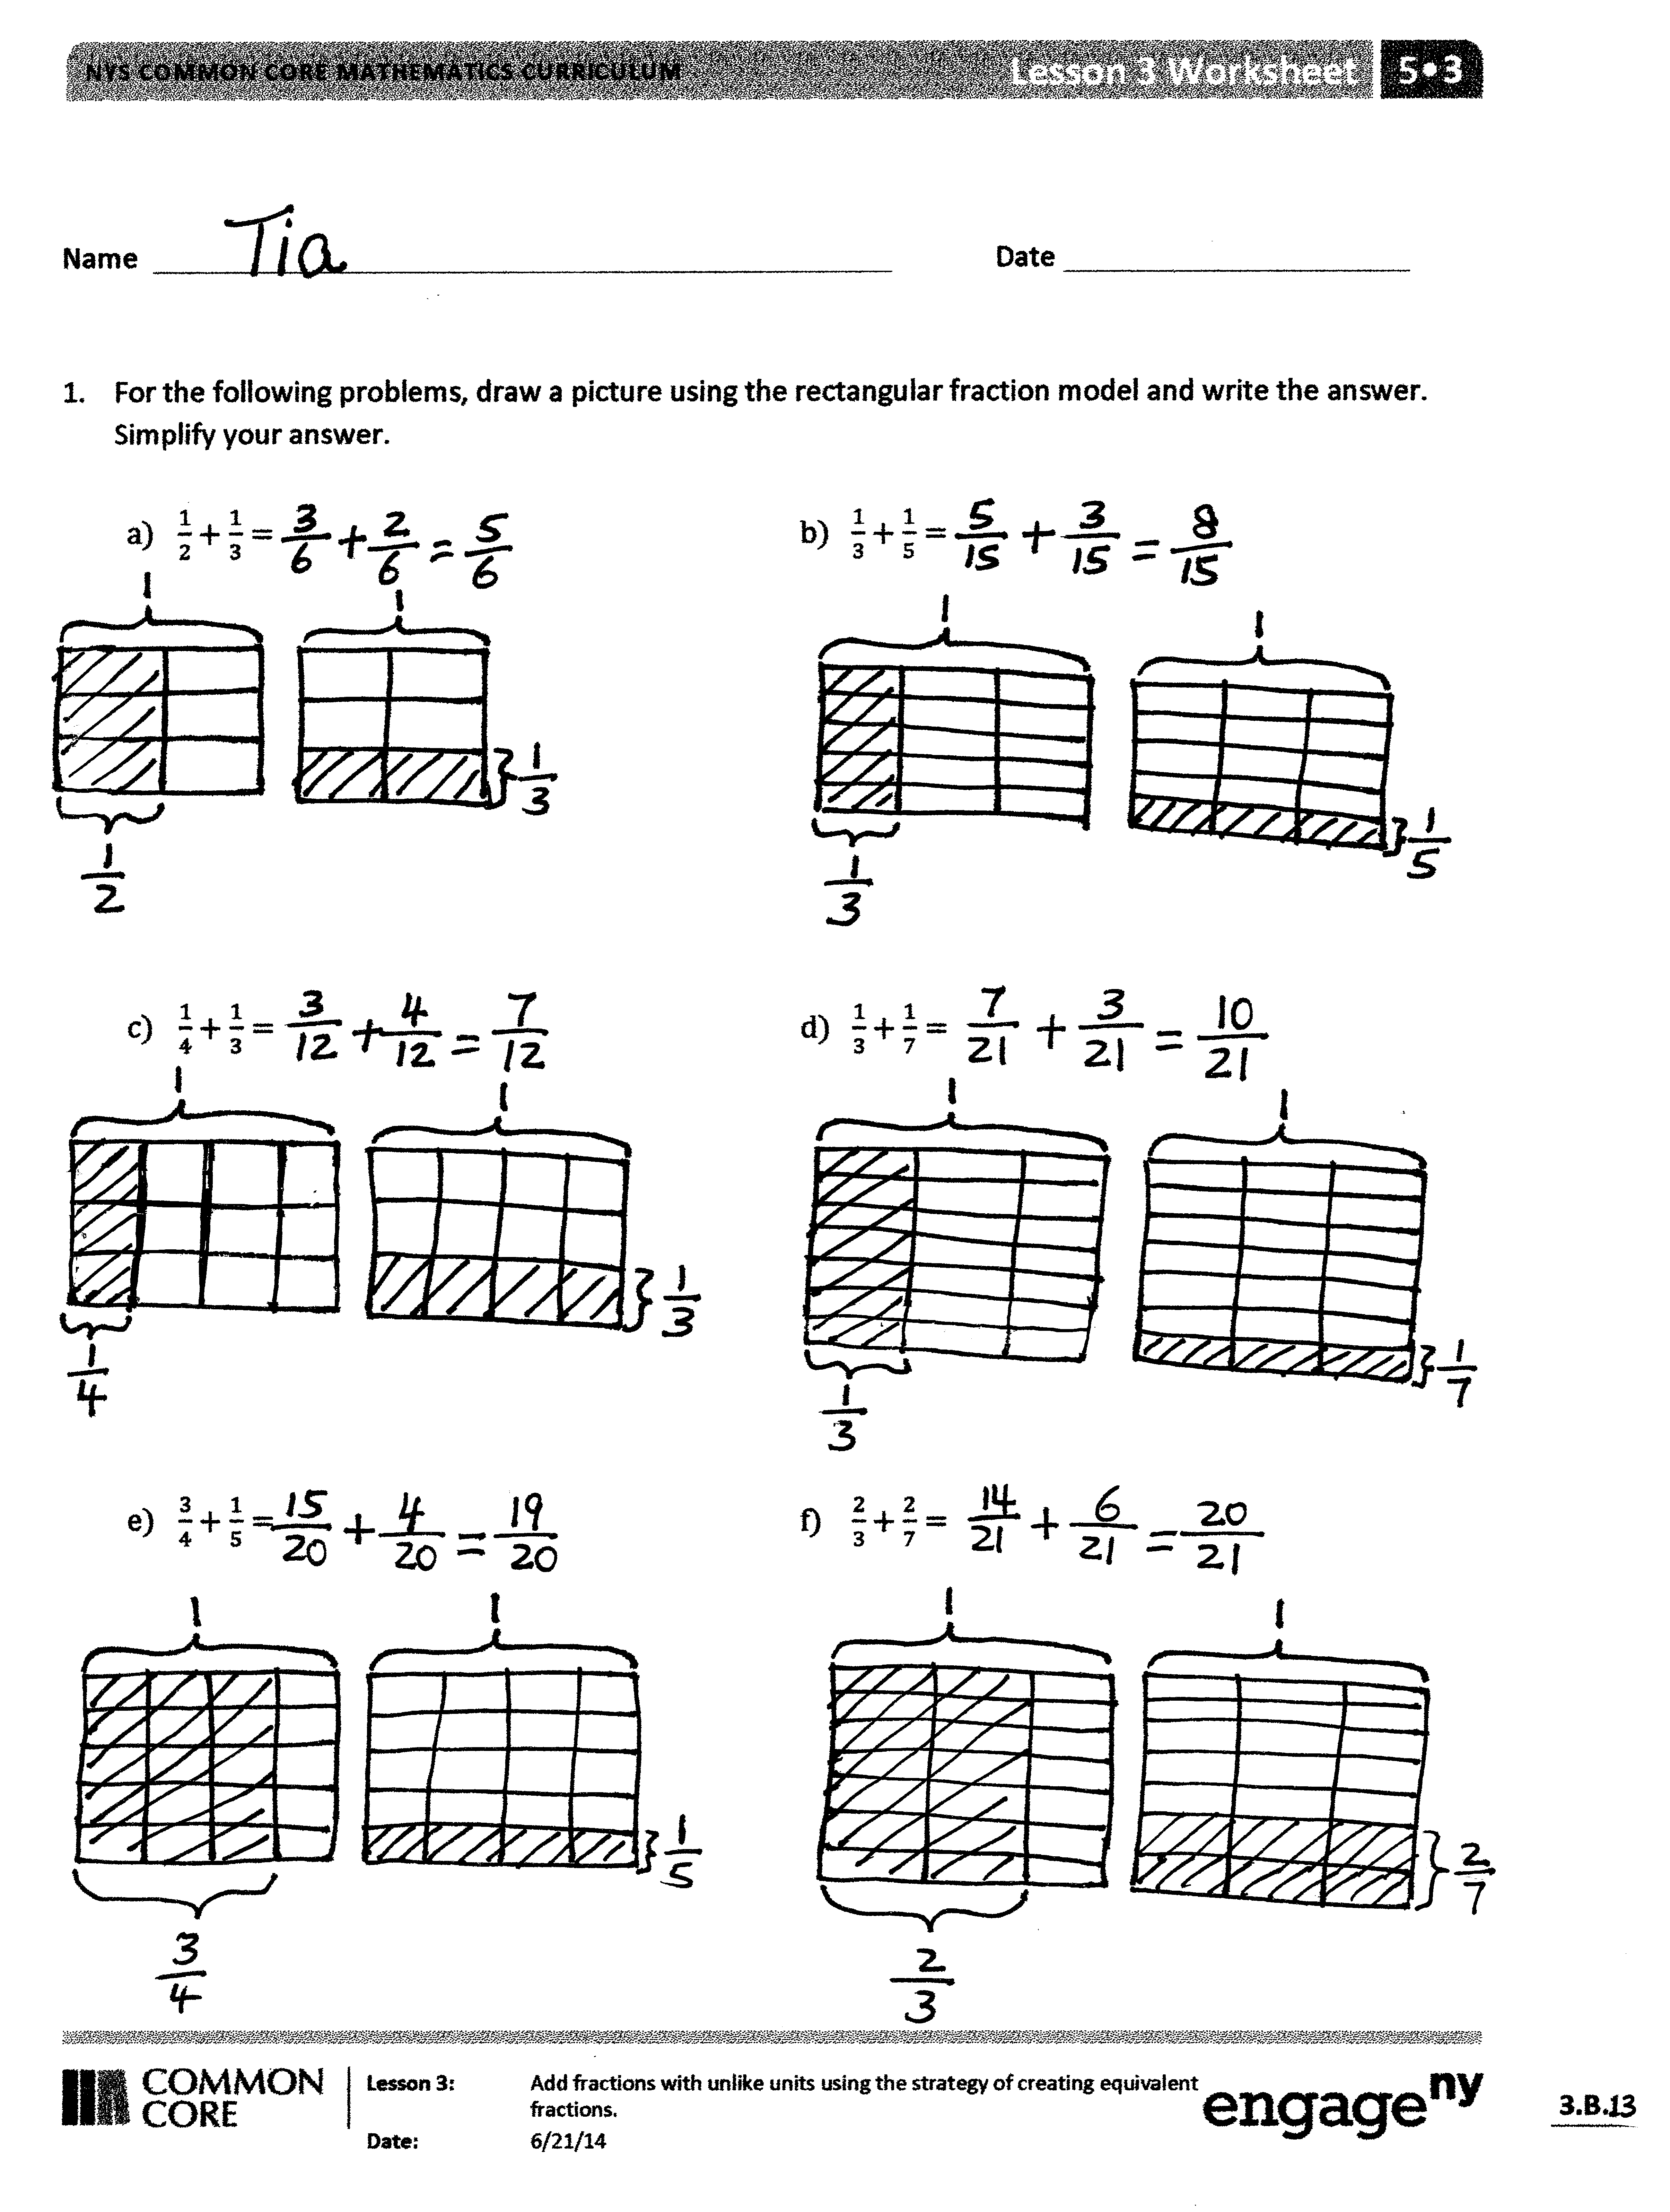
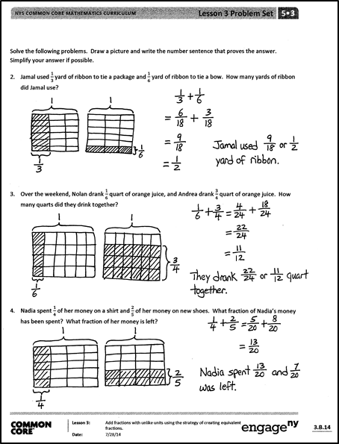
T: For one minute, go over the answers to Problem 1 with your partner. Don’t change your work.
S: (Work together.)
T: Now, let’s correct errors together. I will say the addition problem; you will say the answer. Problem 1(a). 1 half plus 1 third is…?
S: 5 sixths.
Continue with Problems 1(b–f). Then, give students about 2 minutes to correct their errors.
T: Analyze the following problems. How are they related?
- Problems 1 (a) and (b)
- Problems 1 (a) and (c)
- Problems 1 (b) and (d)
- Problems 1 (d) and (f)
S: (Discuss.)
T: Steven noticed something about Problems 1 (a) and (b). Please share.
S: The answer to (b) is smaller than (a) since you are adding only $\frac{1}{5}$ to $\frac{1}{2}$. Both answers are less than 1, but (a) is much closer to 1. Problem (b) is really close to $\frac{1}{2}$ because $\frac{8}{16}$ would be $\frac{1}{2}$.
MP.7
T: Kara, can you share what you noticed about Problems 1(d) and (f)?
S: I noticed that both problems used thirds and sevenths. But the numerators in (d) were 1, and the numerators in (f) were 2. Since the numerators doubled, the answer doubled from 10 twenty-firsts to 20 twenty-firsts.
T: I am glad to hear you are able to point out relationships between different problems.
T: Share with your partner what you learned how to do today.
S: (Share.)
T: (Help students name the objective: We learned how to add fractions that have unlike units using a rectangular fraction model to create like units.)

Exit Ticket (3 minutes)
After the Student Debrief, instruct students to complete the Exit Ticket. A review of their work will help you assess the students’ understanding of the concepts that were presented in the lesson today and plan more effectively for future lessons. You may read the questions aloud to the students.

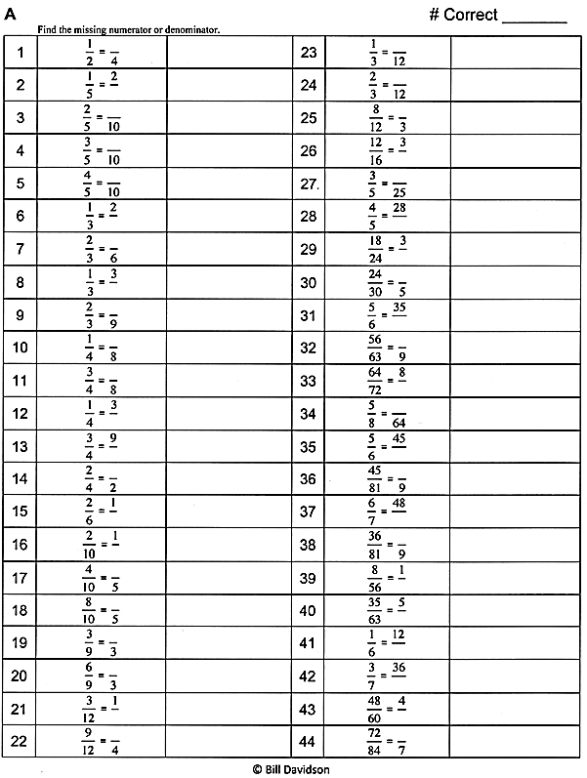

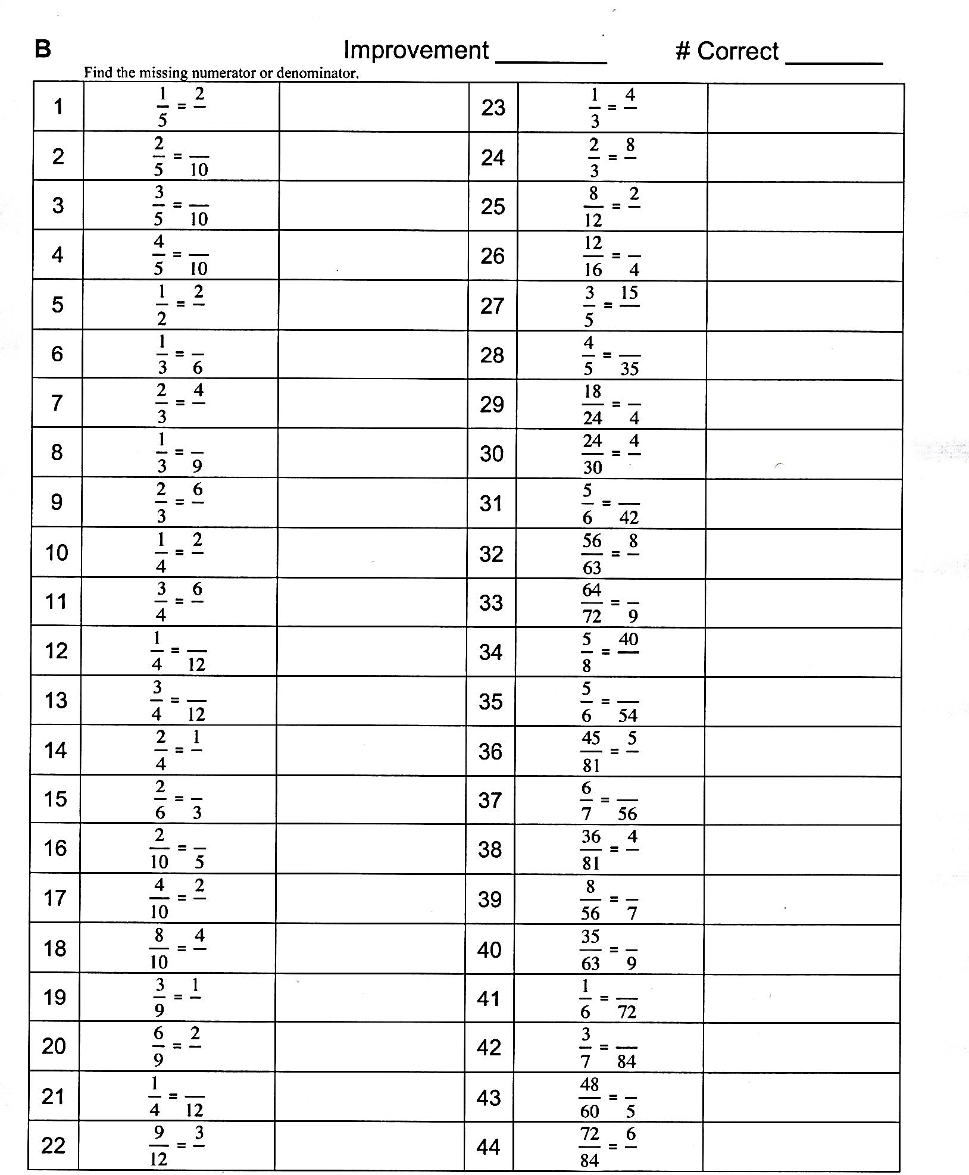

Name Date
- Draw a rectangular fraction model to find the sum. Simplify your answer, if possible.
- $\frac{1}{2}+\frac{1}{3}=$$\frac{1}{2}+\frac{1}{3}=$ | - $\frac{1}{3}+\frac{1}{5}=$$\frac{1}{3}+\frac{1}{5}=$
- $\frac{1}{4}+\frac{1}{3}=$$\frac{1}{4}+\frac{1}{3}=$ | - $\frac{1}{3}+\frac{1}{7}=$$\frac{1}{3}+\frac{1}{7}=$
- $\frac{3}{4}+\frac{1}{5}=$$\frac{3}{4}+\frac{1}{5}=$ | - $\frac{2}{3}+\frac{2}{7}=$$\frac{2}{3}+\frac{2}{7}=$
Solve the following problems. Draw a picture and write the number sentence that proves the answer. Simplify your answer, if possible.
- Jamal used $\frac{1}{3}$ yard of ribbon to tie a package and $\frac{1}{6}$ yard of ribbon to tie a bow. How many yards of ribbon did Jamal use?

- Over the weekend, Nolan drank $\frac{1}{6}$ quart of orange juice, and Andrea drank $\frac{3}{4}$ quart of orange juice. How many quarts did they drink together?

- Nadia spent $\frac{1}{4}$ of her money on a shirt and $\frac{2}{5}$ of her money on new shoes. What fraction of Nadia’s money has been spent? What fraction of her money is left?

Name Date
Solve by drawing the rectangular fraction model.

- $\frac{1}{2}+\frac{1}{5}=$$\frac{1}{2}+\frac{1}{5}=$

- In one hour, Ed used $\frac{2}{5}$ of the time to complete his homework and $\frac{1}{4}$ of the time to check his email. How much time did he spend completing homework and checking email? Write your answer as a fraction. (Extension: Write the answer in minutes.)

Name Date
- Draw a rectangular fraction model to find the sum. Simplify your answer, if possible.

- $\frac{1}{4}+\frac{1}{3}=$$\frac{1}{4}+\frac{1}{3}=$ | - $\frac{1}{4}+\frac{1}{5}=$$\frac{1}{4}+\frac{1}{5}=$
- $\frac{1}{4}+\frac{1}{6}=$$\frac{1}{4}+\frac{1}{6}=$ | - $\frac{1}{5}+\frac{1}{9}=$$\frac{1}{5}+\frac{1}{9}=$
- $\frac{1}{4}+\frac{2}{5}=$$\frac{1}{4}+\frac{2}{5}=$ | - $\frac{3}{5}+\frac{3}{7}=$$\frac{3}{5}+\frac{3}{7}=$

Solve the following problems. Draw a picture, and write the number sentence that proves the answer. Simplify your answer, if possible.
- Rajesh jogged $\frac{3}{4}$ mile, and then walked $\frac{1}{6}$ mile to cool down. How far did he travel?

- Cynthia completed $\frac{2}{3}$ of the items on her to-do list in the morning and finished $\frac{1}{8}$ of the items during her lunch break. What fraction of her to-do list is finished by the end of her lunch break?
(Extension: What fraction of her to-do list does she still have to do after lunch?)

- Sam read $\frac{2}{5}$ of her book over the weekend and $\frac{1}{6}$ of it on Monday. What fraction of the book has she read? What fraction of the book is left?

equivalent fractions
equivalent fractions

