Lesson 2
Objective: Make equivalent fractions with sums of fractions with like denominators.

Suggested Lesson Structure

NOTES ON
MULTIPLE MEANS
OF ENGAGEMENT:
Equivalent Fractions is intentionally placed before the Sprint because it reviews the Sprint skill. Adjust the time for the Sprint as necessary. If students struggle to complete Sprint A, then consider doing another minute or two of Equivalent Fractions before moving them on to Sprint B.

 Fluency Practice (12 minutes)
 Application Problem (8 minutes)
 Concept Development (30 minutes)
 Student Debrief (10 minutes)
Total Time (60 minutes)
Fluency Practice (12 minutes)
- Equivalent Fractions 5.NF.1 (4 minutes)
- Sprint: Find the Missing Numerator or Denominator 4.NF.1 (8 minutes)
Equivalent Fractions (4 minutes)
Note: This fluency activity reviews equivalent fractions.

NOTES ON
MULTIPLE MEANS
OF REPRESENTATION:
Adjusting number words and correctly pronouncing them as fractions (fifths, sixths, etc.) may be challenging. If you have many English language learners, before starting, you might quickly count together to practice enunciating word endings: halves, thirds, fourths, fifths, sixths, etc.

T: (Write $\frac{1}{2}$.) Say the fraction.
S: One half.
T: (Write $\frac{1}{2}=\frac{}{4}.$) One half is how many fourths?
S: Two fourths.
Continue with the following possible sequence:
$\frac{1}{2}=\frac{}{6}, \frac{1}{3}=\frac{}{6}, \frac{2}{3}=\frac{}{6}, \frac{2}{3}=\frac{}{12}, \frac{3}{4}=\frac{}{16}, and \frac{3}{5}=\frac{}{25} .$
T: (Write $\frac{1}{2}$.) Say the fraction.
S: One half.
T: (Write $\frac{1}{2}=\frac{2}{}$.) One half or one part of two is the same as two parts of what unit?
S: Fourths.
Continue with the following possible sequence:
$\frac{\text{1}}{\text{2}}\text{=}\frac{\text{2}}{}\text{, }\frac{\text{1}}{\text{5}}\text{=}\frac{\text{2}}{}\text{, }\frac{\text{2}}{\text{5}}\text{=}\frac{\text{8}}{}\text{, }\frac{\text{3}}{\text{4}}\text{=}\frac{\text{9}}{}\text{, and }\frac{\text{4}}{\text{5}}\text{=}\frac{\text{16}}{}$ .
Sprint: Find the Missing Numerator or Denominator (8 minutes)
Materials: (S) Find the Missing Numerator or Denominator Sprint
Note: Students generate common equivalent fractions mentally and with automaticity (i.e., without performing the indicated multiplication).
Application Problem (8 minutes)
Mr. Hopkins has a 1 meter wire he is using to make clocks. Each fourth meter is marked off and divided into 5 smaller equal lengths. If Mr. Hopkins bends the wire at $\frac{3}{4}$ meter, what fraction of the smaller marks is that?
S: (Solve the problem, possibly using the RDW process independently or in partners.)
T: Let’s look at two of your solutions and compare them.
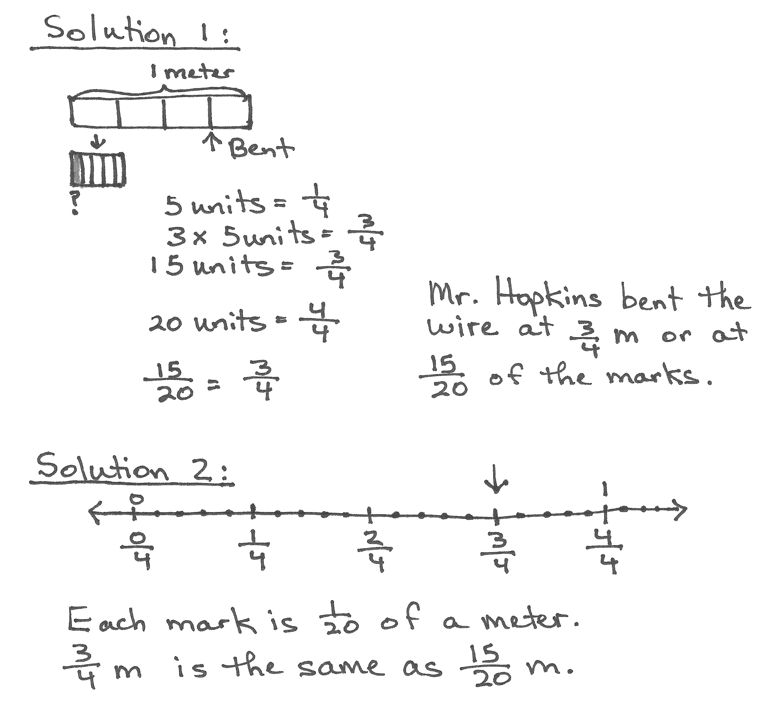

NOTES ON
SOLVING APPLICATION PROBLEMS:
Since Grade 1, students have used the Read, Draw, Write (RDW) approach to solve Application Problems. The method is as follows:
- Read the problem.
- Draw to represent the problem.
- Write one or more equations that either help solve the problem or show how the problem was solved.
- Write a statement that answers the question.
Embedded within Draw are important reflective questions:
- What do I see?
- Can I draw something?
- What conclusions can I reach from my drawing?

T: When you look at these two solutions side by side, what do you see? (You might use the following set of questions to help students compare the solutions as a whole class, or to encourage inter-partner communication as you circulate while they compare.)
- What did each of these students draw?
- What conclusions can you make from their drawings?
- How did they record their solutions numerically?
- How does the tape diagram relate to the number line?
- What does the tape diagram/number line clarify?
- What does the equation clarify?
- How could the statement with the number line be rephrased to answer the question?
Note: This two-step Application Problem offers a problem-solving context for students to review making equivalent fractions with the number line or the area model as taught in Lesson 1.
Concept Development (30 minutes)
Materials: (S) Blank paper
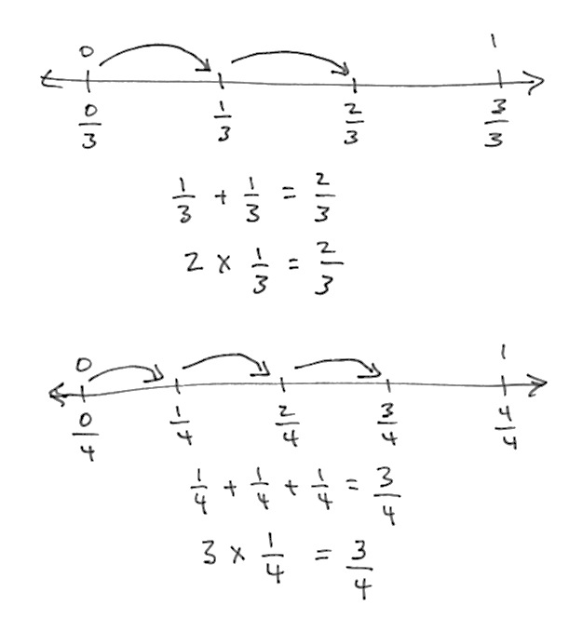
Problem 1: $\frac{1}{3}+\frac{1}{3}=\frac{2}{3}$.
1 third + 1 third = 2 thirds.
T: Draw a number line. Mark the end points as 0 and 1. Between zero and one, estimate to make three units of equal length and label them as thirds.
S: (Work.)
T: On your number line, show 1 third plus 1 third with arrows designating lengths. (Demonstrate, and then pause as students work).
T: The answer is…?
S: 2 thirds.
T: Talk to your partner. Express this as an addition sentence and multiplication equation.
S: $\frac{1}{3}+\frac{1}{3}=\frac{2}{3}$. $2 ×\frac{1}{3}=\frac{2}{3}$.
T: Following the same pattern of adding unit fractions by joining lengths, show 3 fourths on a number line.

Problem 2: $\frac{3}{8}+\frac{3}{8}+\frac{1}{8}=\frac{7}{8}$.
3 eighths + 3 eighths + 1 eighth = 7 eighths.
T: Draw a number line. Again, mark the end points as 0 and 1. Between zero and one, estimate to make eight units of equal length. This time, only label what is necessary to show 3 eighths.
S: (Work.)
T: Represent 3 eighths + 3 eighths + 1 eighth on your number line. (Pause.) What’s the answer?
S: 7 eighths.
T: Talk to your partner. Express this as an addition equation and multiplication equation.
S: $\frac{3}{8}+\frac{3}{8}+\frac{1}{8}=\frac{7}{8}.$ $\left(2 ×\frac{3}{8}\right)+\frac{1}{8}=\frac{7}{8}$.

Problem 3: $\frac{6}{2}=\frac{2}{2}+\frac{2}{2}+\frac{2}{2}=\left(3 ×\frac{2}{2}\right)=3$.
6 halves = 3 $×$ 2 halves = 3 ones = 3.
T: Draw a number line. Below the number line, mark the end points as 0 halves and 6 halves. Estimate to make 6 parts of equal length. This time, only label 2 halves.
S: (Work.)
T: Record the whole number equivalents above the line. (Record 1, 2, and 3 wholes.) Represent
3 $×$ 2 halves on your number line.
S: (Draw 3 arrows, starting with $\frac{\text{0}}{\text{2}}\text{, }\frac{\text{2}}{\text{2}}\text{, }\frac{\text{4}}{\text{2}}\text{, and stop at}\frac{\text{6}}{\text{2}}$.)
T: What’s the answer?
S: 6 halves or 3.
T: 3. What is the unit?
S: 3 ones.
T: Talk to your partner. Express this as an addition equation, as well as a multiplication equation.
S: $\frac{2}{2}+\frac{2}{2}+\frac{2}{2}=\frac{6}{2}=3$. $\frac{2}{2}+\frac{2}{2}+\frac{2}{2}=1+1+1=3.$ $3 ×\frac{2}{2}=\frac{6}{2}=3.$ $3 ×\frac{2}{2}=3 × 1=3.$

Problem 4: $\frac{8}{5}=\frac{5}{5}+\frac{3}{5}=1\frac{3}{5}$.
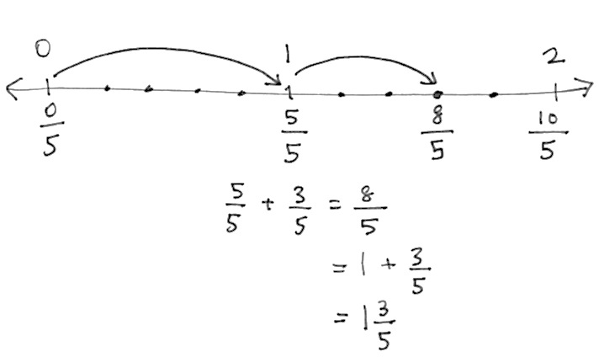
8 fifths = 5 fifths + 3 fifths = 1 and 3 fifths.
T: Draw a number line. Below the number line, mark the end points as 0 fifths and 10 fifths. Estimate and give a value to the halfway point.
T: What is the value of the halfway point?
S: 5 fifths.
T: Make 10 parts of equal length from 0 fifths to 10 fifths.
T: Record the whole number equivalents above the line. (Students work.)
T: Label 8 fifths on your number line. (Work.)
T: Show 8 fifths as the sum of 5 fifths and 3 fifths on your number line.
S: (Work.)
T: Talk to your partner. Express this as an addition equation in two ways—as the sum of fifths, as well as the sum of a whole number and fifths.
S: (Work.)
T: What is another way of expressing 1 plus 3 fifths?
S: 1 and 3 fifths. $\frac{5}{5}+\frac{3}{5}=\frac{8}{5}=1\frac{3}{5}$ .
T: 8 fifths is between what 2 whole numbers?
S: 1 and 2.
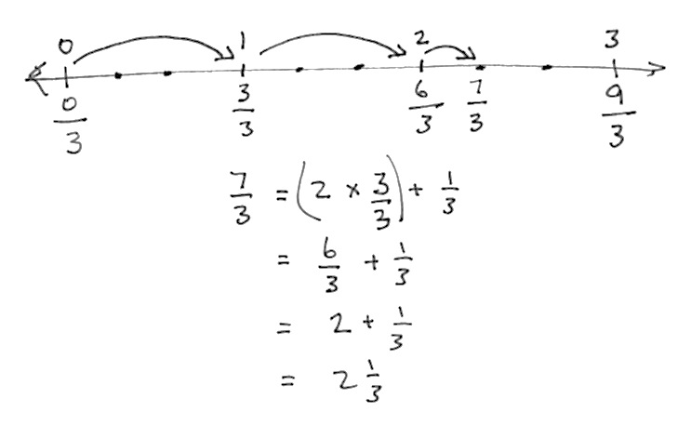
Problem 5: $\frac{7}{3}=\frac{6}{3}+\frac{1}{3}=\left(2 ×\frac{3}{3}\right) +\frac{1}{3}=2+\frac{1}{3}=2\frac{1}{3}$.
7 thirds = 6 thirds + 1 third = 2 and 1 third.
T: Draw a number line. Mark the end points as 0 thirds and 9 thirds below the number line. Divide the whole length into three equal smaller lengths and mark their values using thirds. Work with a partner.
S: (Work.)
T: What are the values of those points?
S: 3 thirds and 6 thirds.
T: Mark the whole number equivalents above the line.
S: (Work.)
T: Divide each of those whole number lengths into three smaller lengths. Mark the number 7 thirds.
S: (Work.)
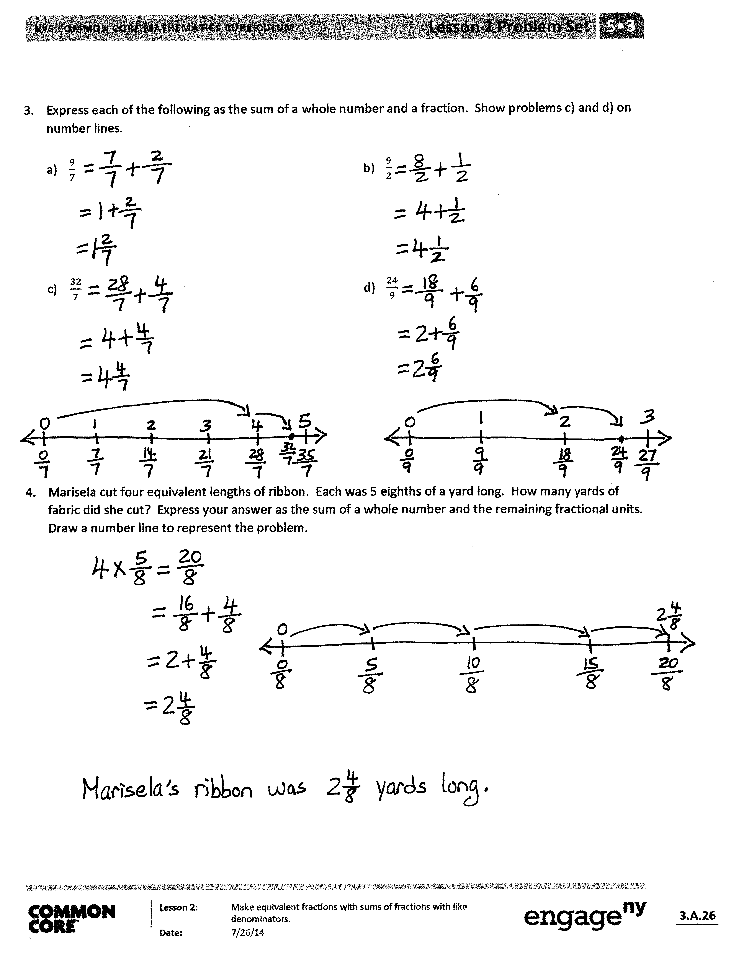
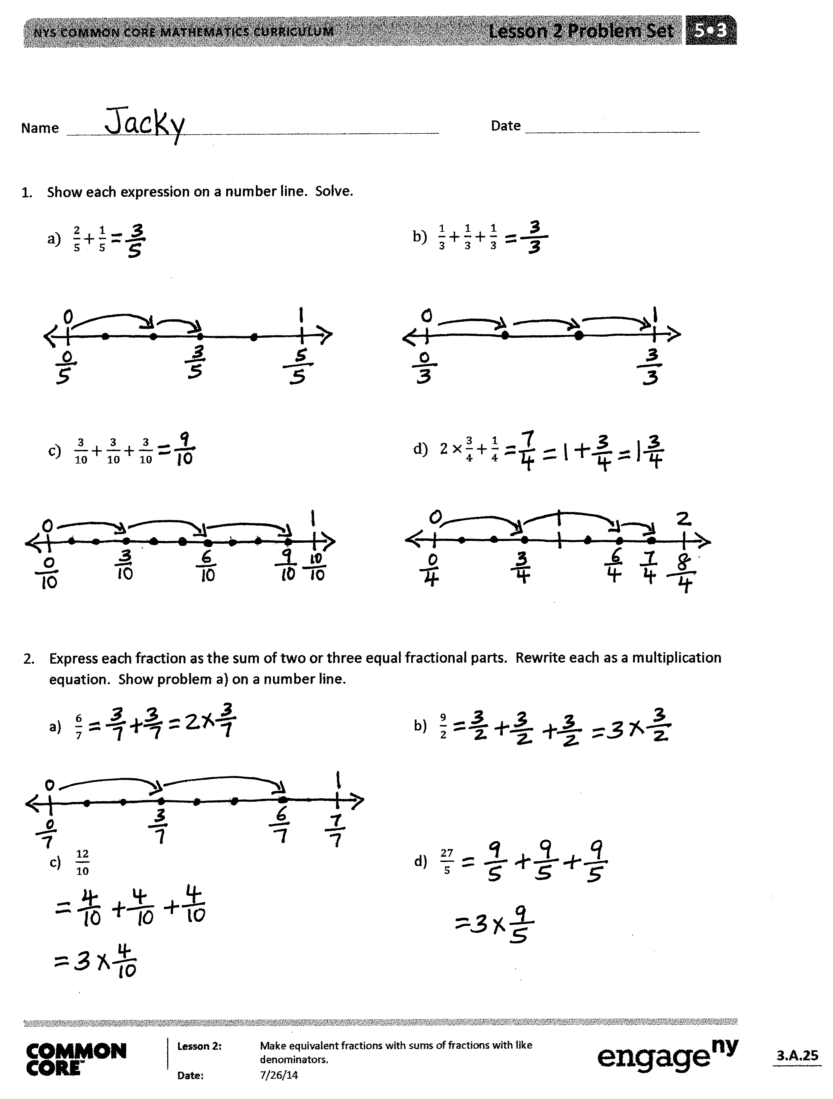
T: Show 7 thirds as two units of 3 thirds and one more third on your number line and in an equation. Work together if you become stuck.
S: (Work and discuss.)
T: 7 thirds is between what two whole numbers?
S: 2 and 3.
Problem Set (10 minutes)
Students should do their personal best to complete the Problem Set within the allotted 10 minutes. For some classes, it may be appropriate to modify the assignment specifying which problems they work on first. Some problems do not specify a method for solving. Students should solve these problems using the RDW approach used for Application Problems.
Student Debrief (10 minutes)
Lesson Objective: Make equivalent fractions with sums of fractions with like denominators.
The Student Debrief is intended to invite reflection and active processing of the total lesson experience.
Invite students to review their solutions for the Problem Set. They should check work by comparing answers with a partner before going over answers as a class. Look for misconceptions or misunderstandings that can be addressed in the Debrief. Guide students in a conversation to debrief the Problem Set and process the lesson.
T: Come to the Debrief and bring your Problem Set. Compare your work to your neighbor’s. On which problems do you have different answers? Discuss your differences. Both may be correct.
T: (After about 3 minutes.) What is a way to express $\frac{3}{7}$ as a sum?
S: 1 seventh + 1 seventh + 1 seventh.
T: Another way?
S: 2 sevenths + 1 seventh.
T: These are equivalent forms of 3 sevenths.
T: On your Problem Set, find and talk to your partner about different equivalent forms of your numbers.
S: 6 sevenths could be expressed as 3 sevenths + 3 sevenths or 3 times 2 sevenths. 9 sevenths can be expressed as 1 + 2 sevenths. 7 fourths can be expressed as 2 times 3 fourths + 1 fourth.
1 and 3 fourths can be expressed as 7 fourths. 32 sevenths can be expressed as
28 sevenths + 4 sevenths or 4 and 4 sevenths.
T: I’m hearing you express these numbers in many equivalent forms. Why do you think I chose to use the tool of the number line in this lesson? Discuss this with your partner. If you were the teacher of this lesson, why might you use the number line?
S: (Discuss.)
T: When we were studying decimal place value, we saw that 9 tenths + 3 tenths is equal to 12 tenths,
1 + 2 tenths, or 1 and 2 tenths.
T: Once more, please review the solution and number line you made for Problem 4 about Marisela’s ribbon. Discuss the equivalence of 20 eighths and 2 and 4 eighths as it relates to the number line.
S: (Discuss.)
T: Discuss the relationship of the equivalence of these sums.
9 tenths + 3 tenths = 12 tenths = 1 + 2 tenths = $1\frac{2}{10}$.
9 elevenths + 3 elevenths = 12 elevenths = 1 + 1 eleventh = $1\frac{1}{11}$.
S: (Discuss.)
T: Yes, our place value system is another example of equivalence.
Exit Ticket (3 minutes)
After the Student Debrief, instruct students to complete the Exit Ticket. A review of their work will help you assess the students’ understanding of the concepts that were presented in the lesson today and plan more effectively for future lessons. You may read the questions aloud to the students.

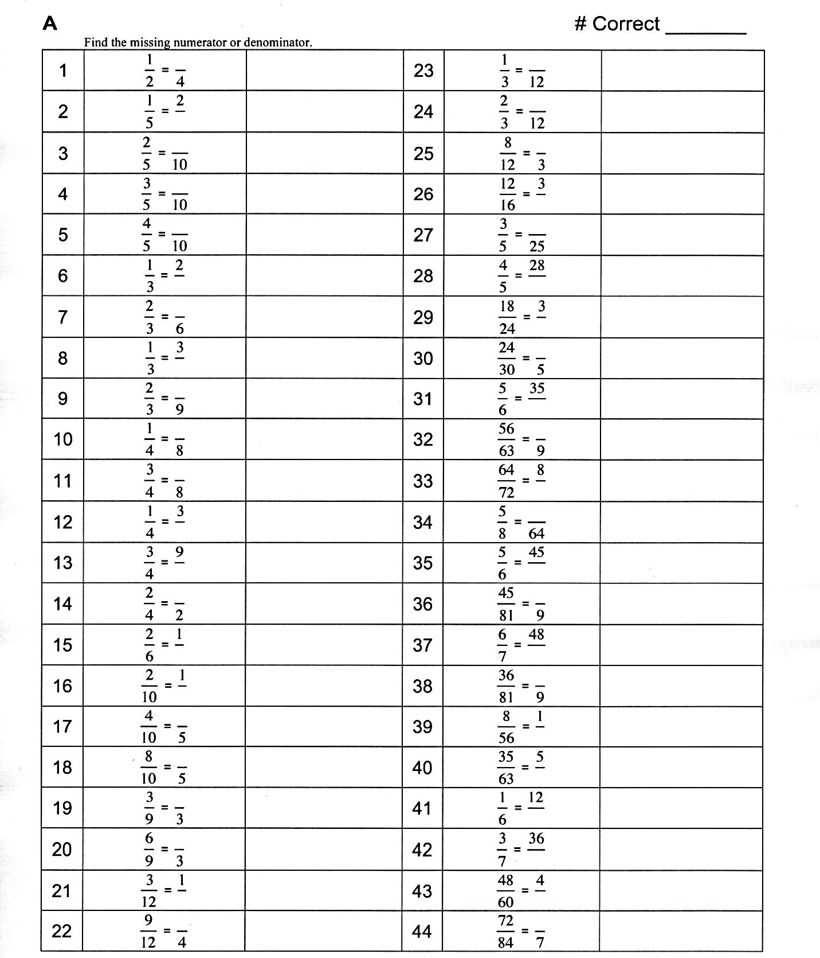
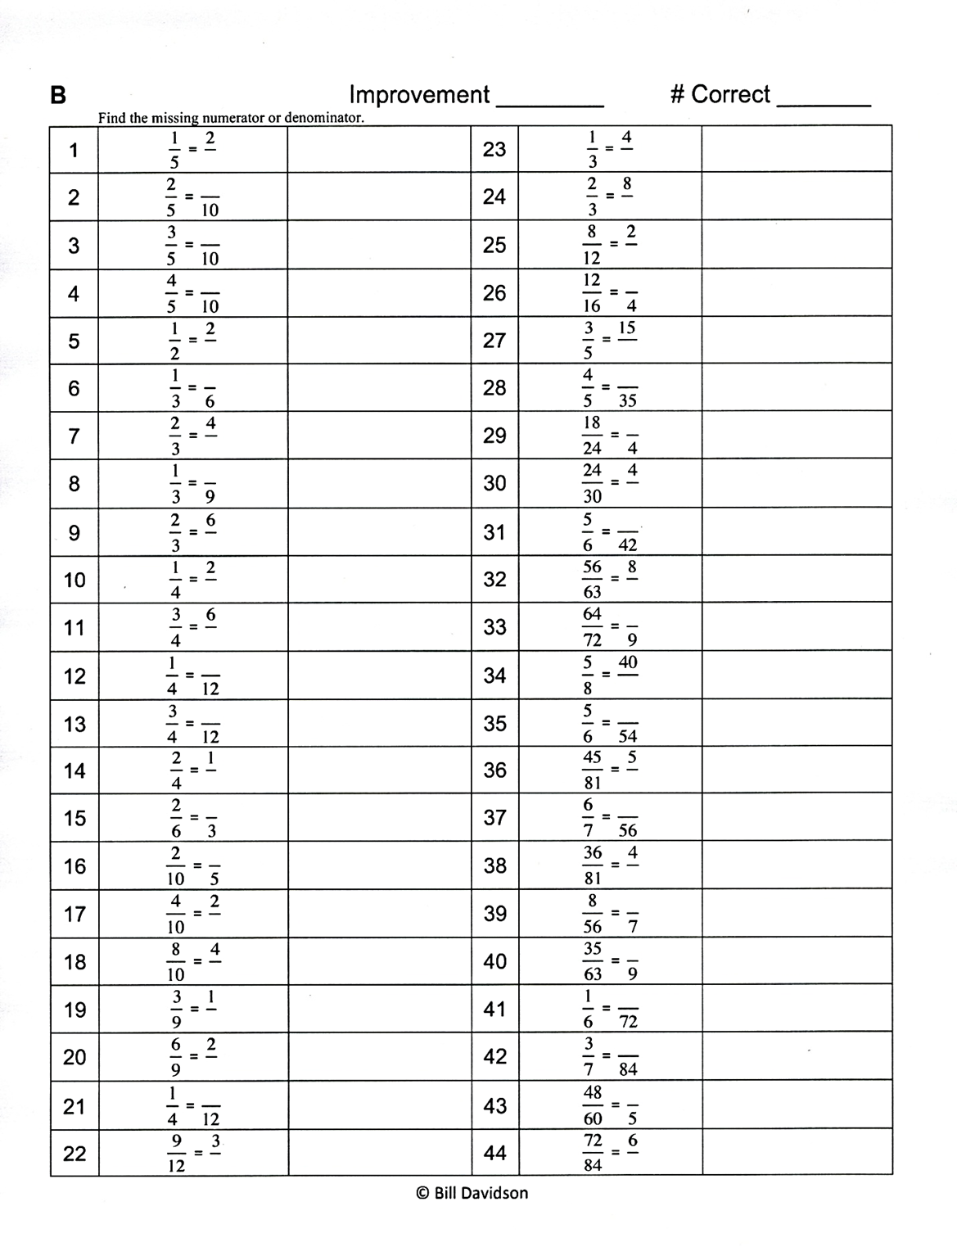

Name Date
- Show each expression on a number line. Solve.

- $\frac{2}{5}+\frac{1}{5}$ | - $\frac{1}{3}+\frac{1}{3}+\frac{1}{3}$
- $\frac{3}{10}+\frac{3}{10}+\frac{3}{10}$ | - $2 ×\frac{3}{4}+\frac{1}{4}$
- Express each fraction as the sum of two or three equal fractional parts. Rewrite each as a multiplication equation. Show Part (a) on a number line.

- $\frac{6}{7}$ | - $\frac{9}{2}$
- $\frac{12}{10}$ | - $\frac{27}{5}$
- Express each of the following as the sum of a whole number and a fraction. Show Parts (c) and (d) on number lines.

- $\frac{9}{7}$ | - $\frac{9}{2}$
- $\frac{32}{7}$ | - $\frac{24}{9}$

- Marisela cut four equivalent lengths of ribbon. Each was 5 eighths of a yard long. How many yards of fabric did she cut? Express your answer as the sum of a whole number and the remaining fractional units. Draw a number line to represent the problem.

Name Date
- Show each expression on a number line. Solve.
- $\frac{5}{5}+\frac{2}{5}$ | - $\frac{6}{3}+\frac{2}{3}$
- Express each fraction as the sum of two or three equal fractional parts. Rewrite each as a multiplication equation. Show Part (b) on a number line.

- $\frac{6}{9}$ | - $\frac{15}{4}$

Name Date
- Show each expression on a number line. Solve.
- $\frac{4}{9}+\frac{1}{9}$ | - $\frac{1}{4}+\frac{1}{4}+\frac{1}{4}+\frac{1}{4}$
- $\frac{2}{7}+\frac{2}{7}+\frac{2}{7}$ | - $2 ×\frac{3}{5}+\frac{1}{5}$
- Express each fraction as the sum of two or three equal fractional parts. Rewrite each as a multiplication equation. Show Part (a) on a number line.

- $\frac{6}{11}$ | - $\frac{9}{4}$
- $\frac{12}{8}$ | - $\frac{27}{10}$
- Express each of the following as the sum of a whole number and a fraction. Show Parts (c) and (d) on number lines.

- $\frac{9}{5}$ | - $\frac{7}{2}$
- $\frac{25}{7}$ | - $\frac{21}{9}$

- Natalie sawed five boards of equal length to make a stool. Each was 9 tenths of a meter long. What is the total length of the boards she sawed? Express your answer as the sum of a whole number and the remaining fractional units. Draw a number line to represent the problem.

find the missing numerator or denominator
find the missing numerator or denominator

