Lesson 1

Objective: Make equivalent fractions with the number line, the area model, and numbers.

Suggested Lesson Structure

 Fluency Practice (11 minutes)

 Application Problem (9 minutes)

 Concept Development (30 minutes)

 Student Debrief (10 minutes)

**Total Time (60 minutes)**

Fluency Practice (11 minutes)

* Sprint: Write the Missing Factor **4.OA.4** (8 minutes)
* Skip Counting by Hour **5.MD.1** (3 minutes)

Sprint: Write the Missing Factor (8 minutes)

Materials: (S) Write the Missing Factor Sprint

Note: Mentally calculating the missing factor prepares students for making equivalent fractions in today’s lesson.

Skip-Counting by Hour (3 minutes)

Note: This fluency activity reviews counting fractions in a real world context.

T: Let’s count by hours. (Rhythmically point up until a change is desired. Show a closed hand, and then point down. Continue, alternating the starting point.)

|  |  |
| --- | --- |
|  | NOTES ON  MULTIPLE MEANS  OF REPRESENTATION: |
| Because students are counting units of time, a clock is a natural visual to incorporate. Gesture to points on the clock as students chant, and possibly use it to help signal the direction of the count. | |

S: hour, hour, hour, 1 hour, (stop). hours, hours, hours, 2 hours, (stop). hours, hours, hours, (stop).

Application Problem (9 minutes)

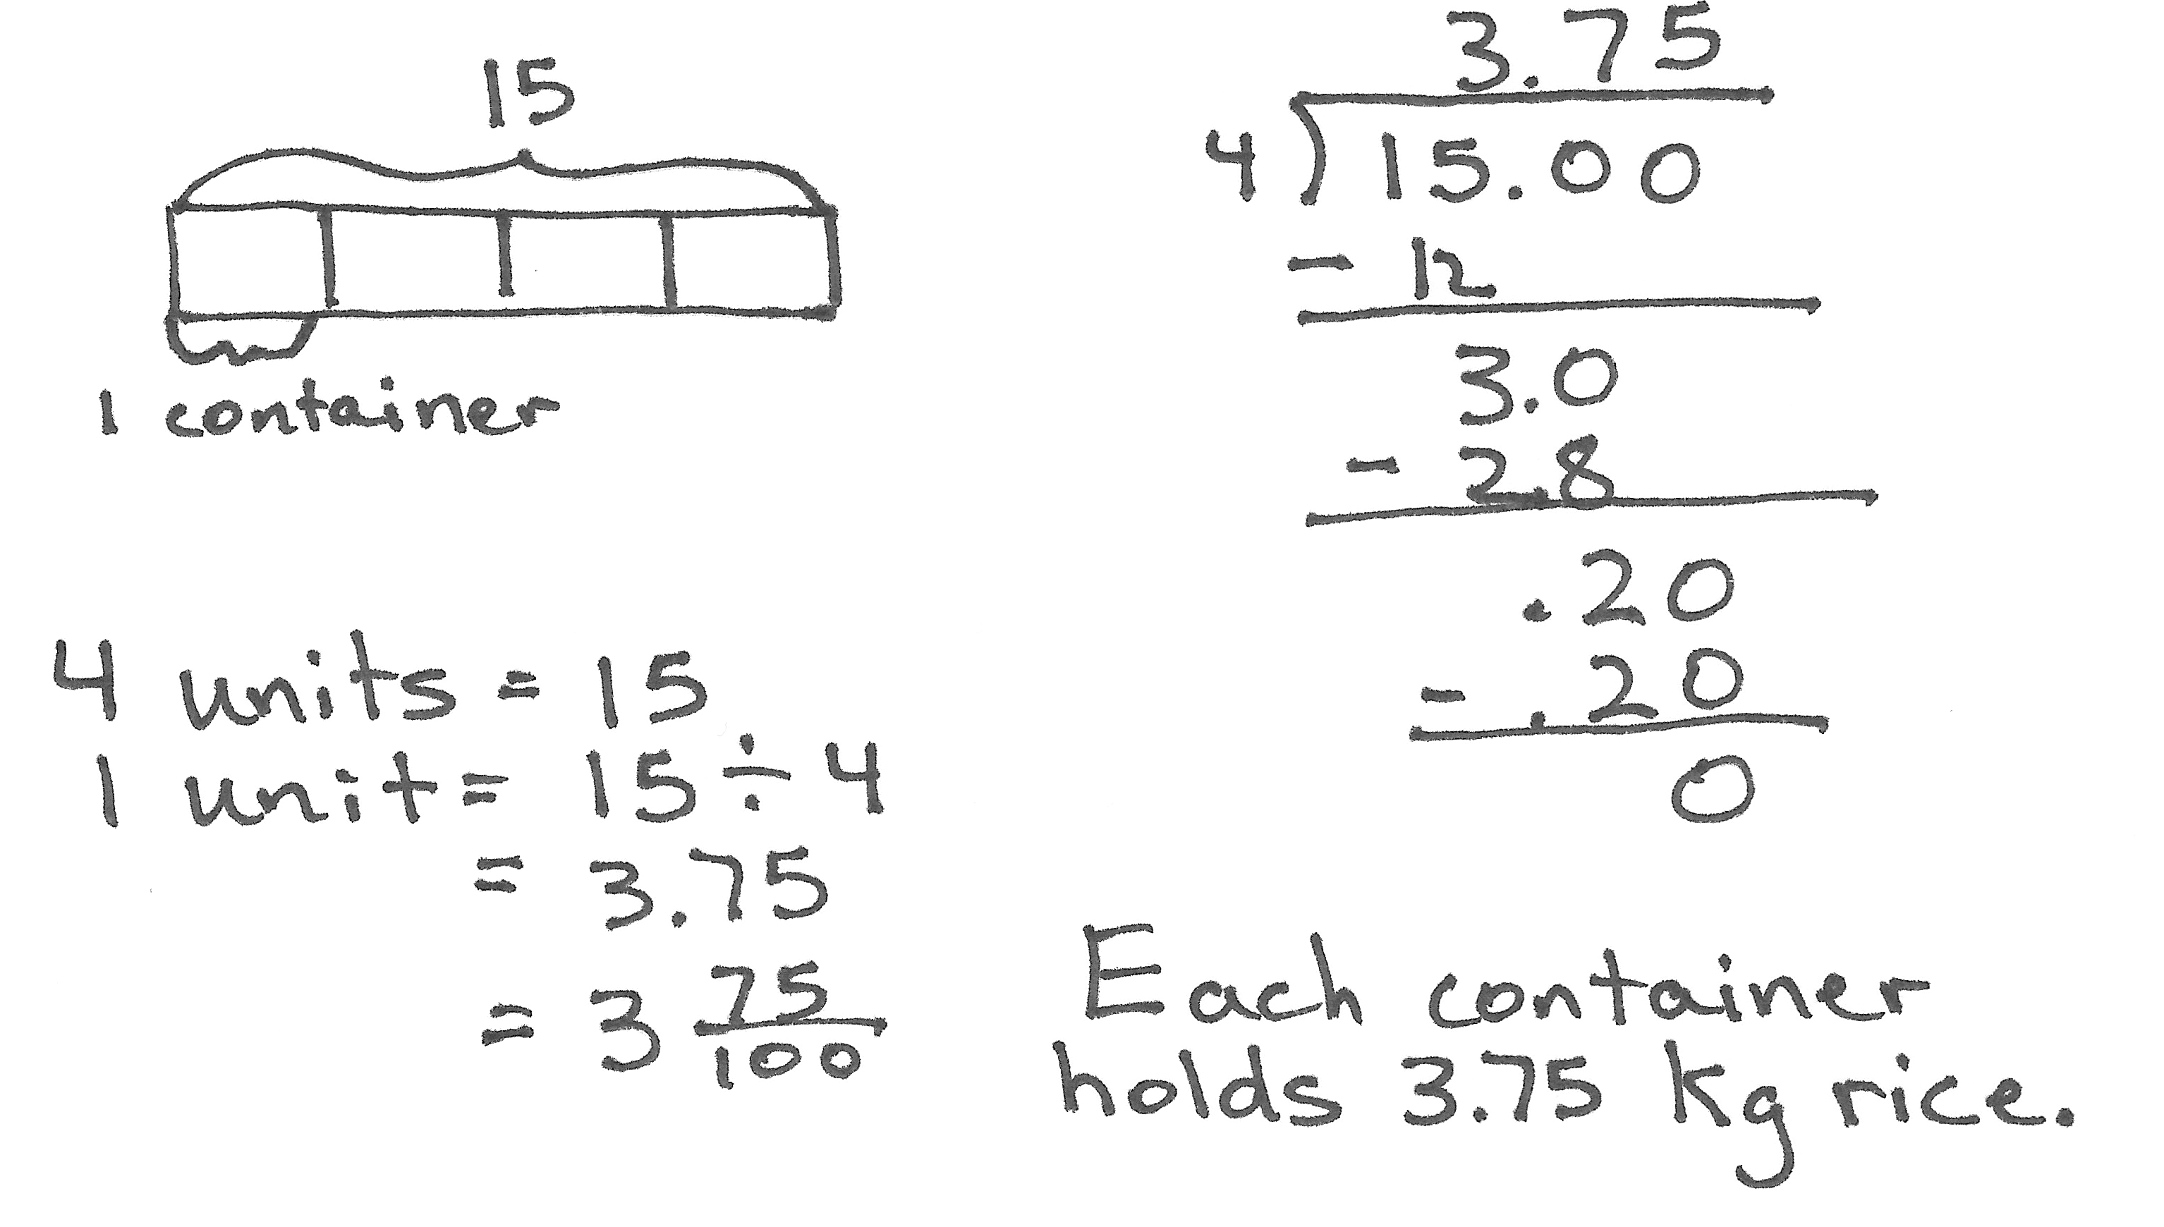15 kilograms of rice are separated equally into 4 containers. How many kilograms of rice are in each container? Express your answer as a decimal and as a fraction.

T: Let’s read the problem together.

S: (Read chorally.)

T: Share with your partner: What do you see when you hear the story? What can you draw?

S: (Share with partners.)

T: I’ll give you one minute to draw.

T: Explain to your partner what your drawing shows.

T: (After a brief exchange.) What’s the total weight of the rice?

S: 15 kilograms.

T: 15 kilograms are being split equally into how many containers?

S: 4 containers.

T: So, the whole is being split into how many units?

S: 4 units.

T: To find 1 container or 1 unit, we have to…?

S: Divide.

T: Tell me the division expression.

S: 15 ÷ 4.

T: Solve the problem on your personal white board. Write your answer both in decimal form and as a whole number and a decimal fraction. (Pause.) Show your board.

T: Turn and explain to your partner how you got the answer. 15 ÷ 4 = 3.75.

T: (After students share.) Show the division equation with both answers.

S: 15 ÷ 4 = 3.75 = 3 .

T: Express 75 hundredths in its simplest form.

S: 3 fourths.

T: Write your answer as a whole number and a fraction in its simplest form.

S: 15 ÷ 4 = 3.75 = 3 = 3.

T: So, 3 and 3 fourths equals 3 and 75 hundredths.

T: Tell me your statement containing the answer.

S: Each container holds 3.75 kg or kg of rice.

Note: This Application Problem reviews division and partitioning as it relates to fractions. Also, it reviews replacing one fraction with another of the same value in anticipation of today’s work with equivalent fractions.

Concept Development (30 minutes)

|  |  |
| --- | --- |
|  | NOTES ON  MULTIPLE MEANS  OF ACTION AND  EXPRESSION: |
| Sentence frames help students remember the linguistic and numerical patterns. As they gain confidence, gradually retract the frames. A suitable sentence frame for this lesson would be the equation to the left without any of the digits included. | |

Materials: (S) 4 paper strips ″ × 1″

Problem 1: Make fractions equal to .

T: Take your paper strip. Hold it horizontally. Fold it vertically down the middle. How many equal parts do you have in the whole?

S: 2.

T: What fraction of the whole is 1 part?

S: 1 half.

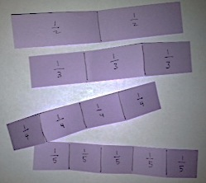T: Draw a line to show where you folded your paper and label each half,   
1 out of 2 units.

T: Make additional paper strips that show thirds, fourths, and fifths.

T: (After about 3 minutes.) Draw a number line that is a little longer than your paper strip. Use your strip as a ruler to mark zero and 1 above the line, as well as below the line.

T: (Allow work time.) Sketch a square that is approximately 1 inch × 1 inch beneath your number line. This is representing the same 1 whole as the number line. For today, show half by vertically dividing the square. Shade 1 half on the left.

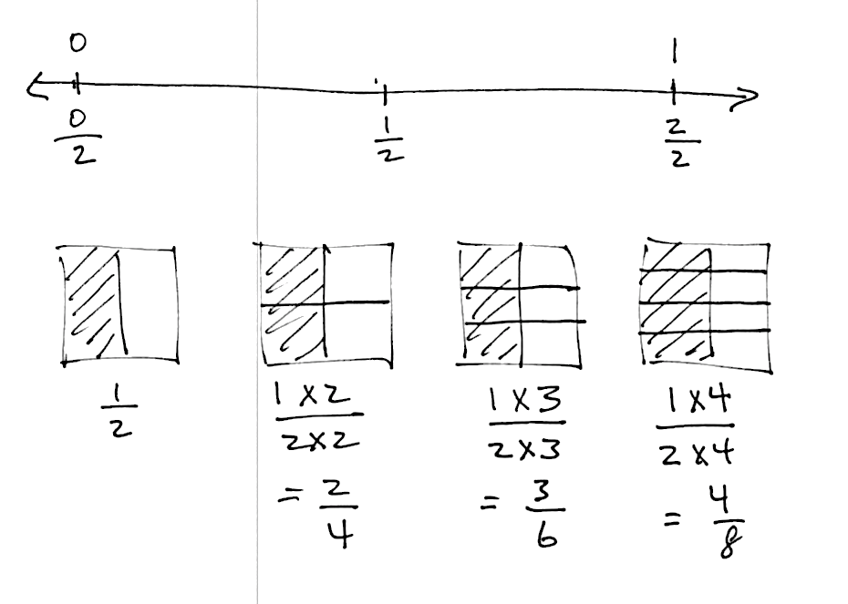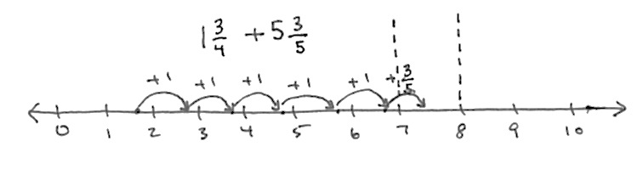

T: (Allow work time.) Draw another square to the right of that one. Shade it in the same way to represent .

T: Partition 1 half horizontally across the middle.

T: What fraction is shaded now?

S: or .

T: (Record numerically referring to the picture.) 1 group of 2 out of two groups of 2.

T: Explain how we have represented the equivalent fractions to your partners. (Students discuss.)

T: Show me on the number line. (Students show.) Yes, it is exactly the same value as 1 half. It is exactly the same point on the number line.

T: Work with your partner to draw another congruent square with 1 half shaded. This time, partition it horizontally into 3 equal units (2 lines) and record the equivalent fraction as we did on the first example. If you finish early, continue the pattern.

Problem 2: Make fractions equal to .

|  |  |
| --- | --- |
|  | NOTES ON  MULTIPLE MEANS  OF ENGAGEMENT: |

Because this lesson is so pictorial, it is perfect for English language learners. Use hand gestures to support the connection between words and numbers and numbers and models. For example, say, “one unit of two.” (Pause and point to the image, and then to the numbers.)

This problem allows students to repeat the procedure with thirds. If necessary for students, try repeating the process thoroughly as outlined in Problem 1. Work with a small group as others work independently, or allow students to work with a partner. It is not necessary for all students to complete the same amount of work. Move on to Problem 3 after about 4 minutes on Problem 2.

Note: Use a model to clarify equivalencies as illustrated below that 6 ninths is shown to be equal to 4 sixths. Go back and ensure that this point is clear with 2 sixths, 3 ninths, and   
4 twelfths.

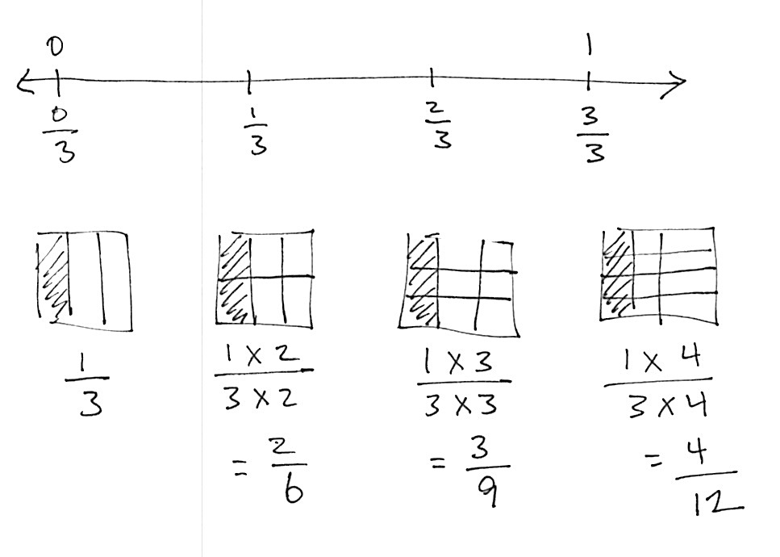

Problem 3: Make fractions equal to .

The next complexity is working with a non-unit fraction.

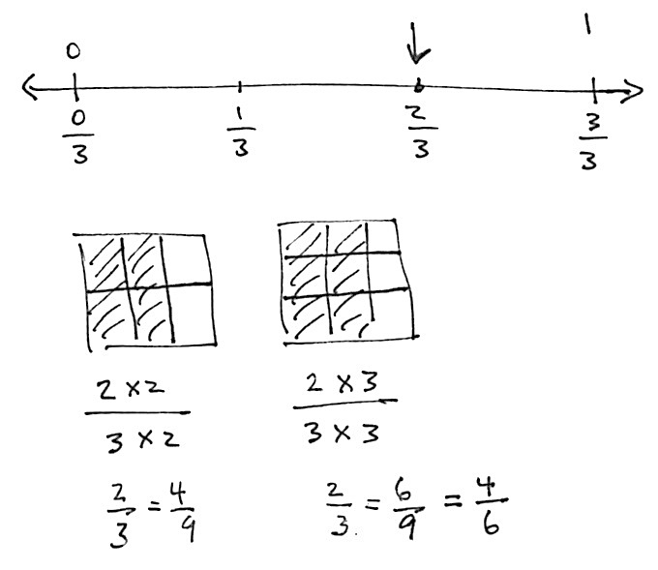

Problem 4: Make fractions equal to .

Note: The final complexity prior to working independently is to model a fraction greater than 1. The same exact process is used. Rectangles are used in the example just to break rigidity. This is not unique to squares!

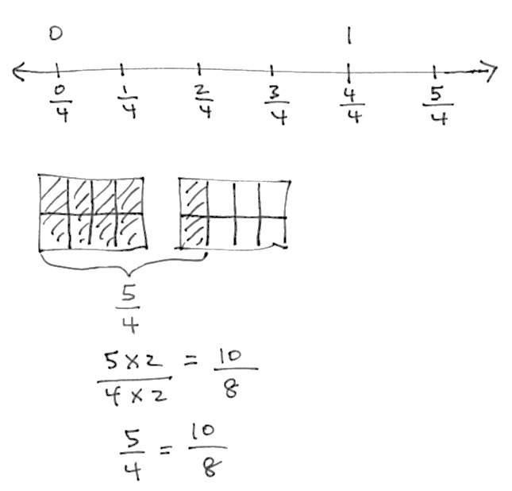

Problem Set (10 minutes)

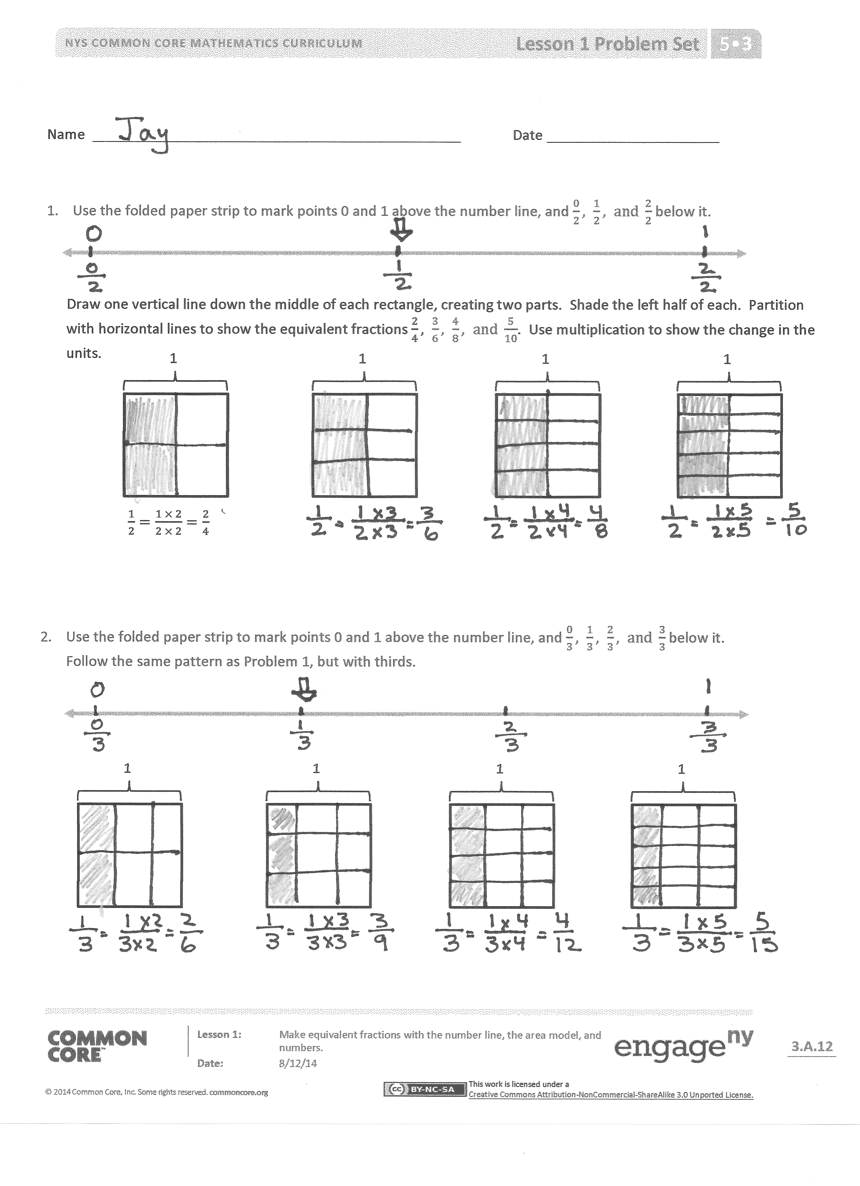Students should do their personal best to complete the Problem Set within the allotted 10 minutes. Some problems do not specify a method for solving. This is an intentional reduction of scaffolding that invokes MP.5, Use Appropriate Tools Strategically. Students should solve these problems using the RDW approach used for Application Problems.

For some classes, it may be appropriate to modify the assignment by specifying which problems students should work on first. With this option, let the purposeful sequencing of the Problem Set guide your selections so that problems continue to be scaffolded. Balance word problems with other problem types to ensure a range of practice. Consider assigning incomplete problems for homework or at another time during the day.

Student Debrief (10 minutes)

**Lesson Objective:** Make equivalent fractions with the number line, the area model, and numbers.

The Student Debrief is intended to invite reflection and active processing of the total lesson experience.

Invite students to review their solutions for the Problem Set. They should check work by comparing answers with a partner before going over answers as a class. Look for misconceptions or misunderstandings that can be addressed in the Debrief. Guide students in a conversation to debrief the Problem Set and process the lesson.

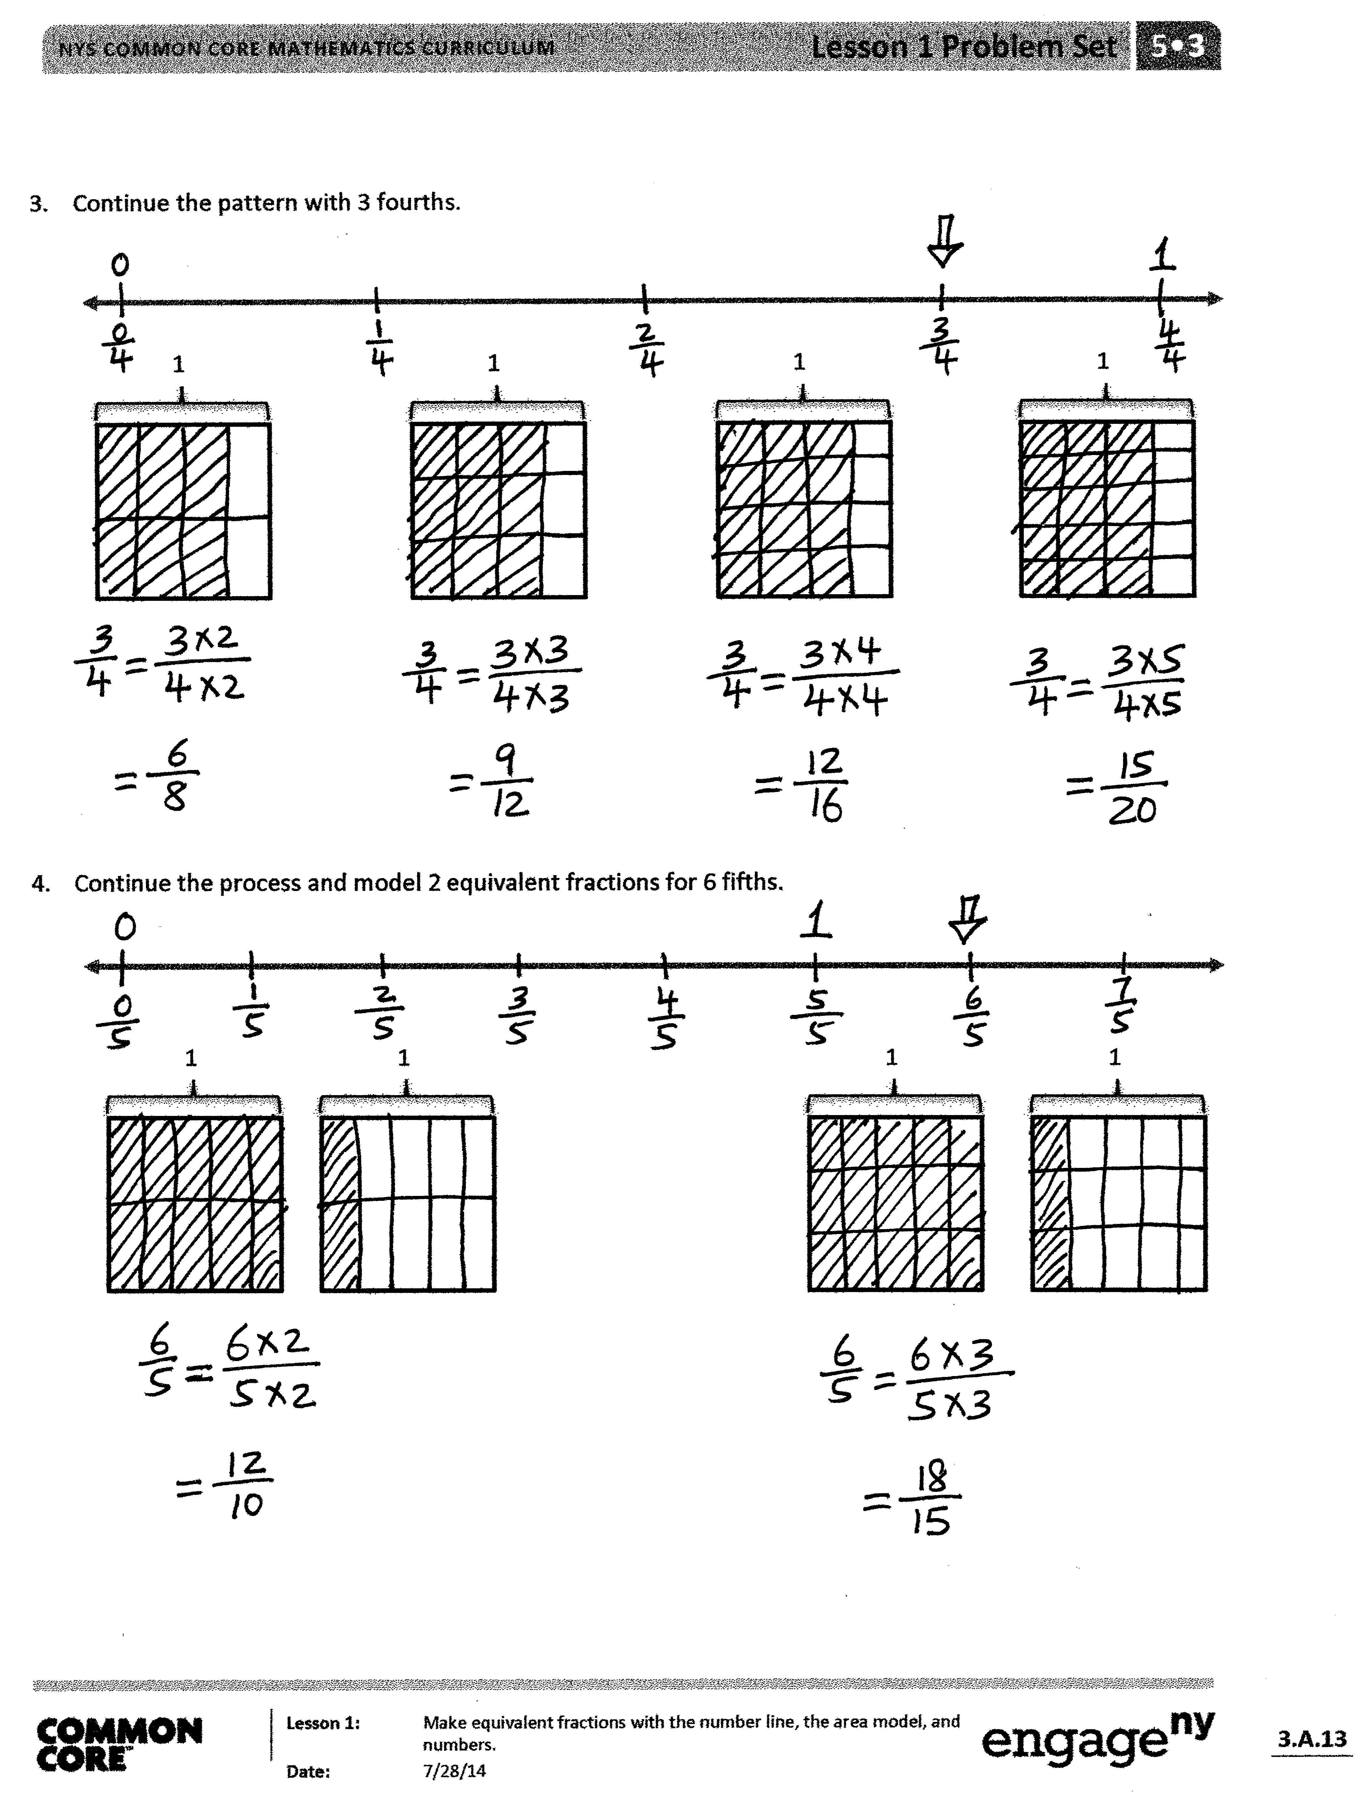T: Looking at your Problem Set, which fractions are equal to ?

S: .

T: Continue the pattern beyond those on the Problem Set with your partner.

T: (After a moment.) Continue the pattern chorally.

S: .

T: Is equal to ?

S: Yes.

T: How can we know if a fraction is equal to 1 third without drawing?

S: When you multiply the numerator by 3, you get the denominator. 🡪 When you divide the denominator by 3, you get the numerator.   
🡪 The total number of equal pieces is 3 times the number of selected equal pieces.

T: In the next minute, write as many other fractions as you can that are equal to 1 third on your personal white board.

|  |  |
| --- | --- |
|  | NOTES ON  MULTIPLE MEANS  OF REPRESENTATION: |
| These number lines and squares are approximate sketches rather than precise drawings. Avoid rulers and graph paper so that students become accustomed to realizing that these images are not intended to be perfect, but symbolic. The lines represent straight lines. The units are cut into equal parts. The Problem Set has pre-drawn squares in the interest of time and to expedite the movement to the abstract number. It is highly preferable to start with hand-drawn squares, so students do not receive the mistaken impression that drawings have to be perfect. A mental schema is developing, not an attachment to the drawing. | |

T: What do we know about all these fractions when we look at the number line?

S: They are the exact same point.

T: So, there are an infinite number of fractions equivalent to ?

S: Yes!

T: The fraction is one number, just like the number two or three. It is not two numbers, just this one point on the number line.

Quickly repeat the process of generating equivalent fractions for 3 fourths and 5 sixths.

T: Discuss with your partner what is happening to the pieces—the units, when the numerator and denominator are getting larger.

**MP.7**

S: The parts are getting smaller. 🡪 The equal pieces are being replaced by smaller equal pieces, but the area of the fraction is staying the same. 🡪 The units are being partitioned into smaller equal units. The value of the fraction is exactly the same.

T: What would that look like, were we to see it on the number line?

S: The length would be divided into smaller and smaller parts.

T: Discuss with your partner what the new smaller unit will be when I divide each of the lengths of 1 fourth into 3 smaller parts of equal length (use the fourths number line from earlier in the lesson). Compare it to the corresponding picture on your Problem Set.

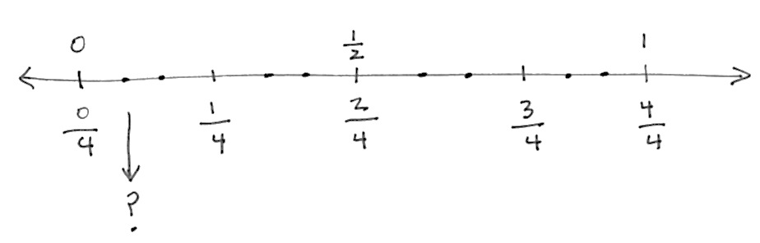

**MP.7**

T: On your Problem Set, divide the lengths of 1 third into 5 equal smaller units. Think about what is happening to the units, length, and name of the fraction. Close the lesson by discussing connections between the number line, the area model, and the equivalent fractions with your partner.

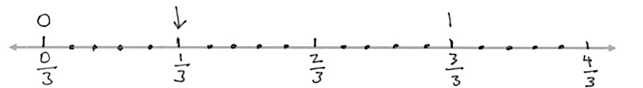

**MP.7**

Exit Ticket (3 minutes)

After the Student Debrief, instruct students to complete the Exit Ticket. A review of their work will help you assess the students’ understanding of the concepts that were presented in the lesson today and plan more effectively for future lessons. You may read the questions aloud to the students.

[1]



**A** # Correct__________

**Write the missing factor.**

[2]



**B** Improvement______# Correct­­­­_______

**Write the missing factor.**

Name Date

1. Use the folded paper strip to mark points 0 and 1 above the number line, and below it.

Draw one vertical line down the middle of each rectangle, creating two parts. Shade the left half of each. Partition with horizontal lines to show the equivalent fractions . Use multiplication to show the change in the units.

1

1

1

1

1. Use the folded paper strip to mark points 0 and 1 above the number line, and below it.

Follow the same pattern as Problem 1, but with thirds.

1

1

1

1

3. Continue the pattern with 3 fourths.

1

1

1

1

1. Continue the process and model 2 equivalent fractions for 6 fifths.

1

1

1

1

Name Date

Estimate to mark points 0 and 1 above the number line, and below it. Use the squares below to represent fractions equivalent to 1 sixth using both arrays and equations.

1

1

1

Name Date

1. Use the folded paper strip to mark points 0 and 1 above the number line, and below it.

Draw two vertical lines to break each rectangle into thirds. Shade the left third of each. Partition with horizontal lines to show equivalent fractions. Use multiplication to show the change in the units.

1

1

1

1

1. Use the folded paper strip to mark points 0 and 1 above the number line, and below it. Follow the same pattern as Problem 1, but with fourths.

1

1

1

1

1. Continue the pattern with 4 fifths.

1

1

1

1

1. Continue the process and model 2 equivalent fractions for 9 eighths. Estimate to mark the points on the number line.

1

1

1

1

1. write the missing factor
2. write the missing factor