Lesson 11: Solution Sets for Equations and Inequalities

Student Outcomes
- Students understand that an equation with variables is often viewed as a question asking for the set of values one can assign to the variables of the equation to make the equation a true statement. They see the equation as a “filter” that sifts through all numbers in the domain of the variables, sorting those numbers into two disjoint sets: the solution set and the set of numbers for which the equation is false.
- Students understand the commutative, associate, and distributive properties as identities; e.g., equations whose solution sets are the set of all values in the domain of the variables.

Classwork
Example 1 (2 minutes)
- Consider the equation shown in Example 1 of your student materials, $x^{2}=3x+4$, where $x$ represents a real number.
- Since we have not stated the value of $x$, this is not a number sentence.
Example 1
Consider the equation, $x^{2}=3x+4$, where $x$ represents a real number.
  - Are the expressions $x^{2}$ and $3x+4$ algebraically equivalent?
No.

- Then we cannot guarantee there will be any real value of $x$ that will make the equation true.

  - The following table shows how we might “sift” through various values to assign to the variable symbol $x$ in the hunt for values that would make the equation true.

$x$-VALUE | THE EQUATION | TRUTH VALUE
Let $x=0$ | $$0^{2}=3(0)+4$$ | FALSE
Let $x=5$ | $$5^{2}=3(5)+4$$ | FALSE
Let $x=6$ | $$6^{2}=3\left(6\right)+4$$ | FALSE
Let $x=-7$ | $${(-7)}^{2}=3(-7)+4$$ | FALSE
Let $x=4$ | $$4^{2}=3(4)+4$$ | TRUE
Let $x=9$ | $$9^{2}=3(9)+4$$ | FALSE
Let $x=10$ | $$10^{2}=3(10)+4$$ | FALSE
Let $x=-8$ | $${(-8)}^{2}=3(-8)+4$$ | FALSE

- Of course, we should sift through ALL the real numbers if we are seeking all values that make the equation $x^{2}=3x+4$ true. (This makes for quite a large table!) So far we have found that setting $x$ equal to $4$ yields a true statement.
- Look at the image in your student materials. Can you see what is happening here and how it relates to what we have been discussing?
  - The numbers are going down the road and being accepted into the solution set or rejected based on whether or not the equation is true.

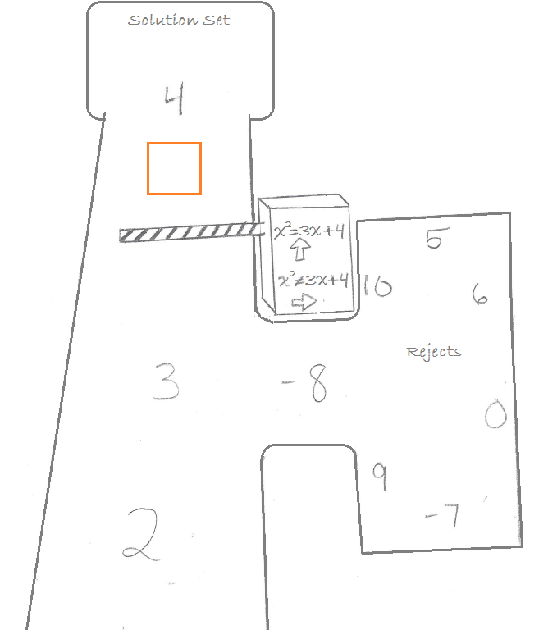

- There happens to be just one more value we can assign to x that makes $x^{2}=3x+4$ a true statement. Would you like to continue the search to find it?
  - $x=-1$

Example 2 (1 minute)
Example 2
Consider the equation $7+p=12$.
 | THE NUMBER SENTENCE | TRUTH VALUE
Let $p=0$ | $$7+0=12$$ | FALSE
Let $p=4$
Let $p=1+\sqrt{2}$
Let $p=\frac{1}{π}$
Let $p=5$

- Here's a table that could be used to hunt for the value(s) of $p$ that make the equation true:

$p$-VALUE | THE EQUATION | TRUTH VALUE
Let $p=0$ | $$7+0=12$$ | FALSE
Let $p=4$ | $$7+4=12$$ | FALSE
Let $p=1+\sqrt{2}$ | $$7+(1+\sqrt{2})=12$$ | FALSE
Let $p=\frac{1}{π}$ | $$7+\frac{1}{π}=12$$ | FALSE
Let $p=5$ | $$7+5=12$$ | TRUE

- But is a table necessary for this question? Is it obvious what value(s) we could assign to $p$ to make the equation true?

Discussion (2 minutes)
The solution set of an equation written with only one variable is the set of all values one can assign to that variable to make the equation a true statement. Any one of those values is said to be a solution to the equation.
To solve an equation means to find the solution set for that equation.

- Recall that it is usually assumed that one is sifting through all the real numbers to find the solutions to an equation, but a question or a situation might restrict the domain of values we should sift through. We might be required to sift only through integer values, the positive real numbers, or the non-zero real numbers, for example. The context of the question should make this clear.

Example 3 (1 minute)
Give students 1 minute or less to complete the exercise and then discuss the answer.
Example 3
Solve for $a$:$a^{2}=25$.
We know that setting $a=5$ or setting $a=-5$ makes $a^{2}=25$ a true statement. And a little thought shows that these are the only two values we can assign to make this so. The solution set is just the set containing the numbers $5$ and$-5$. (And since the question made no mention of restricting the domain of values we should consider, we shall assume both these values are admissible solutions for this question.)

Discussion (6 minutes)
One can describe a solution set in any of the following ways:
IN WORDS: $a^{2}=25$ has solutions $5$ and $-5$. (That is, $a^{2}=25$ is true when $a=5$ or $a=-5$.)
IN SET NOTATION: The solution set of $a^{2}=25$ is $\left\{-5, 5\right\}$.
IN A GRAPHICAL REPRESENTATION ON A NUMBER LINE: The solution set of $a^{2}=25$ is
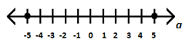
In this graphical representation, a solid dot is used to indicate a point on the number line that is to be included in the solution set. (WARNING: The dot one physically draws is larger than the point it represents. One hopes that it is clear from the context of the diagram which point each dot refers to.)
How set notation works.
- The curly brackets { } indicate we are denoting a set. A set is essentially a collection of things, e.g., letters, numbers, cars, people. In this case, the things are numbers.
- From this example, the numbers $-5$ and $5$ are called elements of the set. No other elements belong in this particular set because no other numbers make the equation $a^{2}=25$ true.
- When elements are listed, they are listed in increasing order.
- Sometimes, a set is empty; it has no elements. In which case, the set looks like { }. We often denote this with the symbol, $∅$. We refer to this as the empty set or the null set.

Exercise 1 (3 minutes)
Allow students to work independently, making sense of the problem and persevering in solving it. Have the students discuss the problem and its solution. As much as possible, let the students find the way to the solution and articulate how they know on their own, interjecting questions as needed to spawn more conversation.
Exercise 1
MP.1
Solve for $a$: $a^{2}=-25$. Present the solution set in words, in set notation, and graphically.
IN WORDS: The solution set to this equation is the empty set. There are no real values to assign to $a$ to make the equation true.
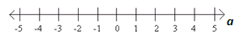
IN SET NOTATION: The solution set is { } (the empty set).
IN A GRAPHICAL REPRESENTATION: The solution set is
.

Exercise 2
Exercise 2
Depict the solution set of $7+p=12$ in words, in set notation, and graphically.
IN WORDS: $7+p=12$ has the solution $p=5$.
IN SET NOTATION: The solution set is $\{5\}$.
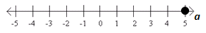
IN A GRAPHICAL REPRESENTATION:

Example 4 (4 minutes)
Example 4

Solve $\frac{x}{x}=1$ for $x$, over the set of positive real numbers. Depict the solution set in words, in set notation, and graphically.

- The question statement indicates that we are to consider assigning values to $x$ only from the set of positive real numbers. Let’s create a table to get a feel for the problem. (It might actually be helpful this time.)

$x$-VALUE | THE EQUATION | TRUTH VALUE
Let $x = 2$ | $$\frac{2}{2}=1$$ | TRUE
Let $x = 7$ | $$\frac{7}{7}=1$$ | TRUE
Let $x = 0.01$ | $$\frac{0.01}{0.01}=1$$ | TRUE
Let $x=562\frac{2}{3}$ | $$\frac{562\frac{2}{3}}{562\frac{2}{3}}=1$$ | TRUE
Let $x = {10}^{100}$ | $$\frac{{10}^{100}}{{10}^{100}}$$ | TRUE
Let $x = π$ | $$\frac{π}{π}=1$$ | TRUE

It seems that each and every positive real number is a solution to this equation.
IN WORDS: The solution set is the set of all positive real numbers.
IN SET NOTATION: This is {$x \text{real}$ | $x>0$}.
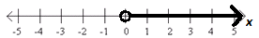
IN A GRAPHICAL REPRESENTATION:

Discussion (4 minutes)
Some comments on set notation:
- If it is possible to list the elements in a set, then one might do so, for example:
$\{-3, 5, \sqrt{40}\}$ is the set containing the three real numbers $-3$, 5, and $\sqrt{40}$.
$\{1, 2, 3, …, 10\}$ is the set containing the ten integers $1$ through $10$. (The ellipsis is used to state that the pattern suggested continues.)

- If it is not possible or not easy to list the elements in a set, then use the notation:
{ variable symbol number type | a description }

- For example:
{$x$ real |$x>0$} reads as, “The set of all real numbers that are greater than zero.”
{$p$ integer | $-3≤p<100$} reads as, “The set of all integers that are greater than or equal to $-3$ and smaller than $100$.”
{$y$ real | $y≠0$} reads as, “The set of all real numbers that are not equal to zero.”

- The vertical bar “|” in this notation is often read as “that” or “such that.”

Some comments on graphical representations are as follows:
- One uses solid dots to denote points on a number line, real numbers, to be included in the solution set, and open dots to indicate points to be excluded.
- Solid lines (possibly with arrows to indicate “extend indefinitely to the right” or “extend indefinitely to the left”) are used to indicate intervals of points on the number line (intervals of real numbers) all to be included in the set.
- For example,
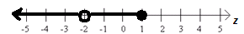
represents the set of real numbers: {$z$ real | $z≤1$ and $z≠-2$}

Exercise 3 (3 minutes)
Exercise 3
Solve $\frac{x}{x}=1$for $x$, over the set of all non-zero real numbers. Describe the solution set in words, in set notation, and graphically.
IN WORDS: The solution set is the set of all non-zero real numbers.
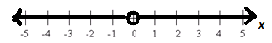
IN SET NOTATION: {$x$ real | $x≠0$}
IN A GRAPHICAL REPRESENTATION:
Example 5 (4 minutes)
Note that the following example is important to discuss with care.
Example 5
Solve for $x$: $x(3+x)=3x+x^{2}$.

- Since it is not specified otherwise, we should again assume that we are considering solutions from the set of all real numbers.
- In drawing a table to sift for possible solutions, students might come to suspect that every real value for $x$ is a solution to this equation.
- The distributive property states that, for all real numbers $a$, $b$, and $c$, the expressions $a(b+c)$ and $ab+ac$ are sure to have the same numerical value. The commutative property for multiplication states for all real numbers $d$ and $e$, the expressions $de$ and $ed$ have the same numerical value.
- Consequently, we can say, for any value we assign to $x$:
$$x\left(3+x\right)=x⋅3+x^{2},$$
that is, $x(3+x)=3x+x^{2}$is sure to be a true numerical statement. This proves that the solution set to this equation is the set of all real numbers.
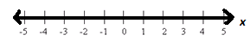

- It is awkward to express the set of all real numbers in set notation. We simply write the “blackboard script” ℝ for the set of all real numbers. (By hand, one usually just draws a double vertical bar in the capital letter: .)

Exercise 4 (2 minutes)
Exercise 4
Solve for $α$: $α+α^{2}=α(α+1)$. Describe carefully the reasoning that justifies your solution. Describe the solution set in words, in set notation, and graphically.
IN WORDS: By the distributive property, we have $α+α^{2}=α(1+α)$. This is a true numerical statement no matter what value we assign to α. By the commutative property of addition, we have $α+α^{2}=α(α+1)$, which is a true numerical statement no matter what real value we assign to α.
MP.3
The solution set is the set of all real numbers.
IN SET NOTATION: The solution set is ℝ.
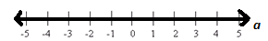
IN GRAPHICAL REPRESENTATION:

Discussion (2 minutes)
- Recall, what does it mean for two expressions to be algebraically equivalent?
  - One expression can be converted to the other by repeatedly applying the commutative, associative, and distributive properties or the properties of rational exponents to either expression.
- When the left side of an equation is algebraically equivalent to the right side of an equation, what will the solution set be?
  - All real numbers.
An identity is an equation that is always true.

Exercise 5 (1 minute)
Exercise 5
Identify the properties of arithmetic that justify why each of the following equations has a solution set of all real numbers:
  - $2x^{2}+4x=2\left(x^{2}+2x\right)$
  - $2x^{2}+4x=4x+2x^{2}$
  - $2x^{2}+4x=2x(2+x)$
(a) Distributive property; (b) commutative property of addition; (c) multiple properties: distributive property, commutative property of addition, and maybe even associative property of multiplication if we analyze the interpretation of $2x^{2}$ with extreme care.

Exercise 6 (2 minutes)
Exercise 6
Create an expression for the right side of each equation such that the solution set for the equation will be all real numbers. (There is more than one possibility for each expression. Feel free to write several answers for each one.)
  - $2x-5$ =

  - $x^{2}+x$ =

  - $4·x·y·z =$

  - ${\left(x+2\right)}^{2}$ =
Sample Answers: (a) $-5+2x \text{ or} 2\left(x-\frac{5}{2}\right)$ (b) $x+x^{2} \text{or} x\left(x+1\right) \text{ or } x\left(1+x\right)$
(c) any rearranging of the factors (d) ${(2+x)}^{2} \text{or} { x}^{2}+4x+4$

Closing/Example 6/Exercise 7 (5 minutes)
- We can extend the notion of a solution set of an equation to that of a solution set of an inequality (that is, a statement of inequality between two expressions).
- For instance, we can make sense of the following example.
Example 6
Solve for $w$: $w+2>4$.

In discussing this problem, have students realize:
- An inequality between two numerical expressions also has a well-defined truth value: true or false.
- Just as for equations, one can “sift” through real values of the variable in an inequality to find those values that make the inequality a true statement. The solution set of an inequality is set of all real values that make the inequality true.

Have students describe the solution set to $w + 2 > 4$ in words, in set notation, and in graphical representation.
IN WORDS: $w$ must be greater than $2$.
IN SET NOTATION: $\left\{w\text{ real} | w>2\right\}$
IN GRAPHICAL REPRESENTATION:

Review their answers, and then have them complete Exercise 7.
Exercise 7
  - Solve for $B$: $B^{2}≥9$. Describe the solution set using a number line.
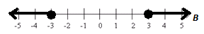

  - What is the solution set to the statement: “Sticks of lengths $2$ yards, $2$ yards, and $L$ yards make an isosceles triangle”? Describe the solution set in words and on a number line.
$L$ must be greater than $0$ yards and less than $4$ yards.
MP.2
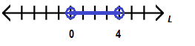

Lesson Summary
The solution set of an equation written with only one variable symbol is the set of all values one can assign to that variable to make the equation a true number sentence. Any one of those values is said to be a solution to the equation.
To solve an equation means to find the solution set for that equation.
One can describe a solution set in any of the following ways:
IN WORDS: $a^{2}=25$ has solutions $5$ and $-5$. (That is, $a^{2}=25$ is true when $a=5$ or $a=-5$.)
IN SET NOTATION: The solution set of $a^{2}=25$ is $\left\{-5, 5\right\}$.
It is awkward to express the set of infinitely many numbers in set notation. In these cases we can use the notation: $\left\{\text{variable symbol number type} | \text{a description}\right\}$. For example $\left\{x \text{real} | x>0\right\}$ reads, “$x$ is a real number where $x$ is greater than zero.” The symbol ℝ can be used to indicate all real numbers.
IN A GRAPHICAL REPRESENTAION ON A NUMBER LINE: The solution set of $a^{2}=25$ is as follows:
In this graphical representation, a solid dot is used to indicate a point on the number line that is to be included in the solution set. (WARNING: The dot one physically draws is larger than the point it represents! One hopes that it is clear from the context of the diagram which point each dot refers to.)

Exit Ticket (3 minutes)

Name ___________________________________________________ Date____________________
Lesson 11: Solution Sets for Equations and Inequalities

Exit Ticket

- Here is the graphical representation of a set of real numbers:
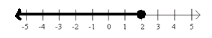

  - Describe this set of real numbers in words.

  - Describe this set of real numbers in set notation.

  - Write an equation or an inequality that has the set above as its solution set.

- Indicate whether each of the following equations is sure to have a solution set of all real numbers. Explain your answers for each.
  - $3\left(x+1\right)=3x+1$

  - $x+2=2+x$

  - $4x(x+1)=4x+4x^{2}$

  - $3x\left(4x\right)\left(2x\right)=72x^{3}$

Exit Ticket Sample Solutions

- Here is the graphical representation of a set of real numbers:
  - Describe this set of real numbers in words.
The set of all real numbers less than or equal to two.

  - Describe this set of real numbers in set notation.
{$r$ real | $r≤2$} (Students might use any variable.)

  - Write an equation or an inequality that has the set above as its solution set.
$w-7≤-5$ (Answers will vary. Students might use any variable.)

- Indicate whether each of the following equations is sure to have a solution set of all real numbers. Explain your answers for each.
  - $3\left(x+1\right)=3x+1$
No, the two algebraic expressions are not equivalent.

  - $x+2=2+x$
Yes, the two expressions are algebraically equivalent by application of the commutative property.

  - $4x(x+1)=4x+4x^{2}$
Yes, the two expressions are algebraically equivalent by application of the distributive property and the commutative property.

  - $3x\left(4x\right)\left(2x\right)=72x^{3}$
No, the two algebraic expressions are not equivalent.

Problem Set Sample Solutions
For each solution set graphed below, (a) describe the solution set in words, (b) describe the solution set in set notation, and (c) write an equation or an inequality that has the given solution set.

1. |  | 2.
 | a. the set of all real numbers equal to $5$ |  | a. the set of all real numbers equal to $\frac{2}{3}$
 | b. {$5$} |  | b. $\left\{\frac{2}{3}\right\}$
 | c. answers vary |  | c. answers vary

3. |  | 4.
 | a. the set of all real numbers greater than $1$ |  | a. the set of all real numbers less or equal to $5$
 | b. {$x$ real | $x > 1$} |  | b. {$x$ real | $x ≤ 5$}
 | c. answers vary |  | c. answers vary
5. |  | 6.
 | a. the set of all real numbers not equal to $2$ |  | a. the set of all real numbers not equal to $4$
 | b. {$x$ real | $x≠2$} |  | b. {$x$ real | $x≠4$}
 | c. answers vary |  | c. answers vary
7. |  | 8.
 | a. the null set |  | a. the set of all real numbers
 | b. { } or $∅$ |  | b. {$R.$}
 | c. answers vary |  | c. answers vary

Fill in the chart below.
 |  | SOLUTION SET IN WORDS | SOLUTION SET IN SET NOTATION | GRAPH
 | $$z=2$$ | The set of real numbers equal to $2$ | $$\{2\}$$
 | $$z^{2}=4$$ | The set of real numbers equal to $2$ or $-2$ | $$\{-2, 2\}$$
 | $$4z≠2$$ | The set of real numbers not equal to $\frac{1}{2}$. | $\{z$ real | $z≠\frac{1}{2}\}$ | 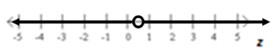
 | $$z-3=2$$ | The set of real numbers equal to $5$ | $$\{5\}$$
 | $$z^{2}+1=2$$ | The set of real numbers equal to $1$ or $-1$ | $$\{-1,1\}$$
 | $$z=2z$$ | The set of real numbers equal to $0$ | $$\{0\}$$
 | $$z>2$$ | The set of real numbers greater than $2$ | $\{z$ real | $z>2\}$
 | $$z-6=z-2$$ | The null set | $$\{ \}$$
 | $$z-6<-2$$ | The set of real numbers less than $4$ | $\{z$ real | $z<4\}$
 | $$4\left(z-1\right)≥4z-4$$ | The set of all real numbers | $$R$$
For Problems 19–24, answer the following: Are the two expressions algebraically equivalent? If so, state the property (or properties) displayed. If not, state why (the solution set may suffice as a reason) and change the equation, ever so slightly, e.g., touch it up, to create an equation whose solution set is all real numbers.
- $x(4-x^{2})=(-x^{2}+4)x$
Yes, commutative

- $\frac{2x}{2x}=1$
No, the solution set is {$x$ real | $x≠0$}. If we changed it to $\frac{2x}{1}=2x$, it would have a solution set of all real numbers.

- $(x-1)(x+2)+(x-1)(x-5)=(x-1)(2x-3)$
Yes, distributive

- $\frac{x}{5}+\frac{x}{3}=\frac{2x}{8}$
No, the solution set is $\{0\}$. If we changed it to $\frac{x}{5}+\frac{x}{3}=\frac{8x}{15}$, it would have a solution set of all real numbers.

- $x^{2}+2x^{3}+3x^{4}=6x^{9}$
No, neither the coefficients nor the exponents are added correctly. One way it could have a solution set of all real numbers would be $x^{2}+2x^{3}+3x^{4}=x^{2}(1+2x+3x^{2})$.

- $x^{3}+4x^{2}+4x=x{\left(x+2\right)}^{2}$
Yes, distributive

- Solve for $w$: $\frac{6w+1}{5}≠2$. Describe the solution set in set notation.
$\left\{w \text{real} | w≠1\frac{1}{2}\right\}$

- Edwina has two sticks, one $2$ yards long and the other $2$ meters long. She is going to use them, with a third stick of some positive length, to make a triangle. She has decided to measure the length of the third stick in units of feet.
  - What is the solution set to the statement: “Sticks of lengths $2$ yards, $2$ meters, and $L$ feet make a triangle”? Describe the solution set in words and through a graphical representation.
One meter is equivalent, to two decimal places, to $3.28$ feet. We have that $L$ must be a positive length greater than $0.56$ feet and less than $12.56$ feet. Within these values, the sum of any two sides will be greater than the third side.
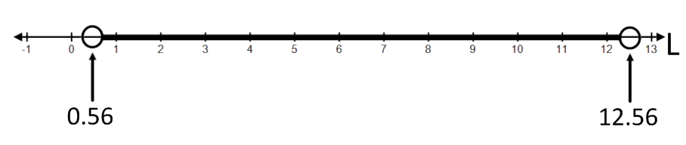

  - What is the solution set to the statement: “Sticks of lengths $2$ yards, $2$ meters, and $L$ feet make an isosceles triangle”? Describe the solution set in words and through a graphical representation.
$L=6$ feet or $L=6.56$feet.

  - What is the solution set to the statement: “Sticks of lengths $2$ yards, $2$ meters, and $L$ feet make an equilateral triangle”? Describe the solution set in words and through a graphical representation.
The solution set is the empty set.

