Lesson 9: Multiplying Polynomials

Classwork
Exercise 1
  - Gisella computed $342×23$ as follows:

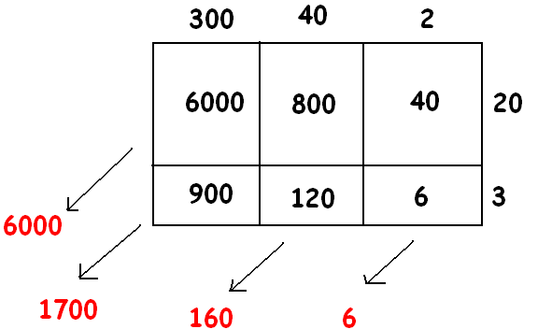

Can you explain what she is doing? What is her final answer?

Use a geometric diagram to compute the following products:
  - $\left(3x^{2}+4x+2\right)×\left(2x+3\right)$

  - $(2x^{2}+10x+1)(x^{2}+x+1)$

  - $(x-1)(x^{3}+6x^{2}-5)$

Exercise 2
Multiply the polynomials using the distributive property: $\left({3x}^{2}+x-1\right)\left(x^{4}-2x+1\right)$.

Exercise 3
The expression $10x^{2}+6x^{3}$ is the result of applying the distributive property to the expression $2x^{2}(5+3x)$. It is also the result of the applying the distributive property to $2(5x^{2}+3x^{3})$ or to $x(10x+6x^{2})$, for example, or even to
$1∙(10x^{2}+6x^{3})$!
For (i) to (x) below, write down an expression such that if you applied the distributive property to your expression it will give the result presented. Give interesting answers!
    - $6a+14a^{2}$

    - $2x^{4}+2x^{5}+2x^{10}$

    - $6z^{2}-15z$

    - $42w^{3}-14w+77w^{5}$

    - $z^{2}\left(a+b\right)+z^{3}(a+b)$

    - $\frac{3}{2}s^{2}+\frac{1}{2}$

    - $15p^{3}r^{4}-6p^{2}r^{5}+9p^{4}r^{2}+3\sqrt{2}p^{3}r^{6}$

    - $0.4x^{9}-40x^{8}$

    - $\left(4x+3\right)\left(x^{2}+x^{3}\right)-(2x+2)(x^{2}+x^{3})$

    - $\left(2z+5\right)\left(z-2\right)-(13z-26)(z-3)$

Exercise 4
Sammy wrote a polynomial using only one variable, $x$, of degree $3$. Myisha wrote a polynomial in the same variable of degree $5$. What can you say about the degree of the product of Sammy’s and Myisha’s polynomials?

Extension
Find a polynomial that, when multiplied by $2x^{2}+3x+1$, gives the answer $2x^{3}+x^{2}-2x-1$.

Problem Set

- Use the distributive property to write each of the following expressions as the sum of monomials.
- $3a(4+a)$  - $x\left(x+2\right)+1$  - $\frac{1}{3}(12z+18z^{2})$  - $4x(x^{3}-10)$  - $(x-4)(x+5)$  - $(2z-1)(3z^{2}+1)$  - $(10w-1)(10w+1)$  - $\left(-5w-3\right)w^{2}$  - $16s^{100}\left(\frac{1}{2}s^{200}+0.125s\right)$  - $(2q+1)(2q^{2}+1)$  - $(x^{2}-x+1)(x-1)$ | - $3xz\left(9xy+z\right)-2yz(x+y-z)$  - $(t-1)(t+1)(t^{2}+1)$  - $(w+1)(w^{4}-w^{3}+w^{2}-w+1)$  - $z(2z+1)(3z-2)$  - $(x+y)(y+z)(z+x)$  - $\frac{x+y}{3}$  - $(20f^{10}-10f^{5})÷5$  - $-5y\left(y^{2}+y-2\right)-2(2-y^{3})$  - $\frac{\left(a+b-c\right)\left(a+b+c\right)}{17}$  - $(2x÷9+(5x)÷2)÷(-2)$  - $(-2f^{3}-2f+1)(f^{2}-f+2)$

- Use the distributive property (and your wits!) to write each of the following expressions as a sum of monomials. If the resulting polynomial is in one variable, write the polynomial in standard form.
- ${\left(a+b\right)}^{2}$  - ${\left(a+1\right)}^{2}$  - ${\left(3+b\right)}^{2}$  - ${\left(3+1\right)}^{2}$  - ${\left(x+y+z\right)}^{2}$ | - ${\left(x+1+z\right)}^{2}$  - ${\left(3+z\right)}^{2}$  - ${\left(p+q\right)}^{3}$  - ${\left(p-1\right)}^{3}$  - ${\left(5+q\right)}^{3}$

- Use the distributive property (and your wits!) to write each of the following expressions as a polynomial in standard form.
- $(s^{2}+4)(s-1)$  - $3(s^{2}+4)(s-1)$  - $s(s^{2}+4)(s-1)$  - $(s+1)(s^{2}+4)(s-1)$ | - $(u-1)(u^{5}+u^{4}+u^{3}+u^{2}+u+1)$  - $\sqrt{5}(u-1)(u^{5}+u^{4}+u^{3}+u^{2}+u+1)$  - $(u^{7}+u^{3}+1)(u-1)(u^{5}+u^{4}+u^{3}+u^{2}+u+1)$

- Beatrice writes down every expression that appears in this problem set, one after the other, linking them with
“$+$” signs between them. She is left with one very large expression on her page. Is that expression a polynomial expression? That is, is it algebraically equivalent to a polynomial?
What if she wrote “ – ” signs between the expressions instead?
What if she wrote “×” signs between the expressions instead?

