Lesson 9: Multiplying Polynomials

Student Outcomes
- Students understand that the product of two polynomials produces another polynomial; students multiply polynomials.

Classwork
Exercise 1 (15 minutes)
Exercise 1
  - Gisella computed $342×23$as follows:
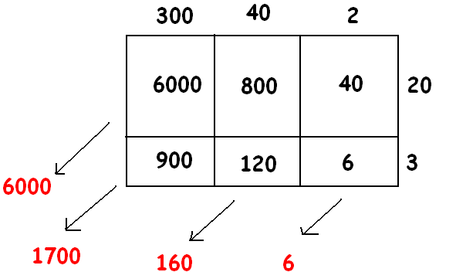
Can you explain what she is doing? What is her final answer?
She is using an area model, finding the area of each rectangle and adding them together. Her final answer is $7,866$.
Use a geometric diagram to compute the following products:
  - $\left(3x^{2}+4x+2\right)×\left(2x+3\right)$
$6x^{3}+17x^{2}+16x+6$

  - $(2x^{2}+10x+1)(x^{2}+x+1)$
${2x}^{4} + 12x^{3}+13x^{2}+11x + 1$

  - $(x-1)(x^{3}+6x^{2}-5)$
$$x^{4}+5x^{3}-6x^{2}-5x+5$$

Ask the students:
- What do you notice about the terms along the diagonals in the rectangles you drew?

Encourage students to recognize that in parts (b) and (c), the terms along the diagonals were all like terms; however, in part (d) one of the factors has no $x$-term. Allow students to develop a strategy for dealing with this, concluding with the suggestion of inserting the term $+ 0x$, for a model that looks like the following:
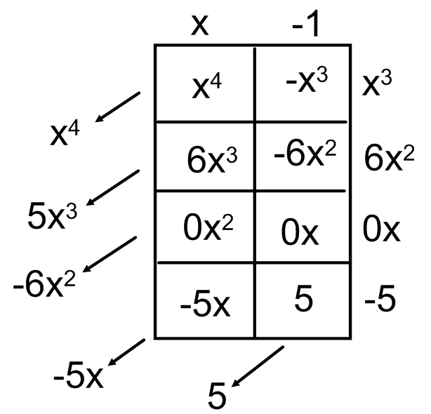

Students may naturally ask about the division of polynomials. This topic will be covered in Grade 11, Module 1. The extension challenge at the end of the lesson, however, could be of interest to students inquiring about this.
- Could we have found this product without the aid of a geometric model? What would that look like?
Go through the exercise applying the distributive property and collecting like terms. As a scaffold, remind students that variables are placeholders for numbers. If $x=5$, for example, whatever the quantity on the right is $(270)$, you have
$5-1$ of “that quantity”, or$5$of “that quantity” minus $1$ of “that quantity”. Similarly we have $x$ of that quantity, minus $1$ of that quantity:
$$(x-1)(x^{3}+6x^{2}-5)$$
$$x\left(x^{3}+6x^{2}-5\right)-1\left(x^{3}+6x^{2}-5\right)$$
$$x^{4}+6x^{3}-5x- x^{3}-6x^{2}+5$$
$$x^{4}+5x^{3}-6x^{2}-5x+5$$

Exercise 2 (5 minutes)
Have students work Exercise 2 independently and then compare answers with a neighbor. If needed, facilitate agreement on the correct answer by allowing students to discuss their thought processes and justify their solutions.
Exercise 2
Multiply the polynomials using the distributive property: $\left({3x}^{2}+x-1\right)\left(x^{4} - 2x + 1\right)$.
$$3x^{2}\left(x^{4}-2x+1\right)+x\left(x^{4}-2x+1\right)-1\left(x^{4}-2x+1\right)$$
$$3x^{6}-6x^{3}+3x^{2}+x^{5}-2x^{2}+x-x^{4}+2x-1$$
$$3x^{6}+x^{5}-x^{4}-6x^{3}+x^{2}+3x-1$$

Exercise 3 (10 minutes)
Give students 10 minutes to complete Exercise 3 and compare their answers with a neighbor.
Exercise 3
The expression $10x^{2}+6x^{3}$ is the result of applying the distributive property to the expression $2x^{2}(5+3x)$. It is also the result of the applying the distributive property to $2(5x^{2}+3x^{3})$ or to $x(10x+6x^{2})$, for example, or even to $1∙(10x^{2}+6x^{3})$!
For (i) to (x) below, write down an expression such that if you applied the distributive property to your expression it will give the result presented. Give interesting answers!
- $6a+14a^{2}$
- $2x^{4}+2x^{5}+2x^{10}$
- $6z^{2}-15z$
- $42w^{3}-14w+77w^{5}$
- $z^{2}\left(a+b\right)+z^{3}(a+b)$
- $\frac{3}{2}s^{2}+\frac{1}{2}$
- $15p^{3}r^{4}-6p^{2}r^{5}+9p^{4}r^{2}+3\sqrt{2}p^{3}r^{6}$
- $0.4x^{9}-40x^{8}$
- $\left(4x+3\right)\left(x^{2}+x^{3}\right)-(2x+2)(x^{2}+x^{3})$
- $\left(2z+5\right)\left(z-2\right)-(13z-26)(z-3)$
Some possible answers:
- $2a\left(3+7a\right)$ or $2\left(3a+7a^{2}\right) \text{or} a(6+14a)$
- $2x^{4}\left(1+x+x^{6}\right) \text{or} x\left(2x^{3}+2x^{4}+2x^{9}\right)$ or$2(x^{4}+x^{5}+x^{10})$
- $3z\left(2z-5\right) \text{or} 3\left(2z^{2}-5z\right)\text{ or } z(6z-15)$
- $7w\left(6w^{2}-2+11w^{4}\right) \text{ or }w\left(42w^{2}-14+77w^{4}\right)$
- $z^{2}\left(\left(a+b\right)+z\left(a+b\right)\right)\text{ or } z(z\left(a+b\right)+z^{2}\left(a+b\right))$
- $\frac{1}{2}(3s^{2}+1)$
- $3p^{2}r^{2}\left(5pr^{2}-2r^{3}+3p^{2}+\sqrt{2}pr^{4}\right)$or$p^{2}r^{2}(15pr^{2}-6r^{3}+9p^{2}+3\sqrt{2}pr^{4})$
- $0.4x^{8}\left(x-100\right) \text{ or } \frac{4}{10}x^{8}(x-100)$
- $(x^{2}+x^{3})(\left(4x+3\right)-\left(2x+2\right))$
- $(z-2)\left(\left(2z+5\right)-13\left(z-3\right)\right)$

Choose one (or more) to go through as a class, listing as many different re-writes as possible. Then remark:
- The process of making use of the distributive property “backwards” is factoring.

Exercise 4 (5 minutes)
Exercise 4
Sammy wrote a polynomial using only one variable, $x$, of degree $3$. Myisha wrote a polynomial in the same variable of degree $5$. What can you say about the degree of the product of Sammy’s and Myisha’s polynomials?
The degree of the product of the two polynomials would be $8$.

Extension
Extension
Find a polynomial that, when multiplied by $2x^{2}+3x+1$, gives the answer $2x^{3}+x^{2}-2x-1$.
$x-1$

Closing (6 minutes)
- Is the product of two polynomials sure to be another polynomial?
  - Yes, by the definition of polynomial expression given in Lesson 8, the product of any two polynomial expressions is again a polynomial expression, which can then be written in standard polynomial form through application of the distributive property.
- Is a polynomial squared sure to be another polynomial (other integer powers)?
  - Yes.

Exit Ticket (4 minutes)

Name ___________________________________________________ Date____________________
Lesson 9: Multiplying Polynomials

Exit Ticket

- Must the product of three polynomials again be a polynomial?

- Find $\left(w^{2}+1\right)(w^{3}-w+1)$.
Exit Ticket Sample Solutions

- Must the product of three polynomials again be a polynomial?
Yes.

- Find $\left(w^{2}+1\right)(w^{3}-w+1)$.
$w^{5}+w^{2}-w+1$

Problem Set Sample Solutions

- Use the distributive property to write each of the following expressions as the sum of monomials.
- $3a(4+a)$  $$3a^{2}+12a$$ | - $x\left(x+2\right)+1$  $x^{2}+2x+1$
- $\frac{1}{3}(12z+18z^{2})$  $$6z^{2}+4z$$ | - $4x(x^{3}-10)$  $$4x^{4}-40x$$
- $(x-4)(x+5)$  $$x^{2}+x-20$$ | - $(2z-1)(3z^{2}+1)$  $$6z^{3}-3z^{2}+2z-1$$
- $\left(10w-1\right)\left(10w+1\right)$  $$100w^{2}-1$$ | - $\left(-5w-3\right)w^{2}$  $$-5w^{3}-3w^{2}$$
- $16s^{100}\left(\frac{1}{2}s^{200}+0.125s\right)$  $$8s^{300}+2s^{101}$$ | - $(2q+1)(2q^{2}+1)$  $$4q^{3}+2q^{2}+2q+1$$
- $(x^{2}-x+1)(x-1)$  $$x^{3}-2x^{2}+2x-1$$ | - $3xz\left(9xy+z\right)-2yz(x+y-z)$  $$27x^{2}yz+3xz^{2}-2xyz-2y^{2}z+2yz^{2}$$
- $(t-1)(t+1)(t^{2}+1)$  $$t^{4}-1$$ | - $(w+1)(w^{4}-w^{3}+w^{2}-w+1)$  $$w^{5}+1$$
- $z(2z+1)(3z-2)$  $$6z^{3}-z^{2}-2z$$ | - $(x+y)(y+z)(z+x)$  $$2xyz+x^{2}y+x^{2}z+xy^{2}+xz^{2}+y^{2}z+yz^{2}$$
- $\frac{x+y}{3}$  $$\frac{1}{3}x+\frac{1}{3}y$$ | - $(20f^{10}-10f^{5})÷5$  $$4f^{10}-2f^{5}$$
- $-5y\left(y^{2}+y-2\right)-2(2-y^{3})$  $$-3y^{3}-5y^{2}+10y-4$$ | - $\frac{\left(a+b-c\right)\left(a+b+c\right)}{17}$  $$\frac{1}{17}a^{2}+\frac{1}{17}b^{2}-\frac{1}{17}c^{2}+\frac{2}{17}ab$$
- $(2x÷9+(5x)÷2)÷(-2)$  $$-\frac{49x}{36}$$ | - $(-2f^{3}-2f+1)(f^{2}-f+2)$  $$-2f^{5}+2f^{4}-6f^{3}+3f^{2}-5f+2$$

- Use the distributive property (and your wits!) to write each of the following expressions as a sum of monomials. If the resulting polynomial is in one variable, write the polynomial in standard form.
- ${\left(a+b\right)}^{2}$  $$a^{2}+2ab+b^{2}$$ | - ${\left(a+1\right)}^{2}$  $$a^{2}+2a+1$$ | - ${\left(3+b\right)}^{2}$  $$b^{2}+6b+9$$
- ${\left(3+1\right)}^{2}$  $$16$$ | - ${\left(x+y+z\right)}^{2}$  $$x^{2}+y^{2}+z^{2}+2xy+2xz+2yz$$ | - ${\left(x+1+z\right)}^{2}$  $$x^{2}+z^{2}+2xz+2x+2z+1$$
- ${\left(3+z\right)}^{2}$  $$z^{2}+6z+9$$ | - ${\left(p+q\right)}^{3}$  $$p^{3}+3p^{2}q+3pq^{2}+q^{3}$$ | - ${\left(p-1\right)}^{3}$  $$p^{3}-3p^{2}+3p-1$$
- ${\left(5+q\right)}^{3}$
$$q^{3}+15q^{2}+75q+125$$

- Use the distributive property (and your wits!) to write each of the following expressions as a polynomial in standard form.
- $(s^{2}+4)(s-1)$  $$s^{3}-s^{2}+4s-4$$ | - $3\left(s^{2}+4\right)\left(s-1\right)$  $$3s^{3}-3s^{2}+12s-12$$
- $s(s^{2}+4)(s-1)$  $$s^{4}-s^{3}+4s^{2}-4s$$ | - $(s+1)(s^{2}+4)(s-1)$  $s^{4}+3s^{2}-4$
- $(u-1)(u^{5}+u^{4}+u^{3}+u^{2}+u+1)$  $$u^{6}-1$$ | - $\sqrt{5}(u-1)(u^{5}+u^{4}+u^{3}+u^{2}+u+1)$  $$\sqrt{5}u^{6}-\sqrt{5}$$
- $(u^{7}+u^{3}+1)(u-1)(u^{5}+u^{4}+u^{3}+u^{2}+u+1)$
$$u^{13}+u^{9}-u^{7}+u^{6}-u^{3}-1$$

- Beatrice writes down every expression that appears in this problem set, one after the other, linking them with
“$+$” signs between them. She is left with one very large expression on her page. Is that expression a polynomial expression? That is, is it algebraically equivalent to a polynomial?
Yes.

What if she wrote “$-$” signs between the expressions instead?
Yes.

What if she wrote “$×$” signs between the expressions instead?
Yes.

