Lesson 6: Algebraic Expressions—The Distributive Property

Classwork
Exercise 2
Using the numbers $1$, $2$, $3$, $4$ only once and the operations $+$ or $×$ as many times as you like, write an expression that evaluates to $16$. Use this expression and any combination of those symbols as many times as you like to write an expression that evaluates to $816$.

Exercise 3
Define the rules of a game as follows:
  - Begin by choosing an initial set of symbols, variable or numeric, as a starting set of expressions.

  - Generate more expressions by placing any previously created expressions into the blanks of the addition operator: $______+_______$.

Exercise 4
Roma says that collecting like terms can be seen as an application of the distributive property. Is writing $x+x=2x$ an application of the distributive property?

Exercise 5
Leela is convinced that ${(a+b)}^{2}=a^{2}+b^{2}$. Do you think she is right? Use a picture to illustrate your reasoning.

Exercise 6
Draw a picture to represent the expression $\left(a+b+1\right)×\left(b+1\right)$.

Exercise 7
Draw a picture to represent the expression $\left(a+b)×(c+d)×(e+f+g\right).$

A Key Belief of Arithmetic
The Distributive Property: If $a$, $b$, and $c$ are real numbers, then $a\left(b+c\right)=ab+ac$.
Lesson Summary
The distributive property represents a key belief about the arithmetic of real numbers. This property can be applied to algebraic expressions using variables that represent real numbers.

Problem Set

- Insert parentheses to make each statement true.
  - $2+3×4^{2}+1=81$
  - $2+3×4^{2}+1=85$
  - $2+3×4^{2}+1=51$
  - $2+3×4^{2}+1=53$

- Using starting symbols of $w$, $q$, $2$, and $-2$, which of the following expressions will NOT appear when following the rules of the game played in Exercise 3?
  - $7w+3q+(-2)$
  - $q-2$
  - $w-q$
  - $2w+6$
  - $-2w+2$

- Luke wants to play the $4$-number game with the numbers $1$, $2$, $3$, and $4$ and the operations of addition, multiplication, AND subtraction.
Leoni responds, “Or we just could play the $4$-number game with just the operations of addition and multiplication, but now with the numbers $-1$, $-2$, $-3$, $-4$, $1$, $2$, $3$, and $4$ instead.”
What observation is Leoni trying to point out to Luke?

- Consider the expression: $\left(x+3\right)∙\left(y+1\right)∙(x+2)$.
  - Draw a picture to represent the expression.
  - Write an equivalent expression by applying the distributive property.

  - Given that $a>b$, which of the shaded regions is larger and why?
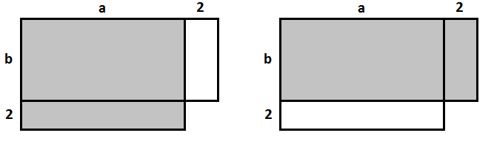

  - Consider the expressions $851×29$ and $849×31$. Which would result in a larger product? Use a diagram to demonstrate your result

- Consider the following diagram.
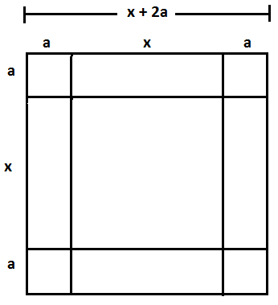

Edna looked at the diagram and then highlighted the four small rectangles shown and concluded:
${(x+2a)}^{2}=x^{2}+4a(x+a)$.
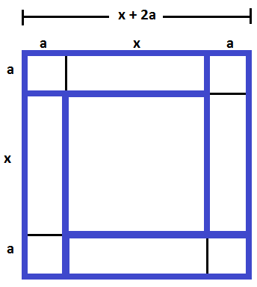
  - Michael, when he saw the picture, highlighted four rectangles and concluded:
${(x+2a)}^{2}=x^{2}+2ax+2a(x+2a)$.
Which four rectangles and one square did he highlight?
  - Jill, when she saw the picture, highlighted eight rectangles and squares (not including the square in the middle) to conclude:
${(x+2a)}^{2}=x^{2}+4ax+4a^{2}$.
Which eight rectangles and squares did she highlight?
  - When Fatima saw the picture, she exclaimed: ${(x+2a)}^{2}=x^{2}+4a\left(x+2a\right)-4a^{2}$. She claims she highlighted just four rectangles to conclude this. Identify the four rectangles she highlighted and explain how using them she arrived that the expression $x^{2}+4a\left(x+2a\right)-4a^{2}$.
  - Is each student's technique correct? Explain why or why not.

