Lesson 6: Algebraic Expressions—The Distributive Property

Student Outcomes
- Students use the structure of an expression to identify ways to rewrite it.
- Students use the distributive property to prove equivalency of expressions.

Lesson Notes
The previous five lessons introduced the graphs of the functions students will study in this algebra course. These next lessons change the focus from graphs to expressions and their structures. In Grades 5–8, the term “expression” was described but not formally defined, and many subtleties may have been overlooked. For example, the associative property may not have been made explicit; $3∙5∙7$, for instance, is really $\left(3∙5\right)∙7$. The lessons that follow will formally define algebraic expression and the equivalency of algebraic expressions and simultaneously introduce students to the notion of a recursive definition, which later becomes a major aspect of Algebra I (recursive sequences). Lesson 6 begins with an expression-building competition. As this is a strange, abrupt change of direction for students from the previous five lessons, it may be worthwhile to mention this change.

- In middle school you learned to find equations for straight line graphs such as the ones that appear in Lesson 1, but as we saw in Lessons 2 and 3, not all graphs are linear. It would be nice to develop the machinery for developing equations for those too, if at all possible. Note that Lesson 4 indicates that graphs still might be very complicated and finding a single equation for them might not be possible. We may, however, be able to find equations that produce graphs that approximate the graphs, or sections thereof. Also, Lesson 5 points out the value of finding the point of intersection of two graphs. Our goal is to develop the algebraic tools to do this.

Classwork
Exercise 1 (13 minutes)
The following is known as the “$4$-number game.” It challenges students to write each positive integer as a combination of the digits $1$, $2$, $3$, and $4$; each used at most once, combined via the operations of addition and multiplication only, as well as grouping symbols. For example, $24$ can be expressed as$(1+3)(2+4)$. Students may use parentheses or not, at their own discretion (as long as their expressions evaluate to the given number, following the order of operations). Digits may not be juxtaposed to represent larger whole numbers, so you cannot use the numerals $1$ and $2$ to create the number $12$ for instance.
Scaffold:
Should you feel your students would benefit from it, you may optionally begin the lesson with the “$3$-number game” using only the digits $1$, $2$, and $3$.
Play the $4$-number game as a competition within pairs. Give the students 3 minutes to express the longest list of numbers they can, each written in terms of the digits $1$, $2$,$3$, and $4$. Students may want to use small dry erase boards to play this game or pencil and paper. Optionally, consider splitting up the tasks (e.g., $1$–$8$, $9$–$20$, $21$–$30$, $31$–$36$) and assign them to different groups.
Below are some sample expressions the students may build and a suggested structure for displaying possible expressions on the board as students call out what they have created.
When reviewing the game, it is likely that students will have different expressions for the same number (see answers to rows 7 and 8 given below). Share alternative expressions on the board and discuss as a class the validity of the expressions.
Challenge the students to come up with more than one way to create the number $21$.
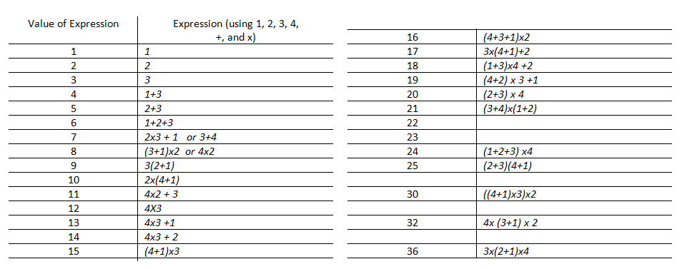
After students share their results, ask these questions:
- What seems to be the first counting number that cannot be created using only the numbers $1$, $2$, $3$, and $4$ and the operations of multiplication and addition?
  - $22$
- What seems to be the largest number that can be made in the $4$-number game?
  - $(1+2)(3)(4)=36$
We can now launch into an interesting investigation to find structure in the game.
- Suppose we were playing the $2$-number game. What seems to be the largest number you could create using the numbers $1$ and $2$ (each at most once) and the operations of multiplication and addition?
  - $(1+2)=3$
- Suppose we were playing the $3$-number game. What seems to be the largest number you could create using the numbers $1$, $2$, and $3$ (each at most once) and the operations of multiplication and addition?
  - $(1+2)(3) = 9$
Encourage students to generalize the pattern for the $5$-number game, and the $N$-number game, and think about why this pattern for an expression gives the largest attainable number.
  - Add $1$ and $2$, and then multiply the remaining numbers. For the $5$-number game, the largest number would be $(1+2)(3)(4)(5)=180$. For the $N$-number game, the largest number would be
$$(1+2)(3)(4)(5)…(n)$$

Discussion (5 minutes)
- We have seen that both $1+2+3$ and $1∙2∙3$ evaluate to $6$. Does it seem reasonable that for any real numbers, $a$,$b$, and $c$, that $a+b+c$ would be equivalent to $a∙b∙c$?
  - No, students will likely quickly think of counterexamples. (Proceed to the next bullet point regardless.)
- How can we show geometrically that they are not generally equivalent? Assume that $a$,$b$, and $c$, are positive integers. Does it seem intuitive that these two geometric representations are equivalent?
  - The geometric representations do not suggest equivalency.
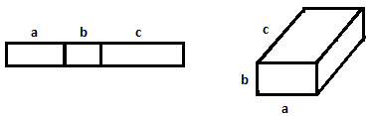
- Therefore, it does not appear that being numerically equivalent in one specific case implies equivalency in other, more general cases.
- Perhaps we should play a game like this with symbols.
- Let’s consider first what the effect would be of allowing for repeat use of symbols in the $4$-number game.
With the repeat use of symbols, we can build larger and larger expressions by making use of expressions we already possess. For example, from$10=1+2+3+4$, we can generate the number$110$ by making repeated use of the expression:
MP.7
$110=10∙10+10=\left(1+2+3+4\right)∙\left(1+2+3+4\right)+\left(1+2+3+4\right)$.

Exercise 2 (1 minute)
Exercise 2
Using the numbers $1$, $2$, $3$, $4$ only once and the operations $+$ or $×$ as many times as you like, write an expression that evaluates to $16$. Use this expression and any combination of those symbols as many times as you like to write an expression that evaluates to $816$.
$$(4+3+1)×2$$
$$\left(\left(4+3+1\right)×2\right)\left(\left(4+3+1\right)×2+\left(4+3+1\right)×2+\left(4+3+1\right)×2\right)+\left(4+3+1\right)×2+\left(4+3+1\right)×2 +(4+3+1)×2$$

Exercise 3 (5 minutes)
- Suppose we now alter the 4-number game to be as follows:
Exercise 3
Define the rules of a game as follows:
  - Begin by choosing an initial set of symbols, variable or numeric, as a starting set of expressions.
$3$, $x$, $y$, and$a$

  - Generate more expressions by placing any previously created expressions into the blanks of the addition operator: $______+_______$.
$3+a$ or $x+y$ or $y+3$ or $a+a$

- Let’s play the game using $3$,$x$, $y$, and $a$ as our set of starting expressions.

Write the symbols to be used on the board. (These are not provided in the student materials.)
- Can you see that:
Part (1) of the game gives us $3$,$x$,$y$, and $a$ to start.
Part (2) gives us expressions, such as $3+a$ or $x+y$ or $y+3$ or $a+a$.
Repeated use of part (2) then gives$\left(3+a\right)+3$ or $x+(x+y)$ and $\left(x+y\right)+(x+y)$, for example,
and then $\left(\left(x+y\right)+\left(x+y\right)\right)+a$ for example, etc.

Make sure students are clear that in this version of the game, we are going to limit ourselves to addition (no multiplication).
- Take 1 minute to generate as many expressions as you can, following the rules of the game. (Time the students for 1 minute.)
- Compare your list with your neighbor. Did your neighbor follow the rules of the game?
- If you followed the rules, you end up generating strings of sums. Is that correct?
- Is it possible to create the expression $4x+5y+3a$ from the game?

Ask a student to verbally describe how they did it and show the string of sums on the board.
$$\left(\left(\left(x+y\right)+\left(x+y\right)\right)+\left(\left(x+y\right)+\left(x+y\right)\right)\right)+\left(\left(y+a\right)+\left(a+a\right)\right)$$

Exercise 4 (4 minutes)
Scaffold: At the teacher’s discretion, begin with the problem $2x+3x=5x$. Or offer the problem just the way it is given, and allow students to ponder and struggle for a bit. Then, suggest “If you are not sure, let’s try this one: is $2x+3x=5x$ an application of the distributive property?”
Exercise 4
Roma says that collecting like terms can be seen as an application of the distributive property. Is writing $x+x=2x$ an application of the distributive property?
Roma is correct. By the distributive properties, we have $x+x=1∙x+1∙x=\left(1+1\right)x=2x$.

Exercises 5–7 (7 minutes)
Have students work the following exercises one at a time, taking time to discuss the solutions between each one.
Exercise 5
Leela is convinced that ${(a+b)}^{2}=a^{2}+b^{2}$. Do you think she is right? Use a picture to illustrate your reasoning.
Leela is not right.
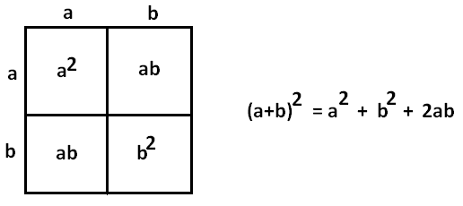
Exercise 6
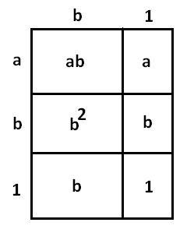
Draw a picture to represent the expression $\left(a+b+1\right)×\left(b+1\right)$.
Answer:

A good discussion to have with your students is whether it is important that the length of $1$ in the width be the same as the length of $1$ in the height. Continue the discussion as to whether it is important how you label the picture to represent the quantities.
Exercise 7
Draw a picture to represent the expression $\left(a+b)×(c+d)×(e+f+g\right).$
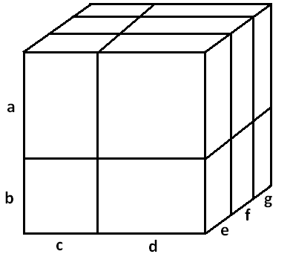
Answer:

Closing (7 minutes)
$$\frac{4(3+a)}{\sqrt{41}}$$
The previous exercises demonstrate the distributive property of arithmetic, which we believe to hold for all real numbers, not just the positive whole numbers. The choice of the word “belief” is intended to reinforce the notion with students that we accept the property as true without the need for proof.
- We can see, geometrically, that the following are true for whole numbers (display on the board):
$${\left(a+b\right)}^{2}=a^{2}+2ab+ b^{2}$$
$$\left(a+b+1\right)×\left(b+1\right)=ab+b^{2}+a+2b+1$$
$$\left(a+b\right)×\left(c+d\right)×\left(e+f+g\right)=ace+acf+acg+ade+adf+adg+bce+bcf+bcg+bde+bdf+bdg$$
- Do we also believe these statements to be true for all real numbers: $a$,$b$,$c$,$d$,$e$,$f$,$g$?
- Which of these statements are extensions of the Distributive Property of arithmetic (stated in your student materials)?
  - All of them.
A Key Belief of Arithmetic:
The Distributive Property: If $a$,$b$, and $c$ are real numbers, then $a\left(b+c\right)=ab+ac$.
Lesson Summary
The distributive property represents a key belief about the arithmetic of real numbers. This property can be applied to algebraic expressions using variables that represent real numbers.

Exit Ticket (3 minutes)
$$\frac{4(3+a)}{\sqrt{41}}$$

Name ___________________________________________________ Date____________________

Lesson 6: Algebraic Expressions—The Distributive Property

Exit Ticket

Consider the expression: $\left(x+y+3\right)×\left(y+1\right)$.

- Draw a picture to represent the expression.

- Write an equivalent expression by applying the distributive property.

Exit Ticket Sample Solutions

Consider the expression: $\left(x+y+3\right)×\left(y+1\right)$.
- Draw a picture to represent the expression.
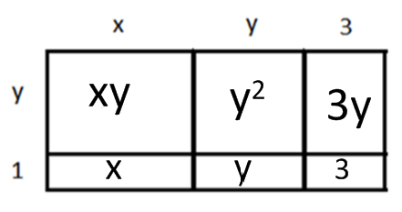

- Write an equivalent expression by applying the distributive property.
$$\left(x+y+3\right)\left(y+1\right)=xy+ {x+y}^{2}+4y+3$$

Problem Set Sample Solutions

- Insert parentheses to make each statement true.
  - $2+3×4^{2}+1=81$ $\left(2+3\right)×4^{2}+1=81$
  - $2+3×4^{2}+1=85$ $\left(2+3\right)×\left(4^{2}+1\right)=85$
  - $2+3×4^{2}+1=51$ $2+\left(3×4^{2}\right)+1=51$ (or no parentheses at all is acceptable as well)
  - $2+3×4^{2}+1=53$ $2+3×\left(4^{2}+1\right)=53$

- Using starting symbols of $w$, $q$, $2$, and $-2$, which of the following expressions will NOT appear when following the rules of the game played in Exercise 3?
  - $7w+3q+(-2)$
  - $q-2$
  - $w-q$
  - $2w+6$
  - $-2w+2$
Expressions (c) and (e) cannot be obtained in this exercise.
Part (d) appears as $w+w+2+2+2$, which is equivalent to $2w+6$.

- Luke wants to play the $4$-number game with the numbers $1$, $2$, $3$, and $4$ and the operations of addition, multiplication, AND subtraction.
Leoni responds, “Or we just could play the $4$-number game with just the operations of addition and multiplication, but now with the numbers $-1$, $-2$, $-3$, $-4$, $1$, $2$, $3$, and $4$ instead.”
What observation is Leoni trying to point out to Luke?
Subtraction can be viewed as the addition of a negative (e.g.,$x-4=x+(-4)$). By introducing negative integers, we need not consider subtraction as a new operation.

- Consider the expression: $\left(x+3\right)∙\left(y+1\right)∙(x+2)$.
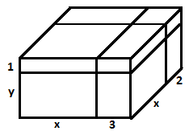
  - Draw a picture to represent the expression.

  - Write an equivalent expression by applying the distributive property.
$$\left(y+1\right)\left(x+3\right)\left(x+2\right)= x^{2}y+5xy+6y+x^{2}+5x+6$$

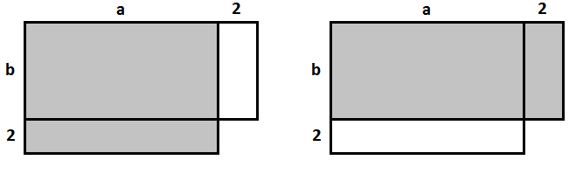
  - Given that $a>b$, which of the shaded regions is larger and why?
The shaded region from the image on the left is larger than the shaded region from the image on the right. Both images are made up of the region of area $a×b$ plus another region of either $2a$ (for the image on the left) or $2b$ (for the image on the right) since $a>b$,$2a>2b$.

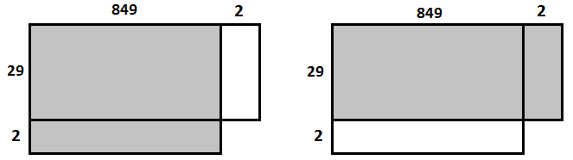
  - Consider the expressions $851×29$ and $849×31$. Which would result in a larger product? Use a diagram to demonstrate your result.
$851∙29$ can be written as: $\left(849+2\right)29=849∙29+2∙29$and
$849∙31$ can be written as: $849\left(29+2\right)=849∙29+2∙849$.
Since $2∙29<2∙849$, the product $849∙31$ is the larger product.

- Consider the following diagram.
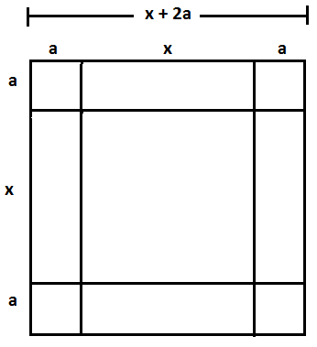
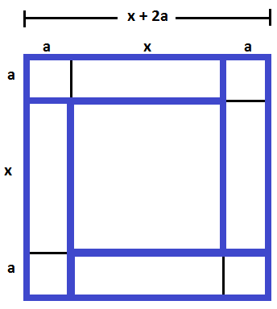
Edna looked at the diagram and then highlighted the four small rectangles shown and concluded:
${(x+2a)}^{2}=x^{2}+4a(x+a)$.

  - Michael, when he saw the picture, highlighted four rectangles and concluded:
${(x+2a)}^{2}=x^{2}+2ax+2a(x+2a)$.
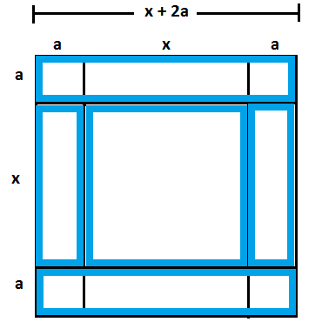
Which four rectangles and one square did he highlight?

  - Jill, when she saw the picture, highlighted eight rectangles and squares (not including the square in the middle) to conclude:
${(x+2a)}^{2}=x^{2}+4ax+4a^{2}$.
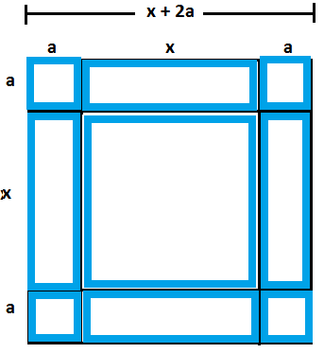
Which eight rectangles and squares did she highlight?

  - When Fatima saw the picture, she exclaimed: ${(x+2a)}^{2}=x^{2}+4a\left(x+2a\right)-4a^{2}$. She claims she highlighted just four rectangles to conclude this. Identify the four rectangles she highlighted and explain how using them she arrived that the expression $x^{2}+4a\left(x+2a\right)-4a^{2}$.
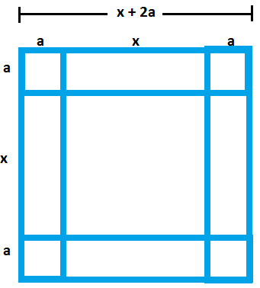
She highlighted each of the four rectangles that form a rim around the inner square. In doing so, she double counted each of the four $a×a$ corners and, therefore, needed to subtract $4a^{2}$.

  - Is each student's technique correct? Explain why or why not.
Yes, all of the techniques are right. You can see how each one is correct using the diagrams. The students broke the overall area into parts and added up the parts. In Fatima’s case, she ended up counting certain areas twice and had to compensate by subtracting those areas back out of her sum.

