Lesson 5: Two Graphing Stories

Student Outcomes
- Students interpret the meaning of the point of intersection of two graphs and use analytic tools to find its coordinates.

Classwork
Example 1 (7 minutes)
Have students read the situation and sketch a graphing story. Prompt them to visualize both the story and what the graph will look like as they read the situation. Share a few student responses.
Some students may raise questions:
- Are the two people traveling at the same rate? If yes, how would their graphs compare?
  - If they were, the graphs of the lines would have opposite slopes.
You may also need to clarify what it means to graph Earl’s distance from Maya’s door. His distance should be decreasing as time passes. Earl’s distance is represented by the dotted line. Notice that this graph shows the story ending when the two people meet each other in the hallway, and it assumes they travel at the same rate. Do not spend too much time developing content or equations here. The rest of the lesson will provide a more formal approach.
Example 1
Consider the story:
Maya and Earl live at opposite ends of the hallway in their apartment building. Their doors are $50$ feet apart. Each starts at his or her own door and walks at a steady pace toward each other and stop when they meet.
What would their graphing stories look like if we put them on the same graph? When the two people meet in the hallway, what would be happening on the graph? Sketch a graph that shows their distance from Maya’s door.
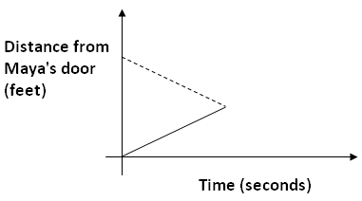

Exploratory Challenge/Exercises 1–4 (20 minutes)
The following video is of a man walking up and then back down a flight of stairs. On the way down, a girl starts walking up the stairs. http://youtu.be/X956EvmCevI
Exploratory Challenge
Watch the following graphing story.
http://youtu.be/X956EvmCevI
The video shows man and a girl walking on the same stairway.
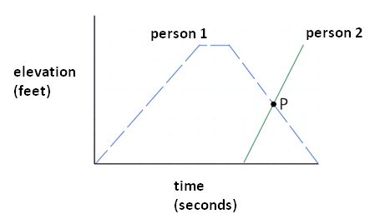
Exercises 1–4
- Graph the man's elevation on the stairway versus time in seconds.

- Add the girl’s elevation to the same graph. How did you account for the fact that the two people did not start at the same time?
Students’ answers should look something like the graph to the right. Student work should also include scales.

Have the students form groups and produce a group graph on whiteboards or poster paper in response to these exercises. Students might have questions about how to incorporate information depicting the motion of the second person. After a few minutes, have students hold up what they have drawn. Give the class further opportunity to revise their own graphs if they wish. Call out groups that have labeled and scaled their axes and ask follow-up questions to elicit their thinking when they created their graphs. The goal should be that all groups have a roughly accurate sketch with axes labeled. Students may struggle with starting the 2nd person at a point along the horizontal axis. Clarify that time $0$ represents the time when the first person started walking up the stairs. Work with students by stopping and starting the video to refine and scale their graphs. Estimate that each rise of each stair is $8$ inches. There are $16$ stairs with a maximum elevation of $10\frac{2}{3}$ ft.
MP.1
Sketch the graph on the board and label the intersection point $P$. Ask the following questions:
- Does it seem reasonable to say that each graph is composed of linear segments?
  - Most students will accept that linear functions represent a good model. We might assume that each person is ascending or descending at a constant rate.

- Suppose the two graphs intersect at the point $P(24, 4)$. What is the meaning of this point in this situation?
Many students will respond that $P$is where the two people pass each other on the stairway.

Lead a discussion that highlights these more subtle points before proceeding.
- We have two elevation-versus-time graphs, one for each of the two people (and that time is being measured in the same way for both people).
- The point $P$ lies on the elevation-versus-time graph for the first person, AND it also lies on the elevation-versus-time graph for the second person.
- We know the coordinates of the point$P$. These coordinates mean that since the first person is at an elevation of $4$ feet at $24$ seconds, the second person is also at an elevation of $4$ feet at $24$ seconds.

- Is it possible for two people, walking in stairwells, to produce the same graphs you have been using and NOT pass each other at time $12$ seconds? Explain your reasoning.
Yes, they could be walking in separate stairwells. They would still have the same elevation of $4$ feet at time $24$seconds but in different locations.

Give students time to revise their work after you discuss this with the entire class.

Closing (13 minutes)
Example 2/Exercises 5–7
Example 2
Consider the story:
Duke starts at the base of a ramp and walks up it at a constant rate. His elevation increases by three feet every second. Just as Duke starts walking up the ramp, Shirley starts at the top of the same $25$ foot high ramp and begins walking down the ramp at a constant rate. Her elevation decreases two feet every second.

Exercises 5–7
- Sketch two graphs on the same set of elevation-versus-time axes to represent Duke’s and Shirley’s motions.

- What are the coordinates of the point of intersection of the two graphs? At what time do Duke and Shirley pass each other?
$$\left(5,15\right)$$
$$t=5$$

- Write down the equation of the line that represents Duke’s motion as he moves up the ramp and the equation of the line that represents Shirley’s motion as she moves down the ramp. Show that the coordinates of the point you found in the question above satisfy both equations.
If $y$ represents elevation in feet and $t$ represents time in seconds, then Duke’s elevation satisfies $y=3t$ and Shirley’s $y=25-2t$. The lines intersect at $\left(5,15\right)$, and this point does indeed lie on both lines.
Duke: $15=3(5)$ Shirley: $15=25-2(5)$

Exercise 6 has a similar scenario to Example 1. After students work this exercise in small groups, have each group share their results as time permits. Circulate around the classroom providing assistance to groups as needed.
Use the results of the exercises in Example 2 to close this session.

- How did you figure out the slope of your linear equations from the story? Why was Shirley’s slope negative?
  - The slope is the rate of change, feet per second. Shirley's slope was negative because she was walking down the ramp, and thus her elevation was decreasing over time.
- Why did Shirley’s graph and equation have the$y$-intercept $(0, 25)$?
MP.3
  - The $y$-intercept was $(0, 25)$ because at time equal to $0$, Shirley was at an elevation of $25$ ft.
- What was easier in this problem, determining the intersection point algebraically or graphically? When might an algebraic approach be better?
  - Students could answer either, depending on the accuracy of their graphs. An algebraic approach would be better when the graphs intersect at non-integer values.

Lesson Summary
The intersection point of the graphs of two equations is an ordered pair that is a solution to BOTH equations. In the context of a distance (or elevation) story, this point represents the fact that both distances (or elevations) are equal at the given time.
Graphing stories with quantities that change at a constant rate can be represented using piecewise linear equations.

Exit Ticket (5 minutes)

Name ___________________________________________________ Date____________________
Lesson 5: Two Graphing Stories

Exit Ticket
Maya and Earl live at opposite ends of the hallway in their apartment building. Their doors are $50$ feet apart. Each person starts at his or her own door and walks at a steady pace towards the other. They stop walking when they meet.
Suppose:
- Maya walks at a constant rate of $3$ feet every second.
- Earl walks at a constant rate of $4$ feet every second.

- Graph both people’s distance from Maya’s door versus time in seconds.

- According to your graphs, approximately how far will they be from Maya’s door when they meet?

Exit Ticket Sample Solutions

Maya and Earl live at opposite ends of the hallway in their apartment building. Their doors are $50$ feet apart. Each person starts at his or her own door and walks at a steady pace towards the other. They stop walking when they meet.
Suppose:
- Maya walks at a constant rate of 3 feet every second.
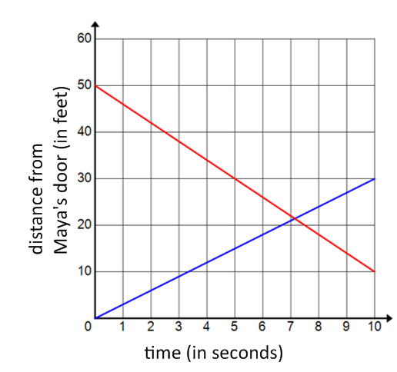
- Earl walks at a constant rate of 4 feet every second.

- Graph both people’s distance from Maya’s door versus time in seconds.
Graphs should be scaled and labeled appropriately. Maya’s graph should start at $(0,0)$ and have a slope of $3$, and Earl’s graph should start at $(0, 50)$ and have a slope of $-4$.

- According to your graphs, approximately how far will they be from Maya’s door when they meet?
The graphs intersect at approximately $7$ seconds at a distance of about $21$ feet from Maya’s door.

Problem Set Sample Solutions

- Reread the story about Maya and Earl from Example 1. Suppose that Maya walks at a constant rate of $3$ feet every second and Earl walks at a constant rate of $4$ feet every second starting from $50$ feet away. Create equations for each person’s distance from Maya’s door and determine exactly when they meet in the hallway. How far are they from Maya’s door at this time?
Maya’s Equation: $y=3t$.
Earl’s Equation: $y=50-4t$.
Solving the equation $3t=50-4t$ gives the solution $=7$ $\frac{1}{7}$. The two meet at exactly this time at a distance of $3\left(7\frac{1}{7}\right)=21$ $\frac{3}{7}$ feet from Maya’s door.

- Consider the story:
May, June, and July were running at the track. May started first and ran at a steady pace of $1$ mile every $11$ minutes. June started $5$ minutes later than May and ran at a steady pace of $1$ mile every $9$ minutes. July started $2$ minutes after June and ran at a steady pace, running the first lap ($\frac{1}{4}$mile) in $1.5$minutes. She maintained this steady pace for $3$more laps and then slowed down to $1$ lap every $3$ minutes.
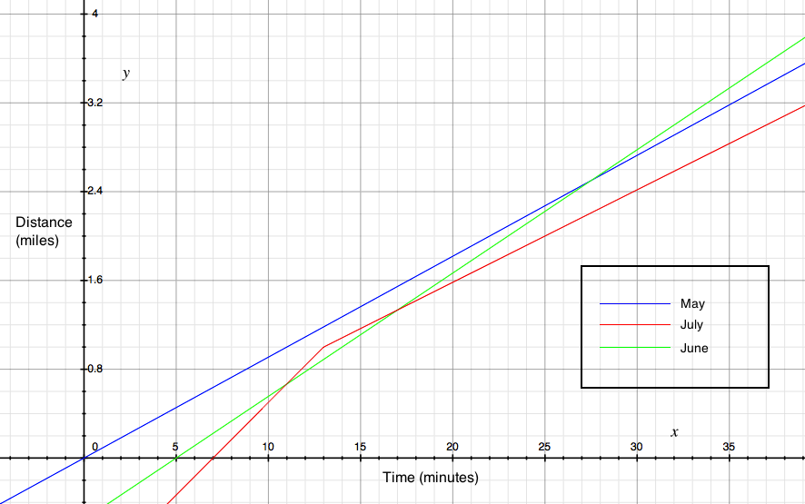
  - Sketch May, June, and July’s distance versus time graphs on a coordinate plane.

  - Create linear equations that represent each girl’s mileage in terms of time in minutes. You will need two equations for July since her pace changes after$4$ laps ($1$ mile).
Equations for May, June, and July are shown below. Notice that July has two equations since her speed changes after her first mile, which occurs $13$ minutes after May starts running.
May: | $$d=\frac{1}{11}t$$
June: | $$d=\frac{1}{9}(t-5)$$
July: | $$d=\frac{1}{6}\left(t-7\right)\text{, }t≤13 \text{and} d=\frac{1}{12}\left(t-13\right)+1\text{, }t>13$$

  - Who was the first person to run $3$ miles?
June at time $32$ minutes

  - Did June and July pass May on the track? If they did, when and at what mileage?
Assuming that they started at the same place, June passes May at time $27.5$minutes at the $2.5$ mile marker. July does not pass May.

  - Did July pass June on the track? If she did, when and at what mileage?
July passes June at time $11$ minutes at the $\frac{2}{3}$mile marker.

- Suppose two cars are travelling north along a road. Car 1 travels at a constant speed of $50$ mph for two hours, then speeds up and drives at a constant speed of$100$ mph for the next hour. The car breaks down and the driver has to stop and work on it for two hours. When he gets it running again, he continues driving recklessly at a constant speed of $100$ mph. Car 2 starts at the same time that Car 1 starts, but Car 2 starts $100$ miles farther north than Car 1 and travels at a constant speed of $25$ mph throughout the trip.
  - Sketch the distance versus time graphs for Car 1 and Car 2 on a coordinate plane. Start with time $0$ and measure time in hours.
A graph is shown below that approximates the two cars traveling north.
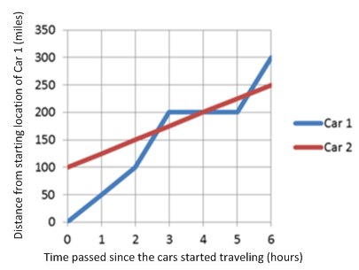

  - Approximately when do the cars pass each other?
The cars pass after about $2\frac{1}{2}$ hours, after $4$ hours, and after about $5\frac{1}{2}$ hours.

  - Tell the entire story of the graph from the point of view of Car 2. (What does the driver of Car 2 see along the way and when?)
The driver of Car 2 is carefully driving along at $25$ mph, and he sees Car 1 pass him at $100$ mph after about $2\frac{1}{2}$ hours. About an hour and a half later, he sees Car 1 broken down along the road. After about another hour and a half, Car 1 whizzes past again.

  - Create linear equations representing each car’s distance in terms of time (in hours). Note that you will need four equations for Car 1 and only one for Car 2. Use these equations to find the exact coordinates of when the cars meet.
Using the variables, $d$ for distance (in miles) and $t$ for time (in hours):
Equation for Car 2: $d=25t+100$
Equations for Car 1:
$d=50t$, $0≤t≤2$,
$d=100\left(t-2\right)+100=100(t-1)$, $2<t≤3$
$d=200$, $3<t≤5$
$d=100\left(t-5\right)+200=100(t-3)$, $5<t$
Intersection points:
First: solving $100\left(t-1\right)=25t+100$ gives $\left(\frac{200}{75},\frac{\left(25\right)\left(200\right)}{75}+100\right)≈\left(2.7, 166.7\right)$,
Second: solving $200=25t+100$ gives $(4, 200)$, and
Third: solving $100\left(t-3\right)=25t+100$ gives $\left(\frac{400}{75},\frac{\left(25\right)\left(400\right)}{75}+100\right)≈(5.3, 233.3)$.

- Suppose that in Problem 3 above, Car 1 travels at the constant speed of $25$ mph the entire time. Sketch the distance versus time graphs for the two cars on the graph below. Do the cars ever pass each other? What is the linear equation for Car 1 in this case?
A sample graph is shown below. Car 1 never overtakes Car 2, and they are $100$ miles apart the entire time. The equation for Car 1 is $y=25t$.
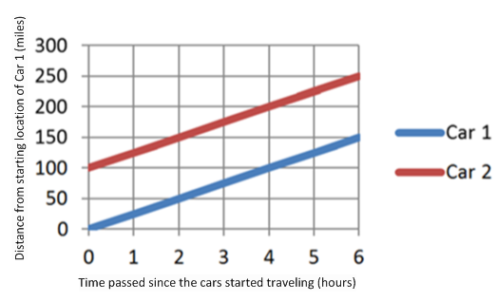

- Generate six distinct random whole numbers between $2$ and $9$ inclusive and fill in the blanks below with the numbers in the order in which they were generated.

$A ( 0 , _______)$, $B (_______, _______)$, $C (10 , _______)$

$D ( 0 , _______)$, $E (10 , _______)$.
(Link to a random number generator http://www.mathgoodies.com/calculators/random_no_custom.html)
  - On a coordinate plane, plot points $A$, $B$, and $C$. Draw line segments from point $A$ to point $B$, and from point $B$ to point $C$.
  - On the same coordinate plane, plot points $D$ and $E$ and draw a line segment from point $D$ to point$E$.
  - Write a graphing story that describes what is happening in this graph. Include a title, $x$- and $y$-axis labels, and scales on your graph that correspond to your story.
Answers will vary depending on the random points generated.

- The following graph shows the revenue (or income) a company makes from designer coffee mugs and the total cost (including overhead, maintenance of machines, etc.) that the company spends to make the coffee mugs.

  - How are revenue and total cost related to the number of units of coffee mugs produced?
Definition: Profit $=$ Revenue $-$ Cost. Revenue is the income from the sales and is directly proportional to the number of coffee mugs actually sold; it does not depend on the units of coffee mugs produced. Total cost is the sum of the fixed costs (overhead, maintaining the machines, rent, etc.) PLUS the production costs associated with the number of coffee mugs produced; it does not depend on the number of coffee mugs sold.

  - What is the meaning of the point $(0, 4000)$ on the total cost line?
The overhead costs, the costs incurred regardless of whether $0$ or $1,000$ coffee mugs are made or sold, is $\$4,000$.

  - What are the coordinates of the intersection point? What is the meaning of this point in this situation?
$(500, 6000)$. The revenue, $\$6,000$, from selling $500$ coffee mugs, is equal to the total cost, $\$6,000$, of producing $500$ coffee mugs. This is known as the break-even point. When Revenue $=$ Cost, the Profit is $\$0$. After this point, the more coffee mugs sold, the more the positive profit; before this point, the company loses money.

  - Create linear equations for revenue and total cost in terms of units produced and sold. Verify the coordinates of the intersection point.
If $u$ is a whole number for the number of coffee mugs produced and sold, $C$ is the total cost to produce $u$ mugs, and $R$ is the total revenue when $u$ mugs are sold, then
$$C=4000+4u, \\ R=12u\text{.}$$
When $u=500$, both $C=4000+4∙500=6000$ and $R=12∙500=6000$.

  - Profit for selling $1,000$ units is equal to revenue generated by selling $1,000$units minus the total cost of making $1,000$units. What is the company’s profit if $1,000$ units are produced and sold?
Profit $=$Revenue $-$ Total Cost. Hence, $P=R-C=12∙1000-\left(4000+4∙1000\right)=12000-8000$
$$=4000$$
The company’s profit is $\$4,000$.

