Lesson 3
Objective: Find and name three-dimensional shapes including cone and rectangular prism, based on defining attributes of faces and points.

Suggested Lesson Structure
 Fluency Practice (10 minutes)
 Application Problem (5 minutes)
 Concept Development (35 minutes)
 Student Debrief (10 minutes)
Total Time (60 minutes)
Fluency Practice (10 minutes)
- Grade 1 Core Fluency Differentiated Practice Sets 1.OA.6 (5 minutes)
- Count by 10 or 1 with Dimes and Pennies 1.NBT.5, 1.MD.3 (5 minutes)
Grade 1 Core Fluency Differentiated Practice Sets (5 minutes)
Materials: (S) Core Fluency Practice Sets
Note: This activity assesses students’ progress toward mastery of the required addition fluency for Grade 1 students. Give the appropriate Practice Set to each student. Students who completed all of the questions correctly on their most recent Practice Set should be given the next level of difficulty. All other students should try to improve their scores on their current level.
Students complete as many problems as they can in 90 seconds. Assign a counting pattern and start number for early finishers, or tell them to practice make ten addition and subtraction on the back of their papers. When time runs out, collect and correct any Practice Sets that are completed.
Count by 10 or 1 with Dimes and Pennies (5 minutes)
Materials: (T) 10 dimes and 10 pennies
Note: This fluency activity uses dimes and pennies as abstract representations of tens and ones to help students become familiar with coins while simultaneously providing practice with counting forward and backward by 10 or 1.
- First minute: Place and take away dimes in a 5-group formation as students count along by 10.
- Second minute: Begin with 2 pennies. Ask how many ones there are. Instruct students to start at 2 and add or subtract 10 while placing and taking away dimes.
- Third minute: Begin with 2 dimes. Ask how many tens there are. Instruct students to begin at 20 and add or subtract 1 while placing and taking away pennies.
Application Problem (5 minutes)
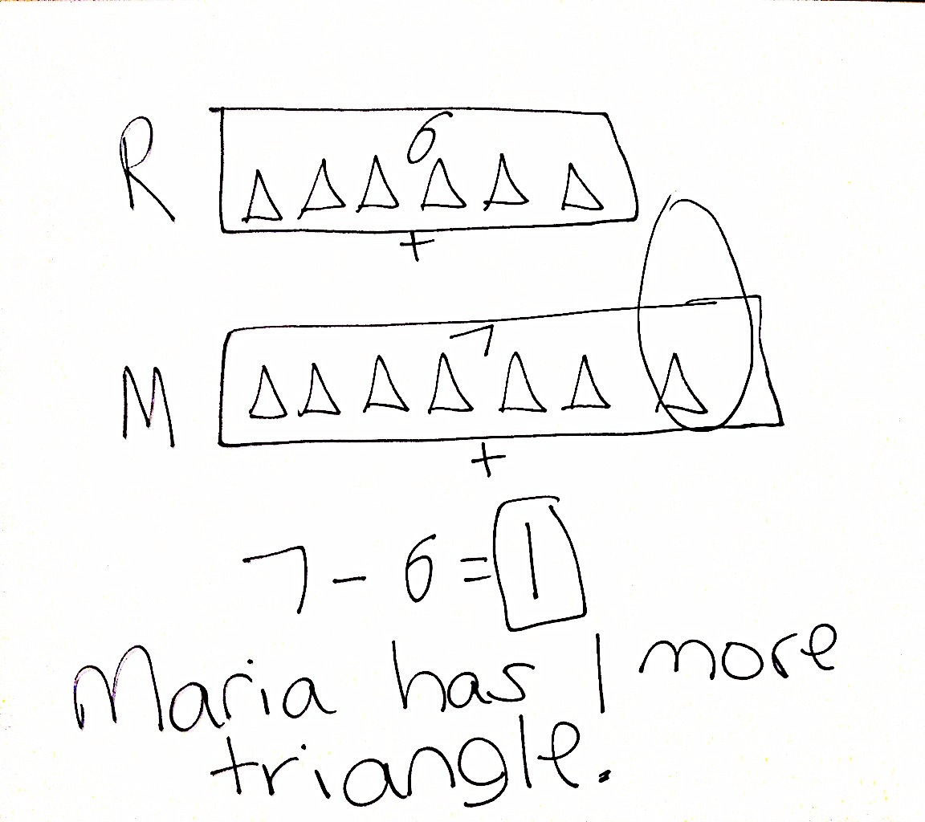
Rose draws 6 triangles. Maria draws 7 triangles. How many more triangles does Maria have than Rose?
Note: Let students know that today’s problem is a little different from past problems because today they are comparing Rose’s triangles with Maria’s. Suggest that they draw two different tapes with the same endpoint on the left, so that they can more easily compare the two numbers. While circulating, support students in aligning their shapes and bars to assist in solving this compare with difference unknown problem type.
Concept Development (35 minutes)

NOTES ON
MULTIPLE MEANS
OF REPRESENTATION:
Be sure to have a pictorial word wall in the classroom that is easily accessible for students. The wall should include the following words at this point in the module: circle, hexagon, rectangle, rhombus, square, trapezoid, triangle, cone, cube, cylinder, rectangular prism, and sphere. Spending some time learning these words would be helpful to all students, especially the word cylinder, whose spelling can be confusing. Also include the describing attributes for three-dimensional solids including face, edge, and vertex.
Materials: (T) Set of three-dimensional shapes, (sphere, cone, cube, rectangular prism, and cylinder), three-dimensional shapes found around home or school, three-dimensional shape description cards (Template), tape
Note: If a kit of three-dimensional shapes is not readily available, then a kit can be borrowed from other grade levels, such as Kindergarten (used in GK─M2 and GK─M6). Another option is to collect three-dimensional shapes from students’ homes as suggested below.
- Spheres: balls (e.g., tennis balls) and marbles
- Cylinders: paper towel and oatmeal containers
- Cubes: small tissue boxes, gift boxes, and large dice
- Rectangular prisms: large tissue boxes, crayon boxes, marker boxes, and pencil holders
- Cones: ice cream cones and party hats
Before the lesson, place examples of three-dimensional figures around the room. Gather students in the meeting area in a semi-circle.
T: (Place one example of each three-dimensional shape on the floor.) Today, we are going to talk about three-dimensional shapes, like these. What do you know about three-dimensional shapes?
S: They are not flat. They have different faces or surfaces. They are solid. That one is called a cube. (Points to cube.) You can touch them on different sides.
T: Great! Yes, three-dimensional shapes have faces (touch each face on a cube), and they have different types of corners or points (touch the vertices). Often times they are solid and can be called 3-D solids. There are lots of three-dimensional shapes around our room. Some look just like the materials we have here, and some look different. Can anyone think of an item in the room that looks like these?
S: Our party hat on the teddy bear looks like that one. (Points to cone.) That one looks like our dice. (Points to cube.) That one looks like the container for our alphabet game! (Points to cylinder.)
T: Find one item in the room that is three-dimensional—an object that has faces, not a flat two-dimensional shape. You have 30 seconds. Walk, find your item, and bring it to the carpet.
S: (Search the room, and bring back one item each to the carpet.)
T: Someone told us the name of this shape earlier. Who remembers the name of this shape?
S: A cube! (Place cube in the middle of the meeting area.)
T: What are the attributes, or characteristics, that make this a cube?
S: It has six faces, and every face is a square. (Ask the student to demonstrate this using the cube, and then tape the appropriate shape description card to the cube.)
T: (Place the cube on the carpet.) Let’s count the faces of the cube. Track the number with your fingers. The bottom. How many faces is that?
S: One!
T: The top. How many now?
S: Two!
T: Now, let’s go around the cube.
S: The side closest to me. How many is that?
S: Three!
T: The side to its right?
S: Four!
Keep going around systematically. Count again to increase the students’ proficiency.
T: Look at your items. Who brought a cube to the meeting area?
S: (Students show items.)
T: Let’s check. Count the faces of the cube with your partner. (Pause.) Does your cube have six faces?
S: (Count faces.) Yes.
T: Are all six faces squares?
S: Yes.
Note: A cube is a special type of rectangular prism. On the Problem Set, some students will not notice that the die could also be considered a rectangular prism. As students are ready for this increased complexity, this can be discussed during the Debrief.
Repeat this process with the students who believe they have a cube. Some students will answer no to one or both of the questions. Explain that the item must have both attributes to be a cube. If they answer yes to one of the two questions, discuss how the object is like a cube in one way but unlike a cube in another way.
T: How are all of these cubes alike?

NOTES ON
MULTIPLE MEANS
OF ACTION AND EXPRESSION:
Students may need some extra practice identifying shapes correctly based on attributes. Listening to others talk about shapes will help these students, especially the English language learners, understand and acquire language pertaining to this topic.

S: They all have six square faces.
T: How are they different from each other?
MP.7
S: Some of them are made of paper. One of them is made of plastic. That one is yellow. The tissue box is empty on the inside, but the dice are not.
T: (Hold up the rectangular prism.) This is a rectangular prism. A rectangular prism also has six faces, but let’s check. Does it have six faces? (Count with students.)
S: Yes.
T: What shape are the faces?
S: They are all rectangles. Some faces are squares, but all squares are also special types of rectangles.
T: The attributes of a rectangular prism are that they have six faces, and all of the faces are rectangles. Remember, squares are a special kind of rectangle, so some of your faces might be squares. Who has a rectangular prism in front of them?
Like the process of checking each cube, repeat this process with the students who believe they have a rectangular prism. If they answer yes to one of the two questions, discuss how the object is like a rectangular prism in one way but unlike a rectangular prism in another way. Ask students which attributes are common to all of the objects and which attributes are found only on some of the objects.
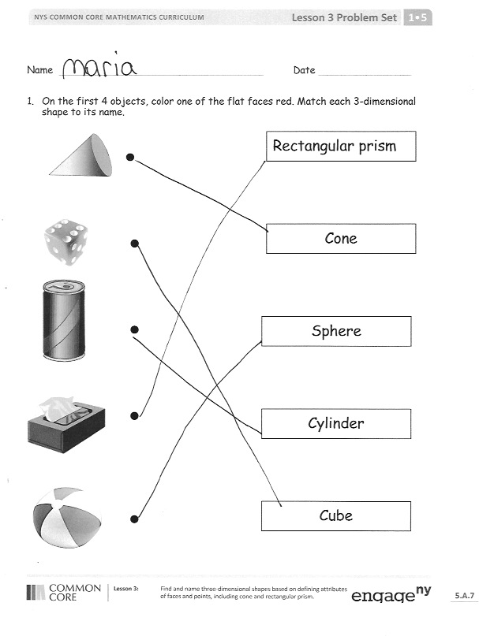
Repeat the process with a cylinder (one circular or oval face or space on each end and one curved side), a cone (one circular or oval face or space and one curved side that comes to a point at the other end), and a sphere (one curved surface with no flat faces).
Problem Set (10 minutes)
Students should do their personal best to complete the Problem Set within the allotted 10 minutes. For some classes, it may be appropriate to modify the assignment by specifying which problems they work on first.
Students may or may not notice that the die is considered a cube and a rectangular prism. Challenge students who are ready to find the shape that could be called by two names.

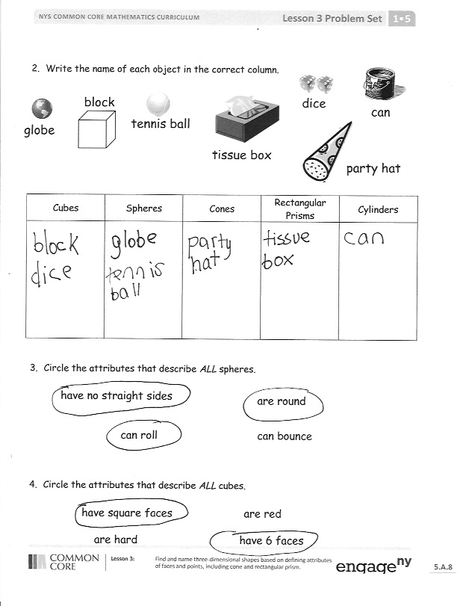
Student Debrief (10 minutes)
Lesson Objective: Find and name three-dimensional shapes including cone and rectangular prism, based on defining attributes of faces and points.
The Student Debrief is intended to invite reflection and active processing of the total lesson experience. Invite students to review their solutions for the Problem Set. They should check work by comparing answers with a partner before going over answers as a class. Look for misconceptions or misunderstandings that can be addressed in the Debrief. Guide students in a conversation to debrief the Problem Set and process the lesson.
Any combination of the questions below may be used to lead the discussion.
- Look at Problem 1. Which face did you color on each three-dimensional shape? How did coloring the face help you find the matching shape name?
- Look at Problem 2. Which materials from around the room could you add to each column on the chart? How are the items that are all spheres similar to each other? How are they different? Which attribute is the most important for naming the objects as spheres? (Repeat with each shape.)
- How are the party hat and paper towel roll different from the cylinder and cone in our three-dimensional shapes?
- What are the names of the three-dimensional shapes that we used today? Tell your partner the important attributes of each shape. (Cubes, spheres, cones, rectangular prisms, and cylinders.)
- Look at your Application Problem. How did you solve this problem? Share drawings and strategies for solving each question.
- Think about today’s Fluency Practice. What part of today’s fluency activities is easier for you now than when we first learned about it? Explain what is easier for you now.
Exit Ticket (3 minutes)
After the Student Debrief, instruct students to complete the Exit Ticket. A review of their work will help with assessing students’ understanding of the concepts that were presented in today’s lesson and planning more effectively for future lessons. The questions may be read aloud to the students.

Name Date
My Addition Practice
1. | 6 + 0 = ___ | 11. | 7 + 1 = ___ | 21. | 5 + 3 = ___
2. | 0 + 6 = ___ | 12. | ___ = 1 + 7 | 22. | ___ = 5 + 4
3. | 5 + 1 = ___ | 13. | 3 + 3 = ___ | 23. | 6 + 4 = ___
4. | 1 + 5 = ___ | 14. | 3 + 4 = ___ | 24. | 4 + 6 = ___
5. | 6 + 1 = ___ | 15. | ___ = 3 + 5 | 25. | ___ = 4 + 4
6. | 1 + 6 = ___ | 16. | 6 + 3 = ___ | 26. | 3 + 4 = ___
7. | 6 + 2 = ___ | 17. | 7 + 3 = ___ | 27. | 5 + 5 = ___
8. | 5 + 2 = ___ | 18. | ___ = 7 + 2 | 28. | ___ = 4 + 5
9. | 2 + 5 = ___ | 19. | 2 + 7 = ___ | 29. | 3 + 7 = ___
10. | 2 + 4 = ___ | 20. | 2 + 8 = ___ | 30. | ___ = 3 + 6
Today, I finished _____ problems.

Name Date
My Missing Addend Practice
1. | 6 + ___ = 6 | 11. | 3 + ___ = 6 | 21. | 4 + ___ = 7
2. | 0 + ___ = 6 | 12. | 4 + ___ = 8 | 22. | 7 = 3 + ___
3. | 5 + ___ = 6 | 13. | 10 = 5 + ___ | 23. | 2 + ___ = 7
4. | 4 + ___ = 6 | 14. | 5 + ___ = 9 | 24. | 2 + ___ = 8
5. | 0 + ___ = 7 | 15. | 5 + ___ = 7 | 25. | 9 = 2 + ___
6. | 6 + ___ = 7 | 16. | 8 = 5 + ___ | 26. | 2 + ___ = 10
7. | 1 + ___ = 7 | 17. | 5 + ___ = 9 | 27. | 10 = 3 + ___
8. | 7 + ___ = 8 | 18. | 8 + ___ = 10 | 28. | 3 + ___ = 9
9. | 1 + ___ = 8 | 19. | 7 + ___ = 10 | 29. | 4 + ___ = 9
10. | 6 + ___ = 8 | 20. | 10 = 6 + ___ | 30. | 10 = 4 + ___
Today, I finished _____ problems.
I solved _____ problems correctly.
Name Date
My Related Addition and Subtraction Practice
1. | 5 + ___ = 6 | 11. | 7 + ___ = 10 | 21. | 4 + ___ = 8
2. | 1 + ___ = 6 | 12. | 10 – 7 = ___ | 22. | 8 – 4 = ___
3. | 6 - 1 = ___ | 13. | 5 + ___ = 7 | 23. | 4 + ___ = 7
4. | 9 + ___ = 10 | 14. | 7 – 5 = ___ | 24. | 7 – 4 = ___
5. | 1 + ___ = 10 | 15. | 5 + ___ = 8 | 25. | 5 + ___ = 9
6. | 10 – 9 = ___ | 16. | 8 – 5 = ___ | 26. | 9 – 5 = ___
7. | 5 + ___ = 10 | 17. | 4 + ___ = 6 | 27. | 6 + ___ = 9
8. | 10 – 5 = ___ | 18. | 6 – 4 = ___ | 28. | 9 – 6 = ___
9. | 8 + ___ = 10 | 19. | 3 + ___ = 6 | 29. | 4 + ___ = 7
10. | 10 – 8 = ___ | 20. | 6 – 3 = ___ | 30. | 7 – 4 = ___
Today, I finished _____ problems.
I solved _____ problems correctly.

Name Date
My Subtraction Practice
1. | 6 - 0 = ___ | 11. | 6 - 3 = ___ | 21. | 8 - 4 = ___
2. | 6 - 1 = ___ | 12. | 7 - 3 = ___ | 22. | 8 - 3 = ___
3. | 7 - 1 = ___ | 13. | 9 – 3 = ___ | 23. | 8 - 5 = ___
4. | 8 - 1 = ___ | 14. | 10 - 8 = ___ | 24. | 9 - 5 = ___
5. | 6 - 2 = ___ | 15. | 10 - 6 = ___ | 25. | 9 - 4 = ___
6. | 7 - 2 = ___ | 16. | 10 – 4 = ___ | 26. | 7 - 3 = ___
7. | 9 - 2 = ___ | 17. | 10 - 5 = ___ | 27. | 10 - 7 = ___
8. | 10 - 10 = ___ | 18. | 7 – 6 = ___ | 28. | 9 - 7 = ___
9. | 10 - 9 = ___ | 19. | 7 - 5 = ___ | 29. | 9 - 6 = ___
10. | 10 - 7 = ___ | 20. | 6 - 4 = ___ | 30. | 8 - 6 = ___
Today, I finished _____ problems.
I solved _____ problems correctly.

Name Date
My Mixed Practice
1. | 4 + 2 = ___ | 11. | 2 + ___ = 6 | 21. | 8 - 5 = ___
2. | 2 + ___ = 6 | 12. | 6 - 2 = ___ | 22. | 3 + ___ = 8
3. | 6 = 3 + ___ | 13. | 6 - 4 = ___ | 23. | 8 = ___ + 5
4. | 2 + 5 = ___ | 14. | 5 + ___ = 7 | 24. | ___ + 2 = 9
5. | 7 = 5 + ___ | 15. | 7 - 5 = ___ | 25. | 9 = ___ + 7
6. | 4 + 3 = ___ | 16. | 7 - 4 = ___ | 26. | 9 – 2 = ___
7. | 7 = ___ + 4 | 17. | 7 - 3 = ___ | 27. | 9 - 7 = ___
8. | 8 = ___ + 4 | 18. | 8 = 6 + ___ | 28. | 9 - 6 = ___
9. | 4 + 5 = ___ | 19. | 8 - 2 = ___ | 29. | 9 = ___ + 4
10. | 9 = ___ + 4 | 20. | 8 – 6 = ___ | 30. | 9 - 6 = ___
Today, I finished _____ problems.
I solved _____ problems correctly.
Name Date
- On the first 4 objects, color one of the flat faces red. Match each 3-dimensional shape to its name.
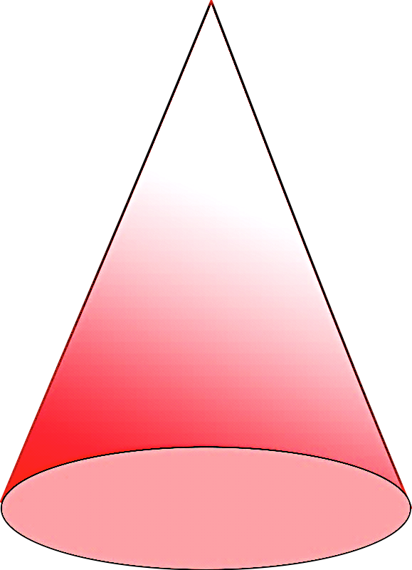
Rectangular prism
a.
Sphere
Cylinder
Cube

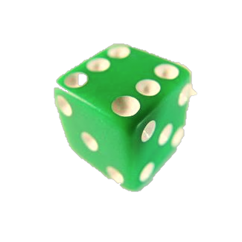
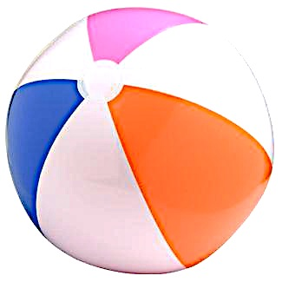
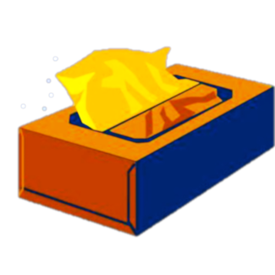
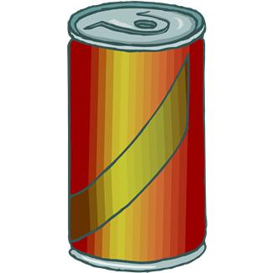
Cone
e.
d.
c.
b.
- 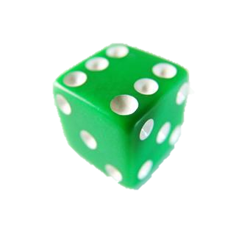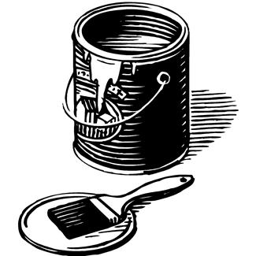Write the name of each object in the correct column.
dice
block
can
globe
tissue box
tennis ball
party hat

Cubes | Spheres | Cones | Rectangular Prisms | Cylinders

- Circle the attributes that describe ALL spheres.
are round
can roll
have no straight sides
can bounce

- Circle the attributes that describe ALL cubes.
are red
have square faces
have 6 faces
are hard
Name Date
Circle true or false. Write one sentence to explain your answer. Use the word bank if needed.
Word Bank
faces circle square
sides rectangle point

This can is a cylinder. True or False
1.
This juice box is a cube. True or False
2.
Name Date
- Go on a scavenger hunt for 3-dimensional shapes. Look for objects at home that would fit in the chart below. Try to find at least four objects for each shape.
Cube | Rectangular Prism | Cylinder | Sphere | 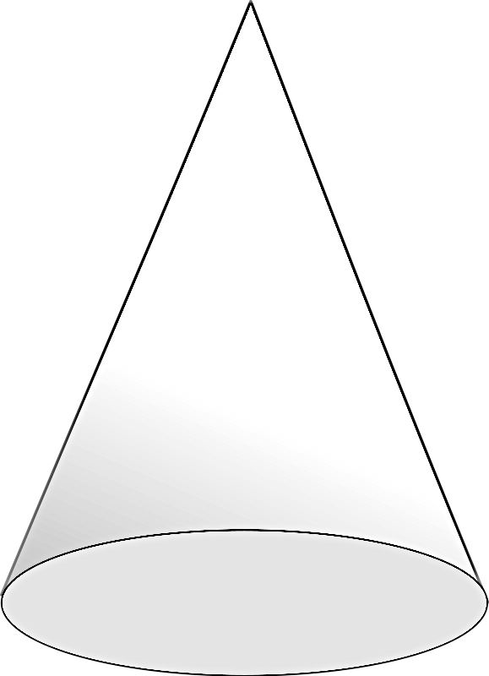  Cone

- Choose one object from each column. Explain how you know that object belongs in that column. Use the word bank if needed.
Word Bank
faces circle square roll six
sides rectangle point flat

- I put the in the cube column because
.

- I put the in the cylinder column because
.

- I put the in the sphere column because
.

- I put the in the cone column because
.

- I put the in the rectangular prism column because
.

cone  3-dimensional shape with only one circle or oval face and one point | cube  3-dimensional shape with 6 square faces
cylinder  3-dimensional shape with 2 circle or oval faces that are the same size | rectangular prism  3-dimensional shape with 6 rectangle faces
sphere

3-dimensional shape with no flat faces

three-dimensional shape description cards

