Lesson 2
Objective: Find and name two-dimensional shapes including trapezoid, rhombus, and a square as a special rectangle, based on defining attributes of sides and corners.

Suggested Lesson Structure
 Fluency Practice (15 minutes)
 Application Problem (5 minutes)
 Concept Development (30 minutes)
 Student Debrief (10 minutes)
Total Time (60 minutes)
Fluency Practice (15 minutes)
- Grade 1 Core Fluency Sprint 1.OA.6 (10 minutes)
- Make It Equal: Subtraction Expressions 1.OA.7 (5 minutes)
Grade 1 Core Fluency Sprint (10 minutes)
Materials: (S) Core Fluency Sprint (Lesson 1 Core Fluency Sprint)
Note: Based on the needs of the class, select a Sprint from Lesson 1. Consider the options below:
- Re-administer the previous lesson’s Sprint.
- Administer the next Sprint in the sequence.
- Differentiate. Administer two different Sprints. Simply have one group do a counting activity on the back of its Sprint while the other group corrects the second Sprint.
Make It Equal: Subtraction Expressions (5 minutes)
Materials: (S) Numeral cards (Lesson 1 Fluency Template), one “=” card, two “–“ cards
Note: This activity builds fluency with subtraction within 10 and promotes an understanding of equality.
Assign students partners of similar skill or ability level. Students arrange numeral cards from 0 to 10, including the extra 5. Place the “=” card between the partners. Write four numbers on the board (e.g., 9, 10, 2, 1). Partners take the numeral cards that match the numbers written to make two equivalent subtraction expressions (e.g., 10 – 9 = 2 – 1). Students can be encouraged to make another sentence of equivalent expressions for the same set of cards as well (e.g., 10 – 2 = 9 – 1). Encourage students to find examples that result in an answer other than 1 = 1, as in the previous example.
Suggested sequence: 10, 9, 2, 1; 2, 10, 3, 9; 4, 5, 9, 10; 10, 8, 7, 9; 7, 10, 9, 6; 2, 4, 10, 8; etc.
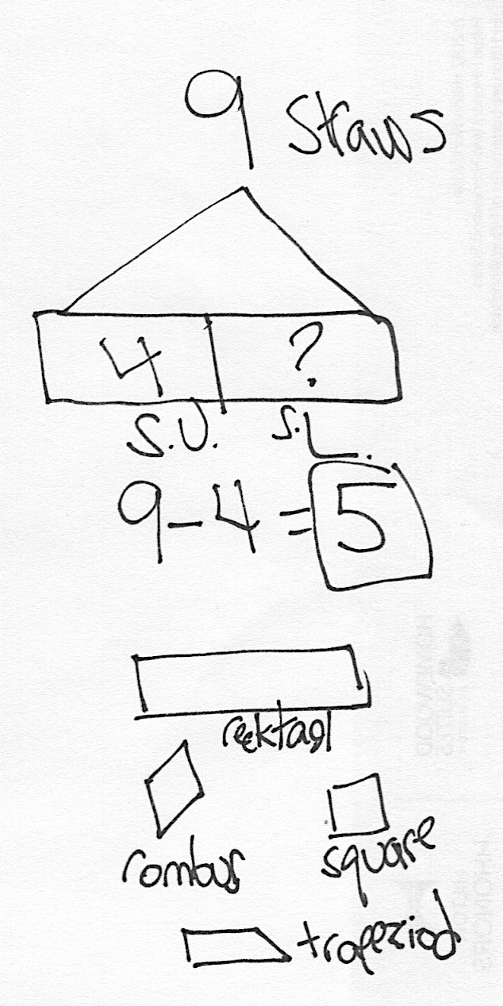
Application Problem (5 minutes)
Lee has 9 straws. He uses 4 straws to make a shape. How many straws does he have left to make other shapes?
Extension: What possible shapes could Lee have created? Draw the different shapes Lee might have made using 4 straws. Label any shapes whose name you know.
Note: Today’s Application Problem uses a familiar context that was established during Lesson 1 of the module. Through the extension, students have the opportunity to apply the previous lesson and generate prior knowledge that is useful for today’s objective.
Concept Development (30 minutes)
Materials: (T) Charts from Lesson 1, shape description cards (Template), tape (S) Straw kit, 10 additional straws per person, square corner tester (Lesson 1 Template 2), shape description cards (Template)
Note: The description of each shape is consistent with mathematical descriptions used throughout the K–12 continuum of this curriculum. Below are some clarifying comments about each shape mentioned in this lesson:

NOTES ON
MULTIPLE MEANS
OF REPRESENTATION:
Highlight the critical vocabulary for English language learners throughout the lesson. Key vocabulary words—characteristic and attribute—were introduced in Lesson 1. Without understanding these words, English language learners will struggle with the first few lessons of this module. Spend some extra time relating the words while describing the classroom or students so that students see the relationship between describing shapes and other things in their environment.

Triangle: Triangles can be described based on their three sides or their three corners or angles.
Rectangle: Rectangles are quadrilaterals with four right angles. The length of each side is not a defining attribute. For this reason, a square is a type of rectangle. While some rectangles have two short sides and two longer sides, that is not a requirement or defining attribute of a rectangle.
Rhombus: A rhombus is a quadrilateral with four sides of the same length. The definition does not depend on the measure of its angles. For this reason, a square is also a special type of rhombus that has right angles.
Square: A square is a special shape that is both a rectangle and a rhombus since it is a quadrilateral with four right angles and four sides of the same length.
T: Yesterday, you made all of these shapes with your straws. (Show charts from Lesson 1.) Today, we’re going to name them based on their attributes, or characteristics. (Hold up the triangle card.) The word triangle actually describes something about the shape! Listen carefully—tri means three, and angle is what gives us corners. So, when we say triangle, we’re saying it has three angles, or three corners. Which can we label as triangles?
S: The ones on the first chart. (Students point to triangles.)
T: Are they all triangles? Tell me about each one.
Students explain or touch each of the three corners of each shape to confirm that they are all triangles. Ensure that students point out that all the triangles also have three straight sides. Tape the triangle description card under triangles.
T: Let’s try another card. (Hold up the hexagon card.) A hexagon is a shape with six straight sides. Do we have any hexagons on our chart?
S: (Point to the two hexagons on Chart 3.) Yes, these shapes have six straight sides!
T: (Tape the card on the chart near hexagons.) Do we have any other hexagons on these charts?
S: No!
Move to the rectangle and square description cards.
T: A rectangle is a shape with four square corners, or right angles. Do we have any rectangles on our chart? Use your square corner tester to check.
S: (Point to any rectangles on the charts, and explain why they fit the description.)
T: (Ensure that students include the squares as shapes that fit the description. Add rectangle cards under shapes.) Do any of these rectangles have another name you know?
S: Yes! The square.
T: Yes, a square is a type of special rectangle with four straight sides of equal length. (Tape a square card under the rectangle card.)
T: A rhombus is a shape with four straight sides of equal length. Do we have any rhombuses?
S: (Point to shapes with four straight sides of equal length, including the shape that is already labeled with square and rectangle.)
T: (As students explain how each shape fits the description, tape the description card below the drawing.) Yes, a square is a special kind of rectangle, and it is also a special kind of rhombus. Squares are pretty special!
T: (Point to the example of a trapezoid on the chart.) Does anyone know what this shape is called?
S: A trapezoid. (If no one knows the name, tell the students it is a trapezoid.)
T: How is this shape the same as the other shapes we have defined?
S: It has four straight sides and four corners.
T: How is this trapezoid different from the other shapes?
S: The sides are not all the same length, like the square. This trapezoid doesn’t have four square corners.
T: Now, you’re ready to play Make the Shape with your partner. Here’s how to play:
- Each pair gets a stack of shape description cards and places 10 additional straws in their straw kit.
- Turn over a card. Use your straws to make that shape, and put the card below your shape.
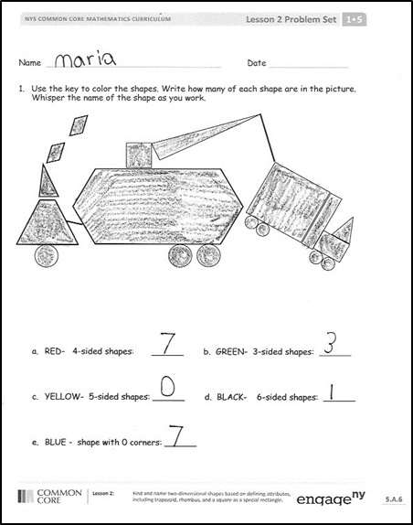
- Take turns until one player has used all of his straws.
- If you have more time, shuffle up the cards, and take turns trying to pick the cards that match the shapes you’ve made.
Problem Set (10 minutes)
Students should do their personal best to complete the Problem Set within the allotted 10 minutes. For some classes, it may be appropriate to modify the assignment by specifying which problems they work on first.
Student Debrief (10 minutes)
Lesson Objective: Find and name two-dimensional shapes including trapezoid, rhombus, and a square as a special rectangle, based on defining attributes of sides and corners.
The Student Debrief is intended to invite reflection and active processing of the total lesson experience.
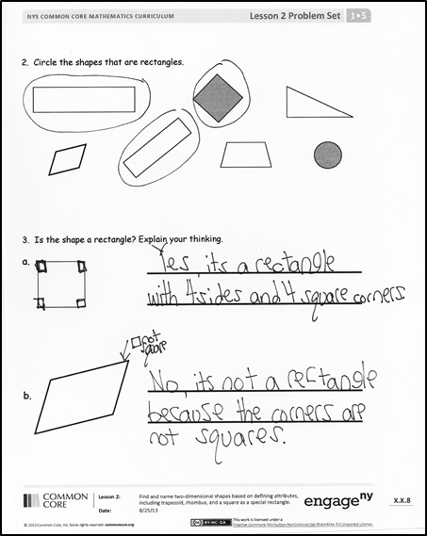
Invite students to review their solutions for the Problem Set. They should check work by comparing answers with a partner before going over answers as a class. Look for misconceptions or misunderstandings that can be addressed in the Debrief. Guide students in a conversation to debrief the Problem Set and process the lesson.
Any combination of the questions below may be used to lead the discussion.
- Look at Problem 1. Which shapes were the most challenging to count or find? Which shapes were the easiest? Explain your thinking.
- Which four-sided shapes are squares? Which are rhombuses? Which are rectangles? Which are trapezoids? (Note that a square is a type of rectangle and a type of rhombus.) How many sides do hexagons have?
- What name can we use for the three-sided shapes? What name can we use for the six-sided shapes? What name can we use for all of the curved shapes in this picture?
- In Problem 1, what do the shapes look like when they are put together in this way?
- Look at Problem 2. Explain why you chose each shape that is a rectangle. Explain why the other shapes are not rectangles.
- Look at Problem 3(b). Explain your thinking. How is the shape in 3(b) like a rectangle? How is it different from a rectangle? What other shapes have similar attributes to 3(b)? How are they similar, and how are they different?
- What shape names did we use today? Name the attributes or characteristics that are important to each shape.
- Look at the Application Problem. What shape or shapes might Lee have created?
- How did your fluency work go today? How do you practice?
Exit Ticket (3 minutes)
After the Student Debrief, instruct students to complete the Exit Ticket. A review of their work will help with assessing students’ understanding of the concepts that were presented in today’s lesson and planning more effectively for future lessons. The questions may be read aloud to the students.

Name Date
- Use the key to color the shapes. Write how many of each shape are in the picture. Whisper the name of the shape as you work.

- RED—4-sided shapes: ______ b. GREEN—3-sided shapes: ______

- YELLOW—5-sided shapes: ______ d. BLACK—6-sided shapes: ______

- BLUE—shape with 0 corners: ______

- Circle the shapes that are rectangles.

- Is the shape a rectangle? Explain your thinking.

Name Date
Write the number of corners and sides that each shape has. Then, match the shape to its name. Remember that some special shapes may have more than one name.
triangle
circle
rectangle
hexagon
square
rhombus

____ corners
____ straight sides

____ corners
____ straight sides

____ corners
____ straight sides

____ corners
____ straight sides

Name Date
- Color the shapes using the key. Write the number of shapes you colored on each line.
Key
RED 3 straight sides: ______
BLUE 4 straight sides: ______
GREEN 6 straight sides: ______
YELLOW 1 curved side: ______

  - A triangle has ____ straight sides and ____ corners.
  - I colored ____ triangles.

- A hexagon has ____ straight sides and ____ corners.
- I colored ____ hexagon.

  - A circle has ____ straight sides and ____ corners.
  - I colored ____ circles.

- A rhombus has ____ straight sides that are equal in length and ____ corners.
- I colored ____ rhombus.
- A rectangle is a closed shape with 4 straight sides and 4 square corners.
  - Cross off the shape that is NOT a rectangle.

  - Explain your thinking: ___________________________________________
______________________________________________________________
- A rhombus is a closed shape with 4 straight sides of the same length.
- Cross off the shape that is NOT a rhombus.

- Explain your thinking: __________________________________________
______________________________________________________________

hexagon  closed shape with 6 straight sides | rectangle  closed shape with 4 straight sides and 4 square corners
square  closed shape with 4 straight sides of the same length and 4 square corners | triangle  closed shape with 3 straight sides
rhombus
closed shape with 4 straight sides of the same length

shape description cards

