Lesson 1
Objective: Classify shapes based on defining attributes using examples, variants, and non-examples.

Suggested Lesson Structure
 Fluency Practice (15 minutes)
 Application Problem (5 minutes)
 Concept Development (30 minutes)
 Student Debrief (10 minutes)
Total Time (60 minutes)
Fluency Practice (15 minutes)
- Grade 1 Core Fluency Sprint 1.OA.6 (10 minutes)
- Make it Equal: Addition Expressions 1.OA.7 (5 minutes)
Grade 1 Core Fluency Sprint (10 minutes)
Materials: (S) Core Fluency Sprint
Note: For the remainder of the year, a portion of each lesson will be devoted to either Core Fluency Sprints or Core Fluency Practice Sets. When Sprints are suggested, choose a Core Fluency Sprint that meets students’ needs. All five Core Fluency Sprints are provided at the end of this lesson and are described below for easy reference. Prepare class sets or save the masters for later use because they will not be included in future lessons. With each Sprint, notice how many problems most of the class is able to complete; discuss and celebrate improvement as students progress toward Grade 1’s required fluency. Quadrants 1, 2, and 3 of each Sprint target Grade 1’s core fluency, while Quadrant 4 of the Sprint sometimes extends beyond the grade-level required fluency.
Core Fluency Sprint List:
- Core Addition Sprint 1 (Targets core addition and missing addends.)
- Core Addition Sprint 2 (Targets the most challenging addition within 10.)
- Core Subtraction Sprint (Targets core subtraction.)
- Core Fluency Sprint: Totals of 5, 6, and 7 (Develops understanding of the relationship between addition and subtraction.)
- Core Fluency Sprint: Totals of 8, 9, and 10 (Develops understanding of the relationship between addition and subtraction.)
Make it Equal: Addition Expressions (5 minutes)
Materials: (S) Numeral cards including one “=” card and two “+” cards (Fluency Template)
Note: This activity builds fluency with Grade 1’s core addition facts and promotes an understanding of equality.
Assign students partners of equal ability. Students arrange numeral cards from 0 to 10, including the extra 5. Place the “=” card between the partners. Write four numbers on the board (e.g., 9, 5, 5, 1). Partners take the numeral cards that match the numbers written to make two equivalent expressions (e.g., 5 + 5 = 9 + 1).
Suggested sequences: 5, 5, 9, 1; 0, 1, 9, 10; 10, 8, 2, 0; 8, 7, 3, 2; 5, 3, 5, 7; 3, 6, 7, 4; 2, 4, 6, 8, etc.
Application Problem (5 minutes)

NOTES ON
MULTIPLE MEANS
OF REPRESENTATION:
Today, students are introduced to the Straw Kit that is used throughout Module 5. Since students have not worked with the straw pieces, show the class what the straw pieces look like before they begin the Application Problem.
Today, everyone will get 7 straw pieces to use in our lesson. Later, you will use your pieces and your partner’s pieces together. How many straw pieces will you have to use when you and your partner put them together?
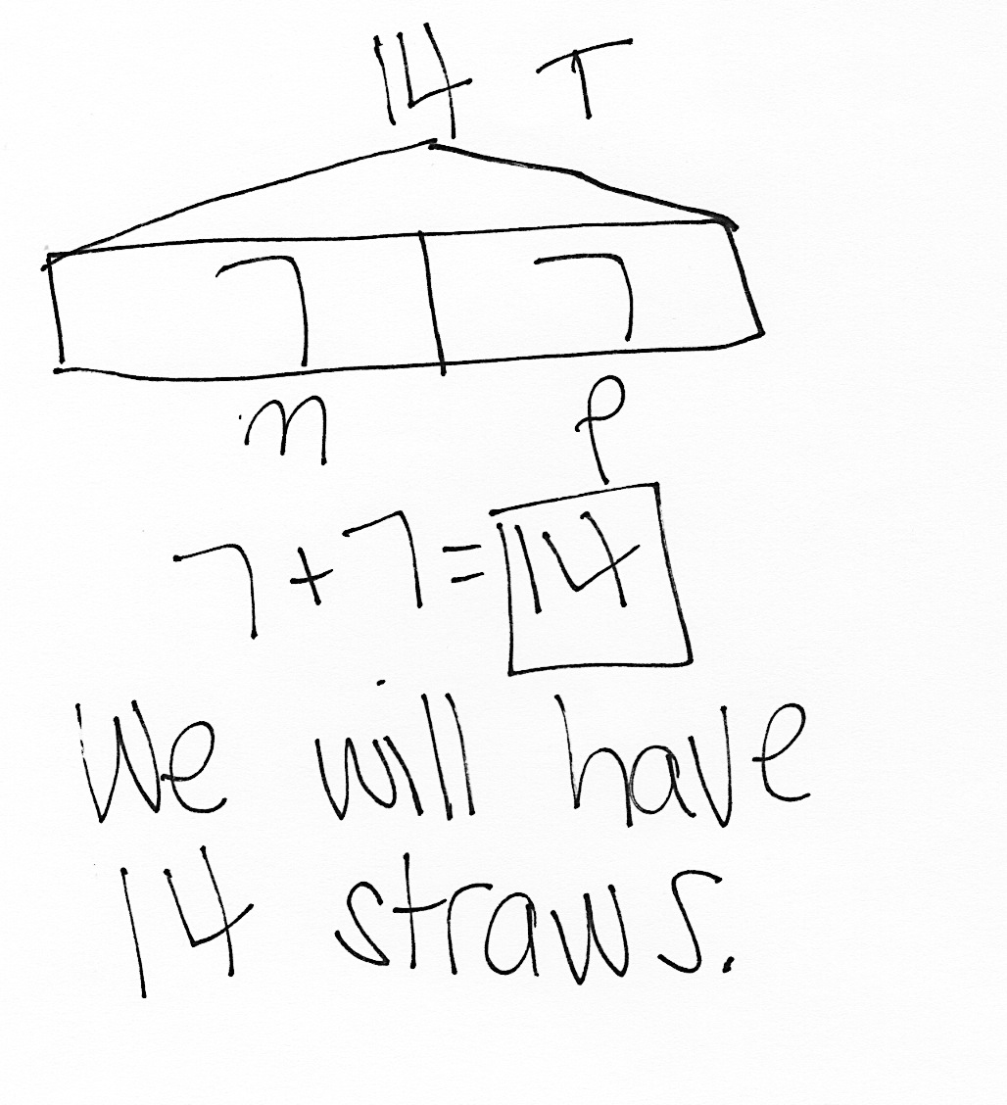

Note: Today’s Application Problem is a put together with total unknown problem type. Some students may have difficulty determining the second addend since it is not directly stated in the problem. When working with students who are having difficulty, ask these prompting questions: Can you draw something? What can you draw? What does your drawing show you? During the Debrief, invite students to explain how they solved the problem.
Concept Development (30 minutes)
Materials: (T) Chart paper, document camera, open and closed shape images (Template 1), square corner tester (Template 2) (S) Blank paper, straw kit (see note), ruler
Note: Prepare the square corner tester by cutting out the L shape from the template. Prepare a straw kit for each student. Coffee straws are recommended because they do not roll as easily and fit more neatly on student desks; however, any available straws can be used. Each student kit contains three sizes of straw pieces, created using four straws: 2 full-length straws, 3 half-length straws, and 2 quarter-length straws. The ruler will be used for drawing straight lines. Check shape posters and any shape resources that are used to ensure that they show the shapes and names accurately.
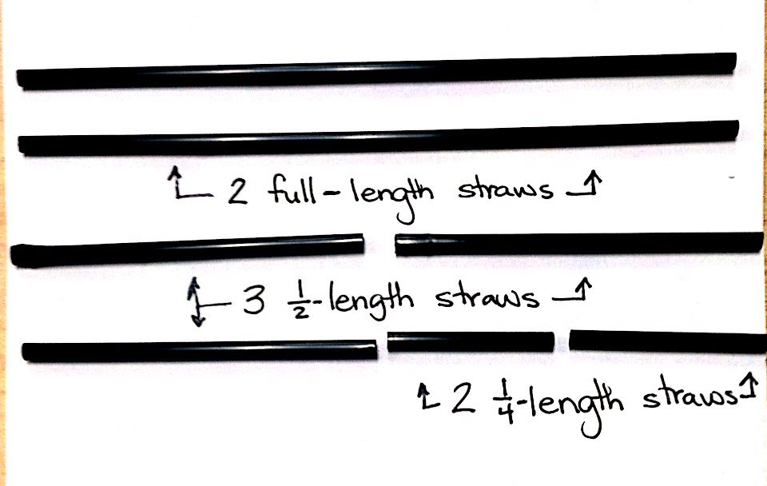
Have students sit at their desks or tables with their materials.
Straw Kit
T: Today, we will be making all kinds of shapes with these straws. Take two minutes to explore the pieces and see what you can make. Keep the straws flat on your desk.
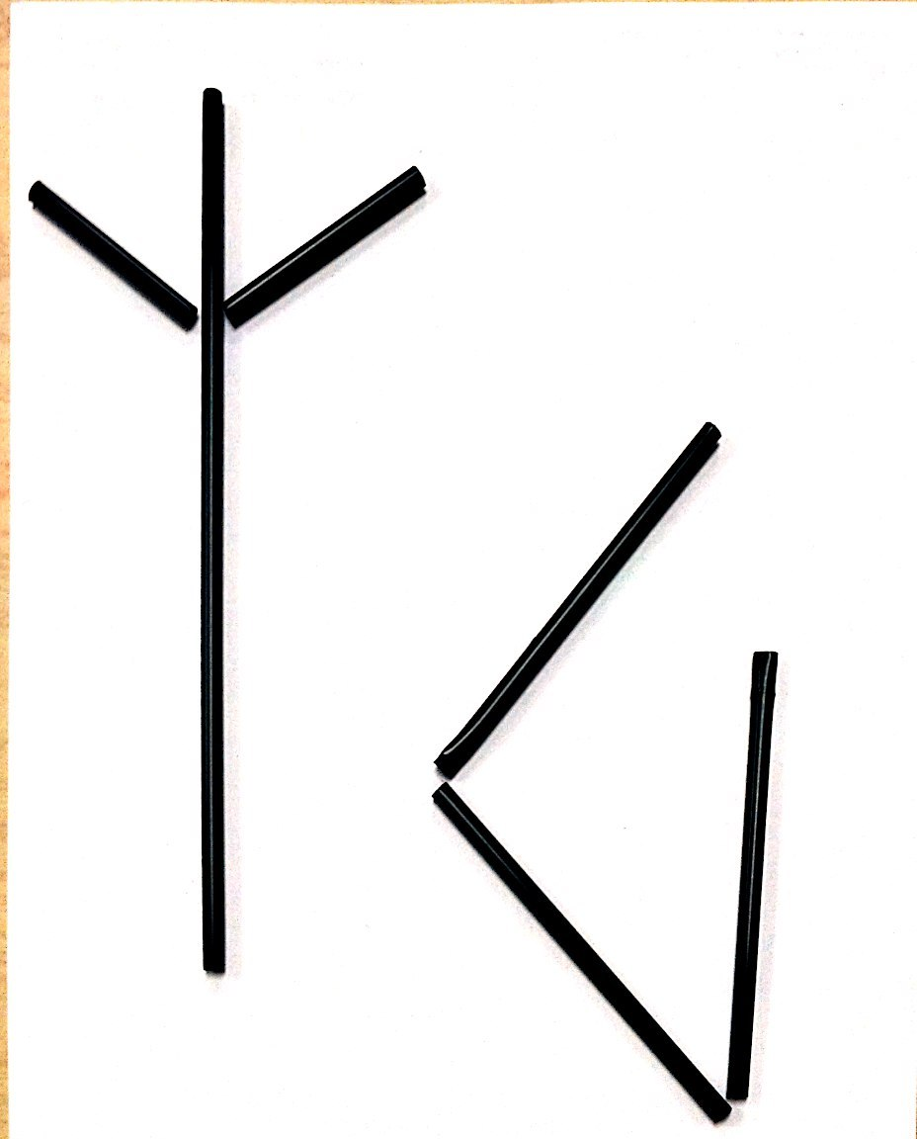
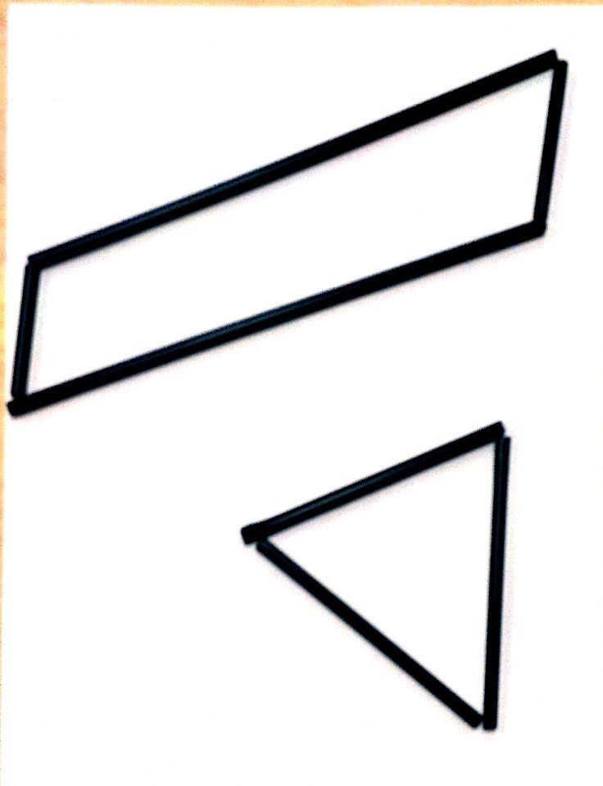
T: (While students explore and create shapes, circulate and notice how they engage with the materials. Do not discuss shape names with students at this time, but rather focus on the number of straight sides, the number of corners, and the length of the sides. During Lesson 2, names are added to the sets of attributes.)
Open Shapes
Closed Shapes
T: (Project open and closed shape images.) Some of you created designs that are open, like this (point to design labeled Open Shapes), and some of you created designs that are closed, like this (point to design labeled Closed Shapes). Think back to what you learned in Kindergarten. Can you remember what the difference is between an open shape (point to the image) and a closed shape (point to the image)?
S: A closed shape is one that has no opening to get out if you were inside the lines. There’s an inside and an outside for a closed shape. Both ends of every straw touch another straw.
T: Who has an example of an open shape to show us?
S: (Share.)
T: Who has an example of a closed shape to show us?
S: (Share.)
T: Today, we’ll be making closed shapes, so try to make sure you keep your straws touching at the ends when we make our shapes. If you have an open shape right now, make a new shape so that you have a closed one.
T: (Look for a student who created a three-sided shape, and place the configuration under the document camera.) Let’s look at this shape. How would you describe it?
S: It has three straight sides. The straws come together at three points. It has three corners.
The sides are different lengths. (Or, the sides are the same length, depending on the shape displayed.)
T: (Write 3 Straight Sides and 3 Corners at the top of the chart paper.) Use your straws to create this exact same shape on top of your blank paper.
S: (Create the shape with straws.)
T: (As students do this, ask questions to draw attention to the length of the sides so that students are creating the same exact congruent shape.)
T: Let’s record the shape. Draw a dot at the corners where each set of straws meet. Remember a corner is where two sides meet.
T/S: (Draw dots.)
T: (Demonstrate as you describe the process.) Now, move your straws away. Line up your ruler so that two dots are touching the side of the ruler. We can touch one dot with our pencil and draw a very straight line to the next dot. You try it.
S: (Draw straight line connecting the dots.)
T: Great job! Let’s do the same thing to draw all three sides of our shape.

NOTES ON
MULTIPLE MEANS
OF REPRESENTATION:
Some students find visual discrimination challenging, particularly when the attributes are at more refined levels. Encourage students to persevere. Have students touch the corners or line up the straws as methods to concretely confirm the attributes discussed.
S: (Complete the drawing.)
T: (Put the shape back under the document camera.) Does anyone else have a shape that is made with three straight sides and three corners?
Repeat the process at least four times to create and record various combinations of three straight sides and three corners.
T: (Point to the shapes on the chart.) All of these shapes have two attributes, or characteristics, in common. What are they?
S: All of the shapes have three straight sides and three corners.
T: Great! Let’s make a new chart with shapes that have a different attribute. Let’s make different shapes that all have four straight sides and four corners. Turn over your paper so you can record the shapes on the other side.
Write 4 Corners and 4 Sides at the top of a new piece of chart paper. Repeat the process from above at least four times, being sure to include shapes such as two rectangles of varied lengths, a trapezoid, and at least one quadrilateral that is not easily named.
T: Now, combine your straws with your partner. Can you come up with other shapes with four corners and four straight sides that we did not record on our list?
MP.1
S: (Work with partner and create shapes such as squares and rhombuses.)
Continue the process of adding these shapes to the chart and having students record the shapes.
T: Let’s look at Chart 2. All of these shapes have four straight sides and four corners. Some of the corners are a special kind, called a square corner. They form this shape. (Hold up and trace the edge of the square corner tester.) Let’s use the square corner tester to find square corners on these four-sided, four-cornered shapes. (Use the tester, placing a square in the corner of each square corner.)
T: Think back to the shapes you made earlier. What closed shapes did you make that would not fit with one of our charts? We’ll make a separate chart for these.
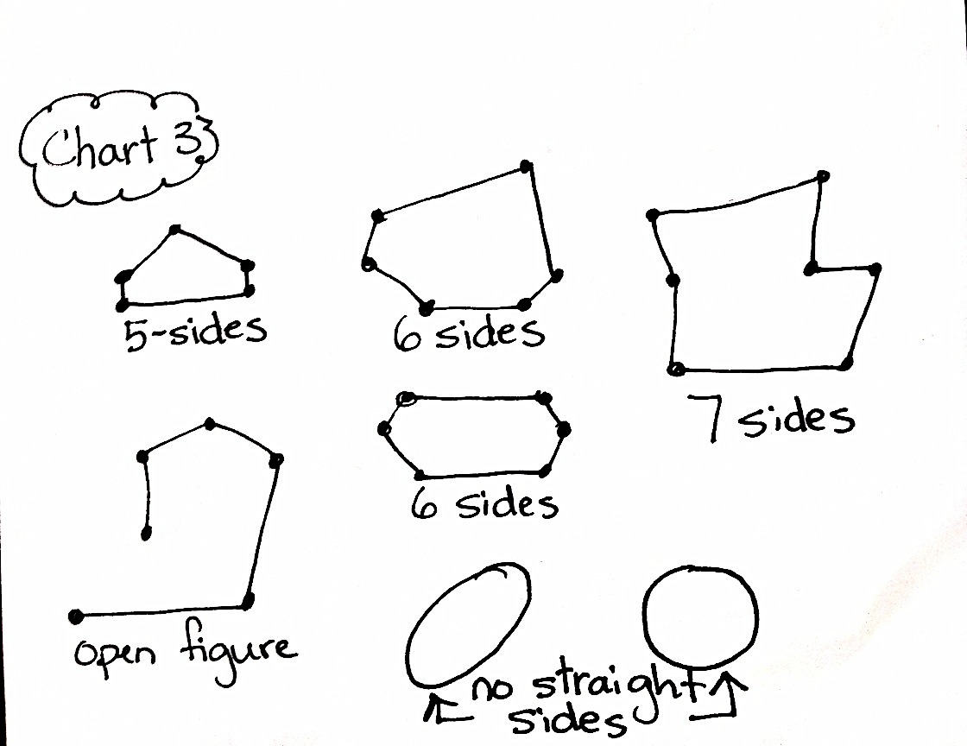
T/S: (Share shapes with five or more straight sides. As students share, create a final chart. Draw each shape, and write its specific attributes next to it.)
T: This paper shows shapes with five straight sides, six straight sides, and even seven straight sides. I want to draw a shape on here that has no straight sides. Who would like to add a shape on here that has no straight sides?
S: (Adds an oval or circle to the chart.)
T: Let’s add one open figure, or shape, to the chart as well. (Student adds open figure.)
Problem Set (10 minutes)
Students should do their personal best to complete the Problem Set within the allotted 10 minutes.
For some classes, it may be appropriate to modify the assignment by specifying which problems students should work on first. With this option, let the purposeful sequencing of the Problem Set guide the selections so that problems continue to be scaffolded. Balance word problems with other problem types to ensure a range of practice.
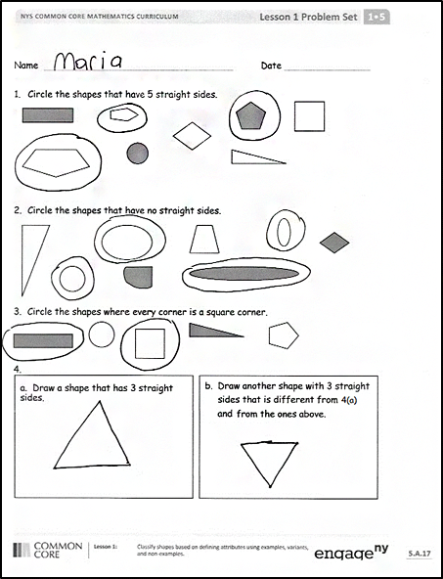
Student Debrief (10 minutes)
Lesson Objective: Classify shapes based on defining attributes using examples, variants, and non-examples.
The Student Debrief is intended to invite reflection and active processing of the total lesson experience.
Invite students to review their solutions for the Problem Set. They should check work by comparing answers with a partner before going over answers as a class. Look for misconceptions or misunderstandings that can be addressed in the Debrief. Guide students in a conversation to debrief the Problem Set and process the lesson.
Any combination of the questions below may be used to lead the discussion.
- Look at Problem 1. Which shapes did you choose? Which shapes did not have the attribute of having five straight sides?

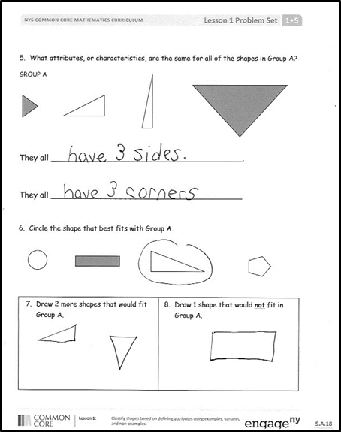
- Look at Problem 4. Compare your shapes to those on our chart. Which shapes look exactly the same? Did anyone draw a shape that is not already represented on our chart?
- Look at Problem 5. Which attributes, or characteristics, are the same for all of the shapes? Which attributes are different among the shapes in Group A?
- What does it mean to share an attribute of a shape?
- Look at your Application Problem and share your solution with a partner. How did your straws help you create different shapes today? Can you make a shape with four straight sides and only three corners? What would that look like? (Students may put two sides next to each other, essentially making a longer line out of two of the four straws. If this is done, let students know this can be considered one side that uses two straws.)
Exit Ticket (3 minutes)
After the Student Debrief, instruct students to complete the Exit Ticket. A review of their work will help with assessing students’ understanding of the concepts that were presented in today’s lesson and planning more effectively for future lessons. The questions may be read aloud to the students.

Name Date
A
Number Correct:
*Write the unknown number. Pay attention to the symbols.
1 | 4 + 1 = ____ | 16 | 4 + 3 = ____
2 | 4 + 2 = ____ | 17 | ____ + 4 = 7
3 | 4 + 3 = ____ | 18 | 7 = ____ + 4
4 | 6 + 1 = ____ | 19 | 5 + 4 = ____
5 | 6 + 2 = ____ | 20 | ____ + 5 = 9
6 | 6 + 3 = ____ | 21 | 9 = ____ + 4
7 | 1 + 5 = ____ | 22 | 2 + 7 = ____
8 | 2 + 5 = ____ | 23 | ____ + 2 = 9
9 | 3 + 5 = ____ | 24 | 9 = ____ + 7
10 | 5 + ____= 8 | 25 | 3 + 6 = ____
11 | 8 = 3 + ____ | 26 | ____ + 3 = 9
12 | 7 + 2 = ____ | 27 | 9 = ____ + 6
13 | 7 + 3 = ____ | 28 | 4 + 4 = ____ + 2
14 | 7 + ____ = 10 | 29 | 5 + 4 = ____ + 3
15 | ____ + 7 = 10 | 30 | ____ + 7 = 3 + 6
Name Date
B
Number Correct:
*Write the unknown number. Pay attention to the symbols.
1 | 5 + 1 = ____ | 16 | 2 + 4 = ____
2 | 5 + 2 = ____ | 17 | ____ + 4 = 6
3 | 5 + 3 = ____ | 18 | 6 = ____ + 4
4 | 4 + 1 = ____ | 19 | 3 + 4 = ____
5 | 4 + 2 = ____ | 20 | ____ + 3 = 7
6 | 4 + 3 = ____ | 21 | 7 = ____ + 4
7 | 1 + 3 = ____ | 22 | 4 + 5 = ____
8 | 2 + 3 = ____ | 23 | ____ + 4 = 9
9 | 3 + 3 = ____ | 24 | 9 = ____ + 5
10 | 3 + ____ = 6 | 25 | 2 + 6 = ____
11 | ____ + 3 = 6 | 26 | ____ + 6 = 9
12 | 5 + 2 = ____ | 27 | 9 = ____ + 2
13 | 5 + 3 = ____ | 28 | 3 + 3 = ____ + 4
14 | 5 + ____ = 8 | 29 | 3 + 4 = ____ + 5
15 | ____ + 3 = 8 | 30 | ____ + 6 = 2 + 7

Name Date
Number Correct:
A
*Write the unknown number. Pay attention to the equal sign.
1 | 5 + 2 = ____ | 16 | ____ = 5 + 4
2 | 6 + 2 = ____ | 17 | ____ = 4 + 5
3 | 7 + 2 = ____ | 18 | 6 + 3 = ____
4 | 4 + 3 = ____ | 19 | 3 + 6 = ____
5 | 5 + 3 = ____ | 20 | ____ = 2 + 6
6 | 6 + 3 = ____ | 21 | 2 + 7 = ____
7 | ____ = 6 + 2 | 22 | ____ = 3 + 4
8 | ____ = 2 + 6 | 23 | 3 + 6 = ____
9 | ____ = 7 + 2 | 24 | ____ = 4 + 5
10 | ____ = 2 + 7 | 25 | 3 + 4 = ____
11 | ____ = 4 + 3 | 26 | 13 + 4 = ____
12 | ____ = 3 + 4 | 27 | 3 + 14 = ____
13 | ____ = 5 + 3 | 28 | 3 + 6 = ____
14 | ____ = 3 + 5 | 29 | 13 + ____ = 19
15 | ____ = 3 + 4 | 30 | 19 = ____ + 16
Name Date
B
Number Correct:
*Write the unknown number. Pay attention to the equal sign.
1 | 4 + 3 = ____ | 16 | ____ = 6 + 3
2 | 5 + 3 = ____ | 17 | ____ = 3 + 6
3 | 6 + 3 = ____ | 18 | 5 + 4 = ____
4 | 6 + 2 = ____ | 19 | 4 + 5 = ____
5 | 7 + 2 = ____ | 20 | ____ = 2 + 7
6 | 5 + 4 = ____ | 21 | 2 + 6 = ____
7 | ____ = 4 + 3 | 22 | ____ = 3 + 4
8 | ____ = 3 + 4 | 23 | 4 + 5 = ____
9 | ____ = 5 + 3 | 24 | ____ = 3 + 6
10 | ____ = 3 + 5 | 25 | 2 + 7 = ____
11 | ____ = 6 + 2 | 26 | 12 + 7 = ____
12 | ____ = 2 + 6 | 27 | 2 + 17 = ____
13 | ____ = 7 + 2 | 28 | 4 + 5 = ____
14 | ____ = 2 + 7 | 29 | 14 + ____ = 19
15 | ____ = 7 + 2 | 30 | 19 = ____ + 15

Name Date
A
Number Correct:
*Write the unknown number. Pay attention to the symbols.
1 | 6 - 1 = ____ | 16 | 8 - 2 = ____
2 | 6 - 2 = ____ | 17 | 8 - 6 = ____
3 | 6 - 3 = ____ | 18 | 7 - 3 = ____
4 | 10 - 1 = ____ | 19 | 7 - 4 = ____
5 | 10 - 2 = ____ | 20 | 8 - 4 = ____
6 | 10 - 3 = ____ | 21 | 9 - 4 = ____
7 | 7 - 2 = ____ | 22 | 9 - 5 = ____
8 | 8 - 2 = ____ | 23 | 9 - 6 = ____
9 | 9 - 2 = ____ | 24 | 9 - ____ = 6
10 | 7 - 3 = ____ | 25 | 9 - ____ = 2
11 | 8 - 3 = ____ | 26 | 2 = 8 - ____
12 | 10 - 3 = ____ | 27 | 2 = 9 - ____
13 | 10 - 4 = ____ | 28 | 10 - 7 = 9 - ____
14 | 9 - 4 = ____ | 29 | 9 - 5 = ____ - 3
15 | 8 - 4 = ____ | 30 | ____ - 6 = 9 - 7
Name Date
B
Number Correct:
*Write the unknown number. Pay attention to the symbols.
1 | 5 - 1 = ____ | 16 | 6 - 2 = ____
2 | 5 - 2 = ____ | 17 | 6 - 4 = ____
3 | 5 - 3 = ____ | 18 | 8 - 3 = ____
4 | 10 - 1 = ____ | 19 | 8 - 5 = ____
5 | 10 - 2 = ____ | 20 | 8 - 6 = ____
6 | 10 - 3 = ____ | 21 | 9 - 3 = ____
7 | 6 - 2 = ____ | 22 | 9 - 6 = ____
8 | 7 - 2 = ____ | 23 | 9 - 7 = ____
9 | 8 - 2 = ____ | 24 | 9 - ____ = 5
10 | 6 - 3 = ____ | 25 | 9 - ____ = 4
11 | 7 - 3 = ____ | 26 | 4 = 8 - ____
12 | 8 - 3 = ____ | 27 | 4 = 9 - ____
13 | 5 - 4 = ____ | 28 | 10 - 8 = 9 - ____
14 | 6 - 4 = ____ | 29 | 8 - 6 = ____ - 7
15 | 7 - 4 = ____ | 30 | ____ - 4 = 9 - 6

Name Date
A
Number Correct:
*Write the unknown number. Pay attention to the symbols.
1 | 2 + 3 = ____ | 16 | 3 + 3 = ____
2 | 3 + ____ = 5 | 17 | 6 - 3 = ____
3 | 5 - 3 = ____ | 18 | 6 = ____ + 3
4 | 5 - 2 = ____ | 19 | 2 + 5 = ____
5 | ____ + 2 = 5 | 20 | 5 + ____ = 7
6 | 1 + 5 = ____ | 21 | 7 - 2 = ____
7 | 1 + ____ = 6 | 22 | 7 - 5 = ____
8 | 6 - 1 = ____ | 23 | 7 = ____ + 5
9 | 6 - 5 = ____ | 24 | 3 + 4 = ____
10 | ____ + 5 = 6 | 25 | 4 + ____ = 7
11 | 4 + 2 = ____ | 26 | 7 - 4 = ____
12 | 2 + ____ = 6 | 27 | 7 = ____ + 3
13 | 6 - 2 = ____ | 28 | 3 = 7 - ____
14 | 6 - 4 = ____ | 29 | 7 - 5 = ____ - 4
15 | ____ + 4 = 6 | 30 | ____ - 3 = 7 - 4

Name Date
B
Number Correct:
*Write the unknown number. Pay attention to the symbols.
1 | 1 + 4 = ____ | 16 | 3 + 3 = ____
2 | 4 + ____ = 5 | 17 | 6 - 3 = ____
3 | 5 - 4 = ____ | 18 | 6 = ____ + 3
4 | 5 - 1 = ____ | 19 | 2 + 4 = ____
5 | ____ + 1 = 5 | 20 | 4 + ____ = 6
6 | 5 + 2 = ____ | 21 | 6 - 2 = ____
7 | 5 + ____ = 7 | 22 | 6 - 4 = ____
8 | 7 - 2 = ____ | 23 | 6 = ____ + 4
9 | 7 - 5 = ____ | 24 | 3 + 4 = ____
10 | ____ + 2 = 7 | 25 | 4 + ____ = 7
11 | 1 + 5 = ____ | 26 | 7 - 4 = ____
12 | 1 + ____ = 6 | 27 | 7 = ____ + 4
13 | 6 - 1 = ____ | 28 | 4 = 7 - ____
14 | 6 - 5 = ____ | 29 | 6 - 4 = ____ - 5
15 | ____ + 5 = 6 | 30 | ____ - 2 = 7 - 3

Name Date
A
Number Correct:
*Write the unknown number. Pay attention to the symbols.
1 | 5 + 5 = ____ | 16 | 2 + 6 = ____
2 | 5 + ____ = 10 | 17 | 8 = 6 + ____
3 | 10 - 5 = ____ | 18 | 8 – 2 = ____
4 | 9 + 1 = ____ | 19 | 2 + 7 = ____
5 | 1 + ____ = 10 | 20 | 9 = 7 + ____
6 | 10 - 1 = ____ | 21 | 9 - 7 = ____
7 | 10 - 9 = ____ | 22 | 8 = ____ + 2
8 | ____ + 9 = 10 | 23 | 8 - 6 = ____
9 | 1 + 8 = ____ | 24 | 3 + 6 = ____
10 | 8 + ____ = 9 | 25 | 9 = 6 + ____
11 | 9 - 1 = ____ | 26 | 9 - 6 = ____
12 | 9 - 8 = ____ | 27 | 9 = ____ + 3
13 | ____ + 1 = 9 | 28 | 3 = 9 - ____
14 | 4 + 4 = ____ | 29 | 9 - 5 = ____ - 6
15 | 8 - 4 = ____ | 30 | ____ - 7 = 8 - 6

Name Date
B
Number Correct:
*Write the unknown number. Pay attention to the symbols.
1 | 9 + 1 = ____ | 16 | 3 + 5 = ____
2 | 1 + ____ = 10 | 17 | 8 = 5 + ____
3 | 10 - 1 = ____ | 18 | 8 - 3 = ____
4 | 10 - 9 = ____ | 19 | 2 + 6 = ____
5 | ____ + 9 = 10 | 20 | 8 = 6 + ____
6 | 1 + 7 = ____ | 21 | 8 - 6 = ____
7 | 7 + ____ = 8 | 22 | 2 + 7 = ____
8 | 8 - 1 = ____ | 23 | 9 = ____ + 2
9 | 8 - 7 = ____ | 24 | 9 - 7 = ____
10 | ____ + 1 = 8 | 25 | 4 + 5 = ____
11 | 2 + 8 = ____ | 26 | 9 = 5 + ____
12 | 2 + ____ = 10 | 27 | 9 - 5 = ____
13 | 10 - 2 = ____ | 28 | 5 = 9 - ____
14 | 10 - 8 = ____ | 29 | 9 - 6 = ____ - 5

15 | ____ + 8 = 10 | 30 | ____ - 6 = 9 - 7

Name Date
- Circle the shapes that have 5 straight sides.

- Circle the shapes that have no straight sides.

- Circle the shapes where every corner is a square corner.

- Draw another shape with 3 straight sides that is different from 4(a) and from the ones above.

- Draw a shape that has 3 straight sides.

- Which attributes, or characteristics, are the same for all of the shapes in Group A?
GROUP A

They all ______________________________________.

They all ______________________________________.

- Circle the shape that best fits with Group A.

- Draw 2 more shapes that would fit
Group A.
- Draw 1 shape that would not fit in
Group A.

Name Date
- How many corners and straight sides does each of the shapes below have?
____ corners  ____ straight sides | ____ corners  ____ straight sides | ____ corners  ____ straight sides

- Look at the sides and corners of the shapes in each row.
- Cross off the shape that does not have the same number of sides and corners.

- Cross off the shape that does not have the same kind of corners as the other shapes.

Name Date
- Circle the shapes that have 3 straight sides.

- Circle the shapes that have no corners.

- Circle the shapes that have only square corners.

- Draw another shape with 4 straight sides that is different from 4(a) and from the ones above.
- Draw a shape that has 4 straight sides.

.
- Which attributes, or characteristics, are the same for all of the shapes in Group A?
GROUP A

They all _________________________________________________.
They all _________________________________________________.

- Circle the shape that best fits with Group A.

- Draw 2 more shapes that would fit
Group A.
- Draw 1 shape that would not fit in
Group A.

0 | 1 | 2 | 3
4 | 5 | 6 | 7
8 | 9 | 10 | 5
= | + | + | –

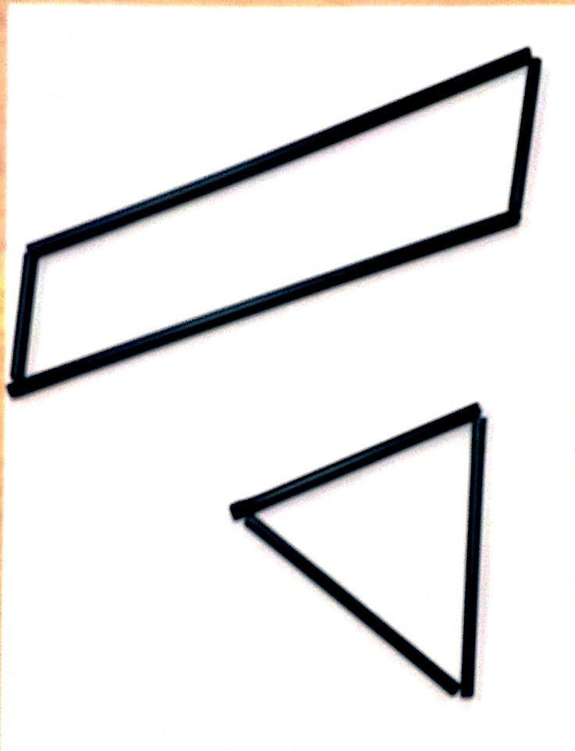
Open Shapes
Closed Shapes

Print on cardstock, and cut out each of the two square corner testers.

numeral cards
open and closed shape images
corner square tester

