Lesson 29
Objective: Add a pair of two-digit numbers with varied sums in the ones.

Suggested Lesson Structure
 Application Problem (5 minutes)
 Fluency Practice (13 minutes)
 Concept Development (32 minutes)
 Student Debrief (10 minutes)
Total Time (60 minutes)
Application Problem (5 minutes)
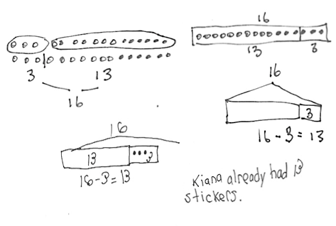
Kiana’s friend gave her 3 more stickers. Now, Kiana has 16 stickers. How many stickers did Kiana already have? Use the RDW process to solve the problem.
Note: This problem allows students to continue practicing the challenging add to with start unknown problem type. According to the Progressions Document, students should have exposure to this problem type, but mastery is not expected until Grade 2.
Students may employ a range of diverse strategies to solve the problem, as depicted in the images to the right. During the Debrief, invite students to share their strategies, as well as the drawings and notation they used to record their thinking. If students find solving the problem difficult, they can practice acting out their solution with a partner as a way to check their thinking.
Fluency Practice (13 minutes)
- Grade 1 Core Fluency Differentiated Practice Sets 1.OA.6 (5 minutes)
- Coin Drop 1.OA.6, 1.NBT.6 (3 minutes)
- Race to the Top 1.OA.6 (5 minutes)
Grade 1 Core Fluency Differentiated Practice Sets (5 minutes)
Materials: (S) Core Fluency Practice Sets (Lesson 23 Core Fluency Practice Sets)
Note: Excitement should be building in this third consecutive day of core fluency practice. Students have had two days and on this third day will have the chance to look back at their progress. Students who completed all questions correctly on their most recent Practice Set should be given the next level of difficulty. All other students should try to improve their scores on their current levels.
Students complete as many problems as they can in 90 seconds. Assign a counting pattern and start number for early finishers, or tell them to practice make ten addition or subtraction on the back of their papers. Collect and correct any Practice Sets completed within the allotted time.
Coin Drop (3 minutes)
Materials: (T) 4 dimes, 10 pennies
Note: In this activity, students practice adding and subtracting ones and tens.
See yesterday’s fluency practice for instructions.
Race to the Top (5 minutes)
NOTES ON
MULTIPLE MEANS
OF ACTION AND EXPRESSION:
Encourage students to describe and compare methods, strategies, and written notation with their partners. At this point, most students should be as comfortable solving the problems as they are describing their thinking while solving.
Materials: (S) Personal white board, race to the top (Fluency Template)
Note: This fluency activity primarily targets the core fluency for Grade 1.
Students take turns rolling the dice, saying an addition sentence, and recording the sums on the graph. The game ends when time runs out or one of the columns reaches the top of the graph.
Concept Development (32 minutes)
Materials: (T) Chart paper (S) Personal white board, 4 ten-sticks from math toolkit (optional), addition and subtraction cards set 3 (Template)
NOTES ON
MULTIPLE MEANS
OF ENGAGEMENT:
Appropriate scaffolds help all students feel successful. As students are working, keep a close eye to see if any would benefit from some one-on-one problem solving.

Have students gather in the meeting area with their materials.
The time allotted for Lesson 29’s Concept Development is also set aside to consolidate and solidify the learning that has occurred in Lessons 24–28. Just as in Lesson 28, three sets of problems have been provided for practice so that students gain accuracy and efficiency when adding a pair of double-digit numbers.
Students should be encouraged to use their number bonds and the arrow way to solve problems while having full access to drawing materials and manipulatives (MP.5). Note that Problems 11–15 involve sums greater than 40. This is intended to serve as a challenge set for advanced learners.
Challenge students to describe and compare methods, strategies, and written notation with their partners and to explain why they chose to solve the way they did using terms such as tens, ones, addend, take apart, add on the tens, and make the next ten.
NOTES ON
MULTIPLE MEANS
OF ACTION AND EXPRESSION:
Continue to challenge your advanced students. After they have completed Problems 11–15 to the left, encourage them to write a word problem to match one of the number sentences. Have students who write a word problem trade papers and solve each other’s problem.
MP.5
Problems 1–5 Problems 6–10 Problems 11–15
16 + 12 26 + 12 34 + 23
28 + 12 27 + 13 24 + 42
18 + 15 17 + 15 23 + 27
18 + 18 16 + 15 28 + 25
17 + 16 18 + 17 26 + 37
For the last five minutes, partners play Addition and Subtraction with Cards (follow Lesson 12 instructions) with the new cards, labeled F.
Problem Set (10 minutes)
Students should do their personal best to complete the Problem Set within the allotted 10 minutes. For some classes, it may be appropriate to modify the assignment by specifying which problems they work on first.
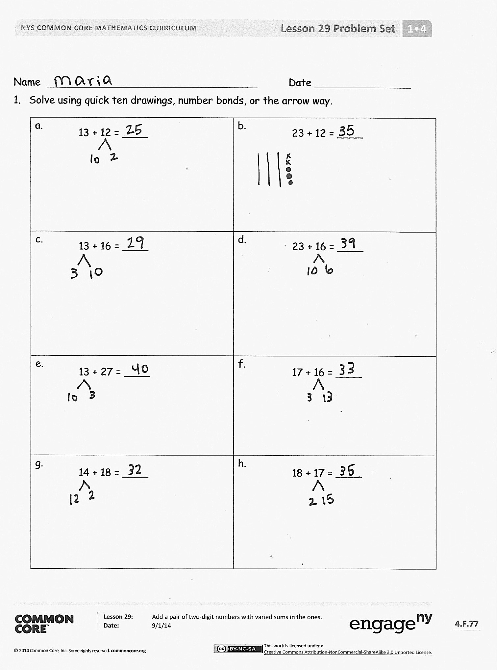
Student Debrief (10 minutes)
Lesson Objective: Add a pair of two-digit numbers with varied sums in the ones.
The Student Debrief is intended to invite reflection and active processing of the total lesson experience.
Invite students to review their solutions for the Problem Set. They should check work by comparing answers with a partner before going over answers as a class. Look for misconceptions or misunderstandings that can be addressed in the Debrief. Guide students in a conversation to debrief the Problem Set and process the lesson.
Any combination of the questions below may be used to lead the discussion.
- Look at Problems 2(b) and 2(h). Did you make a new ten in both problems? Explain why this is so.
- Look at Problem 1(h). Explain which method or strategy you used to solve. Why did you choose this particular method or strategy?
- How can you solve 2(f) using doubles?
- For problems where you need to make a new ten (i.e., Problems 2(d), 2(g), 2(h), etc.), do you prefer to add on the tens first or make a new ten? Explain your choice.
- Share your drawings and solution to your Application Problem with your partner. What was your strategy for solving this? Check your work by acting out each part of the story and matching them to the parts of your drawing.
Exit Ticket (3 minutes)
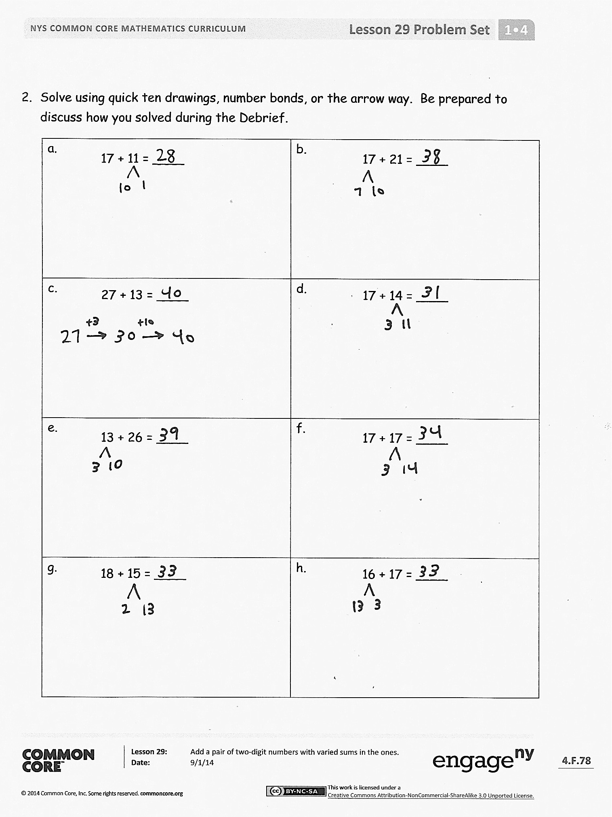
After the Student Debrief, instruct students to complete the Exit Ticket. A review of their work will help with assessing students’ understanding of the concepts that were presented in today’s lesson and planning more effectively for future lessons. The questions may be read aloud to the students.
Name Date
- Solve using quick ten drawings, number bonds, or the arrow way.
a.  13 + 12 = ____ | b.  23 + 12 = ____
c.  13 + 16 = ____ | d.  23 + 16 = ____
e.  13 + 27 = ____ | f.  17 + 16 = ____
g.  14 + 18 = ____ | h.  18 + 17 = ____

- Solve using quick ten drawings, number bonds, or the arrow way. Be prepared to discuss how you solved during the Debrief.
a.  17 + 11 = ____ | b.  17 + 21 = ____
c.  27 + 13 = ____ | d.  17 + 14 = ____
e.  13 + 26 = ____ | f.  17 + 17 = ____
g.  18 + 15 = ____ | h.  16 + 17 = ____

Name Date
Solve using quick ten drawings, number bonds, or the arrow way.
a.  18 + 14 = ____ | b.  14 + 23 = ____
c.  28 + 12 = ____ | d.  19 + 21 = ____

Name Date
- Solve using quick ten drawings, number bonds, or the arrow way.
a.  13 + 15 = ____ | b.  26 + 12 = ____
c.  23 + 16 = ____ | d.  17 + 16 = ____
e.  14 + 17 = ____ | f.  27 + 12 = ____
g.  15 + 18 = ____ | h.  18 + 16 = ____

- Solve using quick ten drawings, number bonds, or the arrow way.
a.  17 + 12 = ____ | b.  21 + 17 = ____
c.  17 + 15 = ____ | d.  27 + 13 = ____
e.  23 + 14 = ____ | f.  18 + 17 = ____
g.  18 + 11 = ____ | h.  18 + 18 = ____

Names Date
Race to the Top!
2 | 3 | 4 | 5 | 6 | 7 | 8 | 9 | 10 | 11 | 12

13 + 14  F | 26 + 13  F
17 + 22  F | 29 + 11  F
15 +15  F | 16 + 24  F
28 + 12  F | 29 + 11  F
19 + 14  F | 18 + 17  F
17 + 15  F | 16 + 15  F
19 + 17  F | 18 + 13  F
17 + 16  F | 18 - 6  F
17 - 3  F | 19 - 4  F

race to the top
addition and subtraction cards set 3
addition and subtraction cards set 3

