|  |
| --- |
|  |

Lesson 2: Graphs of Quadratic Functions

Student Outcomes

* Students represent graphically a non-linear relationship between two quantities and interpret features of the graph. They will understand the relationship between physical quantities via the graph.

Lesson Notes

**Distinctions between and :**

is the height as function of time ; it is not the *actual physical trajectory*. **It has a parabolic “shape or trajectory” in the conceptual - plane. The - parabolic trajectory is not directly visible to the human eye.**

is the actual parabolic trajectory in the physical - plane. The parabolic trajectory is directly visible to the human eye. This parabolic trajectory is easily confused with the if we are not careful.

In the special case of projectiles with straight up-and-down vertical motions; e.g., zero horizontal speed,

is still parabolic when the motion is pure up and down.

is a “delta function” (only poorly defined at ), not a parabola.

In the special case of projectiles with a finite horizontal speed component (throwing a ball at an angle), ***and are directly proportional because physics dictates .* The two graphs and may, therefore, “look similar” to the eyes, but they involve very different concepts.**

**Physics of projectiles:**

In , the constants , , and have definite meanings in physics.

* is of the local gravitational constant. Since on Earth is , or , the constant is, numerically, always or near Earth’s surface, depending on the choice of units for the height. **One does not have the freedom to randomly choose friendly numbers in projectile word problems.**
* is the initial upward speed.
* is the initial height above ground.

In, the constants , , and also have definite meanings in physics.

* is of the local gravitational constant divided by the square of the initial horizontal speed.
* is the initial slope in the - plane, or
* is the initial height above ground.

Classwork

**Example 1 (8 minutes)**

Show the video of a ball rolling down a ramp given at <http://youtu.be/xgODzAwxrx8>, telling the class that our goal will simply be to describe in words the motion of the ball. (If the link does not work, search for “Algebra I, Module 1 Lesson 2 ball rolling down ramp video.”)

After viewing the video, have students share aloud their ideas on describing the motion. Some might speak in terms of speed, distance rolled over time, or change of elevation. All approaches are valid. Help students begin to shape their ideas with language that specifies the names of the quantities being observed and how they are changing over time.

Direct the class to focus on the change of elevation of the ball over time and begin to put into words specific details linking elevation with time.

* It first started at the top of the ramp.
* It rolled down the ramp for about seconds.
* After it hit the bottom of the ramp, it rolled across the floor.

If students do not naturally do so, suggest representing this information on a graph. Display a set of axes on the board.

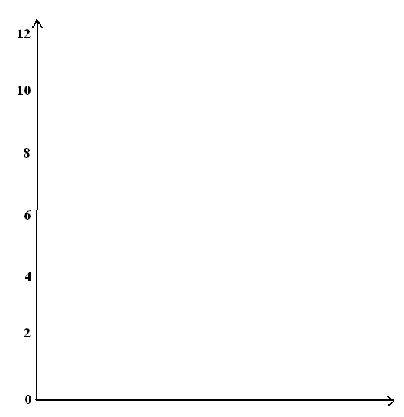

Begin a discussion that leads students through issues of formalizing the diagram: The labels and units of the axes, a title for the graph, the meaning of a point plotted on the graph, the height at time seconds, the time when it reached the bottom of the ramp, etc.

Either individually or in groups of two, have students estimate the general shape of the graph of the elevation-versus-time of the ball rolling down the ramp. At this point, do not worry about engaging students in measuring specific heights and specific times; right now they are just looking for the general shape. Be sure to have students notice the horizontal “tail” of the graph and ask them to interpret its meaning. (The elevation of the ball does not change as it rolls across the floor.) Some students may draw a curved graph. Others will likely draw a straight line for the graph over the interval to seconds. Even though this is not correct, allow it at this stage.

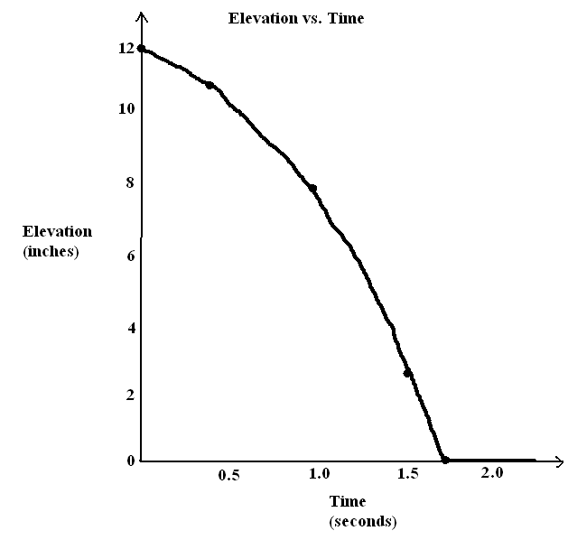After students have created graphs, have them compare their graphs with each other and share with the class. Ask the following questions:

* Should the change in elevation be decreasing at a constant rate? That is, do you think this graph should be a straight line-graph, at least between and about seconds?

Some specific questions (below) can help lead to the correct conclusion:

* Where does the elevation change more slowly? Explain.
* If it is changing more slowly at the top and more quickly at the bottom, should the graph look the same at those times?

In Exploratory Challenge, students will see an elevation-versus-time graph that is clearly not a straight line.

Exploratory Challenge (25 minutes)

Have students plot a graphical representation of change in elevation over time for the following “graphing story.” It is a video of a man jumping from 36 feet above ground into 1 foot of water.

**MP.4**

<https://www.youtube.com/watch?v=ZCFBC8aXz-g> or <http://youtu.be/ZCFBC8aXz-g> (If neither link works, search for “OFFICIAL Professor Splash World Record Video!”)

Exploratory Challenge

Plot a graphical representation of change in elevation over time for the following “graphing story.” It is a video of a man jumping from feet above ground into foot of water.

<http://www.youtube.com/watch?v=ZCFBC8aXz-g> or

<http://youtu.be/ZCFBC8aXz-g> (If neither link works, search for “OFFICIAL Professor Splash World Record Video!”)

Allow students to analyze the full video initially giving them as much control as possible (if not full control) in choosing when to pause a video, or play it half speed, and so on. Perhaps conduct this part of a class in a computer lab or display the video on an interactive Smart Board. Then direct students to investigate one of the two portions of the clip below, depending on the level of technology you have available:

Portion 1: From time seconds to time seconds. Use this to get data for drawing the graph **if they have access to a powerful movie editor that can show each frame.**

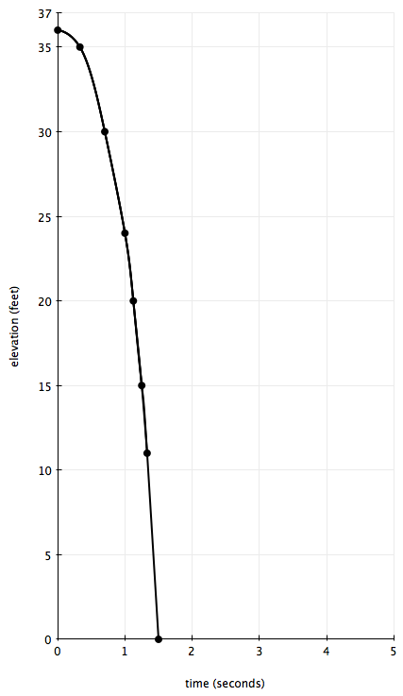Portion 2: From time seconds to time seconds. Use this for a slow-motion version that can be analyzed easily via YouTube.

*Teacher Note: In this lesson, keep students’ focus on understanding the relationship between physical measurements and the graph. Students will revisit scenarios like this one in Modules 4 and 5. We know, from physics, that the height function for this example can be modeled by and that in this case, the function models the situation very accurately. For example, the function predicts that he will hit the water at exactly seconds, which he does. However, quadratic equations and functions are topics for later modules.*

Students should start measuring from the top of the man’s jump, which is about feet high. (He starts at feet and jumps a foot up before falling.)

Solutions are provided below for each portion.

Give students the opportunity to share their work with the class as a whole or with a partner. Have students articulate and justify any interesting choices they have made. For example, instead of plotting points for every second of footage, some students may wish to plot the time per distance markers (, , , , , etc.). Both methods will lead to a graph of a quadratic function.

**MP.1**

|  |  |
| --- | --- |
| Time (sec.) | Elevation (ft.) |
|  |  |
|  |  |
|  |  |
|  |  |
|  |  |
|  |  |
|  |  |
|  |  |

Students should produce graphs that look similar to the following, according to which clip they used:

**Portion 1 Results:** If your students used Portion 1, they should get something that looks similar to the table (left) and graph (above).

The estimates of the heights in the table are based upon the markers in the video. Since the video is taken from the ground, reading height directly from the video can be hampered by the parallax effect. Ideally, for accurate reading, the camera should be at the same height as the jumper AT ALL TIMES so the height reading from the ruler in the background could be accurate. Remind the students to make some necessary corrections or adjustments instead of just *reading horizontally across the frozen video frame*. Regardless, you should not expect your students to have “perfect” graphs, but their graphs should NOT be straight lines.

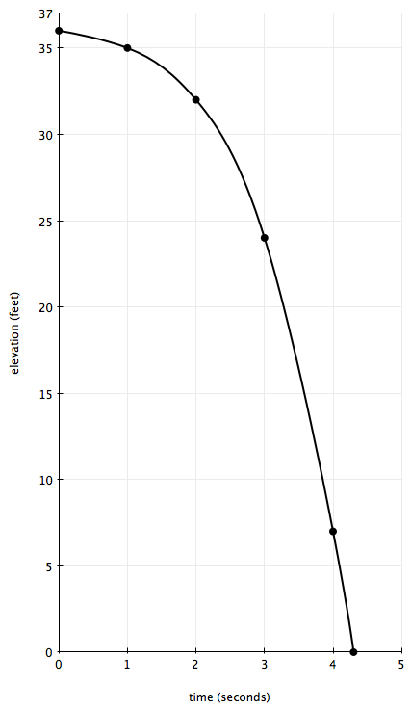**Portion 2 Results:** If your students used Portion of the tape, they should get something that looks similar to the table (below) and graph (right). Have a discussion with them that the results below do not model the actual situation. Byspecifically talking about film time versus real time, we lay the foundation to talk about transformations of functions. Guide students by asking these questions:

* What would you need to do to this graph to correctly model the jump with a graph?
  + *You need to know how long it took for him to complete the jump.*
* It takes the jumper exactly seconds from the top of his jump until he splashes in the water.
* Then we should shrink the graph horizontally until the -intercept is at seconds.
* Learning how to “shrink” graphs in this way will be an important topic in Modules and .

As an extension, encourage students to try adjusting the graph in this way (shrinking it horizontally such that the -intercept is at seconds), using their intuition to guide them, and compare their results with their peers.

|  |  |
| --- | --- |
| Time (sec.) | Elevation (ft.) |
|  |  |
|  |  |
|  |  |
|  |  |
|  |  |
|  |  |

**Example 2 (5 minutes)**

Example 2

The table below gives the area of a square with sides of whole number lengths. Have students plot the points in the table on a graph and draw the curve that goes through the points.

|  |  |  |  |  |  |
| --- | --- | --- | --- | --- | --- |
| *Side* (cm) |  |  |  |  |  |
| *Area* (cm2) |  |  |  |  |  |

On the same graph, reflect the curve across the -axis. This graph is an example of a “graph of a quadratic function.”

Bring up or ask:

* On the graph, what do the points between the plotted points from the table represent?
  + *Areas of squares with non-whole number side lengths.*

Closing (3 minutes)

Ask students to use their th grade geometry background to reflect the graph from Example 2 across the -axis on the same graph they just drew (8.G.A.3). They should get a picture like this:



Mention to them that this is an example of a “graph of a quadratic function.” Students have seen functions of the form in their eighth-grade studies of area as an example of a function that is not linear (8.F.A.3). Tell them that they will be studying these functions throughout the year and that they will learn different ways to recognize and represent quadratic functions and equations.

**Extension:** Show students that the graph in the Exploratory Challenge is also *part of* a graph of a quadratic function by plotting the reflection across the -axis (e.g., points with negative -values).

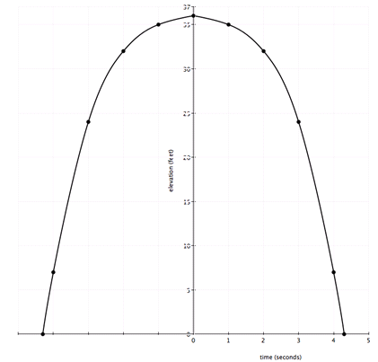

**MP.4**

Bring up or ask:

* Does this extended graph I have just drawn from the Exploratory Challenge model the elevation of the man jumping into the shallow pool?
  + *No, the part of the graph before time was not good. He went up to the platform very slowly compared to how fast he came down.*

If time allows, have students draw a graph of the man’s elevation versus time that incorporates his climbing the ladder. Bring up or ask:

* Can you imagine an elevation versus time situation where the graph would look like the extended graph?
  + *Yes, my elevation when I jump up into the air*

If you need to, show them or have a student demonstrate the answer to this question. Finally, ask:

* Does the reflection of the graph along the -axis in Example 2 make sense?
  + *No, squares cannot have negative side lengths.*

Exit Ticket (4 minutes)

Name ___________________________________________________ Date____________________

Lesson 2: Graphs of Quadratic Functions

Exit Ticket

If you jumped in the air three times, what might the elevation versus time graph of that story look like?

Label the axes appropriately.

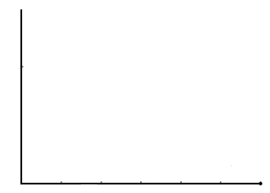

Exit Ticket Sample Solution

If you jumped in the air three times, what might the elevation versus time graph of that story look like?

Label the axes appropriately.

Student answers will vary.

I jump about foot high every other second.

Problem Set Sample Solutions

1. Here is an elevation versus time graph of a ball rolling down a ramp. The first section of the graph is slightly curved.

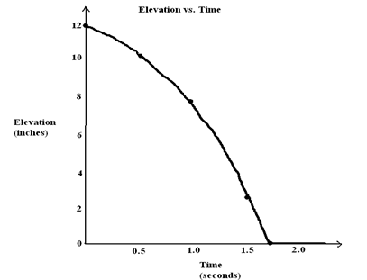

* 1. From the time of about seconds onwards, the graph is a flat horizontal line. If Ken puts his foot on the ball at time seconds to stop the ball from rolling, how will this graph of elevation versus time change?

*Even if the ball is at rest on the floor, its elevation remains inches and does not change. The elevation versus time graph does not change.*

* 1. Estimate the number of inches of change in elevation of the ball from seconds to seconds. Also estimate the change in elevation of the ball between seconds and seconds.

*Between and seconds, the change in elevation was about inches. Between and seconds, the change in elevation was about inches.*

* 1. At what point is the speed of the ball the fastest, near the top of the ramp at the beginning of its journey or near the bottom of the ramp? How does your answer to part (b) support what you say?

The speed of the ball is the fastest near the bottom of the ramp. During the half-second from second to seconds, the ball’s change in elevation is greater than the half-second at the beginning of its journey. It must have traversed a greater length of the ramp during this half-second and so was traveling faster. Its speed is greater near the bottom of the ramp.

1. Watch the following graphing story:

Elevation vs. Time #([http://www.mrmeyer.com/graphingstories1/graphingstories4.mov.](http://www.mrmeyer.com/graphingstories1/graphingstories4.mov) This is the second video under “Download Options” at the site <http://blog.mrmeyer.com/?p=213> called “Elevation vs. Time #.”)

The video is of a man hopping up and down several times at three different heights (first, five medium-sized jumps immediately followed by three large jumps, a slight pause, and then very quick small jumps).

* 1. What object in the video can be used to estimate the height of the man’s jump? What is your estimate of the object’s height?

***The stair step (Answers will vary between inches to inches.)***

* 1. Draw your own graph for this graphing story. Use parts of graphs of quadratic functions to model each of the man’s hops. Label your -axis and -axis appropriately and give a title for your graph.

*Answers will vary but should reflect the estimate made in part (a). See the end of the video for a picture of the graph.*

1. Use the table below to answer the following questions.

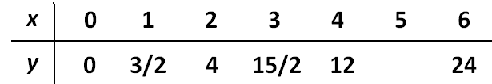

* 1. Plot the points in this table on a graph (except when is ).
  2. The -values in the table follow a regular pattern that can be discovered by computing the differences of consecutive -values. Find the pattern and use it to find the -value when is .

*The -values have differences that increase by one, suggesting that we next have a -value of   
 when is 5.*

* 1. Plot the point you found in part (b). Draw a curve through the points in your graph. Does the graph go through the point you plotted?

Yes.

* 1. How is this graph similar to the graphs you drew in Examples 1 and 2 and the Exploratory Challenge? Different?

*Answers will vary. This graph is similar to the graphs from Examples 1 and 2the Exploratory Challenge in that the curve has the same basic U-shape. (Students may mention that they are all graphs of quadratic functions, although at this point that is not necessary.) This graph is different from the graphs from Example 1 and the Exploratory Challenge because this curve is increasing and the graphs in Example 1 and the Exploratory Challenge are decreasing. This graph is similar to the graph from Example 2 because they are both increasing. However, this graph increases at a slower rate than the one from Example 2. For example this graph has value when is (the Example 2 graph had value ), and this graph has value when is (the Example 2 graph had value ), and so on.*

1. A ramp is made in the shape of a right triangle using the dimensions described in the picture below. The ramp length is feet from the top of the ramp to the bottom, and the horizontal width of the ramp is feet.

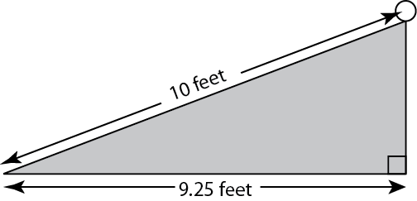

A ball is released at the top of the ramp and takes seconds to roll from the top of the ramp to the bottom. Find each answer below to the nearest feet/sec.

* 1. Find the average speed of the ball over the seconds.

*ft/sec, or ft/sec*

* 1. Find the average rate of horizontal change of the ball over the seconds.

ft/sec or ft/sec

* 1. Find the average rate of vertical change of the ball over the seconds.

By the Pythagorean Theorem, the vertical length is approximately feet. Hence, the average rate of vertical change is ft/sec or ft/sec

* 1. What relationship do you think holds for the values of the three average speeds you found in parts (a), (b), and (c)? (Hint: Use the Pythagorean Theorem.)

*The sum of the squares of the horizontal and vertical rates of change is equal to the square of the speed of the ball.*