Lesson 28
Objective: Add a pair of two-digit numbers with varied sums in the ones.

Suggested Lesson Structure
 Application Problem (7 minutes)
 Fluency Practice (16 minutes)
 Concept Development (27 minutes)
 Student Debrief (10 minutes)
Total Time (60 minutes)
Application Problem (7 minutes)
Anton had some crayons in his desk. His teacher gave him 2 more. When he counted all of his crayons, he had 16 crayons. How many crayons did Anton have in his desk originally? Use the RDW process to solve the problem.
Note: Today’s problem is the challenging add to with start unknown problem type. Although crayons were added within the story because the start is the unknown number, the problem requires subtraction.
Several images are shown below representing students’ varied approaches.
In Model A, the student draws all 16 crayons to begin with, partitioning the last two to find the initial 14.
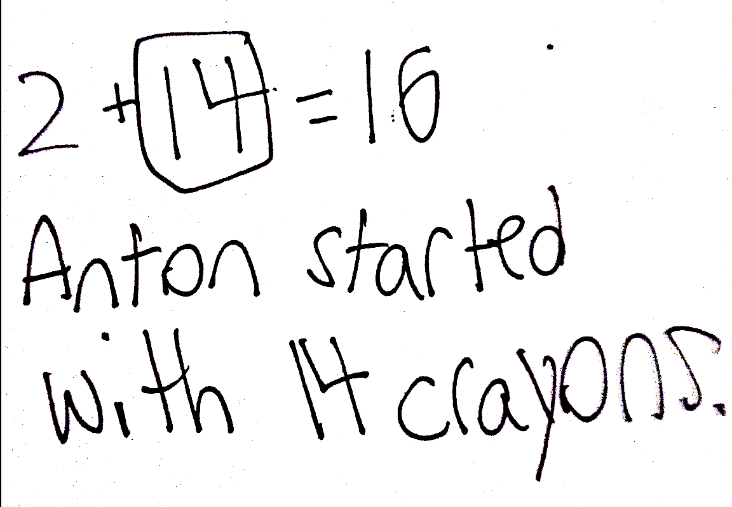
In Model B, the student may have drawn the part she knows, 2, with the total, 16, drawn below. The student then counts up to add more circles until the quantity matches 16, recounting to find the amount drawn.
In Model C, the student represents the unknown with an empty box and builds the chunk of two on the end. This student could use a missing addend number sentence or subtraction number sentence to solve the problem.
Model A
Model C
Model B

Fluency Practice (16 minutes)
- Grade 1 Core Fluency Differentiated Practice Sets 1.OA.6 (5 minutes)
- Coin Drop 1.OA.6, 1.NBT.6 (3 minutes)
- Make Ten: 9 Up 1.OA.6 (3 minutes)
- Addition Strategies Review 1.OA.6 (5 minutes)
Grade 1 Core Fluency Differentiated Practice Sets (5 minutes)
Materials: (S) Core Fluency Practice Sets (Lesson 23 Core Fluency Practice Sets)
Note: This activity assesses students’ progress toward mastery of the required addition fluency for first graders. Students who completed all questions correctly on their most recent Practice Set should be given the next level of difficulty. All other students should try to improve their scores on their current levels.
Students complete as many problems as they can in 90 seconds. Assign a counting pattern and start number for early finishers, or tell them to practice make ten addition or subtraction on the back of their papers. Collect and correct any Practice Sets completed within the allotted time.
Coin Drop (3 minutes)
Materials: (T) 4 dimes, 10 pennies, can
Note: In this activity, students practice adding and subtracting ones and tens.
T: (Hold up a penny.) Name my coin.
S: A penny.
T: How much is it worth?
S: 1 cent.
T: Listen carefully as I drop coins in my can. Count along in your minds.
Drop in some pennies and ask how much money is in the can. Take out some pennies and show them. Ask how much money is still in the can. Continue adding and subtracting pennies for a minute or so. Then, repeat the activity with dimes.
Make Ten: 9 Up (3 minutes)
Note: This fluency activity reviews how to calculate sums within 20 using the make ten strategy students learned in Module 2.
T: When I say “up,” tell me how to get to ten from my number. 9 up.
S 9 + 1 = 10.
Repeat with other numbers within 10.
In the next section, model the first few problems with a number bond and write the two-step addition sentences.
T: (Write 9 + 3 = .) 9 up.
S: 9 + 1 = 10.
T (Draw a number bond under the 3 with 1 as a part and write 9 + 1 = 10, then point to the 3.) How much is left to add?
S: 2.
T: (Write 2 as the other part, and the second addition sentence, 10 + 2.) 10 + 2 is…?
S: 12.
T: So, 9 + 3 is…?
S: 4.
Repeat with the following suggested sequence: 9 + 3, 9 + 5, 9 + 6, 9 + 9, 9 + 8. When students are ready, consider omitting the number bond and number sentences so they can mentally review the make a ten strategy.
Addition Strategies Review (5 minutes)
Note: This review fluency activity helps strengthen students’ understanding of the make ten and add the ones addition strategies, as well as their ability to recognize appropriate strategies based on problem types.
T: (Partner A, show me 9 on your magic counting sticks. Partner B, show me 6. If I want to solve 9 + 6, how can I make a 10?
S: Take 1 from the 6 and add 1 to 9.
T: Yes. Show me! We changed 9 + 6 into an easier problem. Say our new addition sentence with the solution.
S: 10 + 5 = 15.
T: If we want to add 3 to 15, should we make a ten to help us?
S: No. We already have a ten!
T: Should we add 3 to our 5 or our 10?
S: Our 5.
T: Yes! Show me! Say the addition sentence.
S: 15 + 3 = 18.
Concept Development (27 minutes)
NOTES ON
MULTIPLE MEANS
OF ENGAGEMENT:
Appropriate scaffolds help all students feel successful. As students are working, keep a close eye to see if any would benefit from some one-on-one problem solving with you.

Materials: (T) Chart paper (S) Personal white board, 4 ten-sticks from math toolkit (optional)
Have students gather in the meeting area with their materials.
The time allotted for Lesson 28’s Concept Development is set aside to consolidate and solidify the learning that has occurred in Lessons 24–27. Three sets of problems have been provided for practice so students gain accuracy and efficiency when adding a pair of double-digit numbers.
The teaching sequence from earlier lessons may be used to guide remedial instruction. Students should be encouraged to use their number bonds and the arrow way to solve their problems while having full access to drawing materials and manipulatives (MP.5). Note that Problems 11–15 involve sums greater than 40. This is intended to serve as a challenge set for advanced learners.
NOTES ON
MULTIPLE MEANS
OF ACTION AND EXPRESSION:
Continue to challenge your advanced students. After they have completed Problems 11–15, encourage them to write a word problem to match one of the number sentences. Have students who write a word problem trade papers and solve each other’s problem.
Encourage students to use place value language as they describe their methods and strategies for solving. Challenge them to compare strategies with their partners and explain their own method.
Problems 1–5 Problems 6–10 Problems 11–15
15 + 2 14 + 3 13 + 4
15 + 20 14 + 20 23 + 40
28 + 12 17 + 23 28 + 22
18 + 14 17 + 15 26 + 25
17 + 16 16 + 19 36 + 27
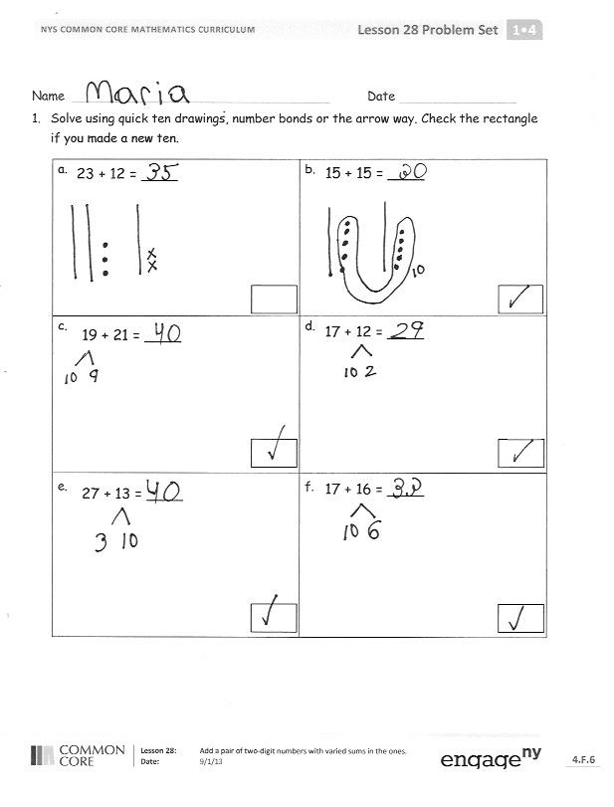
Problem Set (10 minutes)
Students should do their personal best to complete the Problem Set within the allotted 10 minutes. For some classes, it may be appropriate to modify the assignment by specifying which problems they work on first.
Student Debrief (10 minutes)
Lesson Objective: Add a pair of two-digit numbers with varied sums in the ones.
The Student Debrief is intended to invite reflection and active processing of the total lesson experience.
Invite students to review their solutions for the Problem Set. They should check work by comparing answers with a partner before going over answers as a class. Look for misconceptions or misunderstandings that can be addressed in the Debrief. Guide students in a conversation to debrief the Problem Set and process the lesson.
Any combination of the questions below may be used to lead the discussion.
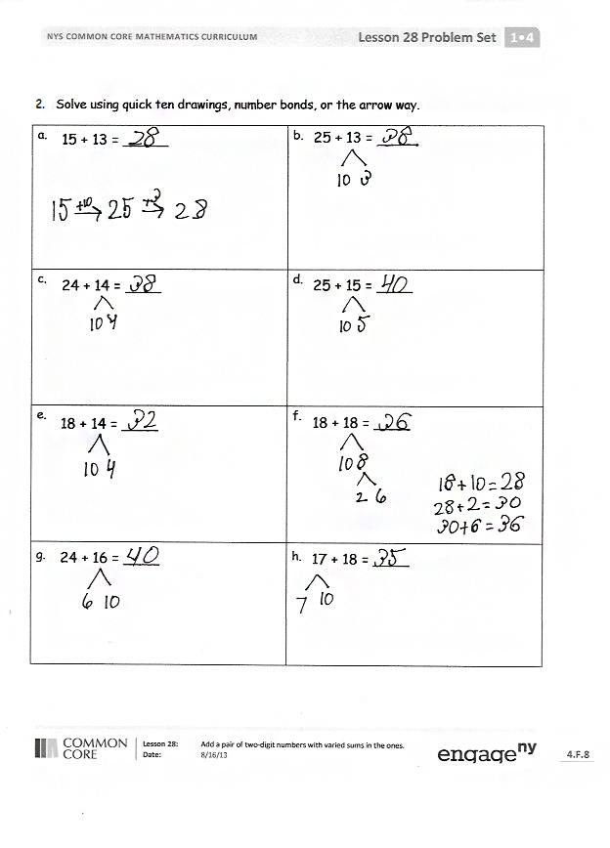
- Which method did you use the most to solve today’s addition problems? Explain the reason for your choice.
- Share how you solved Problem 2(f). How can solving Problem 2(f) help you solve 2(h)?
- A student says he solved Problem 1(f) by adding 2 tens and 13 ones. Is he correct? Explain his strategy for adding.
- With your partner, share how you solved your Application Problem and act out each part of the story. Explain how each part of your drawing or tape diagram represents different parts of the story.
Exit Ticket (3 minutes)
After the Student Debrief, instruct students to complete the Exit Ticket. A review of their work will help with assessing students’ understanding of the concepts that were presented in today’s lesson and planning more effectively for future lessons. The questions may be read aloud to the students.
Name Date
- Solve using quick ten drawings, number bonds, or the arrow way. Check the rectangle if you made a new ten.
a.  23 + 12 = ____ | b.  15 + 15 = ____
c.  19 + 21 = ____ | d.  17 + 12 = ____
e.  27 + 13 = ____ | f.  17 + 16 = ____

- Solve using quick ten drawings, number bonds, or the arrow way.
a.  25 + 13 = _____  15 + 13 = _____ | b.
c.  24 + 14 = ____ | d.  25 + 15 = ____
e.  18 + 14 = ____ | f.  18 + 18 = ____
g.  24 + 16 = ____ | h.  17 + 18 = ____

Name Date
Solve using quick tens and ones, number bonds, or the arrow way.
a.  12 + 16 = ____ | b.  26 + 14 = ____
c.  18 + 16 = ____ | d.  19 + 17 = ____

Name Date
Solve using quick tens and ones, number bonds, or the arrow way.
a.  13 + 16 = ____ | b.  15 + 16 = ____
c.  16 + 16 = ____ | d.  26 + 12 = ____
e.  22 + 17 = ____ | f.  17 + 15 = ____
g.  17 + 16 = ____ | h.  18 + 17 = ____
i.  24 + 13 = ____ | j.  15 + 24 = ____
k.  19 + 16 = ____ | l.  14 + 22 = ____
m.  27 + 12 = ____ | n.  28 + 12 = ____
o.  18 + 17 = ____ | p.  19 + 18 = ____

