Lesson 27
Objective: Add a pair of two-digit numbers when the ones digits have a sum greater than 10.

Suggested Lesson Structure
 Application Problem (5 minutes)
 Fluency Practice (12 minutes)
 Concept Development (33 minutes)
 Student Debrief (10 minutes)
Total Time (60 minutes)
Application Problem (5 minutes)
During the winter, it snowed on 14 different days. On some of the days, we got to stay home. For 9 of the snowy days, we had to go to school. For how many days did we get to stay home? Use the RDW process to solve the problem.
Extension: How many more days did it snow when we were in school compared to when we were home?
Note: Today’s problem poses a take apart with addend unknown problem type. Continue to remind students of the simple questions they can ask themselves as they attempt the problem: Can I draw something? What can I draw? What does my drawing show me that can help me with the question? The goal is for these questions to be internalized by the students over time.
Fluency Practice (12 minutes)
- Grade 1 Core Fluency Differentiated Practice Sets 1.OA.6 (5 minutes)
- Race to the Top 1.OA.6 (5 minutes)
- Take Out 1 or 2 1.OA.5 (2 minutes)
Grade 1 Core Fluency Differentiated Practice Sets (5 minutes)
Materials: (S) Core Fluency Practice Sets (Lesson 23 Core Fluency Practice Sets)
Note: This activity assesses students’ progress toward mastery of the required addition fluency for first graders. Give the appropriate Practice Set to each student. Students who completed all questions correctly on their most recent Practice Set should be given the next level of difficulty. All other students should try to improve their scores on their current levels.
Students complete as many problems as they can in 90 seconds. Assign a counting pattern and start number for early finishers, or tell them to practice make ten addition or subtraction on the back of their papers. Collect and correct any Practice Sets completed within the allotted time.
Race to the Top (5 minutes)
Materials: (S) Personal white board, race to the top (Fluency Template)
Note: This fluency activity primarily targets the core fluency for Grade 1.
Students take turns rolling the dice, saying an addition sentence and recording the sums on the graph. The game ends when time runs out or one of the columns reaches the top of the graph.
Take Out 1 or 2 (2 minutes)
Note: This anticipatory fluency exercise practices taking out 1 or 2 from two-digit numbers in order to prepare students to use this skill when adding two two-digit numbers in upcoming lessons.
Choose numbers between 0 and 10 and follow the script below.
T: Take out 1 from each number. 6. (Snap.)
S: 1 and 5.
Continue with other numbers within 10. Then, start again at 6.
T: 6.
S: 1 and 5.
T: 16.
S: 1 and 15.
T: 26.
S: 1 and 25.
T: 36.
S: 1 and 35.
After students take out 1 for a minute, start again and take out 2.

Concept Development (33 minutes)
NOTES ON
MULTIPLE MEANS
OF ACTION AND EXPRESSION:
Students may choose how they want to solve problems—with drawings, number bonds, or the arrow way. Students should begin to move away from drawing to the more abstract method of adding. However, not all students will be ready to abstractly solve problems, so support students wherever they are in their learning and guide them as they progress.

Materials: (S) Personal white board, 4 ten-sticks from the math toolkit (optional)
The time allotted for Lesson 27’s Concept Development can be used to solidify the learning that occurred in Lesson 26. Three sets of problems have been provided for students to practice and gain accuracy and efficiency when adding a pair of double-digit numbers. The teaching sequence from Lesson 26 may be used to guide instruction. Students should be encouraged to use their cubes, quick ten drawings, and number bonds with pairs of number sentences to solve (MP.5). Note that Problems 9–12 involve numbers greater than 40. This is intended to serve as a challenge set for advanced learners.
Encourage students to use place value language as they describe how their strategy works. Challenge them to compare strategies with their partners and look for related problems within the set.
MP.5
Problems 1–4 Problems 5–8 Problems 9–12
19 + 11 18 + 12 17 + 23
19 + 13 17 + 17 27 + 25
18 + 15 17 + 16 24 + 29
17 + 16 16 + 15 34 + 27
NOTES ON
MULTIPLE MEANS
OF ACTION AND EXPRESSION:
Continue to challenge your advanced students. After they have completed Problems 9–12, give students some word problems to solve with similar numbers.
Problem Set (10 minutes)
Students should do their personal best to complete the Problem Set within the allotted 10 minutes. For some classes, it may be appropriate to modify the assignment by specifying which problems they work on first.
Student Debrief (10 minutes)
Lesson Objective: Add a pair of two-digit numbers when the ones digits have a sum greater than 10.
The Student Debrief is intended to invite reflection and active processing of the total lesson experience.
Invite students to review their solutions for the Problem Set. They should check work by comparing answers with a partner before going over answers as a class. Look for misconceptions or misunderstandings that can be addressed in the Debrief. Guide students in a conversation to debrief the Problem Set and process the lesson.
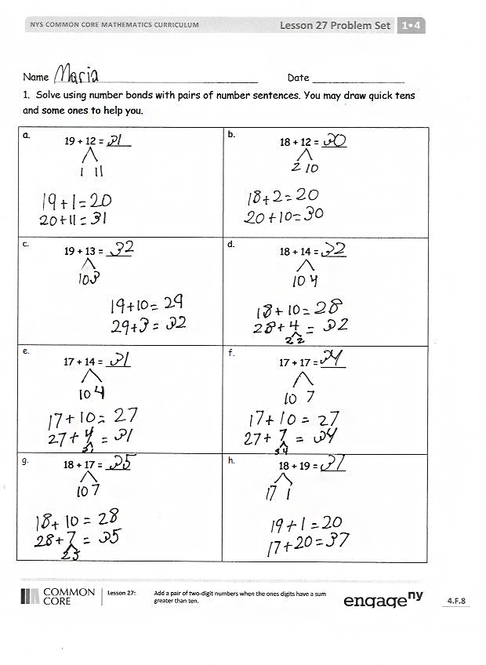
Any combination of the questions below may be used to lead the discussion.
- How can solving Problem 1(a) help solve 1(b)?
- Look at Problem 1(c) and 1(d). Explain how they are related. Why do they have the same answers?
- Look at Problem 2(f). Which addend did you start with to solve this problem? Why?
- Which ten strategy—make the next ten or add on the ten—is easier for you to use when adding? Explain your choice.
- Look at today’s Application Problem. Explain your drawing and solution to your partner.
Exit Ticket (3 minutes)
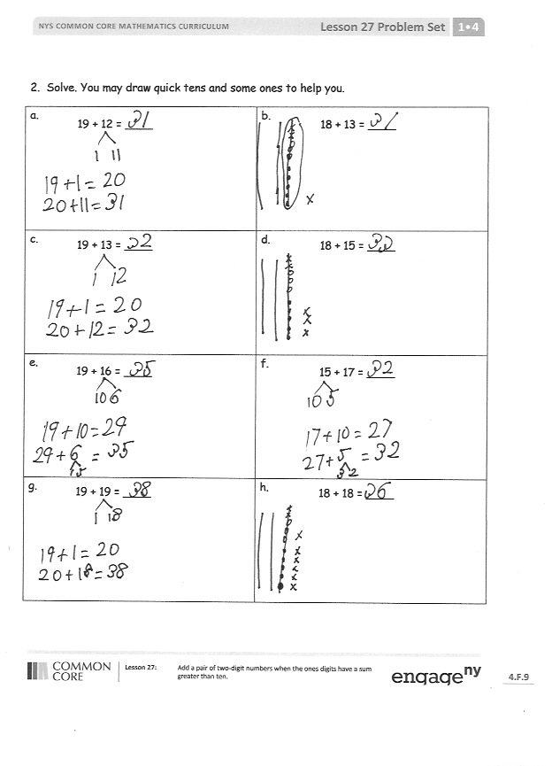
After the Student Debrief, instruct students to complete the Exit Ticket. A review of their work will help with assessing students’ understanding of the concepts that were presented in today’s lesson and planning more effectively for future lessons. The questions may be read aloud to the students.
Name Date
- Solve using number bonds with pairs of number sentences. You may draw quick tens and some ones to help you.
a.  19 + 12 = ____ | b.  18 + 12 = ____
c.  19 + 13 = ____ | d.  18 + 14 = ____
e.  17 + 14 = ____ | f.  17 + 17 = ____
g.  18 + 17 = ____ | h.  18 + 19 = ____
- Solve. You may draw quick tens and some ones to help you.
a.  19 + 12 = ____ | b.  18 + 13 = ____
c.  19 + 13 = ____ | d.  18 + 15 = ____
e.  19 + 16 = ____ | f.  15 + 17 = ____
g.  19 + 19 = ____ | h.  18 + 18 = ____

Name Date
- Solve using number bonds with pairs of number sentences. You may draw quick tens and some ones to help you.
a.  16 + 15 = ____ | b.  17 + 13 = ____
c.  16 + 16 = ____ | d.  17 + 15 = ____

Name Date
- Solve using number bonds with pairs of number sentences. You may draw quick tens and some ones to help you.
a.  17 + 14 = ____ | b.  16 + 15 = ____
c.  17 + 15 = ____ | d.  18 + 13 = ____
e.  18 + 15 = ____ | f.  18 + 16 = ____
g.  19 + 15 = ____ | h.  19 + 16 = ____
- Solve. You may draw quick tens and some ones to help you.
a.  19 + 14 = ____ | b.  19 + 17 = ____
c.  18 + 17 = ____ | d.  16 + 16 = ____
e.  17 + 14 = ____ | f.  15 + 16 = ____
g.  19 + 19 = ____ | h.  18 + 18 = ____

Names Date
Race to the Top!
2 | 3 | 4 | 5 | 6 | 7 | 8 | 9 | 10 | 11 | 12

race to the top

